

**Tribhuvan University**

**Faculty of Humanities and Social Science**

**A Project Report on**

**“Online Electronic Mart”**

***In partial fulfillment of the requirements for the Bachelor in Computer Application***

**Submitted By**

**Suman Khatri**

**6-2-20-28-2021**

**Puskar Neupane**

**6-2-20-18-2021**

**Under the Supervision of**

**Mr. Saroj Maharjan**

**Date: May 12, 2024**



**Tribhuvan University**

**Faculty of Humanities and Social Sciences**

**Bhaktapur Multiple Campus**

**Supervisor Recommendation**

This is to certify that this project prepared by **Suman Khatri** and **Puskar Neupane** entitled **“Online Electronic Mart”** in partial fulfillment of the requirements for the degree of Bachelor in Computer Application is recommended for the final evaluation.

………………………..

**Saroj Maharjan**

Lecturer

Bachelor in Computer Application.

Bhaktapur Multiple Campus, Dudhpati.



**Tribhuvan University**

**Faculty of Humanities and Social Sciences**

**Bhaktapur Multiple Campus**

**Letter of Approval**

This is to certify that this project prepared by **Suman Khatri** and **Puskar Neupane** entitled **“Online Electronic Mart”** in partial fulfillment of the requirements for the degree of Bachelor in Computer Application has been evaluated. In our opinion, it is satisfactory in the scope and quality of a project for the required degree.

|  |  |
| --- | --- |
| ………………………….  **Mr. Soraj Maharjan**  **Supervisor**  **Dudhpati, Bhaktapur** | ………………………….  **Mr. Soraj Maharjan**  **Supervisor**  **Dudhpati, Bhaktapur** |
| ………………………….  **Internal Examiner** | ………………………….  **External Examiner** |

# Acknowledgement

I would like to express my deepest appreciation to all those who provided me the possibility to complete this report. A special gratitude I give to our project Supervisor Mr. Saroj Maharjan Sir and our co-ordinator Mr. Madan Nath sir, whose contribution in stimulating suggestions and encouragement, helped me to coordinate my project especially in writing this report.

Furthermore, I would also like to express my immense gratitude to my parents and friends who helped me a lot in finalizing this project within the limited time frame.

Suman Khatri

Puskar Neupane

May 12, 2024

# Abstract

The purpose of Online Electronic Mart is to automate the existing manual system of shopping by the help of computerized equipment’s. This system has been developed using open source and free software which include XAMPP, HML5, CSS3, JavaScript, Swiper JS, etc. This project is supposed to be beneficial for those people with less IT knowledge with the use of internet access. With this system user were able to shop electronics items through this system after registering. We have created each database for individual entities and using each entity user account can surf through this system. The admin panel was used to manage the user, product, order and so on. User has to sign up at first to use different facilities that is provided by the website. User also can use add to cart button while shopping in the website. User can change the password if they want. In this way, Online Electronic Mart allow users to get information about product and shop through the website.

# Table of Contents

Acknowledgement 4

Abstract 5

Table of Contents 6

List of Abbreviations 8

List of Figures 9

List of tables 10

Chapter 1 Introduction 11

1.1 Introduction to Online Electronic Mart 11

1.2 Problem Statement 11

1.3 Objective 12

1.4 Scope and Limitation 12

1.4.1 Scope 12

1.4.2 Limitation 12

Chapter 2 Background Study and Literature Review 13

2.1 Background Study 13

2.2 Literature Review 13

Chapter 3 System Analysis and Design 14

3.1 System Analysis 14

3.1.1 User stories and Use case 15

3.1.2 Requirement Analysis 16

3.1.3 Feasibility Study 16

3.1.4 Data Modeling(ER Diagram) 17

3.1.5 Process Modeling (Data Flow Diagram) 18

3.2 System Design 19

3.2.1 Architectural Design 19

3.2.2 Database Schema 20

Chapter 4 Implementation and Testing 21

4.1 Implementation: 21

4.1.1 Tools Used 21

4.1.2 Implementation Details of Module 22

4.2 Testing 22

4.2.1 Test Case For Unit Testing 22

4.2.2 Test Case For System Testing 24

Chapter 5 Conclusion and Future Recommendation 25

5.1 Lesson Learnt 25

5.2 Conclusion 25

5.3 Future Recommendation 25

# List of Abbreviations

AR: Augmented Reality

B2B: Business-to-Business

B2C: Business-to-Consumer

CASE: Computer-Aided Software Engineering

CMS: Content Management System

CSS: Cascading Style Sheets

C2B: Consumer-to-Business

C2C: Consumer-to-Consumer

DFD: Data Flow Diagram

ER: Entity-Relationship

GDPR: General Data Protection Regulation

HTML: Hypertext Markup Language

MVC: Model View Controller

PHP: Hypertext Preprocess

RDBMS: Relational Database Management System

SEO: Search Engine Optimization

SDLC: Software Development Life Cycle

SSL: Secure Sockets Layer

VR: Virtual Reality

UI: User Interface

# List of Figures

Figure 1: Waterfall Model 14

Figure 2: ER Diagram 16

Figure 3: DFD Level 0 17

Figure 4: DFD Level 1 17

Figure 5: Architectural Design 18

Figure 6: Database Schema 19

Figure 7: System Function Module 21

# List of tables

Table 1: Test result of view product 22

Table 2: Test result of Add/Delete product 22

Table 3: Test result of update total price with quantity 23

Table 4: Test result of User Registration 24

Table 5: Test result of Shopping Cart Management 24

Table 6: Test result of Order Test 24

# Introduction

## Introduction to Online Electronic Mart

E-Commerce or Electronic Commerce means buying and selling of goods, products, or services over the internet. These services provided online over the internet network.

Online Electronic Mart is a platform which allows customers to directly buy goods or services from a seller over the internet using a web browser or a mobile app. Online Electronic Mart usually enable buyers to use “search” features to find specific models, brands or items.

Add to cart button is features of e-commerce store that allows customers to choose items to purchase without actually completing the payment. It provide add-to-card button which allows customer to save items to their carts so they can continue shopping then complete the checkout process later on in the process resulting. It also allows buyers or customer to purchase multiple items at one time.

This system is developed using HTML, CSS, JavaScript and Swiper JS in the front-end and PHP along with MySQL in the back-end of the system. The system mainly focuses on basic operations of e-commerce like adding and displaying products, updating the products, removing the products.

## Problem Statement

In traditional shopping people had to visit different shop physically to buy items. People are wasting their valuable time visiting shop- to- shop to buy electronics items. It was also difficult to gather information regarding the products they are buying. Online electronic store system is created to identify the issues that people are facing while shopping physically. This system ensures that it will provide up to date information regarding different products to the customers.

## Objective

The objective of the online electronic mart are given below.

1. To make online shopping easy and convenient for user.
2. To provide a user-friendly website navigation experience.
3. To manage inventory effectively.
4. To secure the user data and information.

## Scope and Limitation

#### Scope

1. User friendly environment such that non experience users can also easily use the website.
2. User can register and create new accounts using web application.

#### Limitation

1. Features like comment and review system lack in this system.
2. Online Payment System lacks in this system.
3. Information about available stock (i.e how many store are left) are not provided.

# Background Study and Literature Review

## Background Study

For the background study, we went through the meaning of e-commerce. We went for its types, technologies, environment, and information about its market structure.

In today's society, the use and access to the internet is so widespread that most people are busy with their jobs, thus we created this module to allow users to simply purchase via the internet. The online electronic mart is a hybrid of e-commerce and the electronic product sales business. You can simply purchase electronic items using this website, but you have to first sign in as a user to use it.

## Literature Review

As the technology is changing, the demands of customers are also quickly changing and it is must to respond quickly for changing customer demands and other factors.

There are some external factors to understand consumer’s intention to purchase in the internet which is the consumer personality, situational factors, product characteristics, previous online shopping experiences and the trust in online shopping. For age factor, consumers that are aged under 25 has more potential to shop in online because of their interest in using new technologies to search for product information and compare and evaluate alternatives. For educational level, higher educated consumers are more likely to use the internet for their shopping medium because they are more computer literate.

# System Analysis and Design

## System Analysis

Considering the fact that this project involves design and implementation of software system regardless that is web-based, it is necessary to mention and consider certain models used in software development, including the following generic software development model.

* **The waterfall model:**

For this project we choose the Waterfall Method because the project requirement are well-defined and unlikely to change significantly. It’s beneficial for projects where a clear understanding of the end of product is fixed from start. It is traditional approach where task are completed sequentially in a linear way. Each phase must be completed before moving to the next one. This phase typically include requirements gathering, design, implementation, testing, and maintenance. It’s a structured method but can be less compared to agile method.

1. Waterfall Model

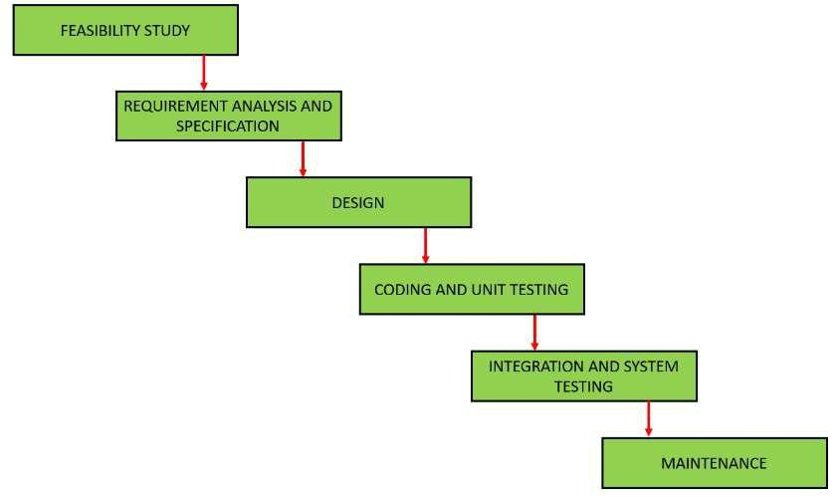

#### User stories and Use case

User stories and use cases have been developed to illustrate how different user roles will interact with the system and achieve their goals. These stories will serve as a foundation for development and testing. The figure below illustrates the use case of our system:

1. Use Case Diagram

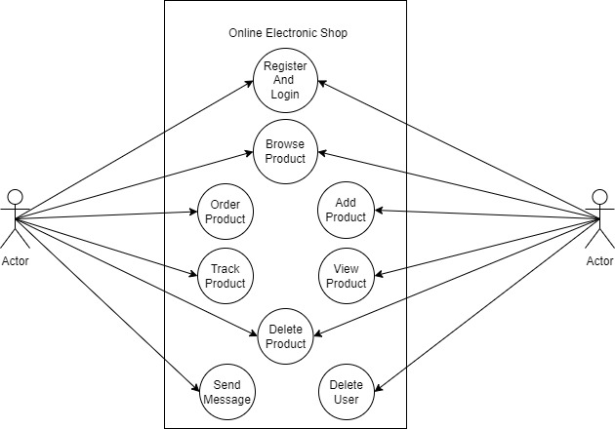

#### Requirement Analysis

1. **Functional Requirements**

**Admin module:**

* + - Admin can delete, add, update and view the products.
    - Admin can add or update his/her details.

**User module:**

* + - User can create their profile update their profile.
    - User can get information about different products.
    - Users can use add product to their cart that they liked.
    - User can browse the product easily with help of searching function.

**Login module:**

* + - Only registered user can login to the website or system.
    - It helps to authenticate the user and make login process secure.

1. **Non-functional Requirements**

* Performance
* Security
* Easy to use

#### Feasibility Study

1. **Technical Feasibility**
   * This project uses existing web technologies and tools so that there is no difficulty in developing this projects.
   * We used HTML, CSS, JS for frontend and for back-end we used PHP , MySql.
2. **Operational Feasibility**

* This project is very user Friendly and can be easily adapted by any new user.

1. **Economic Feasibility**

* Cost friendly as it uses existing free technologies.

#### Data Modeling(ER Diagram)

The Entity-Relationship (ER) model is a conceptual framework used in database design and modeling to represent the structure of data within an organization or system. It provides a visual and abstract way to describe the data entities, their attributes, and the relationships between them. The ER diagram of the E-commerce website is given below:

1. ER Diagram

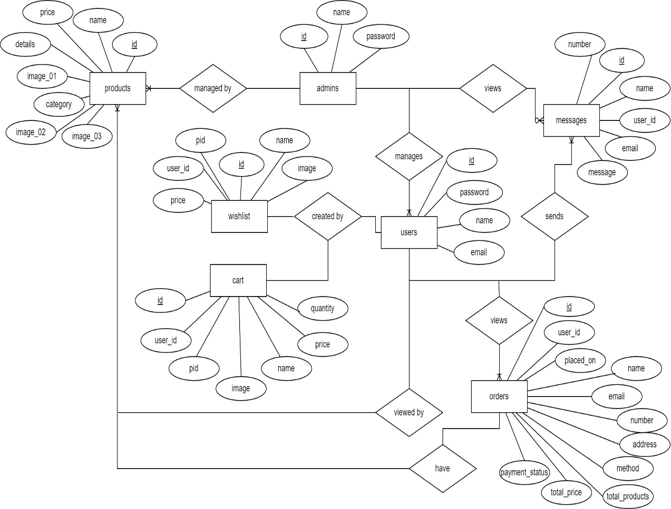

#### Process Modeling (Data Flow Diagram)

A Data flow diagram (DFD) is a graphical representation used in software engineering and system analysis to model and describe the flow of data within a system or process. DFDs provide a clear and visual way to illustrate how data is input, processed, stored, and output within a system.

1. DFD Level 0

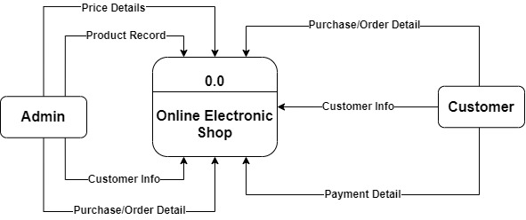

1. DFD Level 1

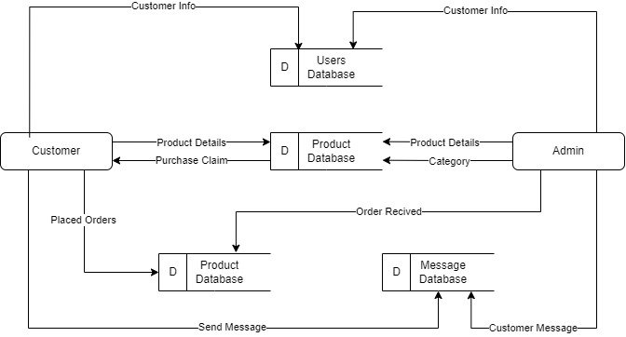

## System Design

The process of creating a system's components, including its architecture, modules, and components, as well as its many interfaces and the data it processes, is known as system design. It is meant to satisfy specific needs and requirements of business or organization through well-running system.

#### Architectural Design

1. Architectural Design

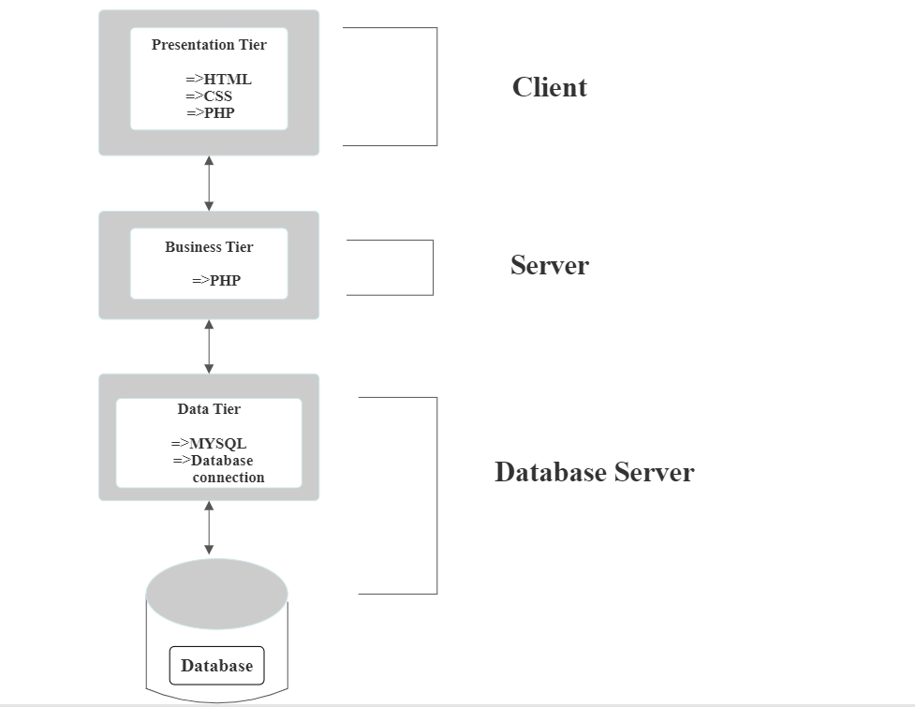

#### Database Schema

1. Database Schema

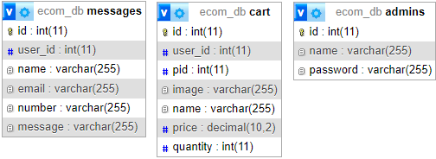

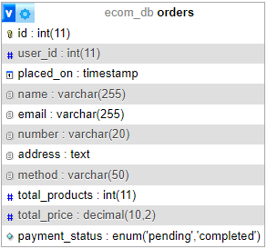

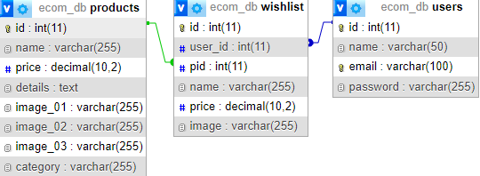

# Implementation and Testing

## Implementation:

In the implementation phase actual code is written according to the designs made in the previous phase. With the use of many tools and technologies actual working computer code is written. Some of the tools that were used during the implementation phase are discussed in the preceding chapter.

#### Tools Used

The system tools that have been used in development of this system are:

1. **CASE Tools**

IDE: Visual Studio Code

Architecture Design: Draw.io

1. **Database**

MySQL

1. **Backend**

PHP

1. **Frontend**

HTML

CSS

Java Script

#### Implementation Details of Module

1. System Function Module

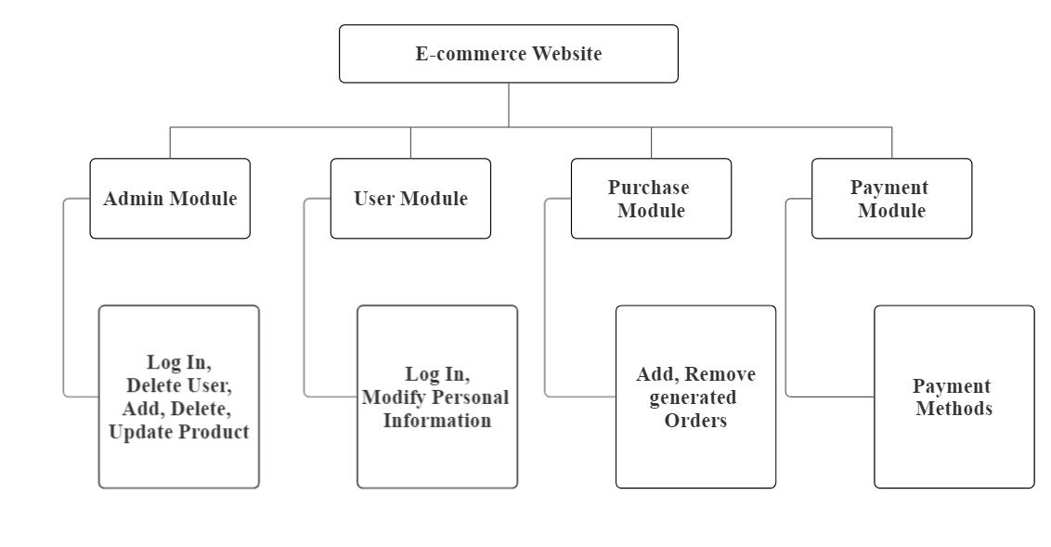

## Testing

It must be tested before deploying the application or websites. A web application may be tested in a variety of ways, including user interaction, functionality, and performance. Given the deadline for submitting this project, we won't do all the tests. Some of the testing we did is described below:

#### Test Case For Unit Testing

Table 1: Test result of view product

|  |  |  |  |  |  |
| --- | --- | --- | --- | --- | --- |
| Test Case Id | Test Scenarios | Test Steps | Test Data | Expected Result | Pass/Fail |
| T1 | View Products | Go to various Products. | Good UI clicks in the products. | Users can view the products. | Pass |

Table 2: Test result of Add/Delete product

|  |  |  |  |  |  |
| --- | --- | --- | --- | --- | --- |
| Test Case Id | Test Scenarios | Test Steps | Test Data | Expected Result | Pass/Fail |
| T2 | Add or Remove Products | Go to the admin panel and add or Delete the Product. | Add any Product. | Product Added! | Pass |

Table 3: Test result of update total price with quantity

|  |  |  |  |  |  |
| --- | --- | --- | --- | --- | --- |
| Test Case Id | Test Scenarios | Test Steps | Test Data | Expected Result | Pass/Fail |
| T3 | Edit the quantity or remove the products and see the changes in total price. | Remove a product from the cart and check the total price. | Item has been removed to see the changes in the cart. | The item has been removed and the total price has been changed accordingly. | Pass |

Table 4: Test result of User Registration

|  |  |  |  |  |
| --- | --- | --- | --- | --- |
| User Registration Test | | | | |
| Username | Email | Password | Re-Password | Pass/Fail |
| Wolf | kas@gmail.com | lucifer | lucifer | Pass |
| King | luca@gmail.com | Lucas123 | Lucas1234 | Fail |
| NULL | Kjdgf@gmail.com | jghghg | NULL | Fail |

Table 5: Test result of Shopping Cart Management

|  |  |  |
| --- | --- | --- |
| Shopping Cart Management Test | | |
| Input | Actual Output | Pass/Fail |
| The operation has been added. | Product name, price, and quantity appear in the cart. | Pass |
| Quantity changes to 3. | The product has been updated. | Pass |
| Click the Delete Item button and delete the product | The product has been removed. | Pass |

|  |  |  |  |
| --- | --- | --- | --- |
| Order Test | | | |
| Test number | Test case | Test Result | Pass/Fail |
| 01 | No information input. | Please fill out the field. | Fail |
| 02 | All information is filled in. | Place an order. | Pass |

Table 6: Test result of Order Test

#### Test Case For System Testing

1. If the site loads properly with all the pictures, pages and features.
2. If the user can register/login to the site
3. If the features like “add to cart”, “add to wishlist”, “search” works properly.
4. If the system works properly in all version of browser.

# Conclusion and Future Recommendation

## Lesson Learnt

1. We learnt how to work as a team in a project.
2. We learnt to use draw.io website to make diagrams.
3. We learnt to build a fully functioning ecommerce website.

## Conclusion

People can do simple online shopping when the shopping website is finished. The present application has met all of the objectives. There were difficulties, particularly with the backend and ensuring that the application responded predictably.

People with little to no IT experience can still benefit from the proposed method by using the internet. It was discovered near the project's conclusion that the system may use a number of upgrades. Any more enhancements to the application can be made during future development.

## Future Recommendation

This project has been developed in such a way that it can be modified and changed later. This project is planned to cover all the stepwise process that takes place in a software development environment.

The following are the future aspects of the project:

1. Consider developing a dedicated mobile app to provide a better shopping experience on smartphones and tablets.
2. Add different payment methods.
3. Addition of more themes and attractive UI.
4. Add multiple categories for items.

**References**