**1. Total Revenue:**

SELECT SUM(TOTAL_PRICE) AS REVENUE FROM pizza_sales

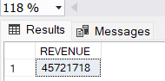

**2. Average Order Value**

SELECT SUM(TOTAL_PRICE)/COUNT(DISTINCT ORDER_ID) AS AVERAGE_ORDER FROM pizza_sales

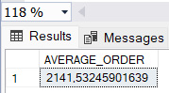

**3. Total Pizzas Sold**

SELECT SUM(QUANTITY) AS TOTAL_PIZZA_SOLD FROM PIZZA_SALES

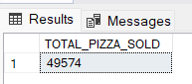

**4. Total Orders**

SELECT COUNT(DISTINCT ORDER_ID) AS TOTAL_ORDERS FROM PIZZA_SALES

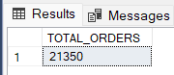

**5. Average Pizzas Per Order**

SELECT SUM(QUANTITY)/COUNT(DISTINCT ORDER_ID) AS AVG_PIZZA_FOR_ORDER FROM pizza_sales

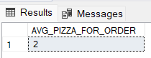

**B. Daily Trend for Total Orders**

SELECT DATENAME(DW,order_date) AS DAY_WEEK,SUM(DISTINCT ORDER_ID) AS TOTAL_ORDER FROM PIZZA_SALES

GROUP BY DATENAME(DW,order_date)

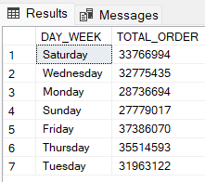

**C. Monthly Trend for Orders**

SELECT DATENAME(MM,order_date) AS DAY_WEEK,SUM(DISTINCT ORDER_ID) AS TOTAL_ORDER FROM PIZZA_SALES

GROUP BY DATENAME(MM,order_date)

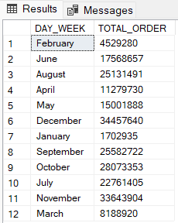

**D. % of Sales by Pizza Category**

SELECT pizza_category,SUM(TOTAL_PRICE) AS REVENUE ,

CAST(SUM(TOTAL_PRICE)*100/ (SELECT CAST(SUM(TOTAL_PRICE) AS DECIMAL(10,2)) FROM PIZZA_SALES) AS decimal(10,2)) AS PIZZA_CATEGORY_PERCENTAGE

FROM PIZZA_SALES

GROUP BY pizza_category

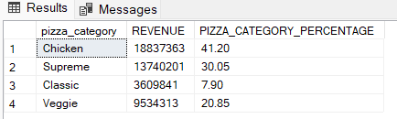

**E. % of Sales by Pizza Size**

SELECT pizza_size,SUM(TOTAL_PRICE) AS REVENUE ,

CAST(SUM(TOTAL_PRICE)*100/ (SELECT CAST(SUM(TOTAL_PRICE) AS DECIMAL(10,2)) FROM PIZZA_SALES) AS decimal(10,2)) AS PIZZA_CATEGORY_PERCENTAGE

FROM PIZZA_SALES

GROUP BY pizza_size

ORDER BY PIZZA_SIZE

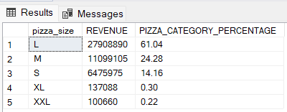

**F. Total Pizzas Sold by Pizza Category**

SELECT pizza_category,SUM(QUANTITY) AS NO_OF_ORDERS FROM pizza_sales

WHERE MONTH(order_date) = 2

GROUP BY pizza_category

ORDER BY NO_OF_ORDERS DESC

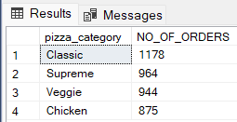

**G. Top 5 Pizzas by Revenue**

SELECT TOP 5 PIZZA_NAME,SUM(TOTAL_PRICE) AS TOTAL_REVENUE FROM PIZZA_SALES

GROUP BY PIZZA_NAME

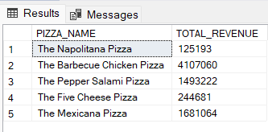

**H. Bottom 5 Pizzas by Revenue**

SELECT TOP 5 PIZZA_NAME,SUM(TOTAL_PRICE) AS TOTAL_REVENUE FROM PIZZA_SALES

GROUP BY PIZZA_NAME

ORDER BY PIZZA_NAME DESC

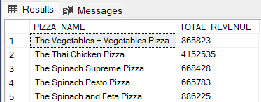

**I. Top 5 Pizzas by Quantity**

SELECT TOP 5 PIZZA_NAME,SUM(QUANTITY) AS TOTAL_REVENUE FROM PIZZA_SALES

GROUP BY PIZZA_NAME

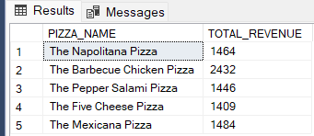

**J. Bottom 5 Pizzas by Quantity**

SELECT TOP 5 PIZZA_NAME,SUM(QUANTITY) AS TOTAL_REVENUE FROM PIZZA_SALES

GROUP BY PIZZA_NAME

ORDER BY PIZZA_NAME DESC

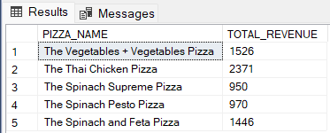

**K. Top 5 Pizzas by Total Orders**

SELECT TOP 5 PIZZA_NAME,COUNT(DISTINCT ORDER_ID) AS TOTAL_ORDERS FROM PIZZA_SALES

GROUP BY PIZZA_NAME

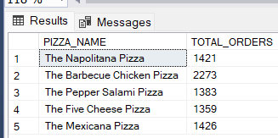

**L. Borrom 5 Pizzas by Total Orders**

SELECT TOP 5 PIZZA_NAME,COUNT(DISTINCT ORDER_ID) AS TOTAL_ORDERS FROM PIZZA_SALES

GROUP BY PIZZA_NAME

ORDER BY pizza_name DESC

