Appointment system.

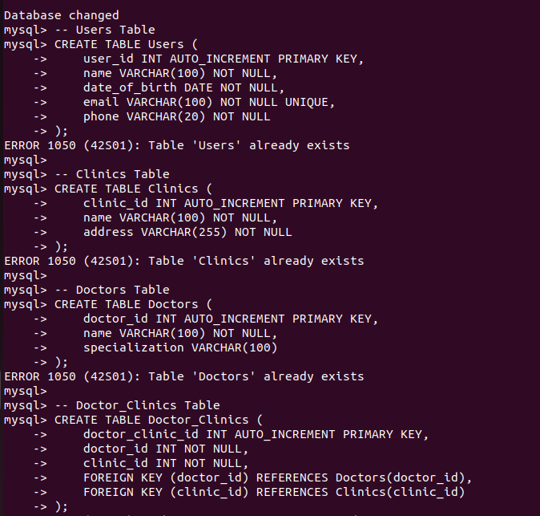

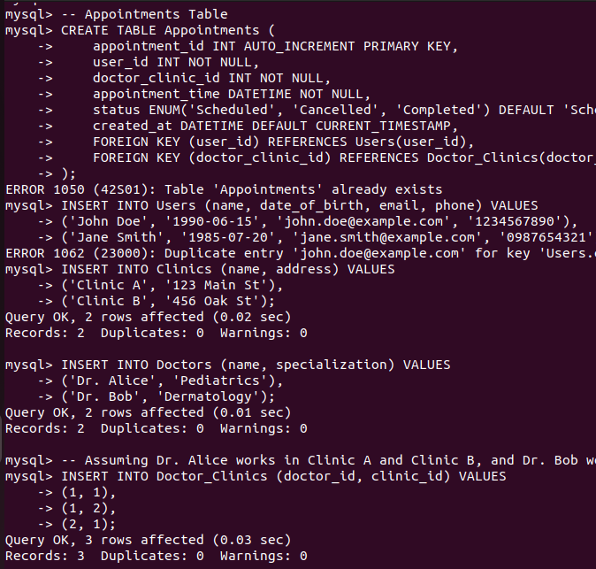
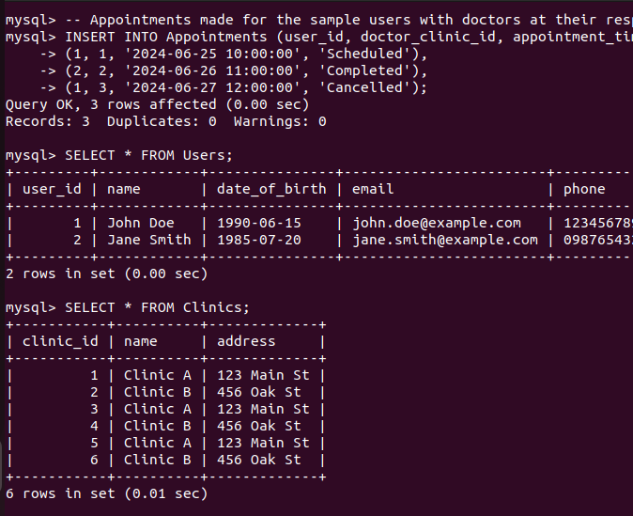
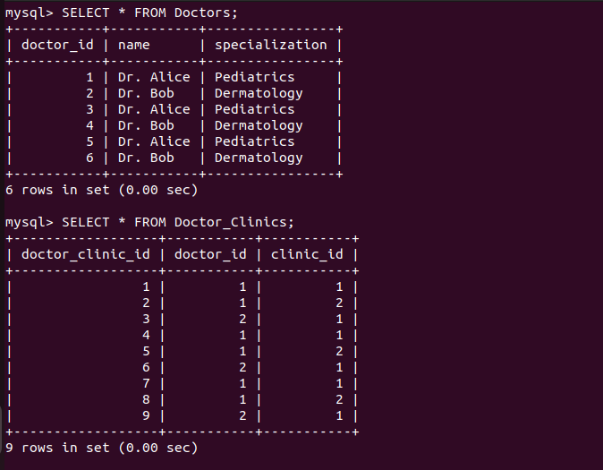
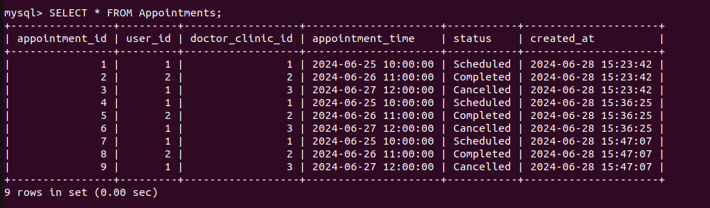
1. All appointments booked in last 7 days for a doctor.

QUERY:
SELECT a.appointment_id, a.user_id, a.doctor_clinic_id, a.appointment_time, a.status
FROM Appointments a
JOIN Doctor_Clinics dc ON a.doctor_clinic_id = dc.doctor_clinic_id
WHERE dc.doctor_id = 1 -- Replace '1' with the doctor_id you are querying for
AND a.created_at >= CURDATE() - INTERVAL 7 DAY;

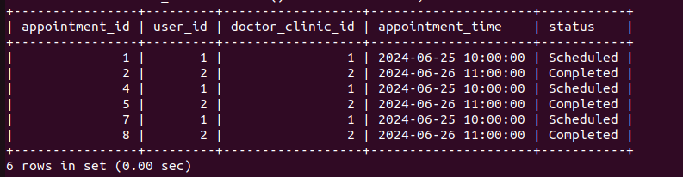

2. All appointments booked in the last 2 days and scheduled within the next 5 hours for a doctor.
QUERY:
SELECT a.appointment_id, a.user_id, a.doctor_clinic_id, a.appointment_time, a.status
FROM Appointments a
JOIN Doctor_Clinics dc ON a.doctor_clinic_id = dc.doctor_clinic_id
WHERE dc.doctor_id = 1 -- Replace '1' with the doctor_id you are querying for
AND a.created_at >= CURDATE() - INTERVAL 2 DAY
AND a.appointment_time <= NOW() + INTERVAL 5 HOUR;

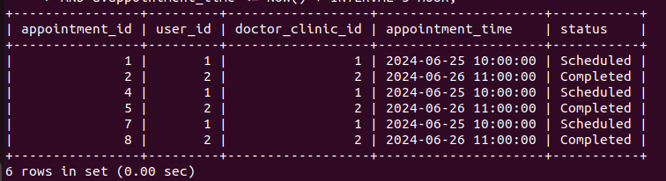
3. User who have at least 1 appointment and have their birthday coming in the next 5 days.
QUERY:
SELECT u.user_id, u.name, u.date_of_birth
FROM Users u
JOIN Appointments a ON u.user_id = a.user_id
WHERE a.status = 'Scheduled' -- Change to appropriate status as needed
AND DATE_ADD(CURDATE(), INTERVAL 5 DAY) >= DATE_ADD(u.date_of_birth, INTERVAL YEAR(CURDATE())-YEAR(u.date_of_birth) +
IF(DAYOFYEAR(CURDATE()) <= DAYOFYEAR(u.date_of_birth),0,1) YEAR);

Empty set (0.00 sec)

4. Appointments for a particular patient in the last 7 days.
QUERY
SELECT appointment_id, doctor_clinic_id, appointment_time, status
FROM Appointments
WHERE user_id = 1 -- Replace '1' with the user_id of the particular patient
AND appointment_time >= CURDATE() - INTERVAL 7 DAY;

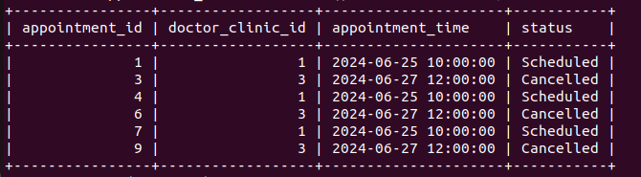

5. Appointment cancellation percentage for a doctor by clinic.
QUERY:
SELECT dc.doctor_id, dc.clinic_id, c.name AS clinic_name,
ROUND(SUM(CASE WHEN a.status = 'Cancelled' THEN 1 ELSE 0 END) / COUNT(a.appointment_id) * 100, 2) AS cancellation_percentage
FROM Appointments a
JOIN Doctor_Clinics dc ON a.doctor_clinic_id = dc.doctor_clinic_id
JOIN Clinics c ON dc.clinic_id = c.clinic_id
WHERE dc.doctor_id = 1 -- Replace '1' with the doctor_id you are querying for
GROUP BY dc.doctor_id, dc.clinic_id, clinic_name;
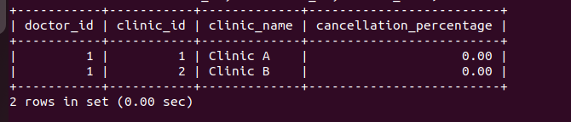
ER Diagram:
