WEEKLY PROJECT DEVELOPMENT DOCUMENTATION
Design and Implementation of a Standardized Blockchain Framework for Interoperable Pharmaceutical Supply Chain Traceability
Proposed Solution, System Design, Application Development and Experimental Analysis

1. Proposed Solution
The proposed solution is a permissioned blockchain-based pharmaceutical supply chain traceability framework for manufacturers, distributors, pharmacies and regulators. The design combines role-based application interfaces, a standardized interoperability layer, Hyperledger Fabric, PostgreSQL and off-chain document storage.
The framework is designed to address the identified research gaps through standardized data exchange, hybrid storage, traceable blockchain events and measurable technical evaluation.

2. System Architecture
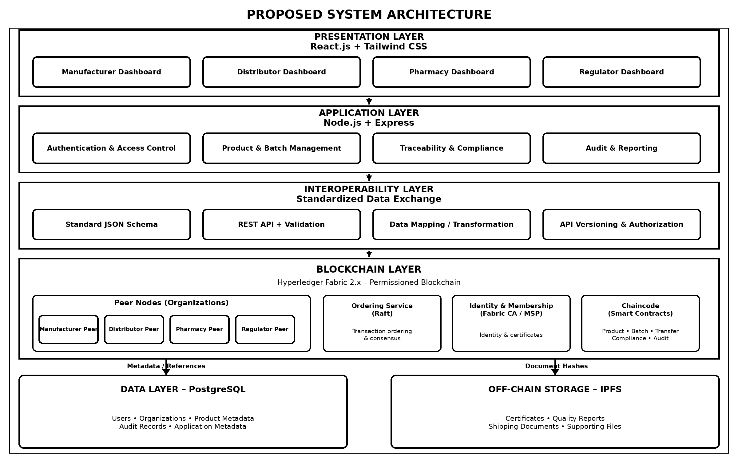
Figure 1: Proposed System Architecture

2.1 Architecture Components
- Presentation Layer – React.js/Tailwind CSS dashboards for Manufacturer, Distributor, Pharmacy and Regulator.
- Application Layer – Node.js/Express services for authentication, product/batch management, traceability, compliance and reporting.
- Interoperability Layer – Standard JSON Schema, REST API validation, data mapping/transformation and API authorization.
- Blockchain Layer – Hyperledger Fabric 2.x with peer organizations, ordering service, MSP/Fabric CA and chaincode.
- Data Layer – PostgreSQL for structured application metadata and audit records.
- Off-chain Storage – IPFS or equivalent storage for supporting documents, with cryptographic hash references recorded for integrity checking.

3. User Workflow
The workflow follows a pharmaceutical batch from manufacturer creation through distribution, pharmacy verification and regulatory audit.
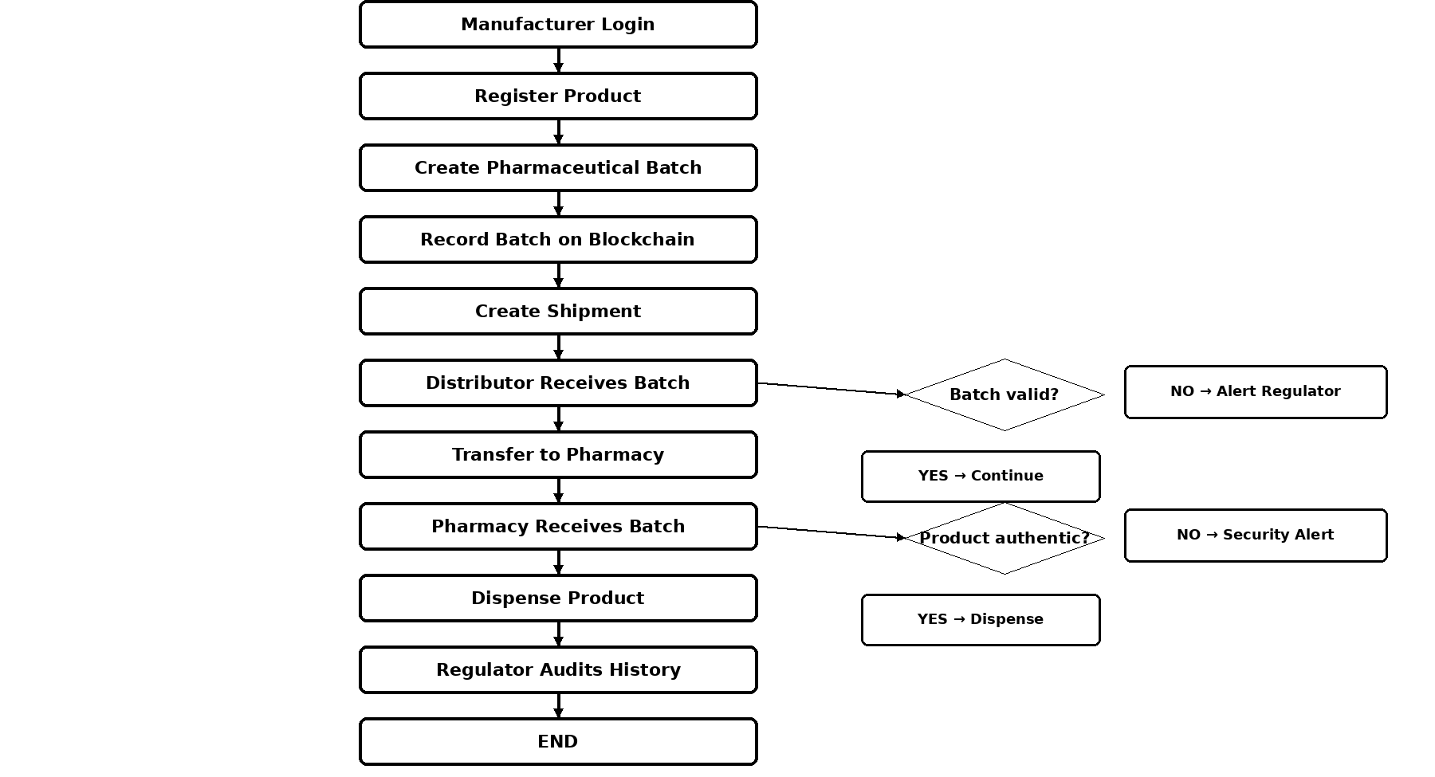
Figure 2: Pharmaceutical Supply Chain User Workflow

4. Sequence Diagram
The sequence diagram describes batch creation from the manufacturer's interface through validation, metadata/document storage and the blockchain transaction.
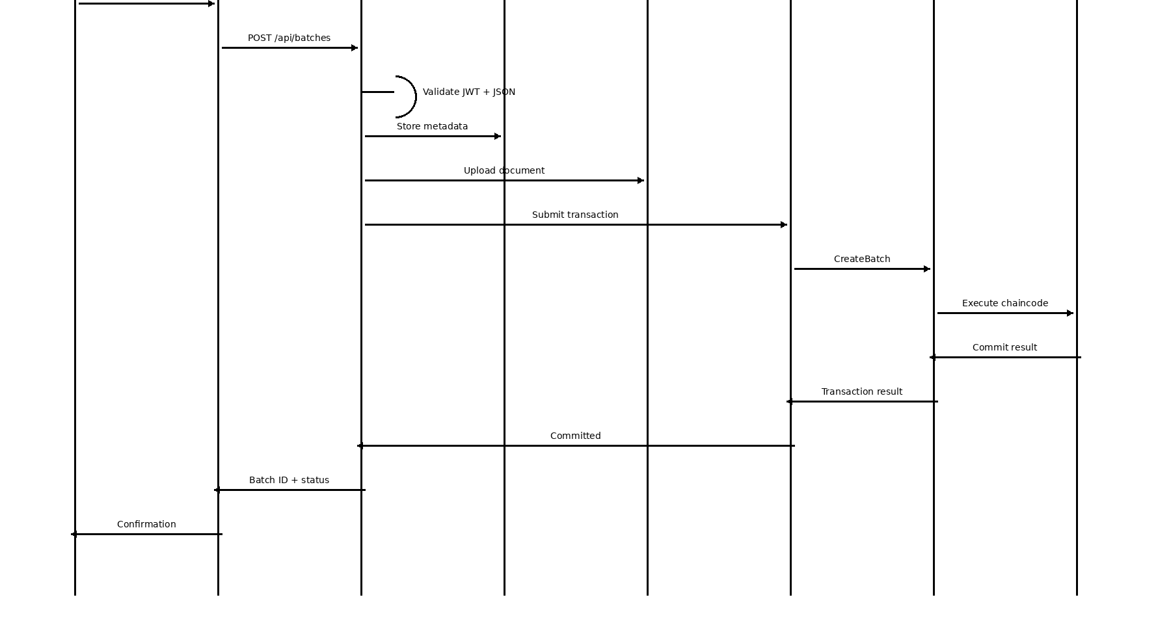
Figure 3: Sequence Diagram – Pharmaceutical Batch Registration

5. Flowcharts

5.1 Product Verification
The verification process checks authentication, batch existence, traceability history, document integrity and product status before returning a verification result or raising an alert.
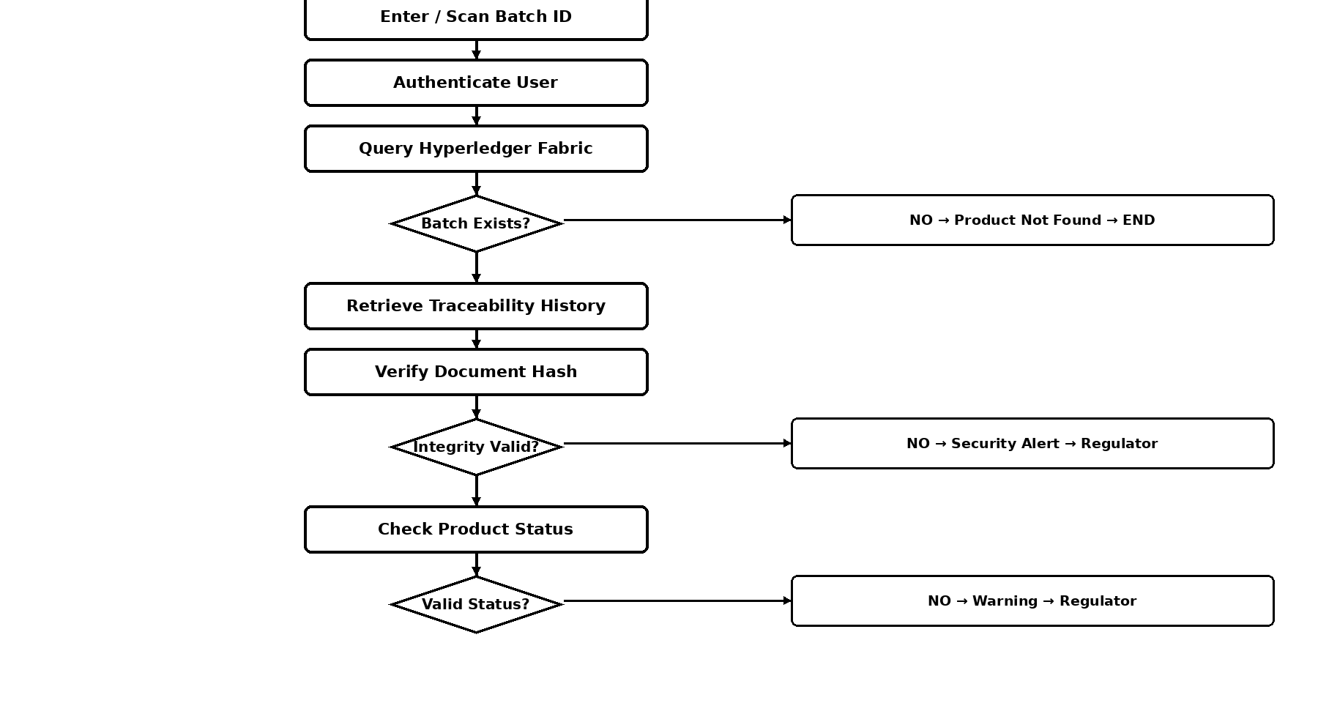
Figure 4: Pharmaceutical Product Verification Flowchart

5.2 Standardized Interoperability
The interoperability process receives data from an external system, validates it against the standardized JSON Schema, authenticates the sender, performs mapping/transformation where needed, records the event through the traceability service and returns a standardized response.
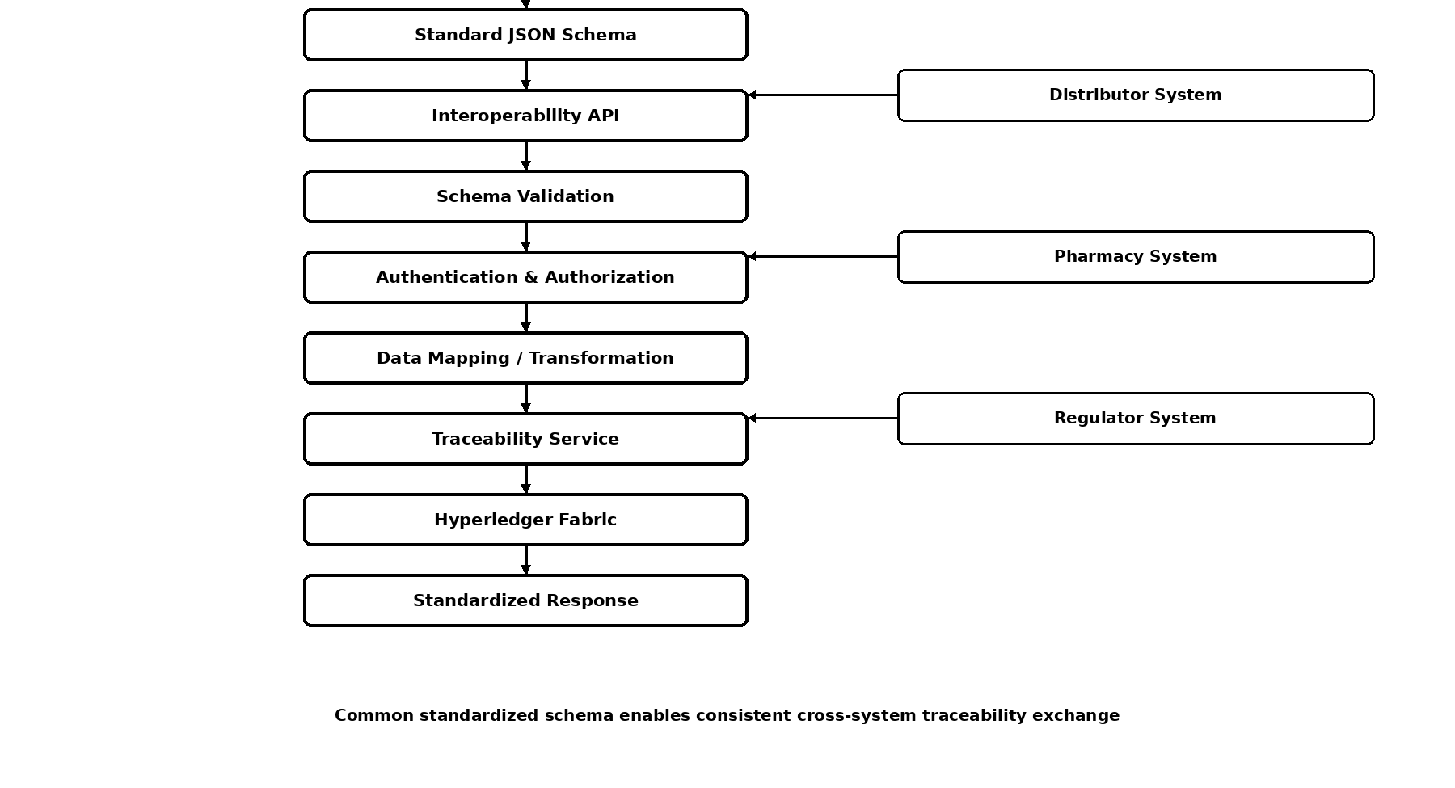
Figure 5: Standardized Interoperability Flowchart

6. Application Development
The implementation baseline contains a local demo mode and an actual Hyperledger Fabric integration path. Demo mode supports rapid development without requiring a running blockchain network, while Fabric mode uses the Fabric Gateway client to submit and evaluate ledger transactions.

6.1 Backend
- Node.js + Express REST API.
- JWT authentication and role-based authorization.
- Product, batch, transfer, receive, verification and compliance endpoints.
- Standardized interoperability endpoints.
- PostgreSQL repository/schema integration point.
- IPFS HTTP upload integration point.

6.2 Blockchain
- JavaScript chaincode for product and batch lifecycle management.
- CreateProduct, CreateBatch, ReadProduct, ReadBatch, TransferBatch, ReceiveBatch, VerifyBatch, GetBatchHistory and UpdateComplianceStatus.
- Fabric Gateway integration for query and transaction submission.

6.3 Frontend
- React-based role-aware dashboard.
- Manufacturer product and batch creation.
- Batch lookup and history.
- Distributor transfer/receive/verify actions.
- Pharmacy receive/verify actions.
- Regulator verification and compliance update.

7. Standardized Traceability Event
The initial event model is versioned to support future schema evolution:
{
"eventVersion": "1.0",
"eventId": "EVT-001",
"eventType": "BATCH_CREATED",
"timestamp": "2026-09-28T00:00:00Z",
"organizationId": "ORG-MAN-001",
"productId": "MED-001",
"batchId": "BATCH-001",
"location": "Auckland",
"status": "MANUFACTURED"
}

8. Experimental Analysis
The experiments are designed to provide evidence for technical performance, interoperability, data integrity and authorization. Final results must be produced from actual executions and reported with the exact test environment and workload.

8.1 Blockchain Performance
- Run controlled workloads such as 100, 500, 1,000 and, if feasible, 5,000 transactions.
- Measure throughput (TPS), average and p95 latency, successful/failed transactions, CPU and memory.
- Repeat tests where practical and preserve raw logs.

8.2 REST API Performance
- Test product creation, batch creation, transfer, receive, verification and traceability-history endpoints.
- Record response time, success rate and errors at controlled concurrency levels.

8.3 Interoperability Experiment
- Submit valid standardized events from a simulated manufacturer system.
- Submit invalid events and confirm schema rejection.
- Measure acceptance/rejection rate and response time.

8.4 Data Integrity Experiment
- Generate a SHA-256 hash for a supporting document.
- Store the integrity reference.
- Retrieve the document and calculate the hash again.
- Compare hashes and record mismatches as integrity alerts.

8.5 Role-Based Access Control
Attempt permitted and prohibited operations using each role and record the expected authorization outcome.

9. Initial Testing Matrix
Test Case | Expected Result | Status
Valid login | Authentication succeeds | Implemented
Invalid login | Access denied | Implemented
Create product | Product registered | Implemented in demo
Create batch | Blockchain-style record created in demo / Fabric transaction in Fabric mode | Implemented in demo
Duplicate batch | Request rejected | Implemented in demo
Transfer and receive | Status/owner updated | Implemented in demo
Verify batch | Verification status returned | Implemented in demo
History query | Traceability history returned | Implemented in demo
Invalid interoperability event | Schema validation failure | Implemented
Unauthorized action | 403 response | Implemented
Document hash mismatch | Integrity issue detected | Pending integrated test

10. Development Evidence to Collect
- Hyperledger Fabric network startup and chaincode deployment evidence.
- Product and batch transaction IDs.
- Transfer, receive, verification and history evidence.
- Postman requests and responses.
- PostgreSQL schema and sample data.
- IPFS CID and SHA-256 hash evidence.
- Valid and invalid interoperability messages.
- Authorization failure tests.
- Benchmark output files and test-environment configuration.

11. Current Implementation Status
The implementation package contains the application baseline, standardized schema, chaincode, tests and experiment scripts. JavaScript syntax checks and the built-in demo-ledger/schema tests have been executed successfully. The actual Fabric network has not been run in this environment because Docker is unavailable, so no Fabric performance result is claimed.
Before final submission, the Fabric-mode network, integrated PostgreSQL/IPFS path, and the full experimental workload must be run on the development machine and their actual results recorded.

12. Next Development Steps
1. Install Docker and the selected Hyperledger Fabric 2.x samples/binaries.
2. Create the pharmaceutical channel and configure organization identities.
3. Deploy the chaincode and configure the Fabric Gateway credentials.
4. Run the complete Manufacturer → Distributor → Pharmacy → Regulator workflow in Fabric mode.
5. Enable PostgreSQL and IPFS and collect evidence.
6. Execute interoperability, integrity, authorization and performance experiments.
7. Create result tables/graphs from the raw experiment outputs.
8. Map measured findings back to the research questions and objectives.

