 BD Perdurable Limited

**Experience Certificate**

**TO WHOM IT MAY CONCERN**

We hereby certify that **MD: JABAD MIAH**, Son of **AKKAS ALI** his worked with as Production and Installation of Windows from 05 February, 2019 to 31 August, 2021. Certificate No: 001-088-21-247-00915. During his tenure of service, we found his character and conduct are to be satisfactory. We wish all success in his future.

Issue Date: 29 July, 2022. BD Perdurable

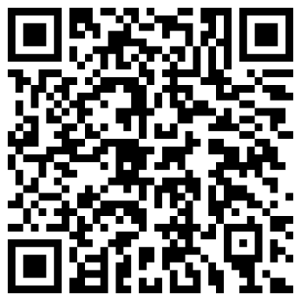

Suman Ahmed

Managing Director

Contact:

Office Location

BD Perdurable Limited

East Kazipara, Ja/244, Mirpur, Dhaka-1216, Bangladesh.

Phone: +8801620506565, +8801767778333

Email: [suman777333@gmail.com](mailto:suman777333@gmail.com)

Web: <https://bdperdurable.com/>