Class Notes

1)**What is MLOps and DevOps?**

* DevOps is a set of practices that combines software development (Dev) and IT operations (Ops) to shorten the development lifecycle and deliver high-quality software continuously. It emphasizes collaboration, automation, and monitoring throughout the software development process.
* MLOps (Machine Learning Operations) extends DevOps principles to machine learning projects, focusing on the collaboration between data scientists and operations teams. It aims to automate and streamline the deployment, monitoring, and management of machine learning models in production, ensuring reliability and scalability.

Example:

In the context of an E-wedding platform, MLOps involves deploying machine learning models to personalize user experiences, such as recommending vendors or creating customized wedding plans based on user preferences. It ensures continuous integration and delivery of ML models, monitoring their performance, and retraining them with new data to improve accuracy.

DevOps focuses on the collaboration between development and operations teams to streamline the deployment of the E-wedding platform. It emphasizes automation, continuous integration, and delivery pipelines to ensure that new features, updates, and bug fixes are released efficiently and reliably, enhancing the overall user experience.

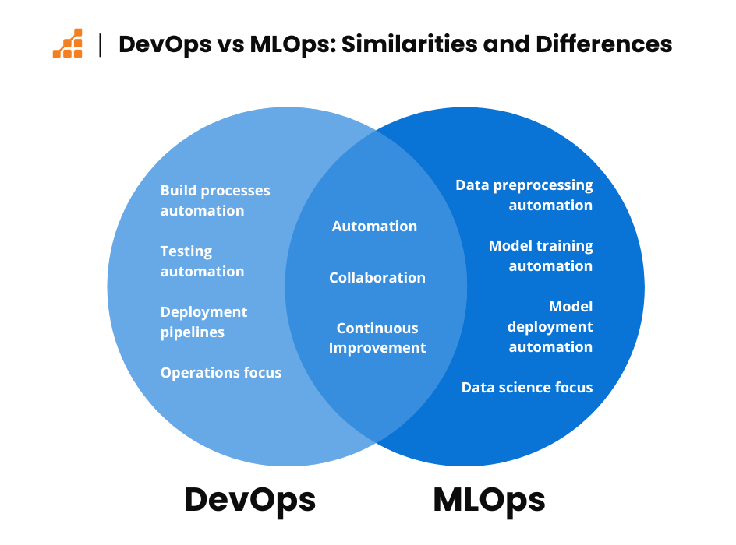

Key Feature of the MLOps:

MLops has 4 popular features that make it unique. The Features are

a) **Reliability**

b) **Scalability**

**c) Maintainability**

**d) Adaptability**

* **Reliability**: Ensures that machine learning models perform consistently and accurately in production, minimizing downtime and errors through robust monitoring and validation processes.
* **Scalability**: Allows models to handle increasing amounts of data and user requests efficiently, enabling the system to grow without performance degradation.
* **Maintainability**: Facilitates easy updates and modifications to models and pipelines, ensuring that they can be quickly adapted to new requirements or improvements.
* **Adaptability**: Supports the ability to retrain models with new data and incorporate feedback, allowing the system to evolve and improve over time in response to changing conditions and user needs.