**MINI-REDDIT**



APRIL 4, 2016

April 4, 2016 Page | 1

TABLE OF CONTENTS

|  |  |
| --- | --- |
| **INTRODUCTION** | **3** |
| **PURPOSE** | **3** |
| **WEBSITE STRUCTURE** | **4** |
| **MODULES** | **5** |
| **LOG IN** | **6** |
| **SIGNUP** | **9** |
| **POST SUBMISSION** | **12** |
| **SEARCH BAR** | **14** |
| **TABS** | **15** |
| **POSTS** | **19** |
| **PLAY BUTTON** | **21** |

April 4, 2016 Page | 2

**INTRODUCTION**

Mini-Reddit is a social news voting website that is used for sharing anything that people with different interests would find interesting. Users are allowed to submit text posts or direct links to other webpages. Registered users can vote submissions up or down to organize the posts and determine the position on the website page. The word Herald means a messenger and Mini-Reddit has been derived from it to indicate an internet messenger.

**PURPOSE**

The purpose of this project is to build a social news voting site where users can post social news with links of images and videos. The users can also like or dislike a post on the website. A user can like or dislike a post only if he is logged in. If he/she is not logged in he/she will not be allowed to like or dislike a certain post.

Even to add a new post to the website the user has to login.

Items of value are “upvoted” and those deemed unworthy are “downvoted”.

April 4, 2016 Page | 3

**WEBSITE STRUCTURE**

Our Mini-Reddit website looks like this when you open it in a browser-

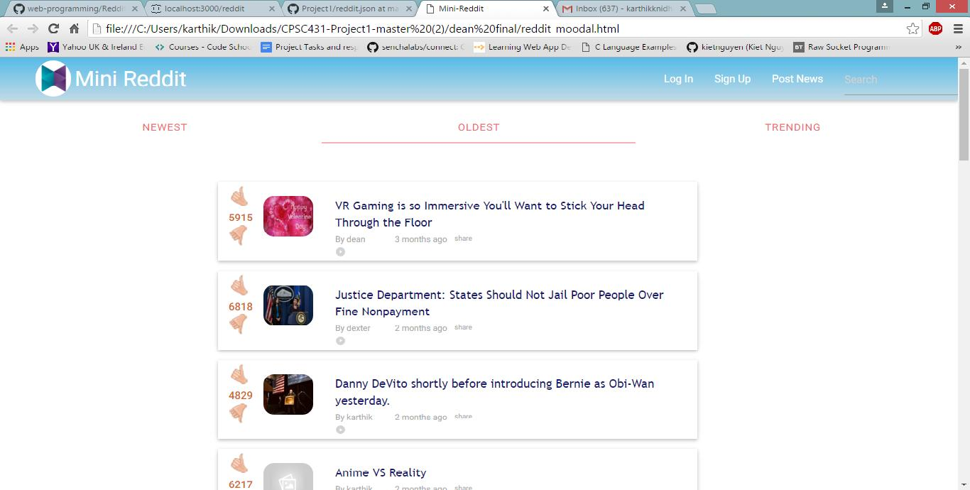

Here you will see three sections

1. **Header**-which contains the logo and name of our website at the left corner and links for login,signup, post news and search.
2. **Main**- which contains links of navigation through different tabs called Newest (to view newlyadded posts), oldest (to view all the old posts) and Trending (to view all the highly upvoted posts). It also contains all the actual posts posted by users. A user can post a url only if he/she is logged in.
3. **Footer**- indicates the end of the webpage and contains copyright information.

April 4, 2016 Page | 4

**MODULES-**

**Header Module**- Contains the logo and name of the website in the left corner and links for login,signup and post news and search.

**Search Module-**Found at the very top right corner of the website. The search performs a task ofsearching for posts.

**Tabs Module-**A horizontal navigation bar to switch between pages of the website to view postsaccording to preference.

**Main Module-** which contains the posts (links to images or videos or text) posted by users.

**Footer Module-**The text at the very bottom of the page that has some copyright information.All these modules are explained in detail further in this documentation.

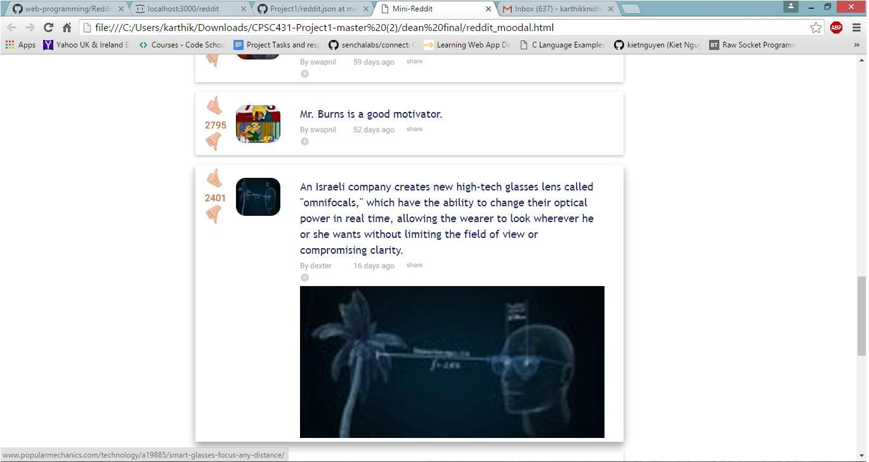

**LOG IN-**

When you click on login a window pops up asking for the username and password. If the username and password is entered correctly then you will be logged in.

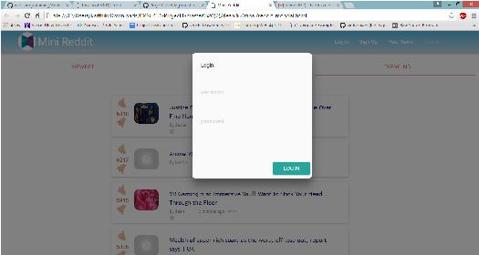

April 4, 2016 Page | 6

**SIGN UP-**

When you click on Signup you will be asked to register your username and password.

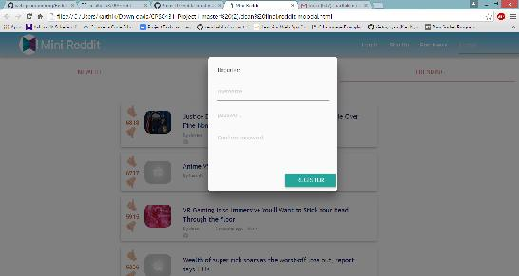

April 4, 2016 Page | 7

**POST SUBMISSION-**

When you click on Post News we have a post title( where we enter the title of the post), a url(where we enter the link), image URL(incase our link directs us to an image) or a video url(incase our link directs us to a video).

There is a post button which if clicked will post the url on the website.

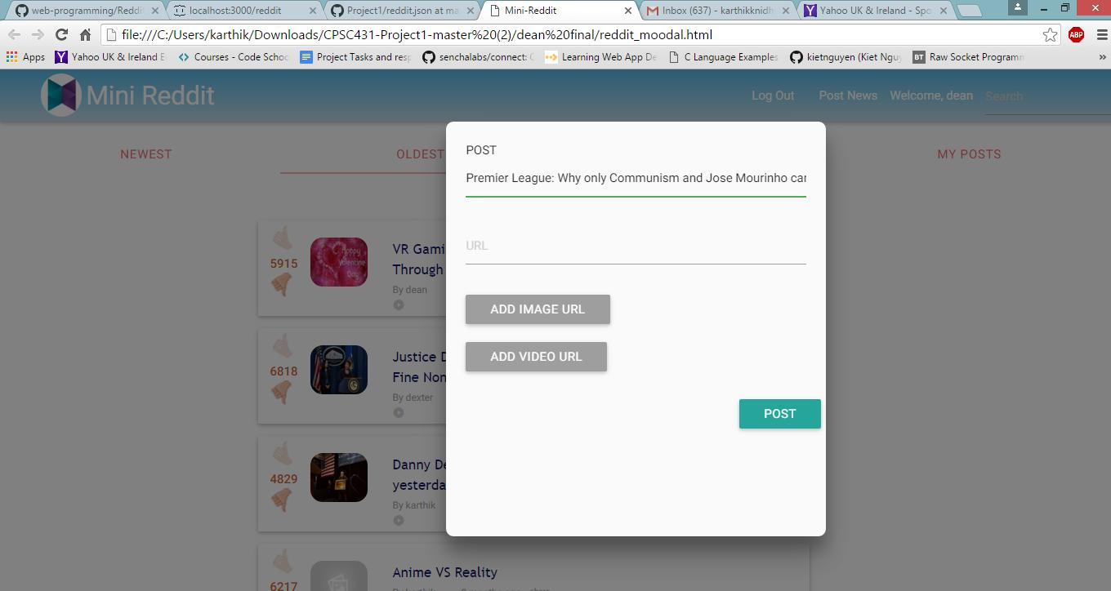

Post without login

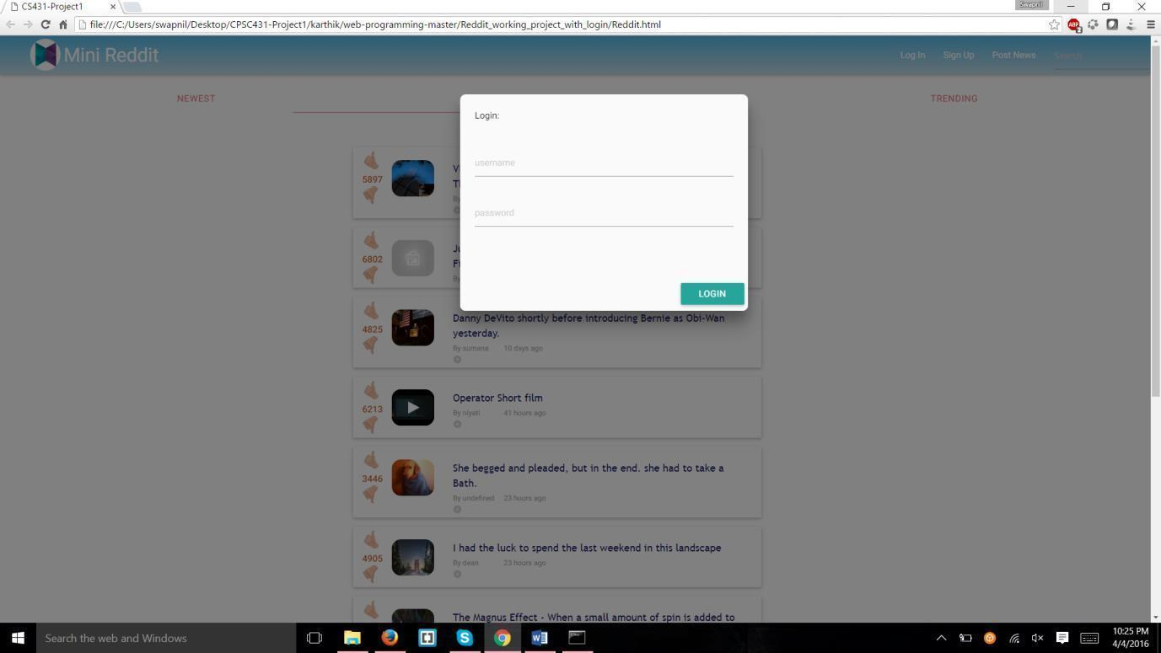

**SEARCH BAR-**

Helps you search for posts related to a certain topic

April 4, 2016 Page | 12

**POSTS-**

This is the section where you can view all the posts posted by the user.

**Upvoting, Downvoting and Score**

When you're logged in to Mini-Reddit, you'll be able to upvote and downvote items to help determine their rank. You get one vote per item, but you can change it after it's logged. The number appearing between the up and down arrows is the submission's score: the number of upvotes minus the number of downvotes.

**Before like**

**After like**

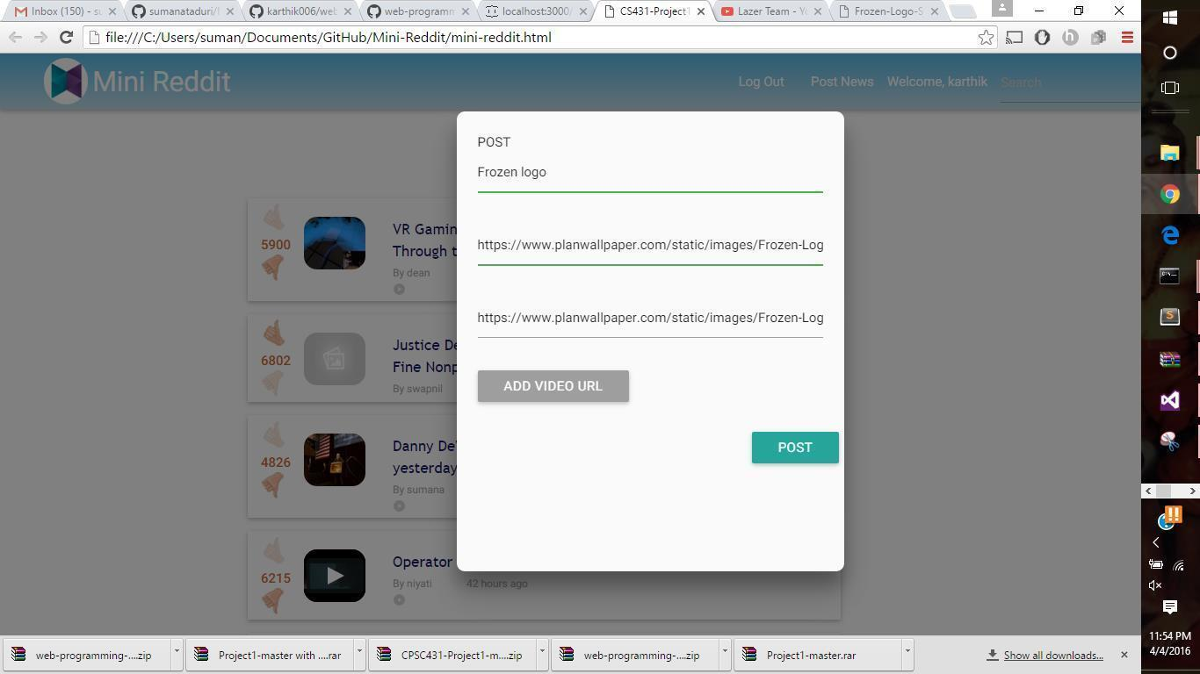

**Like without login**

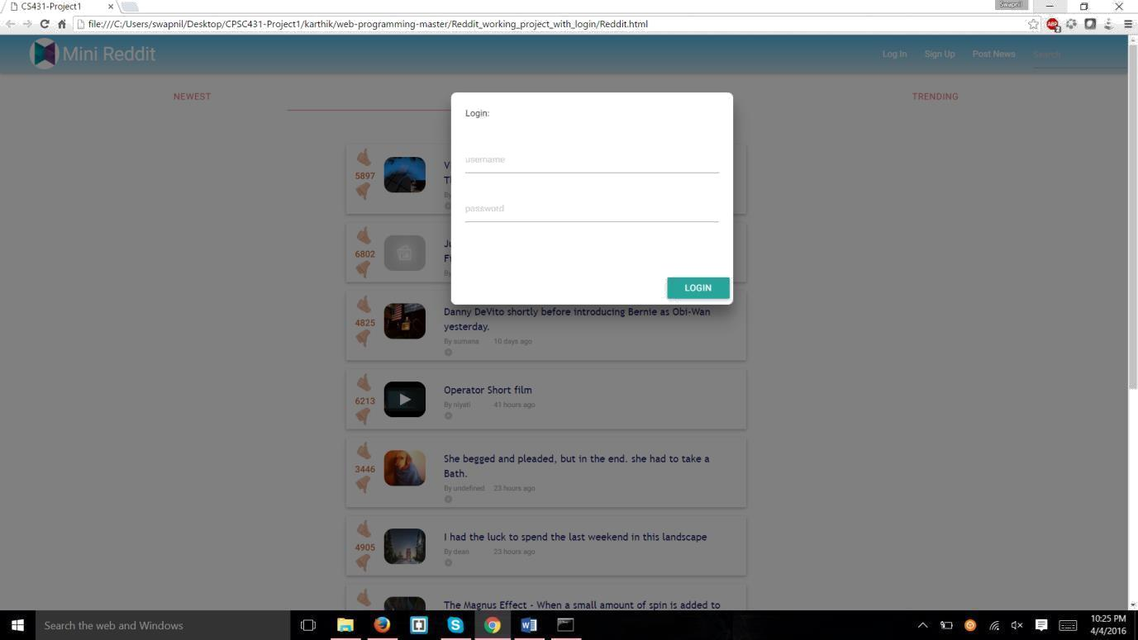

**PLAY BUTTON-**

Each post has a play button which helps the user view the image or video in the link in a bigger screen. This is done using iframe.

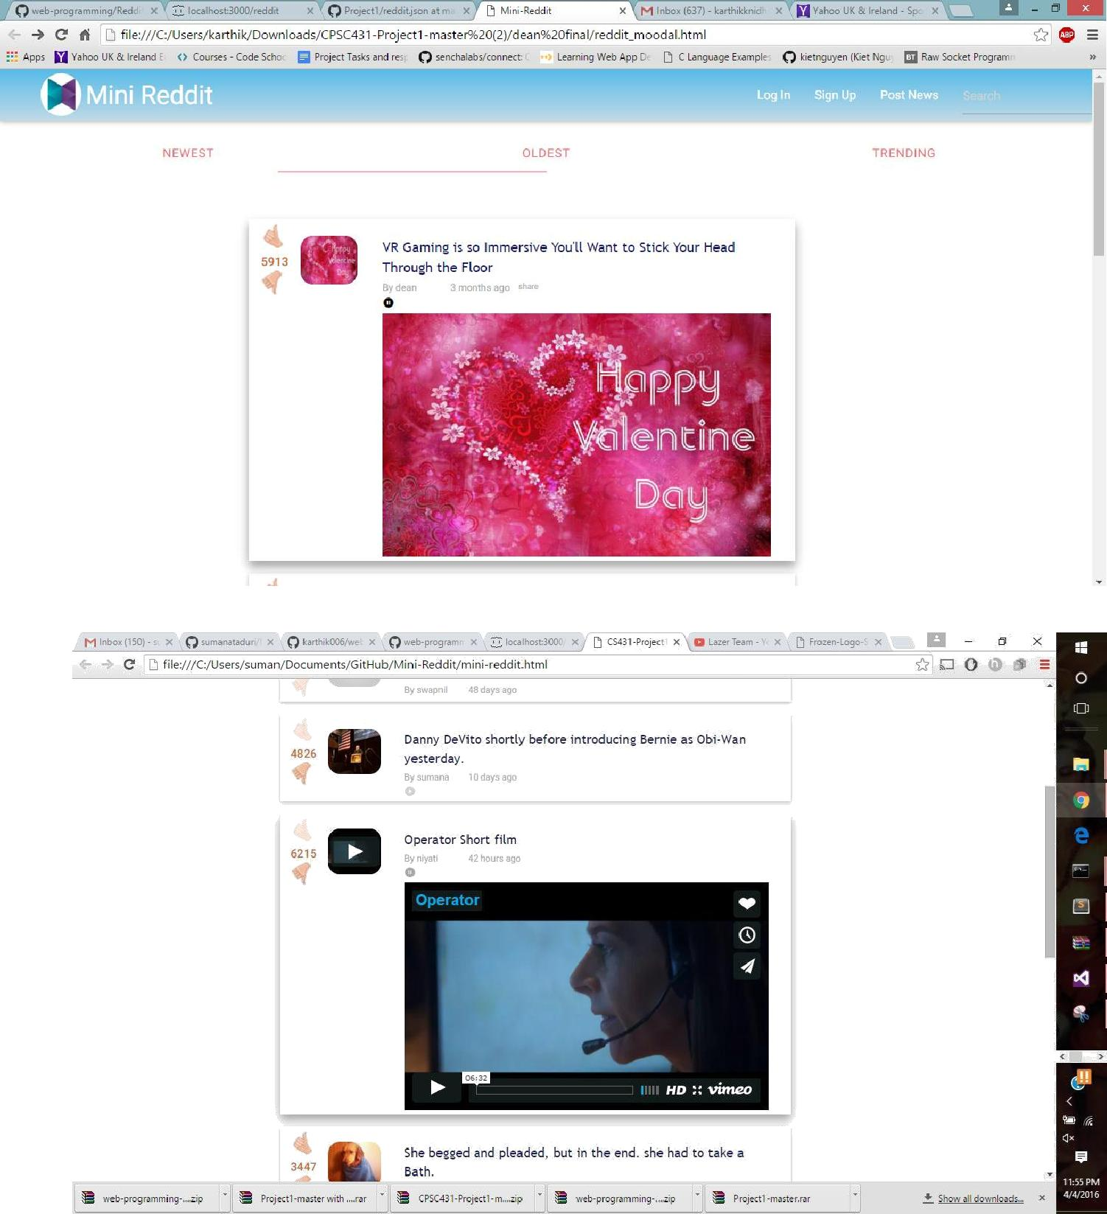

INSTRUCTIONS:

Step1 : Run the json file in the json server

Step2 : load the reddit.html