* Project : Tendable
* Issue Type : Bug
* Summary : The error message is not displayed after clicking on Submit button.
* Priority : High
* Components: Contact Us
* Platform : Windows 64
* Description:

Browser : Chrome.  
Version : 119

Steps:

1. Navigate to url <https://www.tendable.com/>
2. Click on Contact Us present on top menu bar home page.
3. Click on contact button in the marketing section.
4. Fill all the details (Full name, Organisation name, Phone Number, Email)
5. The user keeps the message box empty.
6. Click on radio button “I Agree”.
7. Click on Submit.

Actual Result : The form is getting submitted with the error message.

Expected Result : The error message should be displayed.

* Attachment:

Dummy screen shot for the reference.  
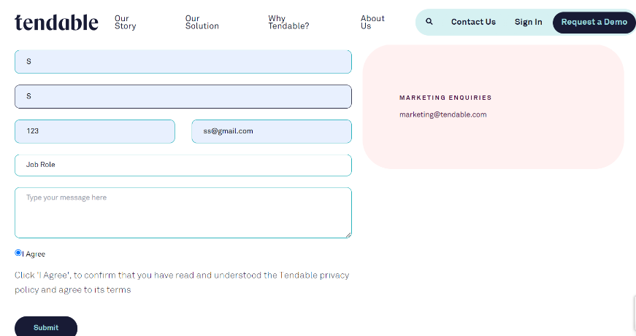

* Link issue with the main ticket : We should add the main ticket Id.