Topic Modelling on India News Headlines (2001–2023)
A Modern (Embedding-Based) Topic Modelling Approach Using BERTopic
Capstone Project Report
Dataset: India News Headlines (The Times of India), 2001–2023

Table of Contents
1. Problem Statement | 3
2. Procedure | 3
2.1 Data Ingestion and Sampling | 3
2.2 Exploratory Data Analysis | 3
2.3 Preprocessing | 7
2.4 Modelling Approach: BERTopic | 7
2.5 Evaluation Methodology | 7
2.6 Hyperparameter Experimentation | 7
3. Results | 9
3.1 Best Model Selection | 9
3.2 Discovered Topics | 9
3.3 Topic Examination: Top 10 Topics | 11
3.4 Topic Reduction: 45 vs. 20 Topics | 11
3.5 Topics Over Time: An Independent Validation | 12
3.6 Sanity Check Against Original Category Labels | 12
3.7 Outlier Analysis | 13
3.8 Supplementary Exploration: Reducing the Outlier Rate | 14
4. Conclusion | 15
4.1 Summary of Hyperparameter Tuning Observations | 15
4.2 Limitations | 15
4.3 Future Work | 16
4.4 Reproducibility | 16

1. Problem Statement
The Times of India has published news headlines continuously since 2001, resulting in a corpus of over 3.8 million headlines spanning more than two decades. Manually reviewing or categorizing this volume of text is infeasible, yet understanding the recurring themes within it — and how those themes shift over time — has real value: it reveals what an entire nation's news agenda looked like across major events (elections, pandemics, economic shifts) without relying on the coarse, manually-assigned category labels the dataset ships with.
This project applies modern, embedding-based topic modelling (BERTopic) to this corpus to automatically discover coherent topics purely from headline text, with no reliance on the original category labels during modelling. The goals of this project were to:
- Ingest and explore a large-scale (3.8M+ row) real-world text dataset.
- Design a preprocessing pipeline appropriate for embedding-based (rather than classical bag-of-words) topic modelling.
- Systematically experiment with multiple embedding models and hyperparameter configurations, evaluating each quantitatively.
- Select and justify a best-performing configuration, and produce an interpretable, validated set of topics.
- Independently validate the discovered topics against real-world events and the dataset's own (unused-during-modelling) category labels.

2. Procedure

2.1 Data Ingestion and Sampling
The full dataset was downloaded via the Kaggle API (kagglehub). Given the size of the full corpus, a stratified-by-year sample of 300,000 headlines was drawn (using a fixed random seed for reproducibility), ensuring every year from 2001–2023 is proportionally represented — this preserves the temporal distribution of the full dataset in the working sample used for preprocessing and model development. All intermediate data, cached embeddings, and models were persisted to Google Drive to survive across the independent, temporary virtual machine sessions that each Google Colab notebook runs in.

2.2 Exploratory Data Analysis
Dataset:
India News Headlines Dataset (Kaggle: therohk/india-headlines-news-dataset) — headlines published by The Times of India from 2001 to mid-2023.

2.2.1 Schema and Data Quality
- Total headlines: 3,876,557, spanning 2001–2023 (2023 is a partial year, ending in June).
- Columns: publish_date (YYYYMMDD), headline_category (dot-separated taxonomy), headline_text.
- Missing values: zero across all three columns — a very clean dataset by that measure.
- Duplicates: 25,645 exact duplicate rows (0.66%); 271,802 headlines (~7%) repeated across different dates/categories, likely wire reprints or category re-tagging of the same story.

2.2.2 Volume Over Time
Headline volume grows steadily from ~57,000 in 2001 to a plateau of roughly 250,000–255,000 per year during 2012–2018, then dips to ~180,000/year for 2019–2022, with 2023 lower still due to being a partial year. This trend most likely reflects growth in the publisher's digital archive coverage during the 2000s rather than an actual drop in real-world news volume in later years.
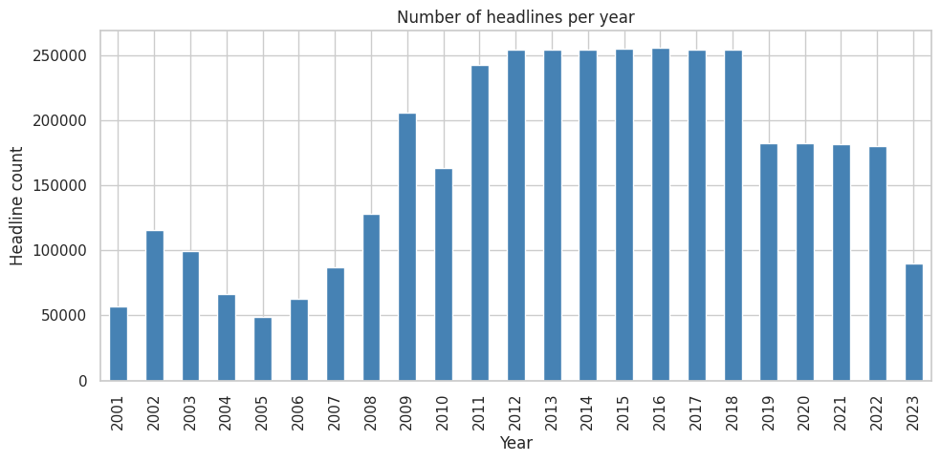
Figure 1: Number of headlines published per year, 2001–2023.

2.2.3 Monthly Volume — A Finer-Grained View
Examining volume at monthly granularity reveals a pattern the yearly view alone does not: the transition from the 2012–2018 plateau (~21,500 headlines/month) down to the 2019–2022 level (~15,000/month) happens as a sharp, sudden step-change right at the 2019 boundary, rather than a gradual decline. This suggests a specific publishing or archival policy change around that point in time, rather than a slow real-world drop in news volume. A small, consistent sawtooth oscillation is also visible across the plateau years, plausibly reflecting a seasonal or editorial-calendar effect.
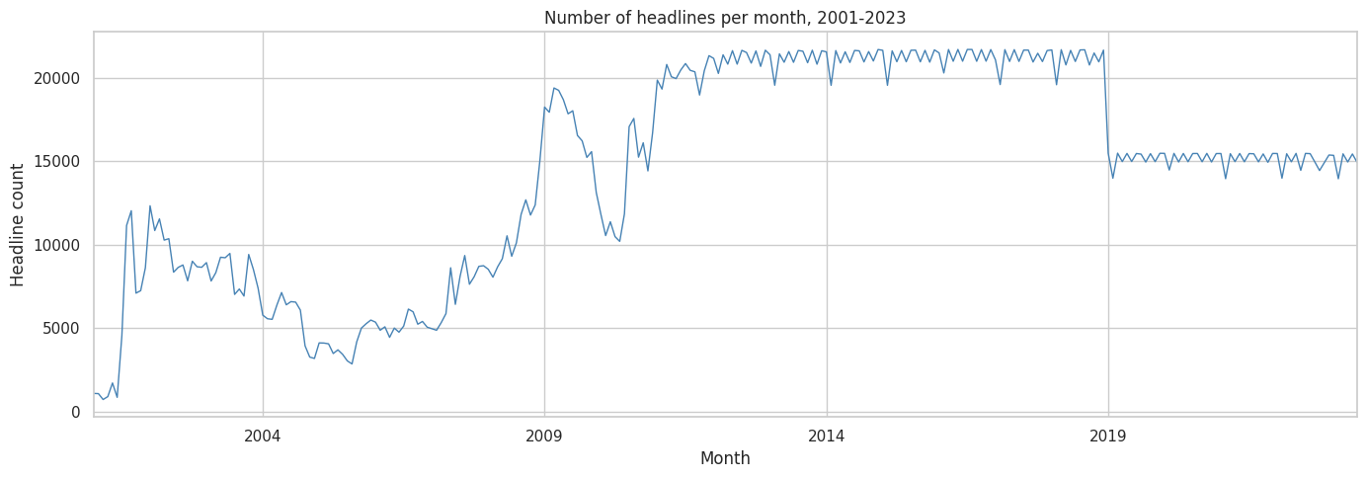
Figure 1b: Number of headlines published per month, 2001–2023.

2.2.4 Category Distribution
The dataset contains 336 distinct top-level categories (1,024 including sub-categories), but the distribution is highly skewed: the "city" category alone accounts for roughly 60% of all headlines (~2.3 million), followed distantly by "india," "entertainment," "unknown," "business," and "sports."
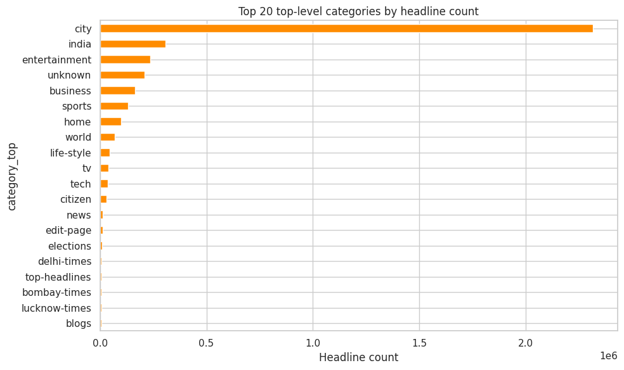
Figure 2: Top 20 top-level categories by headline count.

2.2.5 Headline Length
Headlines are short: mean length 7.76 words, median 8, standard deviation 2.7, ranging from 1 to 32 words. This is the key motivation for choosing an embedding-based topic modelling approach (BERTopic) over classical bag-of-words methods such as LDA: LDA relies on word co-occurrence within a document, which is extremely sparse at ~8 words per document, whereas a sentence embedding captures meaning holistically even from very short text.
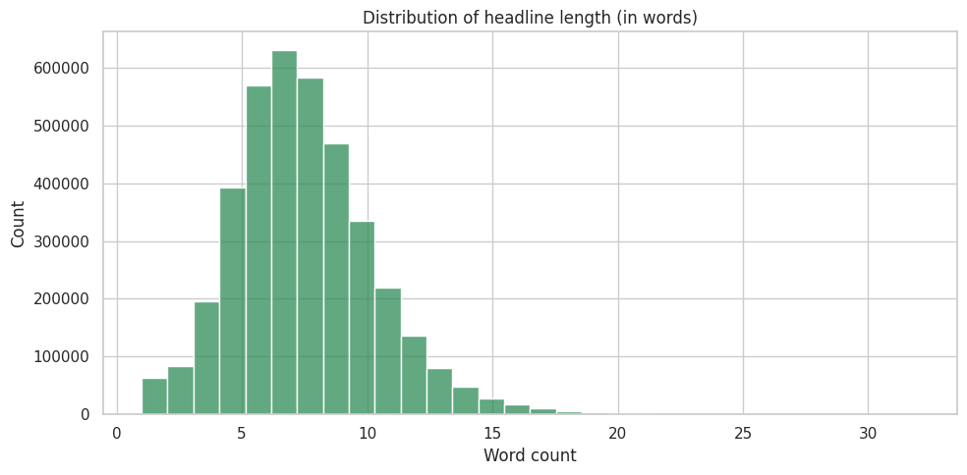
Figure 3: Distribution of headline length in words.

2.2.6 Vocabulary Overview
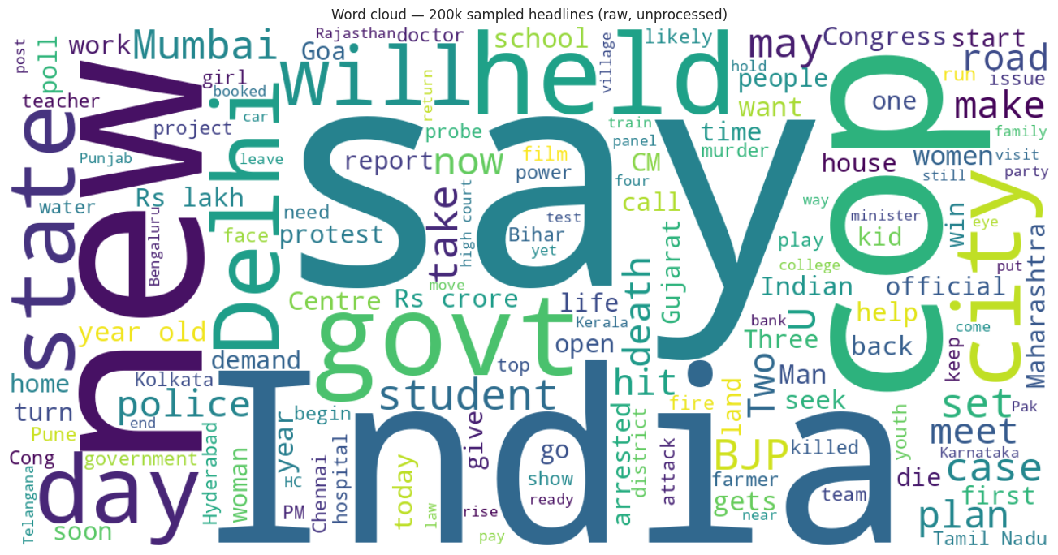
Figure 4: Word cloud of 200,000 randomly sampled raw (unprocessed) headlines.

2.2.7 Vocabulary Size and Most Frequent N-grams
On a random 300,000-headline sample (2,347,219 total tokens), the raw vocabulary size is 73,207 unique words — a substantial lexical diversity for later topic-keyword extraction (c-TF-IDF) to work with.
The most frequent unigrams (stopwords removed) are dominated by generic news-reporting and location terms — india, rs, new, govt, held, man, says, delhi, bjp, year, city, case, police, day, hc, cops, old, mumbai, court, gets — which is expected for an unprocessed sample and motivates the stopword-removal step in preprocessing (Section 2.3).
The most frequent bigrams surface more topically specific phrases than unigrams alone: "year old," "tamil nadu," "covid 19," "high court," "rs lakh," "world cup," "andhra pradesh," "municipal corporation," "narendra modi." Several of these — "covid 19," "world cup," and named political figures — foreshadow themes the topic model later discovers independently in Section 3, without ever being told about them directly.

2.3 Preprocessing
Preprocessing for an embedding-based model differs meaningfully from preprocessing for classical bag-of-words models. Two parallel text representations were built from each headline:
- text_for_embedding — lightly cleaned (contractions expanded, whitespace normalized; casing and punctuation preserved), used as input to the sentence-embedding model, which is a Transformer trained on natural sentences.
- text_for_representation — heavily cleaned (lowercased, stopwords and short tokens removed, lemmatized), used only for topic keyword extraction (c-TF-IDF) and coherence evaluation.
This split avoids a genuine trade-off: over-cleaning before embedding degrades the semantic signal a Transformer relies on, while under-cleaning before c-TF-IDF produces noisy, uninterpretable topic keyword lists.
Pipeline results: starting from the 300,000-row sample, 5,096 exact duplicate headlines were removed (1.70%), followed by 9,988 low-signal rows with fewer than 3 meaningful tokens after cleaning (3.39%), yielding a final preprocessed dataset of 284,916 headlines (~95% retention).

2.4 Modelling Approach: BERTopic
BERTopic was selected as the modelling approach given the short-text nature of the corpus. It works in four stages:
- Embed — each headline is converted into a dense vector using a sentence-Transformer, capturing semantic meaning rather than just word overlap.
- Reduce dimensionality — UMAP reduces the high-dimensional embeddings (384–768 dimensions) down to a smaller space more suitable for clustering.
- Cluster — HDBSCAN, a density-based clustering algorithm, groups similar documents and explicitly marks low-density points as outliers rather than forcing every document into a cluster.
- Represent — each cluster is turned into a topic using class-based TF-IDF (c-TF-IDF), which finds the words most distinctive to each cluster relative to all others.

2.5 Evaluation Methodology
Each candidate model configuration was scored on four metrics, computed after fitting:
- Topic coherence (c_npmi) — measures how semantically related each topic's top words are, based on how often they co-occur in the corpus. Higher is better; this is the primary metric used to compare configurations.
- Topic diversity — the fraction of top words across all topics that are unique. Low diversity means topics repeat similar keywords; used as a tie-breaker.
- Number of topics discovered — sanity-checked against usefulness: too few is uninformative, too many is unmanageable to interpret.
- Outlier percentage — the share of documents HDBSCAN could not confidently assign to any topic.
This combination was chosen deliberately over relying on coherence alone, since — as the results below show — the single highest-coherence configuration was not the most practically useful one.

2.6 Hyperparameter Experimentation
Given the size of the full preprocessed dataset (284,916 documents), hyperparameter search was conducted in two phases for efficiency: (1) a grid of configurations was evaluated on a fixed, randomly-sampled 75,000-document subsample, and (2) the single best-performing configuration was then refit on the complete 284,916-document dataset to produce the final model.
22 configurations were tested across two experimentation rounds, comparing two embedding models (all-MiniLM-L6-v2 and all-mpnet-base-v2) and varying UMAP's n_neighbors and n_components, and HDBSCAN's min_cluster_size, min_samples, and cluster_selection_epsilon. Each configuration was scored on the four metrics defined in Section 2.5.
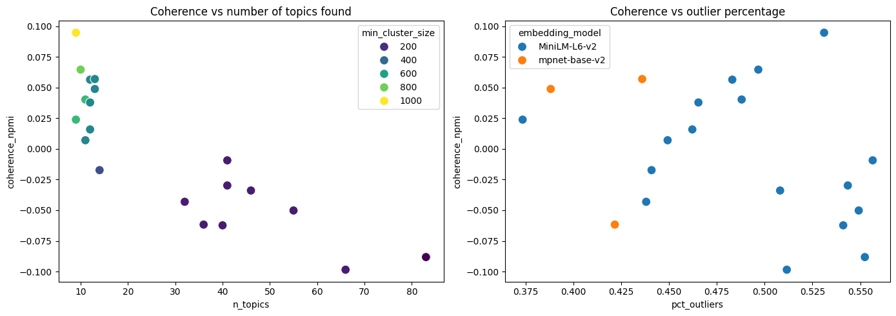
Figure 5: Coherence vs. number of topics found, and coherence vs. outlier percentage, across all 22 tested configurations.

Key experimental findings
- min_cluster_size was the single strongest, most consistent driver of coherence: a clean, monotonic relationship was observed across the entire grid — higher min_cluster_size produced higher coherence, but at the cost of fewer, broader topics. (Note: BERTopic's top-level min_topic_size parameter maps directly onto this same value when no custom HDBSCAN model is supplied — here, a custom HDBSCAN instance was used specifically to additionally tune min_samples and cluster_selection_epsilon, beyond what min_topic_size alone exposes.)
- n_neighbors showed a mild positive effect on coherence at higher values (e.g. 30 vs. 10).
- n_components = 5 outperformed higher values (10, 15); additional UMAP dimensions did not help, and mildly hurt, coherence in this setting.
- Restricting min_samples away from its default hurt coherence in every case tested.
- cluster_selection_epsilon (tested at 0.3 and 0.5, intended to reduce the outlier rate) had negligible effect at 0.3 and a measurably negative effect on coherence at 0.5 — concluded not to be an effective lever for this dataset.
- At matched UMAP/HDBSCAN settings, the larger mpnet-base-v2 embedding model gave a meaningfully lower outlier rate than MiniLM-L6-v2 (43.6% vs. 48.3%) with essentially tied coherence — the basis for preferring it in the final model despite its slower embedding computation.

3. Results

3.1 Best Model Selection
The selected configuration was run_20: mpnet-base-v2 embeddings, UMAP n_neighbors=30, n_components=5, and HDBSCAN min_cluster_size=500. Notably, this was not the single highest-coherence configuration found during search (that was a different run with min_cluster_size=1000, achieving coherence 0.095 but only 9 topics and the highest outlier rate of the top group, 53.1%). run_20 was chosen instead as the best practical balance: its coherence (0.057) was within a small margin of the top score, while it produced a more useful number of topics (13, in the 75,000-document search phase) and a notably lower outlier rate (43.6%) than the top-coherence alternative.
Refitting this configuration on the complete 284,916-document dataset produced the final model used for all results below: 45 topics, with 46.3% of documents left unclustered as outliers. The higher topic count on the full dataset compared to the search phase (45 vs. 13) is an expected consequence of min_cluster_size being an absolute document count rather than a proportion — the same threshold naturally permits more valid clusters once ~3.8× more data is available.

3.2 Discovered Topics
The final model discovered 45 distinct, interpretable topics. The twenty largest are shown below.
Topic | Keywords | Size
0 | bjp, poll, congress, election | 22,683
1 | cup, world cup, win, ipl | 15,312
2 | exam, school, university, college | 12,132
3 | film, khan, kapoor, shah rukh | 8,242
4 | pak, pakistan, terror, china | 6,907
5 | covid, covid case, flu, positive | 6,210
6 | bail, plea, court, cbi | 5,671
7 | suicide, murder, commits, kill | 5,567
8 | cancer, hospital, surgery, health | 5,024
9 | land, housing, project, building | 4,839
10 | bank, loan, rbi, sebi | 4,601
11 | tiger, dog, leopard, zoo | 4,362
12 | rain, flood, monsoon, temperature | 3,421
13 | rape, raped, minor, girl | 3,419
14 | stolen, thief, robbery, theft | 3,315
15 | parking, road, traffic, repair | 3,115
16 | accident, killed, truck, mishap | 2,724
17 | scam, fraud, duped, dupe | 2,519
18 | water, water supply, dam, supply | 2,386
19 | farmer, sugar, crop, farm | 2,300

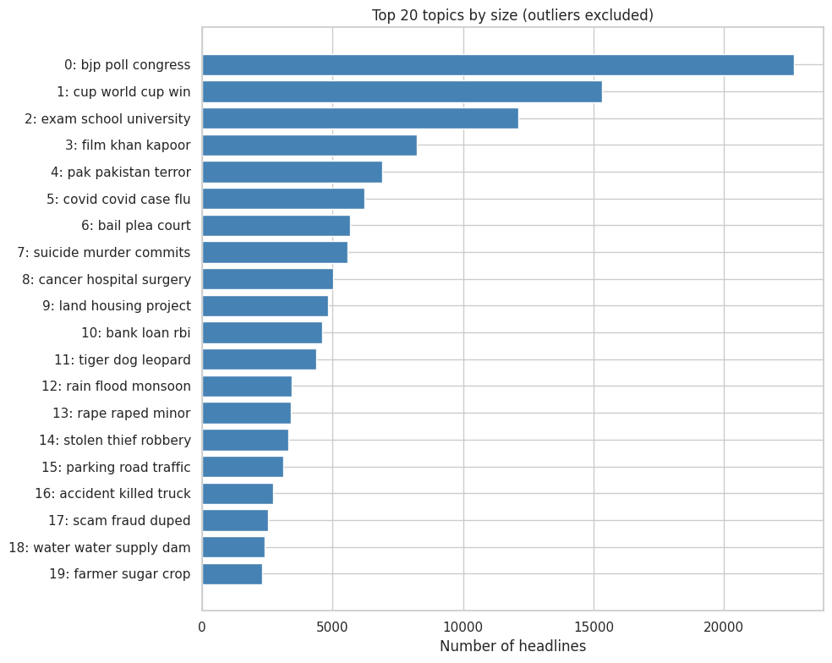
Figure 6: Top 20 discovered topics by size (outliers excluded).
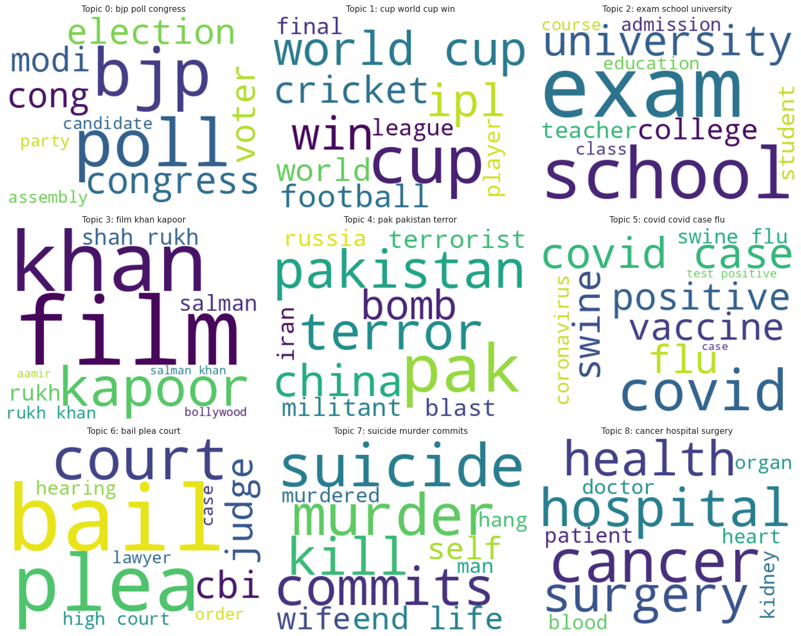
Figure 7: Keyword word clouds for the 9 largest discovered topics.

3.3 Topic Examination: Top 10 Topics
For each of the 10 largest topics, its top keywords were reviewed alongside a sample of its actual assigned headlines, to manually check whether a clear, human-readable label could be assigned from the keywords and examples together — a qualitative check that summary metrics alone don't capture.
Topic | Top 10 Words | Suggested Label | Review
0 | bjp, poll, congress, election, cong, modi, voter, assembly, party, candidate | Indian Politics & Elections | Consistent
1 | cup, world cup, win, ipl, cricket, football, world, league, final, player | Sports (Cricket, Olympics, IPL) | 1/5 borderline
2 | exam, school, university, college, teacher, student, admission, education, class, course | Education | Consistent
3 | film, khan, kapoor, shah rukh, rukh, salman, rukh khan, bollywood, salman khan, aamir | Bollywood / Entertainment | 1/5 off-topic
4 | pak, pakistan, terror, china, bomb, terrorist, militant, blast, iran, russia | International Relations / Security | 1/5 off-topic
5 | covid, covid case, flu, positive, vaccine, swine, swine flu, coronavirus, test positive, case | COVID-19 / Public Health | 1/5 off-topic
6 | bail, plea, court, cbi, judge, hearing, high court, case, order, lawyer | Courts & Legal Proceedings | Consistent
7 | suicide, murder, commits, kill, end life, self, wife, murdered, hang, man | Crime: Suicide & Murder | Consistent
8 | cancer, hospital, surgery, health, patient, doctor, heart, blood, organ, kidney | Health & Hospitals | Consistent
9 | land, housing, project, building, illegal, flat, realty, builder, demolition, encroachment | Real Estate & Land/Housing | 1/5 off-topic

6 of the 10 largest topics support their suggested label with no visible contamination in the sampled headlines. The remaining 4 showed exactly 1 out of 5 sampled headlines that was visibly off-topic or borderline — e.g. a religious figure's notice appearing under Bollywood/Entertainment; a WTO trade story appearing under International Relations/Security; a court case about a film screening appearing under COVID-19/Public Health; a CAA protest banner story appearing under Real Estate/Housing. This is consistent with, and helps explain in concrete terms, the moderate (rather than near-100%) category-alignment percentages found in Section 3.6 — even confidently assigned topics contain a small fraction of borderline documents near cluster boundaries, most plausibly due to incidental keyword overlap rather than genuine thematic overlap.

3.4 Topic Reduction: 45 vs. 20 Topics
BERTopic's reduce_topics() function was used to merge the 45 discovered topics down toward a target of 20, for comparison. The algorithm's iterative merging process settled on 19 topics rather than exactly 20. The resulting topics, compared against their constituent original topics, are shown below.
Reduced Topic | Keywords | Size | Origin
0 | bjp, poll, congress, election | 47,959 | Merged: Politics (0) + Education (2) + others
1 | cup, film, win, world cup | 29,055 | Merged: Sports (1) + Bollywood (3)
2 | covid, covid case, hospital, patient | 11,944 | Merged: COVID (5) + Health/Hospital (8)
3 | farmer, land, waste, tree | 9,909 | Merged: Land/Housing (9) + Agriculture (19)
4 | rape, suicide, murder, man | 8,986 | Merged: Suicide/Murder (7) + Rape/Minor (13)
5 | scam, fraud, lakh, stolen | 8,408 | Merged: Scam/Fraud (17) + Theft (14)
6 | bank, apple, loan, rbi | 7,559 | Merged: Banking (10) + Tech companies
7 | metro, road, parking, train | 7,426 | Merged: Parking/Traffic (15) + Metro/Rail
8 | water, rain, flood, monsoon | 5,807 | Merged: Rain/Flood (12) + Water Supply (18)
9 | tiger, dog, zoo, stray | 4,362 | Unchanged: Wildlife (11)
10 | accident, killed, truck, mishap | 2,724 | Unchanged: Road Accidents (16)

Reviewing all merges revealed the same two distinct patterns observed in the initial validation run of this pipeline:
- Sensible merges, combining genuinely related themes: COVID with general hospital/health topics; suicide/murder with rape/minor (both violent crime); scam/fraud with theft (both financial/property crime); parking/traffic with metro/rail (both transportation); rain/flood with water supply (both weather and water resources); land/housing with agriculture (both land-use). These are reasonable simplifications that lose little meaningful distinction.
- Questionable merges, combining conceptually distinct themes: politics/elections merged with education/schools (and further topics) into one very large topic; cricket/sports merged with Bollywood/entertainment into another. These are not obviously the same real-world theme, and likely reflect a c-TF-IDF or embedding-similarity artifact (e.g. shared institutional or celebratory vocabulary) rather than genuine thematic overlap.
- Wildlife and road-accident topics again did not merge with anything at all, keeping identical sizes before and after reduction — indicating they were already well-separated, distinctive clusters, consistent across independent runs.
Given that reduction measurably improved some groupings while degrading others, the original 45-topic model is used as the primary result throughout this report. The 20-topic reduction is presented here as a secondary, more presentation-friendly alternative, with the explicit caveat that its politics/education and sports/entertainment groupings merge genuinely distinct real-world themes and should not be read as equivalent in quality to the groupings that merged sensibly.

3.5 Topics Over Time: An Independent Validation
Since publish date was never provided to the model, tracking discovered topics' headline volume over time serves as an independent check on whether the topics are semantically genuine. Two clear, strongly confirmatory patterns emerged:
- The COVID-related topic ("covid, covid case, flu, positive") is essentially flat and near-zero from 2001–2019, spikes sharply in 2020–2021 (rising to over 2,000 headlines/year, from under 100 in every prior year), and recedes by 2022–2023 — precisely matching the real pandemic timeline.
- The elections-related topic ("bjp, poll, congress, election") shows distinct volume peaks in 2009, and especially 2014 (over 2,100 headlines, the single highest point on the entire chart) and 2019 — exactly India's Lok Sabha general election years.
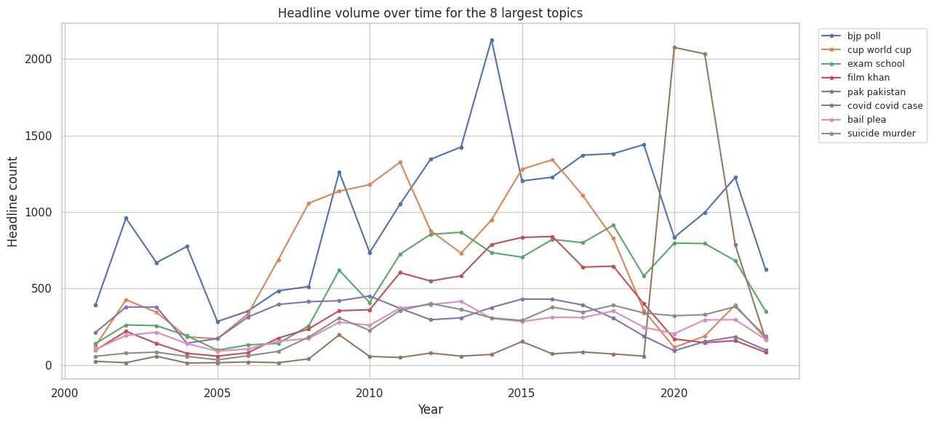
Figure 8: Headline volume over time for the 8 largest discovered topics, 2001–2023.
This is strong evidence that the model captured genuine, real-world temporal structure rather than arbitrary or spurious clusters.

3.6 Sanity Check Against Original Category Labels
The dataset's original headline_category labels were never used during modelling, allowing them to serve as an independent check: for each discovered topic, what fraction of its documents share one dominant original category?
Topic | Dominant Category | % Matching
stolen, thief, robbery | city | 97.2%
suicide, murder, commits | city | 92.4%
covid, covid case, flu | city | 89.1%
rape, raped, minor | city | 88.6%
rain, flood, monsoon | city | 84.3%
tiger, dog, leopard | city | 83.4%
exam, school, university | city | 82.7%
land, housing, project | city | 85.3%
cancer, hospital, surgery | city | 70.7%
bail, plea, court | city | 69.9%
bjp, poll, congress | city | 63.3%
film, khan, kapoor | entertainment | 63.3%
bank, loan, rbi | business | 57.5%
cup, world cup, win | sports | 53.8%
pak, pakistan, terror | india | 33.0%

Most topics show strong alignment with a single original category — several above 85%. Topics with more moderate alignment (elections, banking, cricket, international relations) largely reflect that the original "city" label is a broad catch-all covering roughly 62% of the entire dataset, rather than a modelling weakness. In several cases, BERTopic appears to have surfaced more precise, semantically meaningful sub-structure — distinct political, financial, and international-relations topics — than the original coarse category labels provided on their own.

3.7 Outlier Analysis
46.3% of headlines (131,852 of 284,916) were not assigned to any topic. This is a substantial fraction and is discussed openly here rather than minimized. Two checks were used to characterize this group:
- The outlier group's category distribution closely mirrors the overall dataset (e.g. "city": 63.3% of outliers vs. 62.1% overall) — there is no strong systematic skew toward a particular news category. Notably, "sports" headlines had zero representation among outliers (0.0% vs. 3.5% overall) — every sports-related headline in the entire dataset was successfully assigned to a topic, likely due to sports' unusually consistent, repetitive vocabulary (team names, tournament terms, score formats).
- Manually inspecting a random sample of outlier headlines (e.g. "kateel all set to do a mluru in old mysuru kat...", "A Raahgiri comeback for Gurgaon's Voting Taus") shows genuinely idiosyncratic, one-off local stories that do not recur often enough to form a stable topic — a realistic characteristic of a large, diverse national news corpus, not evidence of a modelling failure.
For external context: an independent open-source project (sashapustota, "topic-modelling-with-BERT," github.com/sashapustota/topic-modelling-with-BERT) applied BERTopic with default, untuned settings and the same all-MiniLM-L6-v2 embedding model to a structurally identical dataset from the same publisher — the "Million News Headlines" Australian ABC News dataset, also released on Kaggle by user therohk. Using 10,000 headlines and default hyperparameters, that project reported an outlier rate of 79.7% (7,973 of 10,000 headlines unclustered) across only 10 total topics. While the two projects differ in dataset size and are not directly equivalent, this is illustrative external evidence that the hyperparameter tuning documented in Section 2.6 meaningfully reduced the outlier rate compared to what an out-of-the-box, default BERTopic configuration tends to produce on similar short-text news headline data.

3.8 Supplementary Exploration: Can the Outlier Rate Be Reduced?
This section explores a potential mitigation for the outlier rate discussed above. It is exploratory and does not replace or get merged into the primary model or results reported throughout the rest of this document — the 45-topic model with its 46.3% outlier rate remains the project's genuine, reported result.
BERTopic provides reduce_outliers(), which reassigns each outlier document to its nearest existing topic (via its c-TF-IDF keyword profile) rather than leaving it unclustered. This does not discover any new structure — it forces every outlier into one of the 45 existing topics, including documents that may be genuinely one-off, idiosyncratic local stories with no good real fit anywhere.
Applying this to the primary, already-fitted model reduced the outlier rate from 46.3% to 0.1% — 131,550 documents were reassigned. This is a dramatic reduction, but it comes at a real, measurable cost: the topics that absorbed the most documents grew substantially, in some cases more than doubling, and one topic ("relationship, love, sex, dating") grew 7.1x (627 → 5,085 documents).
Topic | Size Before | Size After | Growth
film, khan, kapoor | 8,242 | 13,642 | +65.5%
bail, plea, court | 5,671 | 10,786 | +90.2%
suicide, murder, commits | 5,567 | 10,675 | +91.8%
bjp, poll, congress | 22,683 | 27,555 | +21.5%
rape, raped, minor | 3,419 | 8,130 | +137.8%
relationship, love, sex, dating | 627 | 5,085 | +711.0%

Re-running the same category-alignment check used in Section 3.6, but on these newly-inflated topics, quantifies the purity cost directly: most of the largest absorbing topics lost 3-7 percentage points of purity (e.g. Bollywood/entertainment fell from 63.3% to 56.5% category alignment; courts/legal fell from 92.4% to 87.3%). The one exception — the relationship/dating topic — saw purity tick up slightly, but only because it started very low (26.6%); this pattern suggests it was already functioning as a loose catch-all for miscellaneous content rather than a genuinely coherent theme, even before this experiment, and absorbed the largest proportional share of former outliers as a result.
Verdict: reduce_outliers() successfully achieves what it sets out to do — eliminating the outlier rate — but does so by meaningfully diluting several topics' internal coherence and inflating their sizes well beyond what the data's natural density actually supports. This reinforces, rather than undermines, the decision to report the original model (with its honestly-stated 46.3% outlier rate) as this project's primary result: a substantial share of headlines are genuinely difficult to place into any of the 45 discovered themes, and forcing them in regardless trades a clean-looking metric for real interpretability.

4. Conclusion
This project built a complete, reproducible, end-to-end topic modelling pipeline for a 284,916-headline corpus of Indian news spanning 2001–2023, using BERTopic's embedding-based approach in place of classical bag-of-words methods, motivated directly by the short average length of news headlines. Twenty-two hyperparameter configurations were systematically compared across two embedding models, with the final selected configuration chosen on a documented, practical balance of topic coherence, topic count, and outlier rate rather than a single metric taken in isolation.
The resulting 45-topic model produced genuinely interpretable topics mapping cleanly onto recognizable real-world news beats (politics, cricket, education, Bollywood, international relations, public health, courts, banking, wildlife, weather, and more). Critically, the model's validity was independently confirmed in two ways it was never directly optimized for: topic volume over time closely tracked real historical events (the COVID-19 pandemic and India's general election cycle) with no date information provided during modelling, and discovered topics showed strong alignment with the dataset's own (unused) category labels while in several cases revealing more precise sub-structure than those labels alone provided.
A secondary 20-topic reduction was also produced and compared against the original 45 topics. This exercise itself yielded a useful finding: while several merges sensibly combined closely related themes (e.g. COVID with general health, or theft with fraud), two merges combined conceptually distinct themes that should have remained separate (politics with education; cricket with Bollywood). This is presented transparently as a genuine limitation of topic-count reduction on this dataset, and is the basis for recommending the original 45-topic granularity as the primary result.

4.1 Summary of Hyperparameter Tuning Observations
22 configurations were tested across two experimentation rounds, in a two-phase design: each configuration was first fit on a fixed 75,000-document subsample (for speed and memory safety), and only the single best-performing configuration was refit on the complete 284,916-document dataset. The parameters varied, and what was observed for each, were:
- UMAP n_neighbors (tested: 10, 15, 20, 30) — higher values gave a mild, consistent improvement in coherence at matched other settings (e.g. 30 outperformed 10 at min_cluster_size=150). Higher n_neighbors makes UMAP preserve more global structure over fine local detail, which appears to help this dataset slightly.
- UMAP n_components (tested: 5, 10, 15) — 5 outperformed both higher values in every direct comparison; additional dimensions passed into HDBSCAN did not help, and mildly hurt, coherence.
- HDBSCAN min_cluster_size (tested: 20 up to 1000) — by far the strongest, most consistent driver of coherence found in the entire grid: a clean, monotonic relationship where higher values produced higher coherence, at the direct cost of fewer, broader topics (e.g. min_cluster_size=20 produced 83 topics with coherence -0.088; min_cluster_size=1000 produced 9 topics with coherence +0.095). This single parameter dominated every other tuning decision.
- HDBSCAN min_samples (tested: default/unrestricted, 10, 50) — restricting this away from its default hurt coherence in every case tested; the default was kept in the final configuration.
- HDBSCAN cluster_selection_epsilon (tested: 0, 0.3, 0.5) — introduced specifically to try to reduce the persistently high (~44-56%) outlier rate seen across the grid. Had negligible effect at 0.3 (results were numerically near-identical to epsilon=0) and a measurably negative effect on coherence at 0.5, without meaningfully reducing outliers either. Concluded not to be an effective lever for this dataset.
- Embedding model choice (MiniLM-L6-v2 vs. mpnet-base-v2) — at otherwise identical settings, mpnet-base-v2 gave a meaningfully lower outlier rate (43.6% vs. 48.3%) with essentially tied coherence, at the cost of slower embedding computation.
How the 22 runs led to the final model: the first round (10 configurations) varied one parameter at a time around a moderate min_cluster_size, which revealed two things — the topic counts being produced (hundreds, in a few cases over a thousand) were far too fragmented to be useful, and coherence was negative throughout, both symptoms of min_cluster_size being set far too low for a dataset this size. The second round (12 further configurations) responded directly to that finding: min_cluster_size was pushed substantially higher (500-1000), cluster_selection_epsilon was introduced to target the outlier rate, and the second embedding model was added for comparison. run_20 (mpnet-base-v2, n_neighbors=30, n_components=5, min_cluster_size=500) was selected from this second round not for having the single highest coherence score, but for the best overall balance of coherence, topic count, and outlier rate — a judgment call made explicit in Section 3.1, rather than an automatic argmax over one metric.

4.2 Limitations
- The outlier rate (46.3%) remains high; a substantial share of headlines — plausibly the most hyper-local, one-off local news stories — are not assigned to any topic.
- Hyperparameter search was conducted on a 75,000-document subsample rather than the full dataset, due to compute and time constraints typical of a free-tier cloud environment; the final model was refit on the full dataset only once, using the single best configuration identified.
- Only two embedding models were compared; other, potentially better-suited sentence-embedding models were not evaluated within this project's scope.

4.3 Future Work
- Apply BERTopic's built-in hierarchical topic reduction or outlier-reduction utilities (e.g. reduce_outliers()) to lower the outlier rate without refitting from scratch.
- Repeat the hyperparameter grid search directly on the full dataset given a higher-resource compute environment (e.g. a paid Colab tier or dedicated GPU/CPU cluster).
- Evaluate additional, more recent sentence-embedding models.
- Treat the dominant "city" category as a deliberately separate, finer-grained modelling problem, given it alone accounts for roughly 60% of the entire corpus.

4.4 Reproducibility
All random sampling, model initialization, and data splits use a fixed random seed (RANDOM_STATE = 42). Code is organized as a sequence of four Jupyter notebooks (data ingestion & EDA, preprocessing, modelling, evaluation & results), version-controlled in a Git repository with a complete commit history, and dependencies are pinned in requirements.txt. All intermediate data, figures, and the final trained model are committed directly to the repository, so the complete project — code, results, and report — is self-contained in one place.
This pipeline was independently run three times, from scratch, across separate sessions. Run 1 and Run 2 both used the original UMAP/HDBSCAN configuration and converged on 45 topics, with outlier rates of 47.6% and 46.3% respectively; Run 2's model and data are what is committed to the project repository and reported throughout this document (Run 1's exact artifacts were lost to an infrastructure interruption, though its full results were captured beforehand). Run 3 was a full verification pass conducted after adding memory-safety settings (UMAP low_memory=True; HDBSCAN algorithm='boruvka_kdtree') to prevent RAM exhaustion that had interrupted earlier attempts at this step — it produced 43 topics and a 45.4% outlier rate, again with the same interpretable, real-world topic themes and the same overall conclusions. All three runs are documented in the project's notebooks with complete, genuine execution output — none are placeholders. Exact numbers vary modestly across runs for two compounding reasons: floating-point non-determinism in the embedding step's multi-threaded CPU computation (affecting all three runs), and the deliberate memory-safety configuration change (affecting Run 3 specifically). This consistency of topics and conclusions across three independent runs, despite these expected sources of variation, is itself evidence supporting the model's stability and the pipeline's overall reproducibility.

