**Learners have to come up with a Report to support the answers to the following questions and suggestions.**

**Objective Questions:**

1. What is the distribution of account balances across different regions?

Ans:- Here we can see as per the geography location, France got the highest amount of account balance i.e., 311.11M and Spain with the lowest with 153.12M

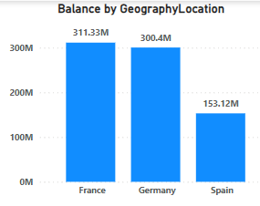

1. Identify the top 5 customers with the highest Estimated Salary in the last quarter of the year. (SQL)

Ans:- We can get the answer by using this formula in MySQL.

SELECT customer_id, Surname, EstimatedSalary FROM customerinfo

WHERE QUARTER(Bank_DOJ) = 4

ORDER BY EstimatedSalary DESC

LIMIT 5;

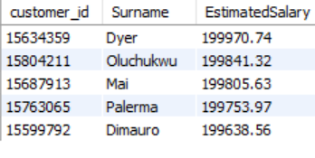

1. Calculate the average number of products used by customers who have a credit card. (SQL)

Ans:- We can get the answer by using this formula in MySQL.

SELECT AVG(NumOfProducts) AS AverageProducts

FROM bank_churn

WHERE HasCrCard = 1;

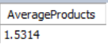

1. Determine the churn rate by gender for the most recent year in the dataset.

Ans:-Here from the diagram, we can see the churn rate as per gender category for the most recent year from the below mentioned diagram for 2019 which is 25.05% for Females and 15.37% for Males.

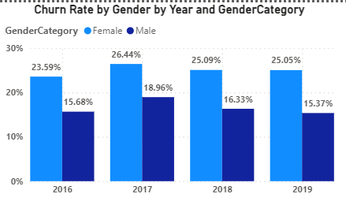

1. Compare the average credit score of customers who have exited and those who remain. (SQL)

Ans:- We can get the answer by using this formula in MySQL.

SELECT

AVG(CASE WHEN Exited = 1 THEN CreditScore ELSE NULL END) AS AvgExitedScore,

AVG(CASE WHEN Exited = 0 THEN CreditScore ELSE NULL END) AS AvgRemainingScore

FROM bank_churn;

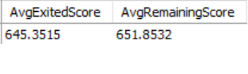

1. Which gender has a higher average estimated salary, and how does it relate to the number of active accounts? (SQL)

Ans:- We can get the answer by using this formula in MySQL.

SELECT c.GenderID,

ROUND(AVG(c.EstimatedSalary),2) AS AvgSalary,

COUNT(DISTINCT b.customer_id) AS NumActiveAccounts

FROM bank_churn b

JOIN customerinfo c ON b.customer_id = c.customer_id

WHERE b.IsActiveMember = 1

GROUP BY c.GenderID

ORDER BY AvgSalary DESC;

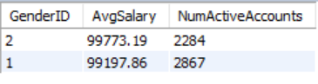

Here we can see, the GenderID 2 got more average salary but lesser number of Active accounts, and for GenderID 1, just the opposite.

1. Segment the customers based on their credit score and identify the segment with the highest exit rate. (SQL)

Ans:- We can get the answer by using this formula in MySQL, and as per this, the Highest exit rate for the customers within the credit limit of <580

WITH CustomerSegments AS (

SELECT

b.customer_id,

CASE

WHEN b.CreditScore < 580 THEN 'Deep Subprime'

WHEN b.CreditScore >= 580 AND b.CreditScore < 620 THEN 'Subprime'

WHEN b.CreditScore >= 620 AND b.CreditScore < 660 THEN 'Near Prime'

WHEN b.CreditScore >= 660 AND b.CreditScore < 720 THEN 'Prime'

ELSE 'Superprime'

END AS CreditSegment

FROM bank_churn b

)

SELECT

CreditSegment,

ROUND(AVG(Exited)*100,2) AS ExitRate

FROM CustomerSegments cs

JOIN bank_churn b ON cs.customer_id = b.customer_id

GROUP BY CreditSegment

ORDER BY CreditSegment ASC

LIMIT 1;



1. Find out which geographic region has the highest number of active customers with a tenure greater than 5 years. (SQL)

Ans:- We can get the answer by using this formula in MySQL.

SELECT c.GeographyID, COUNT(c.customer_id) AS ActiveCustomers

FROM customerinfo c

JOIN bank_churn b ON c.customer_id = b.customer_id

WHERE b.IsActiveMember = 1 AND b.Tenure > 5

GROUP BY c.GeographyID

ORDER BY ActiveCustomers DESC;

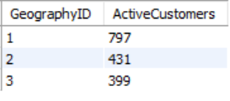

1. What is the impact of having a credit card on customer churn, based on the available data?

Ans:-From the chart, we can see the churn rate for Credit card holders is much higher (69.91%) than the people not having a card.

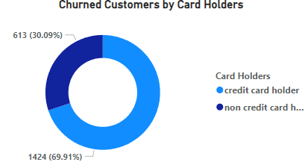

1. For customers who have exited, what is the most common number of products they have used?

Ans:- We can see from the below mentioned graph, the most common number of products they have used is **1,** which is 1409 churned customers from total.

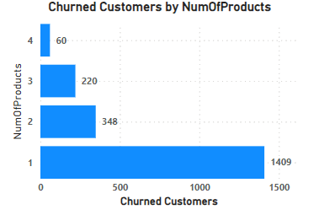

1. Examine the trend of customers joining over time and identify any seasonal patterns (yearly or monthly). Prepare the data through SQL and then visualize it.

Ans:- We can get the answer by using this formula in MySQL, also we can get this from Power BI charts, which seems to be in an increasing trend.9

SELECT

EXTRACT(YEAR FROM Bank_DOJ) AS Join_Year,

EXTRACT(MONTH FROM Bank_DOJ) AS Join_Month,

COUNT(customer_id) AS Total_Customers

FROM customerinfo

GROUP BY Join_Year, Join_Month

ORDER BY Join_Year, Join_Month;

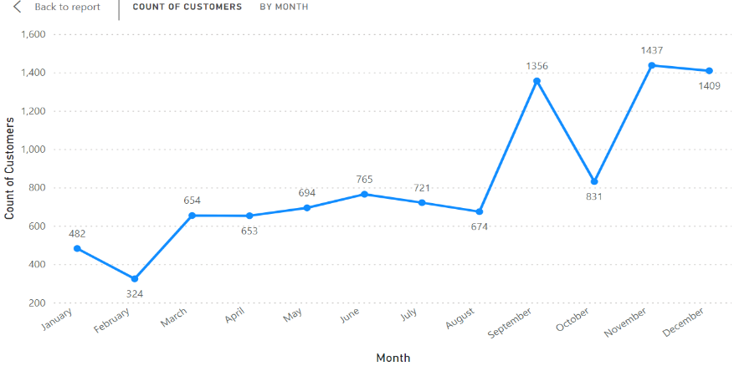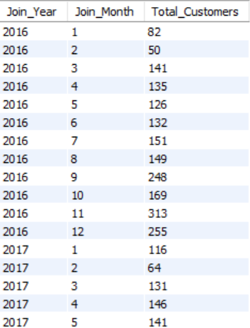

We can use various visualization tools like Power BI, or even Excel to create visual representations of the data trends, this will give us a view for yearly and monthly customer numbers.

1. Analyze the relationship between the number of products and the account balance for customers who have exited.

Ans:- From the graph, we can see the account balance for the customers who have exited is highest for the customers who have purchased 1 number of products, which is 130M and lowest for 4 number of Products, which is 6M.

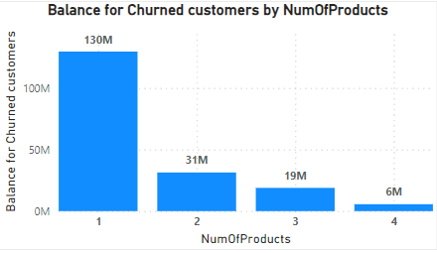

1. Identify any potential outliers in terms of balance among customers who have remained with the bank.

Ans:- Balance for retained customers is more than that of exited ones, i.e., 75.74% to 24.26%

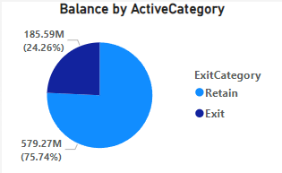

1. How many different tables are given in the dataset, out of these tables which table only consists of categorical variables?

Ans:- The dataset consists of two tables. One table includes the following columns: customer_id, Surname, Age, GenderID, EstimatedSalary, GeographyID, and Bank_DOJ. The other table includes the columns: CustomerId, CreditScore, Tenure, Balance, NumOfProducts, HasCrCard, IsActiveMember, and Exited.

**Out of these tables, the first table only consists of categorical variables, which are customer_id, Surname, GenderID, Geography, and Bank_DOJ**

1. Using SQL, write a query to find out the gender-wise average income of males and females in each geography id. Also, rank the gender according to the average value. (SQL)

Ans:- We can get the answer by using this formula in MySQL.

WITH GenderIncome AS (

SELECT

c.GeographyID,

CASE WHEN c.GenderID = 1 THEN 'Male' ELSE 'Female' END AS Gender,

ROUND(AVG(c.EstimatedSalary),2) AS AvgIncome

FROM customerinfo c

GROUP BY c.GeographyID, Gender

)

SELECT

GeographyID, Gender, AvgIncome,

RANK() OVER(PARTITION BY GeographyID ORDER BY AvgIncome DESC) AS GenderRank

FROM GenderIncome

ORDER BY GeographyID, GenderRanks;

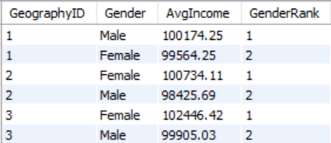

1. Using SQL, write a query to find out the average tenure of the people who have exited in each age bracket (18-30, 30-50, 50+).

Ans:- We can get the answer by using this formula in MySQL.

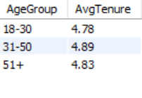SELECT

CASE

WHEN c.Age BETWEEN 18 AND 30 THEN '18-30'

WHEN c.Age BETWEEN 31 AND 50 THEN '31-50'

ELSE '51+'

END AS AgeGroup,

ROUND(AVG(Tenure),2) AS AvgTenure

FROM customerinfo c

JOIN bank_churn b ON c.customer_id = b.customer_id

WHERE Exited = 1

GROUP BY AgeGroup

ORDER BY AgeGroup;

1. Is there any direct correlation between salary and the balance of the customers? And is it different for people who have exited or not?

Ans:- As per the given datasets, these are the findings:

* **No direct correlation between salary and customer balance**
* Salary accounts don't require minimum balance, zero balance accounts also don't need it.
* Relationship between salary and balance may differ for exited vs active customers, but unclear from sources, as there are no data for exit reasons.

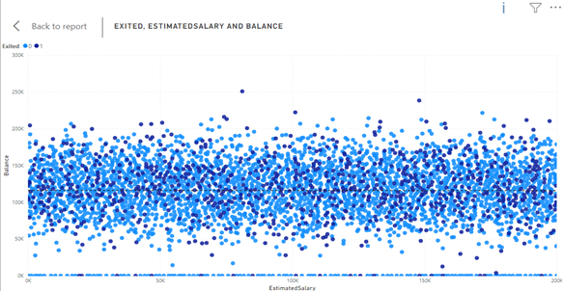

1. Is there any correlation between the salary and the Credit score of customers?

Ans:- As per the datasets give, here are the findings:

* No direct correlation between salary and credit scores of customers
* Credit scores are influenced by payment history, debt-to-credit ratio, credit history length, new credit, and credit amount, not salary.
* Income may affect credit limits but does not directly impact credit scores.

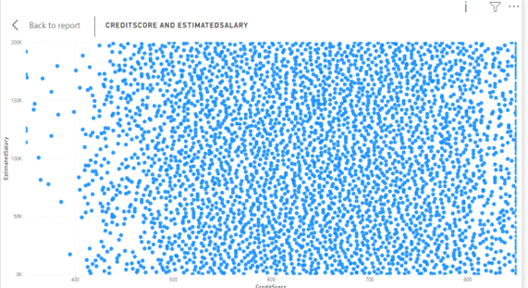

1. Rank each bucket of credit score as per the number of customers who have churned the bank.

Ans:- If we do a grouping for all the credit scores as below and compare it with churned customers, we will get mostly exited customers are those whose Credit score are below 580, and so on which can be seen from below mention chart.

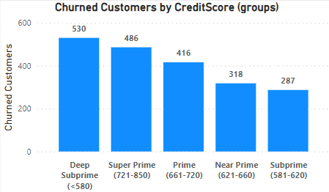

1. According to the age buckets find the number of customers who have a credit card. Also retrieve those buckets that have lesser than average number of credit cards per bucket.

Ans:-From the below mentioned graph, we can see the number of customers who possesses a credit card and who’s not by each age bucket.

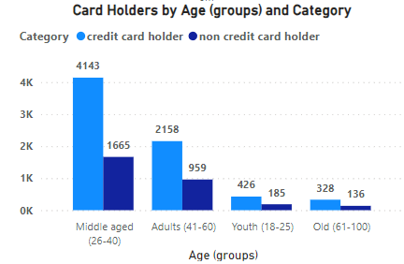

Also, we can get the average number of credit card per bucket by using this DAX:

Avg Credit Cards per Bucket =

DIVIDE(

    SUM(Bank_Churn[HasCrCard]),

    DISTINCTCOUNT('CustomerInfo'[Age (groups)]))

Also, by Filtering the values using the number, i.e., 1763.75(Avg Credit Cards per Bucket), we can get this graph, these are the customers who have lesser than average number of credit cards per bucket.

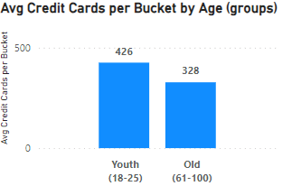

1. Rank the Locations as per the number of people who have churned the bank and average balance of the customers.

Ans:- We can do this by following below mentioned steps:

1. . **Create a measure to count churned customers per location**:

Churned Customers per Location =

CALCULATE(

    COUNT('Bank_Churn'[CustomerId]),

    'Bank_Churn'[Exited] = 1,

    ALLEXCEPT('CustomerInfo', 'CustomerInfo'[GeographyID])

1. **Create a measure to calculate average balance per location**:

Avg Balance per Location =

CALCULATE(

    AVERAGE('Bank_Churn'[Balance]),

    ALLEXCEPT('CustomerInfo', 'CustomerInfo'[GeographyID]))

1. **Create a measure to rank locations by churned customers**:

Rank by Churned =

RANKX(

    ALL('CustomerInfo'[GeographyID]),

    [Churned Customers per Location],

    ,DESC)

1. **Create a measure to rank locations by average balance**:

Rank by Balance =

RANKX(

    ALL('CustomerInfo'[GeographyID]),

    [Avg Balance per Location],

    ,DESC)

1. **Create a combined rank measure**:

Combined Rank =

AVERAGEX(

    VALUES('CustomerInfo'[GeographyID]),

    [Rank by Churned] + [Rank by Balance]) / 2

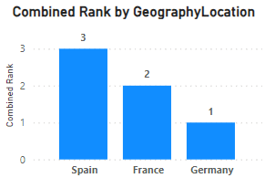

1. As we can see that the “CustomerInfo” table has the CustomerID and Surname, now if we have to join it with a table where the primary key is also a combination of CustomerID and Surname, come up with a column where the format is “CustomerID_Surname”.

Ans:-We can easily do that in Power query editor just by using the merge column feature, separator as a “_” and changing the column name to “CustomerID_Surname”

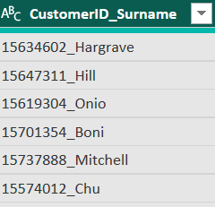

1. Without using “Join”, can we get the “ExitCategory” from ExitCustomers table to Bank_Churn table? If yes do this using SQL.

Ans:- This code retrieves customer data from the Bank_Churn table and adds a new column named "ExitCategory" to classify customers as 'Retain' (not churned) or 'Exit' (churned) based on the value in the Exited column (likely 0 for non-churned, non-zero for churned).

It achieves this without using a JOIN operation, making it simpler for single-table queries**.**

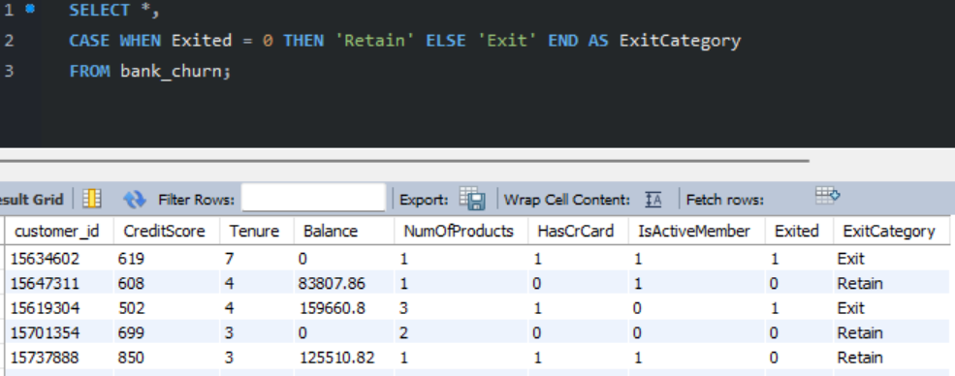

1. Were there any missing values in the data, using which tool did you replace them and what are the ways to handle them?

Ans:- This section addresses missing values, which can occur when data points are not recorded or unavailable. In our analysis, we're fortunate to have a dataset free of missing values. This eliminates the need for imputation techniques that might introduce assumptions or biases.

**General Approaches to Missing Values (for future reference):**

While our dataset is free of missing values, it's valuable to be aware of common approaches for handling them in future analyses:

* Deletion: This involves removing rows or columns with missing values. This can be appropriate if the missing data is minimal and doesn't significantly impact the analysis. However, it can also lead to a loss of information.
* Imputation: This replaces missing values with estimated values. Techniques include mean/median/mode imputation, k-Nearest Neighbors (KNN), or more sophisticated methods. The chosen method should be based on the data type and distribution.
* Modeling Techniques: Some statistical models can handle missing values directly. However, understanding the reasons for missingness is still important.

1. Write the query to get the customer IDs, their last name, and whether they are active or not for the customers whose surname ends with “on”.

Ans:- We can easily get the solution by using REGEXP function in MySQL.

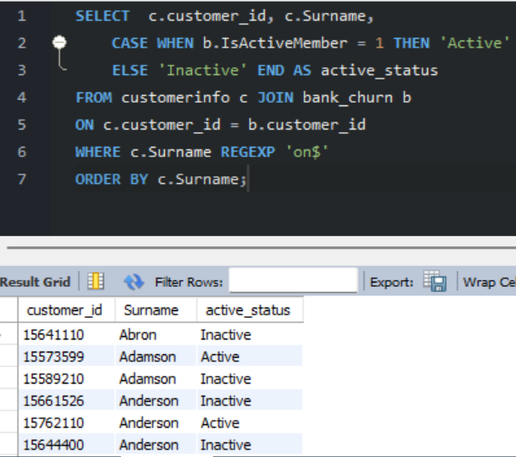

1. Can you observe any data disrupency in the Customer’s data? As a hint it’s present in the IsActiveMember and Exited columns. One more point to consider is that the data in the Exited Column is absolutely correct and accurate.

Ans:-There is some noticeable discrepancy in the Customers data as we can see from the below graph, among the customers who have already exited the bank are still showing as “Active Member” and the number for that is quite large as 735 which should not be there because as per logic: **Churned customers = Inactive customers**

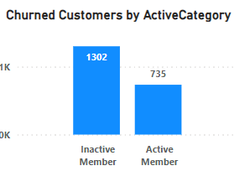

**Subjective Question:**

1. Customer Behaviour Analysis: What patterns can be observed in the spending habits of long-term customers compared to new customers, and what might these patterns suggest about customer loyalty?

Ans:- The analysis of customer spending patterns reveals key insights from three charts focusing on average balance, salary, and number of products held by new and long-term customers:

**Average Balance:**

* New customers (blue line) have consistently lower average balances than long-term customers (orange line).
* New customers show fluctuating balances, while long-term customers exhibit an increasing trend.
* Reasons may include familiarity, income growth, or better incentives for long-term customers.

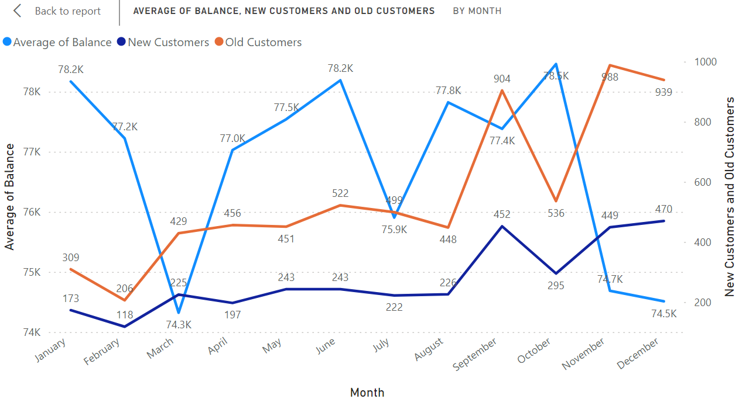

**Average Salary**

* Long-term customers (orange line) have higher average salaries than new customers (blue line).
* New customers show a slight upward salary trend over time.
* Correlation between customer status and salary is observed.

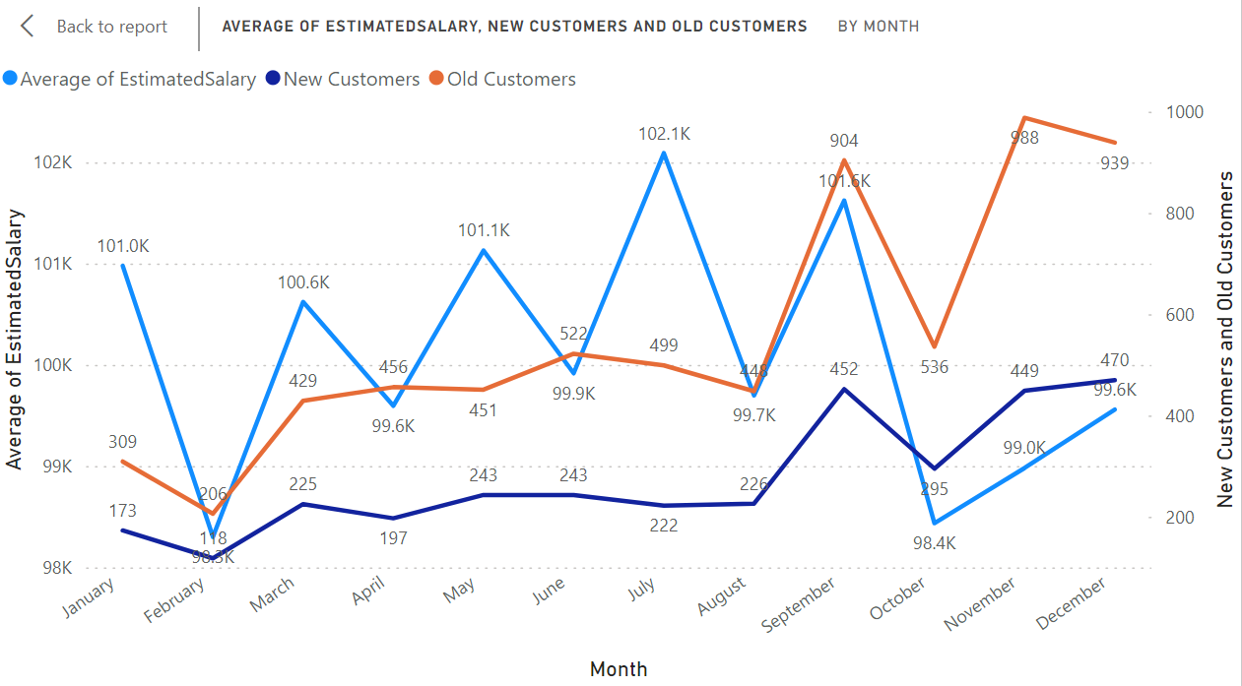

**Number of Products Held**

* Long-term customers (orange line) hold more products on average than new customers (blue line).
* New customers gradually increase products held over time.
* New customers start with fewer products, likely exploring offerings.

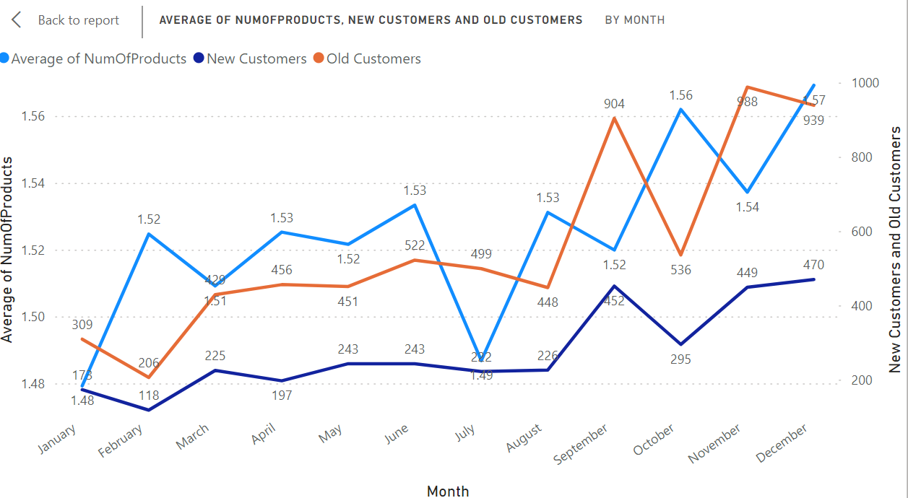

These insights highlight the connection between customer loyalty and increased spending, salary, and product holdings, informing the bank's marketing and retention strategies.

1. Product Affinity Study: Which bank products or services are most commonly used together, and how might this influence cross-selling strategies?

Ans:- Customers often use specific bank products together. Analyzing these pairings helps develop targeted cross-selling strategies to increase customer satisfaction and revenue.

**Commonly Used Products (Examples):**

* Checking Accounts: Essential for daily transactions.
* Debit Cards: Linked to checking accounts, providing convenient fund access.
* Savings Accounts: Facilitate savings growth and often earn interest.
* Credit Cards: Offer credit lines for purchases with interest repayment.
* Loans: Tailored financial solutions like mortgages or auto loans.

**Cross-Selling Strategies:**

* Recommend Complementary Products: For instance, suggest debit cards and online banking to checking account users for easy management. Savings account holders could benefit from automatic transfers or higher-interest options like CDs.
* Personalize Based on Usage: Offer travel rewards cards to credit card users with travel habits. Provide bundled insurance options to loan seekers.
* Leverage Digital Platforms: Promote paperless statements, bill autopay, investment options, and financial tools through online/mobile banking.

Understanding product usage patterns and tailoring recommendations enables banks to boost revenue and meet customers' financial needs effectively.

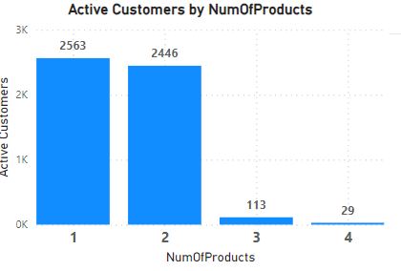

1. Geographic Market Trends: How do economic indicators in different geographic regions correlate with the number of active accounts and customer churn rates?

Ans:- This section explores how economic indicators vary across geographic regions and their potential correlation with customer churn rates. We'll analyze three key economic indicators: average balance, average salary, and credit score.

**Average Balance by Geographic Location:**

* The chart displays average balance across different locations, with Germany showing the highest balance.
* Although not directly linked to churn, regions with lower balances may experience higher churn rates if customers are more sensitive to costs.

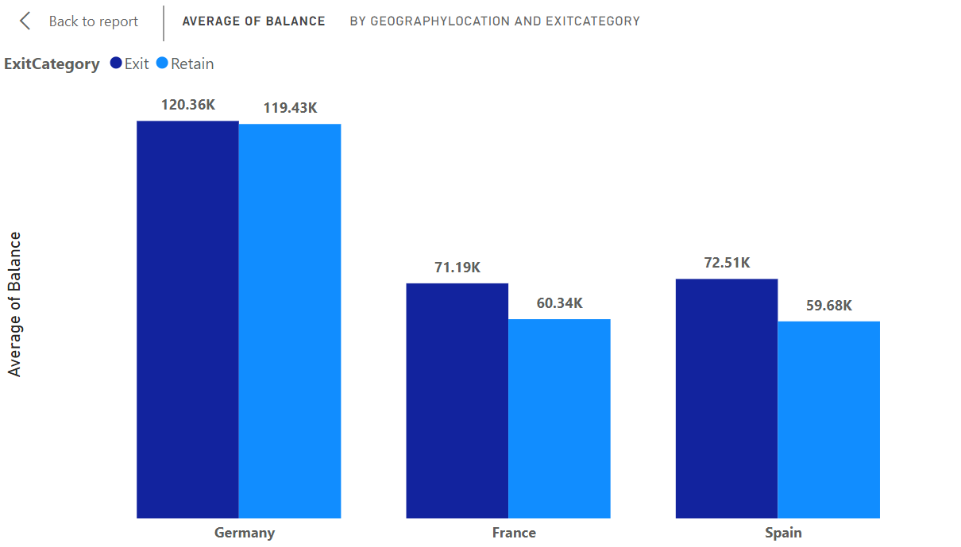

**Average Credit Score by Geographic Location:**

* The chart illustrates variations in credit scores across locations, with Germany exhibiting the highest average.
* This data, combined with churn rate information, may reveal a potential correlation between higher credit scores and lower churn rates, indicating that more creditworthy customers are less likely to switch banks.

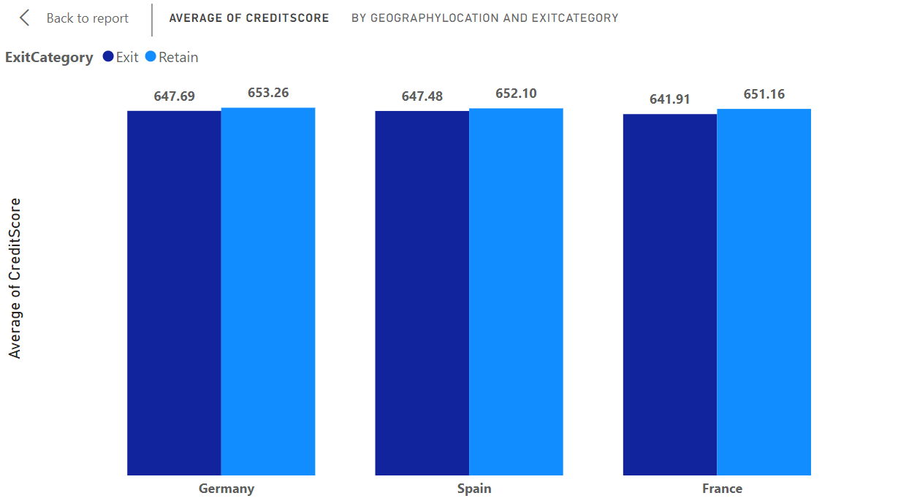

**Average Salary by Geographic Location:**

* The chart displays variations in average salary across locations, with Germany having the highest average.
* This data, when considered alongside churn information, may provide insights into the relationship between higher salaries and customer churn rates.

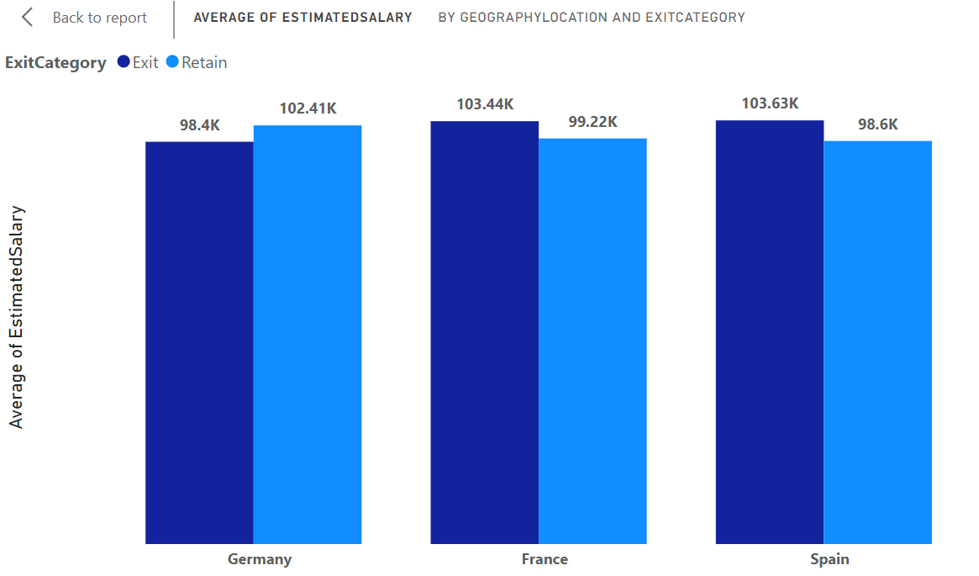

1. Risk Management Assessment: Based on customer profiles, which demographic segments appear to pose the highest financial risk to the bank, and why?

Ans:- Based on the chart, the demographic segments, we can determine the below mentioned findings:

* Lower credit score segments ("Lower Middle Class" and "Poor") have the highest number of customers.
* These segments also represent the largest portion of the bank's customer base.
* Lower credit score segments pose the highest potential financial risk to the bank based on the data.
* Creditworthiness, income, and employment history are crucial factors in assessing customer risk.
* Creditworthiness strongly indicates a customer's loan repayment ability.
* Customers with lower credit scores are more likely to default on loans compared to those with higher credit scores.
* Loans to customers in "Lower Middle Class" and "Poor" segments are at higher risk of loss for the bank.

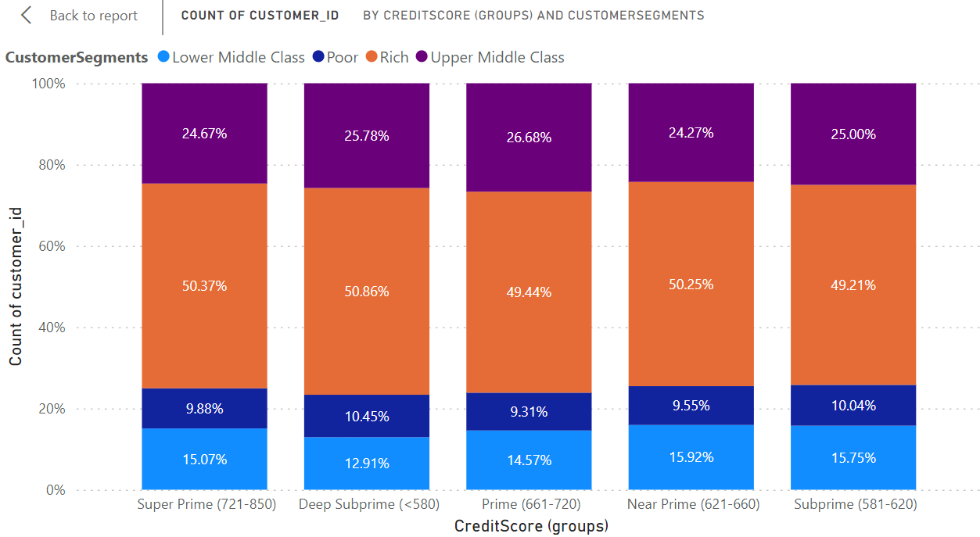

1. Customer Tenure Value Forecast: How would you use the available data to model and predict the lifetime (tenure) value in the bank of different customer segments?

Ans:-

Here are the key insights and predictions based on the chart showing average tenure by balance segments, salary segments, and customer segments:

* Customers with higher average balance segments tend to have longer tenure with the bank.
* This could be due to being more invested in the bank's products and services.
* Or because the bank offers better benefits to retain them

**Balance Segments**:

* Weak trend between salary segments and tenure
* On average, higher salary segments have slightly longer tenures.
* Differences are not substantial across most segments.

**Predicted average tenure for salary segments:**

* + High Salary: 4.8 - 5.4 years
  + Low Salary & Lower Middle Class: 4.5 - 4.9 years
  + Upper Middle Class & Rich: 4.8 - 4.9 years

Balance segments are a more important factor in predicting tenure than salary segments.

* Target retention efforts towards higher balance segments
* Develop strategies to improve customer satisfaction and product adoption across all segments.

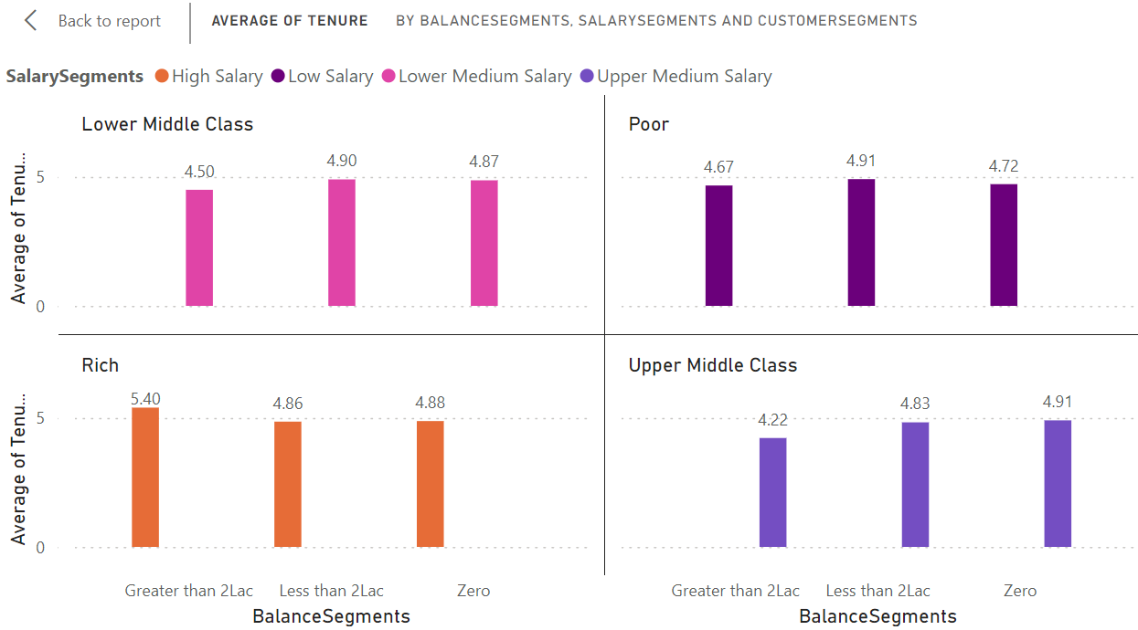

1. Marketing Campaign Effectiveness: How could you assess the impact of marketing campaigns on customer retention and acquisition within the dataset? What extra information would you need to solve this?

Ans:-

To assess the impact of marketing campaigns on customer retention and acquisition within a dataset, one would typically use a combination of data analysis and statistical techniques. Here's a general approach we could take:

* Define key metrics for customer retention and acquisition.
  + - * For retention: customer churn rate, retention rate
      * For acquisition: new customer acquisition rate, customer acquisition cost (CAC)
* Segment data based on different marketing campaigns to analyze the impact of each campaign separately.
* Calculate the defined metrics for each segment and time period (e.g., monthly, quarterly, annually) to understand how each campaign affects customer retention and acquisition over time.
* Compare metrics across different campaigns to identify the most effective ones at retaining and acquiring customers.
* Use statistical tests (e.g., t-tests, ANOVA) to determine if differences in metrics between campaigns are statistically significant.
* Gather additional information for a comprehensive analysis:
* Customer demographics to understand if certain demographics respond better to certain campaigns.
* Campaign details (e.g., duration, channels used, messaging)
* Competitor data to understand the competitive landscape and its impact.
* External factors (e.g., economic conditions, seasonality, industry trends) that might affect customer behaviour.

By following this approach and gathering necessary information, you can assess the impact of marketing campaigns on customer retention and acquisition within this dataset.a

1. Customer Exit Reasons Exploration: Can you identify common characteristics or trends among customers who have exited that could explain their reasons for leaving?

Ans:- The query tasks us with pinpointing common traits or patterns among bank customers who have exited (churned) to comprehend the reasons behind their departure. Two potential characteristics have been identified:

1. **Credit card ownership:** Suggesting that customers with credit cards are more prone to churning compared to those without.
2. **Number of products purchased:** Indicating that customers who purchase fewer products are more inclined to churn than those who buy more.  
   The bar chart labeled "**Churned Customers by HasCrCard and NumOfProducts**" appears to partially validate the assumption regarding credit card ownership.

* **Analysis of Credit Card Ownership:**

The chart titled "**Churned Customers by HasCrCard and NumOfProducts**" displays the number of customers who exited the bank categorized by the number of products they purchased.

It indicates the relationship between the number of products bought by customers and their likelihood of churning.

By analyzing this chart, we can assess whether customers who purchased fewer products are more prone to churning compared to those who bought more products.

* **Analysis of Number of Products Purchased:**

The chart supports the idea that customers who buy fewer products are more likely to churn.

* 1. The highest number of customers who exited the bank purchased zero products.
  2. The number of exited customers steadily declines as the number of products purchased increases.
  3. Very few exited customers (around 41) bought four or more products.
* **Possible reasons for this trend:**

Customers using more products are likely to be more satisfied with the bank overall and find more value in the relationship.

The bank may offer benefits or discounts to customers who use more products, incentivizing them to stay.

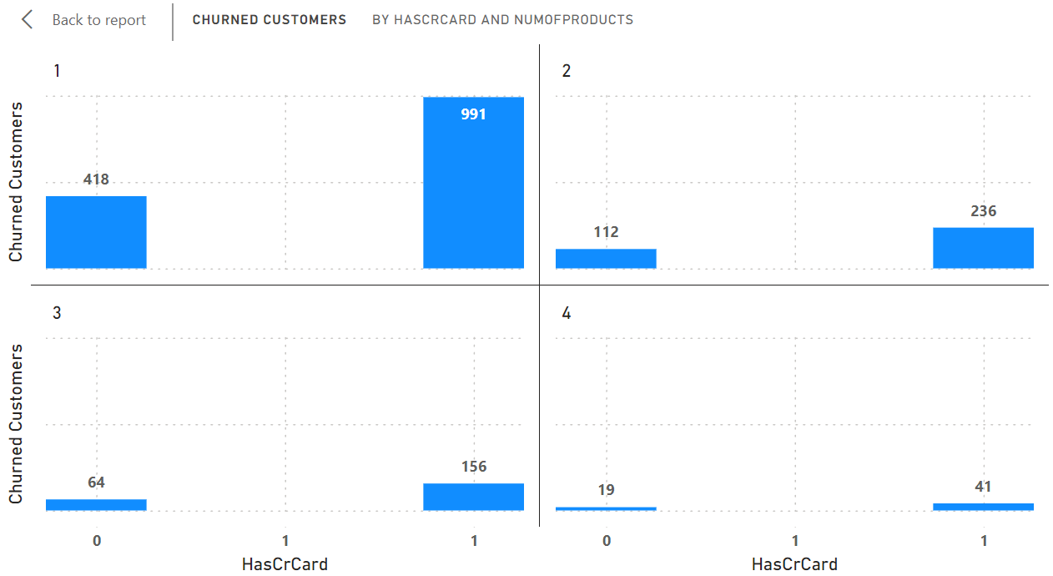

1. Are 'Tenure', 'NumOfProducts', 'IsActiveMember', and 'EstimatedSalary' important for predicting if a customer will leave the bank?

Ans: Based on the Power BI chart provided, here are the key points regarding the importance of ‘Tenure’, ‘NumOfProducts’, ‘IsActiveMember’, and ‘EstimatedSalary’ for predicting customer churn:

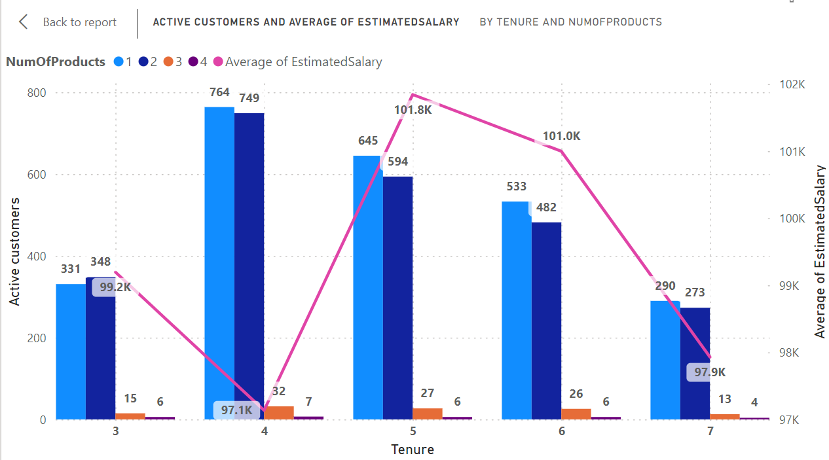

**Tenure**

* The chart shows significant variation in the number of active customers across different tenure periods.
* Customers with shorter tenures (0-5 years) have a higher number of churned customers compared to those with longer tenures.
* This suggests that tenure is a key factor in predicting customer churn, as customers who have been with the bank for a shorter period are more likely to leave.

**Number of Products (NumOfProducts)**

* The chart indicates that the number of products a customer holds is an important factor in predicting churn.
* Customers with fewer products (0-2) have a higher number of churned customers compared to those with more products.
* This implies that customers who use a wider range of the bank's products are less likely to churn.

**Active Member Status (IsActiveMember)**

* Since the chart focuses on active customers, the active member status is inherently considered in the analysis.
* However, the chart does not provide a direct comparison between active and inactive members.
* To fully assess the importance of active member status, a separate analysis comparing churn rates between active and inactive members would be necessary.

**Estimated Salary (EstimatedSalary)**

* The chart does not show a clear trend correlating estimated salary with the number of active customers.
* The importance of estimated salary in predicting churn is uncertain based on the information provided in the chart alone.
* Further analysis would be needed to determine if there is a relationship between salary and churn.

**In summary, the Power BI chart suggests that:**

* Tenure and the number of products held by a customer are important factors in predicting customer churn for a bank.
* The importance of active member status and estimated salary requires additional analysis to draw definitive conclusions.
* By understanding these factors, banks can develop targeted strategies to retain customers and reduce churn.

1. Utilize SQL queries to segment customers based on demographics and account details.

Ans:-

This code segments customers based on:

* Income: categorized as Low, Medium, or High based on estimated salary.
* Location: uses the GeographyLocation field (country/region).
* Gender: assigned as Male or Female based on gender id values.
* Age: included for further analysis within segments.

It will be achieved this by:

* Joining customer data with geographic information (if available).
* Grouping customers by income segment, location, gender, and age.
* Counting the number of customers within each specific segment.
* Ordering the results by location and then age for easier exploration.

This allows you to analyze customer characteristics across various demographics and potentially geographic regions.

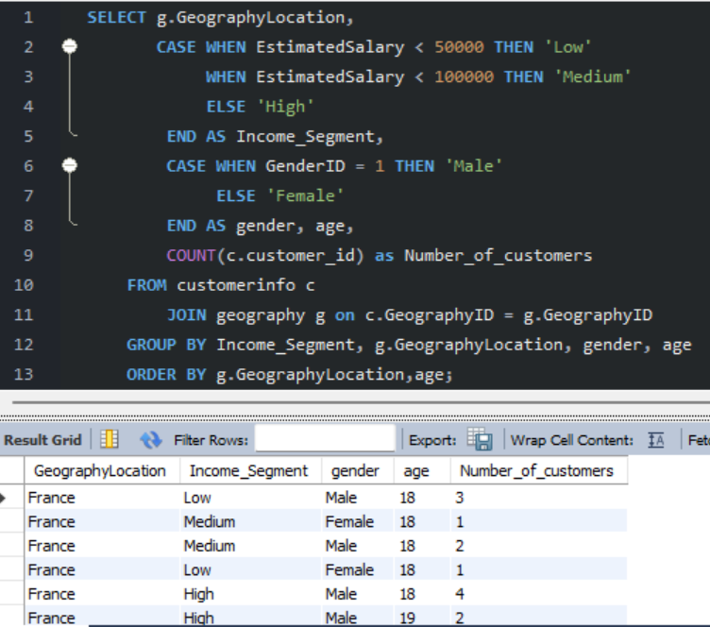

1. How can we create a conditional formatting setup to visually highlight customers at risk of churn and to evaluate the impact of credit card rewards on customer retention?

Ans:- Here's how we can create a conditional formatting setup in Power BI to visually highlight customers at risk of churn and evaluate the impact of credit card rewards on customer retention:

Conditional Formatting for Churn Risk

1. **Create a new column** in your data model called "Churn Risk" that assigns a risk level based on the customer's characteristics. For example:
   * If Tenure < 3 AND NumOfProducts < 2, Churn Risk = "High"
   * If Tenure >= 3 AND NumOfProducts < 2, Churn Risk = "Medium"
   * If NumOfProducts >= 2, Churn Risk = "Low"
2. **In the report**, we need to create a table visual with the following columns: CustomerID, Tenure, NumOfProducts, HasCrCard, Exited, Churn Risk.
3. **Apply conditional formatting** to the Churn Risk column:

Format the background color based on the risk level (e.g., red for High, yellow for Medium, green for Low)

1. **Analyze the table** to identify customers with High churn risk who have active credit cards but have exited. These are prime candidates for credit card rewards to incentivize retention.
   * Fortunately, there are no “High risk” customers, but we have around **5084** potential churn customers (“Medium risk”) which we should take care of.

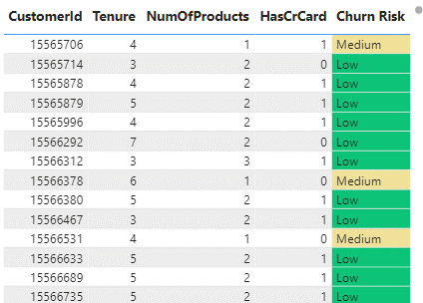

Evaluating Credit Card Rewards Impact

1. **Create a new measure** called "Retained Customers" that counts customers who have not exited:

Retained Customers = COUNTROWS(FILTER(Bank_Churn,Bank_Churn[Exited] = 0))

1. **Create another measure** called "Retained Credit Card Customers" that counts customers with credit cards who have not exited:

Retained Credit Card Customers = CALCULATE([Retained Customers], Bank_Churn[HasCrCard] = 1)

1. **Create a KPI visual** to track the "Retained Credit Card Customers" percentage out of total customers:

Retained Credit Card Customers % = DIVIDE([Retained Credit Card Customers], [Retained Customers])

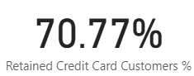

1. **Monitor the KPI** over time to evaluate the impact of credit card rewards on customer retention. An increase in the percentage indicates that credit card rewards are effectively reducing churn among credit card holders.

By combining conditional formatting to identify high-risk customers and measures to track retained credit card customers, you can gain valuable insights into churn patterns and the effectiveness of credit card rewards in improving customer retention.

1. What is the current churn rate per year and overall as well in the bank? Can you suggest some insights to the bank about which kind of customers are more likely to churn and what different strategies can be used to decrease the churn rate?

Ans:-

This analyzes customer churn rates and identifies segments most susceptible to churn. It also proposes strategies to decrease churn and improve customer retention.

Churn Rate:

* The overall churn rate for the bank is **20.37%**
* Year-on-year churn rates show some fluctuations:
  + 2016: 19.27% (lowest)
  + 2017: 22.35% (highest)
  + 2018: 20.21%
  + 2019: 19.86%

The churn rate can be obtained by the following formula:

Churn Rate = DIVIDE(Bank_Churn[Churned Customers],[Total Customers])

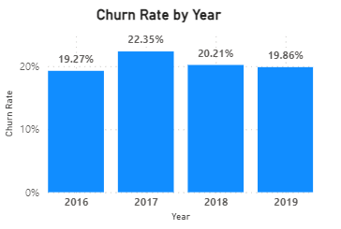

* **Customer Segments Prone to Churn:**
  + Purchases 1 product: Customers using only one product by a bank may perceive less value compared to competitors with broader offerings.
  + Has credit card:
    - Limited credit limits not meeting their needs.
    - Lack of rewarding programs incentivizing card retention.
    - High credit card fees.
  + Tenure of 4-5 years: Customers in this tenure phase may be approaching the end of introductory offers, making them susceptible to competitor offers with better terms.
  + High salary: High-income earners might be more inclined to switch for slightly better rates or benefits elsewhere.
* **Recommendations to Reduce Churn:**
  + Targeted Product Bundles: Create tailored bundles for specific customer segments, emphasizing added benefits and potential cost savings for customers using only one product.
  + Enhanced Credit Card Rewards:
    - Increase credit limits based on customer history and creditworthiness.
    - Offer rewards aligned with spending habits (e.g., travel rewards, cash back).
    - Reduce or waive annual fees, especially for high-value customers.
  + Retention Offers for Existing Customers: Proactively offer personalized retention deals to customers nearing the end of introductory offers.
  + Customer Satisfaction Surveys: Regularly conduct surveys to understand reasons for churn and improve retention strategies.
  + Relationship Management for High-Value Customers: Assign dedicated managers to high-value customers for personalized service and exclusive benefits.

1. Create a dashboard incorporating all the KPIs and visualization-related metrics. Use a slicer in order to assist in selection in the dashboard.

Ans:-

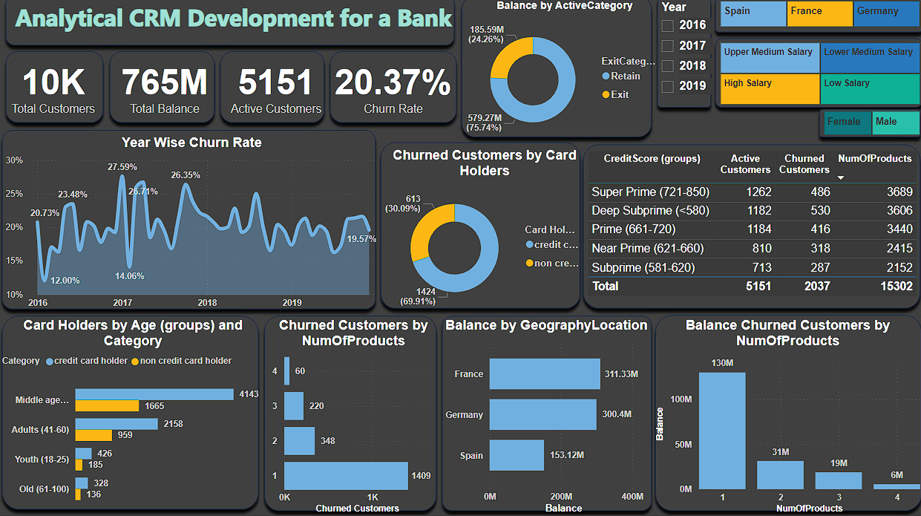

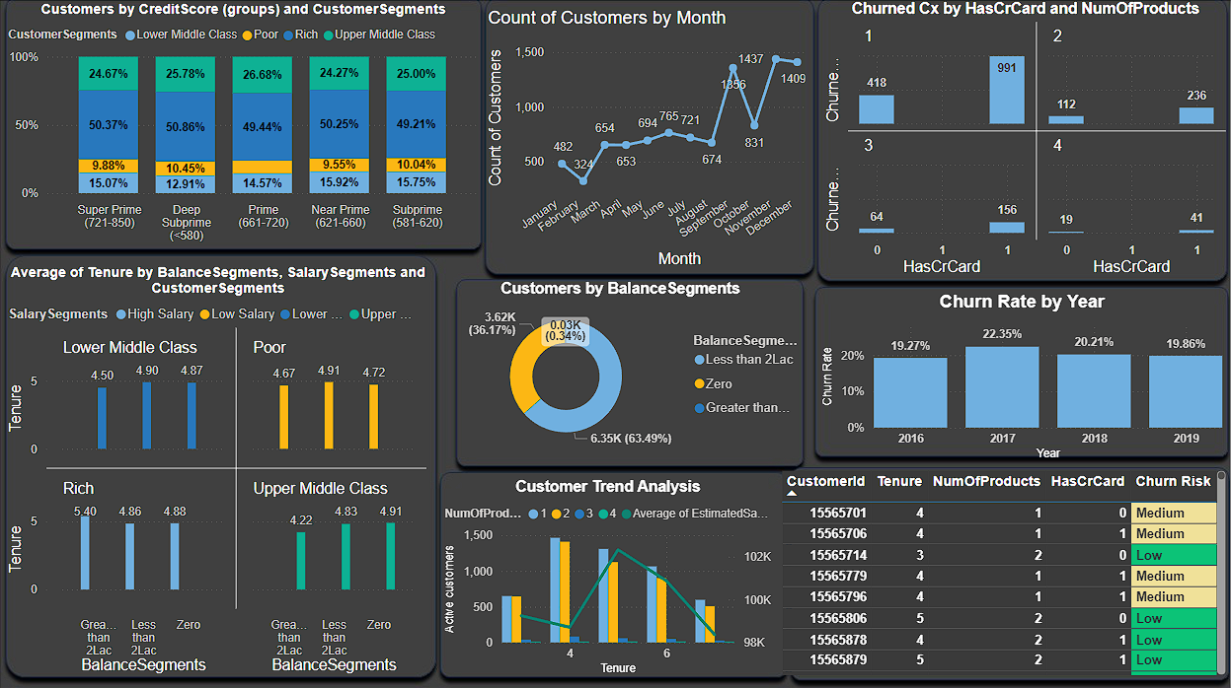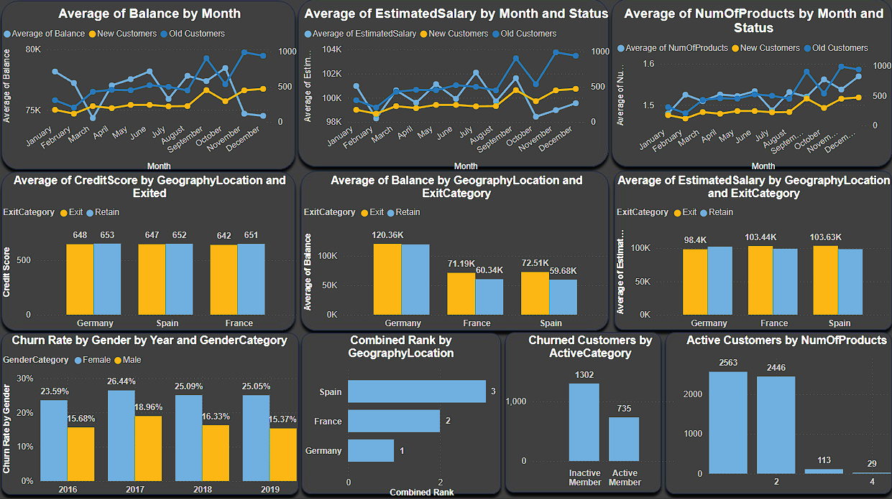

1. How would you approach this problem, if the objective and subjective questions weren't given?

Ans:- Absolutely! Even without explicit objective and subjective questions, We can effectively approach a problem by following a process that involves generating hypotheses, asking your own questions, and deriving insights. Here's a breakdown of this approach:

* **Hypothesis Generation:**
  + Make assumptions about the data or problem based on domain knowledge, industry best practices, or initial observations.
* **Question Formulation:**
  + Formulate questions that can be answered using the available data to validate or refine hypotheses.
  + Examples for Customer Churn Analysis:
    1. Are there demographic patterns (age, income) associated with customer churn?
    2. Does account balance or number of products hold influence churn rates?
    3. How does customer activity (transactions, logins) correlate with churn?
  + Examples for Marketing Campaign Analysis:
    1. Which marketing channels (email, social media) are most effective at reaching target audiences?
    2. Is there a correlation between ad spend and campaign performance?
    3. How does campaign messaging impact customer engagement and conversion rates?
* **Data Exploration and Analysis:**
  + Use data visualization and statistical analysis techniques to answer the formulated questions.
* **Insights and Recommendations:**
  + Draw insights from the analysis findings to inform decision-making in areas such as customer behavior, marketing strategies, product development, etc.

By following this process of hypothesis generation, question formulation, data exploration, and insight derivation, you can effectively approach a problem and gain valuable insights, even without explicit objective and subjective questions.

1. In the “Bank_Churn” table how can you modify the name of the “HasCrCard” column to “Has_creditcard”?

Ans:- We can easily update the name of the "HasCrCard" column to   
"Has_creditcard" in the "Bank_Churn" table by using the below mentioned SQL code. It improves clarity by using a more descriptive name.

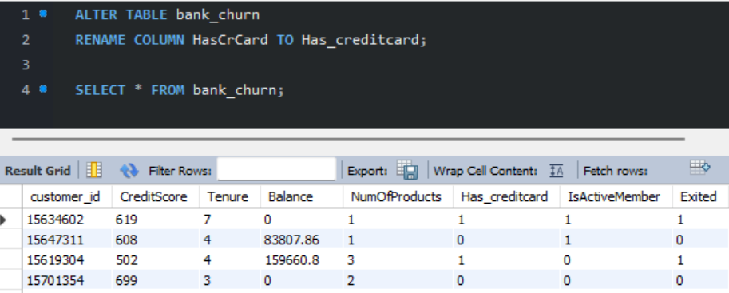

* **REPORT LINK**

**https://app.powerbi.com/view?r=eyJrIjoiYWRiYzE3NWUtZWYxOC00ODVlLTk3Y2YtYTAyM2Q2Y2Y5YWNiIiwidCI6ImRmODY3OWNkLWE4MGUtNDVkOC05OWFjLWM4M2VkN2ZmOTVhMCJ9**

* **PUBLIC LINK**

[**https://project.novypro.com/Pvd8yu**](https://project.novypro.com/Pvd8yu)