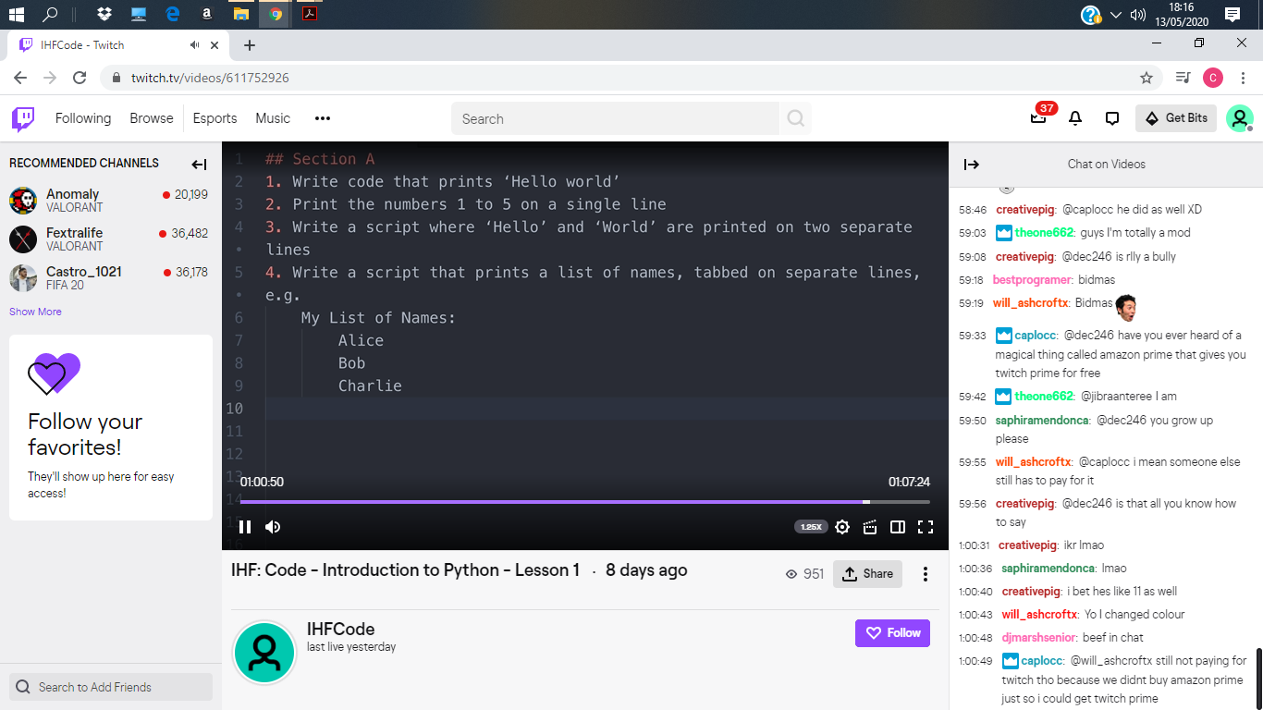5 May

print("Hello world")

print("1 2 3 4 5")

print("Hello")

print("World")

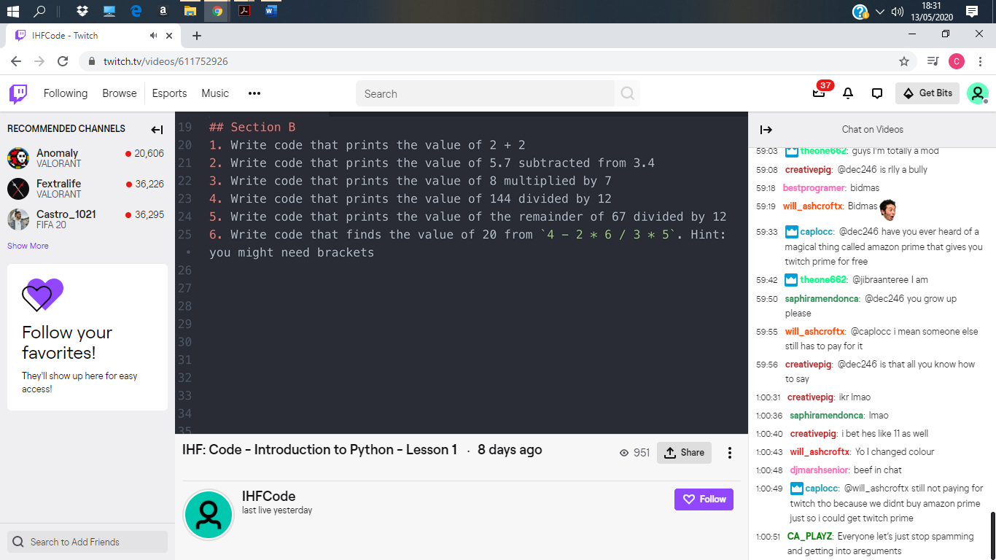print("\tAlice\n\t Bob\n\tCharlie")

print(2 + 2)

print(5.7 + 3.4)

print(8 \* 7)

print(144 / 12)

print(67 % 12)

print((4-2)\*(6/3)\*5)