**Project Report**

**INNOVATION IN SCIENCE PURSUIT FOR INSPIRED RESEARCH (INSPIRE)**

**SUMMER INTERNSHIP**



**Check of Size Consistency in Different Levels of Theory**

|  |
| --- |
| **Under the supervision of**  **Prof. Pratim Kumar Chattaraj**  **Department of Chemistry**  **IIT Kharagpur** |

|  |
| --- |
| **Submitted by:-**  **Suman Bhaumik**  **School of Chemical Sciences**  **NISER, Bhubaneswar** |

**Abstract**

In this work we have verified the “size-consistency” criterion by generating the graphs of potential energy profiles where the y-axis is taken as the energy difference (ΔE = [E(AB) - {E(A) + E(B)}]) between the observed molecule and the isolated atoms and x-axis as the inter-atomic distance in Angstrom of three diatomic molecules (H2,F2 and HF) in Gaussian software. We have done this work using the methods: Hartree-Fock, BPV86, B3LYP, CAM-B3LYP, B3PW91, HCTH, HSEH1PBE, MPW1PW91, LSDA, PBEPBE , TPSSTPSS, ωB97XD, MP2 and the basis sets 6-31G, 6-31G(d,p), 6-311G++(2d,p), cc-pVTZ, and Def2-TZVP.We have faced a problem in obtaining the potential energy graph of molecules using MP2 method which is also discussed. Before going to our project work in detail we have discussed briefly the Gaussian software and various methods and basis sets.

**Table of Contents**

|  |  |
| --- | --- |
| 1. **Introduction** | **4-8** |
| 1. **Computational Details** | **8** |
| 1. **Results and Discussions**   **A. PE Curve of H2 molecule.**  **B. PE Curve of F2 molecule.**  **C. PE Curve of HFmolecule.** | **8-37** |
| 1. **Conclusions** | **37** |
| 1. **References** | **37-38** |

**1. Introduction**

In quantum chemistry, size consistency1, 2 is a property that ensures the energy consistency when we nullify the interaction between atoms of a molecule (by distance). According to Pople, if the energy of a system AB equals the sum of the respective energies of its constituent systems i.e A and B combined when the internuclear distance RAB goes to infinity ( EAB (RAB 🡪 ∞) = EA + EB )3. The distance between the atoms need to be so high so that there is no case of shared electron density. This “non-interacting limit'” is the most important thing in size consistency. Size Consistency calculations are useful in finding out the dissociation curves. However modern definition needs the entire potential energy curve to be well defined during the process of bringing close two non-interacting molecules.

In our work, we are studying the “size consistency” phenomenon of three simple molecules viz. H2, F2 and HF at different types of computational levels and with different basis sets and this is done by obtaining potential energy surfaces (mathematical function mapping the energy to the geometry of a molecule) of the above molecules using Gaussian 09 software. We have computed the energies of the mentioned molecules at the HF, B3LYP, CAM-B3LYP, BPV86, B3PW91, HCTH, HSEH1PBE, LSDA MPW1PW91, PBEPBE, TPSSTPSS, ωB97XD and MP2 levels along with 6-31G, 6-31G(d,p), 6-311G++(2d,p), cc-pVTZ and def2-TZVP basis sets. We are plotting the energy difference (∆E = [E(AB) - {E(A) + E(B)}]) values against the diatomic bond distance to check the size consistency criterion.

* **Theoretical Models**

Theoretical models are ways to model a system using several approximations. A calculation procedure is used and the approximations are combined upon that, and are functioned upon the atomic orbitals, in order to resolve molecular orbitals and their respective energies. The system’s size is important and we have to be very selective of the level at which we are approximating. In this project, the methods which we have used are mainly Hartree-Fock, MP2 and DFT methods like B3LYP, B3PW91, BPV86, CAM-B3LYP, HCTH, HSEH1PBE, LSDA, MPW1PW91, PBEPBE, TPSSTPSS, ωB97XD etc.

* **Basis Set**

To perform theoretical calculation upon a system, the orbitals have to be mathematically defined and that definition is called a basis set. Calculations made by using larger basis sets are more accurate due to the imposition of lesser restriction upon the position of electrons spatially in those basis sets. The basis sets that we use decides on what level it is going to approximate the calculation. A choice have to be made between the time consumed for computations and the accuracy in results while moving forward in computational chemistry.

The normal basis sets use the linear combination of Gaussian functions to form their respective orbitals. The orbitals are approximated using a number of basis functions which are assigned by the basis sets. ***Contracted functions*** are those basis function which are formed of linear combination of Gaussian functions. ***Primitives*** are nothing but the component Gaussian functions. ***Uncontracted function*** is the basis function comprised of a single basis function.

* **Types of Basis sets:-**
* **Split valence basis sets**

More basis functions can be used for an atom to increase the size of a basis set. Here the number of orbitals for the core and the valence electrons are specified separately. It has primed, double primed and unprimed orbitals having different sizes respectively. The ***double zeta valence basis*** ***sets*** form MOs using linear combinations of two sets of Gaussian functions for each valence orbital respectively. Likewise, ***triple split valence basis sets*** form MOs using linear combination of three sets of contracted Gaussian functions. The notation is as follows

K-LMG, where

* K = defines the number of sp type core shell orbitals
* L = defines the number of inner valence s and p type orbitals
* M = total number of outer valence s- and p-type orbitals
* G = indicates that GTOs are used
* **Polarized basis sets**

The previously discussed basis sets could be modified by incorporating orbitals having different shapes, which describes the system in a much better manner. Here we often mix orbitals having angular momentums irrelevant or inappropriate for defining the normal form of each atom in a molecule. This type of basis sets let the atomic orbitals distort from their actual shape due to the influence of its environment. For example, d orbitals are added while calculating for carbon atom that does not have electrons in p orbital in the ground state. Also p orbitals are also included in the case of hydrogen atom. Examples:- 6-31G(d), 6-311G(d, p), etc.

* **Diffused functions**

Another modification of the fundamental basis sets can be done by incorporating ***diffuse functions***. Diffused orbitals inhibit a larger spatial region, and the idea to increase the space is just to maximize the space utilized by electrons in the space even though there is less probability of the electron occupying those extended spaces. There are systems where the electron density is widely distributed and this modification is quite helpful in those cases. Anionic systems, systems having lone pairs and excited states are most often computed with these modifications. Example:- 6-311+G(d, p).

* **Correlation-Consistent**

Thom Dunning5 developed this idea of correlation consistent basis set. These basis sets are denoted using cc-pVXZ, where “cc” represents the correlation consistent basis, “pv” represents the valence basis (polarized), “XZ” indicates the no of zeta functions (X=D,T and Q for double, triple and quadruple respectively).

In order to increase the span, we can add diffuse functions using the terminology “aug”. Example:- cc-pVDZ or aug-cc-pVTZ.

1. **Computational Details**

Here we have checked the size-consistency behaviour of the computational methods taking H2, F2 and HF molecules for case study. We have computed energies of these molecules at different bond lengths at Hartree-Fock, B3LYP, BPV86, B3PW91, CAM-B3LYP, HCTH, HSEH1PBE, LSDA, MPW1PW91, PBEPBE, TPSSTPSS, ωB97XD, and MP2 levels. A large variety of basis sets we have used for the calculations are as follows:- 6-31G, 6-31G (d, p), 6-311G++ (2d, p), cc-pVTZ and Def2-TZVP. We have also computed the energies of the atoms at the same level of theory. Then the energy difference of the diatomic molecule and the summation of the two atoms are plotted against the bond lengths to find out the validity of the size-consistency phenomenon.

**AB 🡪 A + B**

**∆E = [E(AB) - {E(A) + E(B)}]**

E(AB) is the energy of the diatomic molecule and E(A), E(B) are the energy of the atoms; A=B for homo diatomic molecules; A≠B for hetero diatomic molecules.

All of the energy calculations at the gas phase are performed by using Gaussian09 and all of the plots are done using Origin8.

**3. Results and Discussion**

**A. Potential Energy Curve of H2 molecule**

The difference in the energy is plotted against distance between two H-atoms of H2 molecule in figures 1-15. Here the maximum distance between the two H-atoms is considered up to 10,000 Ǻ. Among all of this method B3LYP, B3PW91, BPV86, CAM-B3LYP, HCTH, HF, HSEH1PBE, LSDA, MPWPW91, PBEPBE, TPSSTPSS and B97XD methods define the dissociation path correctly. But the MP2 method gives wrong dissociation path (see figures 11-15). The obtained energy difference curves of H2 molecule using different basis sets and twelve methods viz. B3LYP, B3PW91, BPV86, CAM-B3LYP, HCTH, HF, HSEH1PBE, LSDA, MPWPW91, PBEPBE, TPSSTPSS and B97XD show that in a larger separation the difference is not zero. Thus we have found that in all these cases energy of H2 molecule at infinite distance is higher than the twice the energy of H-atom. Thus size-consistency is maintained in none of these cases for H2 molecule. We have also observed that this inaccuracy in size-consistency is higher in case of Hartree-Fock method than the other. Energy difference between two H-atoms and H2 molecule at 10000 Ǻ is lowest for LSDA/6-311G++(2d,p) level (see table 1).

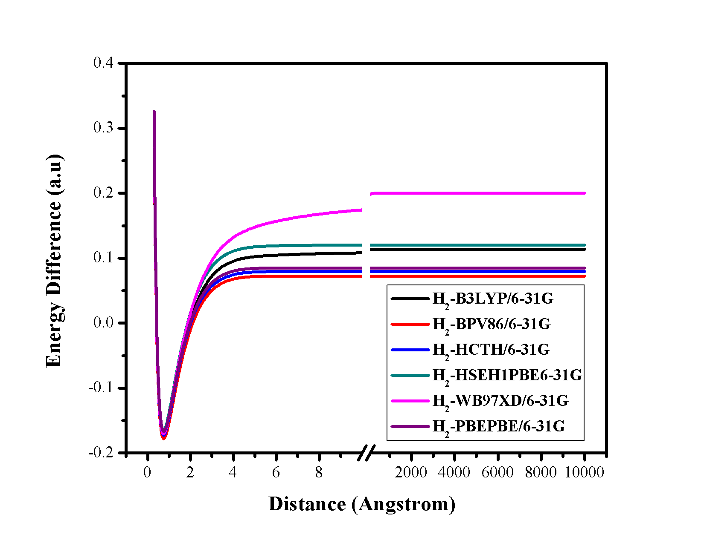

**Figure 1.** Plot of the energy difference versus distance (Ǻ) between two H-atoms of H2 molecule using 6-31G basis set at six different methods.

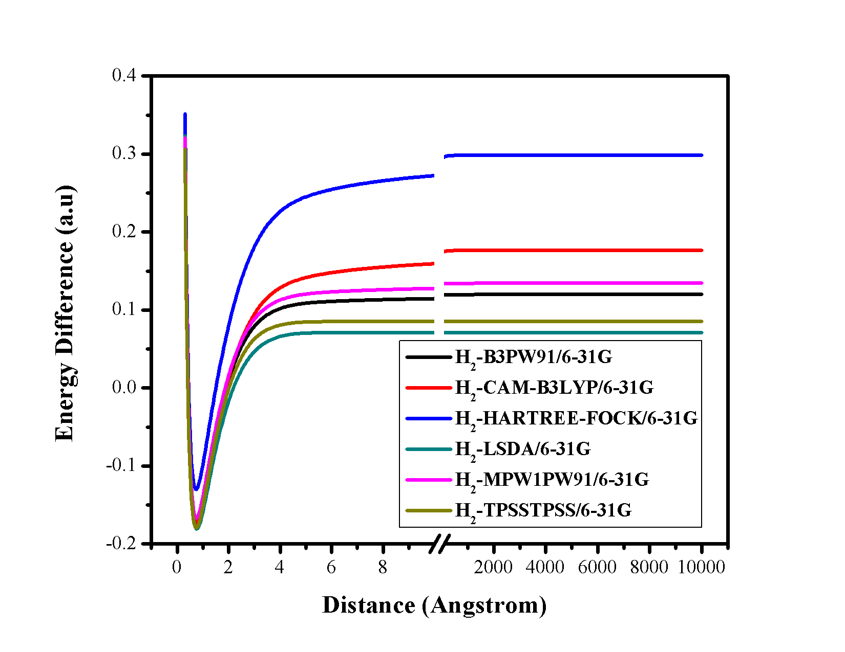

**Figure 2.** Plot of the energy difference versus distance (Ǻ) between two H-atoms of H2 molecule using 6-31G basis set at six different methods.

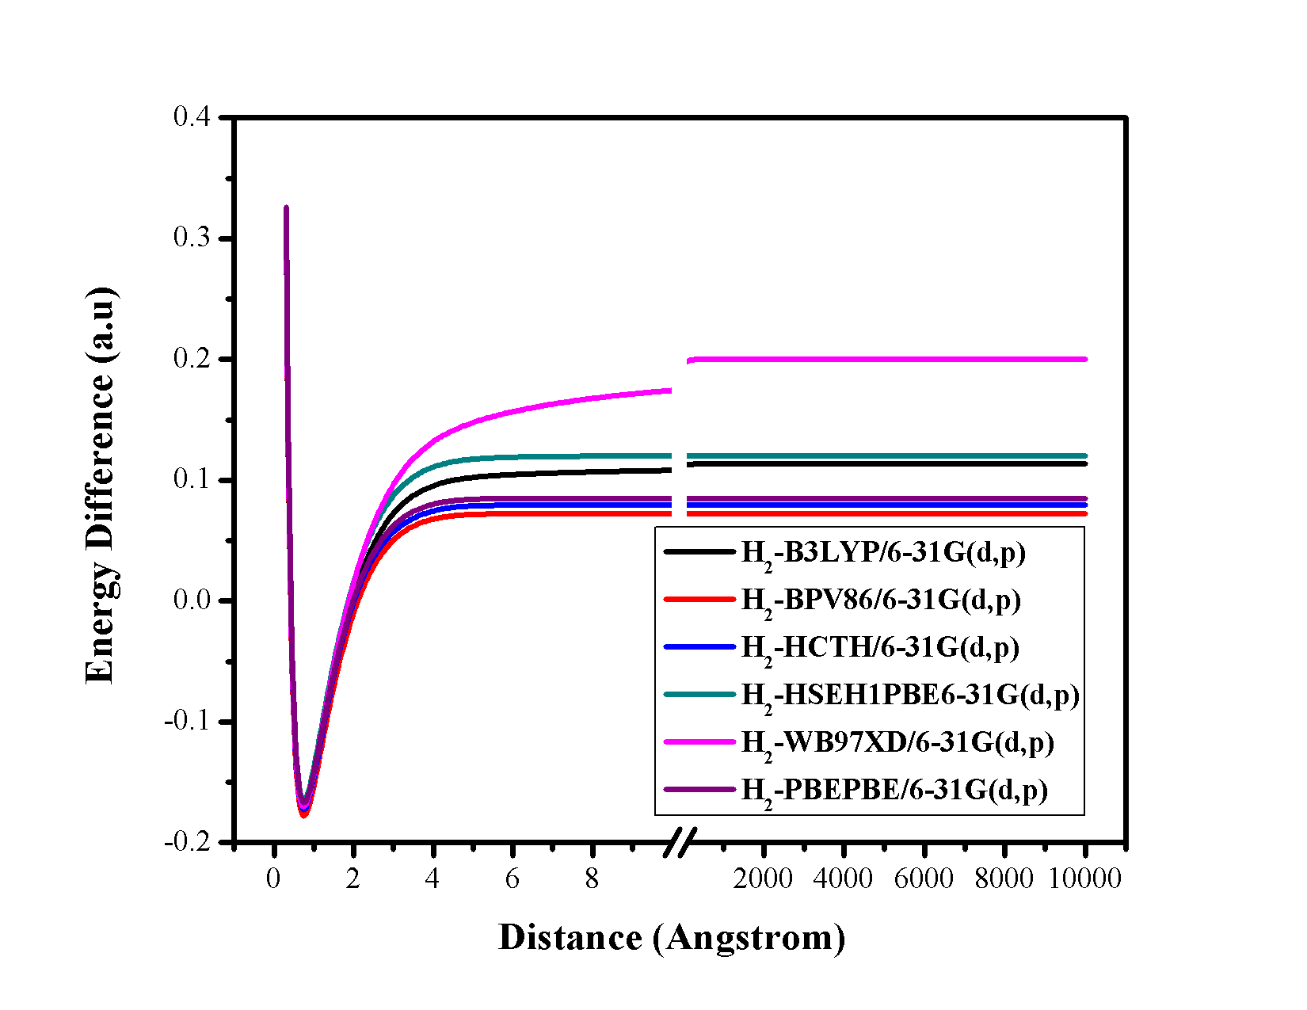

**Figure 3.** Plot of the energy difference versus distance (Ǻ) between two H-atoms of H2 molecule using 6-31G(d,p) basis set at six different method.

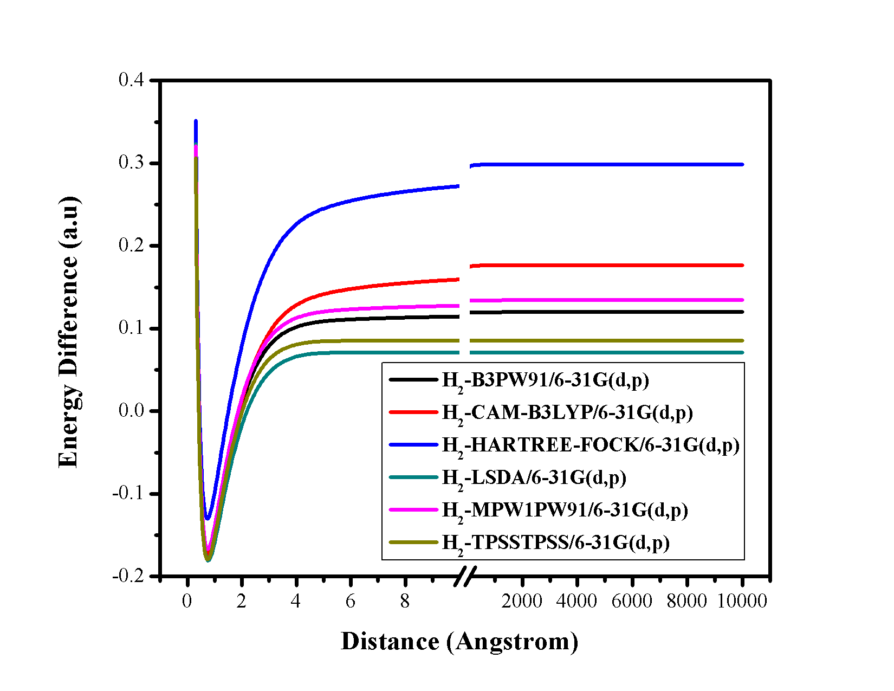

**Figure 4.** Plot of the energy difference versus distance (Ǻ) between two H-atoms of H2 molecule using 6-31G(d,p) basis set at six different methods.

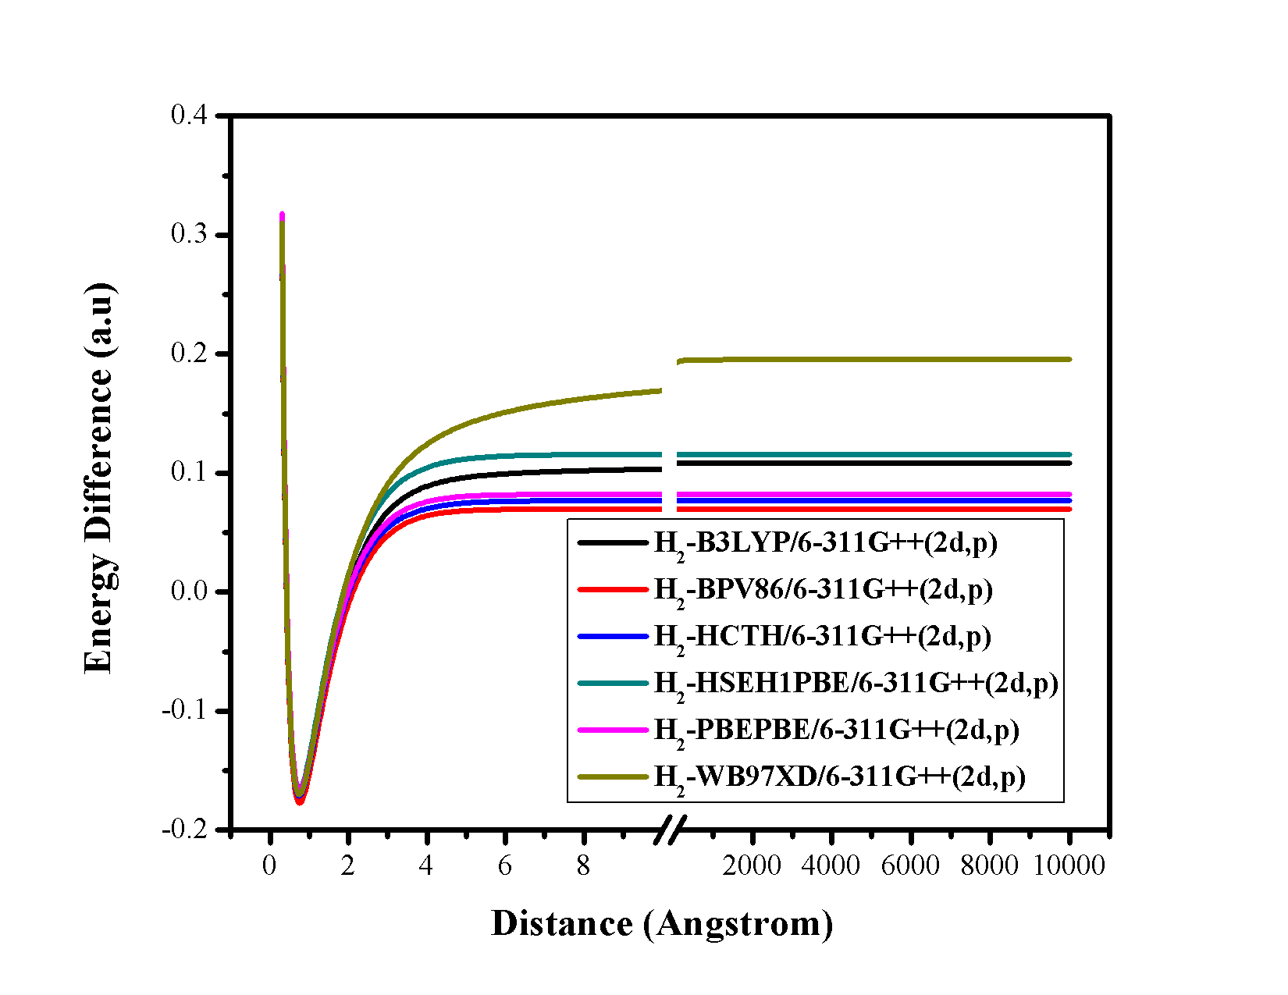

**Figure 5.** Plot of the energy difference versus distance (Ǻ) between two H-atoms of H2 molecule using 6-311G++(2d,p) basis set at six different methods.

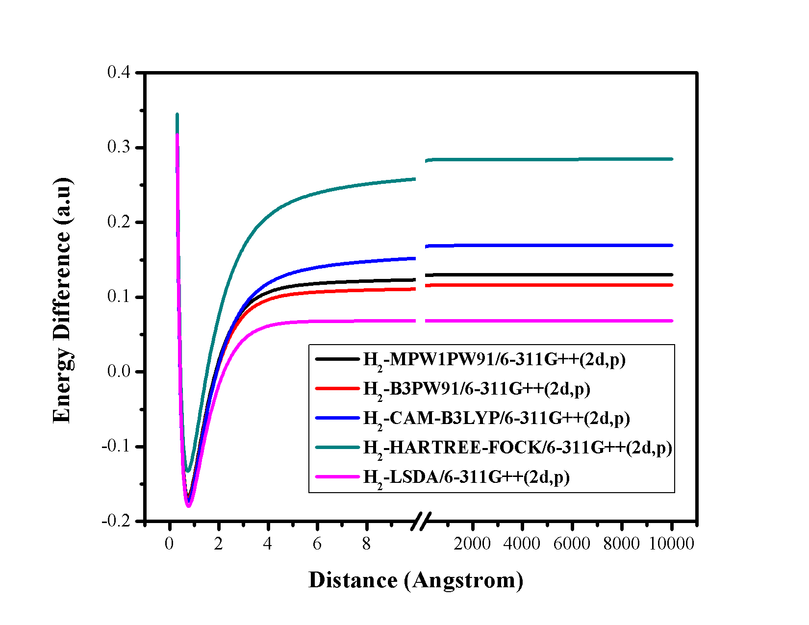

**Figure 6.** Plot of the energy difference versus distance (Ǻ) between two H-atoms of H2 molecule using 6-311G++(2d,p) basis set at six different methods.

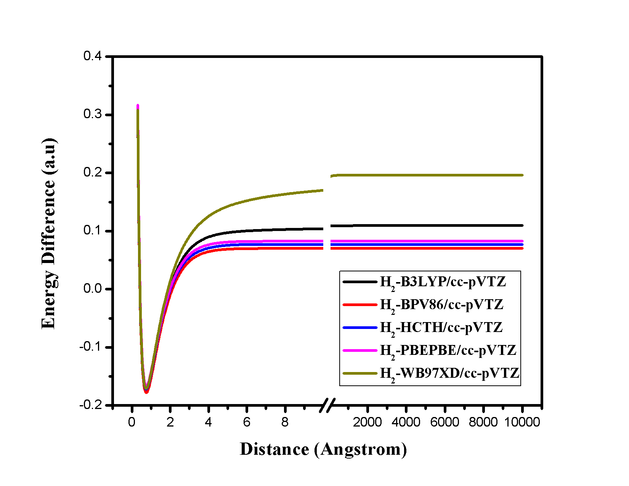

**Figure 7.** Plot of the energy difference versus distance (Ǻ) between two H-atoms of H2 molecule using cc-pVTZ basis set at six different methods.

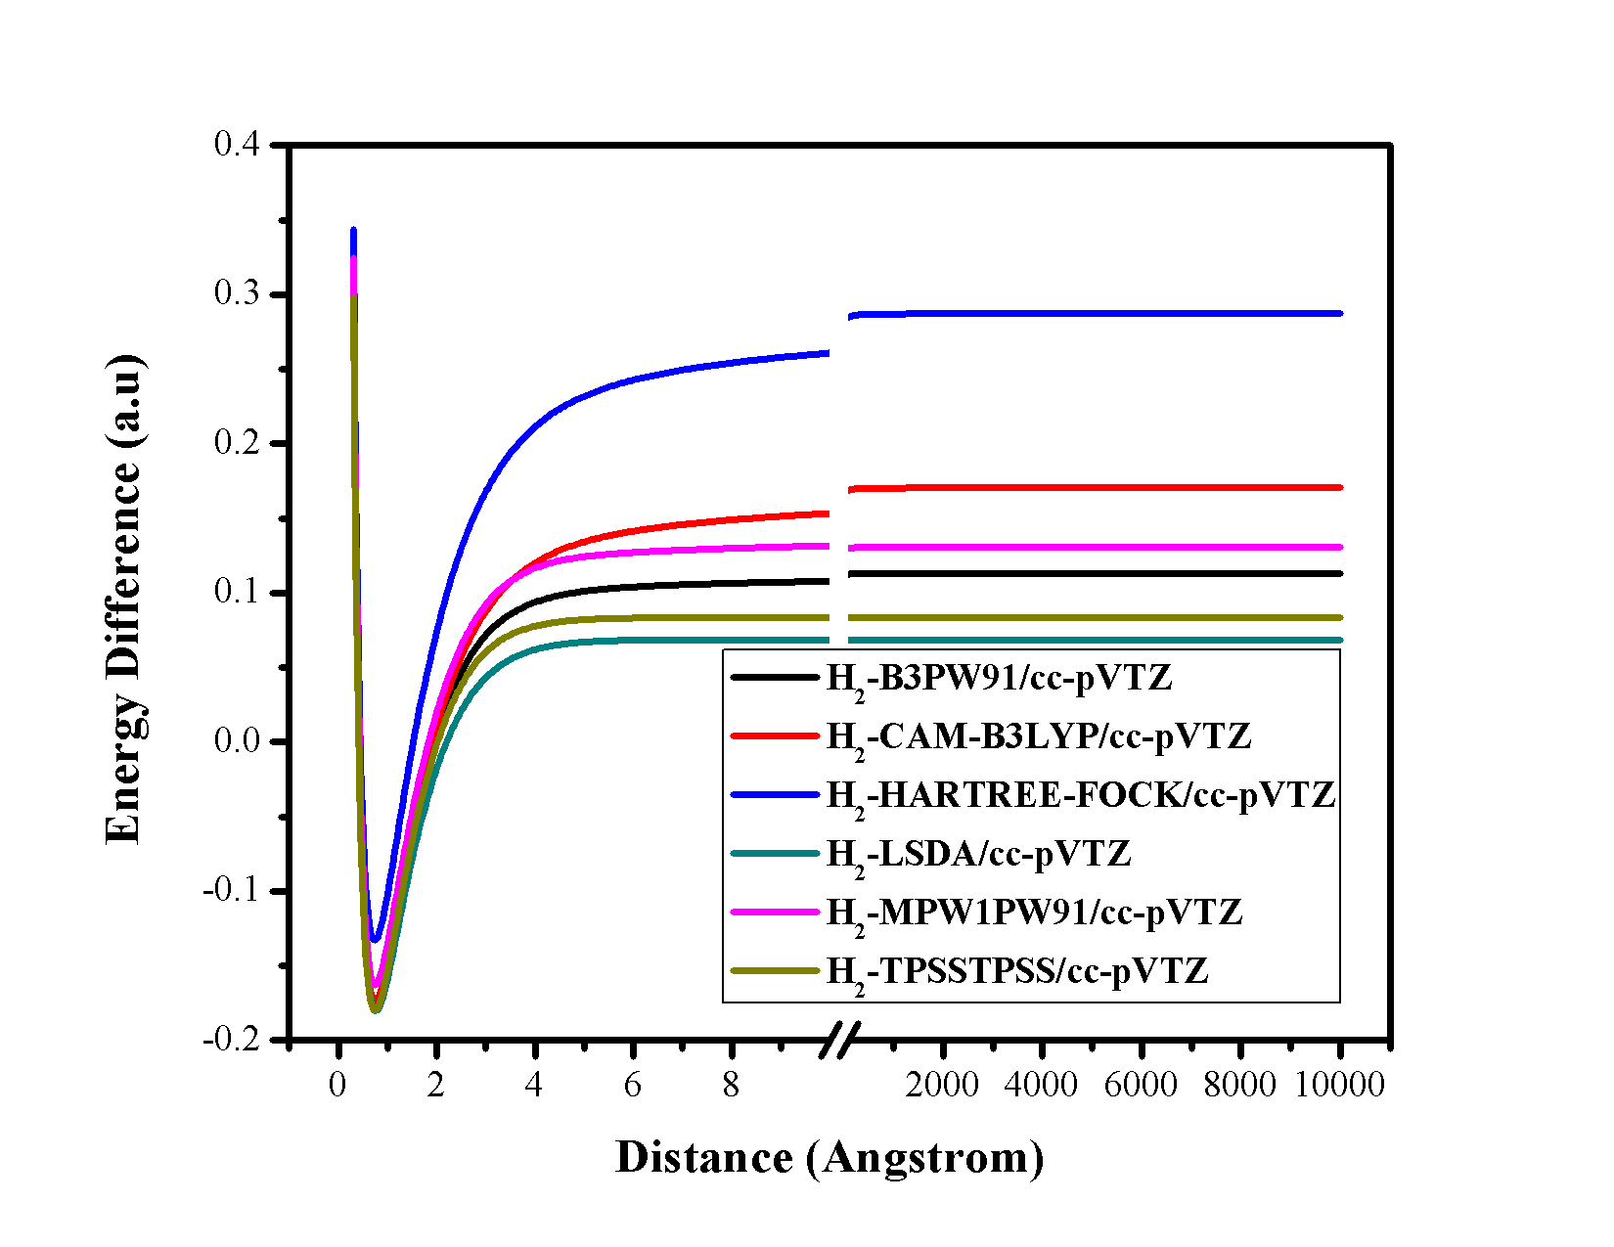

**Figure 8.** Plot of the energy difference versus distance (Ǻ) between two H-atoms of H2 molecule using cc-pVTZ basis set at six different methods.

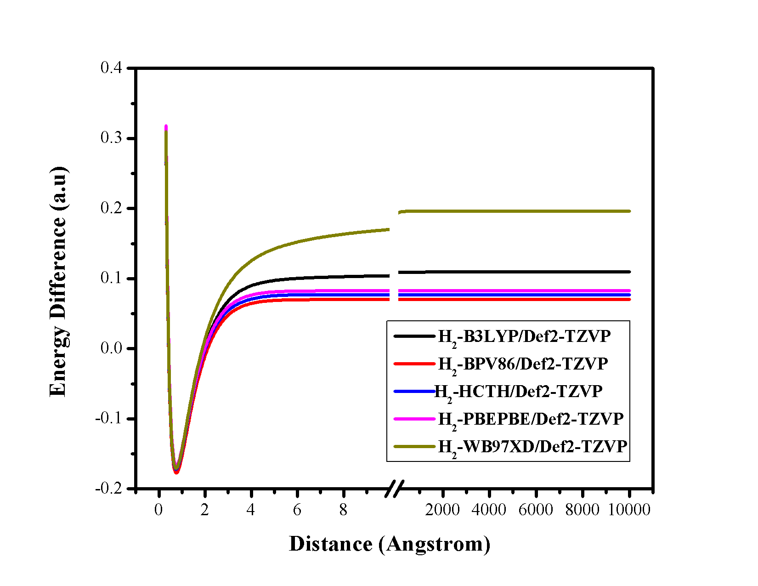

**Figure 9.** Plot of the energy difference versus distance (Ǻ) between two H-atoms of H2 molecule using Def2-TZVP basis set at six different methods.

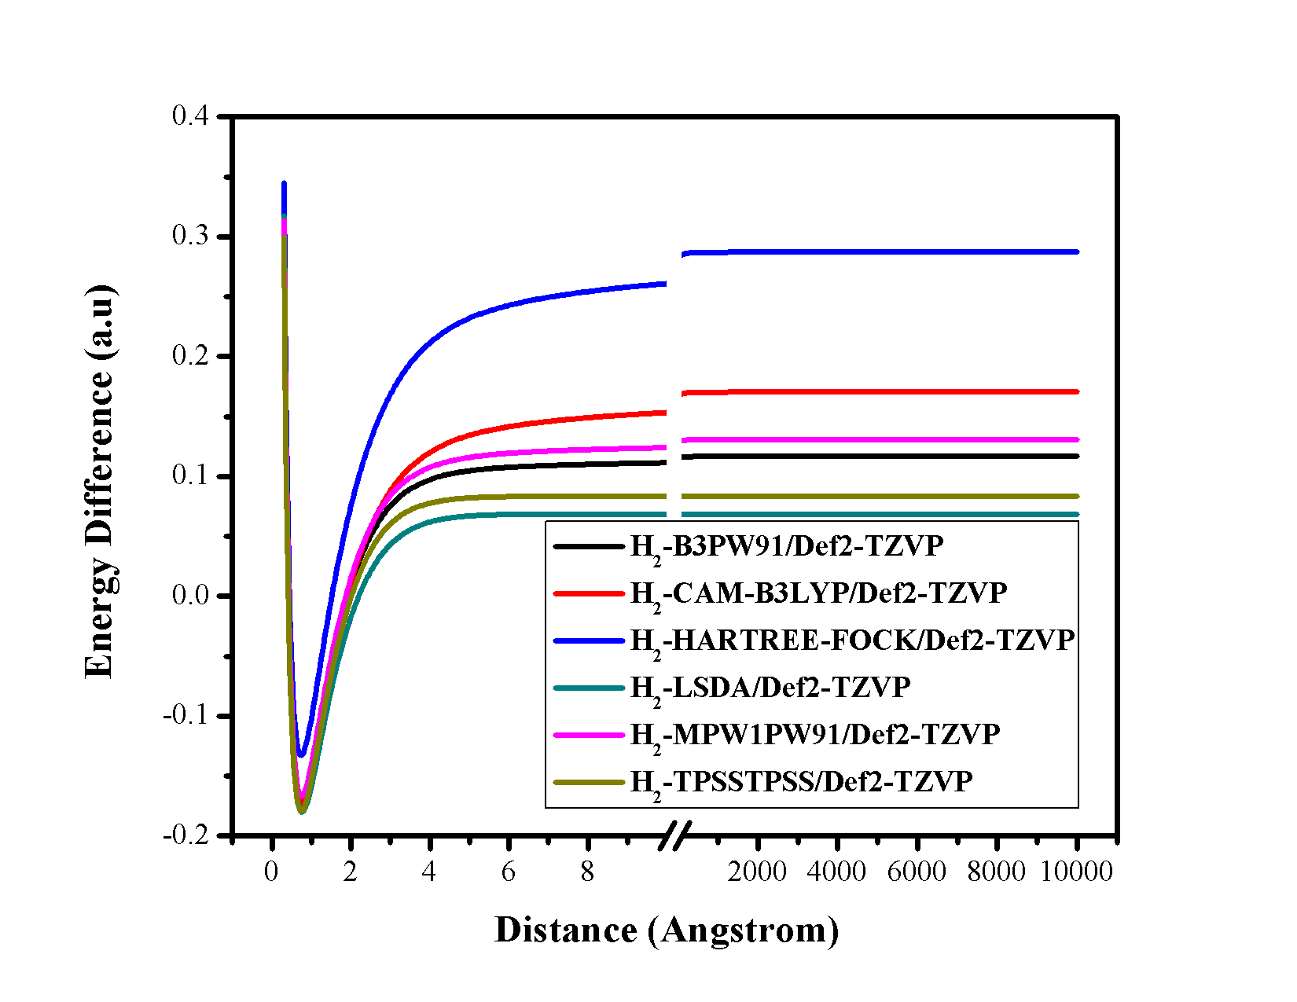

**Figure 10.** Plot of the energy difference versus distance (Ǻ) between two H-atoms of H2 molecule using Def2-TZVP basis set at six different methods.

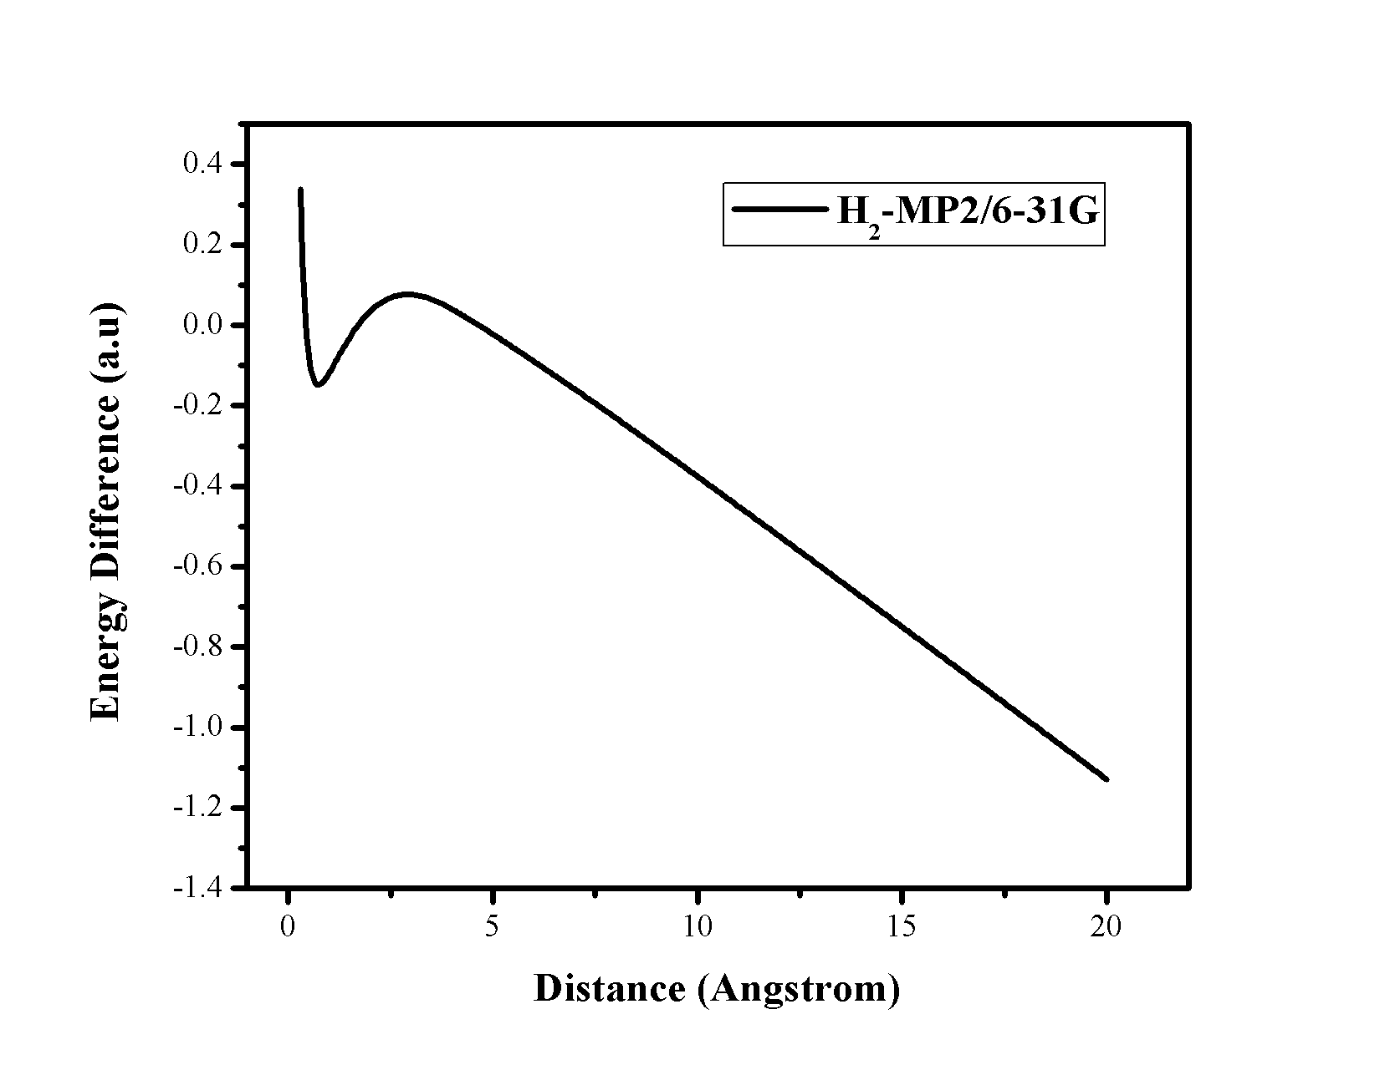

**Figure 11.** Plot of the energy difference versus distance (Ǻ) between two H-atoms of H2 molecule using 6-31G basis set at MP2 method.

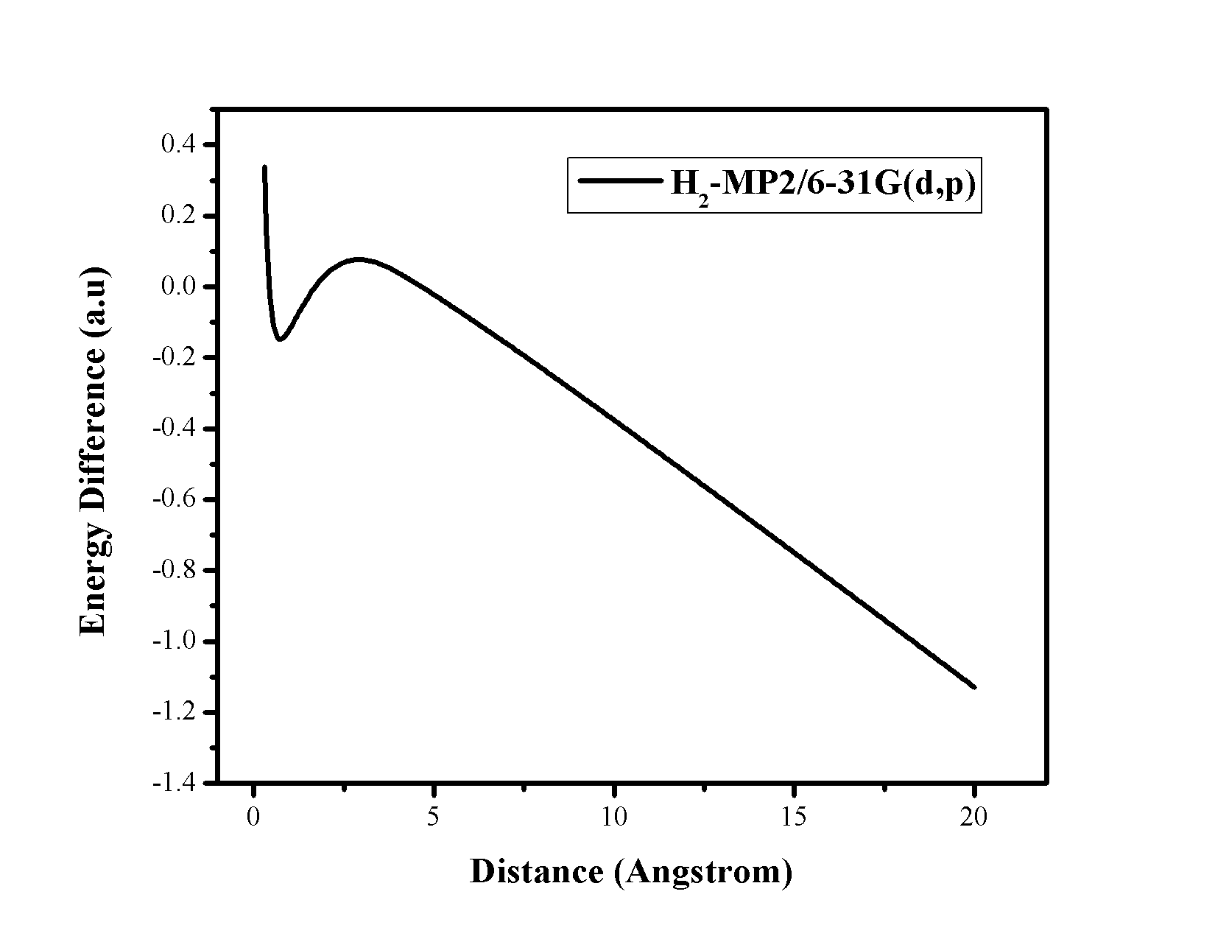

**Figure 12.** Plot of the energy difference versus distance (Ǻ) between two H-atoms of H2 molecule using 6-31G(d,p) basis set at MP2 method.

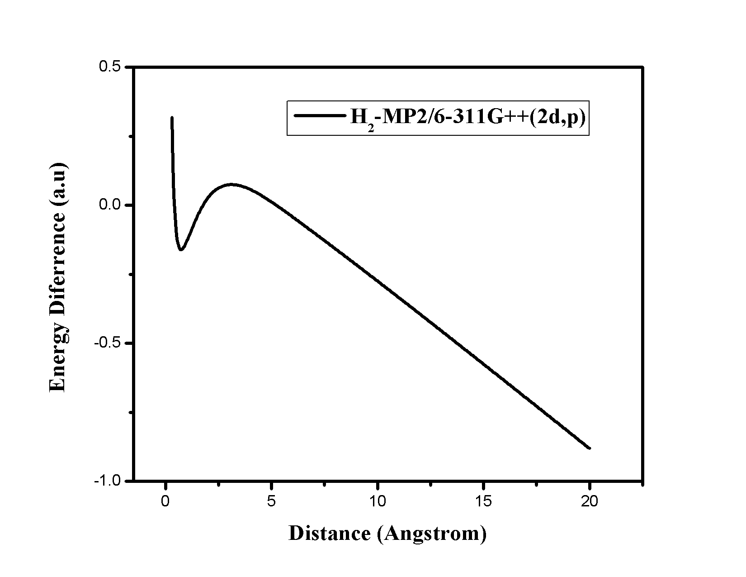

**Figure 13.** Plot of the energy difference versus distance (Ǻ) between two H-atoms of H2 molecule using 6-311G++(2d,p) basis set at MP2 method.

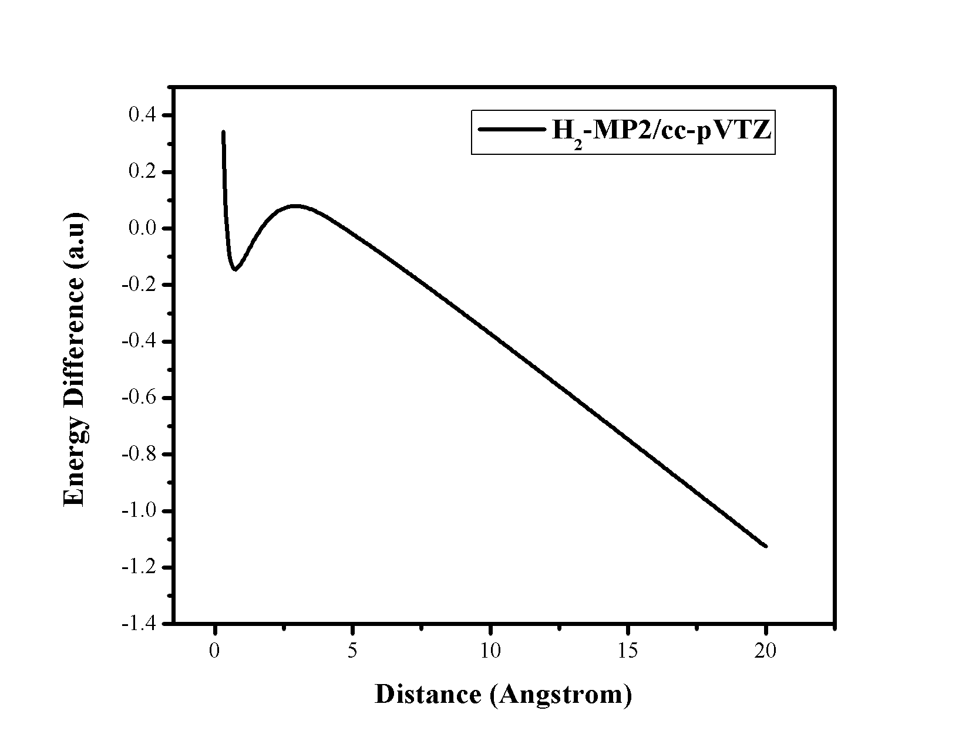

**Figure 14.** Plot of the energy difference versus distance (Ǻ) between two H-atoms of H2 molecule using cc-PVTZ basis set at MP2 method.

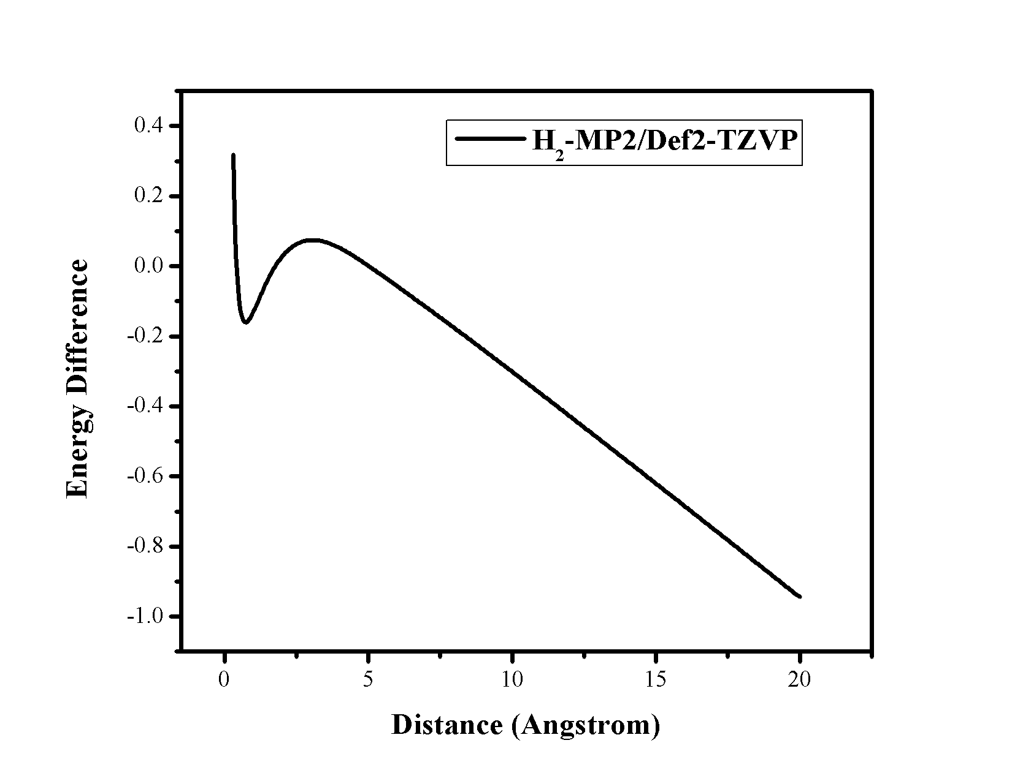

**Figure 15.** Plot of the energy difference versus distance (Ǻ) between two H-atoms of H2 molecule using Def2-TZVP basis set at MP2 method.

The results obtained using the MP2 method along with 6-31G, 6-31G(d,p) and 6-311++G(d,p), cc-pVTZ and Def2-TZVP basis sets for H2 molecule shows that the MP2 method fails to describe the homolytic dissociation of H2 molecule. Up to the distance of 3-4 Ǻ the dissociation curve is well build but after that the discrepancy comes out as the energy gets lower and lower, which is a failure of this method. It may be due to the fact that the MP2 method is perturbative and not variational, so energy can go below the exact energy.

**Table 1.Energy difference between two H-atoms and H2 molecule at 10000 Ǻ**

|  |  |  |  |  |  |
| --- | --- | --- | --- | --- | --- |
| **H2 MOLECULE** | **6-31G** | **6-31G(d,p)** | **6-311G++(2d,p)** | **CC-PVTZ** | **DEF2-TZVP** |
| **B3LYP** | 0.11347 | 0.11347 | 0.10865 | 0.10937 | 0.10939 |
| **B3PW91** | 0.1199 | 0.1199 | 0.11607 | 0.11308 | 0.1167 |
| **BPV86** | 0.0722 | 0.0722 | 0.06973 | 0.07008 | 0.07711 |
| **CAM-B3LYP** | 0.1766 | 0.1766 | 0.16915 | 0.17045 | 0.17047 |
| **HCTH** | 0.07933 | 0.07933 | 0.07671 | 0.07708 | 1.02005 |
| **HARTREE-FOCK** | 0.29874 | 0.29874 | 0.28444 | 0.28726 | 0.28731 |
| **HSEH1PBE** | 0.12008 | 0.12008 | 0.1157 | 0.11641 | 0.11642 |
| **LSDA** | 0.07103 | 0.07103 | 0.06808 | 0.06851 | 0.06852 |
| **MP2** | -38.0407 | -38.045 | -30.677 | -32.5540 | -32.5733 |
| **MPW1PW91** | 0.13429 | 0.13429 | 0.12982 | 0.13062 | 0.13063 |
| **PBEPBE** | 0.08479 | 0.08479 | 0.08208 | 0.08251 | 0.08251 |
| **TPSSTPSS** | 0.0852 | 0.0852 | 0.08295 | 0.08337 | 0.08338 |
| **WB97XD** | 0.20078 | 0.20078 | 0.19563 | 0.19653 | 0.19654 |

**B. Potential Energy Curve of F2 molecule**

The difference in the energy is plotted against distance between two F-atoms of F2 molecule in figures 16-30. Here the maximum distance between the two F-atoms is considered up to 10,000 Ǻ. Among all of this method B3LYP, B3PW91, CAM-B3LYP, HSEH1PBE, HF, MPW1PW91 and B97XD methods define the dissociation path correctly. But the MP2 method gives wrong dissociation path (see figures 26-30). The obtained energy difference curves of F2 molecule using the five different basis sets viz. 6-31G, 6-31G(d,p), 6-311G++(2d,p), cc-pVTZ, Def2-TZVP and seven methods viz. B3LYP, B3PW91, CAM-B3LYP, HSEH1PBE, HF, MPW1PW91 and B97XD show that in a larger separation the difference is not zero. Thus we have found that in all these cases energy of F2 molecule at infinite distance, is higher than the twice the energy of F-atom. Thus size-consistency is not maintained in all these cases for F2 molecule. We have also observed that this inaccuracy in size-consistency is higher in case of Hartree-Fock method than the other as observed in the case of H2 molecule. Energy difference between two F-atoms and F2 molecule at 10000 Ǻ is lowest for B3LYP/6-31G level (see table 2).

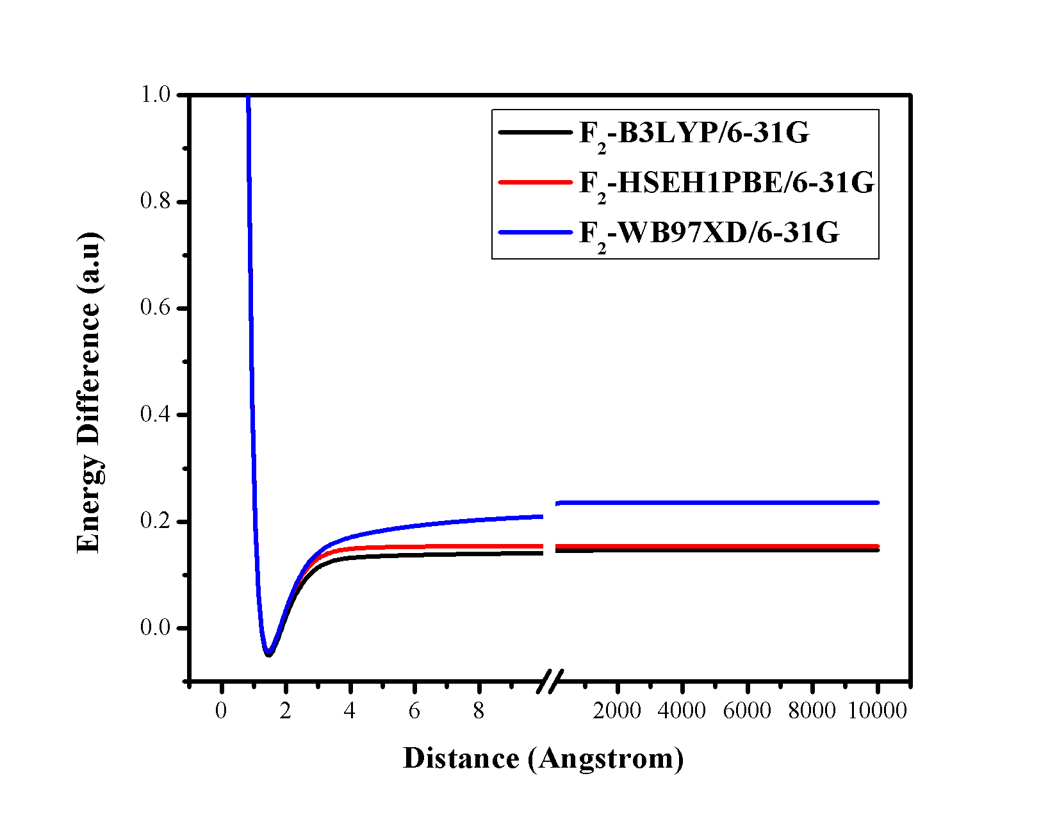

**Figure 16.** Plot of the energy difference versus distance (Ǻ) between two F-atoms of F2 molecule using 6-31G basis set at three different methods.

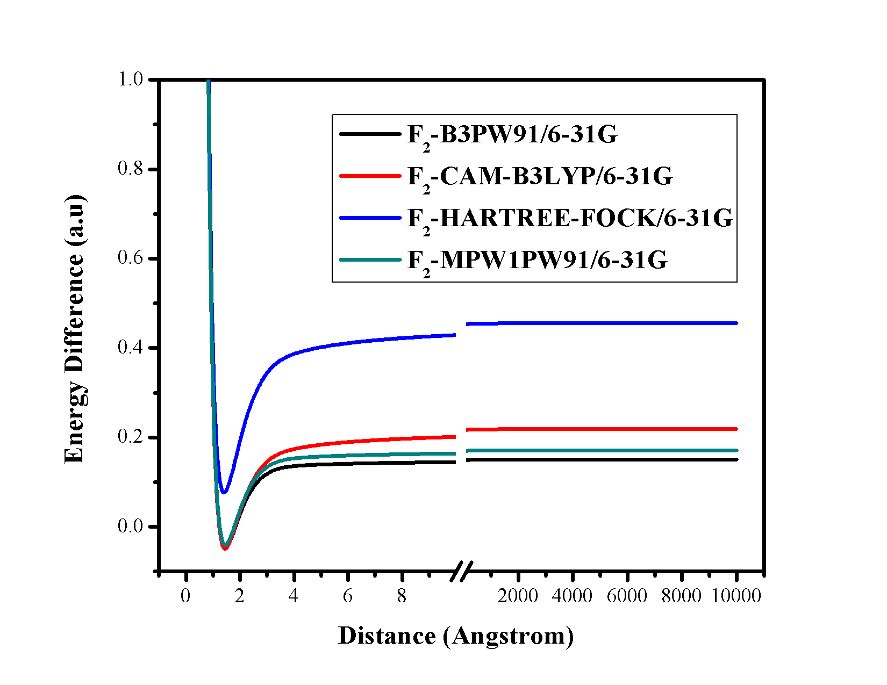

**Figure 17.** Plot of the energy difference versus distance (Ǻ) between two F-atoms of F2 molecule using 6-31G basis set at four different methods.

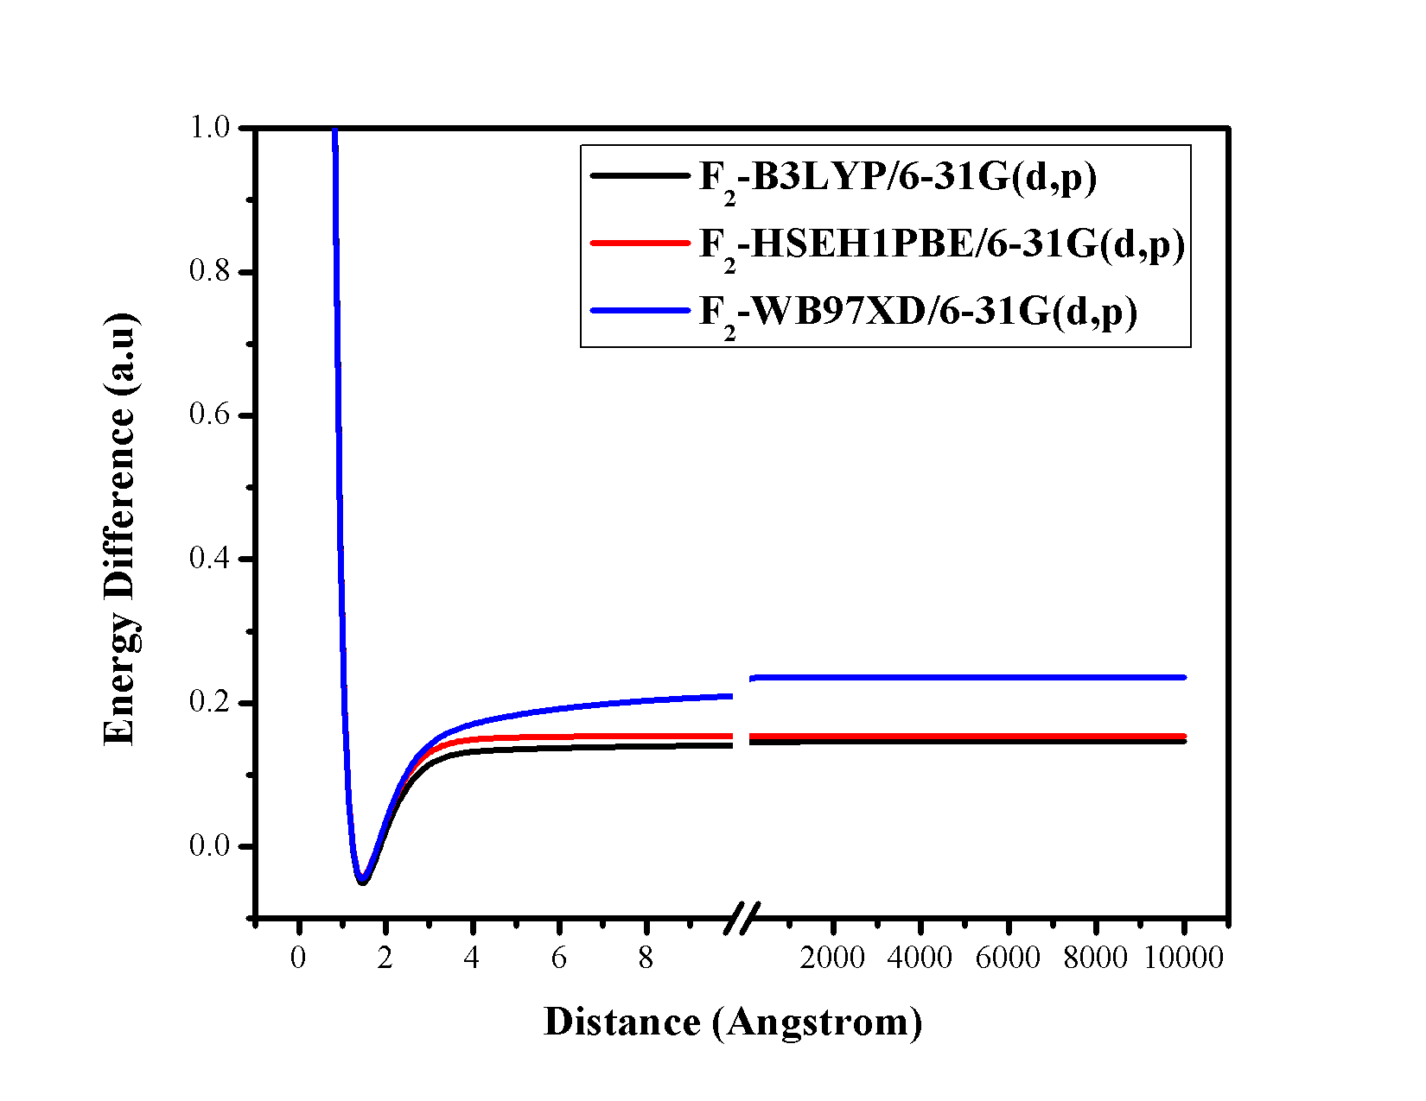

**Figure 18.** Plot of the energy difference versus distance (Ǻ) between two F-atoms of F2 molecule using 6-31G(d,p) basis set at three different methods.

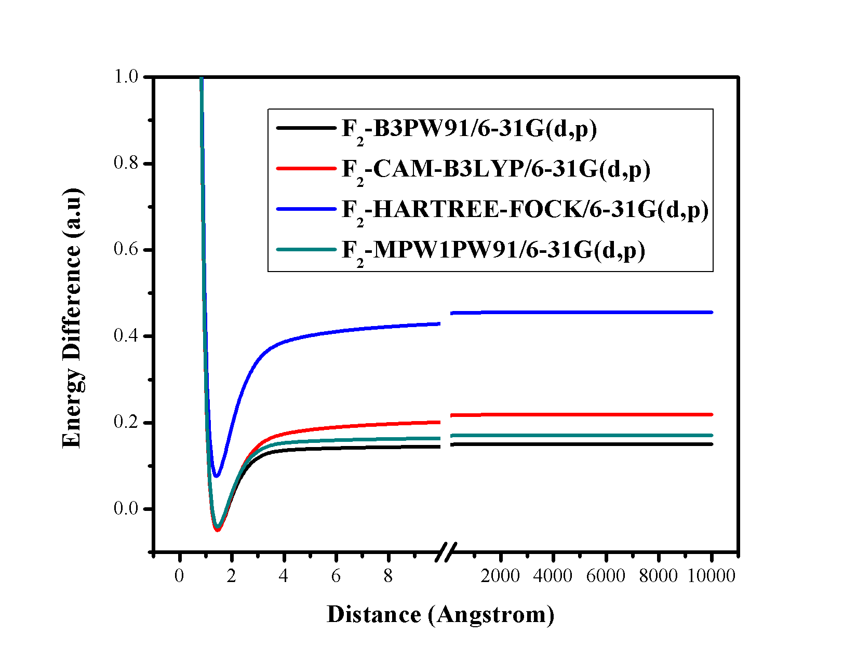

**Figure 19.** Plot of the energy difference versus distance (Ǻ) between two F-atoms of F2 molecule using 6-31G(d,p) basis set at four different methods.

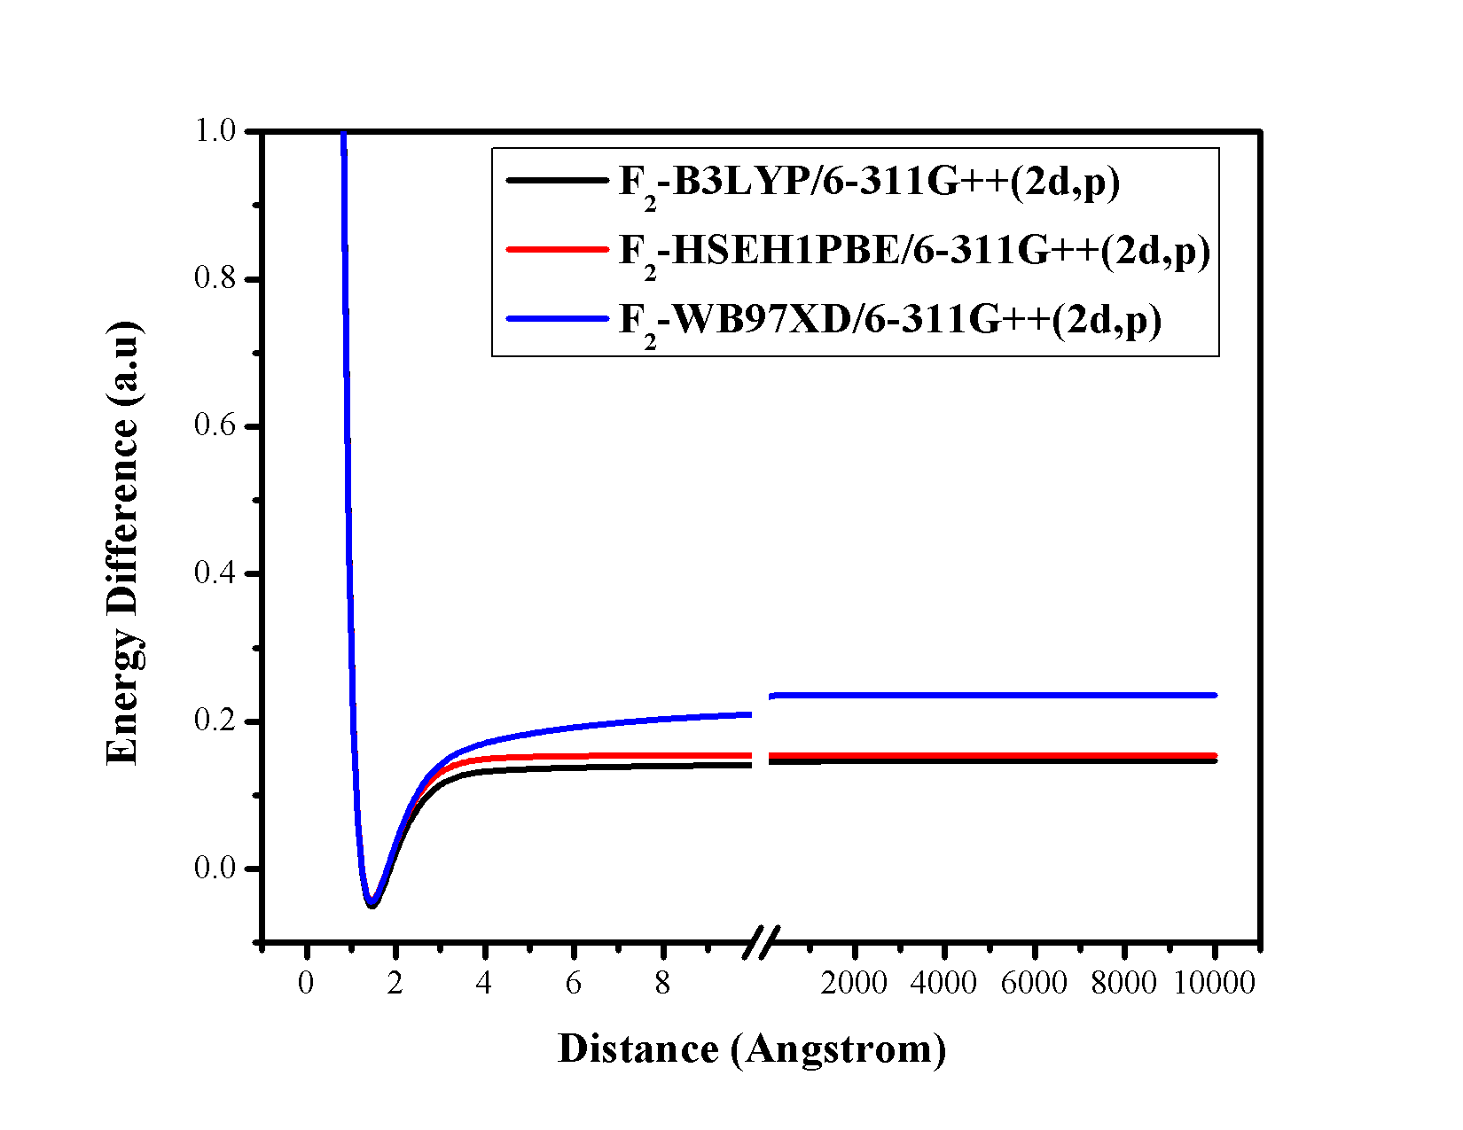

**Figure 20.** Plot of the energy difference versus distance (Ǻ) between two F-atoms of F2 molecule using 6-311G++(2d,p) basis set at three different methods.

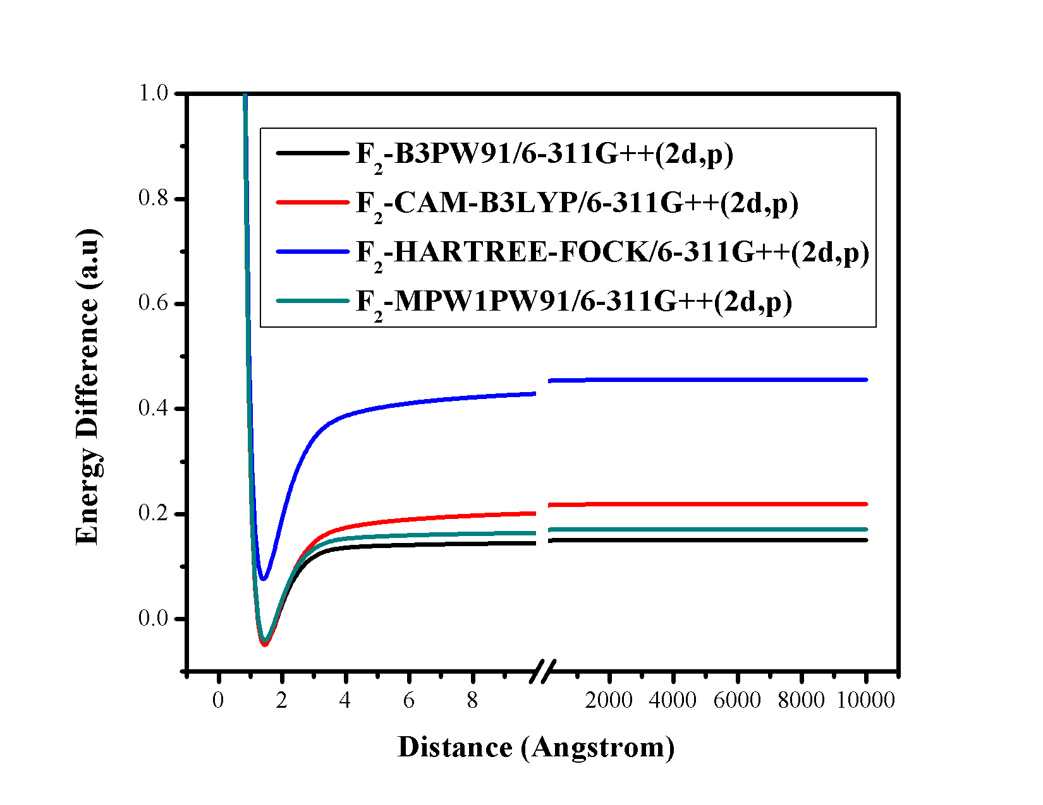

**Figure 21.** Plot of the energy difference versus distance (Ǻ) between two F-atoms of F2 molecule using 6-311G++(2d,p) basis set at four different methods.

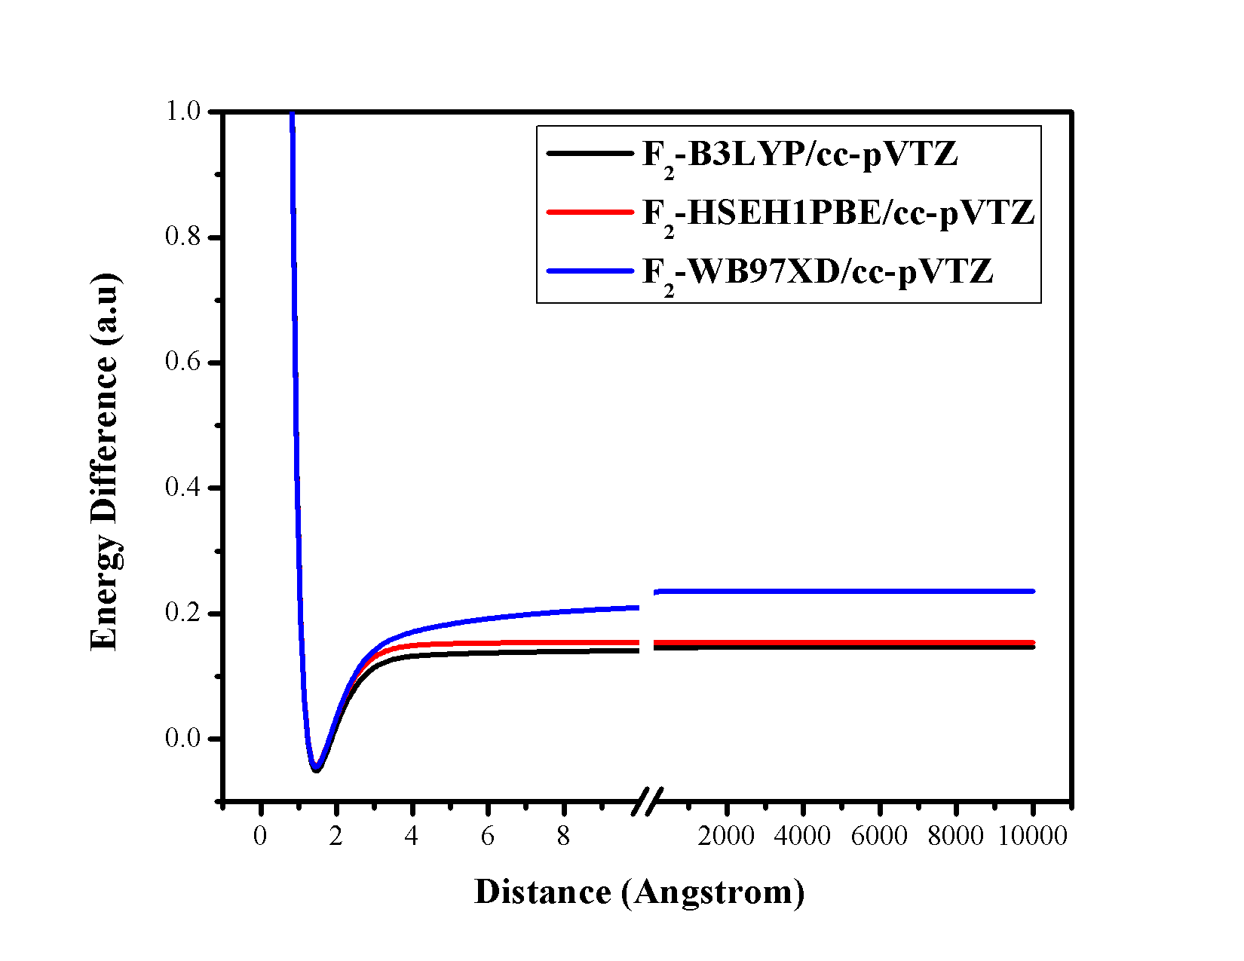

**Figure 22.** Plot of the energy difference versus distance (Ǻ) between two F-atoms of F2 molecule using cc-pVTZ basis set at three different methods.

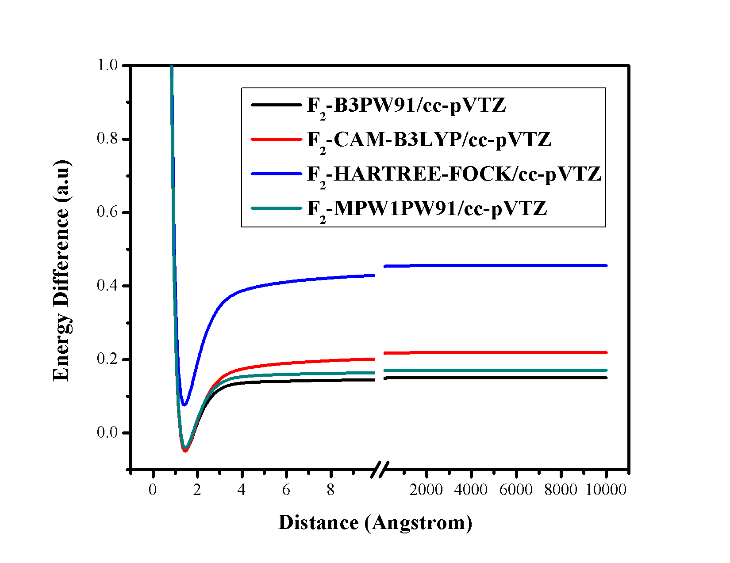

**Figure 23.** Plot of the energy difference versus distance (Ǻ) between two F-atoms of F2 molecule using ccc-pVTZ basis set at four different methods.

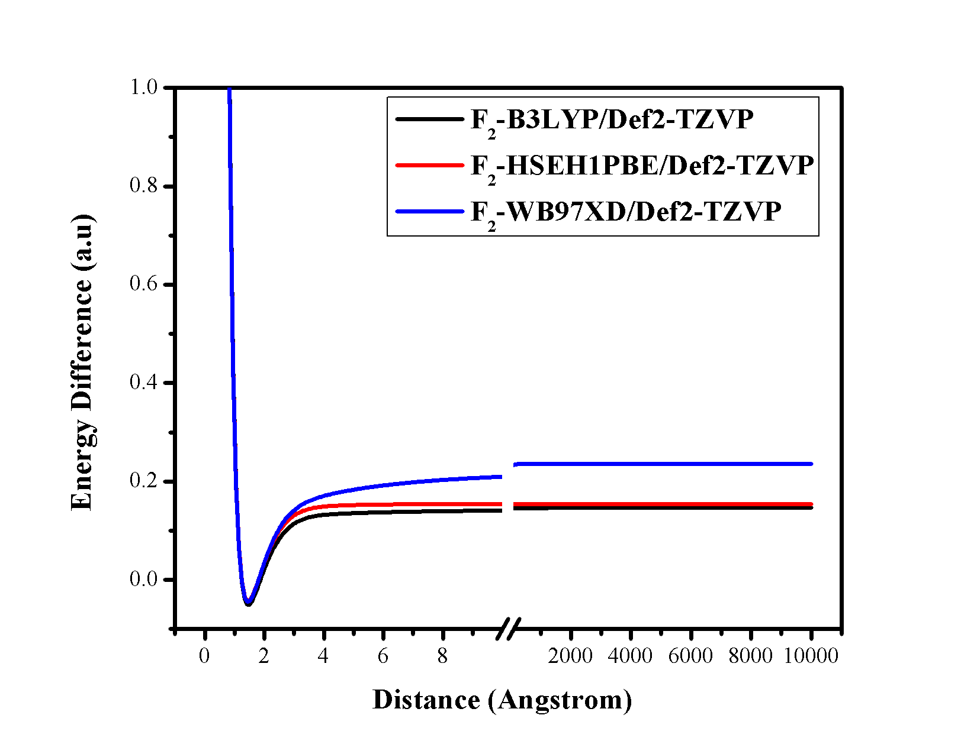

**Figure 24.** Plot of the energy difference versus distance (Ǻ) between two F-atoms of F2 molecule using Def2-TZVP basis set at three different methods.

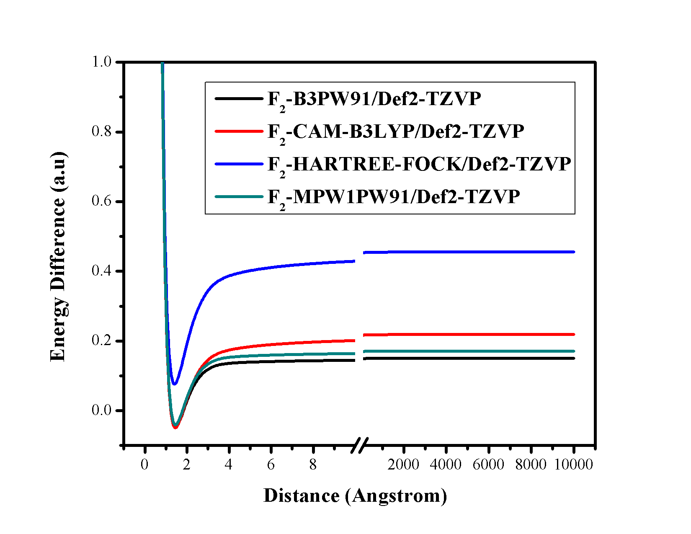

**Figure 25.** Plot of the energy difference versus distance (Ǻ) between two F-atoms of F2 molecule using Def2-TZVP basis set at four different methods.

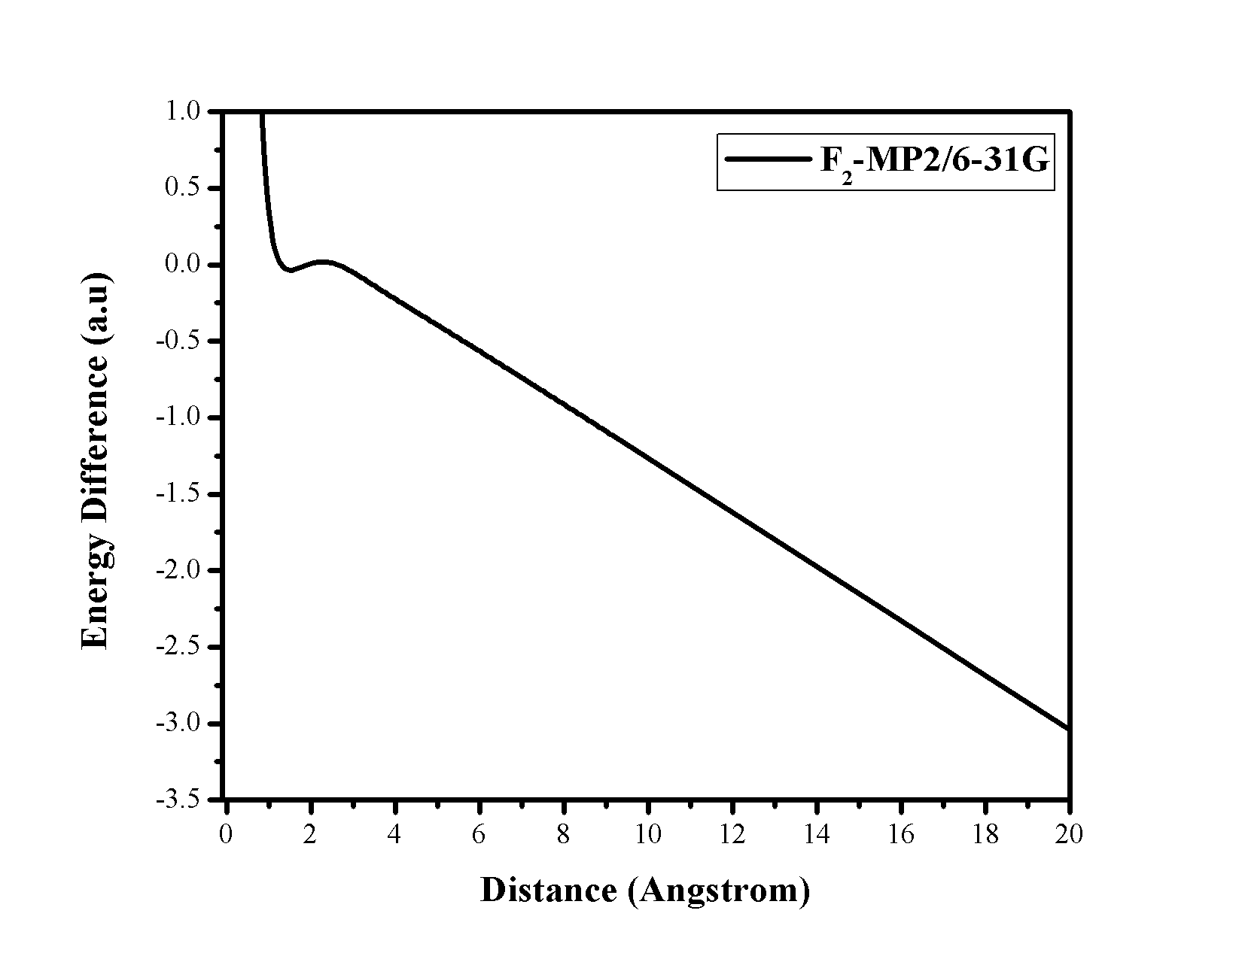

**Figure 26.** Plot of the energy difference versus distance (Ǻ) between two F-atoms of F2 molecule using 6-31G basis set at MP2 method.

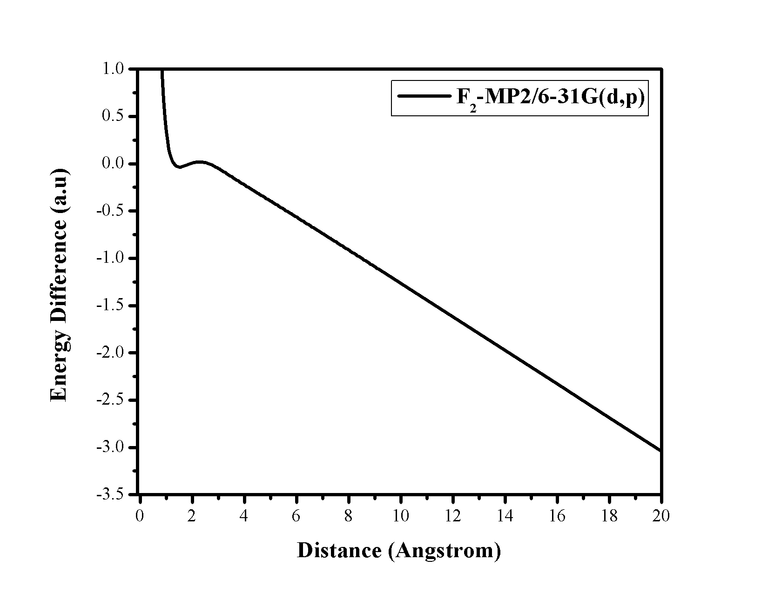

**Figure 27.** Plot of the energy difference versus distance (Ǻ) between two F-atoms of F2 molecule using 6-31G(d,p) basis set at MP2 method.

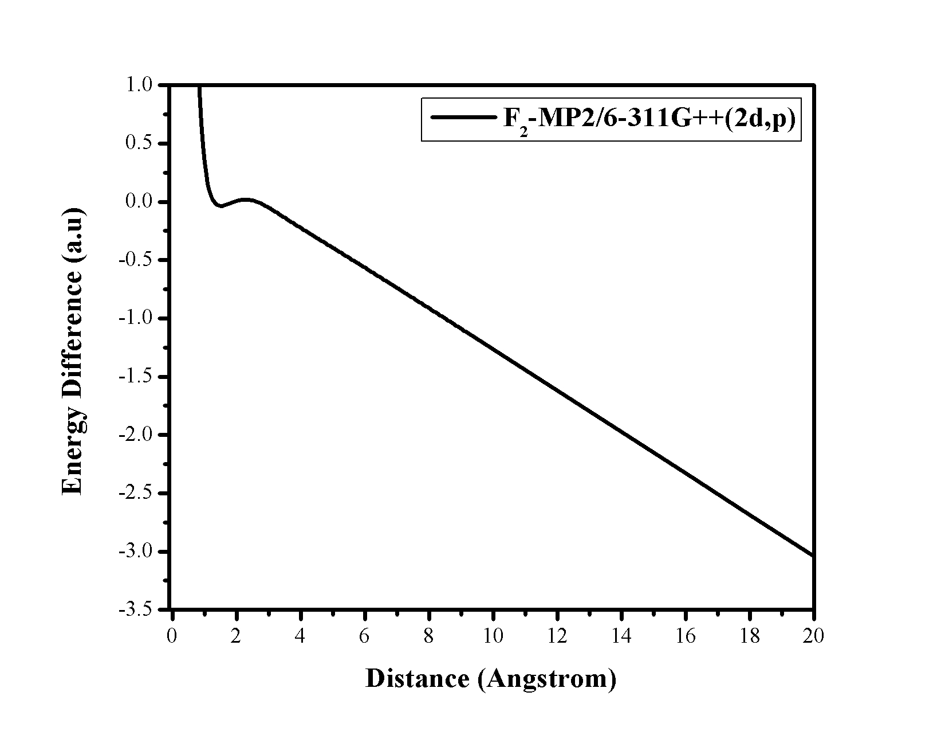

**Figure 28.** Plot of the energy difference versus distance (Ǻ) between two F-atoms of F2 molecule using 6-311G++(2d,p) basis set at MP2 method.

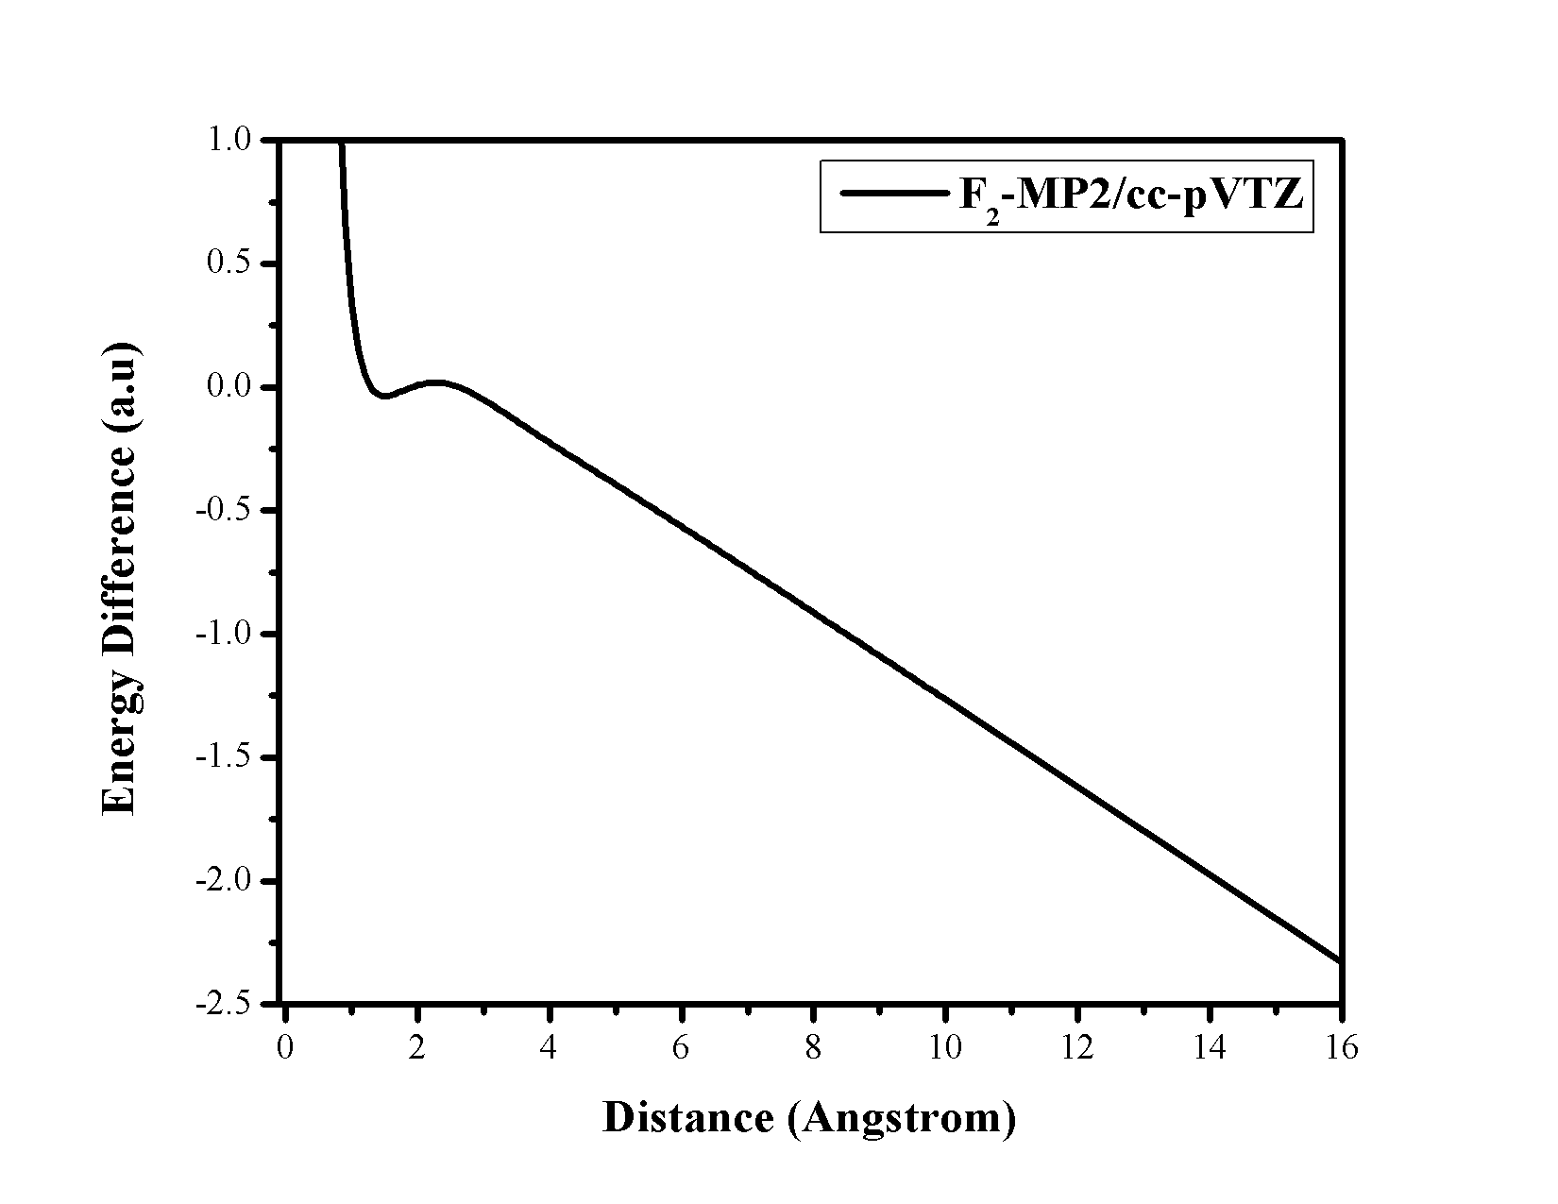

**Figure 29.** Plot of the energy difference versus distance (Ǻ) between two F-atoms of F2 molecule using cc-pVTZ basis set at MP2 method.

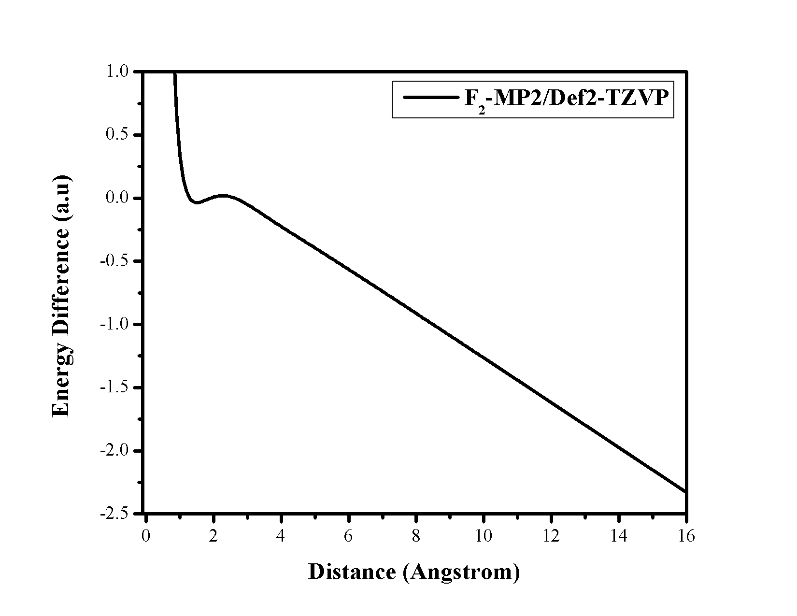

**Figure 30.** Plot of the energy difference versus distance (Ǻ) between two F-atoms of F2 molecule using Def2-TZVP basis set at MP2 method.

The results obtained using the MP2 method along with 6-31G(d,p) and 6-311++G(d,p), cc-pVTZ and Def2-TZVP basis sets for F2 molecule also show that the MP2 method fails to describe the homolytic dissociation of F2 molecule.

**Table 2.Energy difference between two F-atoms and F2 molecule at 10000 Ǻ**

|  |  |  |  |  |  |
| --- | --- | --- | --- | --- | --- |
| **F2 MOLECULE** | **6-31G** | **6-31G(d,p)** | **6-311G++(2d,p)** | **CC-PVTZ** | **DEF2-TZVP** |
| **B3LYP** | 0.146548 | 0.147889 | 0.146689 | 0.148185 | 0.148032 |
| **s**  **B3PW91** | 0.149896 | 0.151394 | 0.150689 | 0.152167 | 0.152075 |
| **CAM-B3LYP** | 0.218815 | 0.220165 | 0.218267 | 0.219984 | 0.219701 |
| **HARTREE-FOCK** | 0.455188 | 0.460306 | 0.454402 | 0.458988 | 0.457638 |
| **HSEH1PBE** | 0.154502 | 0.156233 | 0.155278 | 0.156899 | 0.156816 |
| **MP2** | -88.8537 | -88.8799 | -81.2486 | -84.8944 | -83.2508 |
| **MPW1PW91** | 0.170381 | 0.172128 | 0.171185 | 0.172864 | 0.172701 |
| **WB97XD** | 0.236008 | 0.237281 | 0.236716 | 0.238234 | 0.238062 |

**4. Potential Energy Curve of HF molecule-**

The difference in the energy is plotted against distance between H-atom and F-atom of HF molecule in figures 31-46. Here the maximum distance between the H-atom and F-atom is considered up to 10,000 Ǻ.

Among all of this method and basis sets HF method in all four basis sets viz. 6-31G(d,p), 6-311G++(2d,p), cc-pVTZ and Def2-TZVP and HF, B3LYP,PBEPBE and B97XD methods in 6-31G(d,p) define the dissociation path correctly. But application of the three methods B3LYP, PBEPBE and B97XD in three basis sets 6-311G++(2d,p), cc-pVTZ and Def2-TZVP shows that in a larger separation the difference is not zero. Thus we have found that in all these cases energy of HF molecule at infinite distance is higher than the sum of the energy of one H-atom and one F-atom. Thus size-consistency is not maintained in all these cases for HF molecule. For the other cases though we have not got the correct Potential energy curve at infinite distances for the verification of the size-consistency, we have shown that curves also. We have also observed that this inaccuracy in size-consistency is higher in case of B3LYP method than the other but not in case of Hartree-Fock method (HF) as like H2 and F2 molecules. Energy difference between H-atom and F-atom combined, and HF molecule at 10000 Ǻ is lowest for HF/6-31G(d,p) (see table 3).

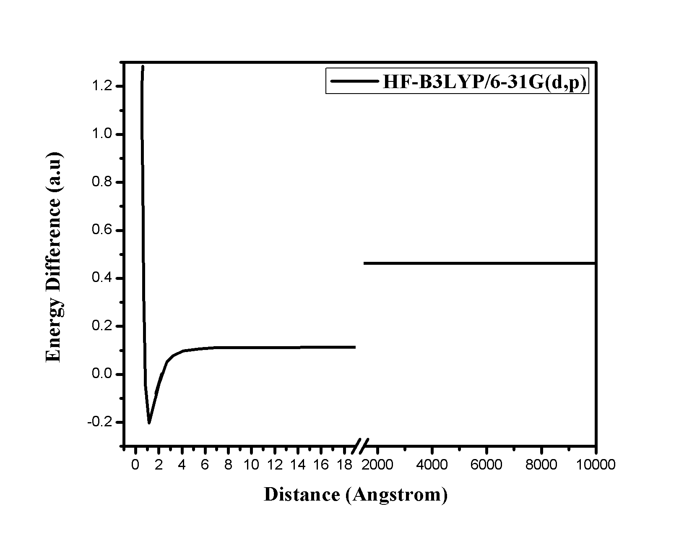

**Figure 31.** Plot of the energy difference versus distance (Ǻ) between H and F atoms of HF molecule using 6-31G(d,p) basis set at B3LYP method.

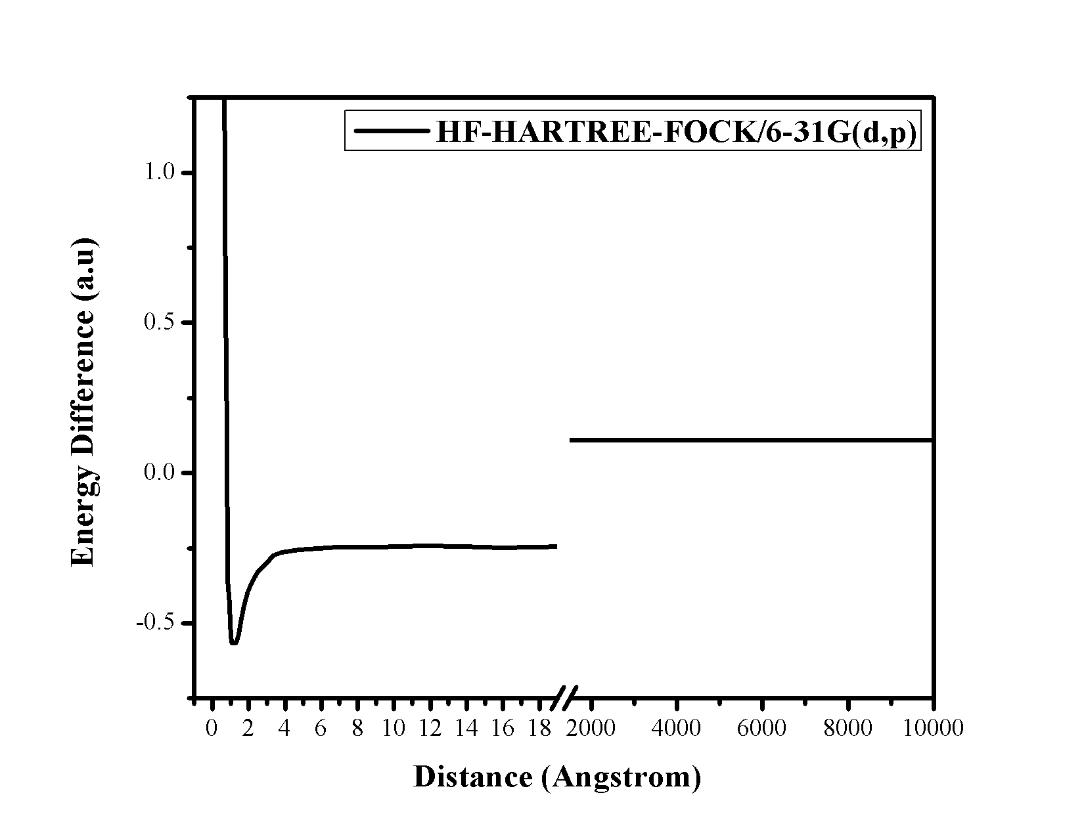

**Figure 32.** Plot of the energy difference versus distance (Ǻ) between H and F atoms of HF molecule using 6-31G(d,p) basis set at HARTREE-FOCK method.

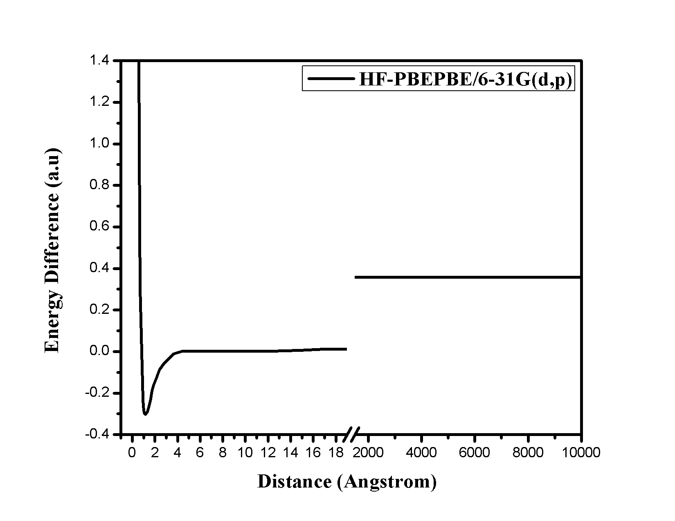

**Figure 33.** Plot of the energy difference versus distance (Ǻ) between H and F atoms of HF molecule using 6-31G(d,p) basis set at PBEPBE method.

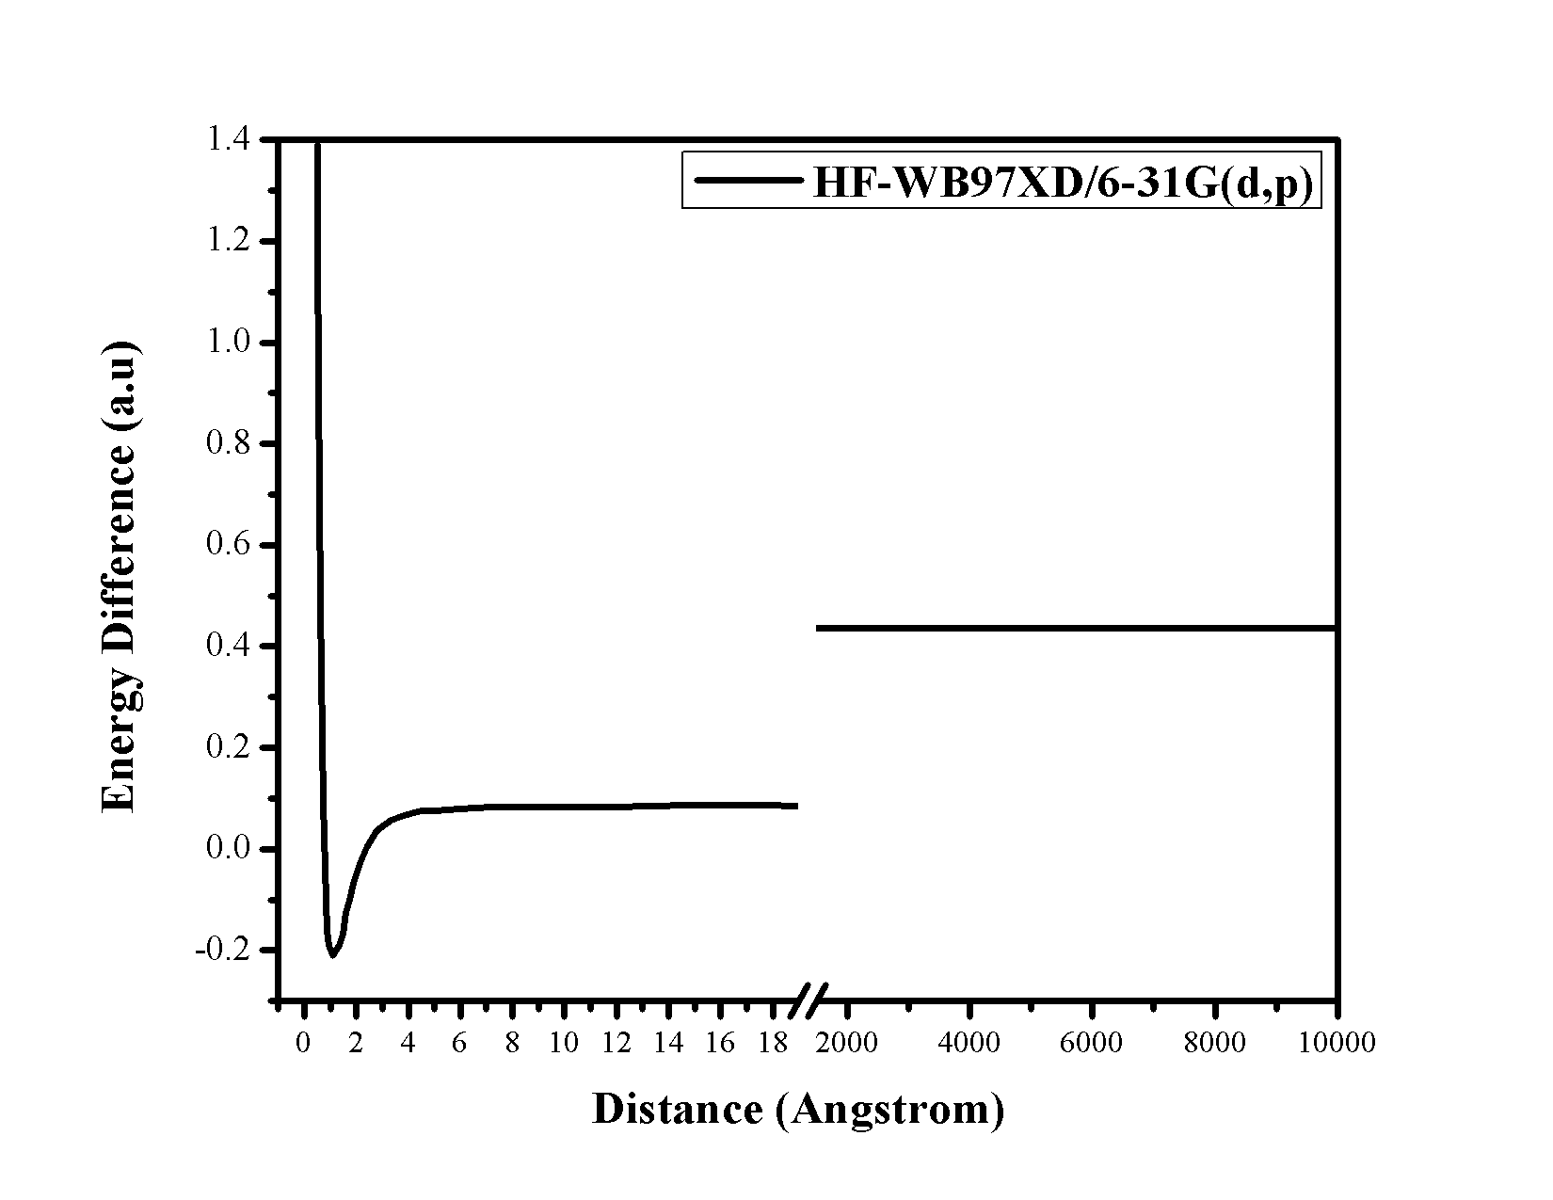

**Figure 34.** Plot of the energy difference versus distance (Ǻ) between H and F atoms of HF molecule using 6-31G(d,p) basis set at ωB97XD method.

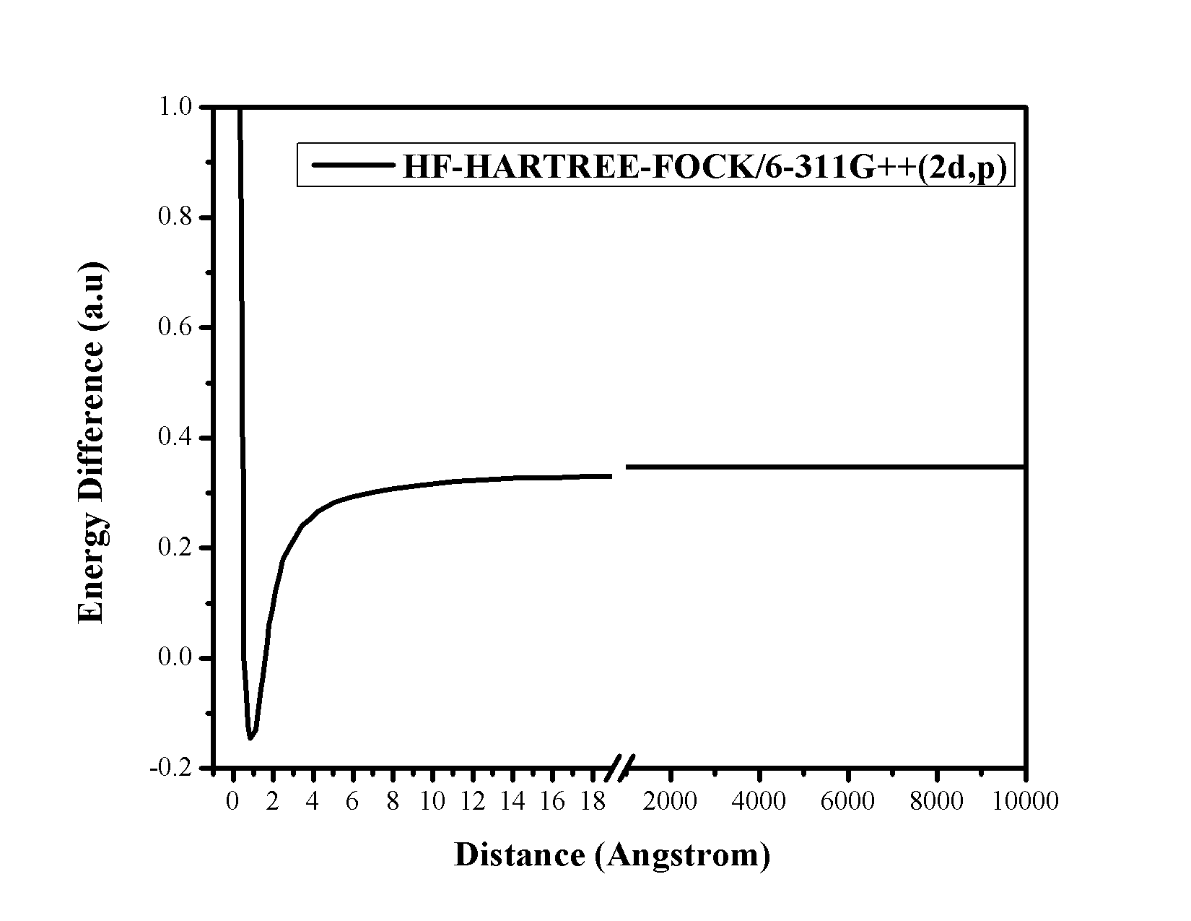

**Figure 35.** Plot of the energy difference versus distance (Ǻ) between H and F atoms of HF molecule using 6-311G++(2d,p) basis set at HARTREE-FOCK method.

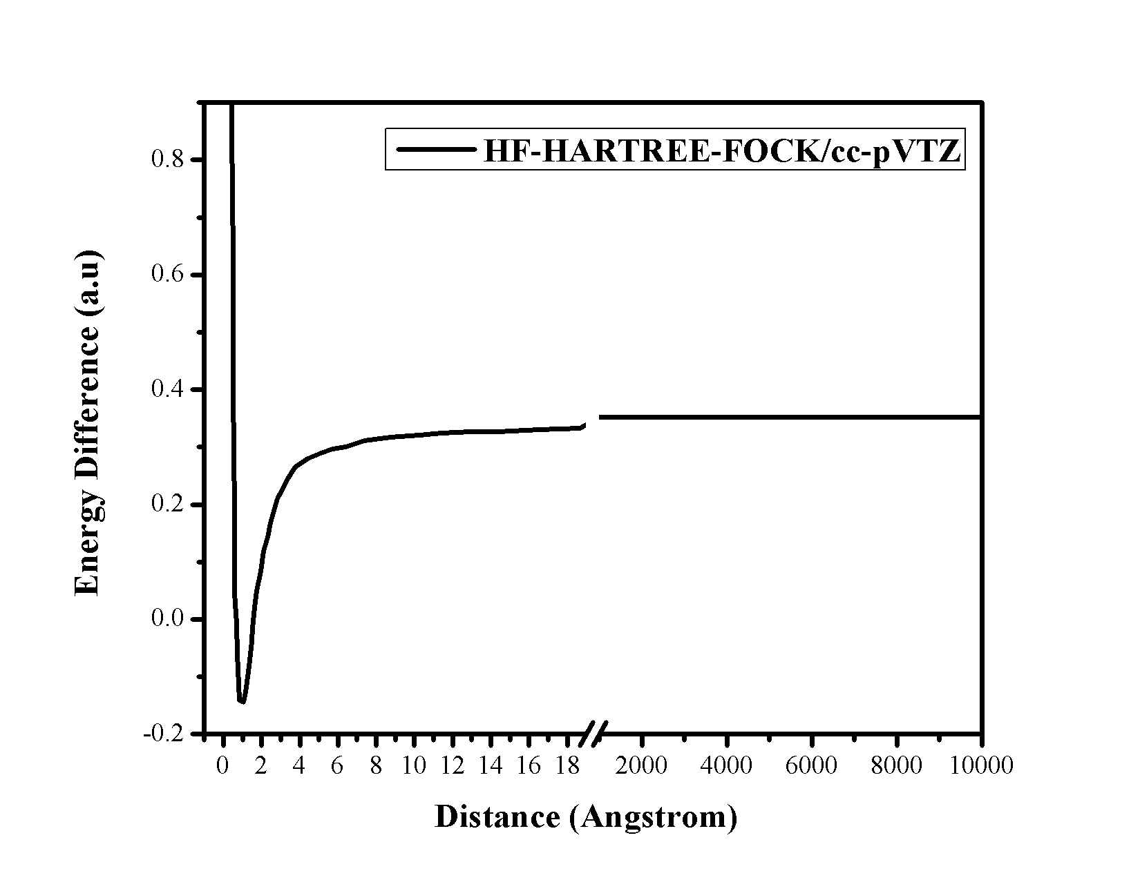

**Figure 36.** Plot of the energy difference versus distance (Ǻ) between H and F atoms of HF molecule using cc-pVTZ basis set at HARTREE-FOCK method.

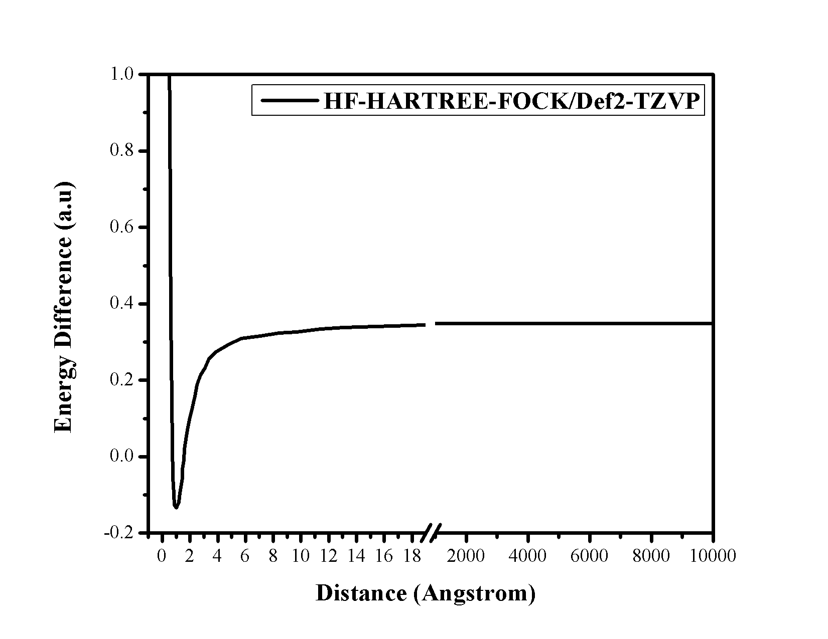

**Figure 37.** Plot of the energy difference versus distance (Ǻ) between H and F atoms of HF molecule using Def2-TZVP basis set at HARTREE-FOCK method.

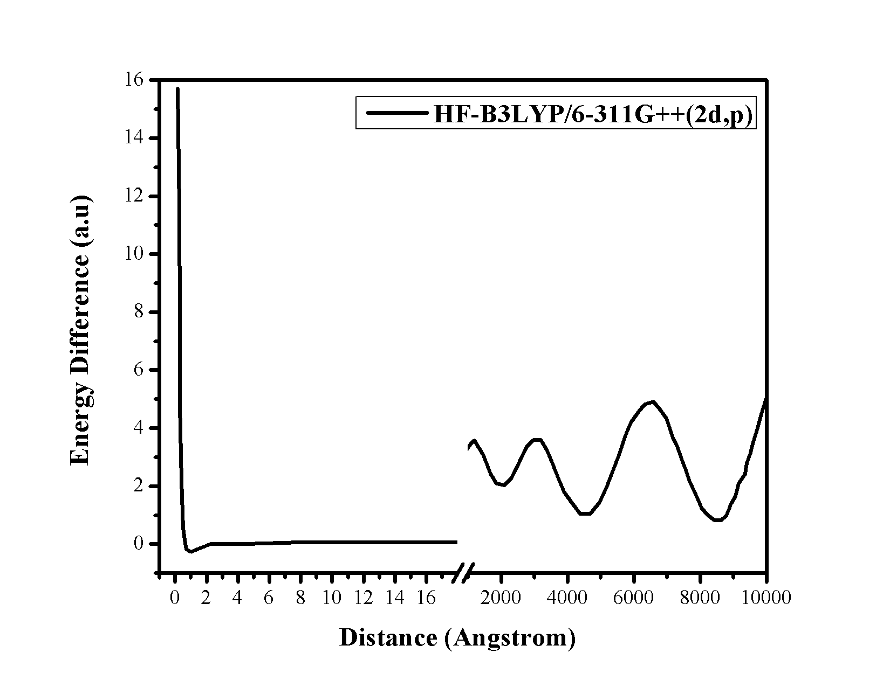

**Figure 38.** Plot of the energy difference versus distance (Ǻ) between H and F atoms of HF molecule using 6-311G++(2d,p) basis set at B3LYP method.

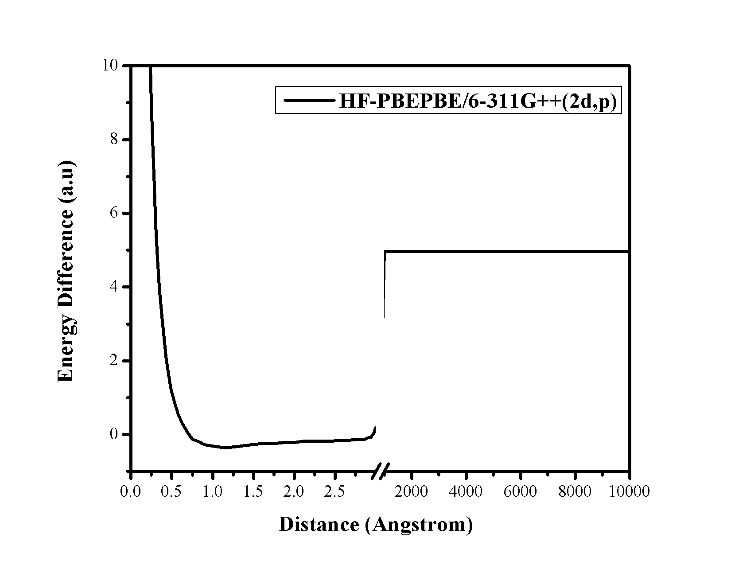

**Figure 39.** Plot of the energy difference versus distance (Ǻ) between H and F atoms of HF molecule using 6-311G++(2d,p) basis set at PBEPBE method.

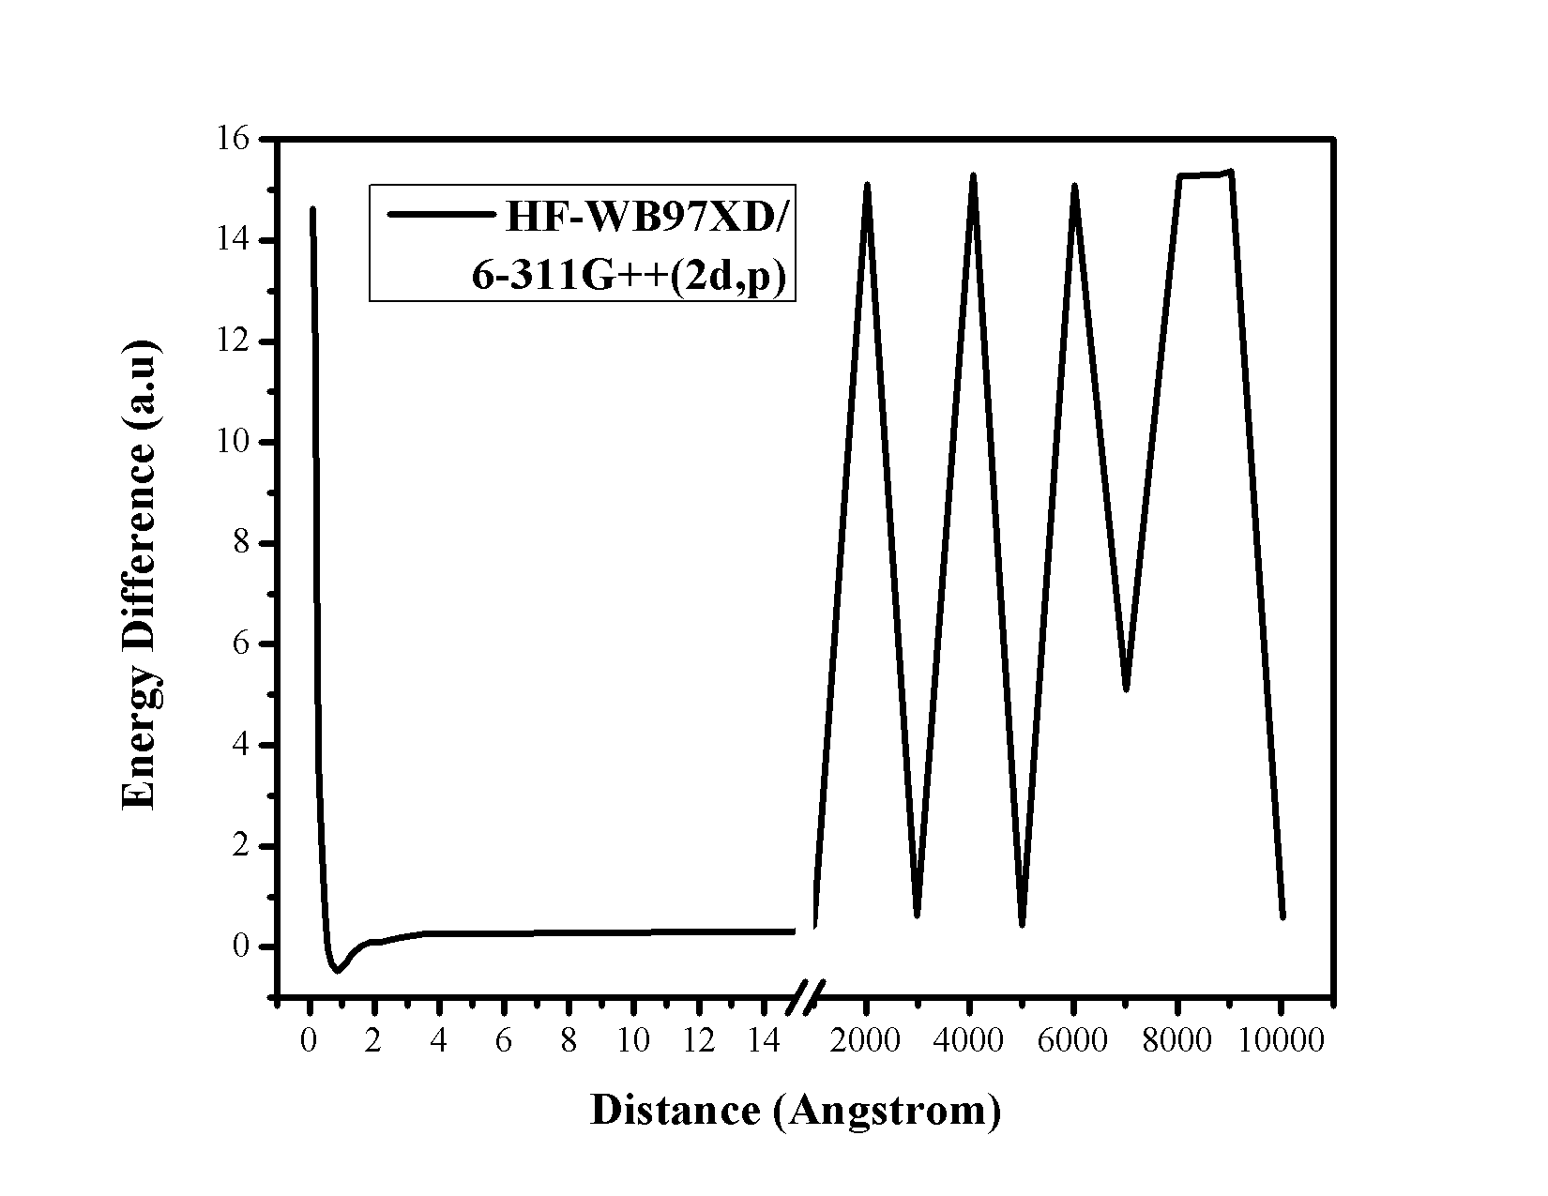

**Figure 40.** Plot of the energy difference versus distance (Ǻ) between H and F atoms of HF molecule using 6-311G++(2d,p) basis set at ωB97XD method.

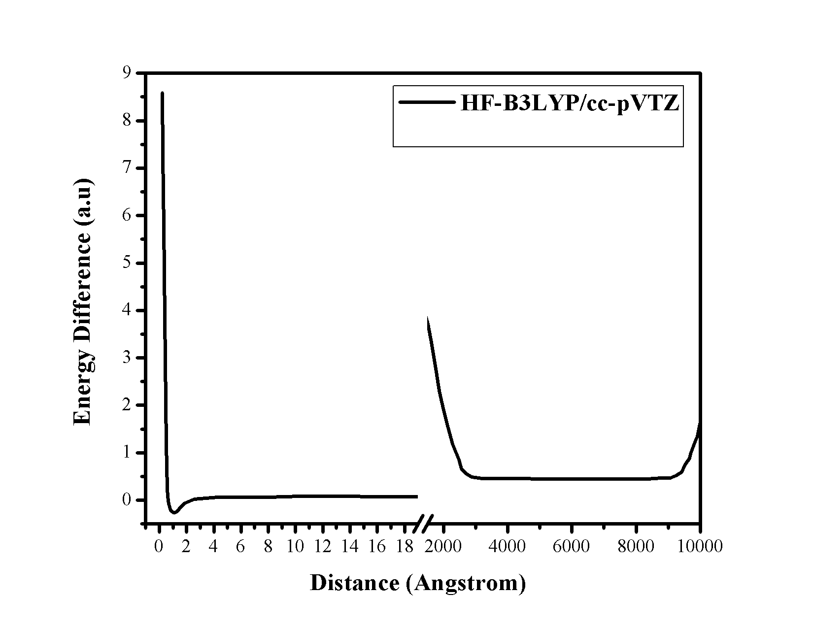

**Figure 41.** Plot of the energy difference versus distance (Ǻ) between H and F atoms of HF molecule using cc-pVTZ basis set at B3LYP method.

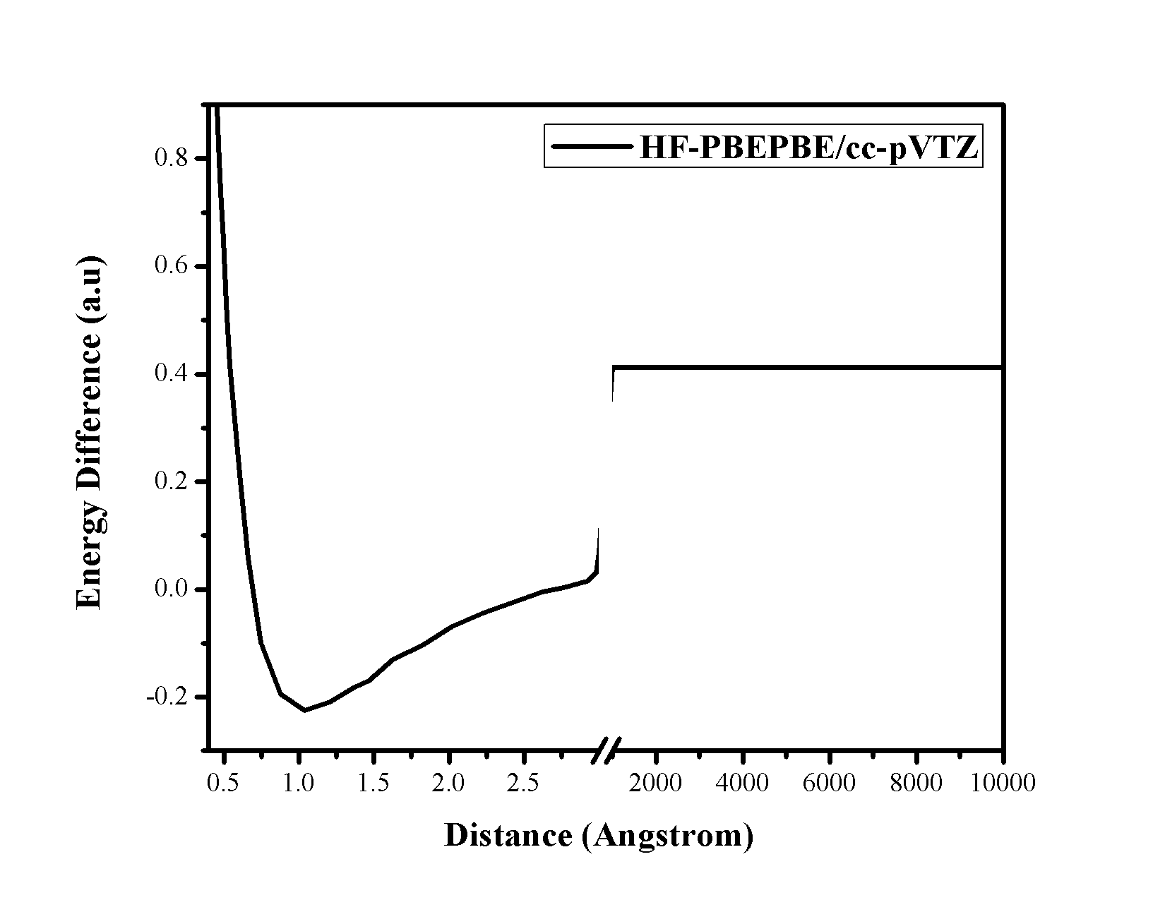

**Figure 42.** Plot of the energy difference versus distance (Ǻ) between H and F atoms of HF molecule using cc-pVTZ basis set at PBEPBE method.

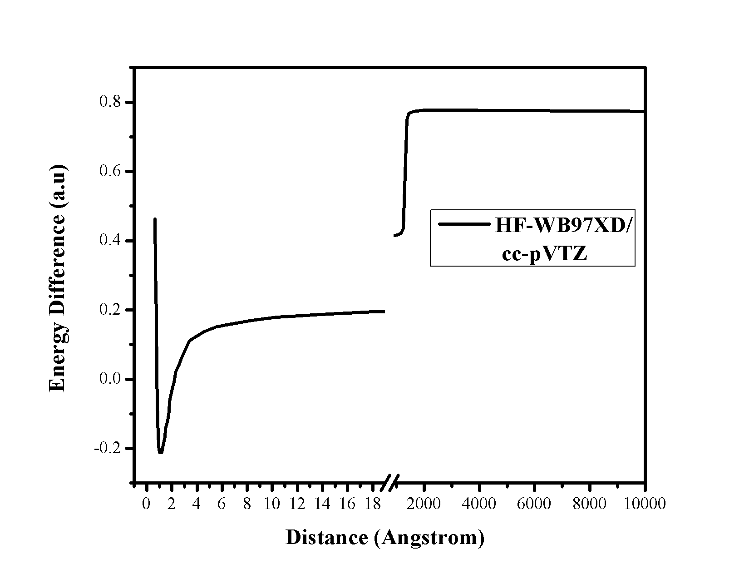

**Figure 43.** Plot of the energy difference versus distance (Ǻ) between H and F atoms of HF molecule using cc-pVTZ basis set at ωB97XD method.

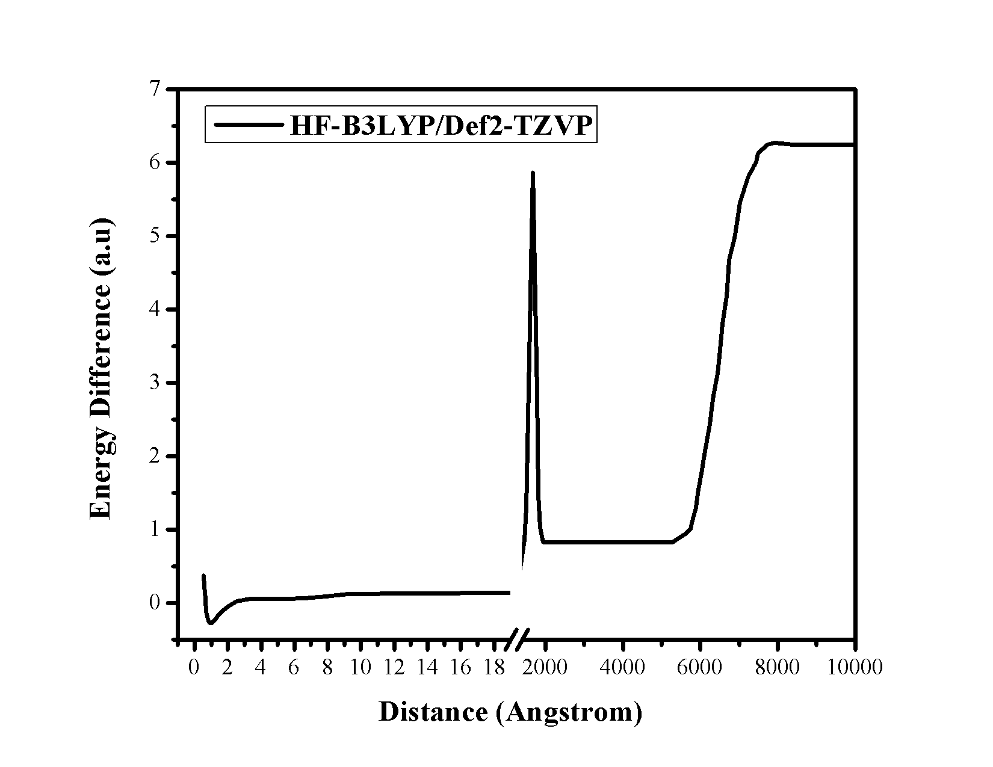

**Figure 44.** Plot of the energy difference versus distance (Ǻ) between H and F atoms of HF molecule using Def2-TZVP basis set at B3LYP method.

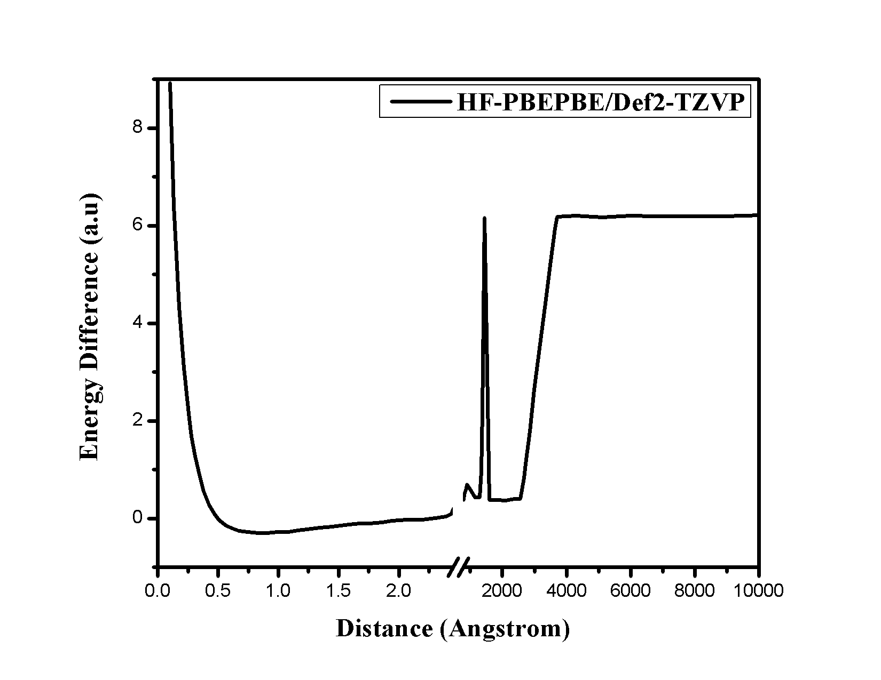

**Figure 45.** Plot of the energy difference versus distance (Ǻ) between H and F atoms of HF molecule using Def2-TZVP basis set at PBEPBE method.

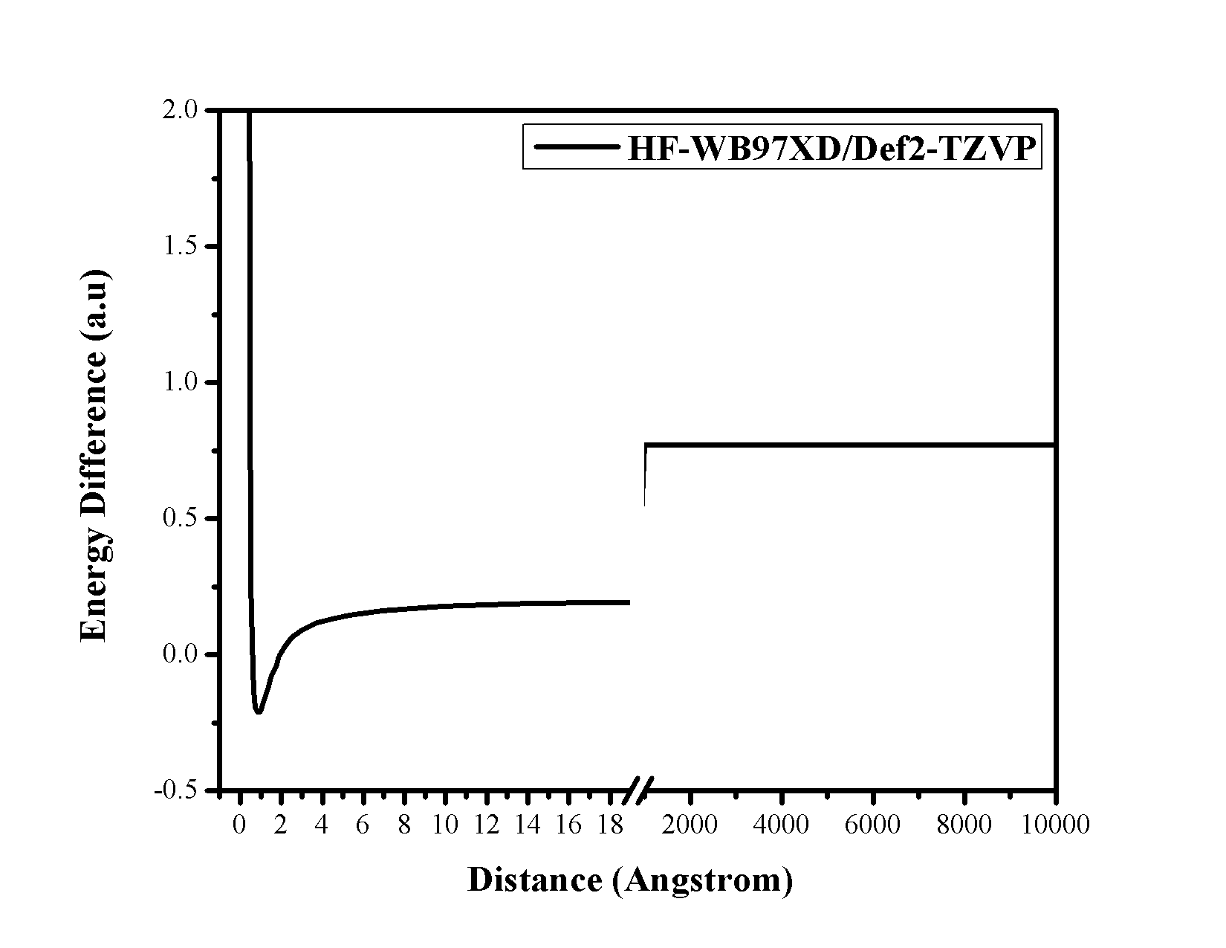

**Figure 46.** Plot of the energy difference versus distance (Ǻ) between H and F atoms of HF molecule using Def2-TZVP basis set at ωB97XD method.

**Table 3.Energy difference between H and F atoms combined and HF molecule at 10000 Ǻ**

|  |  |  |  |  |
| --- | --- | --- | --- | --- |
| **HF-molecule** | **6-31G(d,p)** | **6-311G++(2d,p)** | **CC-PVTZ** | **DEF2-TZVP** |
|  |  |  |  |  |
| **B3LYP** | 0.461 | 5.069 | 6.224 | 6.235 |
|  |  |  |  |  |
| **HF** | 0.109 | 0.346 | 0.350 | 0.349 |
|  |  |  |  |  |
| **WB97XD** | 0.437 | 0.750 | 0.767 | 0.770 |
|  |  |  |  |  |

**6. Conclusion**

From the PES Curves of H2, F2, and HF molecule it is observed that the “size-consistency” criterion is maintained in none of the calculated methods and basis sets using Gaussian software. While the PE curves of H2 and F2 molecules show that the inaccuracy in size-consistency is higher in case of Hartree-Fock method, the PE curves of HF molecule show that the inaccuracy is higher in case of B3LYP method in 6-31G(d, p) basis set. The potential curves obtained in other basis sets using B3LYP method in case of HF molecule are also not correct. The MP2 method cannot give the correct potential energy curve for any molecule using Gaussian software.

1. **References**
   1. Barlet, R. J. Many-Body Perturbation Theory and Coupled Cluster Theory or Electron Correlation in Molecules. *Annual Review of Physical* *Chemistry.* **1981** *, 32* : 359.
   2. Mukhopadhyay, S; Chaudhuri, R; Mukhopadhyay, D; Mukherjee, D. A comparative study of core-valence-extensive coupled-cluster theories for energy differences: Excitation energies. *Chemical Physics Letters.,* **1990**, *173*: 181.
   3. Taylor, P. R. Coupled-cluster Methods in Quantum Chemistry. *Chemistry: European Summer School*,**1994**, 125.
   4. Ditchfield, R; Hehre, W. J; Pople, J. A. Self-Consistent Molecular Orbitals Methods. 9. Extended Gaussian-type basis for molecular-orbital studies of organic molecules. *J. Chem. Phys*., **1971**, *54* : 724.
   5. Woon, D. E; Dunning, T. H. Gaussian-basis sets for use in correlated molecular calculations. 3. The atoms aluminium through argon*. J. Chem.* *Phys.,* **1993**, *98*: 1358.