1.Calculate the sum 1/1 + 1/2 + 1/3 + 1/4 + …. + 1/ N.

/*
* C Program to find the Sum of Series 1 + 1/2 + 1/3 + 1/4 + ... + 1/N
*/
#include <stdio.h>
int main()
{
double number, sum = 0, i;
printf("\n enter the number ");
scanf("%lf", &number);
for (i = 1; i <= number; i++)
{
sum = sum + (1 / i);
if (i == 1)
printf("\n 1 +");
else if (i == number)
printf(" (1 / %lf)", i);
else
printf(" (1 / %lf) + ", i);
}
printf("\n The sum of the given series is %.2lf\n", sum);
return 0;
}

output:
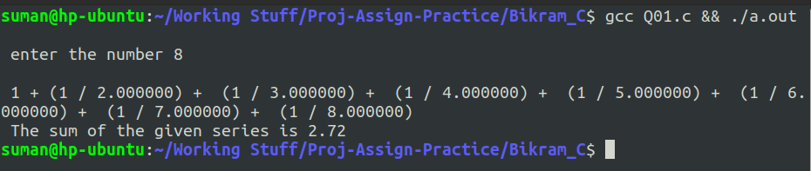

2.Enter 100 integers into an array and sort them in an ascending order.

//C program to accept N numbers and arrange them in an ascending order
#include <stdio.h>
int main()
{
int i, j, a, n, number[30];
printf("Enter the value of N \n");
scanf("%d", &n);
printf("Enter the numbers \n");
for (i = 0; i < n; ++i)
scanf("%d", &number[i]);
for (i = 0; i < n; ++i)
{
for (j = i + 1; j < n; ++j)
{
if (number[i] > number[j])
{
a = number[i];
number[i] = number[j];
number[j] = a;
}

}
}
printf("The numbers arranged in ascending order are given below \n");
for (i = 0; i < n; ++i)
printf("%d\n", number[i]);

}

output:
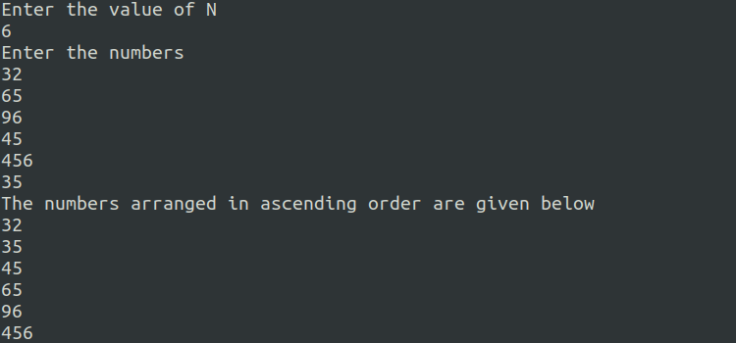

3. Program for Bisection Method in C
// A program of bisection method in c

#include <stdio.h>
#include <math.h>
#include <stdlib.h>
float f(float x)
{
float sum;
sum = pow(x, 3) + x + 3;
return sum;
}
int main()
{
float a, b, e, m;
printf("This Program Illustrates the bisection method in C:\n");
printf("x^3 + 3*x - 5 = 0\n");
step:
printf("Enter the Value of a and b: ");
scanf("%f%f",&a, &b);
printf("Enter tolerable Error: \n");
scanf("%f",&e);
if (f(a)*f(b) > 0)
{
goto step;
}
step1:
m = (a+b)/2;
if (f(m) == 0){
printf("the root is : %f", m);
exit(0);
}
else if (f(a) * f(m) < 0)
b = m;
else if (f(b) * f(m) < 0)
a = m;
if (fabs (a - b) > e){
goto step1;
}
printf("the root is : %f\n", m);
return 0;
}

output:
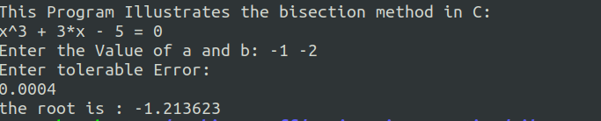

4. Write a C program and run to find the smallest positive root of the equation tanx +a sin²x=1, a=.3 By Newton Raphson Method correct upto 5 significant figure.

/* Solution by Newton Raphson Method */

#include <stdio.h>
#include <math.h>
#define err 0.00001
#define ITNO 20
#define F(x) tan(x)+a* pow(sin(x),2)-1
#define FD(x) (1/pow(cos(x),2))+a*sin(2*x)
int main()
{
int count;
float x0,xn,fx,fdx,a=3;
printf("Give the initial approximation\n");
scanf("%f",&x0);
count=1;
begin:
fx=F(x0);
fdx= FD(x0);
xn=x0-(fx/fdx);
printf("\n n=%d xn=%f",count,xn);
if(fabs(xn-x0)<err)
printf("\n the root is %f",xn);
else
{
x0=xn;
count=count+1;
if(count<=ITNO)
{
goto begin;
}
else
{
printf("the solution does not converge");
}
}
}

output:
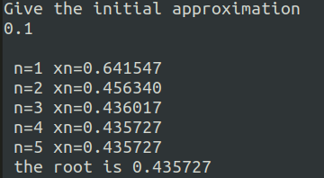

5. Code for JACOBIAN METHOD in C Programming

#include<stdio.h>
#include<math.h>
#define ESP 0.0001
#define X1(x2,x3) ((17 - 20*(x2) + 2*(x3))/20)
#define X2(x1,x3) ((-18 - 3*(x1) + (x3))/20)
#define X3(x1,x2) ((25 - 2*(x1) + 3*(x2))/20)
int main()
{
double x1=0,x2=0,x3=0,y1,y2,y3;
int i=0;
printf("\n ________________________________\n");
printf("\n x1\t\t x2\t\t x3\n");
printf("\n ________________________________\n");
printf("\n %f\t %f\t %f",x1,x2,x3);
do
{
y1=X1(x2,x3);
y2=X2(x1,x3);
y3=X3(x1,x2);
if (fabs(y1-x1)<ESP&&fabs(y2-x2)<ESP&&fabs(y3-x3)<ESP)
{
printf("\n ________________________________\n");
printf("\n\nx1=%.3lf",y1);
printf("\n\nx2=%.3lf",y2);
printf("\n\nx3=%.3lf\n",y3);
i=1;
}
else
{
x1=y1;
x2=y2;

x3=y3;
printf("\n %f\t\t%f\t\t%f\n",x1,x2,x3);
}
}
while(i!=1);
}
output:

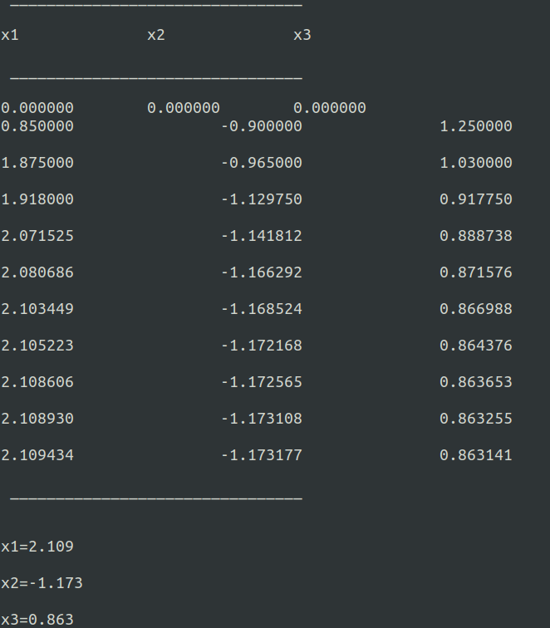

6. Source Code for Lagrange Interpolation in C:
#include<stdio.h>
int main()
{
float x[100],y[100],a,s=1,t=1,k=0;
int n,i,j;
printf("\n\n Enter the number of the terms of the table: ");
scanf("%d",&n);
printf("\n\n Enter the respective values of the variables x and y: \n");
for(i=0; i<n; i++)
{
scanf ("%f",&x[i]);
scanf("%f",&y[i]);
}
printf("\n\n The table you entered is as follows :\n\n");
for(i=0; i<n; i++)
{
printf("%0.3f\t%0.3f",x[i],y[i]);
printf("\n");
}
k=0;
printf("\n Enter the Value of the x to find respective value of y\n");
scanf("%f",&a);
for(i=0;i<n;i++)
{
s=1;
t=1;
for (j=0;j<n;j++)
{
if(j!=i)
{
s=s*(a-x[j]);
t=t*(x[i]-x[j]);
}
}
k=k+((s/t)*y[i]);
}
printf("\n\n THe respective value of the variable y is :%f\n",k); }
output:
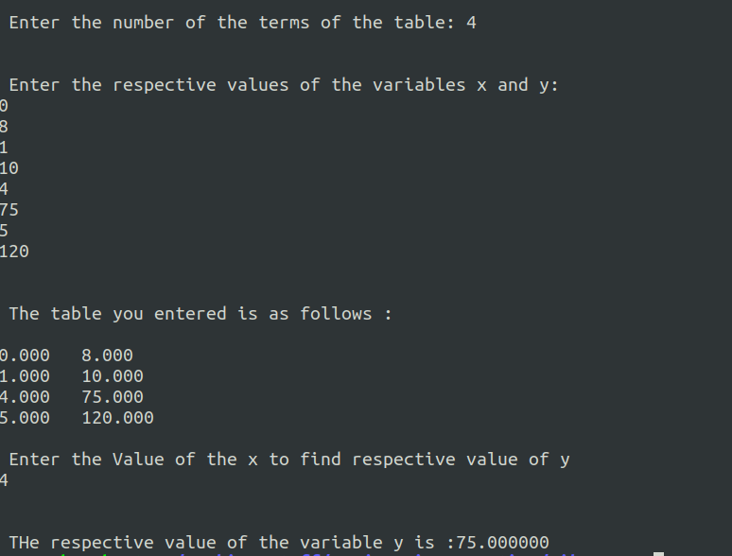

7. Write a C program and run to Evaluate , a=.8 by Simson’s Rule correct upto 5 significant figures.

/*Simson*/
#include <stdio.h>
#include <math.h>
int main( )
{
int n,i;
float a,b,h,sum1,sum2,sum3,intvle;
float F(float x);
printf(" give the initial value of limit a\n");
scanf("%f",&a);
printf( "give the value of final limit b\n");
scanf("%f",&b);
printf( "give the value of interval 'n'\n");
scanf("%d",&n);
h=(b-a)/n;
sum1=(F(a)+F(b));
sum2=0;
for (i=1;i<n;i=i+2)
{
sum2=sum2+F(a+i*h);
}
sum3=0;
for (i=2;i<n-1;i=i+2)
{
sum3=sum3+F(a+i*h);
}
intvle=h*(sum1+4*sum2+2*sum3)/3;
printf("\n");
printf("a..........b............n............Value of Integration\n\n\n");
printf( "\n%f %f %d %5f\n",a,b,n,intvle);
}
float F(float x)
{
float f;
f=(log(1+.8*x+.64))/(.8+x);
return (f);
}

output:
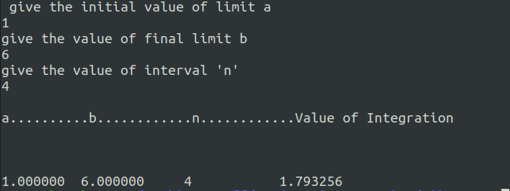

8. Power Method for Dominant Eigen Values
#include<stdio.h>
#include<math.h>
int main()
{
int i,j,n;
float A[40][40],x[40],z[40],e[40],zmax,emax;
printf("\nEnter the order of matrix:");
scanf("%d",&n);
printf("\nEnter matrix elements row-wise\n");
for(i=1; i<=n; i++)
{
for(j=1; j<=n; j++)
{
printf("A[%d][%d]=", i,j);
scanf("%f",&A[i][j]);
}
}
printf("\nEnter the column vector\n");
for(i=1; i<=n; i++)
{
printf("X[%d]=",i);
scanf("%f",&x[i]);
}
do
{
for(i=1; i<=n; i++)
{
z[i]=0;
for(j=1; j<=n; j++)
{
z[i]=z[i]+A[i][j]*x[j];
}
}
zmax=fabs(z[1]);
for(i=2; i<=n; i++)
{
if((fabs(z[i]))>zmax)
zmax=fabs(z[i]);
}
for(i=1; i<=n; i++)
{
z[i]=z[i]/zmax;
}
for(i=1; i<=n; i++)
{
e[i]=0;
e[i]=fabs((fabs(z[i]))-(fabs(x[i])));
}
emax=e[1];
for(i=2; i<=n; i++)
{
if(e[i]>emax)
emax=e[i];
}
for(i=1; i<=n; i++)
{
x[i]=z[i];
}
}
while(emax>0.001);
printf("\n The required eigen value is %f",zmax);
printf("\n\nThe required eigen vector is :%f\n",emax);
for(i=1; i<=n; i++) output:
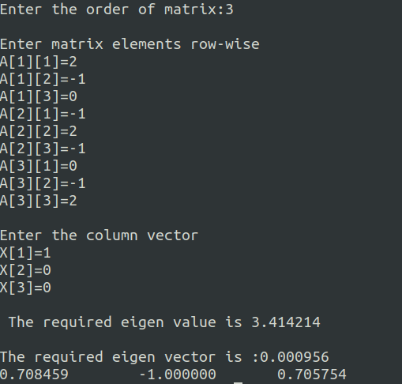
{
printf("%f\t",z[i]);
}
}

9. Euler’s method in C to solve the ordinary differential equation dy/dx = x+y.

#include<stdio.h>
float fun(float x,float y)
{
float f;
f=x+y;
return f;
}
int main()
{
float a,b,x,y,h,t,k;
printf("\nEnter x0,y0,h,xn: ");
scanf("%f%f%f%f",&a,&b,&h,&t);
x=a;
y=b;
printf("\n x\t y\n");
while(x<=t)
{
k=h*fun(x,y);
y=y+k;
x=x+h;
printf("%0.3f\t%0.3f\n",x,y);
}
}
output:
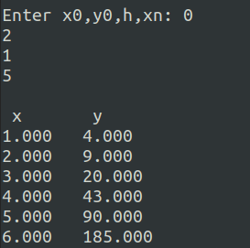

10. Write a C program and run to find the value of y at x=.4 from the ODE given that y(0)=1 by Runge Kutta Method correct uoto 3 significant figures.

/*Runge kutta*/
#include <stdio.h>
#include <math.h>
float f(float x,float y);
int main( )
{
float x0,y0,m1,m2,m3,m4,m,x,y,h,xn;
printf("Enter x0,y0,xn,h :\n");
scanf("%f%f%f%f",&x0,&y0,&xn,&h);
x=x0;
y=y0;
printf("\n\nX\t\tY\n");
while(x<xn)
{
m1=f(x0,y0);
m2=f((x0+h/2.0),(y0+m1*h/2.0));
m3=f((x0+h/2.0),(y0+m2*h/2.0));
m4=f((x0+h),(y0+m3*h));
m= ((m1+2*m2+2*m3+m4)/6);
y=y+m*h;
x=x+h;
}
printf("%f\t%f\n",x,y);
}
float f(float x, float y)
{
float m;
m=(x-y)/(x+y);
return m;
}

output:
