Multimodal Education Creator

Report

  - Course Name: GENERATIVE AI

Institution Name: Medicaps University – Datagami Skill Based Course

Sr no | Student Name | Enrollment Number
1. | SUMAN DANGI | EN22CS301998
2. | VAISHNAVI SARODEY | EN22CS3011056
3. | UDDHAV CHOURASIYA | EN22CS3011042
4. | TANISHQ SHARMA | EN22CS3011021
5. | SUJAL MUKATI | EN22CS301995

Group Name: Group 04D9
Project Number: 04
Industry Mentor Name: Mr. Rishabh Tripathi
University Mentor Name: Prof. Vineeta Rathore
Academic Year: 2026

Problem Statement & Objectives

Problem Statement

Project Objectives

Scope of the Project

Proposed Solution
- Key features (Just mention key features here no need to go into details)
- Overall Architecture / Workflow
- Tools & Technologies Used (If applicable)

Results & Output
Add the below details here:
- Screenshots / outputs
- Reports / dashboards / models
- Key outcomes

Conclusion
Mention a brief conclusion about your project summing up everything you have worked on and the key learning.

Future Scope & Enhancements

Problem Statement & Objectives:-

1. Problem Statement:-
Traditional learning platforms provide static content and lack personalization. Students often struggle to get context-aware explanations and visual learning support. Moreover, most systems cannot dynamically adapt to new knowledge sources like custom documents.

2. Project Objectives:-
- To build an AI-powered educational content generator
- To generate simple explanations for any topic using LLM
- To provide visual learning support (images)
- To implement Retrieval-Augmented Generation (RAG) for accurate answers
- To allow users to upload PDF documents dynamically
- To improve responses using user-provided knowledge sources

3. Scope of the Project:-
- Supports topic-based learning queries
- Allows PDF-based knowledge expansion
- Works for educational content generation
- Can be extended for:
  - e-learning platform
  - AI tutors
  - Document-based Q&A systems

Proposed Solution:-

1. Key Features
- Topic-based explanation generation
- Flashcard generation (conceptual support)
- Image generation using Wikipedia API

- RAG-based contextual answering
- PDF upload interface for dynamic knowledge addition
- Login authentication system

2. Overall Architecture / Workflow:-
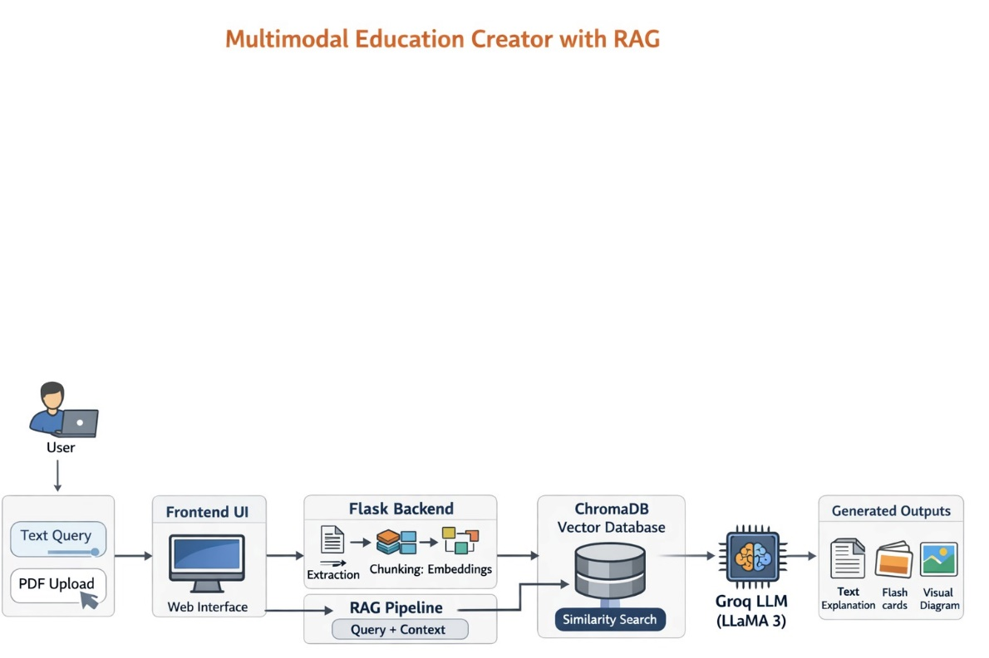

3. Tools & Technologies Used:-

Technology Purpose
- Flask Backend web framework
- HTML/CSS Frontend UI
- Groq API (LLaMA 3) LLM for text generation

- LangChain RAG pipeline orchestration
- ChromaDB Vector database
- HuggingFace Embeddings Text → vector conversion
- PyPDF PDF text extraction
- Wikipedia API Image generation

Results & Output:-

- Screenshots / Outputs:-

- Login page:-

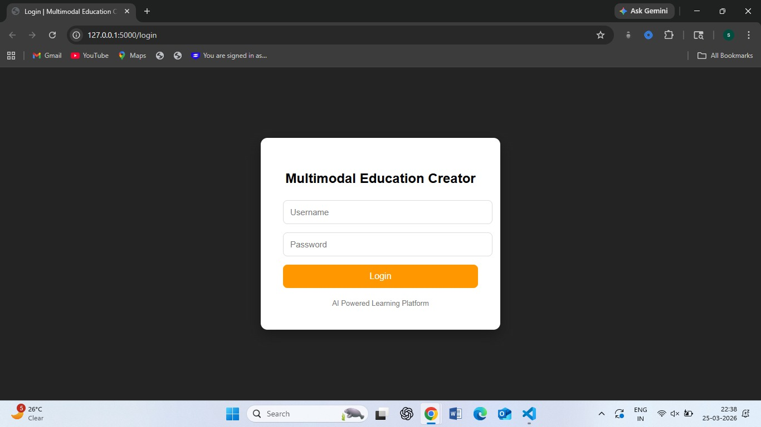

- Home page (topic input + PDF upload)
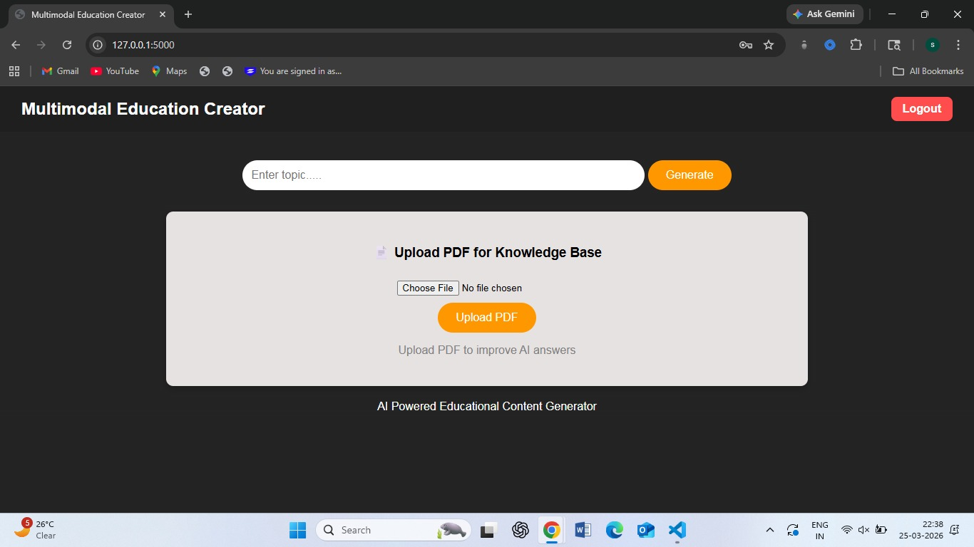

- Generated explanation output

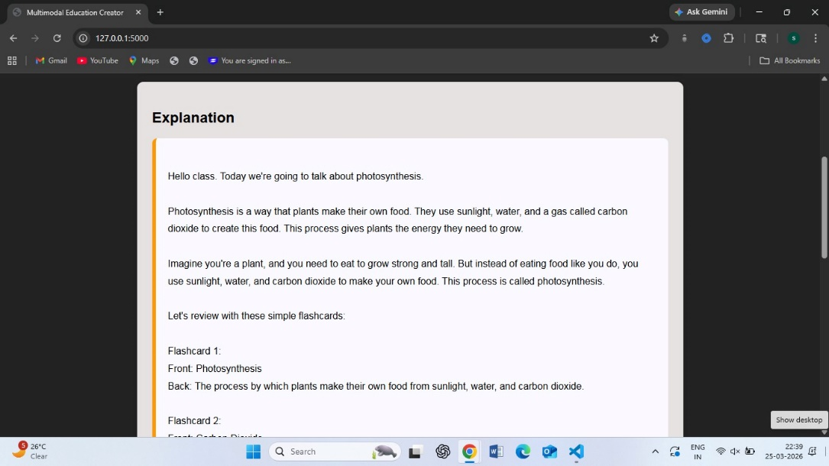

- Flashcards section

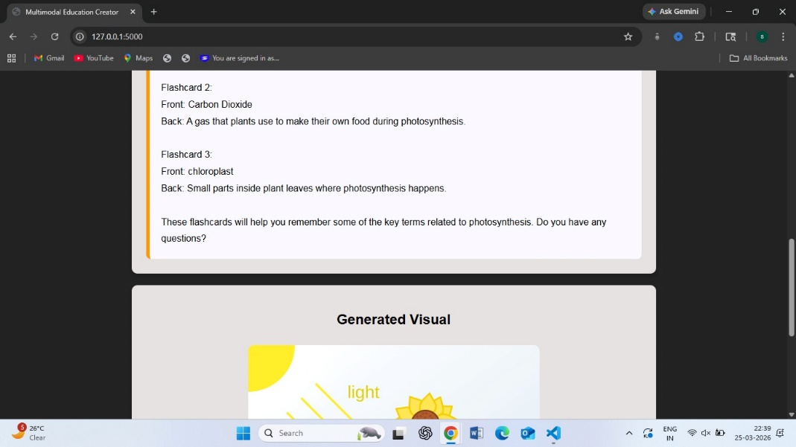

- Image output

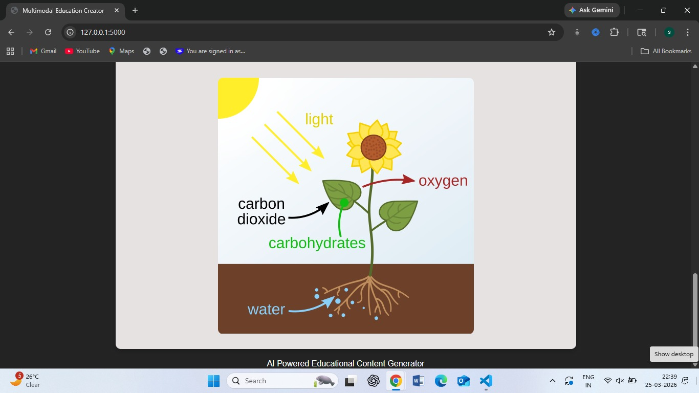

- PDF upload interface

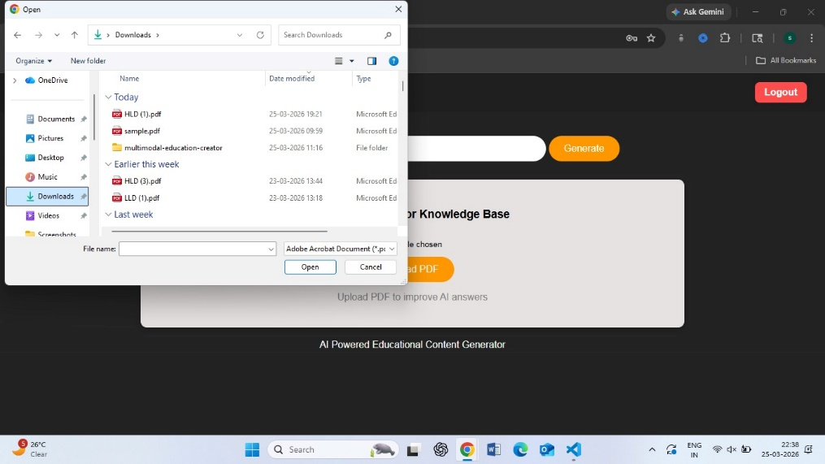

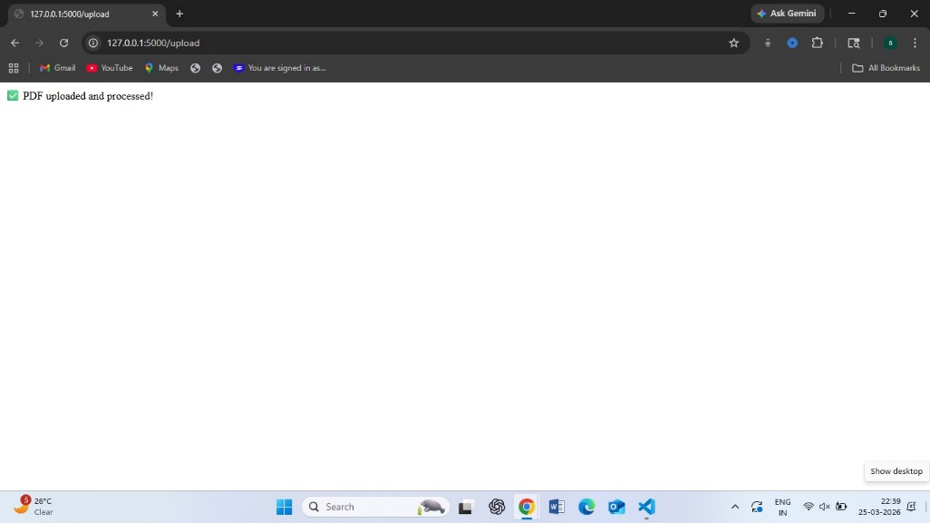

2. Reports / Models:-
- Embedding model: all-MiniLM-L6-v2
- Vector DB: ChromaDB storing chunked text
- LLM: LLaMA 3 via Groq API

3. Key Outcomes:-
- Successfully implemented RAG pipeline
- Enabled dynamic knowledge ingestion via PDF
- Improved response accuracy using context retrieval
- Integrated LLM + Vector DB + UI
- Built a full-stack AI application

Conclusion:-

- This project successfully demonstrates the integration of Generative AI with Retrieval-Augmented Generation (RAG) to create a smart educational assistant.

- By combining LLM capabilities with vector-based retrieval, the system generates more accurate and context-aware explanations.

- The addition of a PDF upload interface enhances the system's flexibility, allowing users to expand the knowledge base dynamically.

- Overall, the project provides a strong foundation for AI-driven learning systems.

Future Scope & Enhancements:-

- Multi-PDF upload support
- Drag-and-drop file upload UI
- Flashcard parsing and structured display
- User-specific knowledge storage
- Real-time streaming responses
- Deployment on cloud (AWS / GCP)
- Chat-based conversational interface
- Support for multiple file formats (DOCX, TXT)

