https://medium.com/@iaravinda33/integrating-keycloak-authentication-with-spring-boot-a-complete-guide-98df2c8d244a
https://developer.temenos.com/temenos-explorer/docs/developer/keycloak/keycloak-step-3/
Integrating Keycloak Authentication with Spring Boot
To start Keycloak server- download and run docker image-
docker run -p 8080:8080 -e KC_BOOTSTRAP_ADMIN_USERNAME=admin -e KC_BOOTSTRAP_ADMIN_PASSWORD=admin quay.io/keycloak/keycloak:26.2.5 start-dev
http://localhost:8080/
username: admin
password: admin
Create a Realm
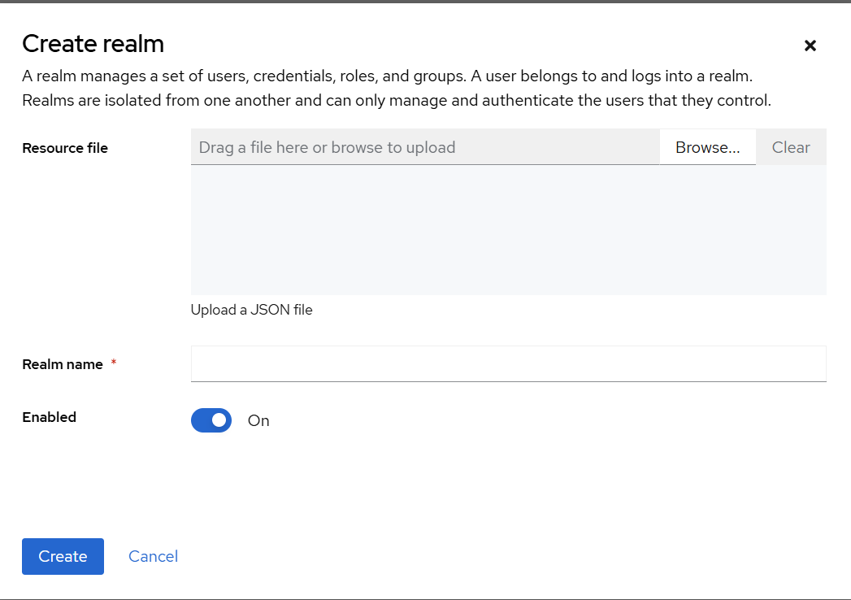
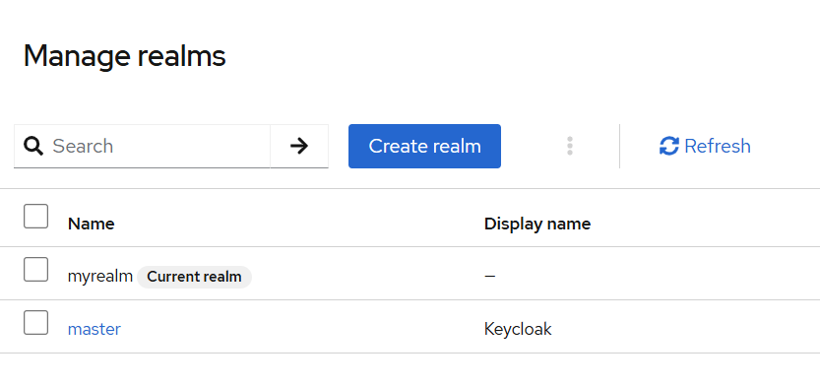
. Create a Client
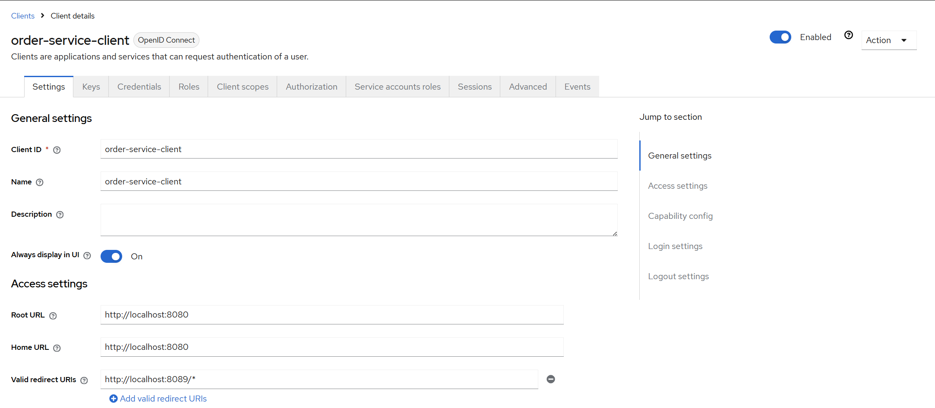

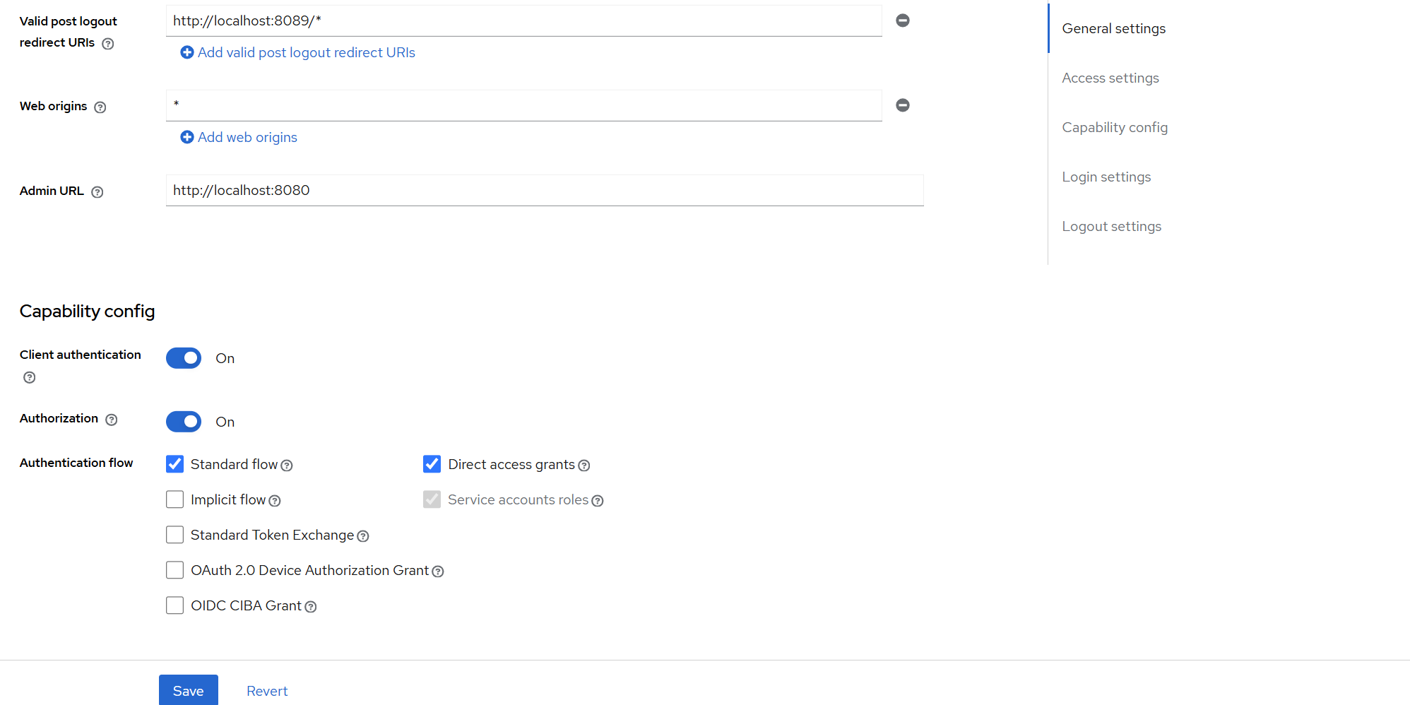

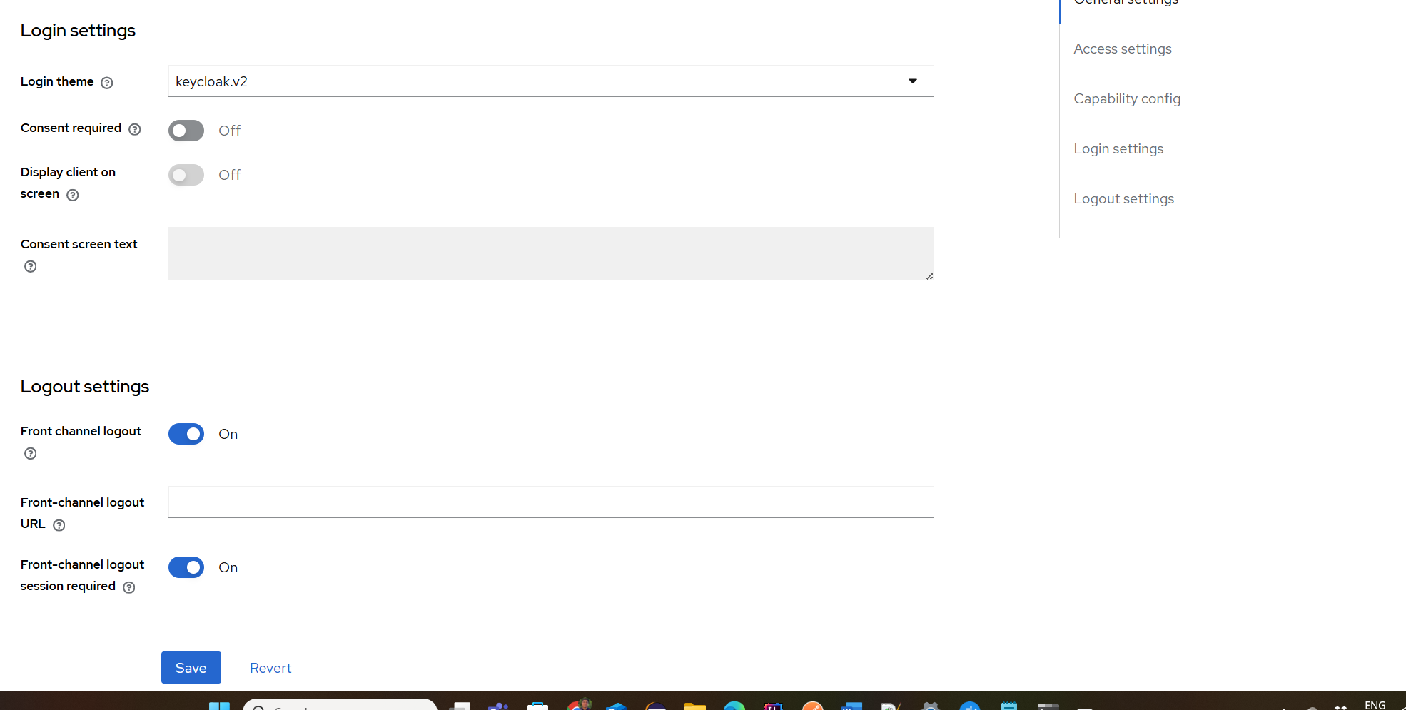

Creating Users
i. Add Users:
- Navigate to the Users section in the Keycloak Admin Console.
- Create three users as admin, user, and admin_user.
- For each user, ensure that you fill out all the fields and make sure to check Email verified option.
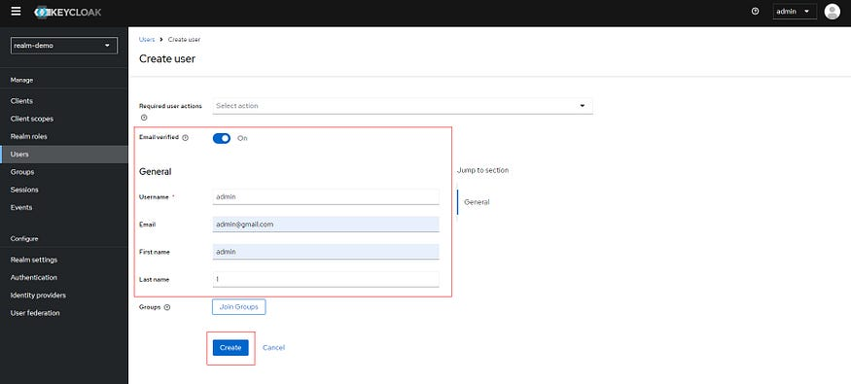
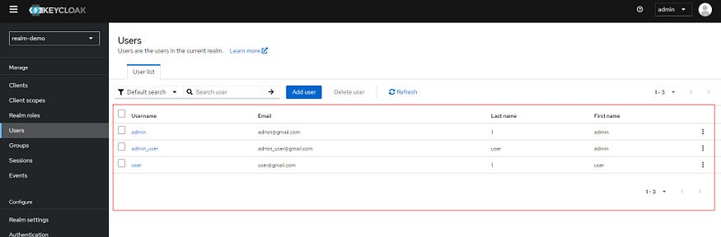
ii. Set User Passwords:
- After creating each user, navigate to the Credentials tab.
- Set a password for each user and uncheck the Temporary option.
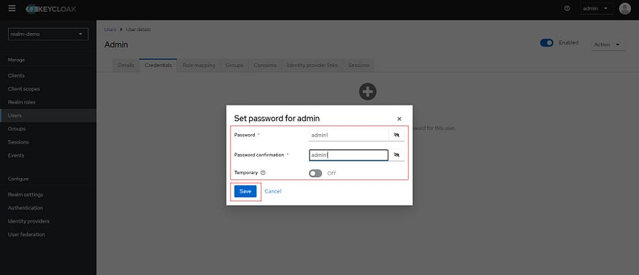
5. Creating Client and Realm roles
i. Client roles:
Start by creating client roles in Keycloak. Navigate to your client and add two new roles as role_admin and role_user.
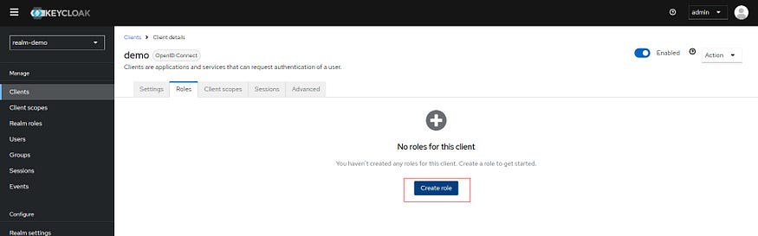
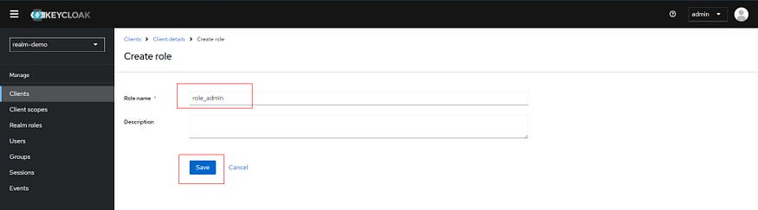
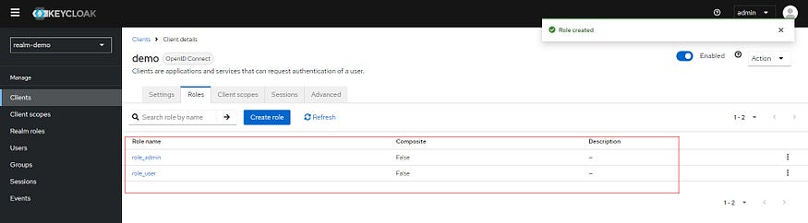
ii. Realm roles: Next, navigate to “Realm roles” and create two roles as admin and user.
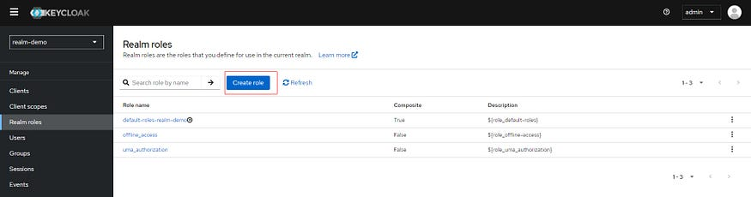
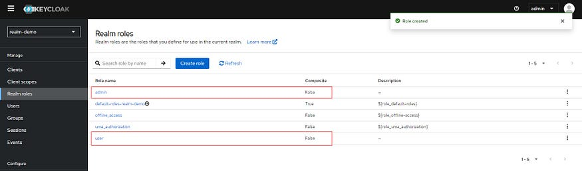
iii. Making Realm roles Composite: To assign client roles to these realm roles, follow these steps:
- Go to “Roles” and select the admin realm role.
- In the “Associated roles” tab, click “Assign role.”
- Select “Filter by clients” to view the client roles, check the role_admin client role, and assign it.
- Repeat the process for the user realm role and assign role_user to it.
- After these steps, both the admin and user realm roles should have their “Composite” attribute set to true, indicating that they are composite roles.
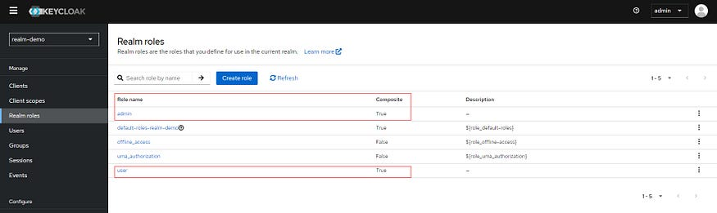
6. Assign Roles to Users
- Now navigate to Users section and select admin and then select Role mapping, select Assign role -> Filter by clients and assign role_admin.
- Repeat the process and assign role_user to user and for the admin_user make sure to assign both role_user and role_admin.
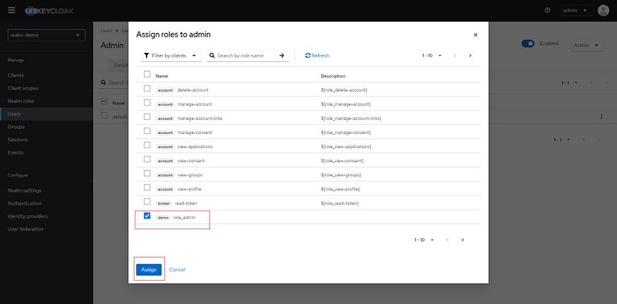
4. Obtaining the token for the users using Postman
Now let’s move on to obtaining the token.
When you go to the Realm settings section on the sidebar you will see the
“OpenID Endpoint Configuration” link:
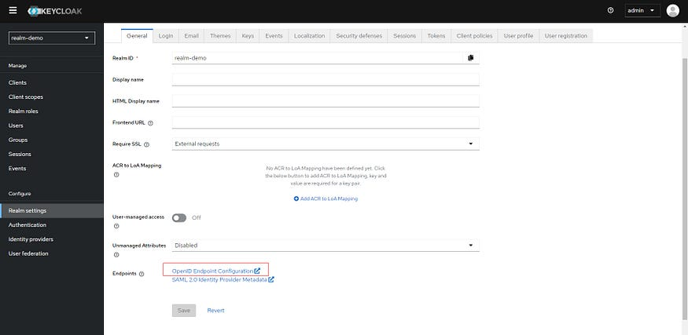
Just copy “token_endpoint” value:
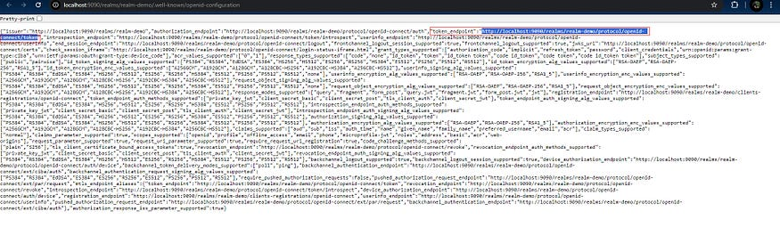
We can now send a POST request to this endpoint to get a token. We can use one of the users we created as the credentials. I use Postman for this request:
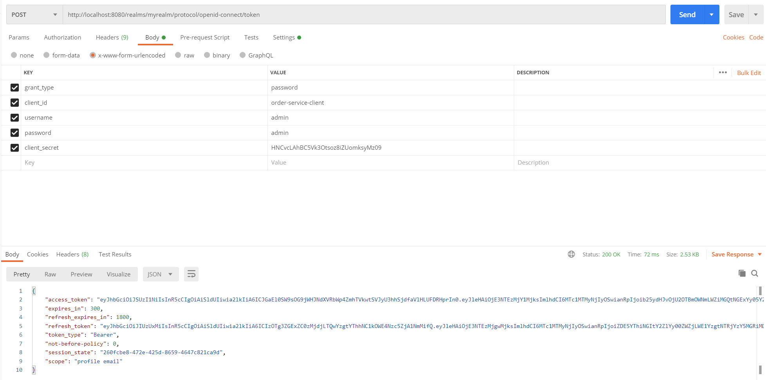

5. Configuring Spring Boot application
- application.yml
Rename the application.properties file in the src/main/resources directory to application.yml. Then, clear its contents and replace them with the following configuration:
spring:
security:
oauth2:
resourceserver:
jwt:
issuer-uri: http://localhost:9090/realms/realm-demo
jwk-set-uri: http://localhost:9090/realms/realm-demo/protocol/openid-connect/certs
logging:
level:
org:
springframework:
security: DEBUG
jwt:
auth:
converter:
resource-id: demo
principle-attribute: preferred_username
- spring.security.oauth2.resourceserver.jwt.issuer-uri: This setting specifies the Issuer URI for JWT authentication. It includes the URI of the Keycloak realm.
- spring.security.oauth2.resourceserver.jwt.jwk-set-uri: Specifies the JWK set URI at the location where JWT will be used. This URI is used to fetch public keys.
- jwt.auth.converter.resource-id: Specifies the resource ID of the JWT. Typically, it includes a client identifier.
- jwt.auth.converter.principal-attribute: Specifies a specific attribute name in the JWT's header (such as principal_username) where principals (users) are indicated.SecurityConfig class
2. Creating a custom JWT to Authentication Token Converter
Create a new package named config and then add a new class called JwtConverter within this package.
Add the following code to the JwtConverter class:
@Component
public class JwtConverter implements Converter<Jwt, AbstractAuthenticationToken> {
private final JwtGrantedAuthoritiesConverter jwtGrantedAuthoritiesConverter =
new JwtGrantedAuthoritiesConverter();
@Value("${jwt.auth.converter.principle-attribute}")
private String principleAttribute;
@Value("${jwt.auth.converter.resource-id}")
private String resourceId;
@Override
public AbstractAuthenticationToken convert(@NonNull Jwt jwt) {
Collection<GrantedAuthority> authorities = Stream.concat(
jwtGrantedAuthoritiesConverter.convert(jwt).stream(),
extractResourceRoles(jwt).stream()
).collect(Collectors.toSet());
return new JwtAuthenticationToken(
jwt,
authorities,
getPrincipleClaimName(jwt)
);
}
private String getPrincipleClaimName(Jwt jwt) {
String claimName = JwtClaimNames.SUB;
if (principleAttribute != null) {
claimName = principleAttribute;
}
return jwt.getClaim(claimName);
}
private Collection<? extends GrantedAuthority> extractResourceRoles(Jwt jwt) {
Map<String, Object> resourceAccess;
Map<String, Object> resource;
Collection<String> resourceRoles;
if (jwt.getClaim("resource_access") == null) {
return Set.of();
}
resourceAccess = jwt.getClaim("resource_access");
if (resourceAccess.get(resourceId) == null) {
return Set.of();
}
resource = (Map<String, Object>) resourceAccess.get(resourceId);
resourceRoles = (Collection<String>) resource.get("roles");
return resourceRoles
.stream()
.map(role -> new SimpleGrantedAuthority("ROLE_" + role))
.collect(Collectors.toSet());
}
}
The JwtConverter class in Spring Boot converts JWT tokens from Keycloak into Spring Security authentication tokens. It uses JwtGrantedAuthoritiesConverter to handle standard JWT scopes and also extracts additional resource-specific roles from the JWT.
- Custom Properties: It leverages properties like principle-attribute for setting the principal claim and resource-id for identifying the Keycloak client. For principle-attribute and resource-id, we use values stored in the application.yml
- Authority Extraction: Combines roles from both the standard JWT claims and resource-specific roles into a single set of GrantedAuthority objects.
- Principal Claim: The principal for the authentication token is typically derived from the sub claim but can be configured.
3. Implementing Security Configuration using Spring Security
Create a new class named SecurityConfig in the config package and add the following code to it:
@Configuration
@EnableWebSecurity
@EnableMethodSecurity
public class SecurityConfig{
@Autowired
private JwtConverter jwtConverter;
@Bean
public SecurityFilterChain securityFilterChain(HttpSecurity http) throws Exception {
http
.csrf(AbstractHttpConfigurer::disable)
.authorizeHttpRequests((authorize)-> authorize
.anyRequest().authenticated())
.oauth2ResourceServer(
(oauth2)-> oauth2.jwt(
jwt-> jwt.jwtAuthenticationConverter(jwtConverter)
))
.sessionManagement(
session-> session.sessionCreationPolicy(
SessionCreationPolicy.STATELESS)
);
return http.build();
}
}
The SecurityConfig class sets up security for the Spring Boot application. It disables CSRF protection, requires authentication for all requests, and configures the application to use JWTs for OAuth2 resource server support. Sessions are managed in a stateless manner, meaning no session state is maintained between requests. This setup ensures that all incoming requests are authenticated using JWT tokens.
- Dependency Injection: The JwtConverter is injected into the configuration using @Autowired. This component is responsible for converting JWT tokens.
- OAuth2 Resource Server: The application is configured to use OAuth2 for resource server support. This setup includes specifying that JWT (JSON Web Tokens) should be used for authentication, with the jwtAuthenticationConverter set to our JwtConverter instance.
6. Creating the endpoints
Create a package named controller and add a class called Controller within it. Include the following code in the Controller class:
import org.springframework.http.ResponseEntity;
import org.springframework.security.access.prepost.PreAuthorize;
import org.springframework.web.bind.annotation.GetMapping;
import org.springframework.web.bind.annotation.RequestMapping;
import org.springframework.web.bind.annotation.RestController;
@RestController
@RequestMapping("/api/v1")
public class Controller {
@GetMapping
public ResponseEntity<String> hello() {
return ResponseEntity.ok("Hello!");
}
@GetMapping("/user")
@PreAuthorize("hasRole('role_user')")
public ResponseEntity<String> helloUser() {
return ResponseEntity.ok("Hello From User!");
}
@GetMapping("/admin")
@PreAuthorize("hasRole('role_admin')")
public ResponseEntity<String> helloAdmin() {
return ResponseEntity.ok("Hello From Admin!");
}
}
In this setup, the first endpoint is accessible to all authenticated users, the second endpoint is reserved to users with the role role_user, and the third endpoint is reserved for users with the role role_admin.
Note: The admin_user is assigned both the role_user and role_admin roles, allowing them to access all endpoints.
Final Project Structure will look like this:
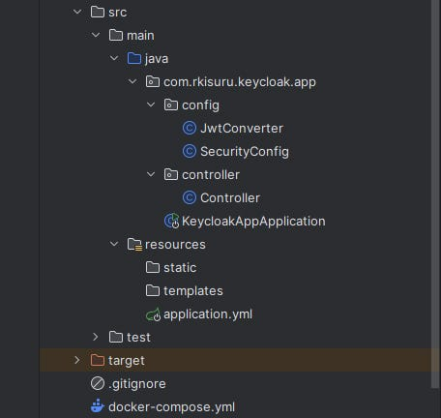
SPECIAL NOTE !
Obtain a token for the user using postman and go to https://jwt.io/ website and paste your token.
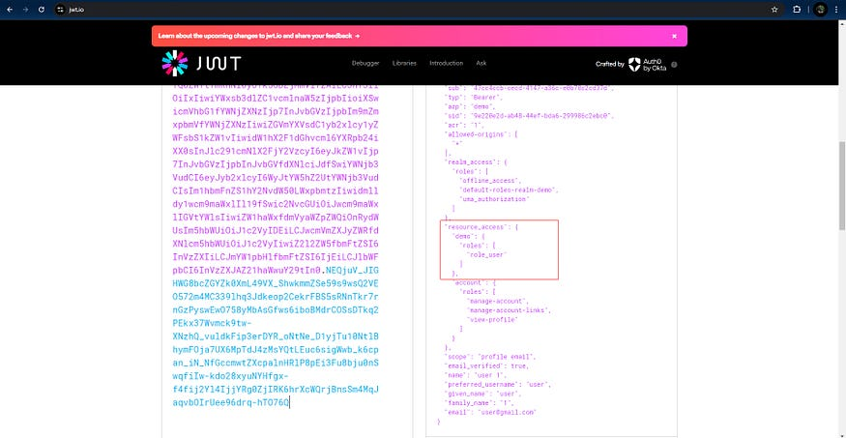
You can see “roles”: [ “role_user” ] as a key , value pair.
We extract this “roles” using extractResourceRoles method in JwtConverter class.
And in Controller class we make sure only user can access http://localhost:8080/api/v1/user endpoint by adding @PreAuthorize(“hasRole(‘role_user’)”).
7. Testing the Authentication flow using Postman
- 1st make sure the Spring Boot application and the keycloak_demo container up and running.
- Let’s start the postman and create new GET requests for user, admin, and admin_user.
- Obtain an access token for the user.
- Enter the endpoint URL for user in the field and select Authorization to Bearer Token.
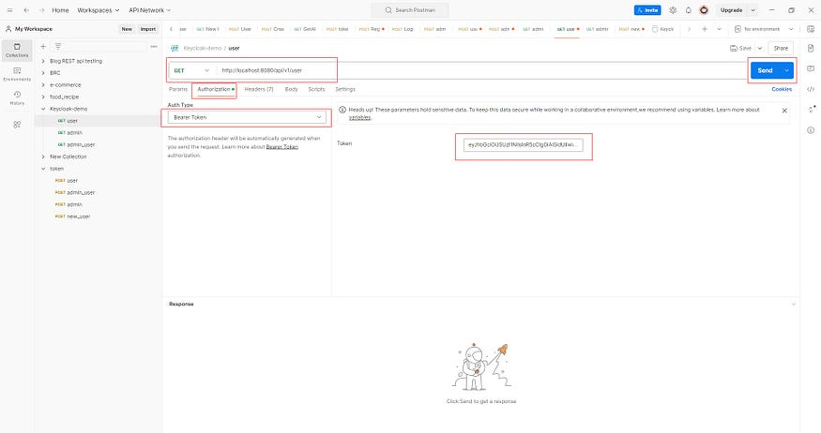
- Paste token in the token field and send the request and you will see the “200 OK” response “ Hello From User! ”.
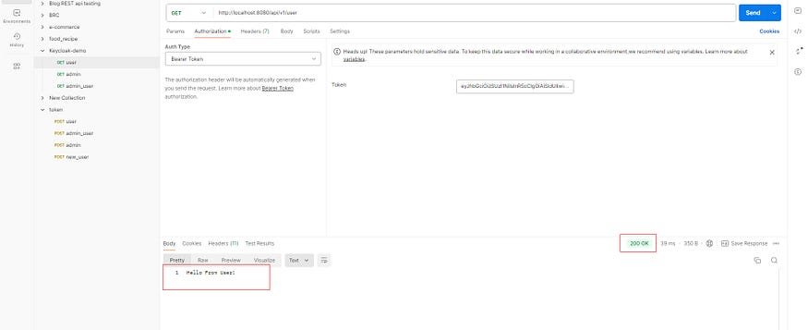
- Now let’s change the http://localhost:8080/api/v1/user to http://localhost:8080/api/v1/admin send the request.
- As you can see we get 403 error as the response. This is because http://localhost:8080/api/v1/admin is reserved for the admin.
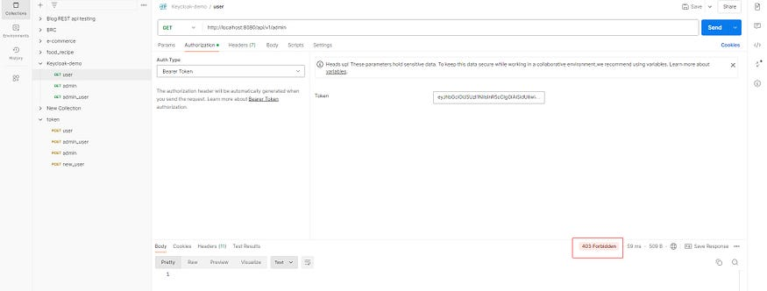
- Just play around as see if the application is working properly.
That’s all!
Conclusion
Integrating Keycloak with Spring Boot provides a secure authentication and authorization system. By using Docker Compose, we simplified the setup process. With Keycloak managing roles and users, and Spring Boot enforcing security through custom configurations, we created a scalable solution for handling role-based access in our Spring Boot application.
Thank you for your precious time !

