Groups_Bin
Part A: Groups (Categorical Data)
Create a Product Group:
Laptop & Tablet → “Electronics”
Mobile → “Handheld Device”

Create a table visual showing:
Product Group
Total Sales Amount

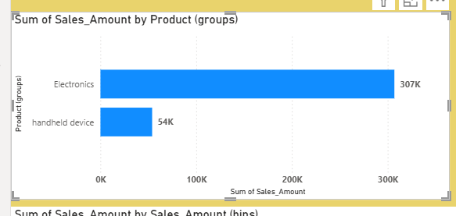

Part B: Bins (Numerical Data)
Create Bins on Sales_Amount with bin size 10,000.
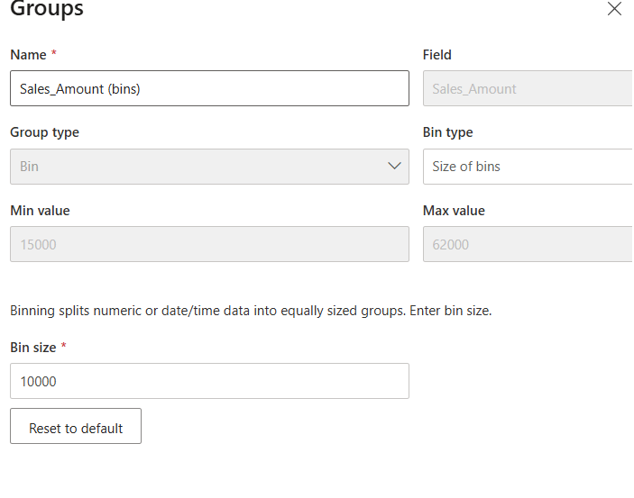
Create Age Bins with the following ranges:
o 18–25
o 26–35
o 36–45
o 46–60
o 60+
Create a column chart showing: o Age Bins vs Total Sales Amount
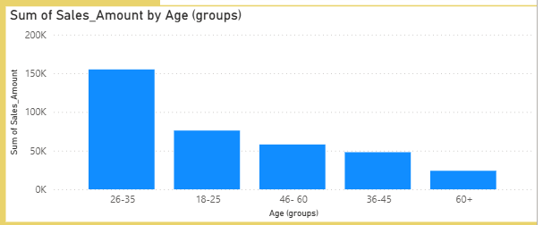

Part C: Visualization
Create a bar/column chart showing:
Sales Amount by Sales Amount groups
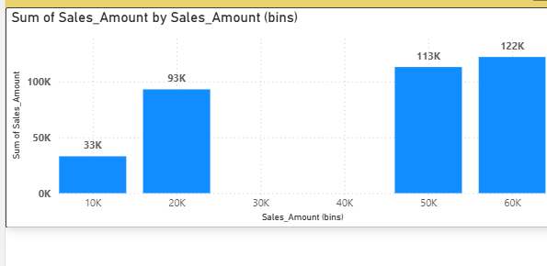
Sales Amount by Region groups
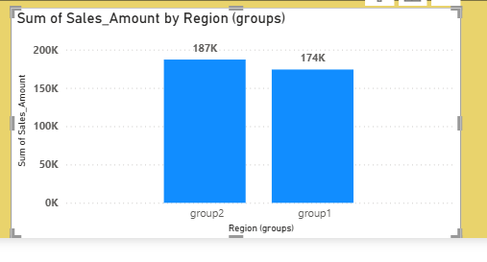

Add a slicer for: Region Group
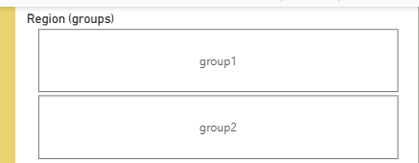
Create a simple report page titled: “Groups & Bins Analysis Dashboard”
