SMALL_MULTIPLES
Question:
Which region has the highest sales for Electronics?
- North and East

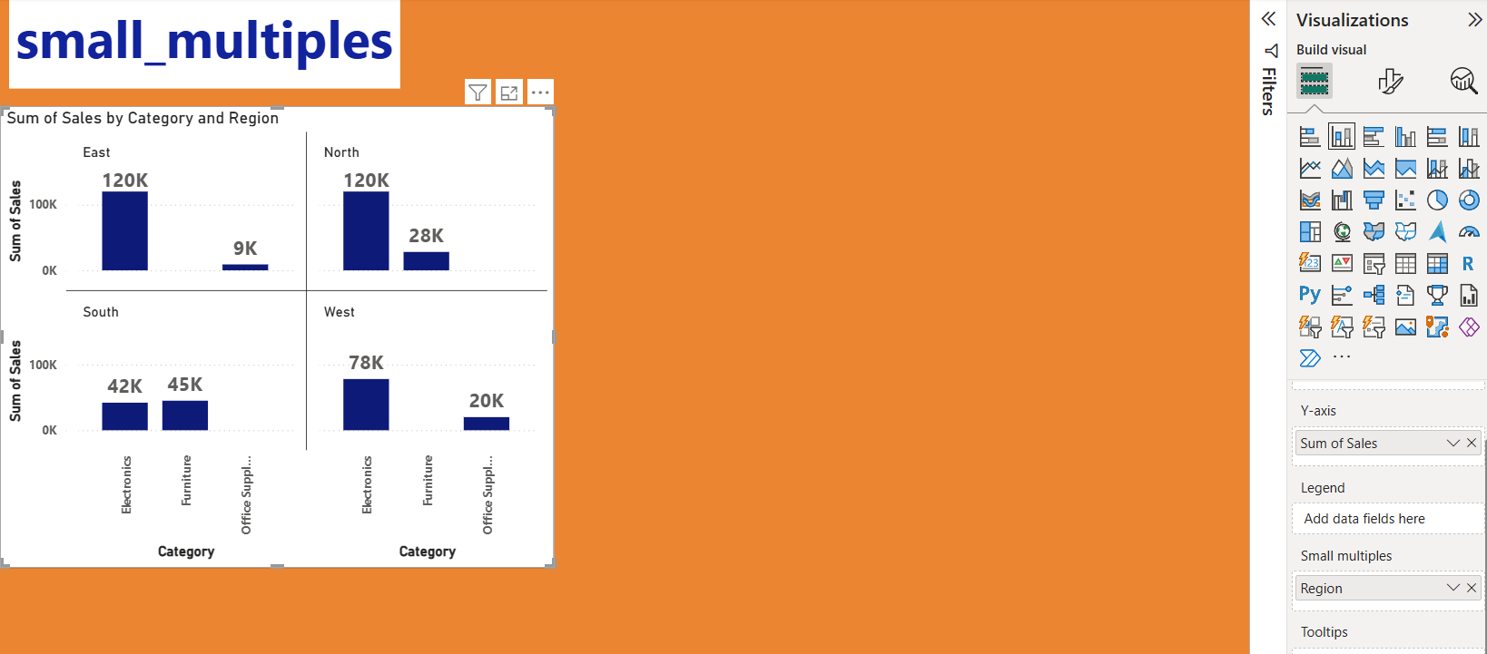

Question:
Which category shows the most consistent sales trend?
- Electronics

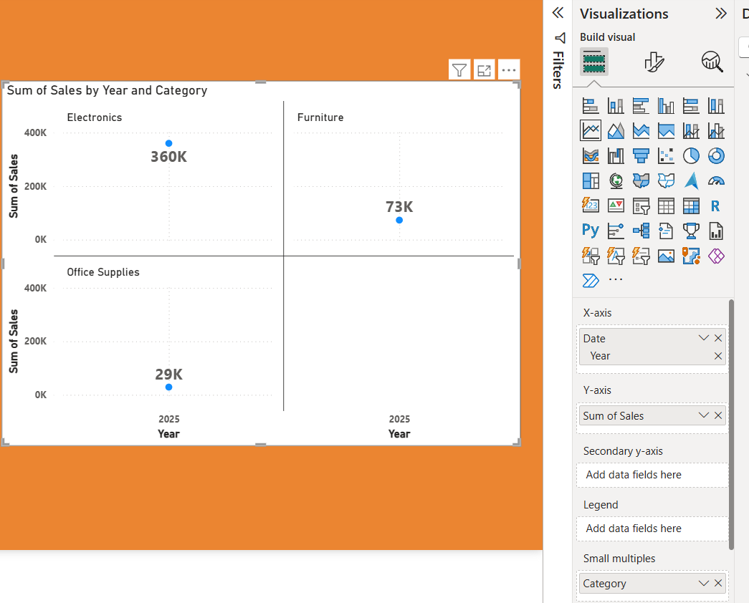

Question:
Which sales person performs best in each region?
- Best performance is by Amit in north 148K.
- In south its ravi , in west its suresh and in east its neha.

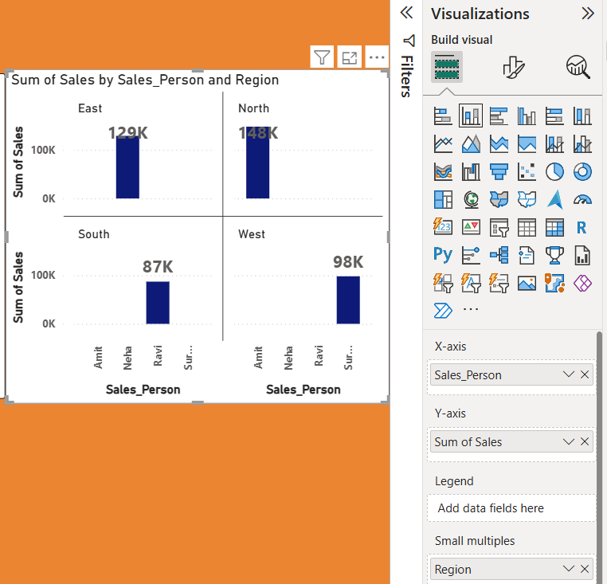

Question:
Which sub-category has the highest quantity sold in each category?
- Lets start with Electronics , mobile sales is highest which is 15
- In furniture , chair sales is highest which is 10.
- Office supp , pen sales is highest which is 110.
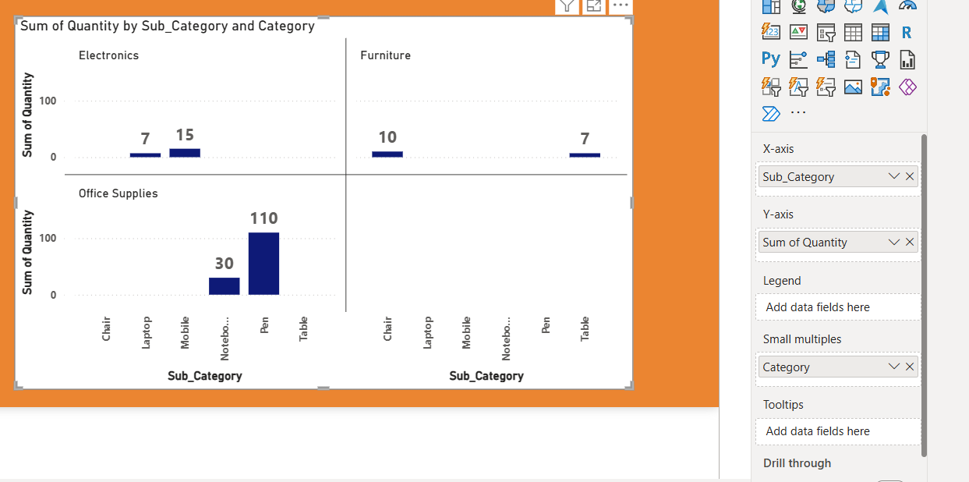

Question: How does filtering affect all small multiple visuals?
- filters apply uniformly across all small multiple visuals, keeping them synchronized with the chosen filter context. And all the date is of jan month. which small multiple make easy to understand..

