# Training vs Test Loss – (Without L1 + L2)

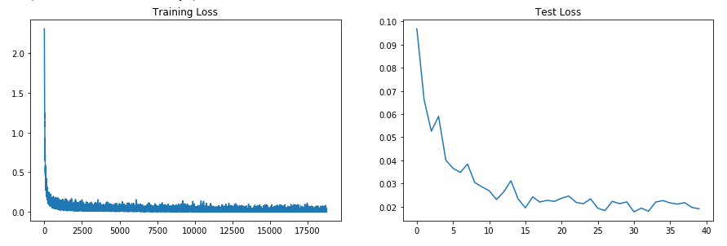

# Training vs Test Loss – (With L1)

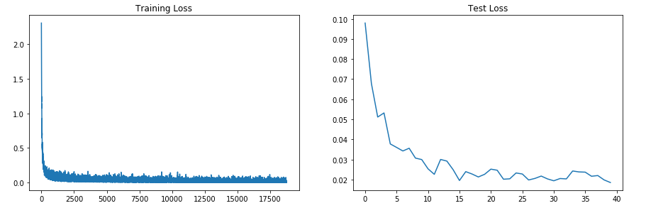

# Training vs Test Loss – (With L2)

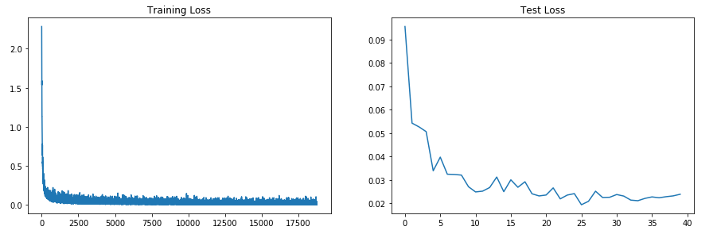

# Training vs Test Loss – (With L1 + L2)

