# Validation Accuracy – (Without L1 and L2)

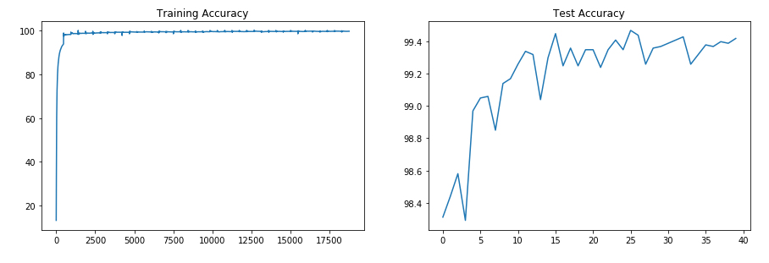

# Validation Accuracy – (With L1)

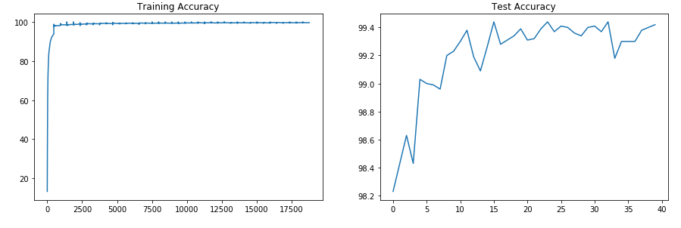

# Validation Accuracy – (With L2)

# 

# Validation Accuracy – (With L1 + L2)

