Add user Page -FRONT END

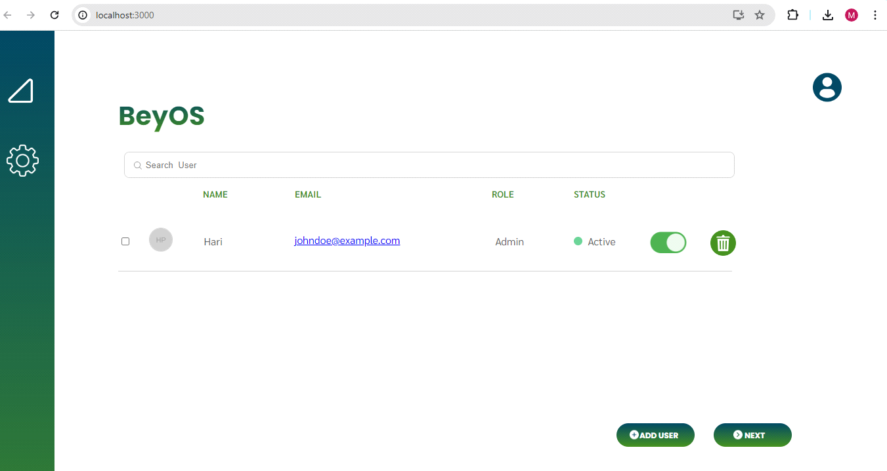

DATA ENTRY PAGE-FRONT END & BACK END

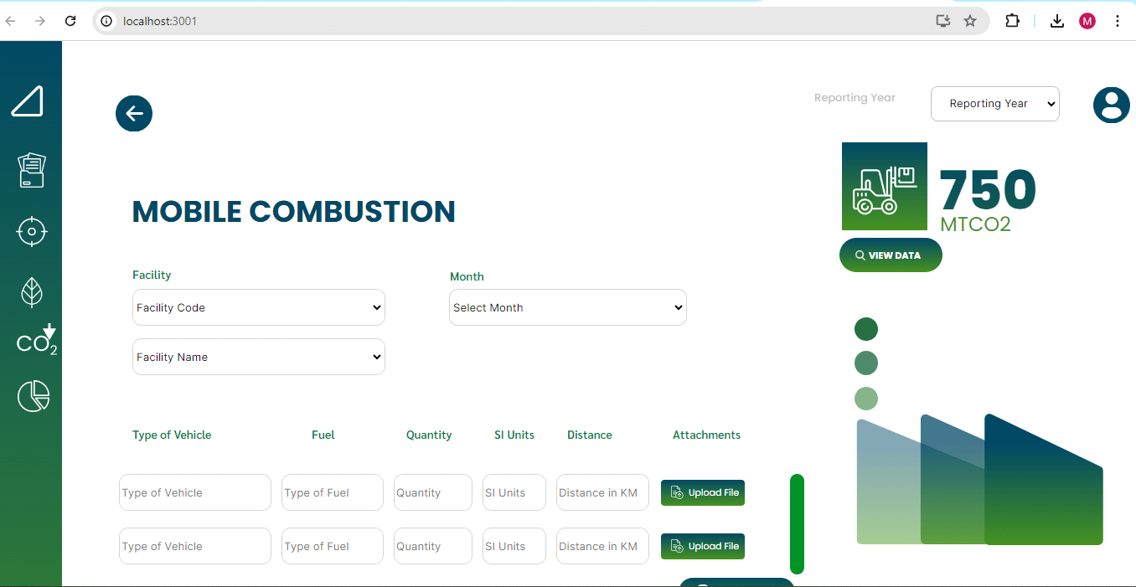

PROFILE DETAILS-FRONT END & BACK END

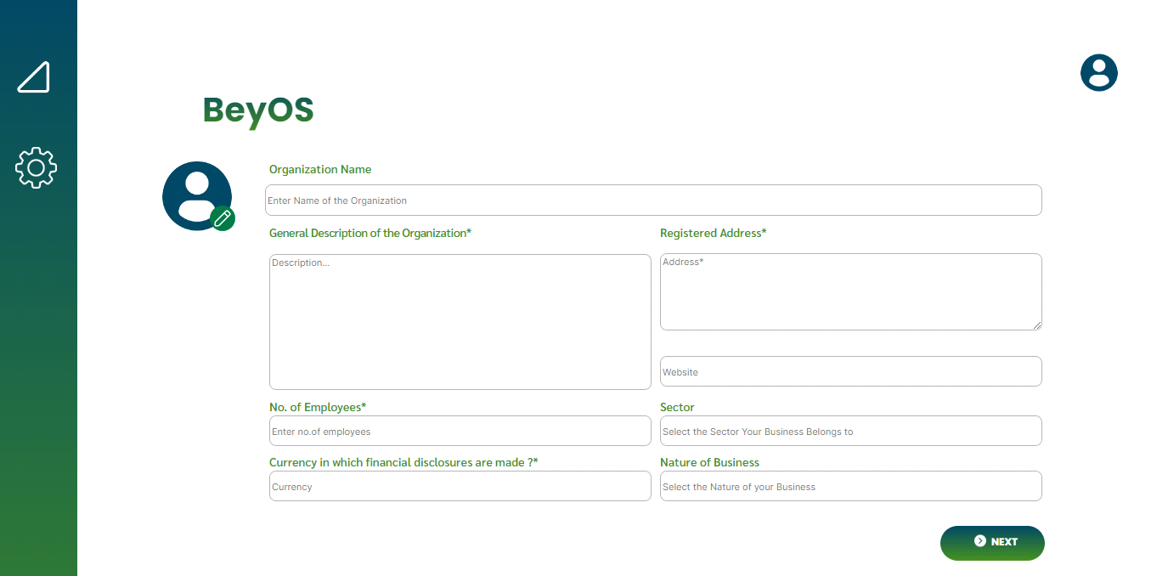

LIST -FRONT END

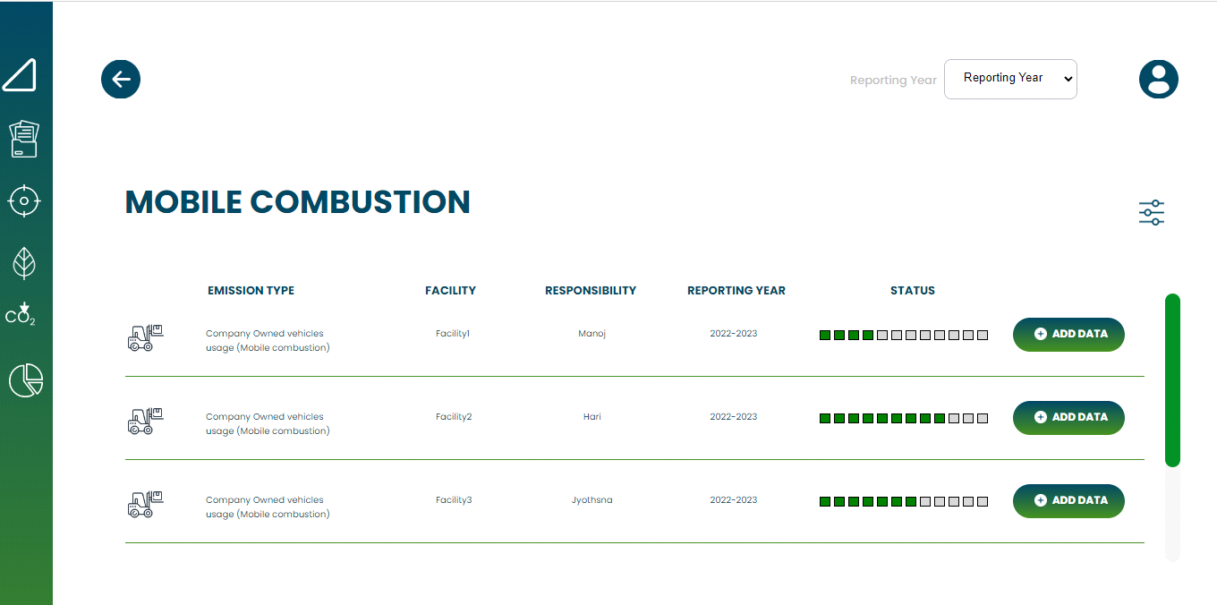

VIEW DATA - FRONTEND & BACKEND

