|  |  |  |  |
| --- | --- | --- | --- |
| **S.No** | **Steps to do** | **Provider** | **Status** |
| 1 | Use Azurerm resource provider | Terraform | **Done** |
| 2 | Generate Service Principle for Terraform in Azure | Azure | **Done** |
| 3 | Create required Vars.tf to create two VMs in Azure | Terraform | **Done** |
| 4 | Create main.tf to create two Linux VMs Terraform Use | Terraform | **Done** |
| 5 | Provisioner to install JDK and Jenkins in VM1 Terraform Use | Terraform | **Done** |
| 6 | Provisioner to install JDK, Maven,Ansible,Docker,AzureCli and Git | Terraform | **Done** |
| 7 | Init,Plan and Apply Terraform Script | Terraform | **Done** |

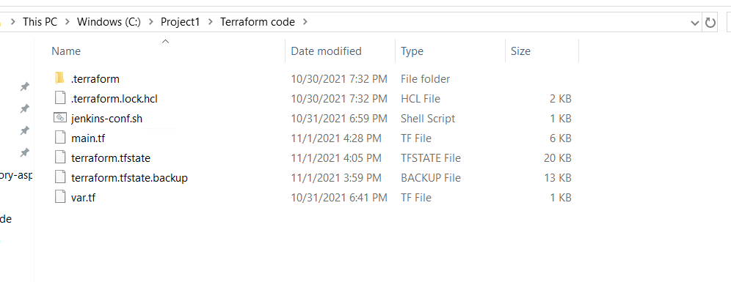

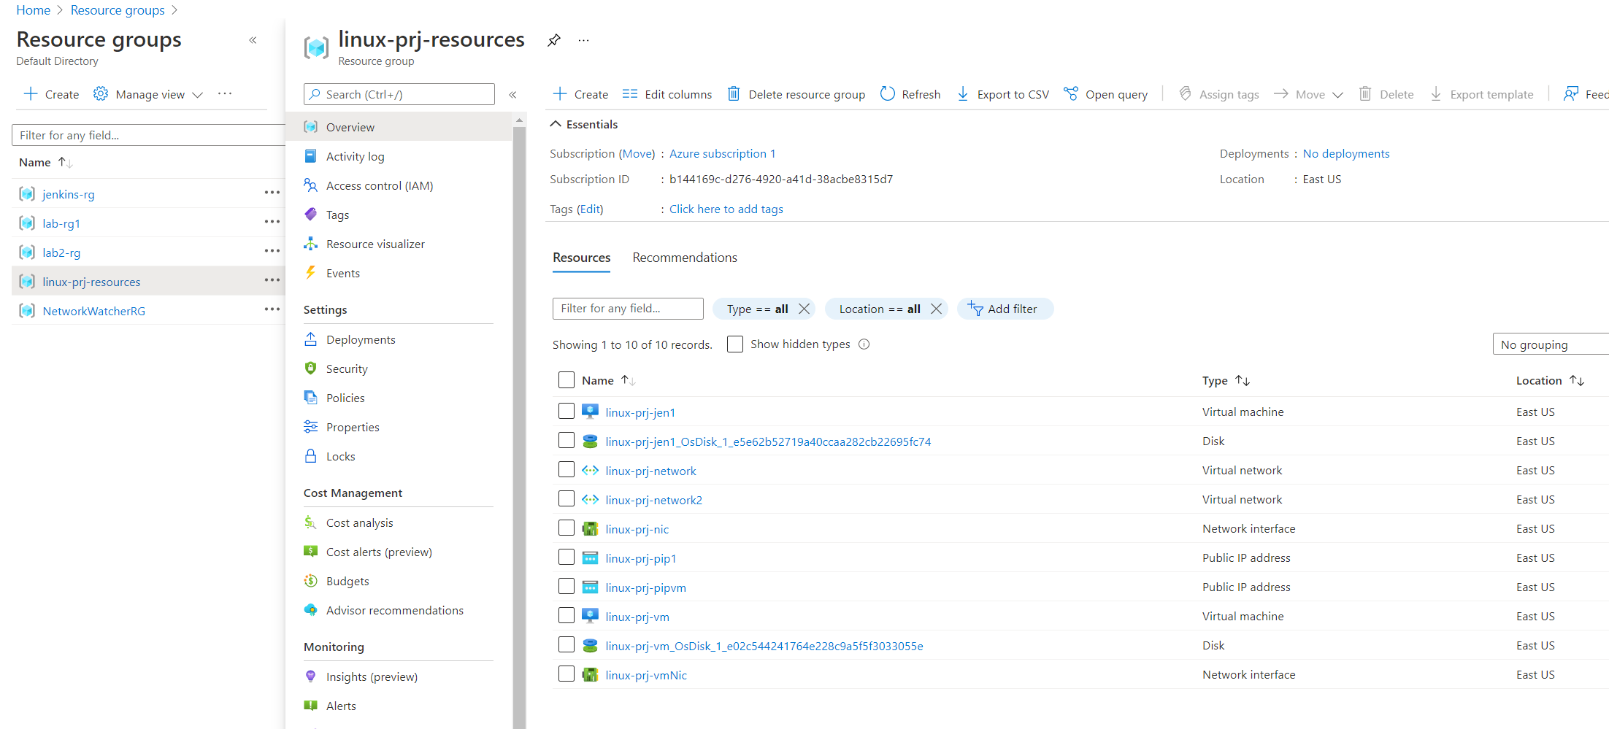

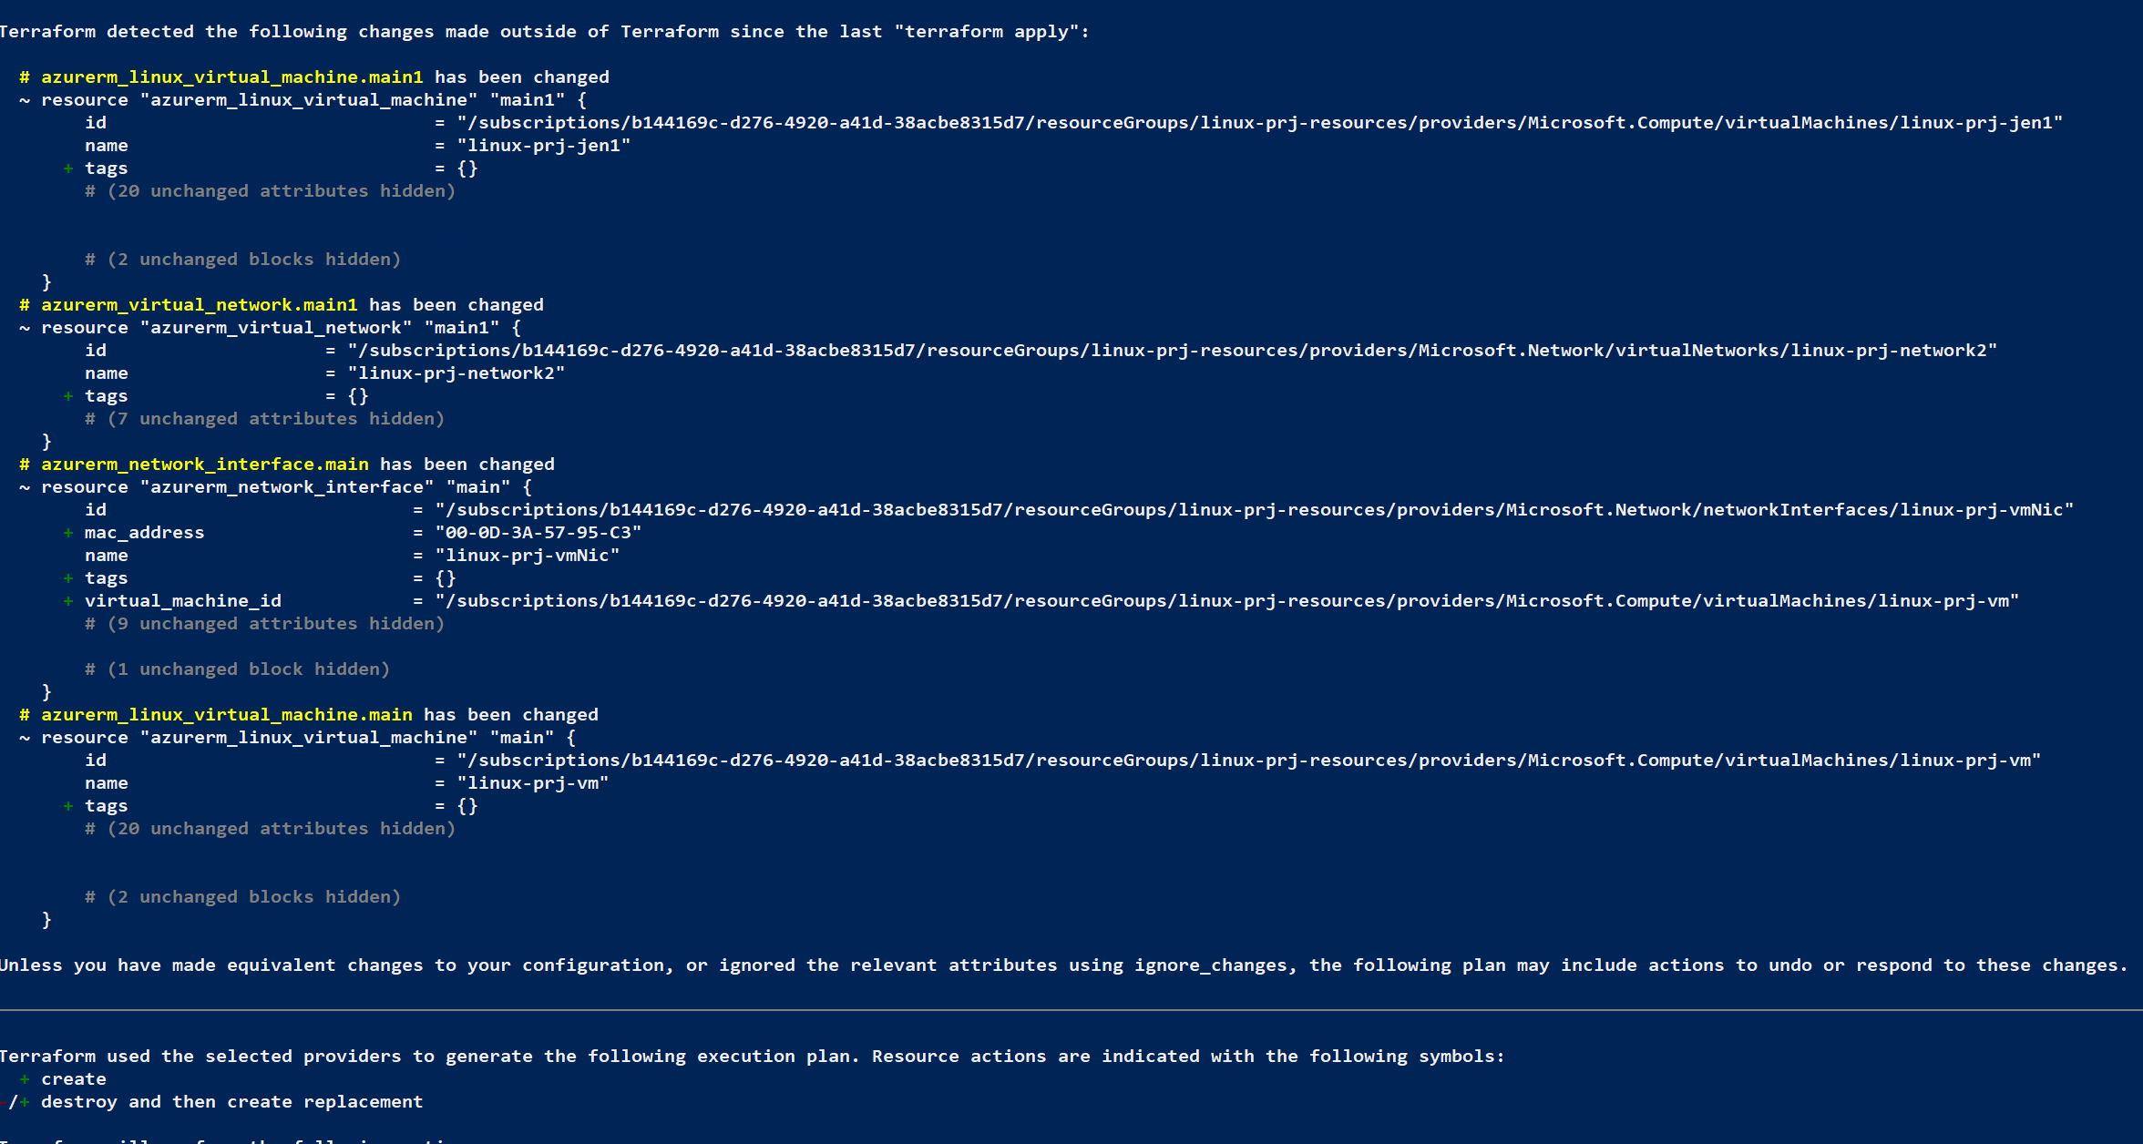

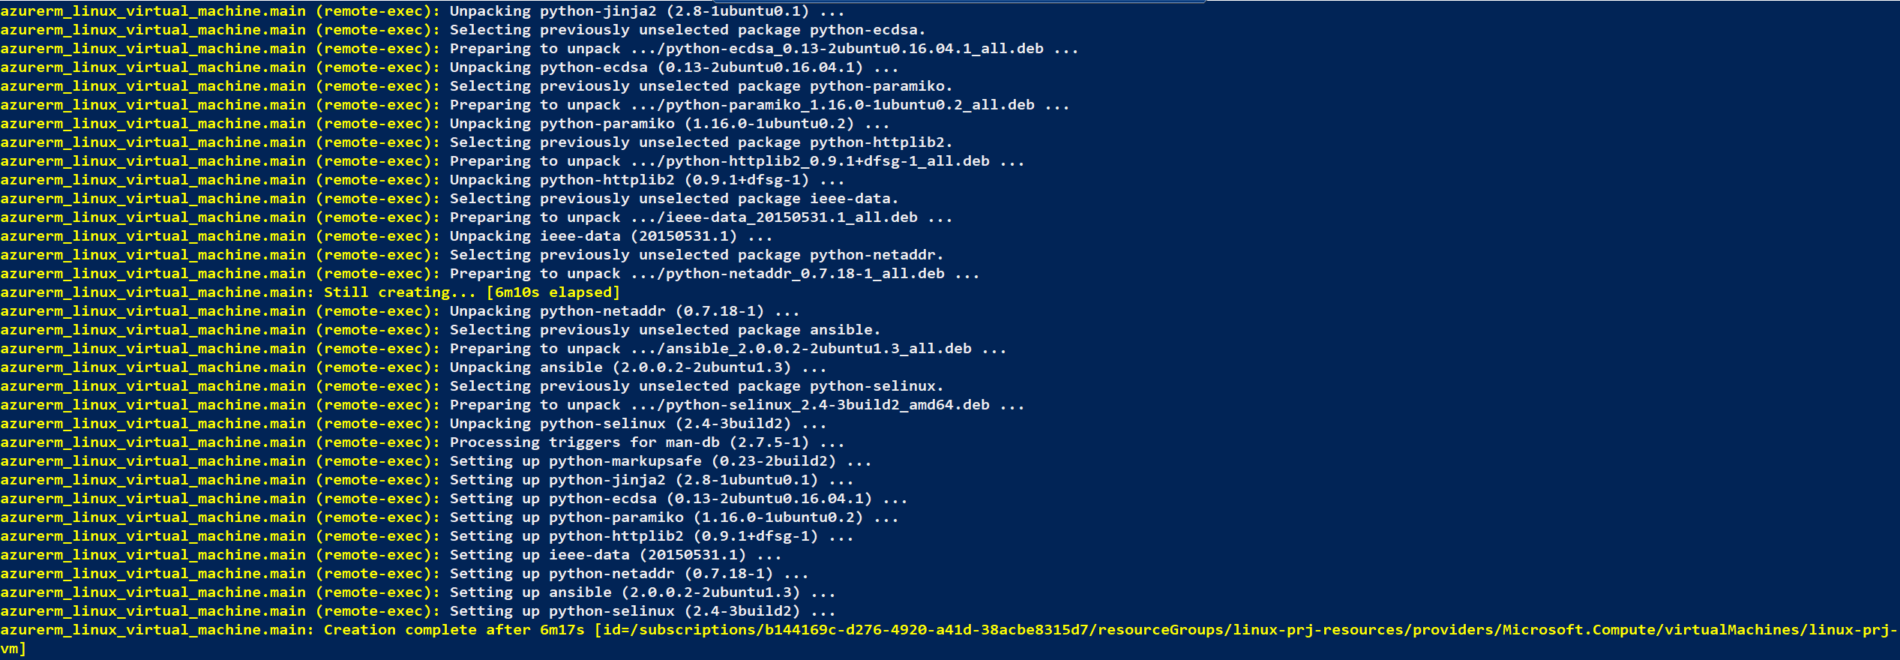

|  |  |  |  |
| --- | --- | --- | --- |
| 8 | Manually Start Jenkins and configure required Plug-ins and Master Slave Configuration | Jenkins | **Pending** |

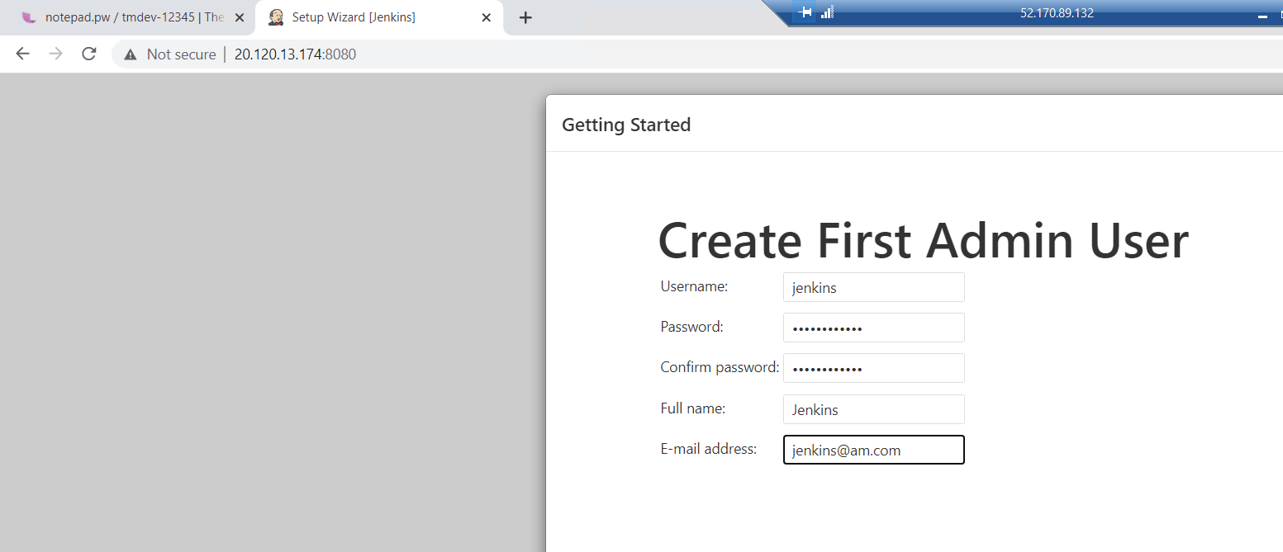

<http://20.120.13.174:8080/>

|  |  |  |  |
| --- | --- | --- | --- |
| 9 | Create Maven Project with Archtype as web application in eclipse | Eclipse | **Done** |
| 10 | Modify Index.jsp under src/main/webcontent to display a custom message | Eclipse | **Done** |
| 11 | Run Maven clean install in eclipse to check the build and ckeck for .war file in target folder | Eclipse | **Done** |
| 12 | Generate Dockerfile under project folder of your app | Eclipse | **Done** |
| 13 | Modify FORM statement to use tomcat as base image | Eclipse | **Done** |
| 14 | Test the Dockerfile by running Docker build and create a container | Docker | **Done** |
| 15 | Access the application from container and check it Browser Create a github repository and copy repo URL | Github Site | **Done** |
| 16 | In Eclipse convert the app in to a local repo from Team meanu share Project Option | Eclipse | **Done** |
| 17 | Commit and Push the code to remote repo | Eclipse | **Done** |
| 18 | Modify Project index.jsp, Commit and Push to remote repo | Eclipse | **Done** |
| 19 | Check for the change in remote Repo | Github Site | **Done** |

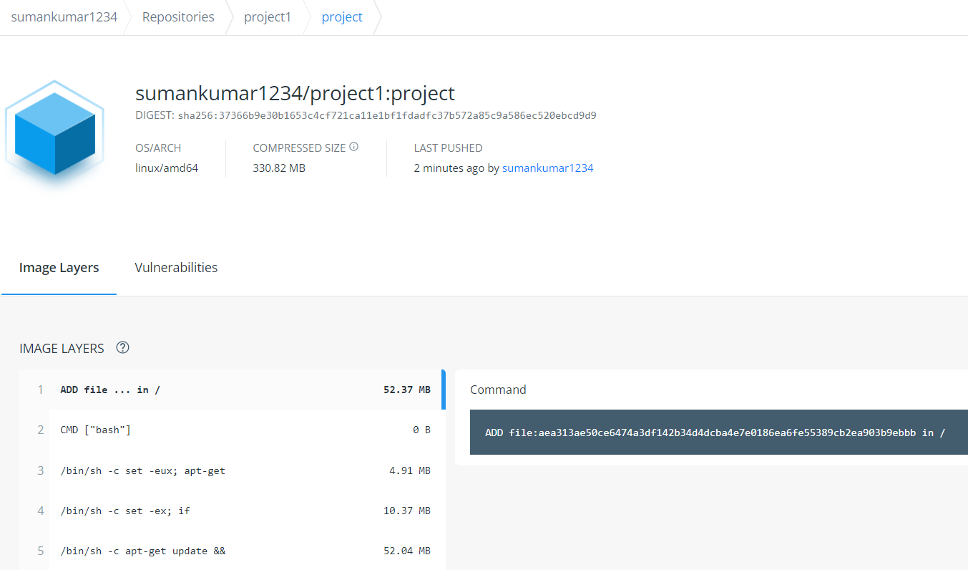

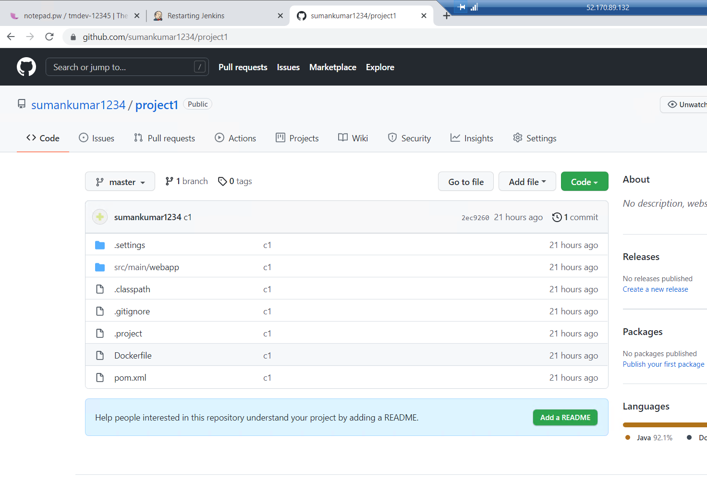

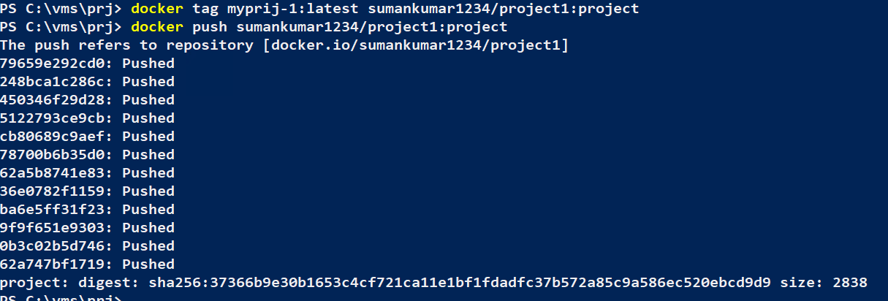

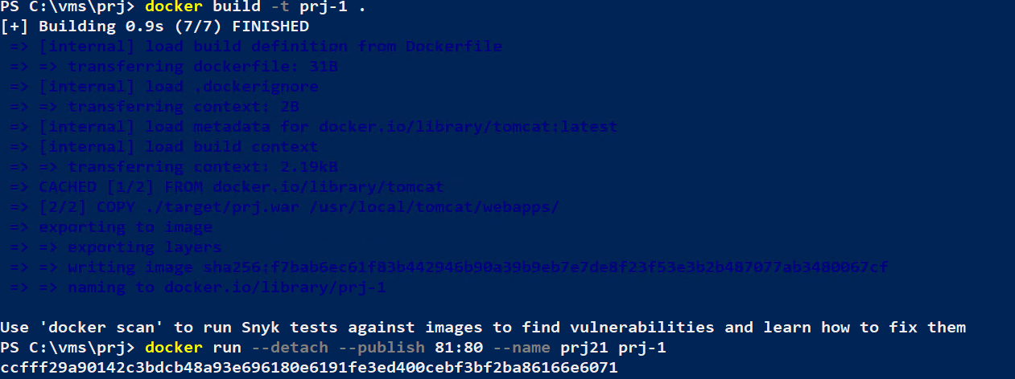

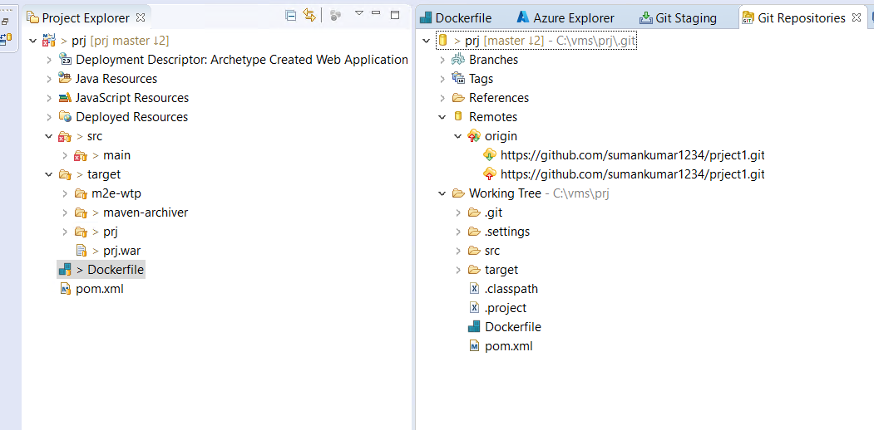

Node Configuration:

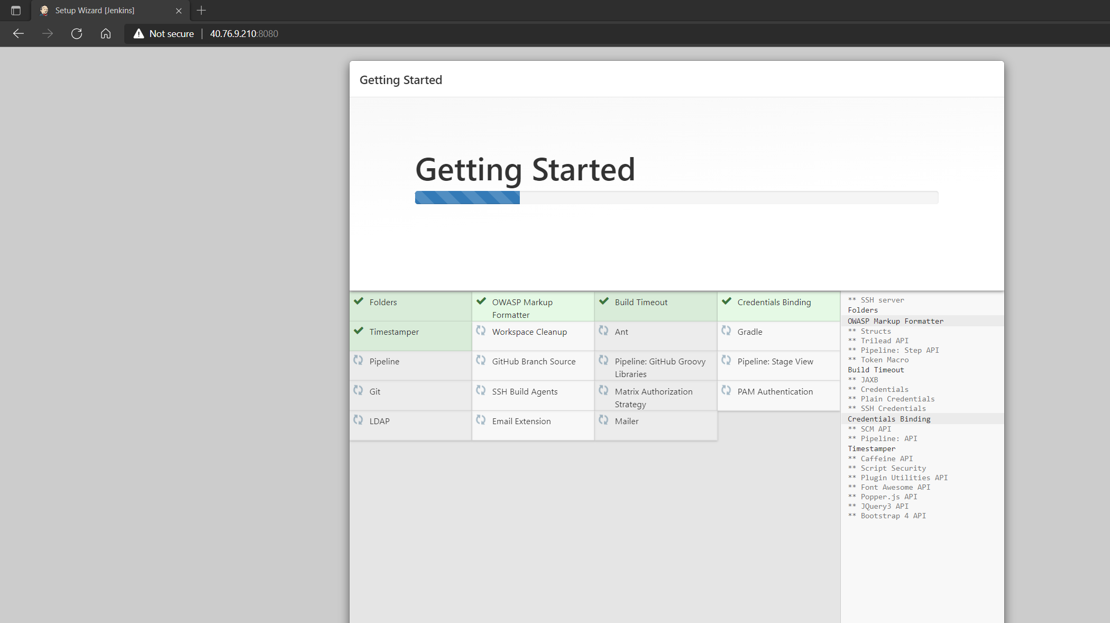

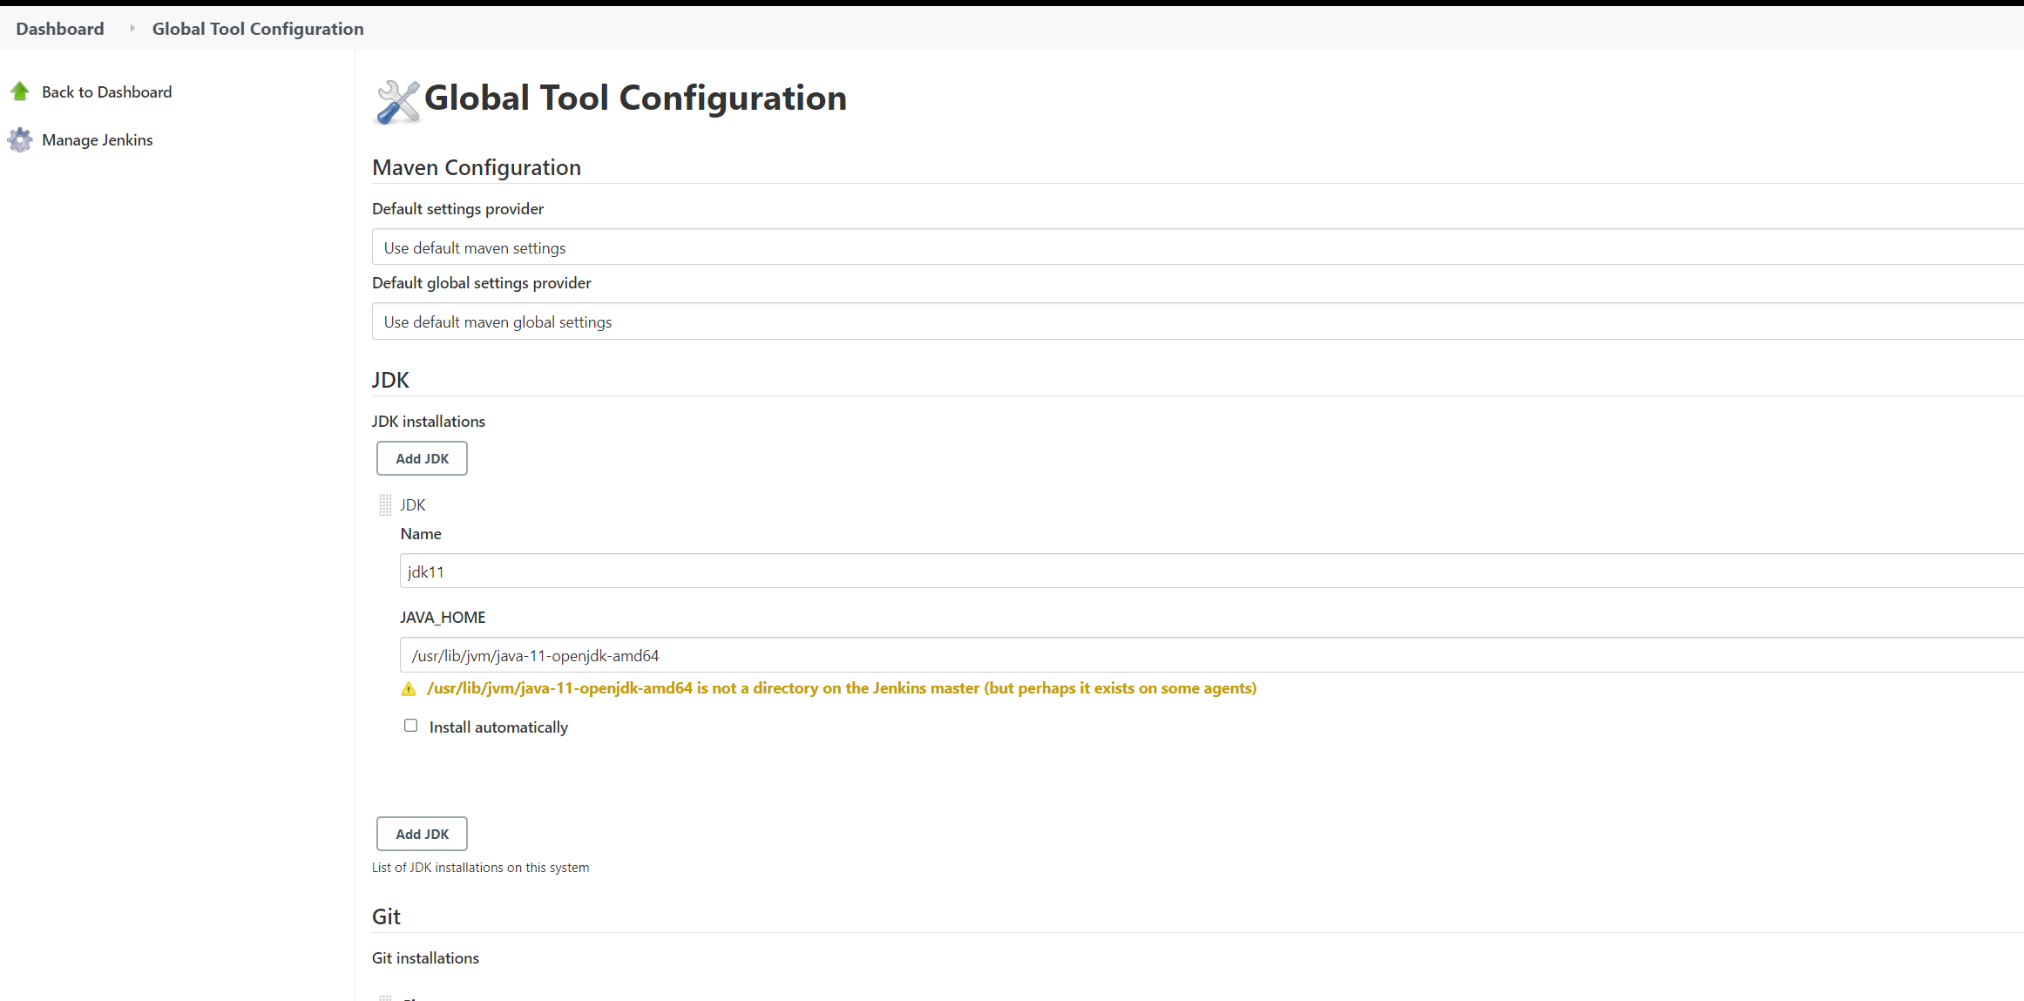

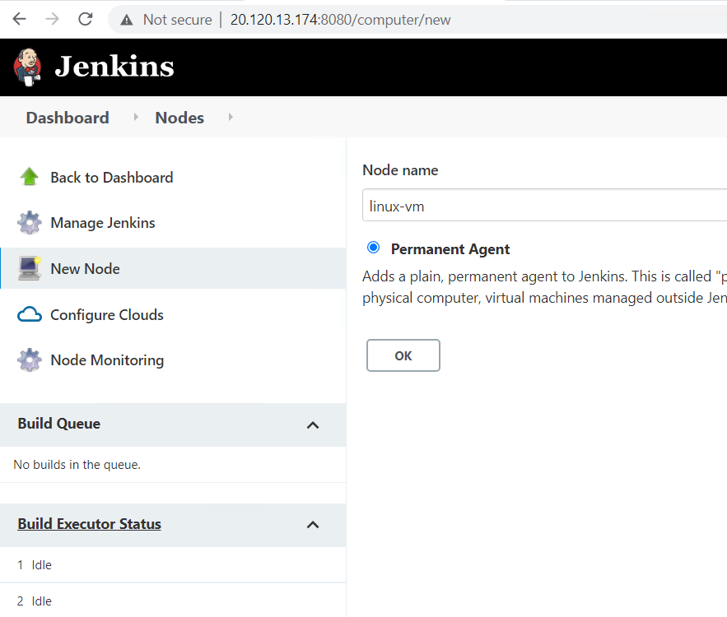

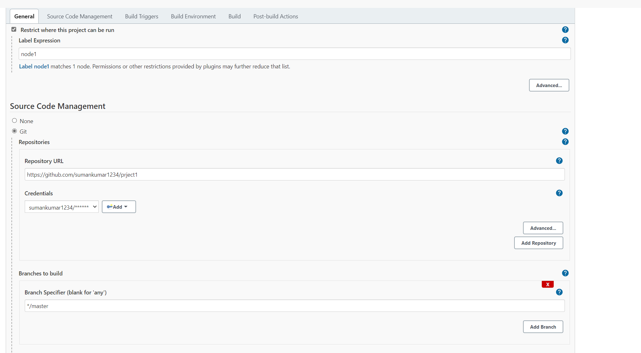

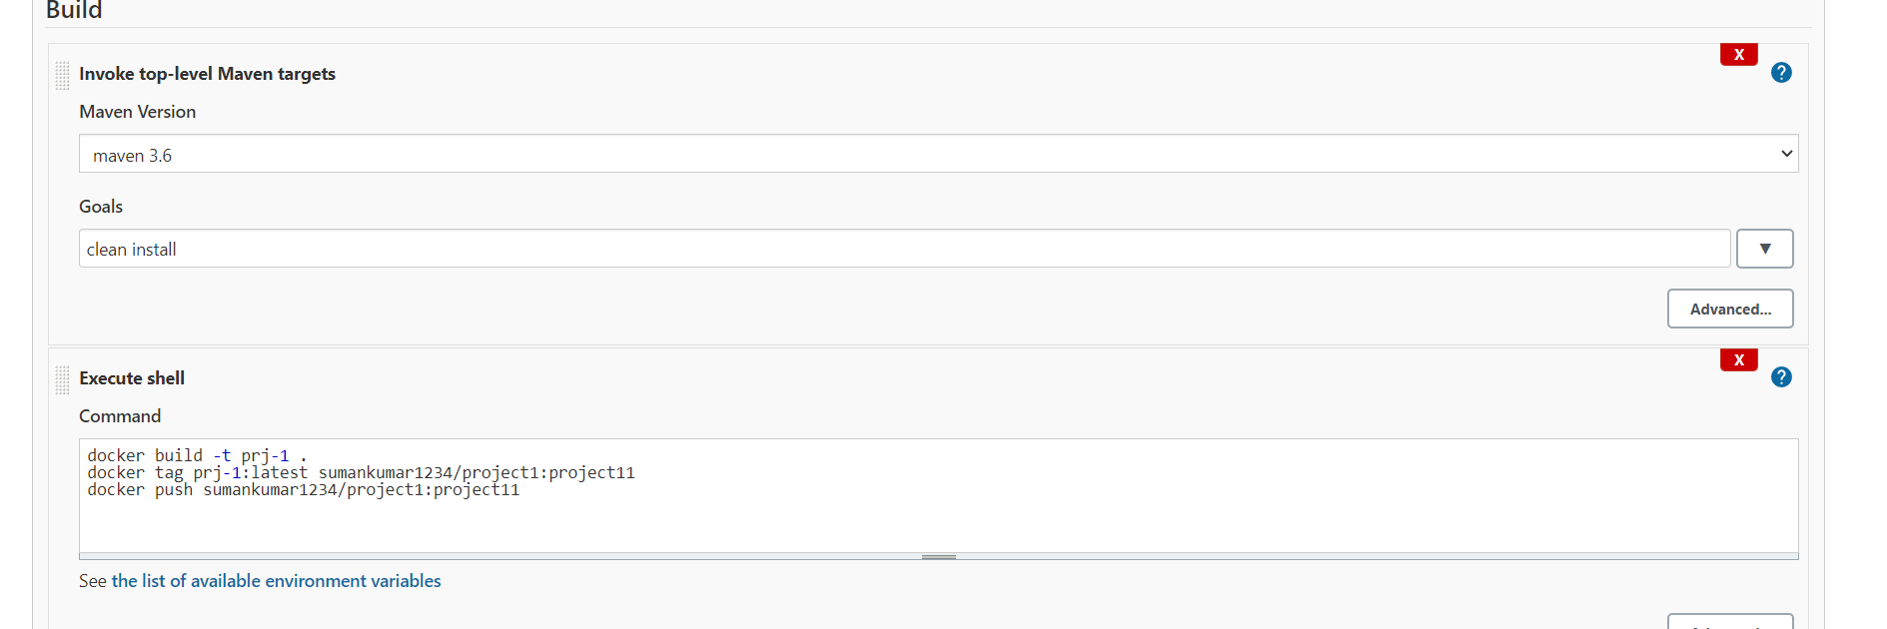

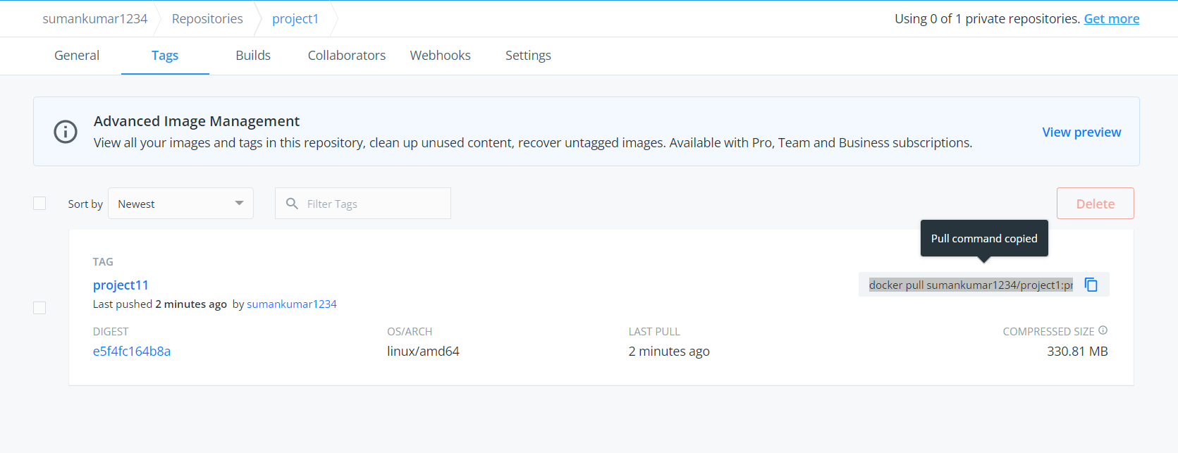

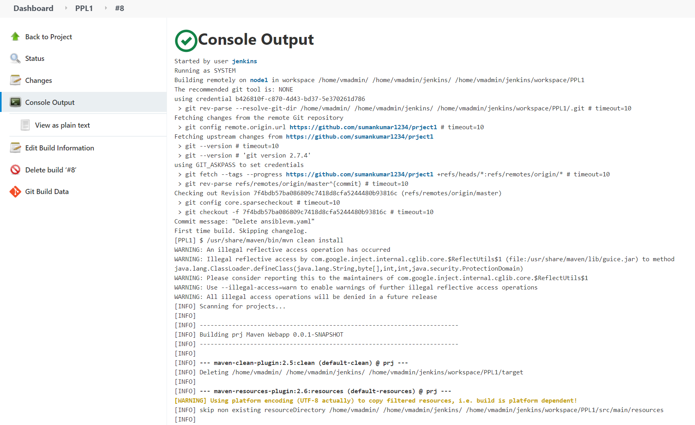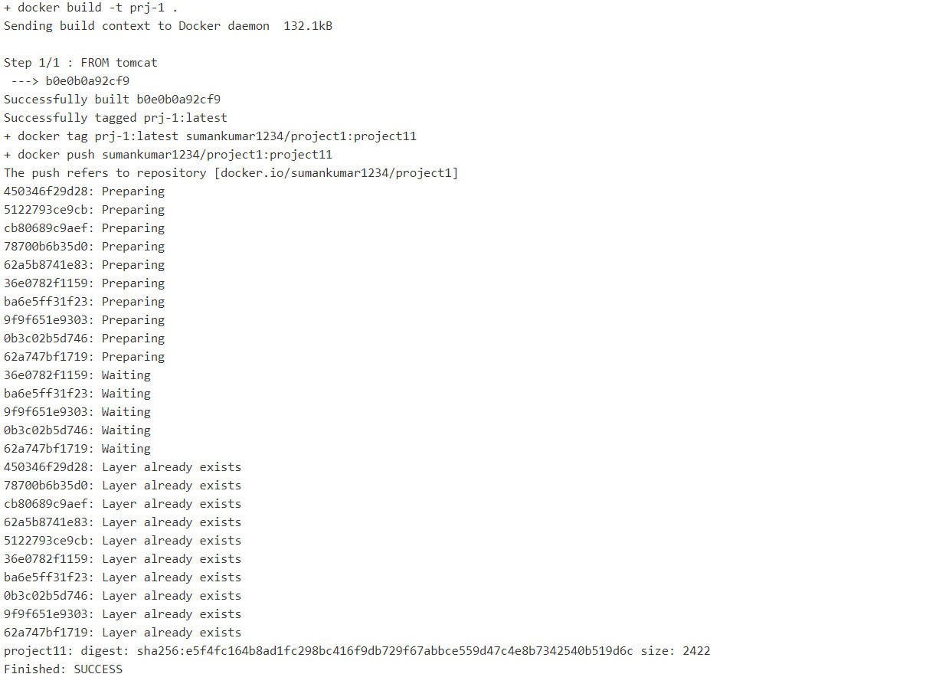

Piplelin 2.

