**To-Do Application**

ToDoApplication

=======

**ToDoApplication** is a simple note taking app for Android. This application has many cool features such as it allows users to create list of tasks which can be managed individually. Each task can have title, description and a time frame.

## Design Pattern

- Model–view–view model (MVVM)

## Features

- Create simple notes, add description and prioritized the notes.

- Search notes in the application.

- Delete notes.

- Delete all notes.

**Download** https://github.com/sumanmahat/MAD1/tree/master/ToDoApp

## Android features used in this app:

• Activities

• Fragments

• Recycler View

• Adapters

• RoomDatabase

• Dao

## Dependencies

- Room components

- implementation "android.arch.persistence.room:runtime:$rootProject.roomVersion"

- annotationProcessor "android.arch.persistence.room:compiler:$rootProject.roomVersion"

- androidTestImplementation "android.arch.persistence.room:testing:$rootProject.roomVersion"

- Lifecycle components

- implementation "android.arch.lifecycle:extensions:$rootProject.archLifecycleVersion"

- annotationProcessor "android.arch.lifecycle:compiler:$rootProject.archLifecycleVersion"

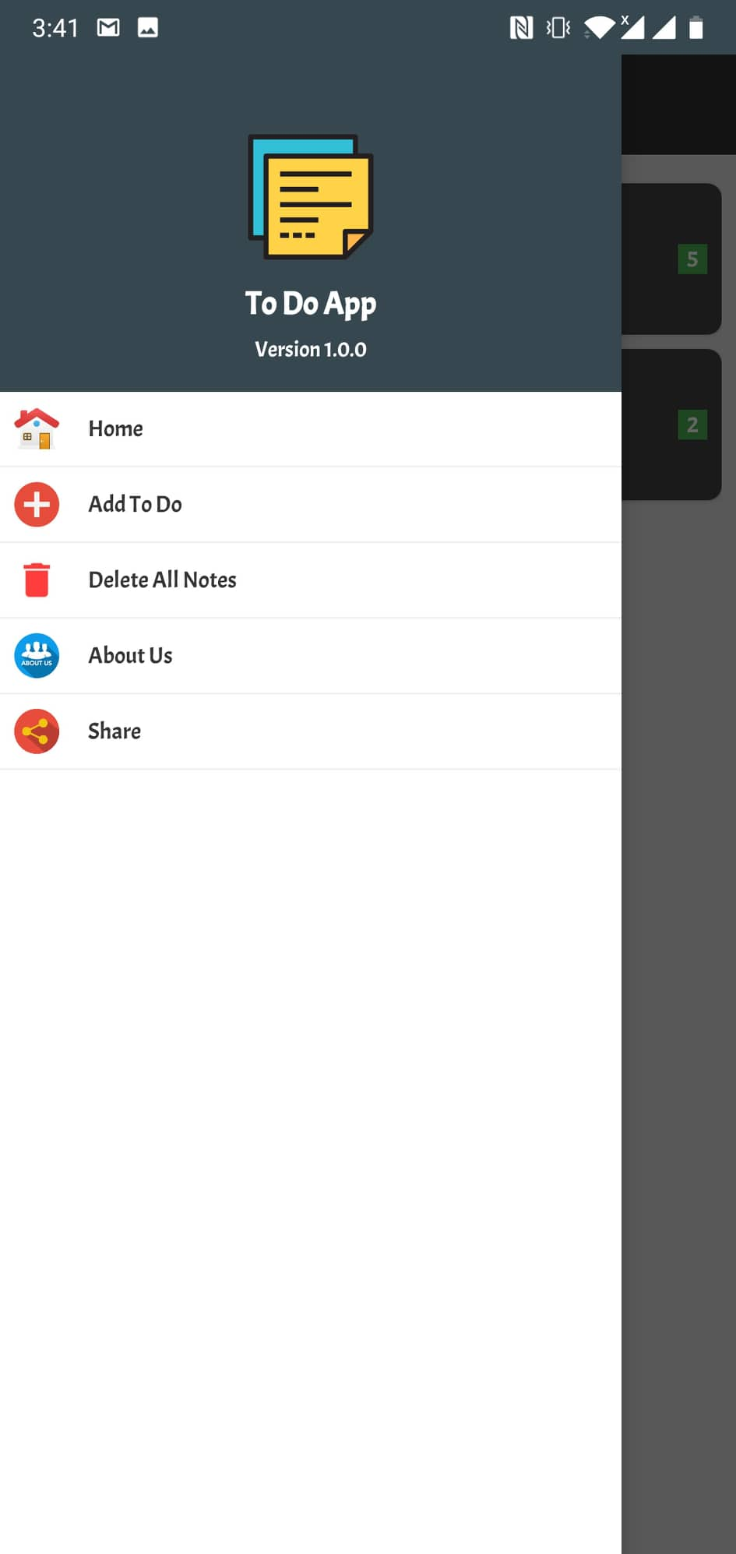

Fig: Home

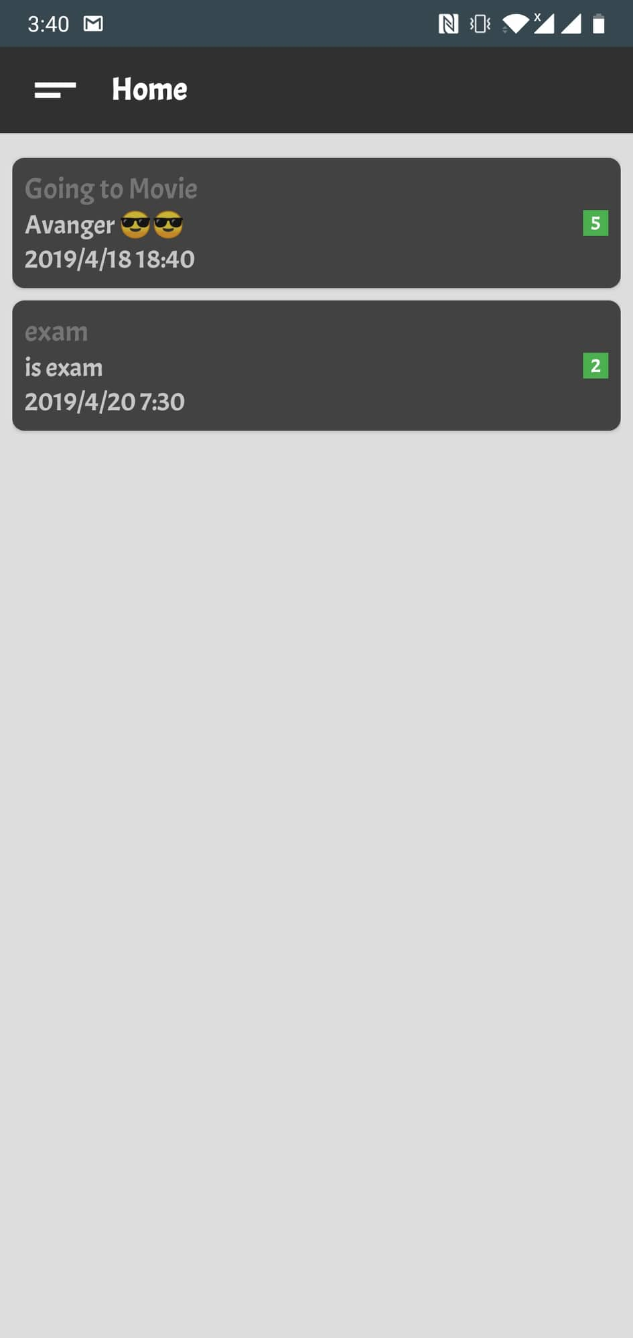

Fig: main screen

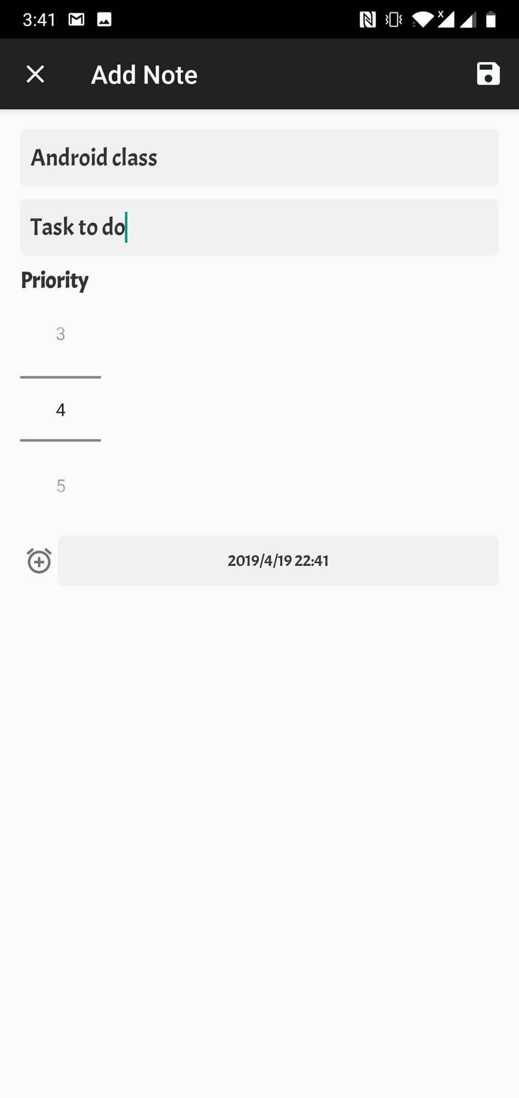

Fig: Add Task

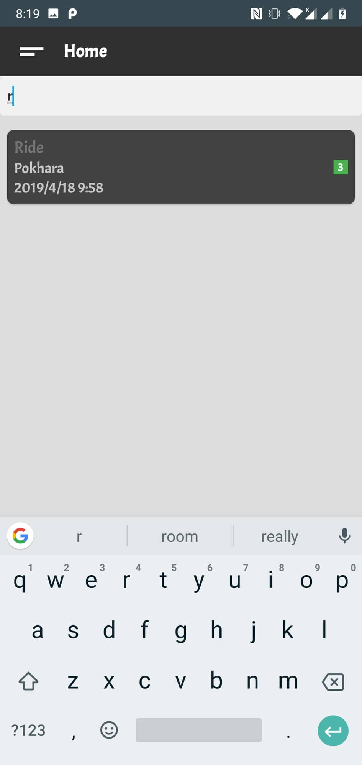

Fig: Search task

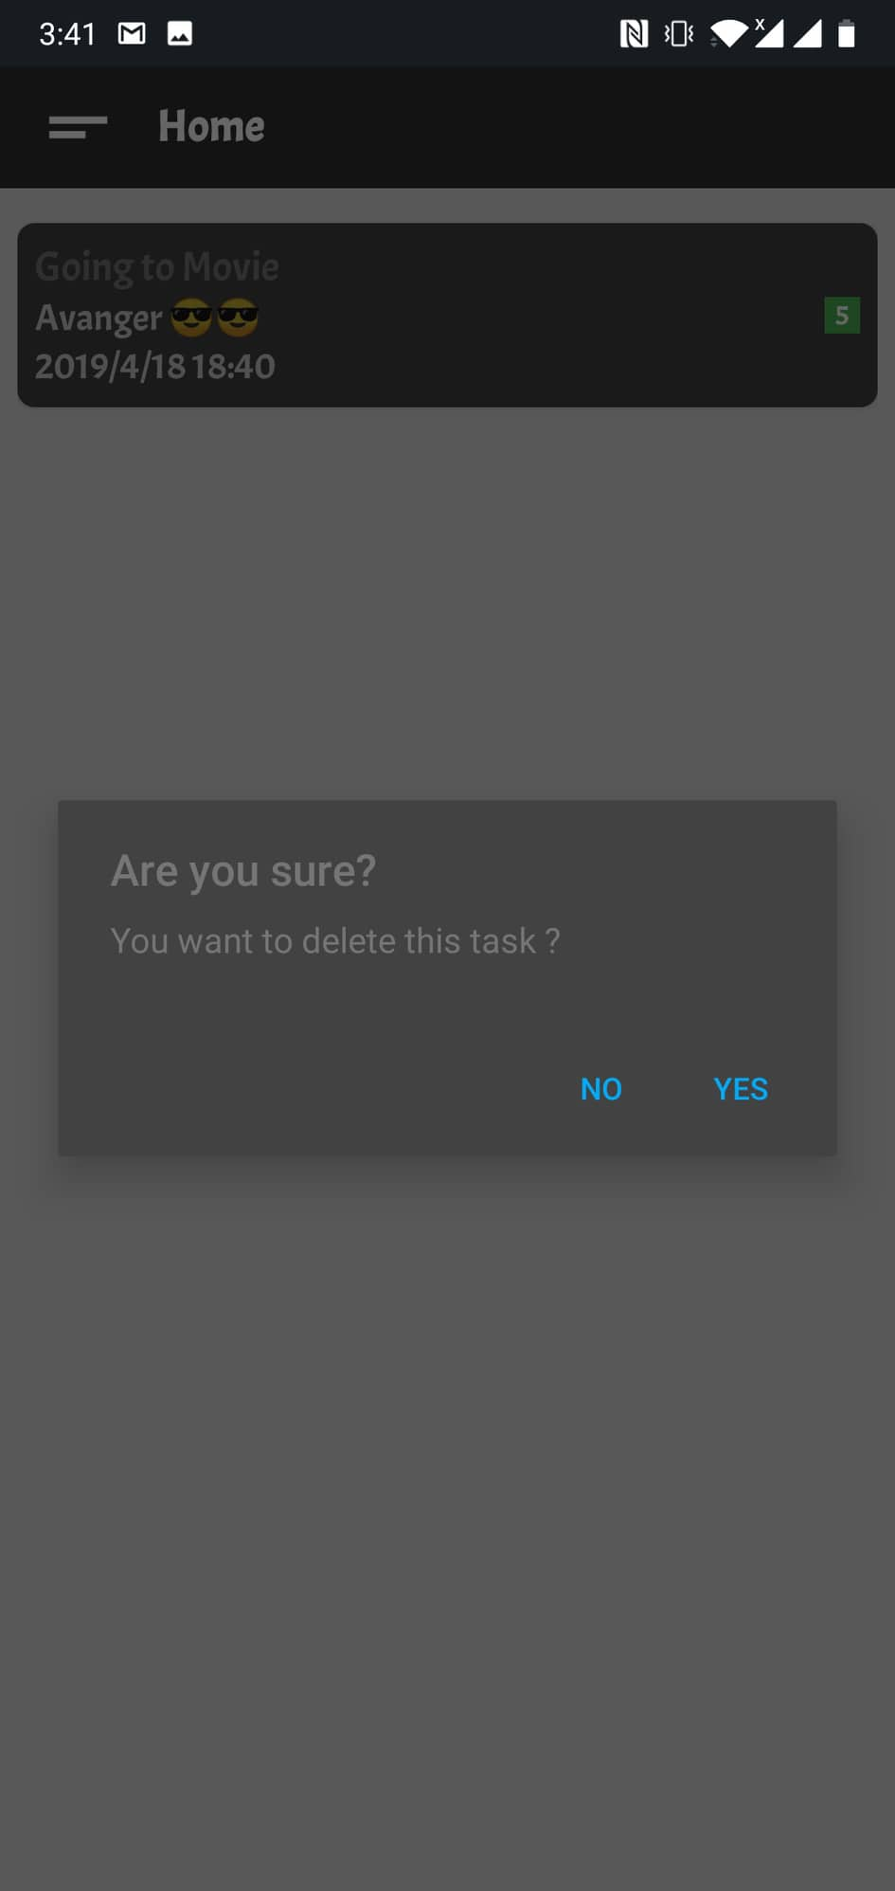

Fig: Deleting task