LAB ASSIGNMENT
Lab 2: Sequential Logic & Memory Hierarchy
Bit | 16-bit Register | RAM8 Register File
Name | Suman Mishra
Course | B.Tech CSE
Section | D
Lab | Lab 2 (CO2, BL3)
Contents
Q-1 1-bit register (Bit chip) with clock cycle trace
Q-2 16-bit Register chip with simulation trace
Q-3 RAM8 (8-register file) with read/write trace

Q-1: 1-bit Register (Bit Chip)
Question: Build the 1-bit DFF-based register (Bit chip) in HDL. Demonstrate read and write timing with a clock cycle trace showing tick-tock behavior.

1. Aim and Working Principle
A Bit chip stores one binary value. A Multiplexer chooses between the stored value (fed back from the D flip-flop) and the new input, using load as the select line. The D flip-flop (DFF) delays its input by one clock cycle and supplies the stored output.

2. Boolean Algebra
muxout = (load · in) + (load' · dffout)
Q(t+1) = muxout(t) [DFF delays by one cycle]
out(t) = Q(t)
When load = 0 the bit holds its value, and when load = 1 it takes the value of in.

3. Truth Table (Next State)
load | in | Q(t) | Q(t+1) | Action
0 | 0 | 0 | 0 | Hold
0 | 0 | 1 | 1 | Hold
0 | 1 | 0 | 0 | Hold (in ignored)
0 | 1 | 1 | 1 | Hold (in ignored)
1 | 0 | 0 | 0 | Write 0
1 | 0 | 1 | 0 | Write 0
1 | 1 | 0 | 1 | Write 1
1 | 1 | 1 | 1 | Write 1

4. Block Diagram
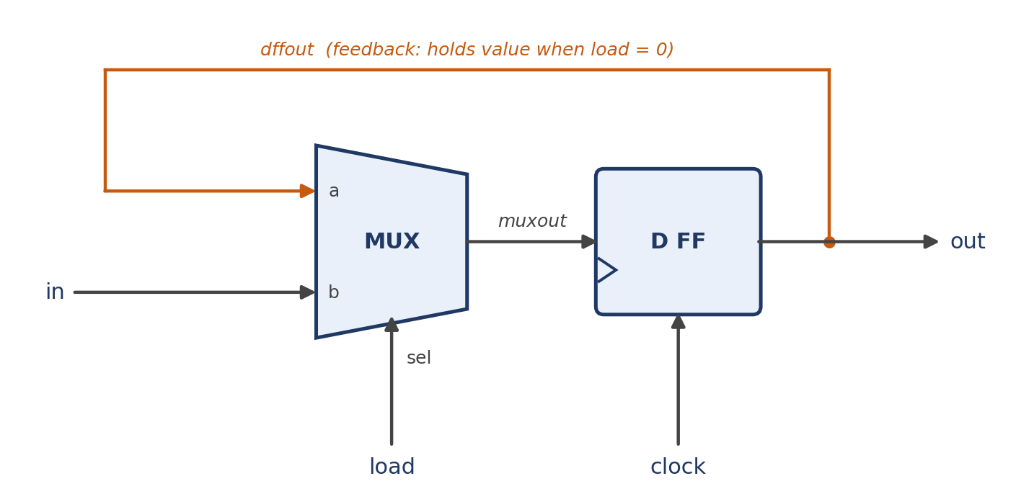
Fig. 1: Block diagram of the 1-bit register (Bit chip)

5. HDL Code
CHIP Bit {
IN in, load;
OUT out;

PARTS:
Mux(a=dffout, b=in, sel=load, out=muxout);
DFF(in=muxout, out=dffout, out=out);
}

6. Clock Cycle Trace (Tick-Tock)
The tick is the rising edge, when the input is sampled. The tock is the falling edge, when the output is updated and stable.
Cycle | in | load | out after tick | out after tock | Action
0 | 0 | 0 | 0 | 0 | Initial state
1 | 1 | 1 | 0 | 1 | Write 1 (visible after tock)
2 | 0 | 0 | 1 | 1 | load = 0, holds 1
3 | 0 | 1 | 1 | 0 | Write 0
4 | 1 | 0 | 0 | 0 | load = 0, input ignored
5 | 1 | 1 | 0 | 1 | Write 1
Observation: a write made at time t appears on out at time t+1. A read is simply out, which always shows the stored value.

Q-2: 16-bit Register
Question: Build the 16-bit Register chip in HDL. Show read/write operations for three sample inputs and capture simulation output.

1. Aim and Working Principle
A 16-bit Register is built from sixteen Bit chips arranged in parallel. All Bits share the same load signal and the same clock, so the whole word is stored or held together.

2. Boolean Algebra
For each bit i = 0 … 15:
out[i](t+1) = (load · in[i]) + (load' · out[i](t))

3. Truth Table
Each bit follows the Bit-chip truth table, so the 16-bit chip is sixteen copies of it. The word-level behaviour is:
load | Behaviour | Result
0 | Hold | out(t+1) = out(t)
1 | Write | out(t+1) = in(t)

4. Block Diagram
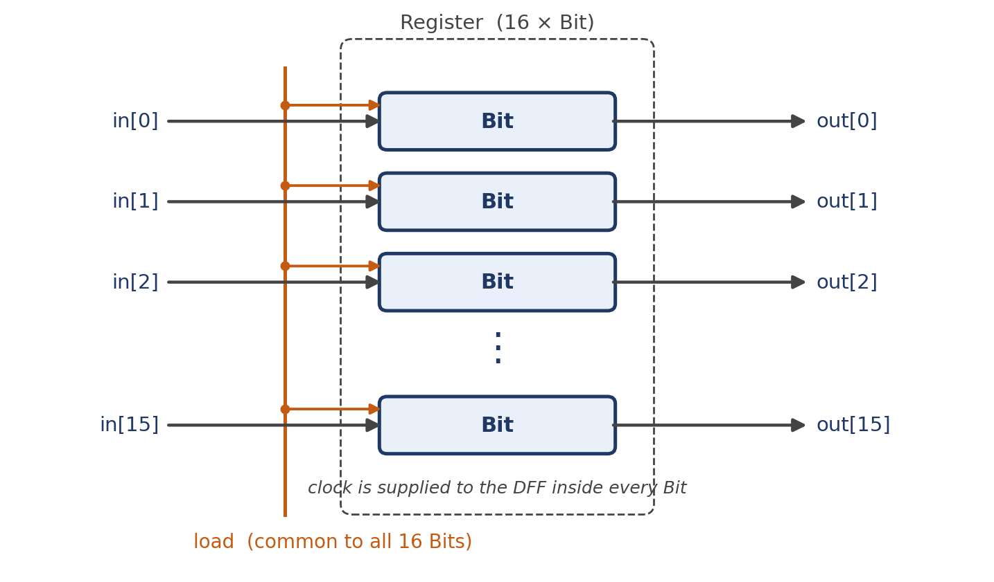
Fig. 2: Block diagram of the 16-bit Register chip

5. HDL Code
CHIP Register {
IN in[16], load;
OUT out[16];

PARTS:
Bit(in=in[0], load=load, out=out[0]);
Bit(in=in[1], load=load, out=out[1]);
Bit(in=in[2], load=load, out=out[2]);
Bit(in=in[3], load=load, out=out[3]);
Bit(in=in[4], load=load, out=out[4]);
Bit(in=in[5], load=load, out=out[5]);
Bit(in=in[6], load=load, out=out[6]);
Bit(in=in[7], load=load, out=out[7]);
Bit(in=in[8], load=load, out=out[8]);
Bit(in=in[9], load=load, out=out[9]);
Bit(in=in[10], load=load, out=out[10]);
Bit(in=in[11], load=load, out=out[11]);
Bit(in=in[12], load=load, out=out[12]);
Bit(in=in[13], load=load, out=out[13]);
Bit(in=in[14], load=load, out=out[14]);
Bit(in=in[15], load=load, out=out[15]);
}

6. Simulation Trace (Three Sample Inputs)
Time | in | load | out (after next tock) | Operation
t0 | 0000000000000000 | 0 | 0000000000000000 | Initial
t1 | 0001001000110100 | 1 | 0001001000110100 | Write 1 (0x1234)
t2 | 1111111111111111 | 0 | 0001001000110100 | Read, input ignored
t3 | 1010101010101010 | 1 | 1010101010101010 | Write 2 (0xAAAA)
t4 | 0000000000000000 | 0 | 1010101010101010 | Read, holds
t5 | 0000111100001111 | 1 | 0000111100001111 | Write 3 (0x0F0F)
t6 | 0000111100001111 | 0 | 0000111100001111 | Read

7. Test Script (Optional)
load Register.hdl,
output-file Register.out,
compare-to Register.cmp,
output-list time%S1.4.1 in%B1.16.1 load%B2.1.2 out%B1.16.1;

set in %B0001001000110100, set load 1, tick, output; tock, output;
set in %B1111111111111111, set load 0, tick, output; tock, output;
set in %B1010101010101010, set load 1, tick, output; tock, output;
set load 0, tick, output; tock, output;
set in %B0000111100001111, set load 1, tick, output; tock, output;

Q-3: RAM8 (8-Register File)
Question: Build the 8-register Register File chip in HDL. Trace read/write operations for at least four different addresses. Show all register states after each write.

1. Aim and Working Principle
RAM8 contains eight 16-bit Registers. A DMux8Way routes the load signal to exactly one register, selected by the 3-bit address, so only that register is written. A Mux8Way16 uses the same address to select which register drives out.

2. Boolean Algebra
Write-enable for each register (DMux8Way outputs), with A = address[2..0]:
L0 = load · A2' · A1' · A0'
L1 = load · A2' · A1' · A0
L2 = load · A2' · A1 · A0'
L3 = load · A2' · A1 · A0
L4 = load · A2 · A1' · A0'
L5 = load · A2 · A1' · A0
L6 = load · A2 · A1 · A0'
L7 = load · A2 · A1 · A0
Read and update equations:
out = R[address] (8:1 Mux over 16 bits)
Ri(t+1) = (Li · in) + (Li' · Ri(t))

3. Truth Table (DMux8Way Write Select)
load | A2 A1 A0 | L0 | L1 | L2 | L3 | L4 | L5 | L6 | L7
0 | xxx | 0 | 0 | 0 | 0 | 0 | 0 | 0 | 0
1 | 000 | 1 | 0 | 0 | 0 | 0 | 0 | 0 | 0
1 | 001 | 0 | 1 | 0 | 0 | 0 | 0 | 0 | 0
1 | 010 | 0 | 0 | 1 | 0 | 0 | 0 | 0 | 0
1 | 011 | 0 | 0 | 0 | 1 | 0 | 0 | 0 | 0
1 | 100 | 0 | 0 | 0 | 0 | 1 | 0 | 0 | 0
1 | 101 | 0 | 0 | 0 | 0 | 0 | 1 | 0 | 0
1 | 110 | 0 | 0 | 0 | 0 | 0 | 0 | 1 | 0
1 | 111 | 0 | 0 | 0 | 0 | 0 | 0 | 0 | 1

4. Block Diagram
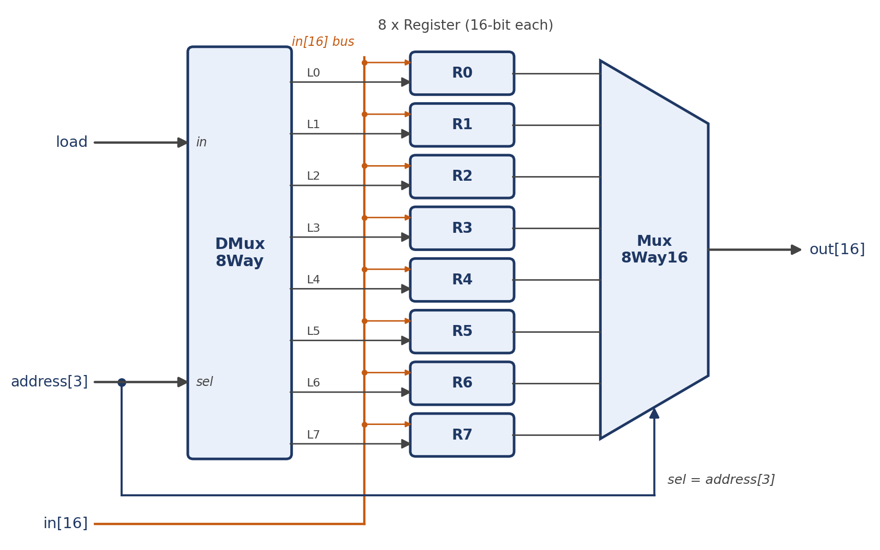
Fig. 3: Block diagram of RAM8 (8-register file)

5. HDL Code
CHIP RAM8 {
IN in[16], load, address[3];
OUT out[16];

PARTS:
DMux8Way(in=load, sel=address,
a=l0, b=l1, c=l2, d=l3, e=l4, f=l5, g=l6, h=l7);

Register(in=in, load=l0, out=r0);
Register(in=in, load=l1, out=r1);
Register(in=in, load=l2, out=r2);
Register(in=in, load=l3, out=r3);
Register(in=in, load=l4, out=r4);
Register(in=in, load=l5, out=r5);
Register(in=in, load=l6, out=r6);
Register(in=in, load=l7, out=r7);

Mux8Way16(a=r0, b=r1, c=r2, d=r3, e=r4, f=r5, g=r6, h=r7,
sel=address, out=out);
}

6. Read/Write Trace (Four Different Addresses)
All registers start at 0. Values are in decimal. Highlighted cells show the register changed by each write.
Step | Addr | in | load | Operation | R0 | R1 | R2 | R3 | R4 | R5 | R6 | R7
0 | - | - | - | Initial | 0 | 0 | 0 | 0 | 0 | 0 | 0 | 0
1 | 000 | 10 | 1 | Write R0 | 10 | 0 | 0 | 0 | 0 | 0 | 0 | 0
2 | 011 | 25 | 1 | Write R3 | 10 | 0 | 0 | 25 | 0 | 0 | 0 | 0
3 | 101 | 100 | 1 | Write R5 | 10 | 0 | 0 | 25 | 0 | 100 | 0 | 0
4 | 111 | 7 | 1 | Write R7 | 10 | 0 | 0 | 25 | 0 | 100 | 0 | 7
5 | 011 | 99 | 0 | Read R3 | 10 | 0 | 0 | 25 | 0 | 100 | 0 | 7
6 | 000 | 0 | 0 | Read R0 | 10 | 0 | 0 | 25 | 0 | 100 | 0 | 7
7 | 111 | 0 | 0 | Read R7 | 10 | 0 | 0 | 25 | 0 | 100 | 0 | 7

7. Output Read at Each Read Step
Step | address | Register read | out
5 | 011 | R3 | 25
6 | 000 | R0 | 10
7 | 111 | R7 | 7
Observation: writes take effect after the clock edge, while reads are combinational, so out follows address immediately. Step 5 shows that load = 0 blocks the write even though in = 99.

