Transactional Log Shipping in SQL Server 2016

SQL Server Log shipping allows you to automatically send transaction log backups from a primary database on a primary server instance to one or more secondary databases on separate secondary server instances. The transaction log backups are applied to each of the secondary databases individually. An optional third server instance, known as the monitor server, records the history and status of backup and restore operations and, optionally, raises alerts if these operations fail to occur as scheduled.

The Transaction Log Shipping under goes three steps.

Steps carried out in Primary Server.

1. Backup the Transaction Log of Primary Server (Database) by the SQL Server Agent to Network drive/Mapped Drive or the shared folder.

Other two steps are carried out in secondary server.

1. Copy the Transaction Log from the Primary Server which has been backup in step 1 and copy to the local drive folder.
2. Restore the copied backup in Secondary server.

There is some Pre-requisite before set up of the Transaction Log Shipping in SQL Server 2016

1. You need at least two server Primary Server (Production Server) and Secondary Server (Report Server OR Server to Ship logs of Primary Server).
2. Need to Create Shared Folder in Primary Server with Read/Write permission but recommended to use the Network drive for the backup in case primary server fails.

Steps to make a Share Folder.

Right Click on the Folder which you want to make a Shared Folder. Click on Sharing Tab of the Properties window. And click on the Share.. Button of the window as shown in the figure.

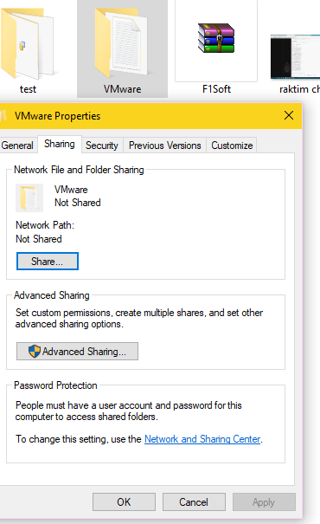

The privilege windows pops which ask to choose whom to share the folder the permission. Click on **Share** if the owner is OK if now you can add from the user adding on Text box. And click on **Done** Button and we are all set. The Chosen folder is shared.

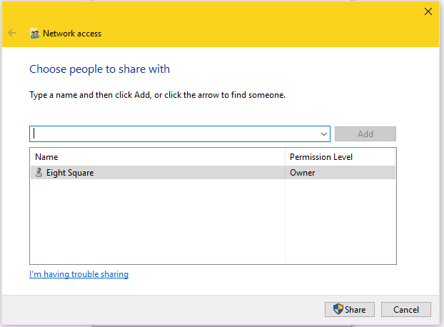

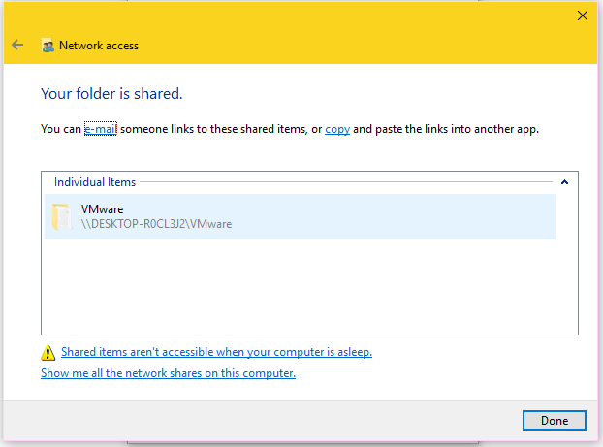

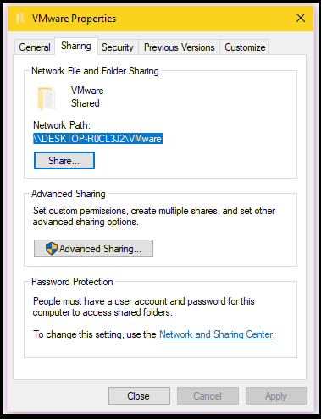

As Shown in above figure the Network Path has been display. You can use this Network Path afterward while defining the network path for the Backup of the Transaction Log.

1. Need to install feature .NET framework 3.5 in Secondary Server.

The steps to Configure Transaction Log Shipping is illustrated in images.

**Step 1**

Before carried out the process to set up of Primary server the Database which we are planning to be Log Ship should be on Full Recovery mode OR Bulk Recovery Mode. We can change the Database Recovery Mode in following two steps.

Right Click on Database which you are going to Log Ship and Click to the Properties as in below image.

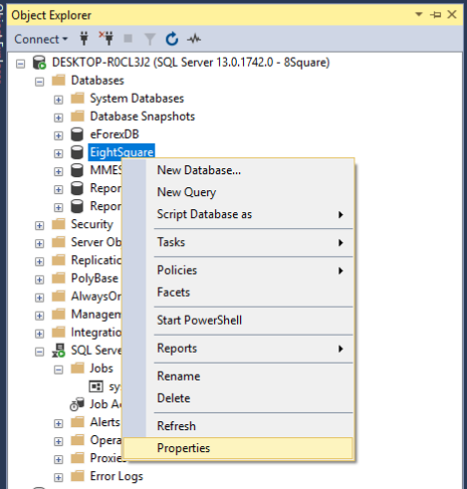

And go Option Menu and Change the Database Recovery mode from Recovery mode option.

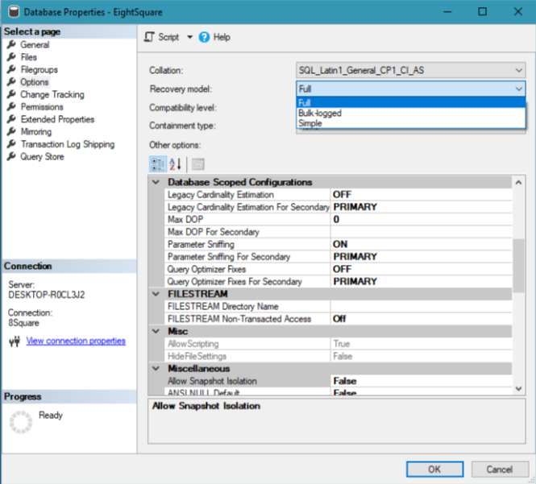

After the Recovery mode is changed we are all set to go Transaction Log Shipping.

The very first step for the Transactional Log Shipping right click on the Database whose logs do you we want to ship. In My case I am using EightSquare Database for the Log Shipping. And click on Task 🡪 Ship Transactional Log.. as shown in the image.

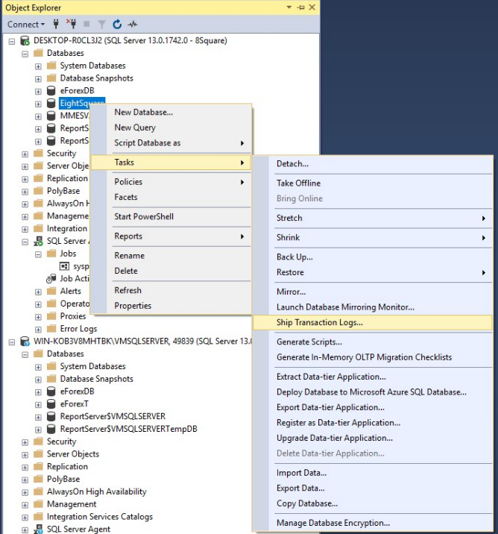

Now, new Windows will pop-up. As in the below image.

In this window we will set the Transaction log Backup of the selected database

Click on Backup Setting Button which pops up the new window to set the backup path and the backup schedule as shown in the following images.

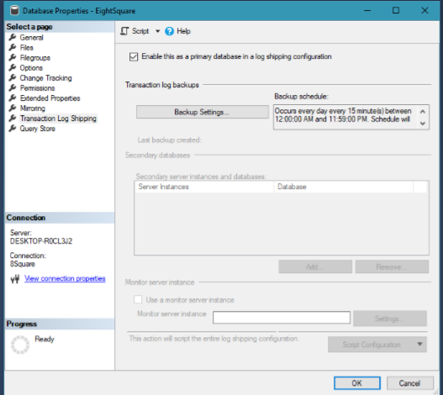

The backup path should be in Network drive or Shared folder on the sever other than Primary and Secondary Server because if the Primary server fails we won’t lose more data. But in my case I am using Shared Folder in Primary server for the demo purpose. According to the size of the Transaction Log and the Time needed to back up the Transaction Log of the database we can schedule the backup as per the requirement from the Schedule.. Button. And Click OK, Our **STEP 1** has been completed.has

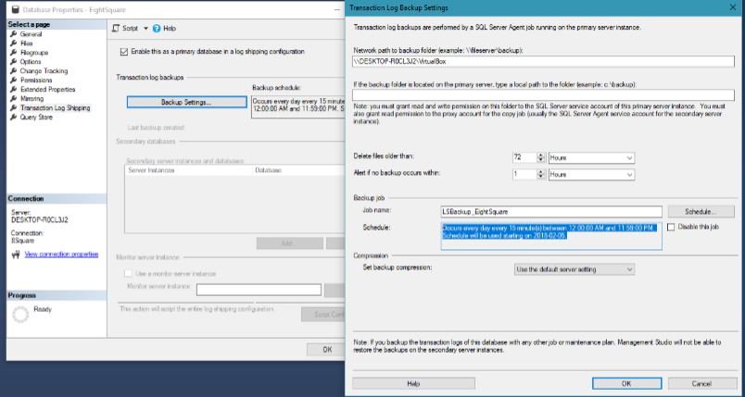

**STEP 2:**

In this Step the Transaction Log which has been backup is moved to the Secondary Server by the Scheduler Job of the Secondary Server. For the Setup of the process we should first add the secondary server by clicking the **Add** Button as shown in below image which pops out the new window. In this new window we need to Initialize the Secondary Server. Click the **Connect** Button and database connect wizard pops up and fill the secondary sever details for the connection.

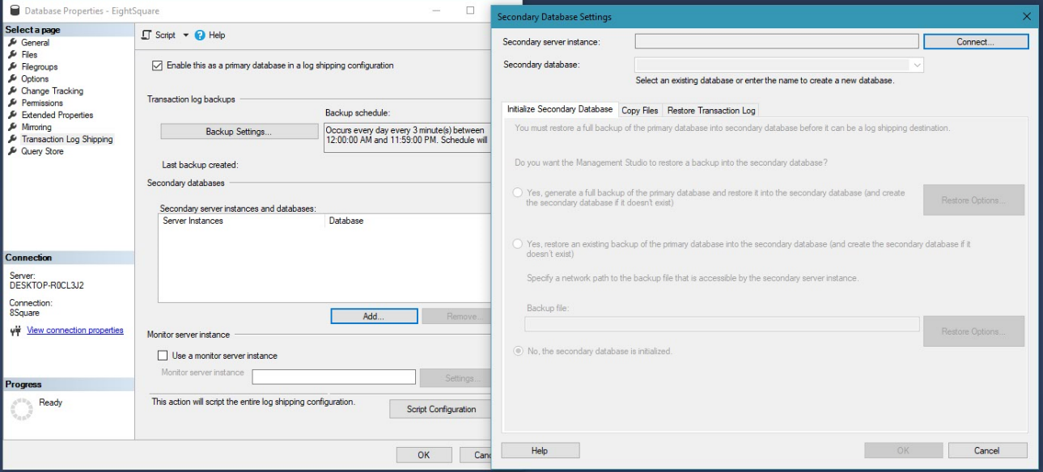

As I am Using the following Secondary Server for the Transactional Log Shipping. 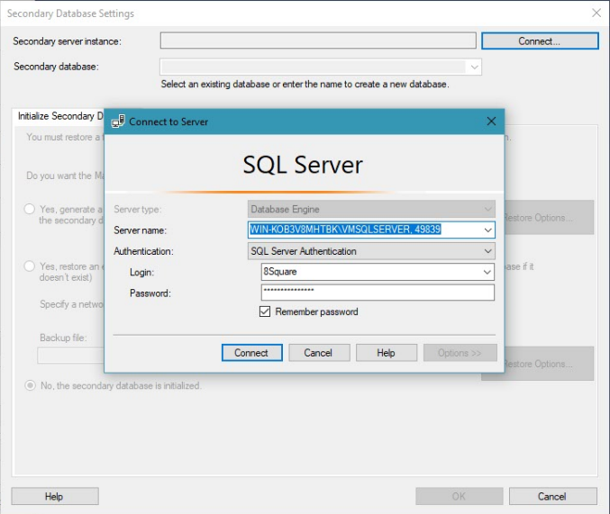

As soon as the Secondary Server is connected we are asked how the database is Restored in the secondary server. There are 3 ways to restore the database from Primary server to Secondary server. 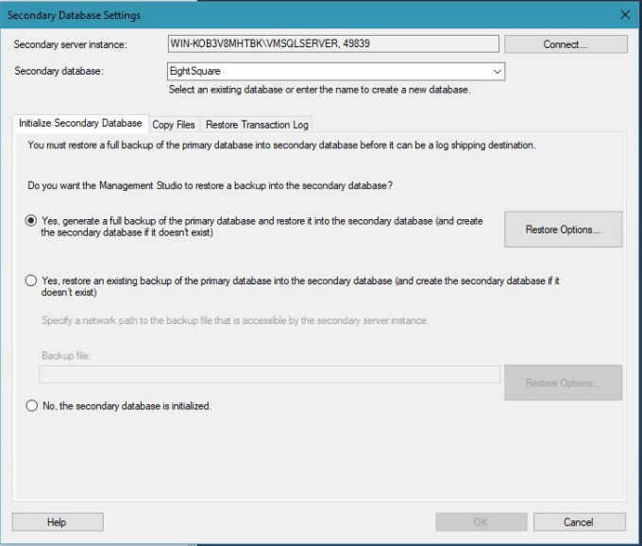

Now, We need to Set the Location in Secondary server to copy the transaction log backup from Primary server to the Secondary server. We need to supply the location in local drive in secondary server as shown in the below figure.

Also the Job Schedule to copy the backup from Primary server to Secondary Server can be defined as per the requirements from the Schedule Button.

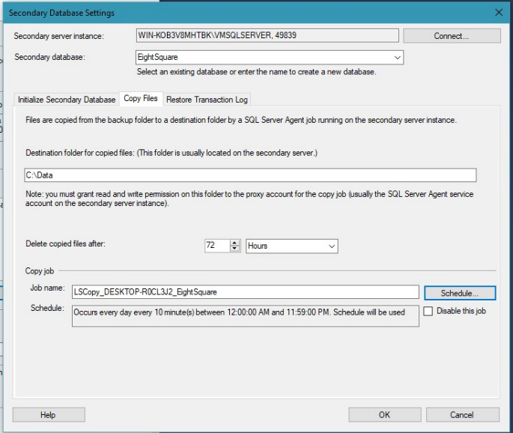

Which completes out **STEP 2.**

The final step **, STEP 3** is to Restore the copied backup file in Secondary server

We have two option to chose when restoring Backups .

1. No Recovery mode: In this mode we cannot read the database.
2. Standby mode : In this mode we are can read the database.

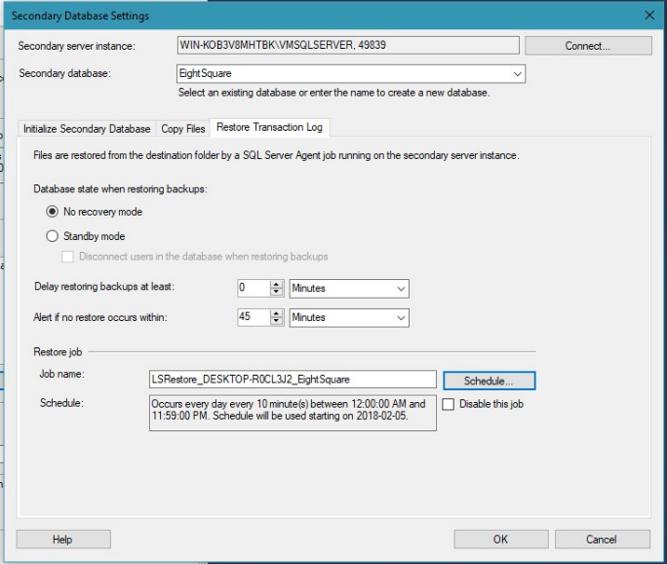

With all this steps we have completed our setup of Transaction Log Shipping.

Click **OK**  and complete the process as shown in below image.

