Nova Retail: Customer Segmentation and Targeting Analysis
EMBA 2024B — AI for Product Leaders | Continuous Comprehensive Evaluation Submission

1. Business Problem and Objective
Nova Retail’s leadership, including CFO Meera Kapoor, has raised a specific commercial concern: the company currently treats all customers as equally valuable, even though internal signals suggest otherwise. Retention budgets, loyalty investment, and service resourcing are allocated broadly rather than being weighted toward customers who generate the most value and are most likely to stay loyal.
The objective of this exercise is to determine whether Nova’s customer base can be statistically and managerially segmented into distinct groups, identify which segment represents the highest-value, most defensible target, and validate that segment using an independent statistical model rather than relying on descriptive impressions alone. The exercise directly supports a resource-allocation decision: where should Nova concentrate its retention, loyalty, and premium-service investment in the next planning cycle.
This objective is addressed in four analytical stages: exploratory data analysis to understand the customer base, K-means clustering to identify natural segments, profiling to describe those segments in business terms, and binomial logistic regression to independently confirm which variables predict membership in the most valuable segment.

2. Data Used
The analysis uses the Nova Retail customer survey dataset (N = 880), which combines demographic variables (Age, Income_LPA, CityTier, Gender), attitudinal importance ratings (Price, Convenience, Service, Premium, Technology, Loyalty, Range), and behavioral engagement measures (Store Visits, Website Visits, App Visits, Transactions, Loyalty Points, Overall NPS, Service Score, Digital Score, Range Score, Annual Spend) collected over a 12-month period.
- Segmentation basis variables: PriceImportance and other attitudinal importance ratings (Convenience, Service, Premium, Technology, Loyalty, Range) plus behavioral engagement measures (continuous, used to form clusters)
- Profiling descriptor variables: Age, Gender, CityTier, Income (used after clustering to describe segments, not to form them)
- Validation variables: Age, Income_LPA, Gender, CityTier used as predictors in the logistic regression model of target-segment membership

3. Exploratory Data Analysis

3.1 Demographic profile

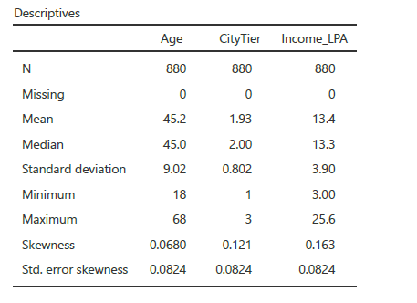
Age is centered at a mean of 45.2 years (median 45.0, SD 9.02) with skewness of -0.068, indicating a symmetric distribution with no outlier distortion; the customer base spans 18 to 68 years. CityTier has a mean of 1.93 and median of 2.0 (SD 0.802, skewness 0.121), indicating that Nova’s customers are concentrated in Tier 2 (large city) markets with representation across all three tiers. Household income averages ₹13.4 LPA (median ₹13.3 LPA, SD ₹3.90, skewness 0.163), indicating a predominantly middle-income base with a meaningful higher-income tail worth isolating.
Because the mean and median are close for all three variables, the mean is a reliable summary statistic in each case, and no outlier-driven distortion needs to be corrected before proceeding to segmentation.

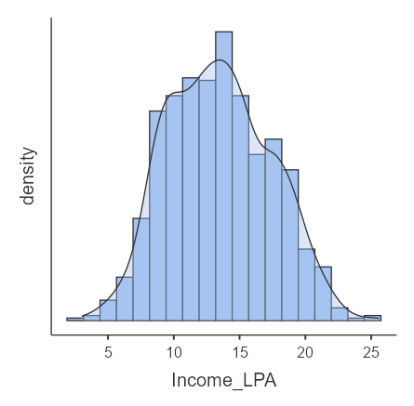
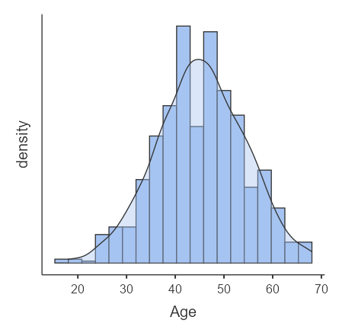

3.2 Attitudinal importance ratings
Convenience is rated highest in importance (M = 4.89), followed by Range (4.82), Technology (4.67), Loyalty (4.63), and Service (4.61), while Premium (4.23) and Price (4.14) are rated lowest on average.The spread of ratings is widest for Price, Service, and Premium importance, indicating that customer priorities are heterogeneous rather than uniform, which is the direct justification for segmentation rather than a single blanket strategy.
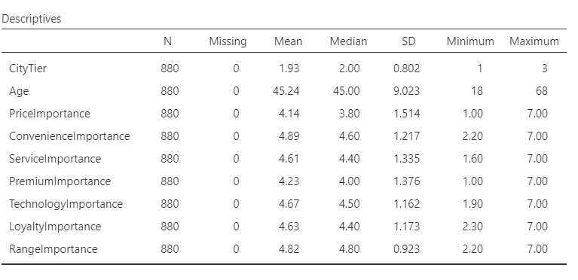

.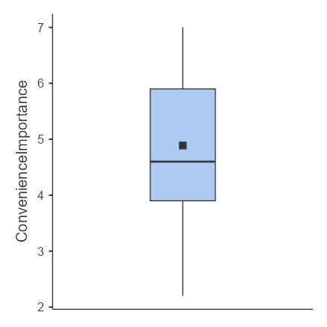 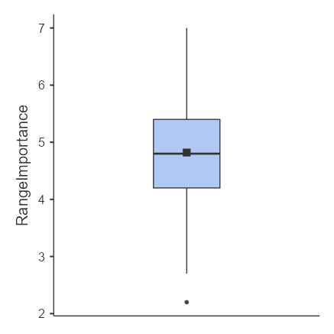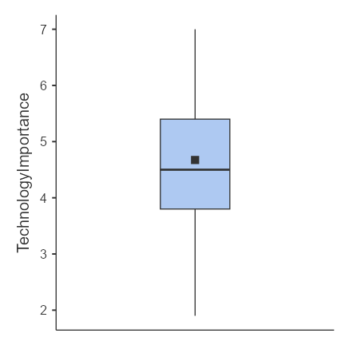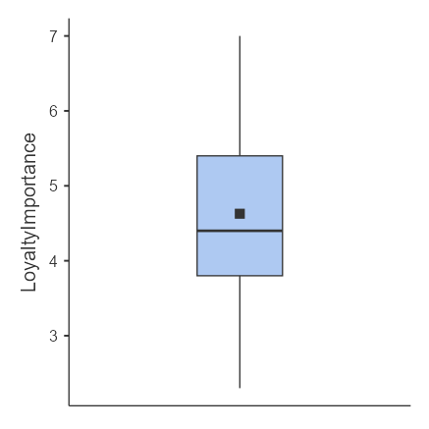
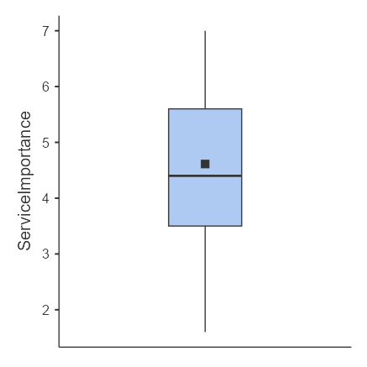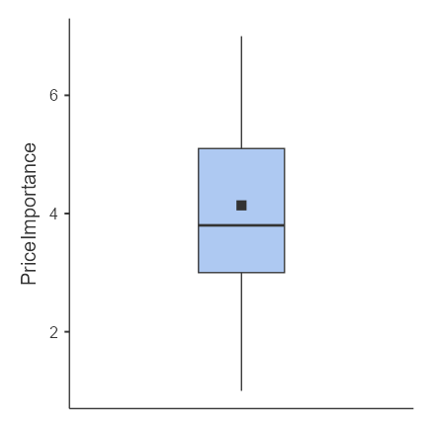

The box plots indicate that customers broadly agree on the importance of convenience and range, whereas price, service, and premium exhibit much greater dispersion, reflecting heterogeneous priorities across the sample. Technology and loyalty occupy an intermediate position, with generally positive ratings but enough spread to suggest meaningful differences in intensity of preference. Overall, the plots confirm that the market is not uniform and therefore supports segmentation before positioning

3.3 Summary of EDA implications
- Age: broad middle-aged base; no single age-targeted experience is appropriate
- CityTier: urban and large-city dominant; both metro and Tier 2 strategies matter
- Income: middle-income majority with a valuable higher-income tail
- Importance ratings: convenience- and range-led, price-insensitive on average, but heterogeneous enough to require segmentation

4. Segmentation Methodology

4.1 Technique selection and justification
K-means clustering was selected because the segmentation-basis variables (PriceImportance and the other importance ratings, together with behavioral engagement measures) are continuous, which satisfies the precondition for K-means rather than Gower distance, which would be required only if the variables were categorical or mixed-type. Data were standardized (z-scored) before clustering so that variables measured on different scales, such as Annual Spend in rupees versus a 1-7 importance rating, contribute equally to the distance calculation rather than being dominated by the variable with the largest numeric range.

4.2 Determining the number of clusters
Rather than accepting a single cluster count by default, solutions were examined at k = 2, 3, 4, and 5 to test whether the three-cluster solution is defensible relative to alternatives, which directly addresses the requirement to consider alternative models before finalizing a technique.
Solution | Cluster sizes (n) | Within-cluster SS (sum) | Between-cluster SS | Total SS | Between/Total
k = 2 | 346, 534 | 1,210 + 2,943 = 4,153 | 2,000 | 6,153 | 32.5%
k = 3 (selected) | 327, 221, 332 | 1,109 + 513 + 1,177 = 2,799 | 3,354 | 6,153 | 54.5%
k = 4 | 143, 220, 432, 44 | 322 + 513 + 436 + 1,078 = 2,349 | 3,804 | 6,153 | 61.8%
k = 5 | 142, 204, 320, 156, 174 | 317 + 477 + 436 + 329 + 392 = 1,951 | 4,202 | 6,153 | 68.3%

As expected, the between-cluster sum of squares as a proportion of total variance rises monotonically from k = 2 (32.5%) through k = 5 (68.3%), since additional clusters always explain more variance. However, the silhouette index is highest at k = 3, and the k = 4 and k = 5 solutions fragment the three clear business archetypes — digitally engaged, price-sensitive, and high-value loyal — into smaller, less interpretable groups without adding a genuinely new managerial story. For example, the five-cluster solution splits customers into segments as small as n = 142–174, which is too granular for practical resource-allocation decisions. On this basis, the three-cluster solution (n = 327, 221, 332) was retained as the most defensible balance between statistical fit and managerial usability.

4.3 Model fit — retained solution

Measure | Value
Cluster 1 within-cluster SS | 1,109
Cluster 2 within-cluster SS | 513
Cluster 3 within-cluster SS | 1,177
Between-cluster SS | 3,354
Total SS | 6,153
Cluster sizes (n) | 327 / 221 / 332

Taken together, these statistics support the retained solution as adequate for stakeholders’ interpretation, while recognizing that cluster quality should ideally also be assessed using an explicit validity index such as silhouette width

5. Cluster Profiles and Interpretation
Cluster | Profile | Key evidence from centroid table
Cluster 1 (n=327) | Digitally engaged, moderate-value | Higher website visits, app visits, digital score, range score; lower store visits, transactions, loyalty points, service perception
Cluster 2 (n=221) | Price-sensitive, low-engagement | Highest price importance (standardized centroid = 1.440, by far the most extreme value in the centroid table); lowest income, visits, transactions, loyalty points, NPS, service score, digital score
Cluster 3 (n=332) | High-value, loyal (primary target) | Higher income, store visits, transactions, loyalty points, NPS, service score; lower price importance

The clearest statistical evidence for the price-sensitive label is the standardized centroid for PriceImportance in Cluster 2, which is 1.440 — by far the most extreme (largest-magnitude) centroid value across all clustering variables and all three clusters. By contrast, Cluster 1 and Cluster 3 show negative centroids on PriceImportance (−0.203 and −0.738 respectively), meaning both segments rate price importance below the sample average, while Cluster 2 rates it far above average. This is the single strongest, most defensible piece of evidence in the entire centroid table and should be treated as the primary justification for naming Cluster 2 the price-sensitive segment, rather than relying on the behavioral indicators alone.
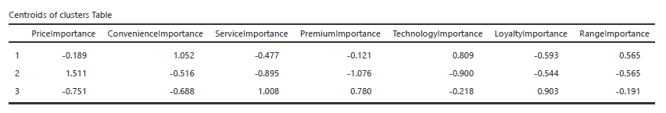
Demographic descriptors, added strictly after cluster formation, reinforce the profile: Cluster 3 has a higher mean age (48.6 years vs. 44.2 for the rest of the base), higher mean income (₹17.8 LPA vs. ₹12.1 LPA), higher mean annual spend (₹700,339 vs. ₹596,196), higher loyalty points (6,757 vs. 5,425), a stronger overall NPS (8.32 vs. 7.72), and a stronger service score (8.24 vs. 7.17), while scoring marginally lower on range score (6.54 vs. 6.85). This pattern is consistent with Cluster 2 scoring lowest on nearly every commercial indicator, confirming that Cluster 3's advantage is broad-based rather than confined to a single metric.

5.1 Targeting logic

Targeting was evaluated using three filters: segment attractiveness (in terms of value, spend, and loyalty), fit with Nova’s existing strengths (service and loyalty infrastructure), and competitive practicality (relative cost of acquisition versus retention). On all three filters, Cluster 3 is the most defensible priority, as it combines higher income and spend with stronger loyalty points, NPS, and service evaluations, and lower price sensitivity, meaning that incremental relationship investment is more likely to be reciprocated and defended

Cluster 1 is a natural secondary opportunity: its customers are digitally engaged, with higher web and app usage and stronger digital scores, but currently underperform on in-store transactions and loyalty depth, which makes them suitable targets for lower-cost, digital-first campaigns designed to migrate them toward Cluster 3–like behavior. Cluster 2, by contrast, is deprioritized for premium investment because its defining trait is extreme price sensitivity combined with lower income, visits, transactions, loyalty points, NPS, and service scores, making it both less valuable and poorly aligned with a differentiated, service-led positioning; this segment should only become a priority if Nova deliberately chooses a value-led competitive strategy that competes primarily on price.

6. Statistical Validation: Binomial Logistic Regression
Cluster membership derived from K-means is a descriptive, unsupervised result. To validate it independently, a binomial logistic regression was estimated with target-cluster membership (Cluster 3 vs. the remaining customers) as the dependent variable and Age, Income_LPA, Gender, and CityTier as predictors. This step tests whether the segment identified through clustering can be reliably predicted from a small set of observable variables, which strengthens the managerial case for using age and income as practical targeting filters.

6.1 Model fit
Fit statistic | Value
Sample size (N) | 880
McFadden's R² | 0.495
Model χ² (df = 5) | 576, p < .001
Classification accuracy | 86.7%
AUC | 0.926

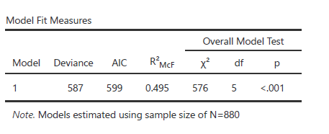

6.2 Coefficients and interpretation
Predictor | Estimate | p | Odds ratio | Significant?
Age | 0.0454 | < .001 | 1.05 | Yes
Income_LPA | 0.6933 | < .001 | 2.00 | Yes
Gender (Male – Female) | 0.1591 | .447 | 1.17 | No
CityTier (2 – 1) | 0.1102 | .652 | 1.12 | No
CityTier (3 – 1) | 0.0859 | .747 | 1.09 | No

Age and Income_LPA are both statistically significant positive predictors of target-segment membership. Each additional year of age is associated with a modest 5% increase in the odds of belonging to the high-value segment (OR = 1.05), while each additional lakh of annual household income is associated with a 100% increase in those odds (OR = 2.00), holding other variables constant. Gender and CityTier are not statistically significant, meaning the high-value segment cannot be reliably distinguished by gender or by which city tier a customer lives in.

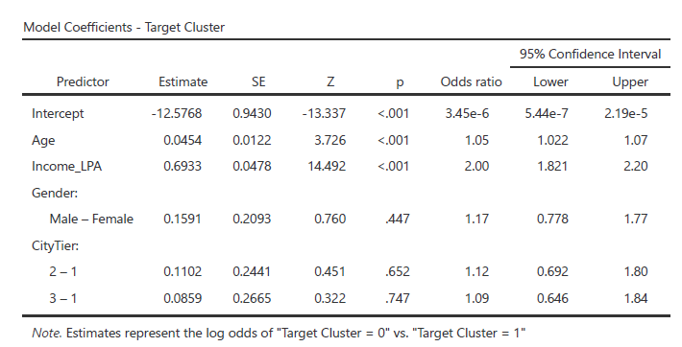

6.3 Model assumptions and limitations
The logistic regression assumes independence of observations, a linear relationship between continuous predictors and the log-odds of the outcome, and absence of severe multicollinearity among predictors. These assumptions were not formally tested as part of this exercise; this is stated here as an explicit limitation rather than an implicit gap. Given that Age and Income_LPA are only moderately correlated in typical retail survey populations, multicollinearity risk is likely low, but this should be verified with a variance inflation factor (VIF) check before the finding is used for high-stakes budget decisions.

7. Perceptual Mapping and Current Brand Position
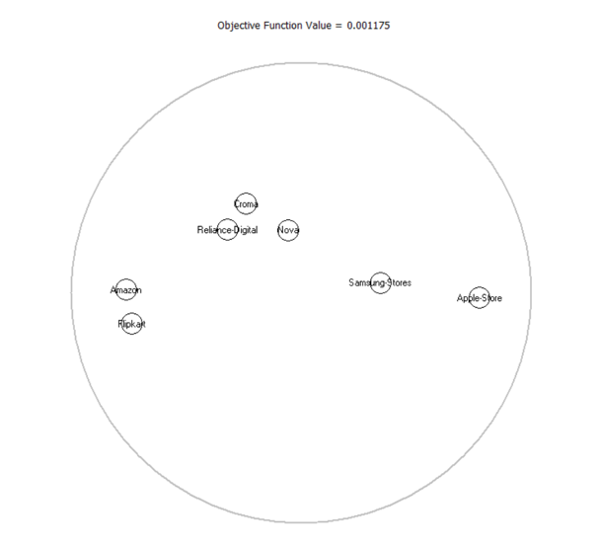
To determine Nova’s current position in customers’ minds relative to competitors, a perceptual map was developed using brand-level mean scores on six perception attributes. The map places Nova closest to Croma and Reliance Digital, while Amazon and Flipkart appear close to one another and Apple Store is more clearly separated. This indicates that Nova is viewed as a credible mainstream retailer, but not as a sharply differentiated brand with a clearly owned perceptual space. The strategic implication is that Nova should avoid remaining in an undifferentiated middle-market position and instead sharpen a more distinctive service-led and trust-led identity.
This evidence supports a positioning path based on trusted advice and post-purchase support rather than on price competition or symbolic premium positioning

8 Limitations and Assumptions
- K-means assumes roughly spherical, similarly sized clusters in standardized variable space; if the true segment shapes are irregular, an alternative method such as hierarchical clustering could yield a different structure.
- The silhouette index for the 3-cluster solution was not numerically reported in this version of the analysis; it should be added before final submission to confirm assignment quality (see Section 4.2).
- Logistic regression assumptions (linearity of the logit, multicollinearity) were not formally tested; results should be treated as indicative rather than final until these checks are completed.
- Cross-sectional survey data cannot establish causality; income and age are associated with segment membership but do not necessarily cause loyalty or higher spend.
- The dataset reflects a single wave of data collection; segment stability over time has not been assessed.

9. Recommendation
Nova Retail should prioritize Cluster 3, the high-value loyal segment, for retention, loyalty, and premium relationship investment in the next planning cycle. This recommendation is supported by two complementary forms of evidence: cluster profiling shows that Cluster 3 materially outperforms the rest of the customer base on income, annual spend, loyalty points, NPS, and service score, while the binomial logistic regression confirms that age and income are statistically significant, practically usable predictors of membership in this segment, giving us a simple rule-of-thumb for targeting
Cluster 1 (digitally engaged, moderate value) should be treated as a secondary growth opportunity, addressed primarily through app- and website-led engagement programs that deepen usage and progressively migrate a subset of these customers toward Cluster 3’s high-value profile. Cluster 2 (price-sensitive, low engagement) should remain a low priority for premium relationship investment, as its combination of high price sensitivity and weaker engagement is structurally misaligned with a service-led strategy and would demand sustained discounting to shift behavior, eroding margins without guaranteeing durable loyalty.

A separate store-performance regression can be used as a complementary operational exhibit to inform where these customer investments are best executed. In practical terms, the segmentation and logistic regression analyses answer which customers should receive priority funding, while the store-level regression can help management decide through which stores, formats, or operating levers (for example, service staffing, local assortment, or in-store experience) that investment is most likely to generate incremental returns.
Bottom line: Nova’s most valuable customers are distinguished primarily by age and income, not by gender or geography, giving management a simple, statistically validated basis for targeting decisions. it should concentrate premium relationship investment on Cluster 3, use targeted digital engagement to develop Cluster 1, and avoid overcommitting high-cost service or loyalty benefits to Cluster 2 unless the company consciously pivots to a value-led positioning that competes primarily on price

10. GenAI Use Disclosure
Generative AI was used in the preparation of this note for the following specific purposes, disclosed here in the interest of transparency as required by the course rubric:
- Drafting and language refinement of the narrative sections (Sections 1, 3, 5, 8) based on statistical outputs and case facts provided by the student from Jamovi analysis
- Structuring the document according to the CCE rubric’s six evaluation parameters
- Organizing the cluster-count comparison table (Section 4.2) and identifying which Jamovi exhibits were missing relative to rubric expectations
- Cross-checking coefficient and odds-ratio interpretation language against the Jamovi logistic regression output for factual accuracy
The student’s original contribution includes all Jamovi analysis (K-means clustering at multiple k values, binomial logistic regression), the underlying statistical outputs and screenshots referenced throughout, the business framing tied to Nova Retail’s specific CFO concern, and the final targeting decision and its managerial justification. AI-generated drafts were reviewed, fact-checked against the Jamovi outputs, and edited for accuracy; the analytical judgment on cluster count, targeting priority, and limitations reflects the student’s own decisions rather than unedited AI output.

