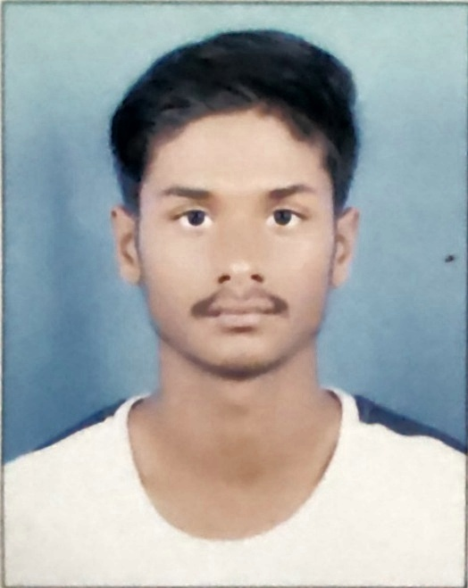

Name: Suman Kumar Shah Teli

Mobile: +9779809284095

Email: shahsuman2076@gmail.com

**CAREER SUMMARY/PROFILE/OBJECTIVE:**

- Looking for opportunities to incorporate my skills and training to help the company grow.

- To secure a challenging position in a reputable organization to expand my learning, knowledge and skills.

**Technical Skills:**

- Programming Languages: C, C++, Java, JavaScript

- Technologies: SQL, Java, HTML

**Communication:**

- Fluent in speaking English, Hindi, Nepali, Bhojpuri.

- Empathic listener.

- Excellent written and verbal communication skills.

**Team work:**

- Worked with team in various Web development project

- Participated in team building activities in a coding society

**QUALIFICATIONS:**

B-Tech(CSE) 3rd Year

**Kalinga Institute of Industrial Technology**

+2 Science 2019

**Nation Infotech College**

Secondary school 2017

**Marigold Sec. Shoool**

**Certificates & Licences:**

- Machine Learning and Sentimental Analysis (coding blocks)

- Complete MySQL Basics (GreatLearning)

- Object oriented design and design patterns (Geeks for Geeks)

**INTERESTS:**

- Reading books

- Travelling

- Coding

- Watching web series movies