Given 2 numbers(interval) display(space separated) odd numbers between two intervals.

Input Size : N,Q <= 100000

Sample Testcase :

INPUT

1 6

OUTPUT

3 5

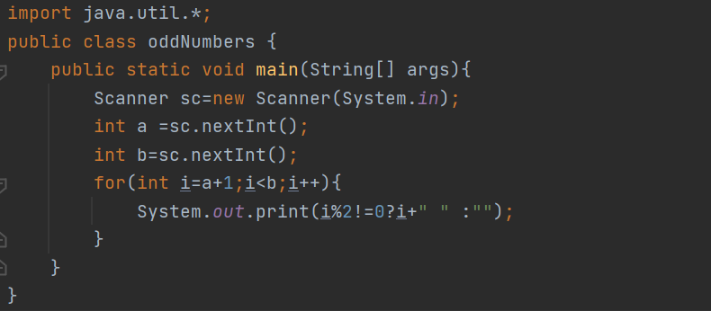

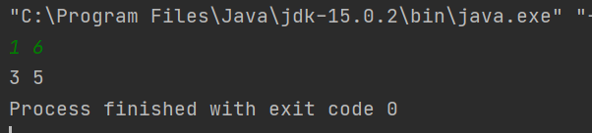

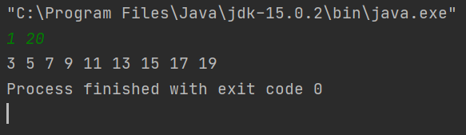

Given a number N and an array of N integers, print the median element.

Input Size : 1 <= N <= 1000

Sample Testcase :

INPUT

3

2 1 3

OUTPUT

2

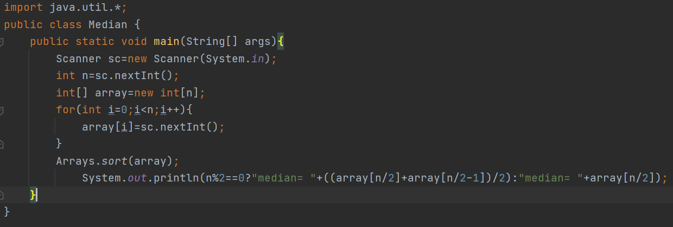

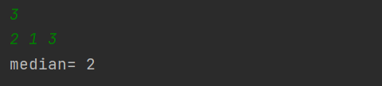

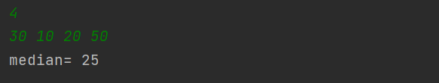

Program to print half pyramid using \*

\*

\* \*

\* \* \*

\* \* \* \*

\* \* \* \* \*

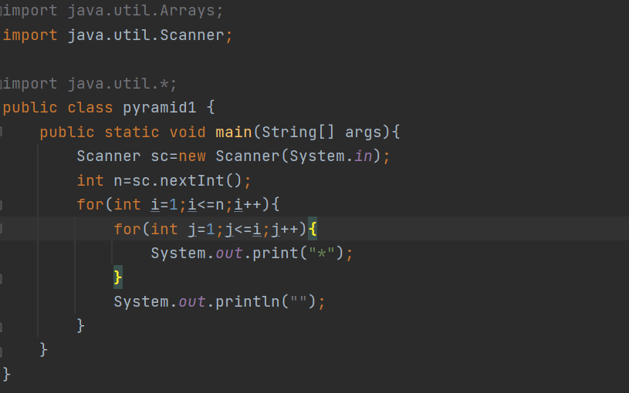



Inverted half pyramid using \*

\* \* \* \* \*

\* \* \* \*

\* \* \*

\* \*

\*

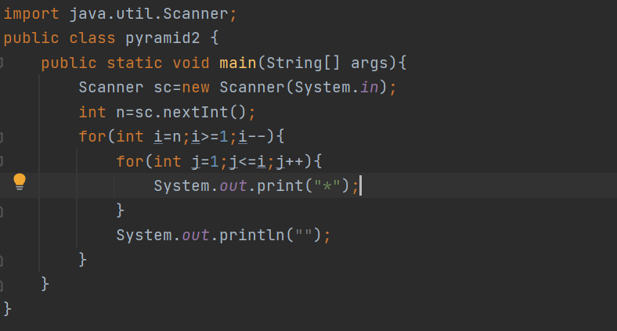



\*

\* \* \*

\* \* \* \* \*

\* \* \* \* \* \* \*

\* \* \* \* \* \* \* \* \*

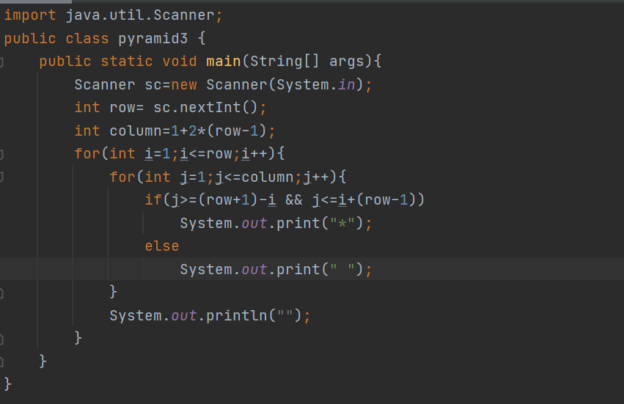



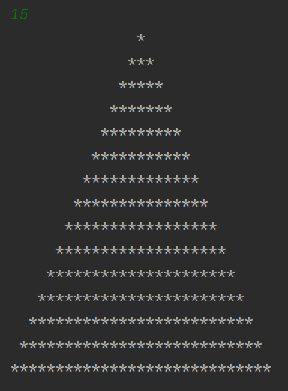

armstrong number between two numbers

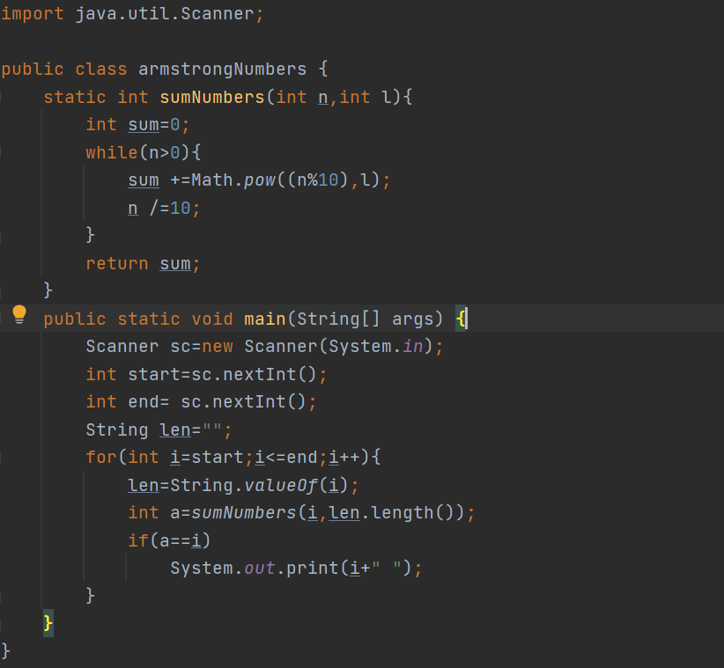

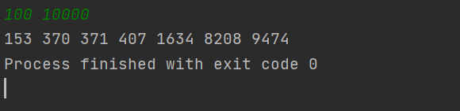

swap two numbers using bitwise

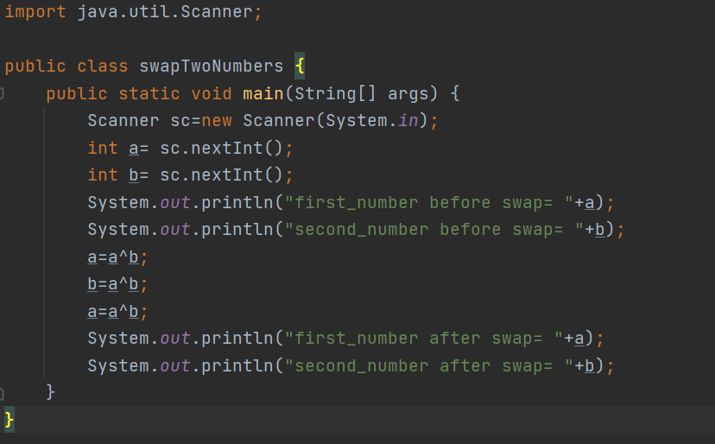

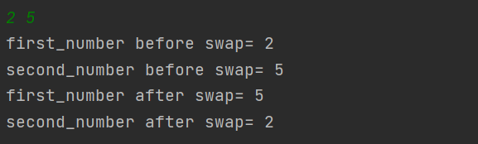

sum of digits to one digit

Method 1:

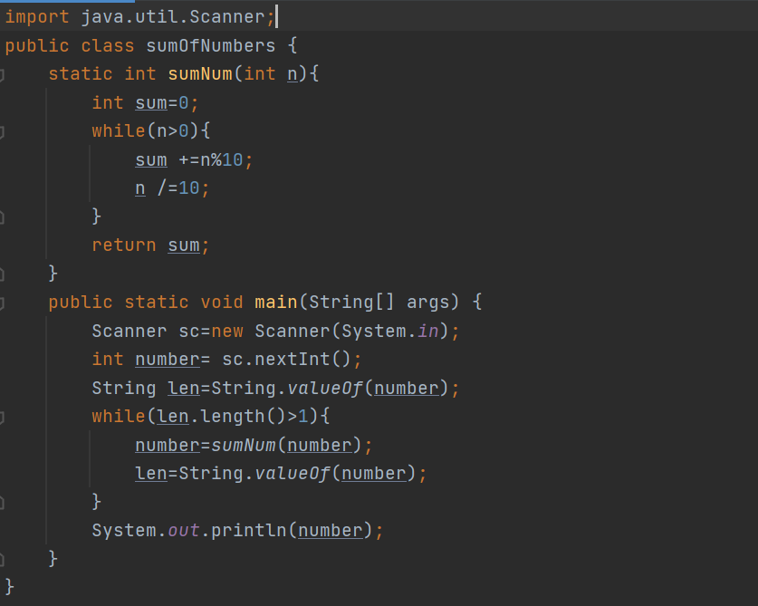





sum of digits to one digit

Method 2:

