1. Rearrage the elements in a array in a specific manner mentioned in a clue

the clue says cursed are the odd and sorted are the even the clue translates to sort the even positioned elements of an array starting from the element at index 0 in ascending order

Input

size of the array followed by elements

output

even index array elements are sorted in ascending order

Sample IP

6

3 9 1 4 4 6

Sample OP

1 9 3 4 4 6

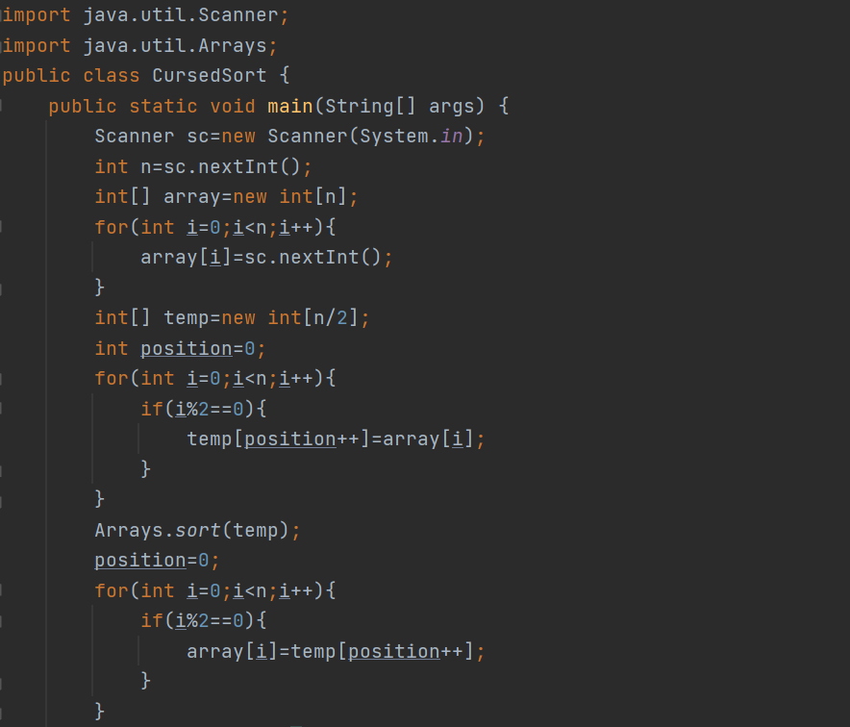

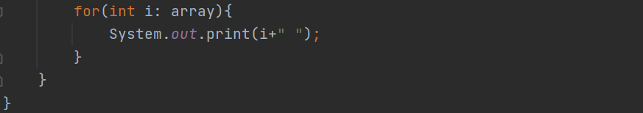

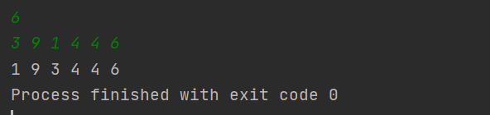

2. List<Integer> ls=new ArrayList<Integer>()

List<Integer> ls=new ArrayList<>()

ArrayList<Integer> ls=new ArrayList<>()

3. ArrayList.ensureCapacity(20)

4. ArrayList.trimToSize()

5. ArrayList.isEmpty()

6. ArrayList.contains()

7. count repeated charcters using recursion in a given string

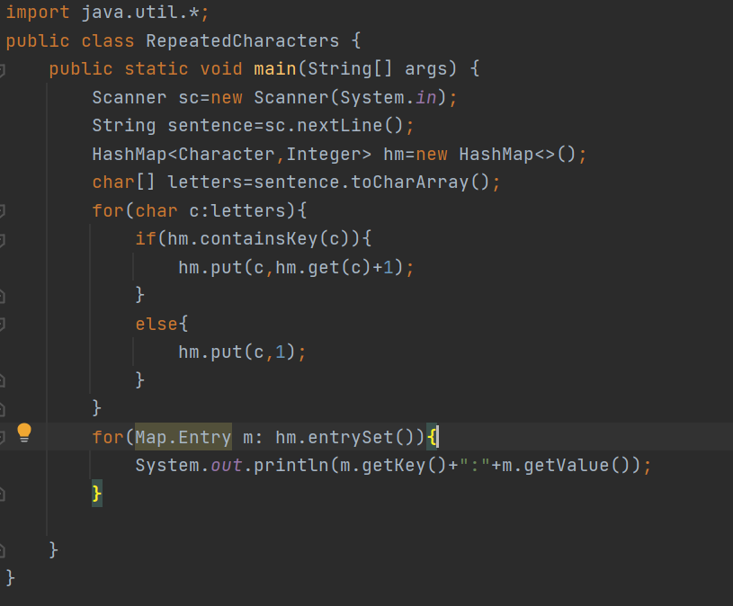

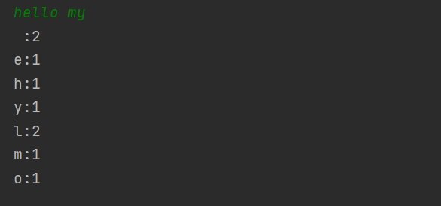

8. Print pyramid pattern of prime numbers with in a given range

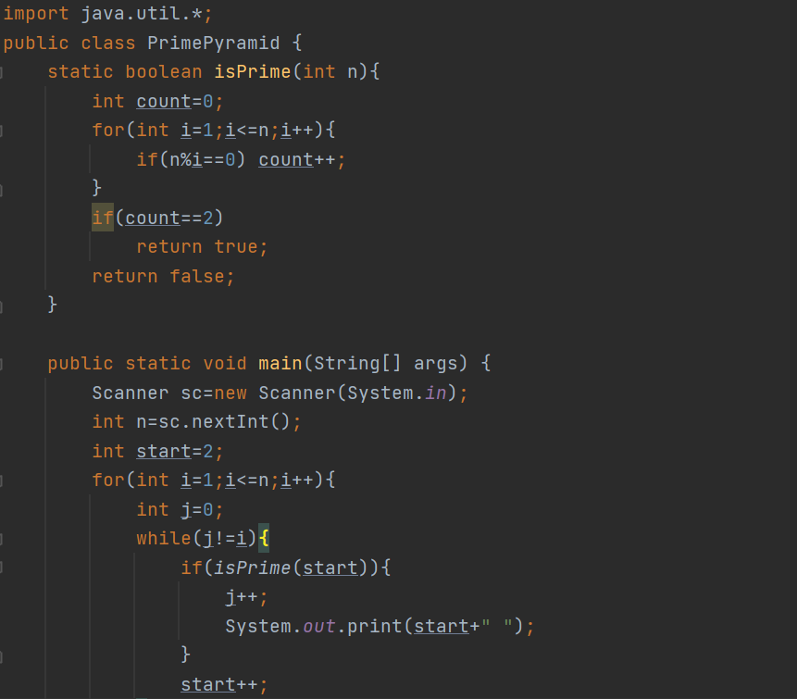

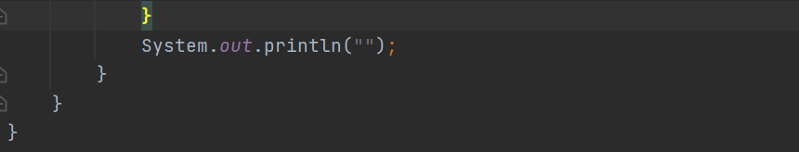

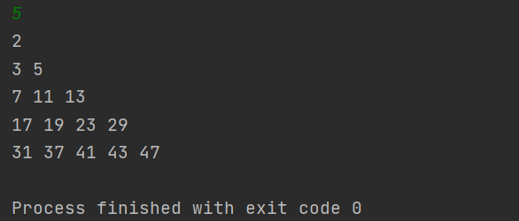

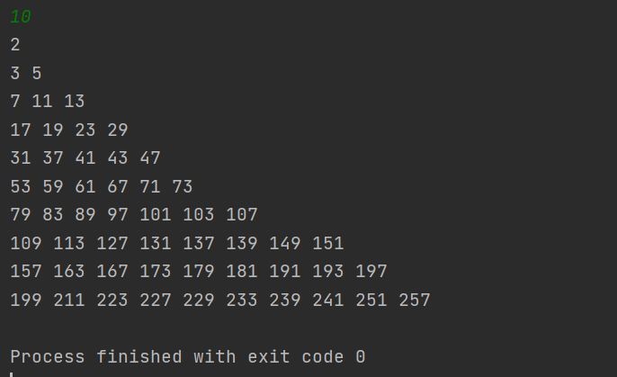

9. Reverse every word in a given sentence

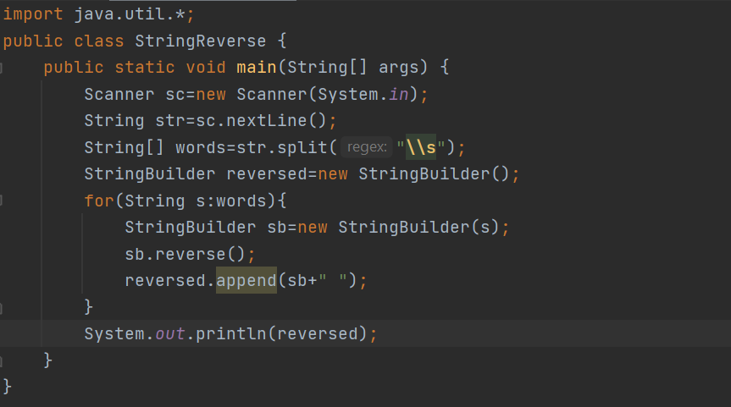



10. find the most repeated character in a sentence.

