ACE BANK

1. Download Git  
https://git-scm.com/downloads

2. Download TomCat server

https://downloads.apache.org/tomcat/tomcat-9/v9.0.46/bin/apache-tomcat-9.0.46-windows-x64.zip

3. Download Eclipse  
https://www.eclipse.org/downloads/

4. Create a Github account  
https://github.com/join?ref_cta=Sign+up&ref_loc=header+logged+out&ref_page=%2F&source=header-home

5. Oracle X G Express Edition  
https://drive.google.com/drive/u/0/folders/1L2tUjhmNk7zt2-sjZxfXFPMZF-qSRjys

6. Install NotePad ++  
<https://notepad-plus-plus.org/downloads/v7.9.5/>

There are many ways to add local jar files to a Maven project:

1.Install manually the JAR into a local Maven repository

Use this plugin:

*mvn install:install-file -Dfile=<path-to-file>*

Example:

*mvn install:install-file –Dfile=C:\dev\app.jar -DgroupId=com.roufid.tutorials -DartifactId=example-app -Dversion=1.0*

Now, add the dependency to your Maven project by adding these lines to your pom.xml file:

*<dependency>*

*<groupId>com.roufid.tutorials</groupId>*

*<artifactId>example-app</artifactId>*

*<version>1.0</version>*

*</dependency>*

2. Adding directly the dependency as system scope:

Consider that the JAR is located in <PROJECT_ROOT_FOLDER>/lib.

After this add the dependency in your pom.xml file as following:

*<dependency>*

*<groupId>com.roufid.tutorials</groupId>*

*<artifactId>example-app</artifactId>*

*<version>1.0</version>*

*<scope>system</scope>*

*<systemPath>${basedir}/lib/yourJar.jar</systemPath>*

*</dependency>*

3. Creating a different local Maven repository:

This one is quite similar to the first one, the only difference lies in the fact that the JARs will be installed in a different local Maven repository.

First, deploy the local JARs in the new local maven repository as below:

*mvn deploy:deploy-file -Dfile=<path-to-file> -DgroupId=<group-id>*

After deploying the JARs you need to add the repository in your pom.xml file:

*<repositories>*

*<repository>*

*<id>maven-repository</id>*

*<url>file:///${project.basedir}/maven-repository</url>*

*</repository>*

*</repositories>*

After this add the dependency into your pom.xml

*<dependency>*

*<groupId>com.roufid.tutorials</groupId>*

*<artifactId>example-app</artifactId>*

*<version>1.0</version>*

*</dependency>*

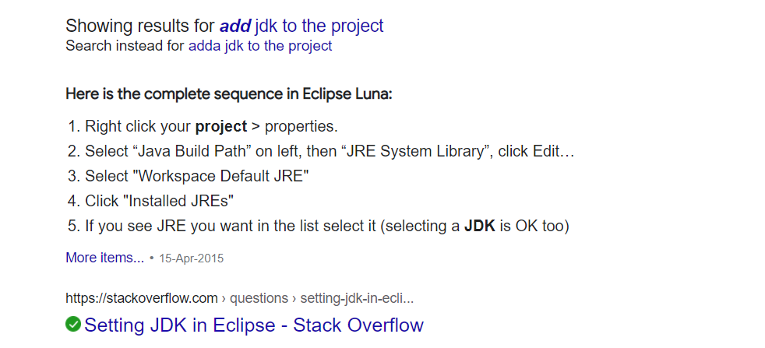

SCHEMAS

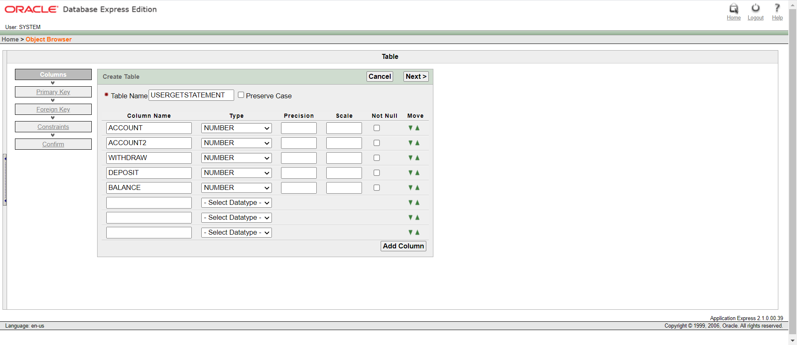USERGETSTATEMENT