**BIT BUCKET**

**by Atlassian**

version Control System are tools which help team to manage and track changes in source code over time.

When we start coding we must consider a version control system.

Ie: GIR, SVN, Mercurial, PerForce.

Type of VC

1. Centralised
   * SVN
2. Distributed
   * GIT

Centralised Version Control

Working copy is after completion is stored in a server repository

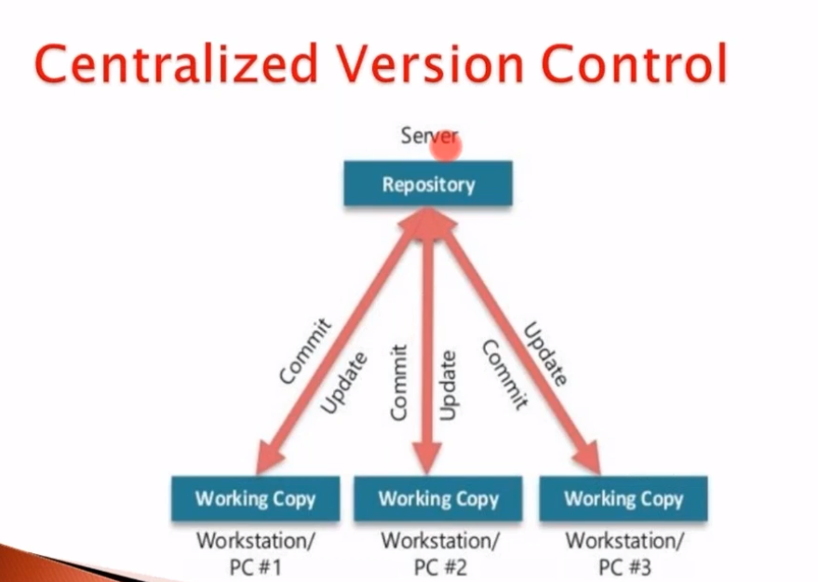

Disadvantage:

All the devs are dependent on a central remote server.

If it goes down all will become idle and unable to work.

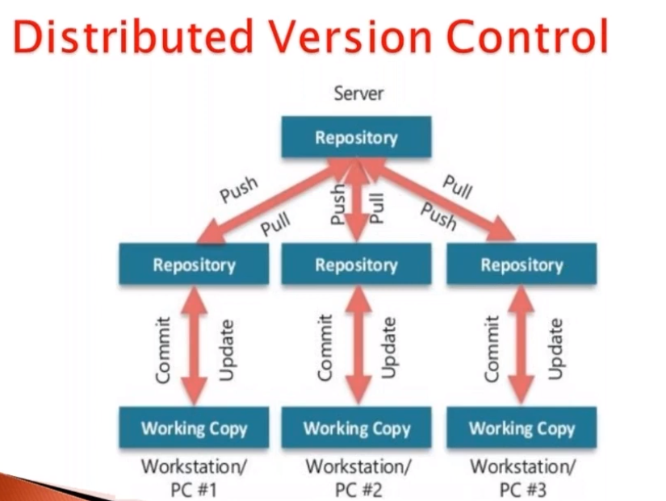

**In Distributed**

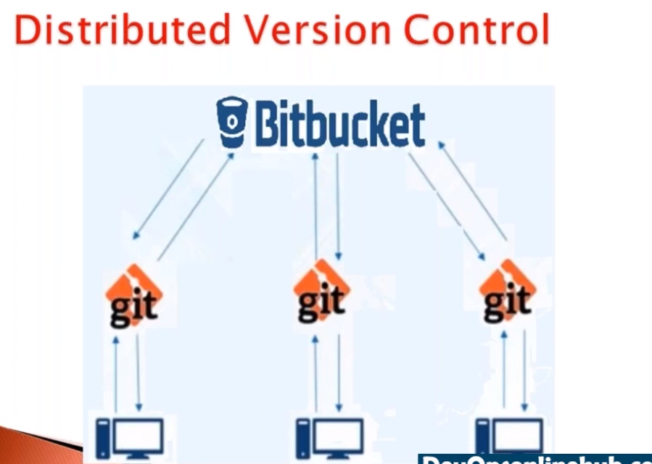

Advantages

Dev will commit there commit to GIT instead of directly to BitBucket.

And if everything goes well they will comit to BitBucket.

**Advantages**

Not dependent on the remote repository.

Resolve the merge conflicts

Installation

debian

sudo apt-get update // DNS update

sudo apt-get install git

Fedora, Cent OS

sudo yum update

sudo yum install git

Windows

Downlaod latest git installer

gitforwindows.org

Version check

git –version

Git Monitors the comits and the version of comtted code

and maintains a log.

Configure username and Email id

git config –global user.name “USERNAME”

git config –global user.email “EMAIL ID” //Optional

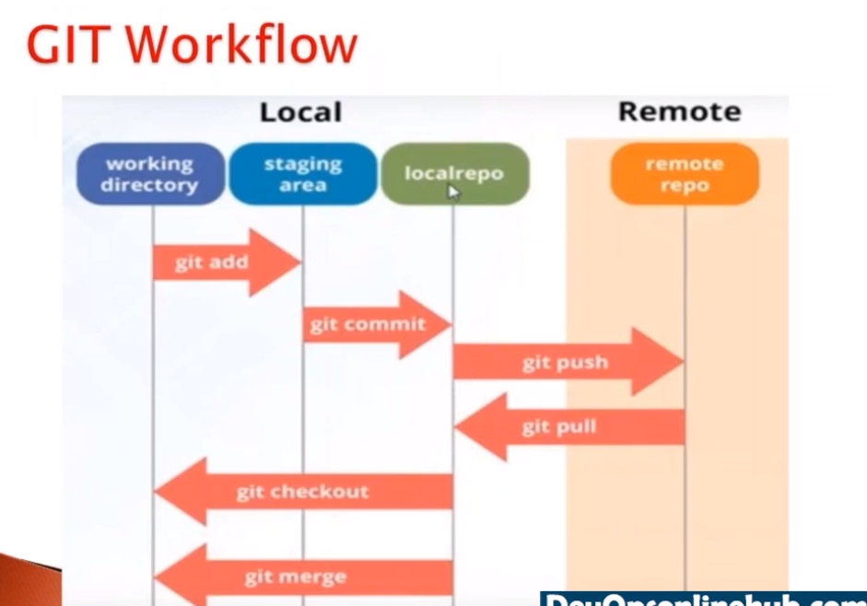

## Creating a repository

### Local Repository

Git init

creates a fresh or existing folder as repository

git clone

to clone or download repository from bit bucket.

Remote Repository

BitBucket

SUMU@KRATOS MINGW64 ~/desktop/CODES_/Spring (master)

$ git remote add origin https://sumanshekhar698@bitbucket.org/sumanshekhar698/spring.git

SUMU@KRATOS MINGW64 ~/desktop/CODES_/Spring (master)

$ git remote -v

origin https://sumanshekhar698@bitbucket.org/sumanshekhar698/spring.git (fetch)

origin https://sumanshekhar698@bitbucket.org/sumanshekhar698/spring.git (push)

SUMU@KRATOS MINGW64 ~/desktop/CODES_/Spring (master)

$ git branch

firstBranch

* master

thirdbranch

SUMU@KRATOS MINGW64 ~/desktop/CODES_/Spring (master)

$ git push -u origin master

To https://bitbucket.org/sumanshekhar698/spring.git

! [rejected] master -> master (fetch first)

error: failed to push some refs to 'https://bitbucket.org/sumanshekhar698/spring.git'

hint: Updates were rejected because the remote contains work that you do

hint: not have locally. This is usually caused by another repository pushing

hint: to the same ref. You may want to first integrate the remote changes

hint: (e.g., 'git pull ...') before pushing again.

hint: See the 'Note about fast-forwards' in 'git push --help' for details.

SUMU@KRATOS MINGW64 ~/desktop/CODES_/Spring (master)

$ git push -u origin master

To https://bitbucket.org/sumanshekhar698/spring.git

! [rejected] master -> master (fetch first)

error: failed to push some refs to 'https://bitbucket.org/sumanshekhar698/spring.git'

hint: Updates were rejected because the remote contains work that you do

hint: not have locally. This is usually caused by another repository pushing

hint: to the same ref. You may want to first integrate the remote changes

hint: (e.g., 'git pull ...') before pushing again.

hint: See the 'Note about fast-forwards' in 'git push --help' for details.

SUMU@KRATOS MINGW64 ~/desktop/CODES_/Spring (master)

$ git pull

warning: no common commits

remote: Counting objects: 4, done.

remote: Compressing objects: 100% (4/4), done.

remote: Total 4 (delta 0), reused 0 (delta 0)

Unpacking objects: 100% (4/4), 1.72 KiB | 31.00 KiB/s, done.

From https://bitbucket.org/sumanshekhar698/spring

* [new branch] master -> origin/master

There is no tracking information for the current branch.

Please specify which branch you want to merge with.

See git-pull(1) for details.

git pull <remote> <branch>

If you wish to set tracking information for this branch you can do so with:

git branch --set-upstream-to=origin/<branch> master

SUMU@KRATOS MINGW64 ~/desktop/CODES_/Spring (master)

$ ls

error: RPC failed; curl 55 OpenSSL SSL_write: Connection was aborted, errno 10053

send-pack: unexpected disconnect while reading sideband packet

Writing objects: 100% (312/312), 12.21 MiB | 58.00 KiB/s, done.

Total 312 (delta 38), reused 0 (delta 0), pack-reused 0

fatal: the remote end hung up unexpectedly

Everything up-to-dateorg/sumanshekhar698/spring.git

! [rejected] master -> master (non-fast-forward)

SUMU@KRATOS MINGW64 ~/desktop/CODES_/Spring (master)t.org/sumanshekhar698/spring.git'

$ nt: Updates were rejected because the tip of your current branch is behind

hint: its remote counterpart. Integrate the remote changes (e.g.

SUMU@KRATOS MINGW64 ~/desktop/CODES_/Spring (master)

$ ^C: See the 'Note about fast-forwards' in 'git push --help' for details.

SUMU@KRATOS MINGW64 ~/desktop/CODES_/Spring (master)

$ ^Ct pull

There is no tracking information for the current branch.

SUMU@KRATOS MINGW64 ~/desktop/CODES_/Spring (master)

$ e git-pull(1) for details.

git pull <remote> <branch>

SUMU@KRATOS MINGW64 ~/desktop/CODES_/Spring (master)nch you can do so with:

$

git branch --set-upstream-to=origin/<branch> master

SUMU@KRATOS MINGW64 ~/desktop/CODES_/Spring (master)

SUMU@KRATOS MINGW64 ~/desktop/CODES_/Spring (master)

$ sh: syntax error near unexpected token `1'

SUMU@KRATOS MINGW64 ~/desktop/CODES_/Spring (master)

$ git push -f origin master

Enumerating objects: 312, done.

Counting objects: 100% (312/312), done.

SUMU@KRATOS MINGW64 ~/desktop/CODES_/Spring (master)

$ mpressing objects: 100% (231/231), done.

Writing objects: 20% (63/312)

SUMU@KRATOS MINGW64 ~/desktop/CODES_/Spring (master)

$

SUMU@KRATOS MINGW64 ~/desktop/CODES_/Spring (master)

$

SUMU@KRATOS MINGW64 ~/desktop/CODES_/Spring (master)

$

SUMU@KRATOS MINGW64 ~/desktop/CODES_/Spring (master)

$

SUMU@KRATOS MINGW64 ~/desktop/CODES_/Spring (master)

$

SUMU@KRATOS MINGW64 ~/desktop/CODES_/Spring (master)

$

SUMU@KRATOS MINGW64 ~/desktop/CODES_/Spring (master)

$

SUMU@KRATOS MINGW64 ~/desktop/CODES_/Spring (master)

$

SUMU@KRATOS MINGW64 ~/desktop/CODES_/Spring (master)

$

SUMU@KRATOS MINGW64 ~/desktop/CODES_/Spring (master)

$

SUMU@KRATOS MINGW64 ~/desktop/CODES_/Spring (master)

$

SUMU@KRATOS MINGW64 ~/desktop/CODES_/Spring (master)

$

SUMU@KRATOS MINGW64 ~/desktop/CODES_/Spring (master)

$ git push -u origin master

To https://bitbucket.org/sumanshekhar698/spring.git

! [rejected] master -> master (non-fast-forward)

error: failed to push some refs to 'https://bitbucket.org/sumanshekhar698/spring.git'

hint: Updates were rejected because the tip of your current branch is behind

hint: its remote counterpart. Integrate the remote changes (e.g.

hint: 'git pull ...') before pushing again.

hint: See the 'Note about fast-forwards' in 'git push --help' for details.

SUMU@KRATOS MINGW64 ~/desktop/CODES_/Spring (master)

$ git pull

There is no tracking information for the current branch.

Please specify which branch you want to merge with.

See git-pull(1) for details.

git pull <remote> <branch>

If you wish to set tracking information for this branch you can do so with:

git branch --set-upstream-to=origin/<branch> master

SUMU@KRATOS MINGW64 ~/desktop/CODES_/Spring (master)

$ git pull git pull <remote> <branch>

bash: syntax error near unexpected token `<'

SUMU@KRATOS MINGW64 ~/desktop/CODES_/Spring (master)

$ git pull <remote> <branch>

bash: syntax error near unexpected token `<'

SUMU@KRATOS MINGW64 ~/desktop/CODES_/Spring (master)

$ git pull <remote> <branch>

bash: syntax error near unexpected token `<'

SUMU@KRATOS MINGW64 ~/desktop/CODES_/Spring (master)

$ git pull master master

fatal: 'master' does not appear to be a git repository

fatal: Could not read from remote repository.

Please make sure you have the correct access rights

and the repository exists.

SUMU@KRATOS MINGW64 ~/desktop/CODES_/Spring (master)

$ git pull spring master

fatal: 'spring' does not appear to be a git repository

fatal: Could not read from remote repository.

Please make sure you have the correct access rights

and the repository exists.

SUMU@KRATOS MINGW64 ~/desktop/CODES_/Spring (master)

$ git pull Spring master

fatal: 'Spring' does not appear to be a git repository

fatal: Could not read from remote repository.

Please make sure you have the correct access rights

and the repository exists.

SUMU@KRATOS MINGW64 ~/desktop/CODES_/Spring (master)

$ git pull Spring

fatal: 'Spring' does not appear to be a git repository

fatal: Could not read from remote repository.

Please make sure you have the correct access rights

and the repository exists.

SUMU@KRATOS MINGW64 ~/desktop/CODES_/Spring (master)

$ git pull spring

fatal: 'spring' does not appear to be a git repository

fatal: Could not read from remote repository.

Please make sure you have the correct access rights

and the repository exists.

SUMU@KRATOS MINGW64 ~/desktop/CODES_/Spring (master)

$ git pull spring

fatal: 'spring' does not appear to be a git repository

fatal: Could not read from remote repository.

Please make sure you have the correct access rights

and the repository exists.

SUMU@KRATOS MINGW64 ~/desktop/CODES_/Spring (master)

$ git pull

There is no tracking information for the current branch.

Please specify which branch you want to merge with.

See git-pull(1) for details.

git pull <remote> <branch>

If you wish to set tracking information for this branch you can do so with:

git branch --set-upstream-to=origin/<branch> master

SUMU@KRATOS MINGW64 ~/desktop/CODES_/Spring (master)

$ git pull origin master

From https://bitbucket.org/sumanshekhar698/spring

* branch master -> FETCH_HEAD

fatal: refusing to merge unrelated histories

SUMU@KRATOS MINGW64 ~/desktop/CODES_/Spring (master)

$ git commit -m "final commit before pushing"

On branch master

nothing to commit, working tree clean

SUMU@KRATOS MINGW64 ~/desktop/CODES_/Spring (master)

$ git status

On branch master

nothing to commit, working tree clean

SUMU@KRATOS MINGW64 ~/desktop/CODES_/Spring (master)

$ git fetch

SUMU@KRATOS MINGW64 ~/desktop/CODES_/Spring (master)

$ ls

Github.txt InfySpringRest/ SpringCore/ SpringMVC/ gitTest/

In28mins/ Notes/ SpringJDBC/ SpringORM/

SUMU@KRATOS MINGW64 ~/desktop/CODES_/Spring (master)

$ git reset --hard origin/master

Unlink of file 'Notes/BitBucket.docx' failed. Should I try again? (y/n) y

Unlink of file 'Notes/BitBucket.docx' failed. Should I try again? (y/n) n

warning: unable to unlink 'Notes/BitBucket.docx': Invalid argument

Updating files: 100% (189/189), done.

HEAD is now at 212ab51 Initial commit

SUMU@KRATOS MINGW64 ~/desktop/CODES_/Spring (master)

$ git status

On branch master

Untracked files:

(use "git add <file>..." to include in what will be committed)

In28mins/

InfySpringRest/

gitTest/

nothing added to commit but untracked files present (use "git add" to track)

SUMU@KRATOS MINGW64 ~/desktop/CODES_/Spring (master)

$ git add .

warning: LF will be replaced by CRLF in In28mins/spring-in-5-steps/HELP.md.

The file will have its original line endings in your working directory

warning: LF will be replaced by CRLF in InfySpringRest/firstrest/HELP.md.

The file will have its original line endings in your working directory

SUMU@KRATOS MINGW64 ~/desktop/CODES_/Spring (master)

$ git commit -m "removing notes folder"

[master e919271] removing notes folder

13 files changed, 177 insertions(+)

create mode 100644 In28mins/spring-in-5-steps/.classpath

create mode 100644 In28mins/spring-in-5-steps/.project

create mode 100644 In28mins/spring-in-5-steps/.settings/org.eclipse.core.resources.prefs

create mode 100644 In28mins/spring-in-5-steps/.settings/org.eclipse.jdt.core.prefs

create mode 100644 In28mins/spring-in-5-steps/.settings/org.eclipse.m2e.core.prefs

create mode 100644 In28mins/spring-in-5-steps/HELP.md

create mode 100644 InfySpringRest/firstrest/.classpath

create mode 100644 InfySpringRest/firstrest/.project

create mode 100644 InfySpringRest/firstrest/.settings/org.eclipse.core.resources.prefs

create mode 100644 InfySpringRest/firstrest/.settings/org.eclipse.jdt.core.prefs

create mode 100644 InfySpringRest/firstrest/.settings/org.eclipse.m2e.core.prefs

create mode 100644 InfySpringRest/firstrest/HELP.md

create mode 100644 gitTest/log.txt

SUMU@KRATOS MINGW64 ~/desktop/CODES_/Spring (master)

$ git pull origin master

From https://bitbucket.org/sumanshekhar698/spring

* branch master -> FETCH_HEAD

Already up to date.

SUMU@KRATOS MINGW64 ~/desktop/CODES_/Spring (master)

$ git push

fatal: The current branch master has no upstream branch.

To push the current branch and set the remote as upstream, use

git push --set-upstream origin master

SUMU@KRATOS MINGW64 ~/desktop/CODES_/Spring (master)

$ git push --set-upstream origin master

Enumerating objects: 18, done.

Counting objects: 100% (18/18), done.

Delta compression using up to 4 threads

Compressing objects: 100% (13/13), done.

Writing objects: 100% (17/17), 2.38 KiB | 222.00 KiB/s, done.

Total 17 (delta 3), reused 0 (delta 0), pack-reused 0

To https://bitbucket.org/sumanshekhar698/spring.git

212ab51..e919271 master -> master

Branch 'master' set up to track remote branch 'master' from 'origin'.

SUMU@KRATOS MINGW64 ~/desktop/CODES_/Spring (master)

$

SUMU@KRATOS MINGW64 ~/desktop/CODES_/Spring (master)

$ git push

Everything up-to-date

SUMU@KRATOS MINGW64 ~/desktop/CODES_/Spring (master)

$ ls

In28mins/ InfySpringRest/ README.md SpringMVC/ gitTest/

SUMU@KRATOS MINGW64 ~/desktop/CODES_/Spring (master)

$ git merge firstBranch

fatal: refusing to merge unrelated histories

SUMU@KRATOS MINGW64 ~/desktop/CODES_/Spring (master)

$ git checkout firstBranch

Switched to branch 'firstBranch'

SUMU@KRATOS MINGW64 ~/desktop/CODES_/Spring (firstBranch)

$ ls

GitLearning.txt Github.txt InfySpringRest/ SpringCore/ SpringMVC/ firstBranch.txt

GitLearning.txtt In28mins/ Notes/ SpringJDBC/ SpringORM/ gitTest/

SUMU@KRATOS MINGW64 ~/desktop/CODES_/Spring (firstBranch)

$ git push

fatal: The current branch firstBranch has no upstream branch.

To push the current branch and set the remote as upstream, use

git push --set-upstream origin firstBranch

SUMU@KRATOS MINGW64 ~/desktop/CODES_/Spring (firstBranch)

