Reverse Engineering Report

Group Name: DEBUG1-1

Group Members:
ADARSHA M
ANUSHA N
PURUSHOTHAM REDDY
LIKITH REDDY
SHREYAS
SHREEJA
SUMAN SINGH

Register Number:
1MV24ET002
1MV24ET005
1MV24ET025
1MV24ET014
1MV24ET033
1MV24ET032
1MV24ET035

Semester: 4
Date:23/3/2026
Department: ELECTRONICS AND TELECOMMUNICATION
College: SIR M VISHVESHWARAYA INSTITUTE OF TECHNOLOGY

1. Our product - Product Selected for Reverse Engineering

ELECTRIC ARC BBQ LIGHTER, BOFZ9Y7LM2, GLUN, A USB rechargeable electric arc lighter with a long flexible neck. Uses dual arc plasma technology for instant ignition. Includes LED battery indicator and charging system. Designed for kitchen use, candles, gas stoves, and BBQ.Works efficiently even in windy or outdoor conditions.

2. Project Insight - Introduction of the Product
- The Electric Arc BBQ Lighter (GLUN – BOFZ9Y7LM2) is a rechargeable, flameless ignition device.
- It uses a high-voltage electric arc instead of gas or fuel to create heat for ignition.
- It is commonly used for lighting gas stoves, candles, BBQ grills, and campfires.
- The product is designed for household users, campers, and outdoor cooking enthusiasts.
- Its convenience, reusability, and reliability make it highly relevant in everyday and outdoor applications.

3. How our Product works - Operational Characteristics
- The lighter has a slim, lightweight body with a long, flexible neck for safe and precise ignition.
- It typically includes a push-button switch as the main user interface for generating the electric arc.
- A USB charging port (usually Type-C or micro-USB) is provided for recharging the internal battery.
- It may have LED indicators to show charging status and battery level.
- The tip contains dual electrodes that produce a high-voltage plasma arc for ignition.
- It works on the principle of converting low battery voltage into a high-voltage electric arc to ignite materials without a flame.

4. Engineering behind our product - Hardware Architecture and Circuit Analysis

External Features
- The Electric Arc BBQ Lighter has a slim, lightweight body with a long flexible neck for safe ignition.
- It is made of durable plastic/metal with a heat-resistant tip containing two electrodes.
- It includes a push-button switch as the main user interface for generating the arc.
- A USB (Type-C/Micro-USB) port is provided for charging the internal battery.
- LED indicators show charging status and battery condition.
- It operates on the principle of high-voltage electric arc generation to produce a flameless spark for ignition.
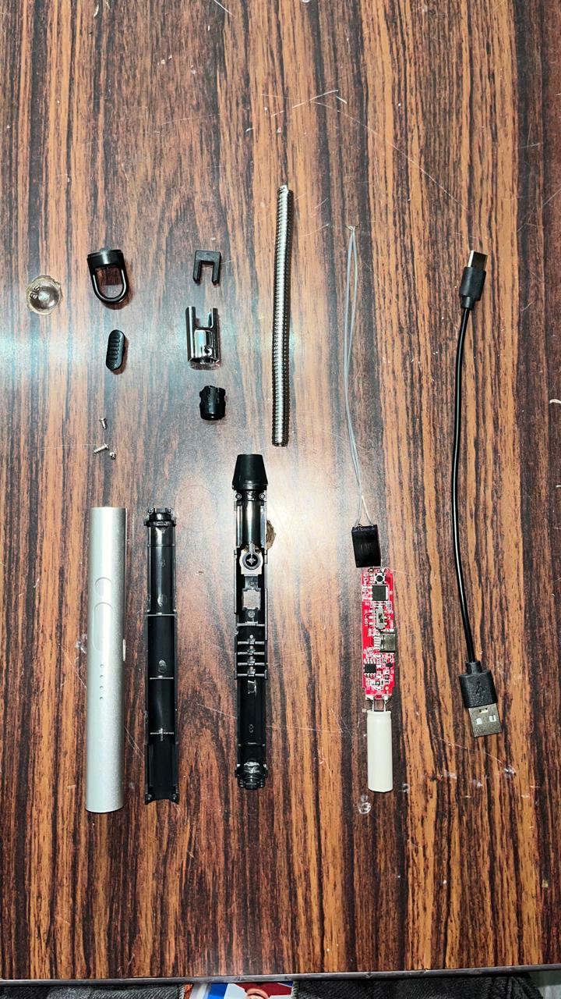

Internal Hardware Components
- The device contains a compact PCB that integrates control circuitry and high-voltage generation components.
- A rechargeable lithium-ion battery acts as the primary power supply source.
- The circuit includes a DC-DC boost converter to step up low battery voltage to high voltage.
- An oscillator and transformer/coil are used to generate the electric arc at the electrodes.
- Charging circuitry (USB interface + protection IC) ensures safe battery charging and prevents overcharging.
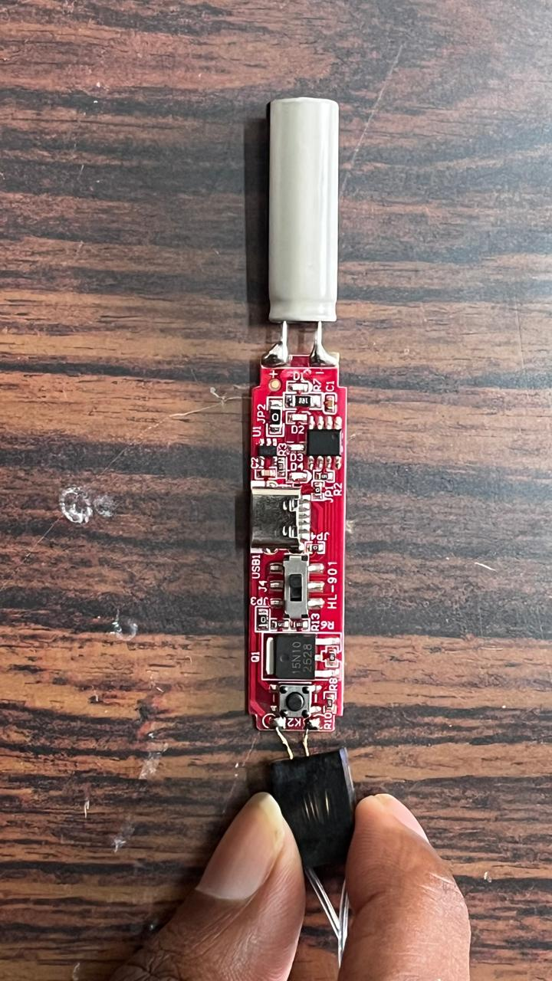
- All components are interconnected via the PCB, linking the power supply, control switch, and arc-generating electrodes.

5. Our product’s IC - Integrated Circuit Identification and Functional Analysis

Major Integrated Circuits Used
- The lighter typically uses a lithium battery charging IC such as LTC4054, manufactured by Analog Devices, for safe USB charging of a 3.7 V Li-ion battery.
- This IC provides constant-current/constant-voltage charging with protections like overcharge and thermal regulation (≈4.2 V output).
- A small microcontroller (e.g., NY8B062F) controls timing, LED indication, and auto shut-off functions.
- The MCU operates at low voltage (~2–5 V), consumes low power, and generates control pulses for switching circuits.
- An internal oscillator/driver IC (sometimes custom or similar to NE555 type) generates high-frequency pulses (~15 kHz) to drive the power stage.
- These ICs collectively control battery charging, pulse generation, and switching of a MOSFET-based boost circuit to produce high-voltage arc output (~kV range).
.

6. Our Inferences - Conclusion
- The activity improved understanding of real-world electronic product design and system integration.
- It helped in identifying components, PCB layout, and working principles of high-voltage circuits.
- A major challenge was tracing compact PCB connections and identifying unmarked or custom ICs.
- Understanding the high-voltage arc generation and boost circuitry required careful analysis.
- The process provided insights into power management, safety features, and miniaturized design techniques.
- Overall, it enhanced practical knowledge of reverse engineering, circuit analysis, and embedded hardware systems.

7. E-References
• Datasheet of LTC4054 Li-Ion Battery Charger IC – Analog Devices official website.
• Datasheet of NY8B062F Microcontroller – Nuvoton Technology / Nyquest Technology resources.
• Application notes on DC-DC Boost Converter Circuits from Texas Instruments and STMicroelectronics.
• Technical articles on arc lighter working from EDN Network.
• Product listings and specifications from Amazon and Flipkart.
• General electronics reference material on PCB design and power electronics concepts from standard engineering textbooks and online resources.

