The data for this analysis is in part in a csv file and in part ina ipynb file(in a json format)

1. Extracting data from ipynb files:
   1. Treat the useful data as a json data and extract using json load.
   2. Store the data in list format
2. Extracting data from csv files:
   1. Load using pandas
   2. Change column names by stripping the spaces between words in a column name. This is required so that the column names can be easily referred without using quotes. This is not necessary but the reference without quotes is simple and preferred.

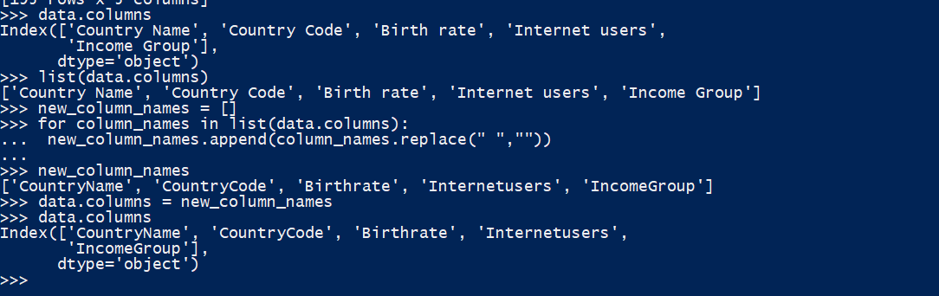

1. Identifying required data:
   1. The problem statement asks us to plot the numeric data types ‘Birthrate’ and ‘Internetuser’. Let’s get a feel of the data:  
      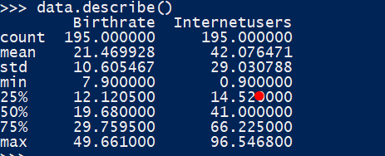  
      We see that the data for both the columns are well within logical range of 0% to 100%.
2. Merging data from python lists and the csv into pandas dataframes.
   1. Merge Country Data

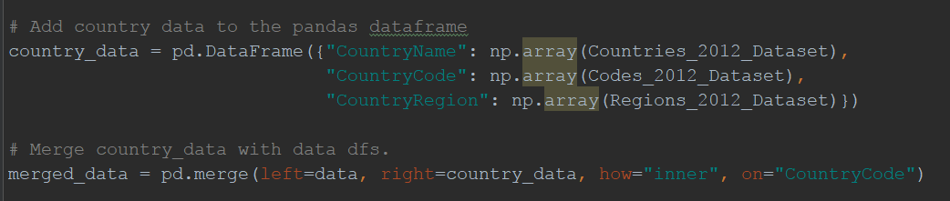

* 1. Merge Life Expectancy data

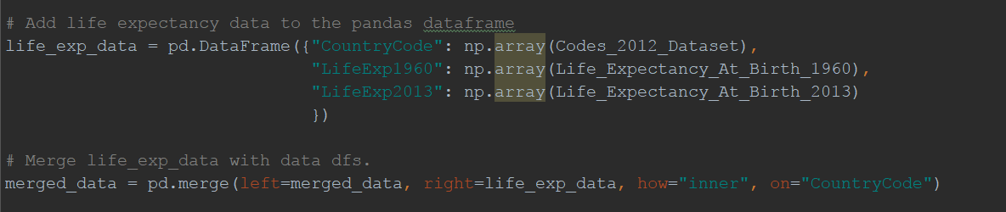

* 1. Deleting duplicate rows and renaming properly

These merges create a column “CountryName_y” and renames “CountryName” as “CountryName_x”. Correct using the following code:

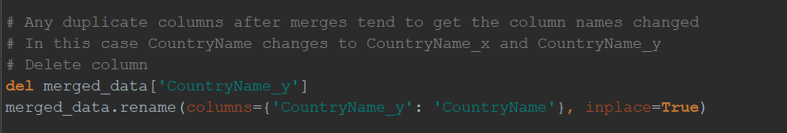

1. Create LifeExpectancy vs BirthRate plots and compare them over years.

