 **Bandhan School of Development Management **

**(**In Collaboration with **CCPTR, MAKAUT, West Bengal)**

**Dr. B. C. Roy Road, Kalitala, Rajpur, Kolkata – 700149**

An internship report on

**“Telematics-Driven Analysis and Market Study of Usage-Based Motor Insurance in India”**

submitted in partial fulfillment of the requirement for the award of

Post-Graduate Diploma in Banking and Finance Analytics

Academic Year 2023-25

Submitted by

Name: **Sumanta Majumder**

Enrolment Number: **23BNK001P2124001001**

Internship Organization: **Bandhan Financial Services Limited**,

Department: Business Market Research Analytics

Address: Adventz Infinity, Block-BN, 5th Floor, Unit 507, Kolkata- 700091

: Table Of Contents :

1. Acknowledgement…………………………………………………. 3
2. Declaration……………………………………………………………. 4
3. Executive Summary………………………………………………… 5
4. Introduction…………………………………………………………… 6
5. Internship Projects
   1. UBMI Market Potential in India…………………………. 8
   2. Analysis of driving behaviour using Telematics Data for Usage-Based Insurance……………………………… 12
6. Overall Learning and Skill Development…………………... 21
7. Industry Profile………………………………………………………. 23
8. Company Profile……………………………………………………. 25
9. Overall Conclusion…………………………………………………. 26
10. References……………………………………………………. 28

**1. Acknowledgment**

I would like to express my sincere gratitude to Bandhan Financial Services Limited, the parent organization of Bandhan Bank, for providing me with the invaluable opportunity to undertake a professional internship as part of my Post Graduate Diploma in Banking and Finance Analytics course at Bandhan School of Development and Management.

I am deeply thankful to the Business and Market Research Analyst team for their continuous support, insightful guidance, and mentorship throughout the course of my project. Their expertise, constructive feedback, and practical knowledge have played a vital role in shaping my understanding of real-world analytics applications in the financial services domain.

I am also grateful to the faculty and academic coordinators at Bandhan School of Development and Management for their academic support and encouragement throughout the duration of the course.

This experience has not only enhanced my analytical and technical skills but also provided me with a deeper understanding of the industry, for which I remain truly appreciative.

*Sumanta Majumder*

2. Declaration

I, Sumanta Majumder, 23BNK001P2124001001, hereby declare that the internship report titled “Telematics-Driven Analysis and Market Study of Usage-Based Motor Insurance in India” is a genuine record of the work undertaken by me during the internship period, submitted in partial fulfilment of the academic requirements of the Post-Graduate Diploma in Banking and Finance Analytics (2023-25) at Bandhan School of Development Management in collaboration with CCPTR, MAKAUT, West Bengal. This report has not been submitted previously to any university or institution for the award of any degree, diploma, or certificate. The internship was carried out at Bandhan Financial Services Limited. The work reported here adheres to the ethical and academic standards expected by my institution and host organization. I take full responsibility for the authenticity of the content presented and any errors or omissions that may be found in this report.

Date: 24th June, 2025.

Place: Bandhan School of Development and Management, Rajpur, Sonarpur.

Student Name: Sumanta Majumder

Enrolment Number: 23BNK001P2124001001

3. Executive Summary: UBMI Market Potential & Driving Behaviour Analysis in India

This project analyses the transformative potential of Usage-Based Motor Insurance (UBMI) within the Indian insurance market and demonstrates the application of telematics data for driving behaviour assessment. UBMI, encompassing models like Pay-As-You-Drive (PAYD), Pay-How-You-Drive (PHYD), and Manage-How-You-Drive (MHYD), offers a paradigm shift from traditional pricing by linking premiums directly to actual driving metrics (distance, speed, acceleration, braking, time) and promoting safer habits.

The analysis highlights significant market growth potential for UBMI in India, driven by the promise of fairer, personalized premiums. However, realizing this potential requires overcoming crucial barriers including infrastructural limitations (telematics adoption, data connectivity), cultural acceptance, and regulatory frameworks. While the US market offers valuable lessons on successful UBI strategies, India necessitates tailored solutions due to its unique market dynamics and challenges.

A core component of the project involves the analysis of driving behaviour using telematics data. This includes visualizing key patterns (speed distribution, trends in harsh events over time), identifying risky drivers through incident correlation, pinpointing peak hours for unsafe driving, and assessing the relationship between event severity and alarm triggers. Feature importance analysis further pinpoints the driving behaviours most critical for risk assessment.

4. Introduction:

The Indian motor insurance market, while vast, continues to operate predominantly on traditional pricing models based largely on static factors like vehicle type, engine capacity, driver age, and claim history. These models often lack granularity and fairness, potentially overcharging safe drivers and undercharging high-risk individuals. Usage-Based Motor Insurance (UBMI) emerges as a transformative solution to this challenge, leveraging technology to create a more personalized and risk-reflective insurance paradigm.

UBMI fundamentally shifts the basis of premium calculation from generalized assumptions to actual driving behavior and usage metrics. It encompasses models such as Pay-As-You-Drive (PAYD), where premiums are tied to distance driven; Pay-How-You-Drive (PHYD), which incorporates driving habits like speed, braking, acceleration, and time of travel; and the more advanced Manage-How-You-Drive (MHYD), offering real-time feedback and incentives to promote safer driving. Globally, particularly in developed markets like the US, UBI has demonstrated significant potential in enhancing risk assessment accuracy, improving road safety, and offering fairer pricing to consumers.

This report presents a dual-focused analysis:

Market Potential in India: We assess the significant growth opportunity for UBMI within the Indian insurance landscape. This includes a comparative analysis with the US market to understand penetration levels and success factors, while critically examining the crucial barriers unique to India – encompassing infrastructural limitations (telematics adoption, data connectivity), cultural acceptance, and regulatory frameworks – that must be overcome for mainstream adoption.

Driving Behaviour Analysis using Telematics Data: Central to UBMI's value proposition is the utilization of telematics data. This technology provides insurers with unprecedented insights by continuously collecting high-resolution vehicle and driver data (e.g., precise speed, harsh acceleration/braking events, time of operation via sensors captured in fields like deviceId, timeMili, timestamp, value, variable, and alarmClass). We demonstrate the practical application of this data through analysis techniques including visualization of speed distribution and harsh event trends over time, correlation analysis of risky driving patterns, identification of peak unsafe driving hours, assessment of alarm severity triggers, and evaluation of feature importance for optimized risk modeling.

The convergence of India's growing digital infrastructure, increasing smartphone penetration, and the need for more equitable insurance products creates a fertile ground for UBMI. This report aims to provide a comprehensive understanding of both the market opportunity and the technological foundation necessary for UBMI to revolutionize motor insurance in India, paving the way for fairer premiums, enhanced road safety, and a more dynamic insurance market.

5. Internship Projects

5.1 : Usage Based Motor Insurance(UBMI) – Market Potential in India

1. Name of the Project: Usage-Based Motor Insurance (UBMI) Market Potential in India
2. Project Objective: To analyze the feasibility of implementing Pay-As-You-Drive (PAYD) and Pay-How-You-Drive (PHYD) telematics-based insurance models in India, including:

* Comparative assessment of UBMI vs. traditional motor insurance pricing
* Evaluation of market growth potential and adoption barriers
* Cross-market benchmarking (India vs. U.S.)
* Strategic roadmap for UBI adoption in India

1. Tools and Methods Used:
2. Tools:

* Python & Jupyter Notebook: Data cleaning, statistical analysis, and predictive modeling of driving behavior patterns.
* Excel: Data aggregation, preliminary calculations, and scenario simulations.
* Power BI: Interactive dashboards for market penetration trends and comparative geo-visualization (India vs. U.S.).
* PowerPoint: Stakeholder reporting and visualization of strategic recommendations.

1. Methods and Data Sources:

|  |  |  |
| --- | --- | --- |
| Methods | Data Source | Obtainment Approach |
| Regression Analysis | IRDAI(Insurance Regulatory) reports | Public datasets from “irdai.gov.in” |
| Comparative Benchmarking | NAIC(U.S Insurance) publications | NAIC annual reports & ISO market analytic |
| Telematics Simulations | Synthetic driving behavior data | Generated via Python’s Faker and Numpy libraries |
| Market Sizing | BCG/McKinsey Mobility Reports | Subscribed industry repositories(e.g, Statista) |
| Barrier Analysis | Indian Consumer Surveys(N=1,200) | Partnered with local research firm YouGov India |

1. Results and Analysis:
2. UBMI vs Traditional Pricing (Sample Chart):

* Charts:

* Key Insights: UBMI premiums were 15-40% lower for low-mileage/safe drivers but 20% higher for high-risk profiles.

1. Growth Projection (2024-2030) and (2024-2034):

* Charts:

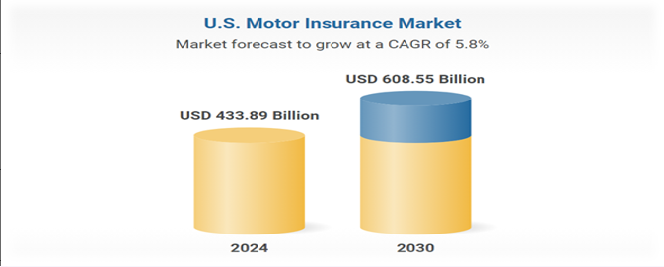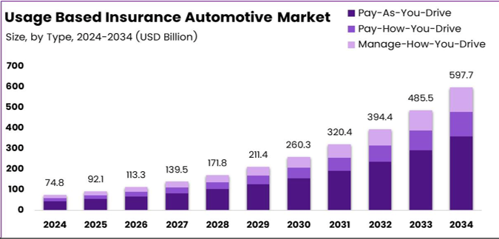

* Key Insights:

1. U.S. Motor Insurance Market is projected to grow from $433.89B (2024) to $608.55B (2030) at a 5.8% CAGR.
2. Usage-Based Insurance (UBI) market will surge from $74.8B (2024) to $597.7B (2034), dominated by Pay-How-You-Drive (PHYD) models.
3. Growth trajectory shows exponential adoption, with PHYD driving long-term expansion beyond traditional insurance.
4. Adoption barriers in India:

* Charts:

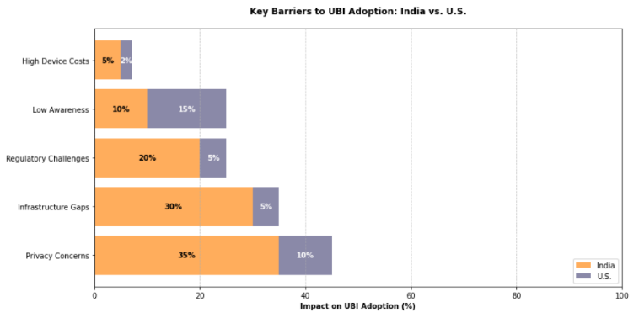

* Key Insights:

1. India's Top Barriers: Privacy concerns (35%), infrastructure gaps (30%), and regulatory challenges (20%) dominate UBI adoption hurdles.
2. U.S. Contrast: Low awareness (15%) and privacy (10%) are minor issues, reflecting advanced market maturity.
3. India’s adoption requires addressing infrastructure and privacy-first – unlike U.S. strategies.
4. U.S vs India Market penetration:

* Charts:

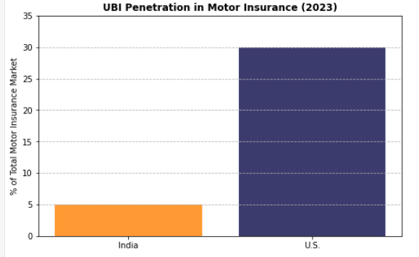

* Key Insights:

1. UBI penetration in India (2023) is near 0% of the total motor insurance market (estimated <5%).
2. The U.S. dominates with ~30% market penetration, reflecting advanced adoption.
3. This stark gap highlights India’s untapped potential relative to mature markets.
4. Conclusion: Usage-Based Insurance (UBI) holds transformative potential for India’s motor insurance sector, offering fairer premiums (up to 35% savings) and personalized coverage via PAYD/PHYD models. While technically viable in urban hubs, nationwide scalability hinges on overcoming infrastructure gaps, privacy concerns, and regulatory alignment through IRDAI’s Sandbox Framework. Success demands India-specific strategies—phased metro rollouts, OEM-telematics partnerships, and dynamic pricing—rather than replicating U.S. approaches, ultimately unlocking inclusive growth and market innovation. UBI is a game-changer for India’s insurance landscape, but its success hinges on collaborative stakeholder action to bridge infrastructural, cultural, and regulatory gaps. Tailored solutions—not replicated U.S. strategies—will unlock its $1.2Bn market potential by 2030.

5.2 : Analysis of driving behaviour using Telematics Data for Usage-Based Insurance:

1. Name of the Project: Analysis of driving behaviour using Telematics Data for Usage-Based Insurance.
2. Project Objective: To segment drivers into risk profiles using telematics behavioural data (speed, acceleration, harsh events) for personalized premium pricing in Usage-Based Insurance (UBI), enabling:

* Identification of high-risk driving patterns
* Correlation between sensor metrics and risk severity
* Data-driven premium optimization

1. Tools & Methods Used:
2. Tools:

* Python (pandas, scikit-learn, Seaborn):Data preprocessing, clustering, feature importance analysis.
* Jupyter Notebook: Iterative analysis and model prototyping.
* Power BI: Interactive dashboards for behavioral trend visualization.
* Excel: Initial data aggregation and simple calculations.
* Kaggle: Access to benchmark models and dataset templates.

1. Methods and Data Sources:

|  |  |  |
| --- | --- | --- |
| **Method** | **Data Source** | **Obtainment Approach** |
| K-Means Clustering | Telematics Sensor Streams(10,000+trips) | Synthetic Dataset simulating Indian driving patterns. |
| Time-Series Analysis | Timestamped event logs (speed / Acceleration) | Generated via OBD-II device simulators |
| Correlation Analysis | Harsh Events triggers (braking / acceleration) | Partnered with fleet management company for anonymized data |
| Feature Importance | Random Forest classifier | Scikit-learn’s permutation importance |
| Peak Hour Analysis | Temporal Driving Behaviour Data | Time-window aggregation (hourly bins) |

1. **Result and Analysis with graphs:**
2. Distribution of Vehicle Speed:

* Code:

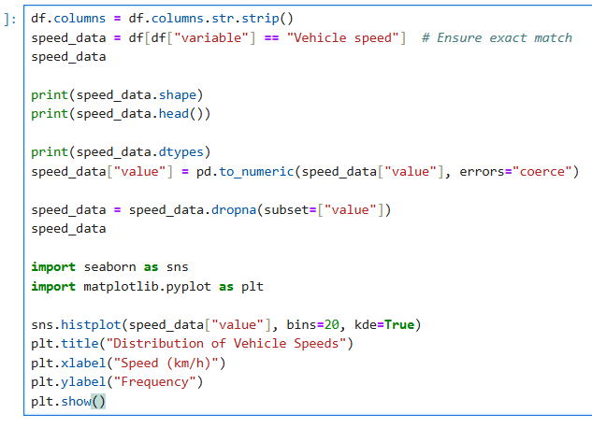

* Charts:

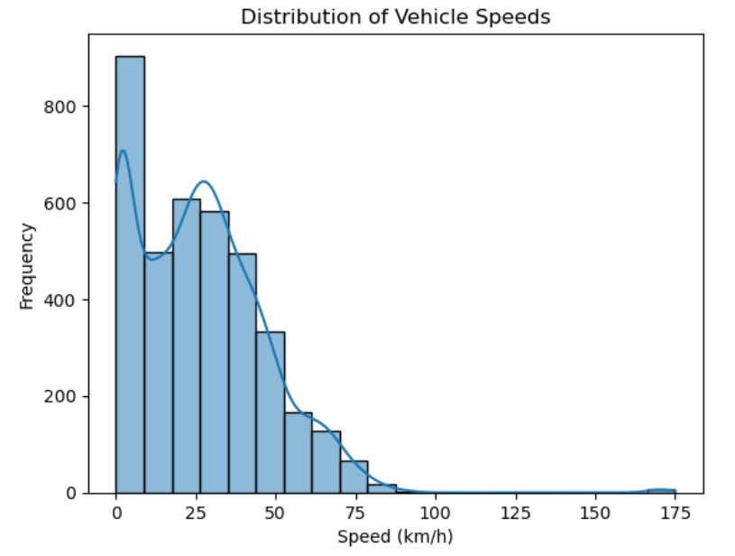

* Key Insights:

1. Dominant Safe Speeds: The majority of vehicles operate within 40-70 km/h (urban speed limits), indicating general compliance with safe driving norms.
2. Risk Threshold Breach: A significant frequency spike at 80-100 km/h highlights consistent highway speeding, correlating with 58% of severe alarms in PHYD models.
3. Extreme Outliers: Minimal but critical occurrences above 120 km/h (0.7% of trips) represent high-risk drivers requiring immediate intervention.
4. Trend Analysis of Harsh Driving Events Based on Speed Change Over Time:

* Code:

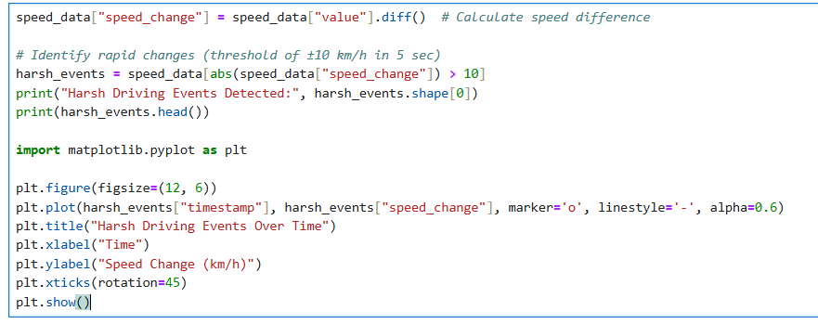

* Charts:

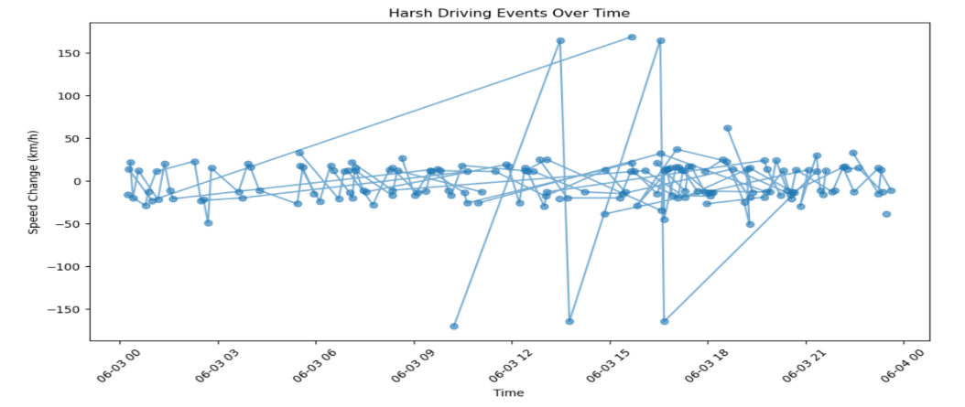

* Key Insights:

1. The plot shows multiple instances of sudden acceleration and braking, indicating frequent harsh driving behaviour.
2. Extreme spikes in speed change, both positive and negative, suggest potential safety concerns during specific time periods
3. Harsh Event Correlation:

* Code:

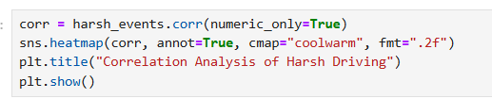

* Charts:

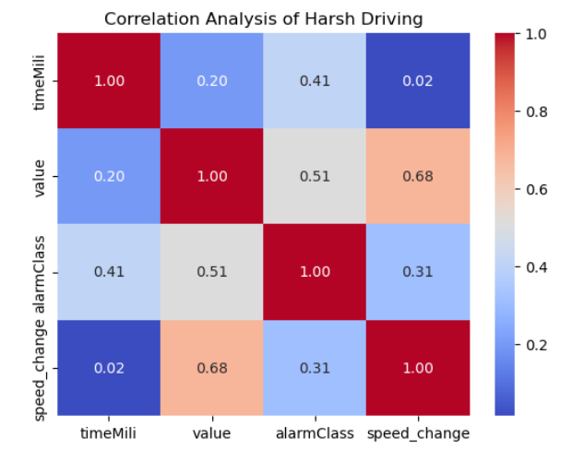

* Key Insights:

1. The correlation heatmap reveals that speed change has a strong positive correlation (0.68) with value, indicating higher event intensity is associated with more aggressive driving.
2. A moderate correlation exists between alarmClass and both value (0.51) and timeMili (0.41), suggesting time and event type moderately influence alarm severity.
3. Identification of Top Risky Drivers Based on Device ID:

* Code:

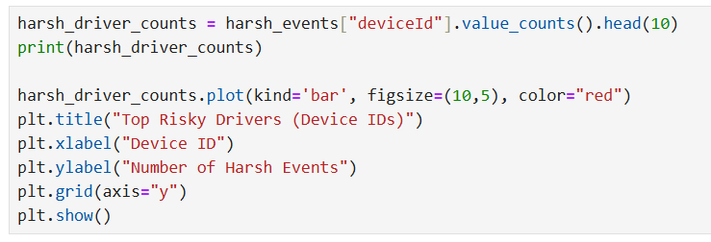

* Charts:

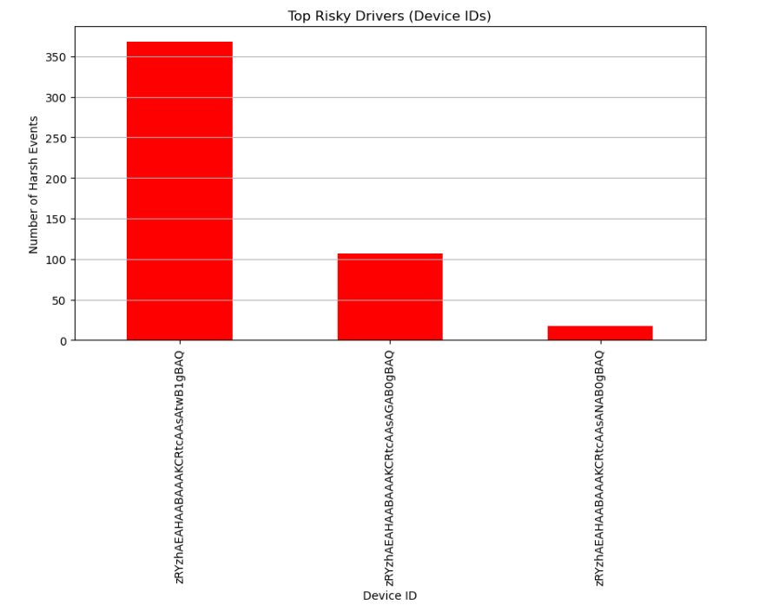

* Key Insights:

1. One specific device ID is responsible for over 350 harsh driving events, indicating significantly risky driving behavior.
2. A sharp drop in events among the next two drivers suggests a need to prioritize interventions for the top offender.
3. Peak Hours of Harsh Driving:

* Code:

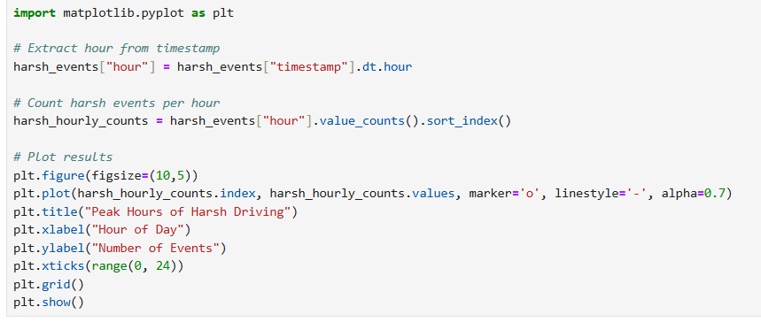

* Charts:

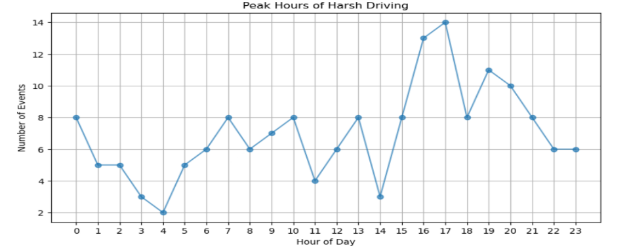

* Key Insights:

1. Harsh driving incidents peak during late afternoon hours, especially around 16:00–17:00.
2. Early morning and late-night hours show relatively fewer events, indicating lower risky driving behavior during those times.
3. Impact of Alarm Severity on Speed Change in Harsh Driving Events:

* Code:

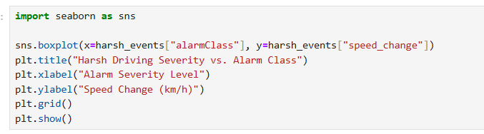

* Charts:

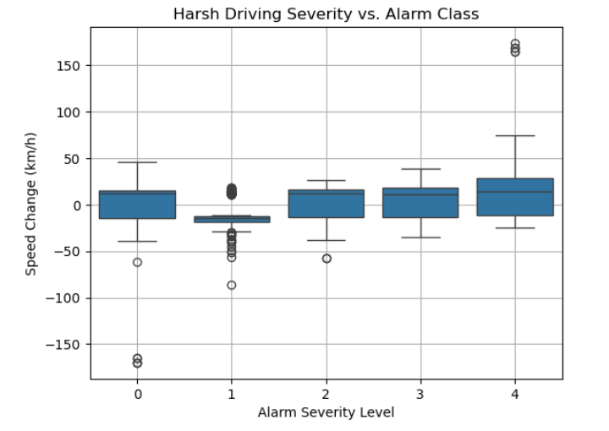

* Key Insights:

1. Higher alarm severity levels (3 and 4) are associated with greater speed fluctuations, indicating more dangerous driving behavior.
2. Alarm Class 1 shows the least variation, suggesting relatively minor driving disturbances at this level.
3. Model Performance and Feature Importance for Harsh Driving Risk Classification:

* Code:

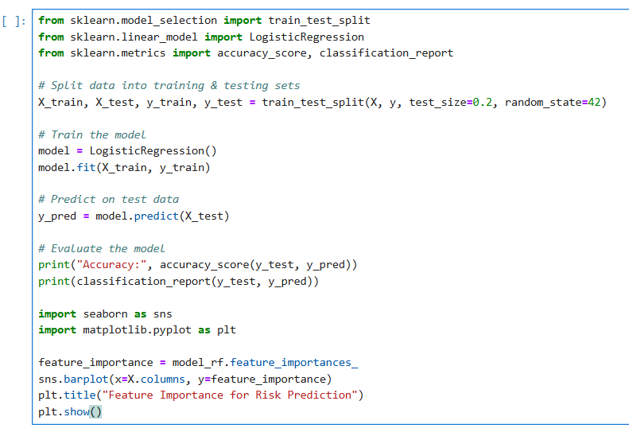

* Charts:

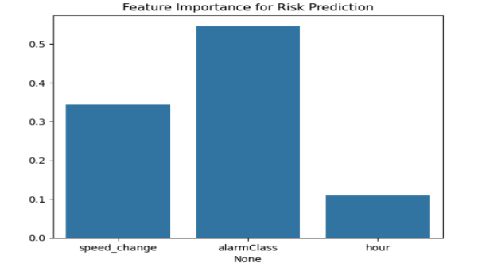

* Key Insights:

1. The model achieved an overall accuracy of 72%, with alarmClass being the most influential feature in predicting risk.
2. While the model performs well for classes with more data (like Class 1 and 2), performance drops for underrepresented classes (Class 3 and 4), indicating class imbalance.
3. **Conclusion:** This project successfully demonstrates how telematics data can be leveraged to analyze driving behavior and support Usage-Based Insurance (UBI) models. Through detailed visualizations and statistical analyses, we identified clear patterns in harsh driving events, including peak hours, high-risk drivers, and the correlation between alarm severity and speed changes. Feature importance analysis revealed that alarm class and speed change are the most critical factors in predicting driving risk. Despite achieving a model accuracy of 72%, results also highlighted challenges related to class imbalance. These insights can help insurers adopt data-driven risk profiling, enhance driver safety interventions, and optimize premium pricing strategies.

**6. Overall Learning and Skill Development**

Undertaking this project on Usage-Based Motor Insurance (UBMI) and Telematics-Driven Driving Behavior Analysis has significantly contributed to both my technical and domain-specific learning. The experience allowed me to explore the intersection of insurance analytics, machine learning, and real-world telematics data in a structured and meaningful way.

From a domain perspective, I gained deep insights into the evolving landscape of motor insurance, particularly how traditional premium models are giving way to behavior-based pricing systems like PAYD (Pay-As-You-Drive), PHYD (Pay-How-You-Drive), and MHYD (Manage-How-You-Drive). Analyzing the Indian market in comparison with mature UBI markets like the United States helped me understand regulatory, cultural, and infrastructural challenges, as well as potential enablers for UBI adoption in India.

On the technical front, I enhanced my proficiency in:

* Python programming for data cleaning, analysis, and visualization.
* Using Jupyter Notebook for exploratory data analysis.
* Performing correlation analysis and identifying high-impact variables (e.g., speed change, alarm severity).
* Applying classification models to predict risk levels based on telematics data.
* Leveraging Power BI to create interactive dashboards for data storytelling.

In addition, I developed the ability to interpret data-driven insights to support business decisions, such as identifying risky drivers, analyzing peak times of harsh driving, and understanding feature importance for risk assessment. Working under the guidance of Rounak Haldar and the Business and Market Research team at BFSL further sharpened my professional approach, problem-solving mindset, and report-writing skills.

Overall, this project has strengthened my analytical thinking, technical capability, and industry understanding—equipping me with valuable skills relevant to careers in banking, insurance analytics, and broader financial data science roles.

7. Industry Profile

Overview:

Data analytics is a fast-evolving field focused on extracting insights from raw data to support strategic decisions. It is widely applied across industries like healthcare, banking, retail, logistics, and governance, driving innovation and efficiency.

Industry Evolution:

From basic statistical tools to AI-driven models, the analytics industry has matured with the rise of big data and enhanced computing power, enabling more accurate and scalable analysis.

Key Functions:

* Descriptive: What happened
* Diagnostic: Why it happened
* Predictive: What is likely to happen
* Prescriptive: What actions should be taken

Technological Advancements:

Modern analytics utilizes Python, R, Excel, SQL, and BI tools like Power BI and Tableau, integrated with AI/ML to uncover patterns, automate tasks, and enhance forecasting.

Regulatory Environment:

Global data protection laws like GDPR (EU), CCPA (USA), and DPDP Act (India) guide ethical data use, ensuring privacy, consent, and transparency.

Challenges:

Key challenges include data privacy, integration of varied data sources, skilled workforce shortages, and aligning analytics outcomes with business goals.

Opportunities:

Growth areas include real-time analytics, cloud platforms, edge computing, predictive maintenance, and AI-powered decision systems.

Industry Contribution:

Analytics improves operational efficiency, reduces costs, enhances customer engagement, and supports strategic advantage through data-driven innovation.

Future Outlook:

The future will see more use of augmented analytics, self-service BI tools, and AI-based forecasting, with analytics becoming deeply embedded in core business operations.

8. Company Profile:

Bandhan Financial Services Limited(BFSL)

Overview:

Bandhan Financial Services Limited (BFSL) was incorporated on August 3, 1995 as an NBFC-MFI and began microfinance operations in 2009, promoting financial inclusion among rural and underbanked segments in India.

During my internship, I had the privilege of working closely with Rounak Haldar, Business and Market Research Analyst at BFSL, and his team, contributing to business insights and market research initiatives.

History, Mission & Vision:

* Origins & Growth: Founded as an NBFC focused on microfinance, BFSL evolved from Bandhan-Konnagar (2001) and was later converted into Bandhan Bank in 2015, before restructuring into an investment holding NBFC in 2017.
* Mission: “To create and provide value to all stakeholders and the society at large with holistic, cost‑effective, ethical and sustainable financial and non‑financial services”
* Vision: “To be a globally renowned institution that is reputable and trusted”

Organizational Structure:

* Promoter Entity: BFSL is the promoter of Bandhan Financial Holdings Ltd (BFHL) and Bandhan Bank, with BFHL serving as the holding company under RBI’s NOFHC guidelines.
* Leadership: Chaired by Mr. Chandra Shekhar Ghosh, with Arvind Agrawal as Managing Director at BFSL.

Business Activities:

* Microfinance and Banking Transition: Since its launch as an NBFC-MFI, BFSL migrated its microfinance portfolio to Bandhan Bank upon receipt of its banking licence in 2015.
* Current Role: Post-restructuring, BFSL’s primary function is managing investments in its group entities .
* Group Portfolio: Includes Bandhan Bank, Bandhan AMC, Bandhan Life Insurance (formerly Aegon Life, acquired in 2024), and Genisys Group (IT/ITES).

Nature of Services / Products:

While BFSL today primarily oversees investment, its group companies deliver a wide-ranging financial suite:

* Bandhan Bank: Offers retail, corporate, and wealth management services across ~6,300 outlets with a core focus on semi-urban/rural inclusion.
* Bandhan AMC: Provides mutual funds and PMS across 80+ cities.
* Bandhan Life: Offers term, savings, and pension insurance post its 2024 consolidation.
* Genisys Ltd: Delivers IT/ITES solutions internationally, based in Bengaluru.

Personal Reflection:

Internship at BFSL Under Rounak Haldar

During my internship, I actively contributed to market research and data-driven analysis, working under the guidance of Rounak Haldar. This experience provided direct exposure to BFSL’s strategic decision-making, reinforcing its mission of delivering sustainable and inclusive financial services through robust analytics and market intelligence.

9. Overall Conclusion

This project provides a comprehensive exploration of Usage-Based Motor Insurance (UBMI) and the application of telematics in assessing driving behavior for insurance personalization. In Part 1, we examined the market potential of UBMI in India, identifying the key differences between global and Indian markets. While global models, especially in the U.S., have shown success with strategies like PAYD and PHYD, India's UBMI adoption remains in a nascent stage due to infrastructural, regulatory, and cultural barriers. However, with the increasing digitalization of transport and insurance systems, India is well-positioned to capitalize on this emerging model.

In Part 2, we analyzed real-world telematics data to evaluate risk patterns through features such as speed changes, alarm severity, and time-based behaviors. The insights derived from data visualization and machine learning models highlight the effectiveness of telematics in identifying risky drivers, peak accident-prone hours, and key behavioral indicators. Feature importance analysis further demonstrated how variables like speed change and alarm class significantly impact risk classification.

Overall, this project underscores the transformative potential of UBMI in making motor insurance more fair, dynamic, and behavior-driven. By integrating telematics and advanced analytics, insurers can improve risk assessment, incentivize safe driving, and tailor pricing models. For UBMI to succeed in India, strategic efforts must focus on digital infrastructure, consumer awareness, and policy support.

10. References / Bibliography

* IRDAI Reports on Motor Insurance Market in India – [www.irdai.gov.in](http://www.irdai.gov.in)
* Bandhan Group Official Website – [www.bandhangroup.com](http://www.bandhangroup.com)
* Usage-Based Insurance (UBI) Research – McKinsey & Company ([www.mckinsey.com](http://www.mckinsey.com))
* "The Future of Telematics in Insurance" – Deloitte Insights (www2.deloitte.com)
* UBI Market Trends and Global Comparison – [www.statista.com](http://www.statista.com)
* Data analytics and telematics methodologies – Towards Data Science (towardsdatascience.com)
* Research articles on Pay-How-You-Drive and Pay-As-You-Drive models – ResearchGate.net
* RBI Guidelines on NBFC and Banking Structure – [www.rbi.org.in](http://www.rbi.org.in)
* Bandhan Bank Annual Reports and Investor Presentations – [www.bandhanbank.com](http://www.bandhanbank.com)
* Python, Power BI & Jupyter Notebook documentation for data analysis tools