Implicit:

Activity_main.xml:

<?xml version="1.0" encoding="utf-8"?>
<androidx.constraintlayout.widget.ConstraintLayout xmlns:android="http://schemas.android.com/apk/res/android"
xmlns:app="http://schemas.android.com/apk/res-auto"
xmlns:tools="http://schemas.android.com/tools"
android:layout_width="match_parent"
android:layout_height="match_parent"
tools:context=".MainActivity">
<EditText
android:id="@+id/phh"
android:layout_width="wrap_content"
android:layout_height="wrap_content"
android:ems="10"
android:inputType="text"
android:text="Name"
app:layout_constraintBottom_toBottomOf="parent"
app:layout_constraintEnd_toEndOf="parent"
app:layout_constraintStart_toStartOf="parent"
app:layout_constraintTop_toTopOf="parent" />
<Button
android:id="@+id/btt"
android:layout_width="wrap_content"
android:layout_height="wrap_content"
android:text="Button"
app:layout_constraintBottom_toBottomOf="parent"
app:layout_constraintEnd_toEndOf="parent"
app:layout_constraintStart_toStartOf="parent"
app:layout_constraintTop_toTopOf="parent"
app:layout_constraintVertical_bias="0.77" />
</androidx.constraintlayout.widget.ConstraintLayout>

MainActivity.java:

package com.example.implicit;
import androidx.appcompat.app.AppCompatActivity;
import android.content.Intent;
import android.net.Uri;
import android.os.Bundle;
import android.view.View;
import android.widget.Button;
import android.widget.EditText;
public class MainActivity extends AppCompatActivity {
EditText ph;
Button bt;
@Override
protected void onCreate(Bundle savedInstanceState) {
super.onCreate(savedInstanceState);
setContentView(R.layout.activity_main);
ph=findViewById(R.id.phh);
bt=findViewById(R.id.btt);
bt.setOnClickListener(new View.OnClickListener(){
@Override
public void onClick(View view){
String phone=ph.getText().toString();
Uri myuri=Uri.parse("tel:"+phone);
Intent it=new Intent(Intent.ACTION_DIAL,myuri);
startActivity(it);
}
});
}
}
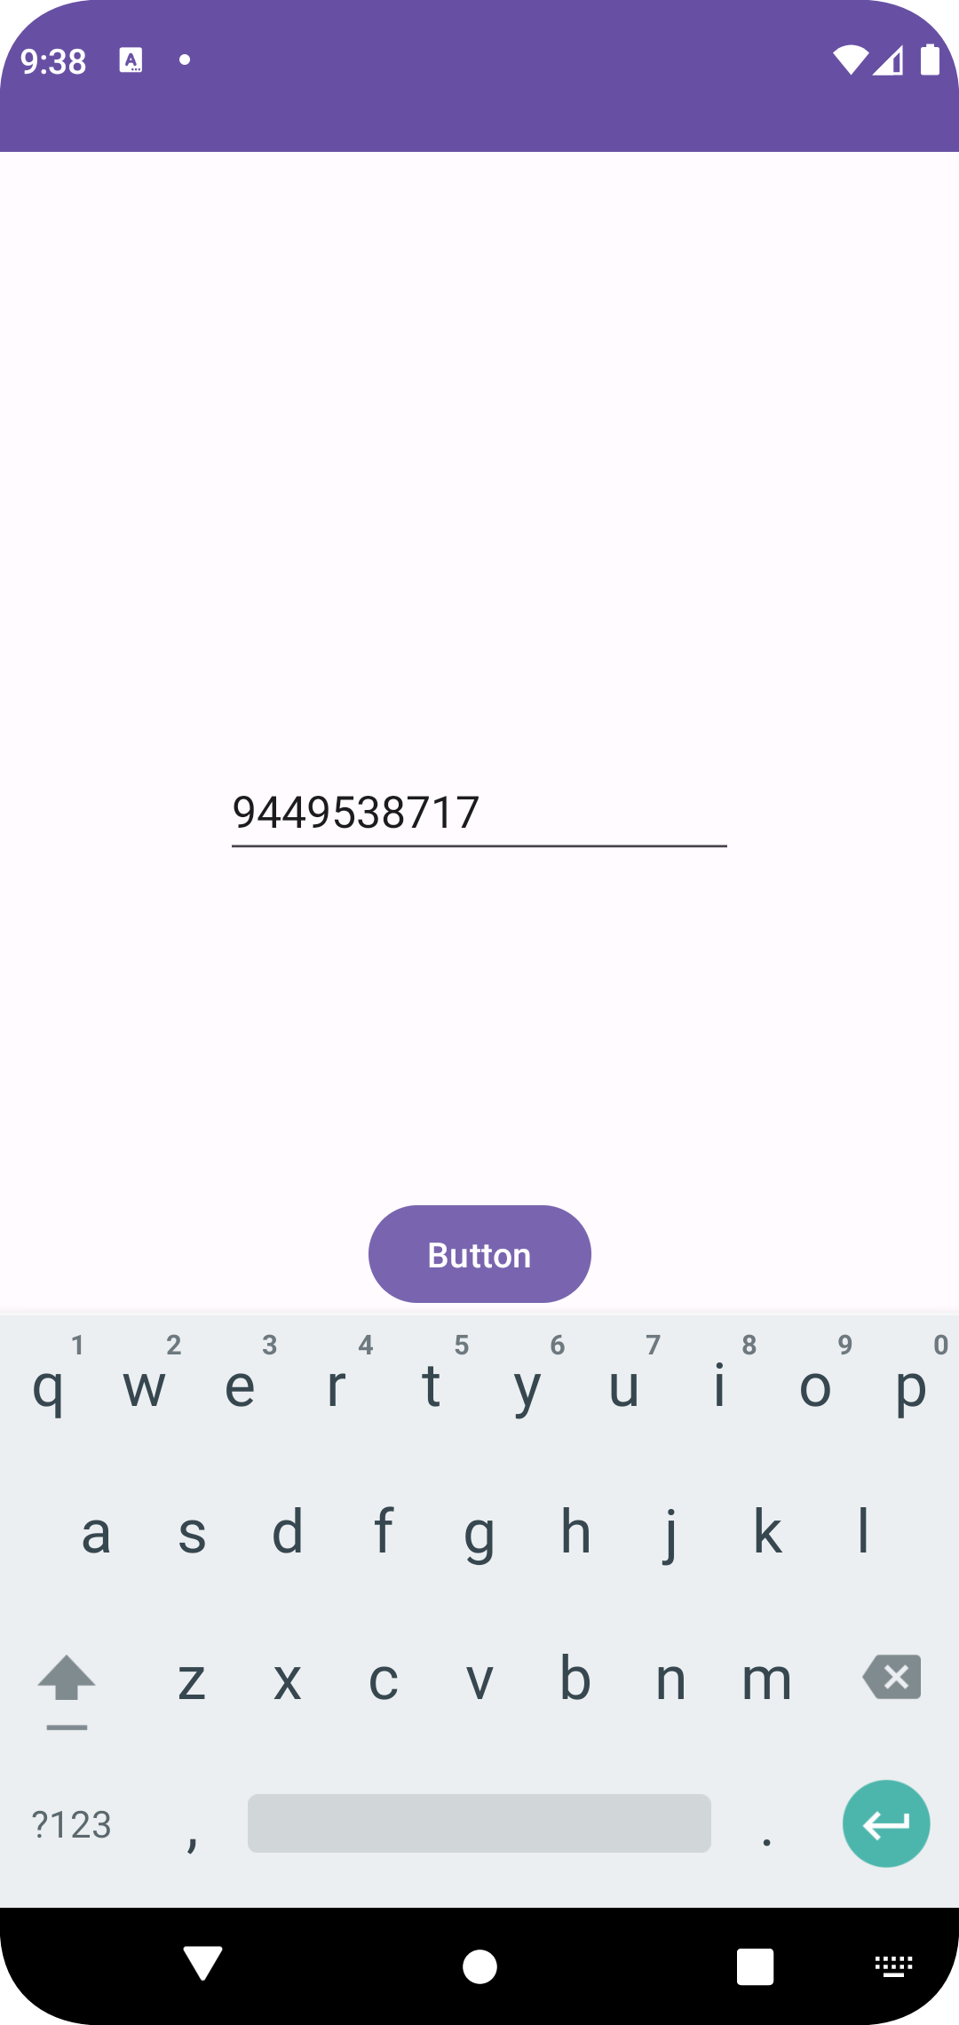
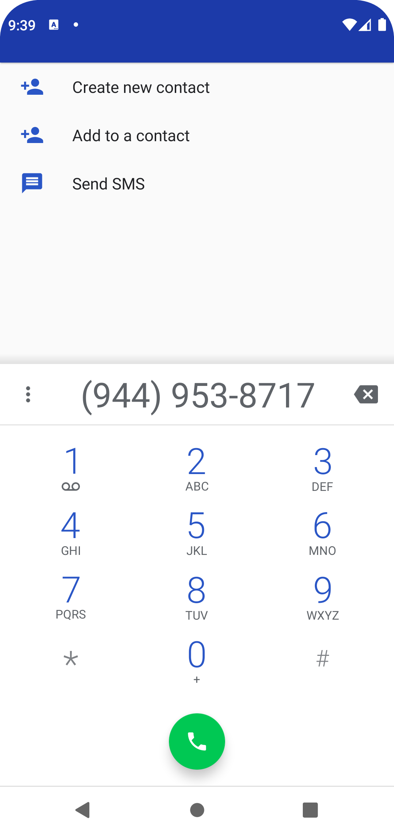
Explicit:

activity_main.xml:

<?xml version="1.0" encoding="utf-8"?>
<androidx.constraintlayout.widget.ConstraintLayout xmlns:android="http://schemas.android.com/apk/res/android"
xmlns:app="http://schemas.android.com/apk/res-auto"
xmlns:tools="http://schemas.android.com/tools"
android:layout_width="match_parent"
android:layout_height="match_parent"
tools:context=".MainActivity">
<EditText
android:id="@+id/phh"
android:layout_width="wrap_content"
android:layout_height="wrap_content"
android:ems="10"
android:inputType="text"
android:text="Name"
app:layout_constraintBottom_toBottomOf="parent"
app:layout_constraintEnd_toEndOf="parent"
app:layout_constraintStart_toStartOf="parent"
app:layout_constraintTop_toTopOf="parent" />
<Button
android:id="@+id/btt"
android:layout_width="wrap_content"
android:layout_height="wrap_content"
android:text="Button"
app:layout_constraintBottom_toBottomOf="parent"
app:layout_constraintEnd_toEndOf="parent"
app:layout_constraintStart_toStartOf="parent"
app:layout_constraintTop_toTopOf="parent"
app:layout_constraintVertical_bias="0.752" />
</androidx.constraintlayout.widget.ConstraintLayout>

MainActivity.java

package com.example.explicit;
import androidx.appcompat.app.AppCompatActivity;
import android.content.Intent;
import android.os.Bundle;
import android.view.View;
import android.widget.Button;
import android.widget.EditText;
public class MainActivity extends AppCompatActivity {
EditText data;
Button bt;
@Override
protected void onCreate(Bundle savedInstanceState) {
super.onCreate(savedInstanceState);
setContentView(R.layout.activity_main);
data=findViewById(R.id.phh);
bt=findViewById(R.id.btt);
bt.setOnClickListener(new View.OnClickListener(){
@Override
public void onClick(View view){
String finalmessage=data.getText().toString();
Intent it=new Intent(MainActivity.this, MainActivity2.class);
Bundle bd=new Bundle();
bd.putString("key",finalmessage);
it.putExtras(bd);
startActivity(it);
}
});
}
}

activity_main2.xml:

<?xml version="1.0" encoding="utf-8"?>
<androidx.constraintlayout.widget.ConstraintLayout xmlns:android="http://schemas.android.com/apk/res/android"
xmlns:app="http://schemas.android.com/apk/res-auto"
xmlns:tools="http://schemas.android.com/tools"
android:layout_width="match_parent"
android:layout_height="match_parent"
tools:context=".MainActivity2">
<TextView
android:id="@+id/text"
android:layout_width="wrap_content"
android:layout_height="wrap_content"
android:text="TextView"
android:textSize="30dp"
app:layout_constraintBottom_toBottomOf="parent"
app:layout_constraintEnd_toEndOf="parent"
app:layout_constraintHorizontal_bias="0.458"
app:layout_constraintStart_toStartOf="parent"
app:layout_constraintTop_toTopOf="parent"
app:layout_constraintVertical_bias="0.341" />
</androidx.constraintlayout.widget.ConstraintLayout>

MainActivity2.java

package com.example.explicit;
import androidx.appcompat.app.AppCompatActivity;
import android.os.Bundle;
import android.widget.TextView;
public class MainActivity2 extends AppCompatActivity {
TextView data;
@Override
protected void onCreate(Bundle savedInstanceState) {
super.onCreate(savedInstanceState);
setContentView(R.layout.activity_main2);
data=findViewById(R.id.text);
String val=getIntent().getStringExtra("key");
data.setText(val);
}
}


