**Database Management and System Design**

**The City Library – EER Diagram**

**TEAM MEMBERS**

PARAKALA SAI SUMANTH GOUD

KARAN GAUR

JAGADHABI MANIDEEP

**INDEX**

Page No

1. Goals 1
2. Extended ER Diagram 2
3. Assumptions 3
4. Constraints beyond the Diagram 3
5. Difficulties and Solutions 3

**1) Goals**

* To analyse “The City Library” database system based on the requirements.
* To conceptualize the flow of data and organize it to create a schema.
* Build an EER Diagram based on the schema by using different entities, attributes, and relationship types.
* To ensure minimalism and avoid redundancy.

**2) Extended ER Diagram**

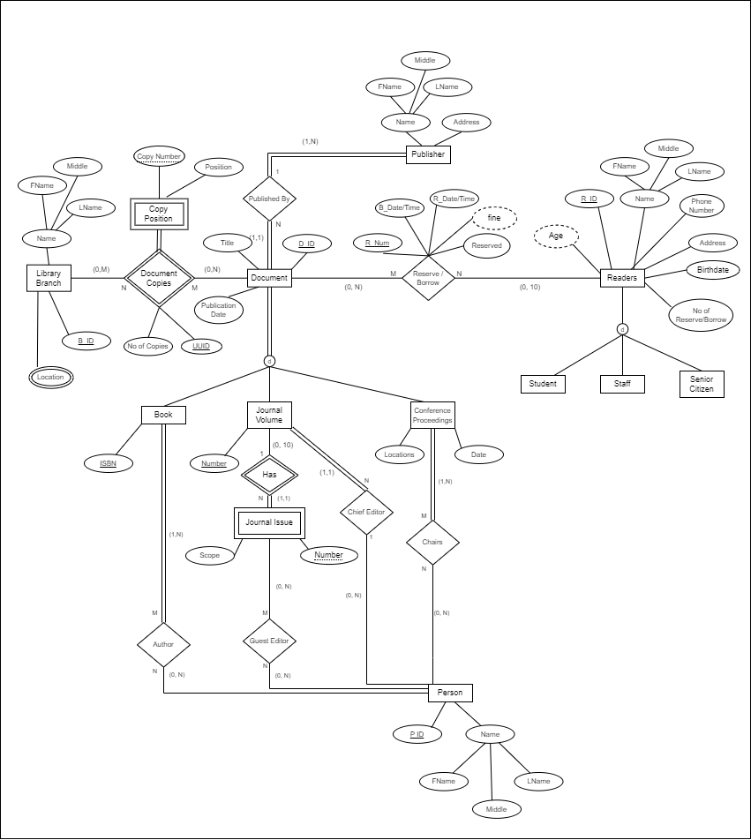

**3) Assumptions**

* The library system has multiple branches with each branch holding many copies of the respective documents.
* A particular copy from all the available copies can be uniquely identified by branch ID, Document ID, and Copy Number.
* For better database handling we have used UUID which represents Bid, Did, and copy number and uniquely identifies each copy.
* Readers are expected to register in the database while reserving documents by giving the required details.
* Reservation and Borrowing transactions will be recorded in a single relation (RId = BId).
* Reader is expected to provide birthdate to derive his age.

**4) Constraints beyond the Diagram**

* Online catalogue is not represented separately in the diagram.
* Time constraint to cancel a reservation is beyond the diagram.

**5) Difficulties and Solutions**

* Found it difficult to relate and uniquely identify each copy of the document. Solved it by adding a ternary relationship between library branch and document. Also added UUID to uniquely identify each copy and reduce redundancy.
* Difficulty to prevent readers from borrowing a document that is reserved by others. Solved it by creating a single relationship for both(reserve/borrow) transactions.