**Database Management and System Design**

**The City Library – EER Diagram**

**TEAM MEMBERS**

PARAKALA SAI SUMANTH GOUD

KARAN GAUR

JAGADHABI MANIDEEP

**INDEX**

Page No

1. Goals 1
2. EER to Relational mapping 2
3. Constraints
4. Difficulties and Solutions

**1) Goals**

A logical design is a conceptual, abstract design. The process of logical design involves arranging data into a series of logical relationships called entities and attributes. An entity represents a chunk of information. In relational databases, an entity often maps to a table. An attribute is a component of an entity and helps define the uniqueness of the entity. In relational databases, an attribute maps to a column. We have revised the previous phase by relating the Borrow/reserve relation to copy instead of document.

Goals of this phase:

* To create well-structured tables that reflect the need of the user. Use normalization to validate the logical model
* Tables of the Logical database store data in a non-redundant manner and foreign keys will be used in tables so that relationships among tables and entities will be supported
* The logical data model also has long-term value as documentation for later stages in the development process and beyond

**2) EER to Relational mapping**

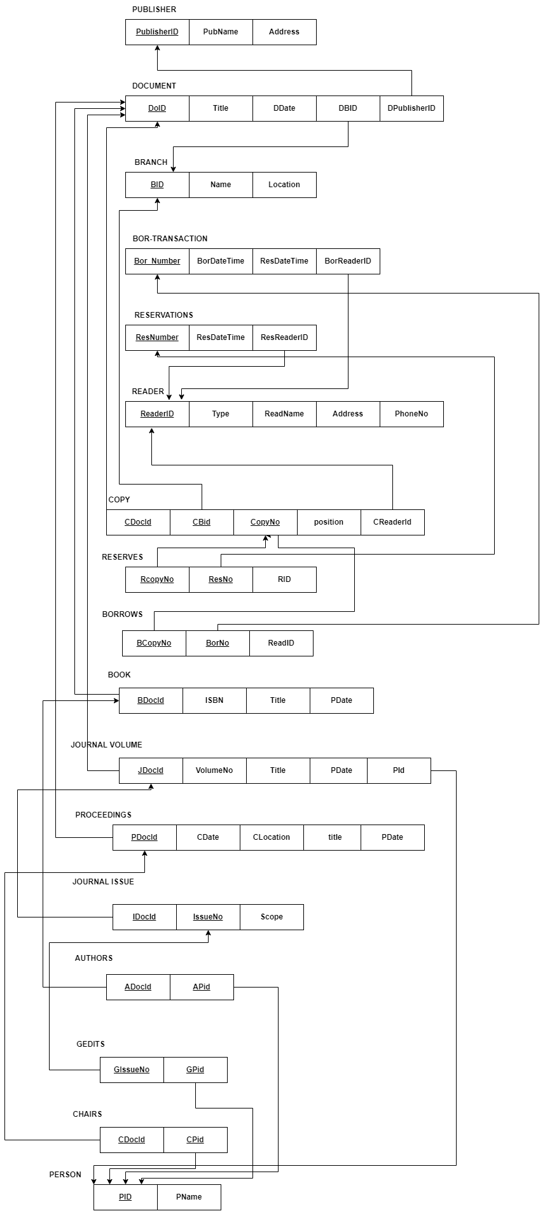

**3) Constraints**

* A journal can only have a single chief editor at a time
* A reader cannot borrow more than 10 documents
* A document can have only one publisher
* A reserved copy has to be picked up before 6pm or else the reservation is cancelled

**4) Difficulties and Solutions**

* Choosing an entity to relation mapping strategy from the various available ways