YOLOv8 Poly-Distance (TensorFlow)
Training Handbook
Detection + Polygon Segmentation + Distance Estimation
Architecture, representations, augmentation, and losses — with exact formulas, worked examples, and speed engineering

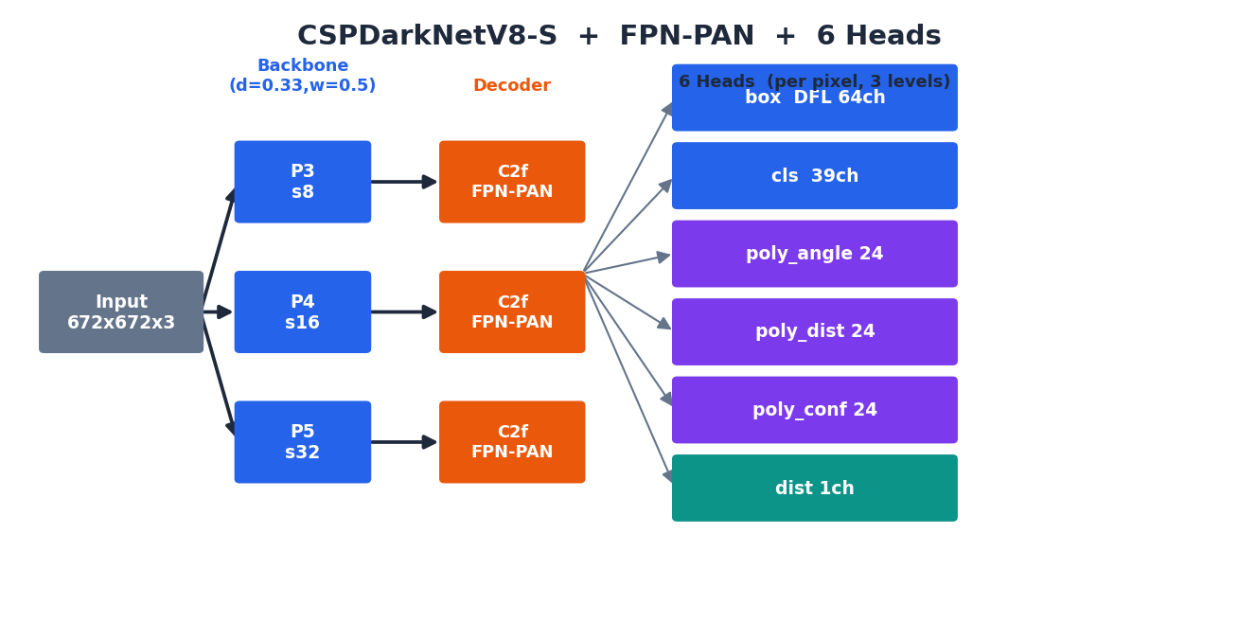
Figure. The model at a glance: a CSPDarkNetV8-S backbone feeds an FPN-PAN decoder and six prediction heads.
About this document. An engineer-deep reference for the TensorFlow 2.16 reimplementation of YOLOv8 with two extensions: 24-vertex PolyYOLO polygon segmentation and per-object distance estimation. Every number, formula, channel count, and file:line below was extracted directly from the live source and the experiment config configs/experiments/yolo/yolov8_poly_dist.yaml. Sections 2 (architecture), 4 (augmentation), 5 (representations), and 6 (losses) include real formulas and worked numeric examples. Fully editable in Word / Google Docs / LibreOffice.

Contents
1. System Overview
2. Architecture — backbone, decoder, heads, detection generator (with shape traces)
3. The Data Pipeline — two streams, stage by stage
4. Data Augmentation — every transform, its parameters, and how labels move with it
5. Representations — polygon, box (DFL), distance, with worked examples
6. Losses and Their Effects — assignment + every formula
7. How We Made Training FASTER
8. Additional Training Features
9. Configuration Cheat-Sheet
10. Worked Examples & File Map

1. System Overview
A TensorFlow reimplementation of YOLOv8 that predicts three things from one 672×672 image: object boxes + classes (detection), a per-object polygon outline (segmentation), and a per-object distance in meters. The polygon and distance heads are extensions on top of stock YOLOv8.
Tier (configs/experiments/yolo/) | Heads enabled | Use case
yolov8_bbox.yaml | box + cls | Detection only
yolov8_poly.yaml | box + cls + polygon | Detection + segmentation
yolov8_poly_dist.yaml | all 6 heads | Detection + segmentation + distance

Property | Value
Input | 672 × 672 × 3 (RGB)
Backbone | CSPDarkNetV8-S (width 0.50, depth 0.33)
Classes | 39
Strides / levels | 8, 16, 32 (3 FPN levels)
Anchors (672²) | 84²+42²+21² = 9261 points
Activation / Norm | ReLU (config-selectable) / BatchNorm (momentum 0.97, eps 0.001)
Optimizer | SGD+Nesterov (m=0.937), cosine LR, EMA
Precision | mixed bfloat16 (heads + loss pinned float32)
Batch | 128 detection + 16 distance = 144

2. Architecture
Images flow through a shared backbone and an FPN-PAN decoder, then split into six heads that read all three FPN levels. This section gives the exact block composition, channel counts (after the S-model scaling), and a forward shape trace.

2.1 Model scaling (how '-S' is derived)
Channel and depth counts come from base values scaled by width=0.50 and depth=0.33, rounded as:
backbone.py:267-277
_make_div8(v) = max(8, int(v+4)//8 * 8) # round channels to a multiple of 8
channels = _make_div8(base_ch * width) # base [64,128,256,512,1024]
n_blocks = max(1, round(base_n * depth)) # base depths [3,6,6,3]
Base channels | → S (×0.50) | Base depths | → S (×0.33)
64,128,256,512,1024 | 32,64,128,256,512 | 3,6,6,3 | 1,2,2,1

2.2 Backbone — CSPDarkNetV8-S
A stem (total stride 4) followed by three downsampling stages producing P3/P4/P5. Every conv is a ConvBnAct: Conv2D (no bias) → BatchNorm (momentum 0.97, eps 0.001) → ReLU. Stride-2 convs use explicit asymmetric ZeroPadding + VALID.
Stage | Composition | Out ch | Stride | Output
stem | ConvBnAct k3 s2 → ConvBnAct k3 s2 → C2f(n=1) | 64 | 4
P3 | ConvBnAct k3 s2 → C2f(n=2) | 128 | 8 | “3” → [B,84,84,128]
P4 | ConvBnAct k3 s2 → C2f(n=2) | 256 | 16 | “4” → [B,42,42,256]
P5 | ConvBnAct k3 s2 → C2f(n=1) → SPPF(k5) | 512 | 32 | “5” → [B,21,21,512]

Forward shape trace (672² input, S):
input [B,672,672,3]
stem_conv1 s2 → [B,336,336,32]
stem_conv2 s2 → [B,168,168,64]
stem_c2f → [B,168,168,64]
down1 s2 → c2f → P3 [B,84,84,128] (stride 8)
down2 s2 → c2f → P4 [B,42,42,256] (stride 16)
down3 s2 → c2f → sppf → P5 [B,21,21,512] (stride 32)

2.3 The C2f block and the SPPF block
C2f (Cross-Stage Partial, 'faster') is the workhorse. A 1×1 conv expands to 2·c, the result is split in two; one half is passed through n bottlenecks (each = two 3×3 ConvBnAct with an optional residual); every intermediate tensor is kept and concatenated, then a 1×1 conv mixes them. This dense feature reuse gives rich gradient flow cheaply.
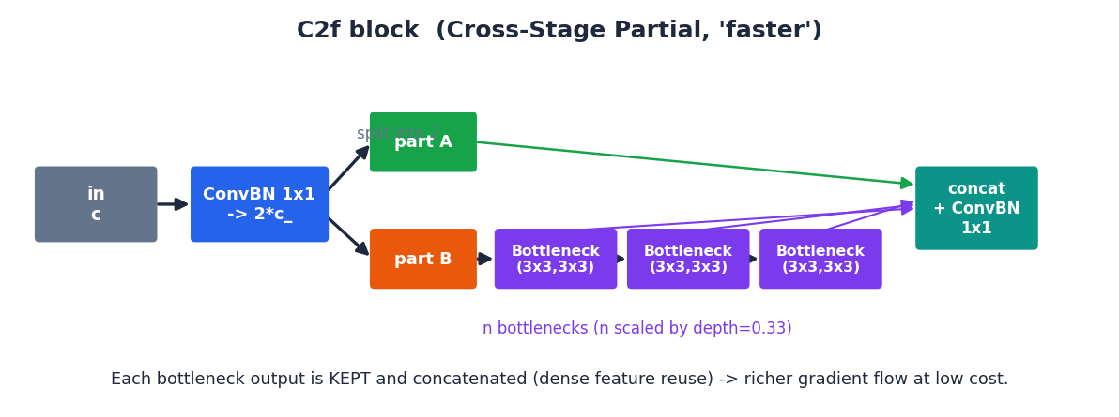
Figure. C2f keeps every bottleneck output and concatenates them — (2+n) tensors of c/2 channels — before a 1×1 mix.
SPPF (Spatial Pyramid Pooling - Fast) at the end of P5 applies one 5×5 max-pool three times sequentially and concatenates [x, pool¹, pool², pool³] (4·(c/2) channels) → 1×1 conv. It widens the receptive field cheaply (three 5×5 pools ≈ a 13×13 field) without extra strides.

2.4 Decoder — FPN-PAN
The decoder fuses P3/P4/P5 twice: a top-down path (FPN) pushes coarse semantics down to the fine grids, then a bottom-up path (PAN) pushes precise localization back up. Every fusion is a concat followed by a C2f (n=1, no shortcut). Upsampling is nearest-neighbor; downsampling is a stride-2 3×3 conv.
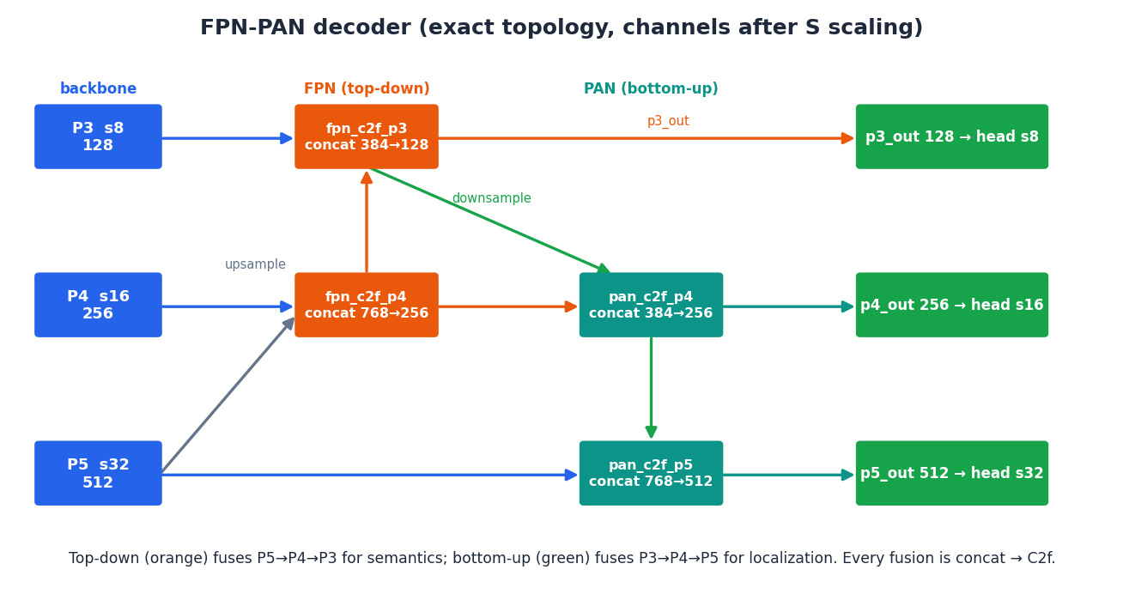
Figure. Exact decoder topology with post-scaling channel counts. The C2f after each concat fixes the output to 128/256/512.
Node | Inputs (concat) | Concat ch → out
fpn_c2f_p4 | upsample(P5)=512 + P4=256 | 768 → 256
fpn_c2f_p3 = p3_out | upsample(fpn_p4)=256 + P3=128 | 384 → 128
pan_c2f_p4 = p4_out | down(p3_out)=128 + fpn_p4=256 | 384 → 256
pan_c2f_p5 = p5_out | down(p4_out)=256 + P5=512 | 768 → 512

2.5 Heads — six branches per level
The box head and the three polygon heads share a 2-conv stem (cv2feat, 136 channels = 4·reg_max + 3·24); the cls head and the dist head each have their own 2-conv stem (128 channels) reading the raw fused feature. Every branch ends in a 1×1 projection. All six projection convs are pinned to float32 (numerically stable logits under bf16).
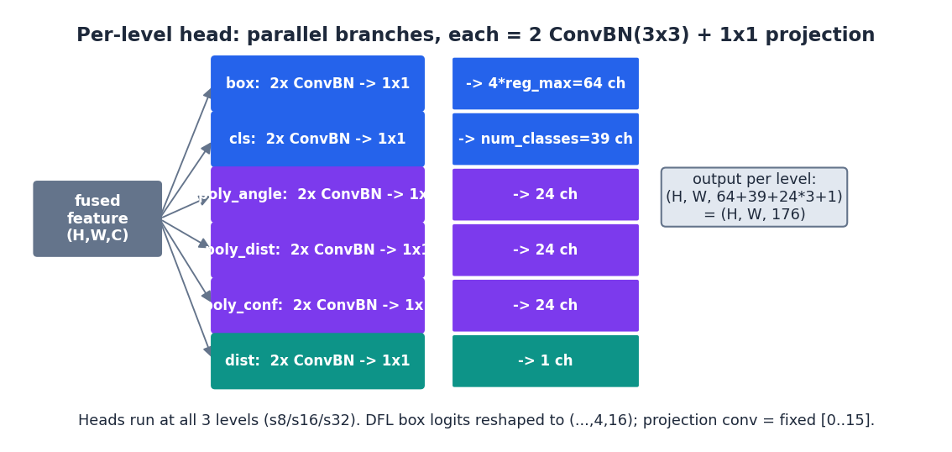
Figure. Per-level head structure. Box+polygon share cv2feat; cls and dist have separate stems. Output is (H,W,176) per level.
Head | Stem (input) | Projection | Channels
box | cv2feat (shared) | 1×1 → float32 | 64 = 4×16 DFL
poly_angle / dist / conf | cv2feat (shared) | 1×1 → float32 | 24 each
cls | own 2×ConvBnAct(128) (raw feat) | 1×1 → float32 | 39
dist | own ConvBnAct(128) (raw feat) | 1×1 → float32 | 1

Smart bias init (models/head.py:226). After a dummy forward, biases are set so the model starts sane:
class bias = log( 5 / num_classes / (input_size/stride)^2 ) # input_size = 672
box bias = 1.0
→ each level's total background prob mass = 5.0 → cls loss starts ~5, not in the hundreds (see §6.4)

2.6 Detection generator — raw heads → predictions
At inference (deploy=True) the raw head dict is post-processed: DFL → expected value, ltrb → boxes, per-class NMS, and polygon/distance activation. (At training the raw heads go straight to the loss.)
- Anchor grid: (range+0.5)·stride per cell → 9261 points in input pixels.
- DFL decode: reshape box logits to (…,4,16) → softmax → Σ j·p[j] = expected ltrb (feature-map units) → ×stride → cx∓l/t/r/b.
- NMS: top-1 class per anchor, then tf.image.non_max_suppression per class (iou=0.65, score=0.05), merged, top-300.
- Polygon / distance decode: poly: sigmoid(conf), softplus(dist), sigmoid(angle); distance: clip in log-space then exp → meters.
Output key | dtype | Shape | Meaning
bbox | float32 | [B,300,4] | yxyx normalized [0,1]
classes | int64 | [B,300] | class index
confidence | float32 | [B,300] | score
num_detections | int32 | [B] | valid count
polygons | float32 | [B,300,24,3] | (conf, dist, angle) activated
distance | float32 | [B,300] | meters

3. The Data Pipeline
Two independent tf.data streams are built and merged. The detection stream does the heavy augmentation; the distance stream (servingbot) is training-only and rides along, concatenated onto each batch.
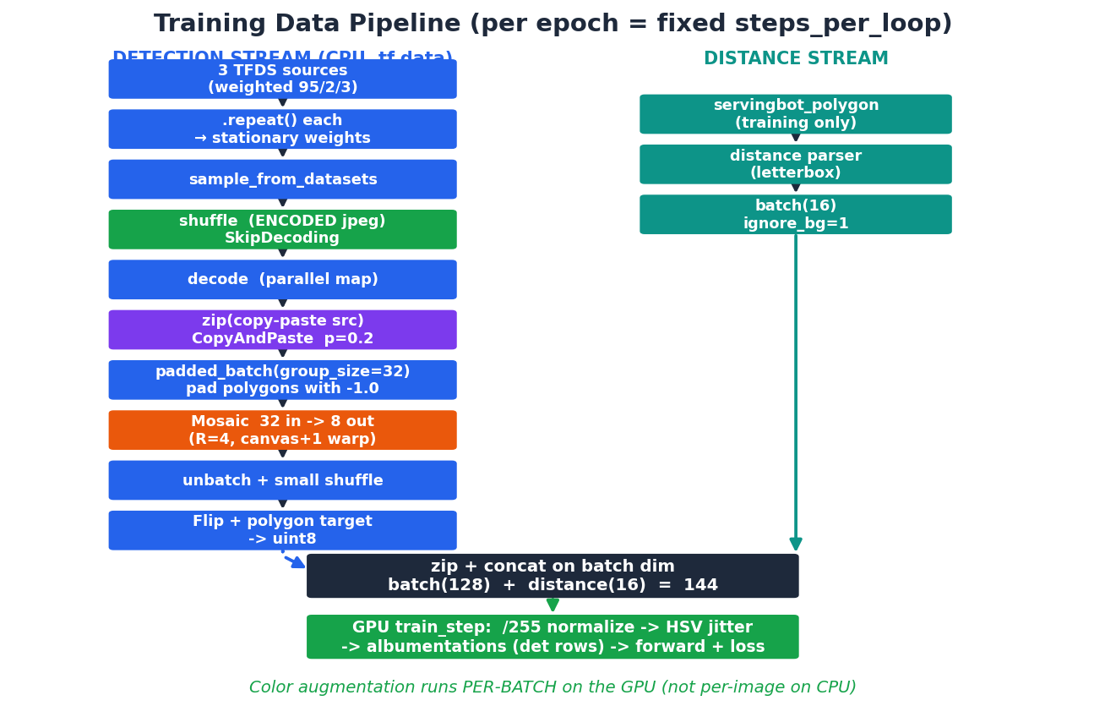
Figure. The full training pipeline. Green = throughput tricks; orange = mosaic; the two streams merge just before the GPU step.
Stage | What happens | Why it matters
Sources + repeat | 3 TFDS sets, each .repeat()ed, then sample_from_datasets(95/2/3) | Infinite stream; weights stay stationary
Shuffle (encoded) | SkipDecoding keeps JPEG bytes compressed through the buffer | KBs not MBs → big buffer, low RAM
Decode | parallel map decodes + arc-length resamples polygons to 64 pts | Runs parallel with the GPU step
Copy-Paste | p=0.2; composite RGBA objects onto the background | Cheap instance diversity
padded_batch(32) | group of 32; polygons padded with the -1.0 sentinel | Mosaic group; -1.0 ≠ a real vertex
Mosaic + perspective | 32 in → 8 out, R=4, canvas + one warp | Stock-YOLO diversity at ~3× lower cost
Unbatch + shuffle | small post-mosaic shuffle | Breaks per-group correlation
Flip + polygon target | flip; build the [N,72] radial target; emit uint8 | Geometry + labels done; color deferred to GPU
Merge + GPU aug | concat distance(16); GPU: /255, HSV, albumentations | Color math on GPU (§7)

CPU vs GPU split. Steps 1–7 (decode, copy-paste, mosaic+perspective, flip, polygon-target) run on the CPU tf.data workers. All COLOR augmentation (HSV + albumentations) runs per-batch on the GPU inside train_step (train/task.py:293-302), in parallel with the next batch's CPU decode.

4. Data Augmentation
Seven augmentations, applied in a fixed order. Geometric ones (copy-paste, mosaic, perspective, flip) transform BOTH the image and the labels (boxes + 24-vertex polygons); color ones (HSV, albumentations) touch only pixels. Every transform is governed by the -1.0 polygon-vertex sentinel: a vertex is valid iff x > -1.0, so padding and dropped vertices never read as real geometry.
Order and device (poly_dist tier):
# | Augmentation | Prob / freq | Device | Touches labels?
1 | Copy-Paste | p = 0.2 | CPU | yes (append object)
2 | Mosaic (+MixUp) | freq 0.5 (mixup 0.0) | CPU | yes (stitch + clip)
3 | Random perspective | rotate 0.10 / scale always | CPU | yes (warp + clip)
4 | Horizontal flip | 0.5 | CPU | yes (mirror)
5 | HSV jitter | always (per-image) | GPU | no
6 | Albumentations | freq 1.0, each p 0.01 | GPU | no (det rows only)
7 | MixUp | 0.0 (off) | CPU | yes (concat)

4.1 Copy-Paste (data_pipeline/copy_paste.py)
What | Composites an RGBA object crop (from the separate cleaner_copy_paste TFDS) onto the already-672²-resized background, and appends its box / class / polygon to the ground truth.
Probability | p = 0.2 per image (tf.random.uniform() < prob); object resize ratio ~ U(0.2, 1.5).
Image | HARD alpha mask, not blended: hard = alpha > 0.5; out = where(hard, object, background) — matches the original codebase. Placement is random within [10%, 60%]×[10%, 90%] of the frame, gray void elsewhere.
Size correction | Object scaled by resize_ratio × (current/original) per axis, using the background's stored orig height/width, so compositing at 672² is pixel-equivalent to compositing at full-res then resizing.
Box label | Object box (yxyx-norm in the crop) mapped to background-normalized coords and clipped to [0,1]; distance appended as the -1.0 sentinel (a pasted object has no distance).
Polygon label | Vertices mapped to background coords; out-of-bounds vertices are DROPPED (set to -1), NOT clipped — clipping would inject a false radial distance. If the object carries more vertices than the polygon column budget, they are evenly ARC-LENGTH resampled (compact=True first to gather scattered sentinels), never sliced to a leading arc.

4.2 Mosaic (data_pipeline/mosaic.py)
What | Ultralytics 4-image stitch into a 2×-size canvas at a moving split center, then ONE perspective warp/crop to the output. The same warp is also applied to non-mosaic singles, so mosaic is the pipeline's only affine.
Frequency | Per-OUTPUT coin U() < 0.5 (not per-group) → exact per-sample frequency, no batch clustering.
Moving center | Split center drawn in [H(1−2c), H(1+2c)] with c = mosaic_center = 0.25; boxes/polygons are cut at the moving edges.
Consistent scale | Each source is resized so its long side = output size (upright tiles); the ONLY per-sample size variety is the single canvas→output warp scale gain [0.5, 1.5]. Void is gray 114.
G-in/G-out | A group of group_size=32 emits 32//R = 8 outputs; each mosaic draws a width-4 window of one per-group permutation (R = decodes_per_output = 4 → disjoint tiles, zero reuse = stock-YOLO; R<4 → reuse 4/R).
Labels | All 4 tiles' boxes/polygons are mapped into the 2× canvas (no clip), then the single global affine M clips boxes (drop if area < 0.5× original) and clips polygon vertices to the edge.

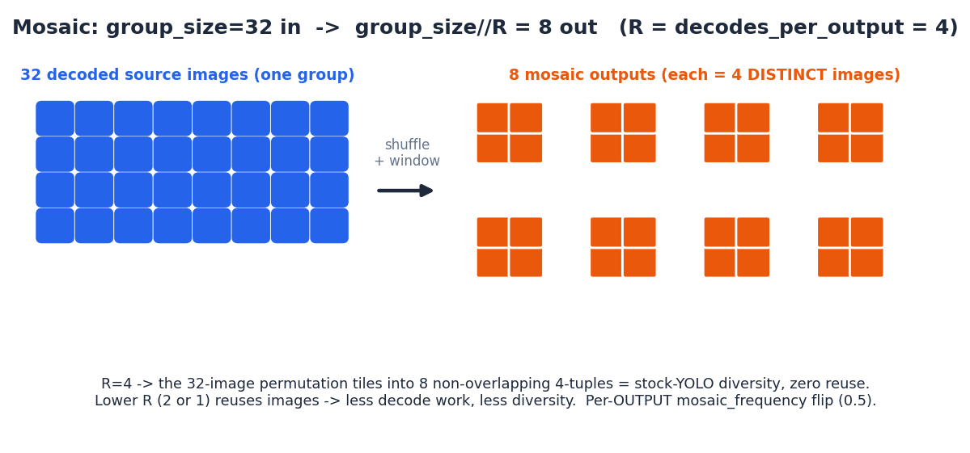
Figure. Mosaic G-in/G-out: 32 decoded images → 8 outputs; at R=4 the permutation tiles into non-overlapping 4-tuples.
4.3 Random perspective / affine (data_pipeline/augmentations.py)
What | Full affine: center → perspective → rotation·scale → shear → translate, warping the 2× canvas down to the output with gray-114 fill and a center-crop.
Matrix order | M = T · Sh · R · P · C (input→output), drawn once per output (make_perspective_matrix). Applied to the image via tf.raw_ops.ImageProjectiveTransformV3 using the normalized INVERSE map, BILINEAR, fill 114.
Rotation (rare) | angle ~ U(−10°, 10°) but FORCED to 0 with probability 1 − rotate_prob (=0.10) → images are upright 90% of the time. shear = 0, perspective = 0 by default.
Scale gain | Explicit bounds U(0.5, 1.5) (the symmetric-magnitude form widened the range and caused a 'mostly-gray-frame' bug, since fixed).
Box labels | 4 corners transformed → re-fit axis-aligned box → clip [0,1]; KEEP only if transformed area ≥ 0.5× original and min side ≥ 0.005.
Polygon labels | Vertices transformed and CLIPPED to [0,1] (clip-to-edge, not dropped), keeping polygon GT consistent with the clipped box; the -1.0 sentinel (> -1.0, not >= 0) preserves slightly-negative real vertices from canvas overflow.

4.4 Horizontal flip (augmentations.py)
What | Left-right mirror, in the parser (CPU).
Probability | 50% (U() > 0.5).
Labels | Boxes (yxyx-norm): [ymin, 1−xmax, ymax, 1−xmin]. Polygons: valid x → 1 − x (y unchanged), -1 padding preserved. Width-agnostic.

4.5 HSV color jitter (batch_color_aug.py — GPU)
What | Per-image HSV jitter for the whole batch in one rgb→hsv→rgb pass, on the GPU inside train_step.
Params | hue 0.015 (additive, wrap mod 1.0), saturation 0.7 (multiplicative gain U(0.3, 1.7)), brightness/value 0.4 (additive on RGB).
Detail | h = (h + dh) mod 1; s = clip(s·ds, 0, 1); rgb = clip(rgb + dv, 0, 1) — mathematically identical to sequential adjust_hue→saturation→brightness, but vectorized per-image across the batch.

4.6 Albumentations (batch_color_aug.py — GPU)
What | Four pure-TF photometric transforms, batched on GPU, applied in order (each sees the previous output): Blur 3×3, MedianBlur 3×3, ToGray, CLAHE (unsharp-mask local contrast).
Frequency | Enter gate albumentations_frequency = 1.0 per image, then EACH transform fires with p = 0.01 — so most images get none, a few get one.
Detection rows only | Applied only where ignore_bg == 0; distance-stream rows are skipped. Image-only (no label change). CLAHE's costly 33×33 blur is guarded so it runs only when some row selected it.

4.7 MixUp (mosaic.py — off by default)
What | Blends the primary output with a SECOND mosaic (drawn from a distant window of the permutation so the sources differ) and concatenates their labels.
Frequency | mixup_frequency = 0.0 → OFF. The partner ops are Python-gated behind if mixup_freq > 0, so at 0.0 they are never added to the graph (byte-identical to no-mixup).
Blend | weight r = Beta(32, 32) via a gamma ratio — tightly concentrated near 0.5; out = r·img1 + (1−r)·img2. Labels: concat of both sets, then the parser caps at max_num_instances.

Master parameter table:
Aug | Prob/freq | Key params | Label handling | Device
Copy-paste | 0.2 | resize U(0.2,1.5)×(cur/orig); alpha>0.5 hard mask | box clip; poly drop-OOB + resample; dist=−1 | CPU
Mosaic | 0.5 | center 0.25; per-img scale=H/long (fixed); void 114 | canvas (no clip) → affine clip-to-edge | CPU
Perspective | rot 0.10 | deg 10, scale U(0.5,1.5), shear 0, translate 0.1 | box AABB+clip (area≥0.5×); poly clip-to-edge | CPU
Flip | 0.5 | horizontal | x→1−x (boxes & vertices) | CPU
HSV | always | hue .015 add, sat .7 mult, val .4 add | none | GPU
Albumentations | 1.0 / 0.01 | Blur, MedianBlur, ToGray, CLAHE | none; ignore_bg==0 only | GPU
MixUp | 0.0 | Beta(32,32) blend | concat all GT | CPU

5. Representations
Three quantities are encoded in non-obvious ways. Each is given with its exact transform and a worked numeric example.

5.1 Polygon — PolyYOLO radial format
A polygon is stored as 24 radial bins, one every 360°/24 = 15°, measured from the box center. Each occupied bin holds a radial distance, a sub-bin angle offset, and a confidence.
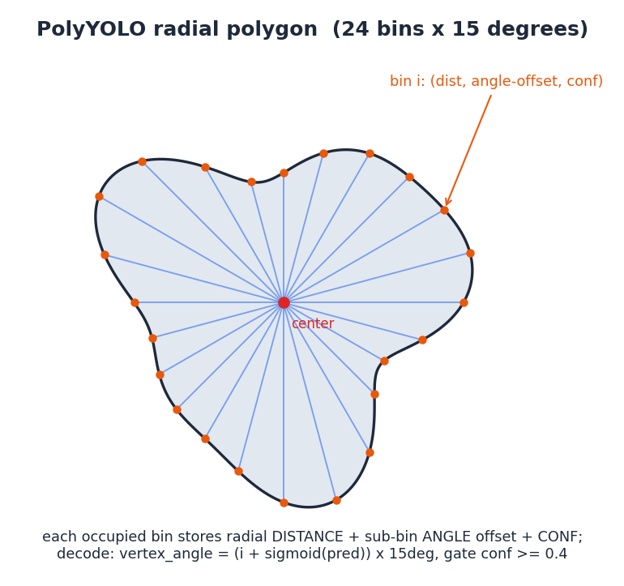
Figure. 24 rays at 15° steps sample the outline; each occupied bin stores (distance, sub-bin angle, confidence).
Encoding (Cartesian vertex → radial), per vertex relative to the box center (cx, cy):
yolo_parser.py:_preprocess_polygons_v2 (337-394)
dx = x − cx ; dy = y − cy
dist = sqrt(dx² + dy²)
angle = floormod( atan2(dy, dx)·180/π , 360 ) # degrees in [0,360)
bin i = floor(angle / 15) ∈ [0,23]
offset = angle/15 − floor(angle/15) ∈ [0,1) # SUB-BIN, not one-hot
Binning is a segment formulation (not a dense one-hot): per (instance,bin) segment id, `unsorted_segment_max` picks the bin's distance, a first-winner `unsorted_segment_min` picks the representative vertex (reproducing argmax's first-max tie-break), and conf = (max_dist > 0). Result is the interleaved [N,72] layout [dist₀,angle₀,conf₀, dist₁,…].
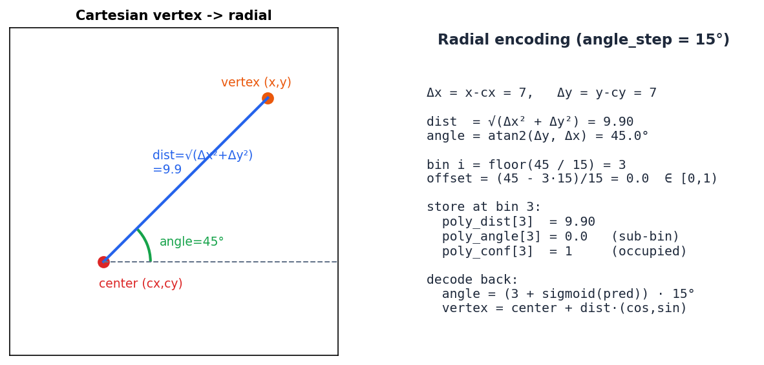
Figure. Worked example: a vertex at (cx+7, cy+7) → 45° → bin 3, offset 0.0 → stored as (dist, 0.0, 1).
Decoding (radial → Cartesian pixels):
eval/polygon_metrics.py:_radial_to_cartesian (82-88)
vertex_angle = (i + sigmoid(angle_pred)) · 15°
vertex_x = (cx_norm + dist · cos(vertex_angle)) · W
vertex_y = (cy_norm + dist · sin(vertex_angle)) · H
keep bin iff conf ≥ 0.4 # decode/viz gate
- Arc-length resample (64 pts): resample_polygons samples 64 points uniformly ALONG the closed contour (cumulative edge length + linear interpolation), so a 4-corner rectangle fills every bin its boundary crosses instead of collapsing to a diamond. Sampled points lie exactly on the original contour.
- -1.0 sentinel: vertex validity is keyed on x > -1.0 (not ≥ 0), so slightly-negative real vertices from mosaic overflow survive; only the reserved -1.0 padding is dropped.

5.2 Box — DFL (Distribution Focal Loss) encoding
Each of the 4 box sides (left/top/right/bottom offset from the anchor point) is a distribution over reg_max = 16 bins (4×16 = 64 channels). The decoded offset is the expected value of that distribution — classification-style localization with sub-pixel precision.
detection_generator.py:97-111, 256-271 / tal_loss.py:303-332
# decode (per side):
p = softmax(box_logits[...,0:16])
offset_fm = Σ j · p[j] for j in 0..15 # feature-map units
offset_px = offset_fm · stride
x1 = cx − l·s ; y1 = cy − t·s ; x2 = cx + r·s ; y2 = cy + b·s
# target (encode):
tgt_fm = clip( (offset_px / stride), 0, 14.999 )
soft two-bin: floor & floor+1, weights (1−frac, frac)
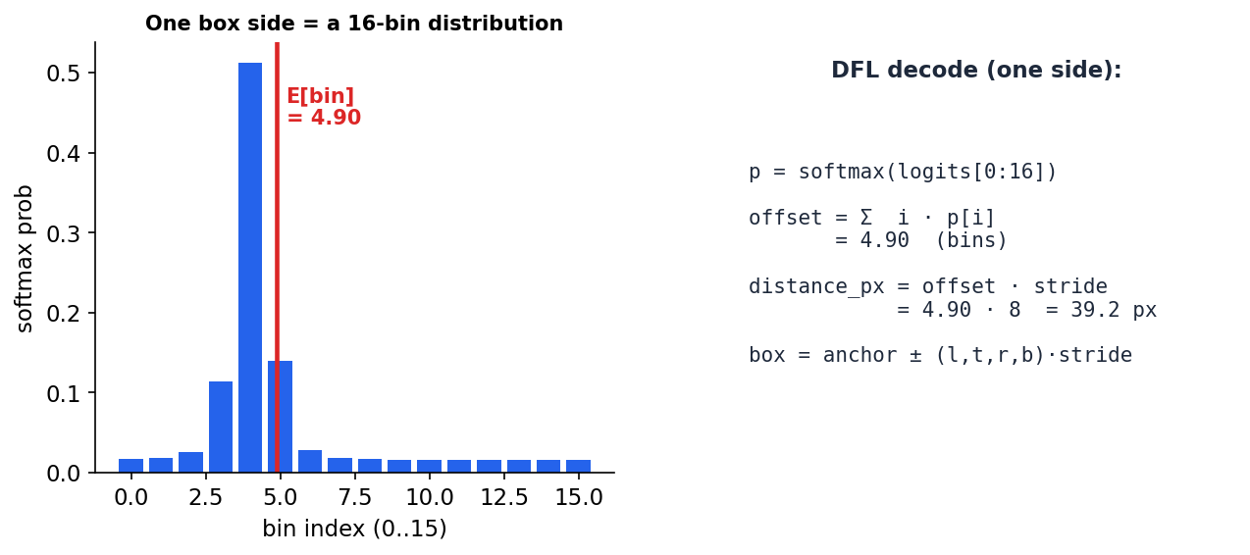
Figure. A box side is a 16-bin distribution; its expected value × stride gives the sub-pixel offset in pixels.
Anchor points are cell centers: (range + 0.5)·stride, in input pixels. At 672² there are 9261 anchors total across the three levels.

5.3 Distance — log-scale meters
Distance is stored in natural-log space, clamped to the valid range; an invalid sentinel marks rows with no distance (detection-stream rows and pasted objects).
distance_parser.py:152-156 / detection_generator.py:206-211
encode: log_dist = log( clip(d, 0.5, 10.0) ) # natural log
invalid (d ≤ 0) → −10.0 (sentinel)
decode: d = exp( clip(log_dist, log0.5, log10) ) # clamp in log-space first
example: d = 3.0 m → log(3)=1.0986 → exp(1.0986)=3.0 m
d = 20 m → clip→log(10)=2.302 → exp=10.0 m
Log-space makes the relative error uniform across the range — being off by 0.2 m at 1 m matters more than at 9 m.

6. Losses and Their Effects
The total loss is a gain-weighted sum of box, dfl, cls, distance, and three polygon terms, after a Task-Aligned assignment decides which predictions are responsible for which ground truth. All formulas below are the exact implemented expressions.

6.1 Task-Aligned assignment
Each ground-truth selects the anchors that are both confident AND well-localized for it.
tal_assigner.py:102-203
align_metric = (score + ε)^α · (IoU + ε)^β # α=0.5, β=6.0, ε=1e-9
candidates = (anchor center inside GT box) # spatial constraint
positives = top-10 anchors by align_metric (per GT)
duplicates = anchor claimed by many GTs → max-IoU GT wins
# normalized soft target (per GT g, anchor a):
align_norm[a,g] = align[a,g] · pos_overlap[g] / (max_a align[a,g] + ε)
target_scores = one_hot(class) · align_norm(at assigned GT)
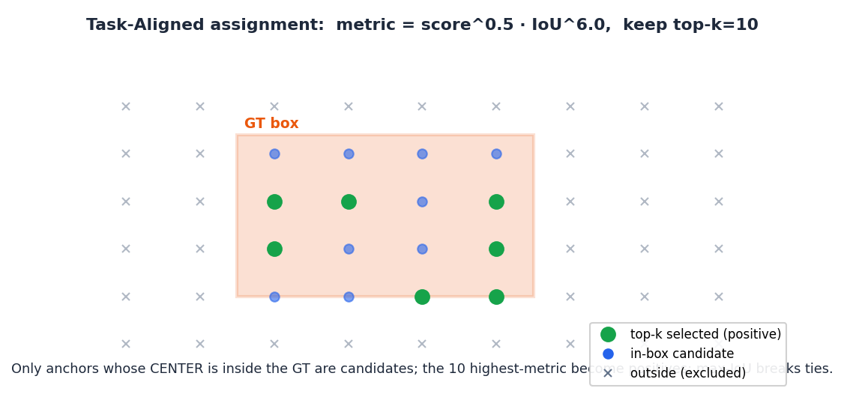
Figure. Only anchors whose center is inside the GT are candidates; the 10 highest-metric become positives.
Effect. score^0.5·IoU^6 weights localization heavily (β≫α): a confident-but-misplaced box is not assigned. The soft target = align_norm (which bakes in the per-GT max IoU), so the classification target equals the box quality — the model learns calibrated confidence, not a hard 1.

6.2 Box IoU losses (config-selectable)
Default is CIoU; giou/diou/eiou/siou are selectable via losses.box_iou_type. CIoU adds a center-distance term and an aspect-ratio term to IoU:
tal_loss.py:153-159
CIoU = IoU − ρ²(b,bgt)/c² − α·v
ρ² = squared distance between box centers
c² = squared diagonal of the smallest enclosing box
v = (4/π²) · ( atan2(w_gt,h_gt) − atan2(w,h) )² # aspect mismatch
α = v / (1 − IoU + v + ε) # ε=1e-7
loss = 1 − CIoU
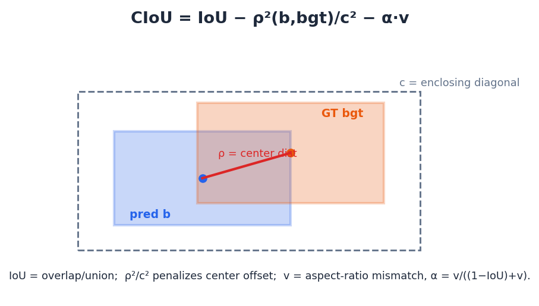
Figure. CIoU = overlap (IoU) − center-offset penalty (ρ²/c²) − aspect-ratio penalty (α·v).
Variant | Penalty added to IoU
giou | − (enclosing_area − union)/enclosing_area
diou | − ρ²/c² (center distance only)
ciou (default) | − ρ²/c² − α·v (center + aspect)
eiou | − ρ²/c² − (Δw)²/cw² − (Δh)²/ch² (explicit w,h)
siou | − ½(distance_cost + shape_cost) with an angle term

6.3 DFL — distribution focal loss
tal_loss.py:298-334
# target offset split into the two adjacent integer bins:
wr = tgt_fm − floor(tgt_fm) ; wl = 1 − wr
DFL = −( wl · log_softmax(pred)[floor] + wr · log_softmax(pred)[floor+1] )
averaged over L,T,R,B, weighted per-anchor by Σ target_scores,
normalized by target_scores_sum
Effect. Trains each side's 16-bin distribution to concentrate on the bins straddling the true offset → sub-pixel boxes. Shares the box normalizer.

6.4 Classification — BCE (config-selectable) + smart bias
tal_loss.py:340-386
cls = sigmoid_cross_entropy(target_scores, logits)
summed over 39 classes, divided by target_scores_sum
focal: × α(1−p_t)^γ (α=0.25, γ=1.5)
varifocal: × [ target if pos else α·p^γ ]
Why cls starts at ~5. The smart bias makes each FPN level's total background probability mass = 5.0 at step 0; almost all anchors are background, so their summed BCE ≈ 5 per level. The positive term is bounded by target_scores_sum, and the logged value is gain-weighted (cls_gain = 0.5) → ~5. Without the bias you start in the hundreds and waste epochs suppressing background.
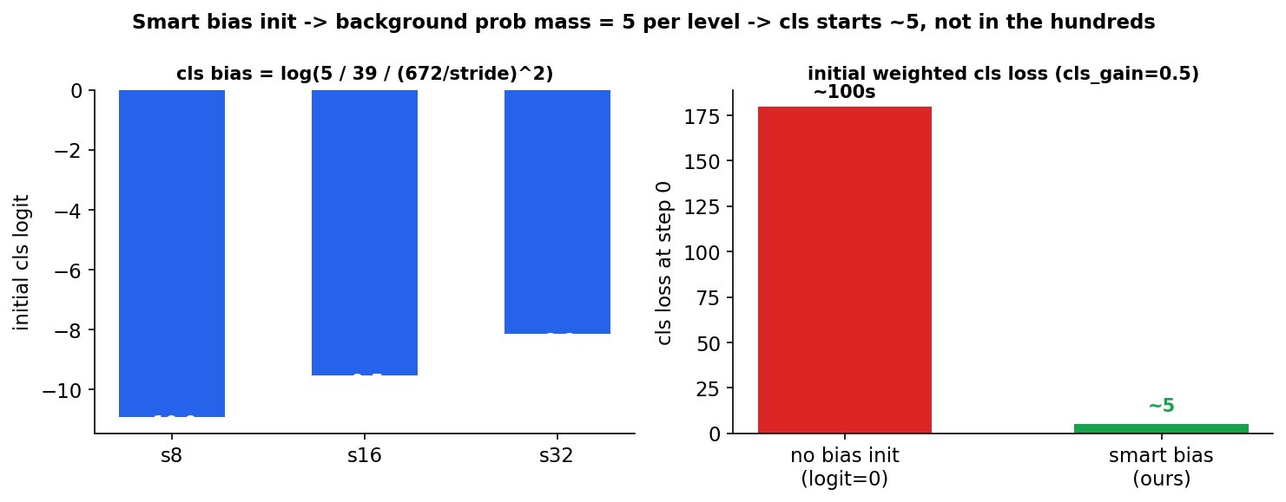
Figure. Smart bias init keeps initial cls loss ~5 instead of exploding with 39 classes × thousands of anchors.

6.5 Distance and polygon losses
distance_loss.py:16-40 / polygon_loss.py:40-149
distance = Σ |pred − target|·[target > −10]·fg / num_objs # L1 in log-space
poly_angle = Σ_anchor fg · mean_over_VALID_bins( BCE(sigmoid(pred), offset) ) / num_objs
poly_dist = Σ_anchor fg · mean_over_VALID_bins( (target − softplus(pred))² ) / num_objs
poly_conf = Σ_anchor fg · mean_over_ALL_24_bins( BCE(sigmoid(pred), occupied) ) / num_objs
Why poly_conf averages over ALL 24 bins (not just valid ones). conf is the decode gate, so empty bins MUST get negative gradient to stay below 0.4. The earlier valid-bins-only form left empty bins untrained → their conf drifted above the gate while their distance stayed random → the spiky-star polygon artifacts. angle and dist, by contrast, are masked to valid bins (an empty bin has no meaningful angle/radius).

6.6 Normalizers, gains, and the total
Loss | Per-element form | Normalizer | Gain
box (CIoU) | 1 − CIoU, ×Σtarget_scores per anchor | target_scores_sum | 7.5
dfl | two-bin cross-entropy | target_scores_sum | 1.5
cls (BCE) | sigmoid CE over 39 classes | target_scores_sum | 0.5
distance | |Δ| in log-space, masked | num_objs | 1.0
poly_angle | BCE, valid-bin mean | num_objs | 0.5 × 0.4
poly_dist | (Δ softplus)², valid-bin mean | num_objs | 0.5 × 0.45
poly_conf | BCE, all-24-bin mean | num_objs | 0.5 × 0.2

tal_loss.py:597-667
target_scores_sum = max( Σ target_scores , 1 ) # box/dfl/cls
num_objs = max( Σ valid GT , 1 ) # distance/polygon
total = 7.5·CIoU + 1.5·DFL + 0.5·cls + 1.0·dist
+ 0.5·( 0.4·angle + 0.45·pdist + 0.2·conf ) # poly_gain=0.5
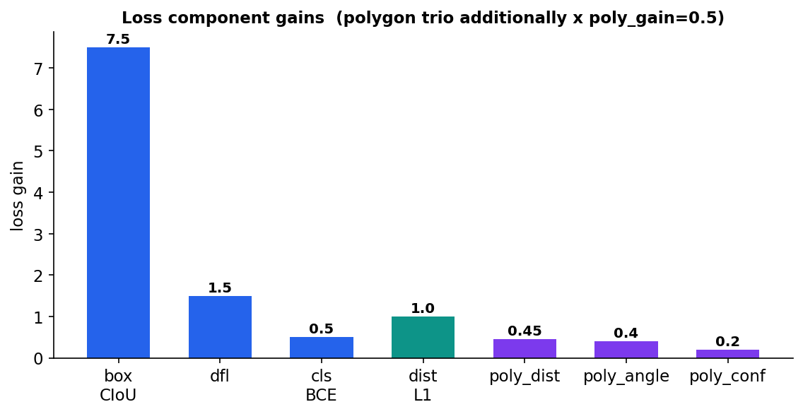
Figure. Loss-component gains. The three polygon terms are additionally multiplied by poly_gain = 0.5.

7. How We Made Training FASTER
The changes that cut epoch time and kept the GPU fed. Each card: what it is, why it is faster, the knob, an example, where it lives. Golden rule: the step log splits compute vs data-wait so you know whether you are GPU-bound or data-bound BEFORE optimizing.
7.1 SkipDecoding — encoded through shuffle
What | SkipDecoding() keeps JPEG bytes compressed through the shuffle buffer; decode happens later in a parallel map.
Why faster | Buffer holds KBs not MBs (~40× less RAM) → a large, well-mixing buffer is affordable, no spill.
Knob | shuffle_buffer_size (1500)
Example | 1500 imgs: ~0.04 GB encoded vs ~1.9 GB decoded.
Where | input_reader.py

7.2 Mosaic canvas formulation
What | Per-image resize → place in 2× canvas → ONE perspective warp per output.
Why faster | The composed-affine alternative warps 4 full frames per mosaic; ImageProjectiveTransformV3 is several× costlier per pixel than resize — measured ~3× slower on the production CPU.
Knob | group_size, decodes_per_output (R)
Example | R=4 stock diversity; R=2/1 less decode.
Where | data_pipeline/mosaic.py

7.3 Per-batch GPU color augmentation
What | Normalize/HSV/albumentations moved off the CPU parser onto the GPU in train_step, per-batch.
Why faster | Color runs on GPU in parallel with the next batch's CPU decode; parsers emit uint8 (half the tensor bytes through tf.data and the host→device copy).
Knob | aug_rand_* / albumentations_frequency
Example | HSV for 144 imgs = one GPU op, not 144 CPU ops.
Where | batch_color_aug.py, train/task.py

7.4 Mixed bfloat16 (heads float32)
What | Global mixed_bfloat16 policy; heads + loss stay float32, no loss scaling.
Why faster | bf16 convs/matmuls ~2× on Tensor Cores with half the activation memory; bf16 keeps fp32 exponent range → no NaN, no scaling machinery.
Knob | runtime.mixed_precision_dtype
Where | run_train.py, models/head.py

7.5 Repeat-before-sample + thread caps
What | Each source .repeat()ed before sample_from_datasets (stationary weights); TF thread pools capped to the host's real core quota.
Why faster | No epoch-boundary refill stalls; capping avoids context-switch thrash on cgroup-capped hosts (was ~29 threads on 13 cores).
Knob | inter_op_threads/intra_op_threads, private_threadpool_size
Where | input_reader.py, run_train.py

7.6 deterministic=False + prefetch + honest epochs
What | Training stream deterministic=False; prefetch(AUTOTUNE); fixed steps_per_loop from one persistent iterator.
Why faster | Elements emit as soon as ready; prefetch overlaps input with compute; fixed steps make epoch/LR/checkpoint true by construction.
Knob | train_total_examples
Where | input_reader.py, trainer.py

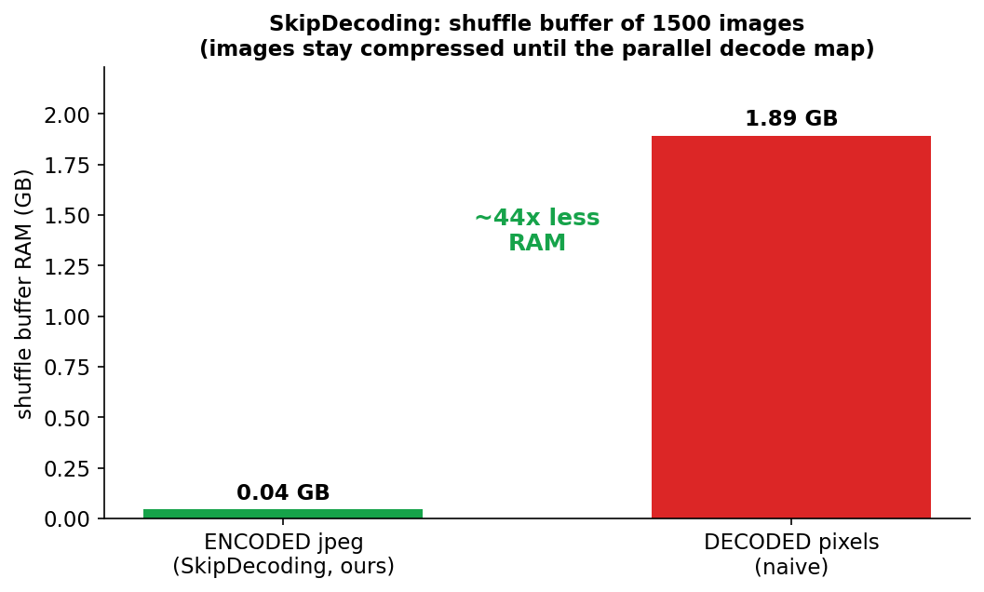
Figure. Keeping images compressed through the shuffle buffer cuts its memory ~40×.

8. Additional Training Features

8.1 Configurability
- Three tiers: bbox / poly / poly_dist from one codebase, picked by YAML.
- Registries: optimizer {sgd, adamw, adam}; LR {cosine, linear, step, polynomial, constant} + warmup; box_iou_type, cls_loss_type, activation — defaults byte-identical.
- Validated config: run_train.py:_validate_config checks invariants (e.g. output_poly_size == 360//angle_step) before training.

8.2 Robust long runs
- Auto-restart supervisor: train_supervisor.sh under nohup restarts on crash/OOM, STOP-file graceful stop, crash-loop guard.
- Mid-epoch resume: runs only the remainder to the next epoch boundary.
- Fine-tune vs transfer-init: finetune_from loads the full model into a fresh optimizer; init_checkpoint transfers backbone+decoder only.
- Corrupt-dataset tolerance: TFDS assert_cardinality=False reads a short shard as-is instead of crashing.
- Checkpoint migration: native (exact) + legacy frozen/structural/map/name, with a coverage guard.

8.3 Observability
- Self-documenting TensorBoard: every scalar carries a name + formula; grouped train//val//per_class//epoch//system.
- Per-class metrics: grouped by metric, zero-padded + class-named.
- Image overlays: box + polygon overlays to TensorBoard.
- val_history store: every eval → val_history.jsonl; tools/val_history.py extracts (--epoch/--best/--list).
- Failure mining: worst-K fp/fn/lowIoU per class.
- TTY-aware progress: live bar on a terminal; one summary line / 15 s under nohup.

8.4 Optimization controls
- EMA dynamic decay: min(0.9999, (1+step)/(10+step)); swapped in for eval; shadows = deployed weights.
- Gradient accumulation: grad_accum_steps=N advances optimizer/LR once per N micro-steps (set decay_steps = train_steps//N).
- Gradient clipping: task.gradient_clip_norm; pre-clip global norm logged as train/grad_norm.
- Best-checkpoint: F1score50 (confidence-sweep F1 with dontcare absorption).
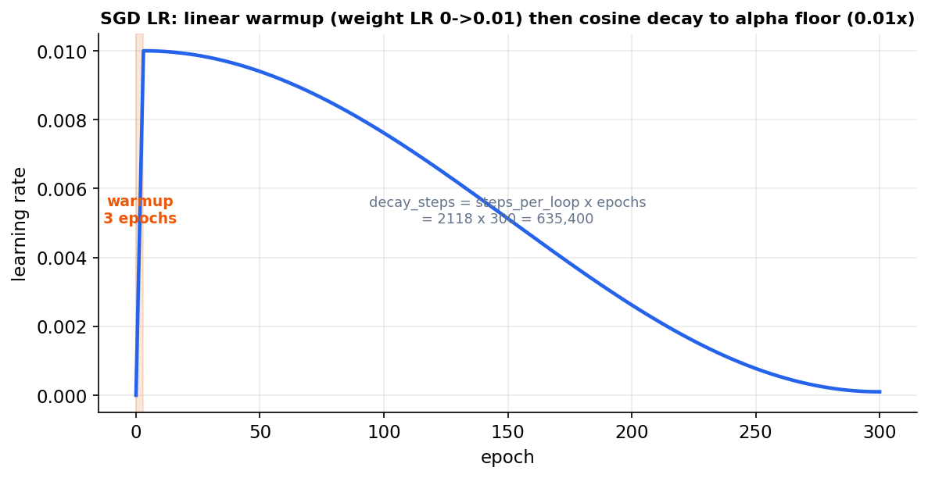
Figure. Default LR: 3-epoch linear warmup then cosine decay to the alpha floor, sized to anneal at the end of training.

9. Configuration Cheat-Sheet
Knob | Section | Default | What it does
global_batch_size | train_data | 128 | detection imgs/step (+16 distance)
train_total_examples | trainer | 271166 | epoch size → steps_per_loop = //batch
train_epochs | trainer | 300 | epochs
tfds_sampling_weights | train_data | [95,2,3] | per-source mix (stationary)
shuffle_buffer_size | train_data | 1500 | shuffle window (encoded)
group_size / decodes_per_output | mosaic | 32 / 4 | mosaic group + R
mosaic_frequency | mosaic | 0.5 | fraction of outputs that are mosaics
prob_copy_n_paste | train_data | 0.2 | copy-paste probability
degrees / rotate_prob | mosaic | 10 / 0.10 | rotation magnitude / how often it fires
aug_scale_min/max | mosaic | 0.5 / 1.5 | warp scale gain
mixed_precision_dtype | runtime | bfloat16 | compute precision (heads fp32)
learning_rate.cosine.* | optimizer | 0.01 / 635400 / 0.01 | init LR / decay_steps / alpha
warmup_steps | optimizer | 6354 | 3 epochs of linear warmup
loss gains | losses | 7.5/1.5/0.5/1.0/0.45/0.4/0.2 | relative weight per loss

10. Worked Examples & File Map
Train (recommended, supervised under nohup):
nohup bash tools/train_supervisor.sh \
--config configs/experiments/yolo/yolov8_poly_dist.yaml \
--output_dir /path/to/run_dir >> /path/to/run_dir/supervisor.log 2>&1 &
tail -f /path/to/run_dir/supervisor.log # watch | touch <dir>/STOP # stop
Eval / benchmark / export / infer:
python -m tools.eval --config <yaml> --data_dir <tfds> --out_dir <dir> --ckpt <ckpt-N>
python -m tools.benchmark_pipeline --config <yaml>
python -m tools.pipeline.diagnose_pipeline --config <yaml>
python -m tools.export_saved_model --config <yaml> --ckpt <ckpt-N> --out_dir <dir>
python -m tools.infer --saved_model <dir> --images <folder>
Where to look:
Area | Files
Pipeline | data_pipeline/{input_reader, mosaic, copy_paste, augmentations, batch_color_aug, yolo_parser, distance_parser}.py
Model | models/{backbone, decoder, head, detection_generator, yolo_v8}.py
Losses | losses/{tal_assigner, tal_loss, polygon_loss, distance_loss}.py
Eval | eval/{coco_metrics, coco_eval_custom, polygon_metrics, distance_metrics, metrics_report, val_history}.py
Train | train/{task, trainer, viz_utils, metric_meta}.py
Config | configs/{model_config, yaml_loader, class_map}.py + experiments/yolo/*.yaml

Glossary:
- TAL: Task-Aligned assignment — matches predictions to GT by score^0.5·IoU^6.
- DFL: Distribution Focal Loss — box sides as 16-bin distributions.
- EMA: smoothed deployed weights used for evaluation.
- R / decodes_per_output: mosaic decode multiplier; R=4 = stock-YOLO no-reuse.
- ignore_bg: masks classification loss on background / distance-only rows.
- num_objs / target_scores_sum: the two loss normalizers (GT count / summed soft targets).
— End of Handbook —

