**Revision 1.0**

**09 April 2019**

|  |  |  |  |
| --- | --- | --- | --- |
| **Revision** | **Name(s)** | **Description / Changes** | **Date** |
|  |  |  |  |
|  |  |  |  |
|  |  |  |  |
|  |  |  |  |
|  |  |  |  |
|  |  |  |  |
|  |  |  |  |
|  |  |  |  |
|  |  |  |  |
|  |  |  |  |
|  |  |  |  |
|  |  |  |  |
|  |  |  |  |
|  |  |  |  |

# Table of Contents

Introduction

1.1 Purpose

1.2 Juniper Module

1.3 Revision history

1.4 Intended audience and reading suggestions

1.5 Technical project stakeholders

1.6 Objectives

1.7 Public GIT Details

1.8 References

2 Prerequisites

**Softwares required as party of Juniper**

3 Highlevel Architecture/Flow Chart

3.1 Flow Chat

4 Installation Steps

4.1 Server 1: MICRO SERVICES FRONT END AND BACKEND

4.2 SERVER 2: SCHEDULER HOST

4.3 SERVER 3: MIDDLEWARE

4.4 SERVER 4: Oracle

5 Integration/Configuration of Different Modules

6 Verify Installation and Configuration

7 Troubleshooting

8 Anything more to be Added

9 Anything more to be added

10 Appendix

**Introduction**

# **Introduction**

## **Purpose**

The purpose of this is to describe in technical terms the steps necessary to install the software and make it operational.

## **Juniper Module**

This module of Juniper consists of all relevant microservices responsible for migrating a File from a Linux premises to Google Cloud Storage.

## **Revision history**

The Revision history table shows the date, changes, and authors who have worked on this document.

| Version/Change request number | Version date | Description of changes | Author |
| --- | --- | --- | --- |
| 1.0 | 09/04/2019 | First Draft | To be filled… |

## **Intended audience and reading suggestions**

This is intended to be used by technical stakeholders of the project who will be responsible for planning, performing, or maintaining the installation or deployment, such as the Systems Administrator, Chief Information Officer (CIO), Analysts, or Developers.

It is intended that stakeholders and software support personnel can read this document and coordinate their efforts in the installation/deployment of the application.

## **Technical project stakeholders**

This section provides a list of all known stakeholders with an interest in the project.

| Name | E-mail address | Phone | Role |
| --- | --- | --- | --- |
|  |  |  | Owner |
|  |  |  | Lead Developer |
|  |  |  | Systems Administrator |

To be filled..

## **Objectives**

Juniper is an Open source tool which establishes Industry standards for Enterprise grade secure and scaling to Cloud platform enabling community based enrichment of data services using Micro-services based architecture at low cost.

## **Public GIT Details**

To be filled

## **References**

Refer the below links for installations of the following software/tools

| Reference No. | Document | Tools(s) |
| --- | --- | --- |
| REF-1 | <https://nifi.apache.org/> | Apache Nifi |
| REF-2 | <https://kafka.apache.org/downloads> | Kafka |
| REF-3 | <https://www.linode.com/docs/development/java/how-to-deploy-spring-boot-applications-nginx-ubuntu-16-04/> | Java |
| REF-4 | <https://www.linode.com/docs/development/java/how-to-deploy-spring-boot-applications-nginx-ubuntu-16-04/> | Spring Boot |
| REF-5 | <https://tecadmin.net/install-python-2-7-on-centos-rhel/> | Python |
| REF-6 | <https://www.tecmint.com/install-oracle-database-12c-on-centos-7/> | Oracle |
| REF-7 | <https://www.linode.com/docs/development/java/how-to-deploy-spring-boot-applications-nginx-ubuntu-16-04/> | Maven |

**2 Prerequisites**

* Google Cloud Platform
* Spring Tool Suite
* Maven
* Oracle Database
* SQL Developer Tool
* NIFI
* KAFKA

**3 Highlevel Architecture/Flow Chart**

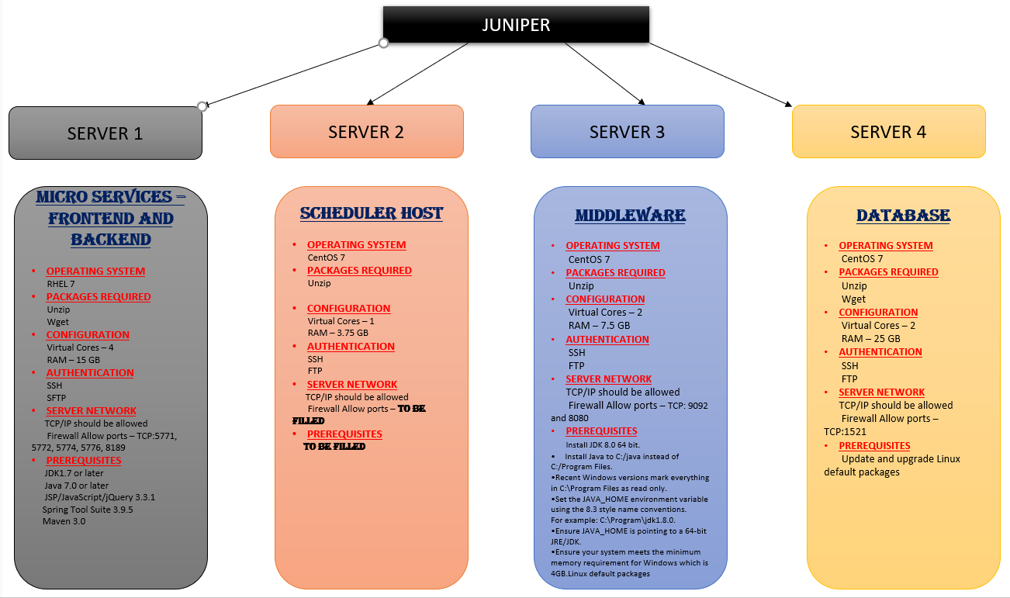

**4 Installation Steps**

**4.1 Server 1: MICRO SERVICES FRONT END AND BACKEND**

1. Switch to Root User -- sudo -i
2. Update and Upgrade if any patches available -- yum update && upgrade -y
3. Install open jdk version 1.7 -- yum install java-1.7.0-openjdk -y
4. Install zip unzip for compression and extraction -- yum install zip unzip
5. Install sdkman -- curl -s https://get.sdkman.io | bash
6. Verify SDKMAN is installed – sdk help
7. Install Spring Boot -- sdk install springboot
8. Verify Installation – spring version
9. Install maven -- sdk install maven
10. Dump the project source codes into a directory.
11. Create an initialization script -- /etc/systemd/system/juniper.service

[Unit]

Description=Spring Boot HelloWorld

After=syslog.target

After=network.target[Service]

User=username

Type=simple

[Service]

ExecStart=/usr/bin/java -jar /[path to the project directory]

Restart=always

StandardOutput=syslog

StandardError=syslog

SyslogIdentifier=helloworld

[Install]

WantedBy=multi-user.target

1. Start the service -- systemctl start helloworld

**4.2 SERVER 2: SCHEDULER HOST**

To Be Filled…

**4.3 SERVER 3: MIDDLEWARE**

**NIFI:**

1)

Download NIFI from <https://nifi.apache.org/download.html>

2)

From the above link download the bin.tar.zip file

3)

wget <http://mirrors.estointernet.in/apache/nifi/1.9.2/nifi-1.9.2-bin.tar.gz>

4)

unzip the downloaded folder

5)

go to conf folder and take a copy of the nifi.properties file to make changes.

6)

vi nifi.properties

7)

under web properties change the nifi.web.http.port = 1001(or choice port of yours)

8)

./nifi.sh start

9)

open the port number specified in properties files in chrome browser to connect to nifi

**KAFKA:**

1)Go to <https://kafka.apache.org/downloads>

2) Click on the hyperlink to download

3) Download and keep the zip file in the C drive and extract the contents.

4) We will now start Apache Kafka-

* This Kafka installation comes with an inbuilt zookeeper. Zookeeper is mainly used to track status of nodes present in Kafka cluster and also to keep track of Kafka topics, messages, etc.  
  Open a command prompt and start the Zookeeper-
* C:\kafka_2.12-0.10.2.1>.\bin\windows\zookeeper-server-start.bat .\config\zookeeper.Pr operties

5)Open a new command prompt and start the Apache Kafka.

**4.4 SERVER 4: DATABASE(Oracle)**

**Integration/Configuration of Different Modules**

To be decided

**Verify Installation and Configuration**

To be decided (Once all the prerequisite installation steps are confirmed by SME , post installation verification details will be shared)

**Troubleshooting**

During the time of installationany bottle necks will be shared here.

**Anything more to be Added**

**Appendix**

---Dummy----