**Logging in as USER(USER role doesnot have permission to update and delete):**

1. Navigate to <http://localhost:8080/StudentManagement/students/list> in browser

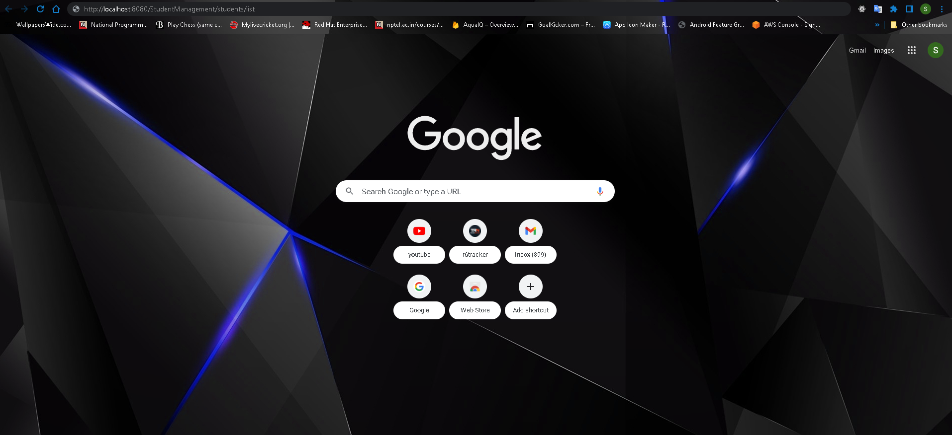

1. User is redirected to login page

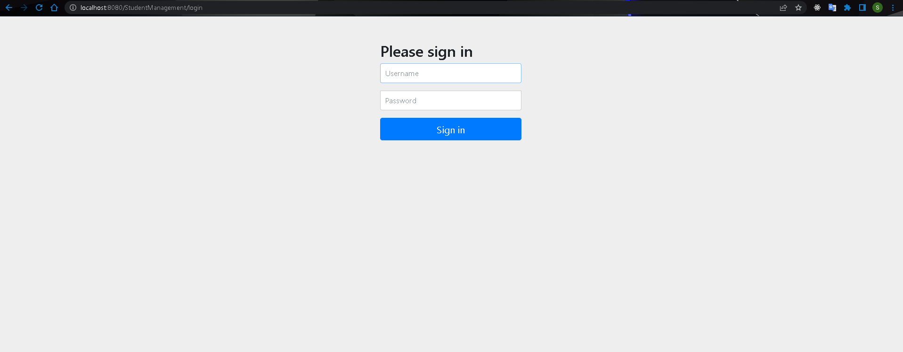

1. Login as USER/user.
2. Students List is shown

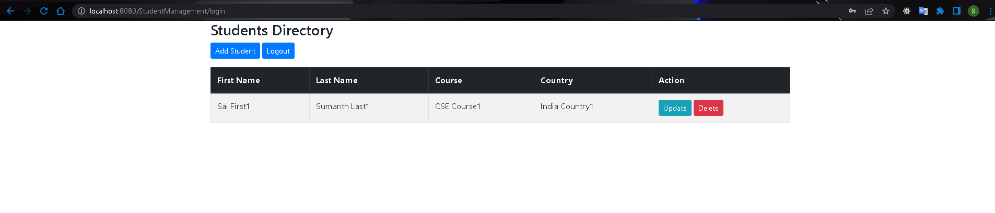

1. Click on Add Student
2. Fill all details

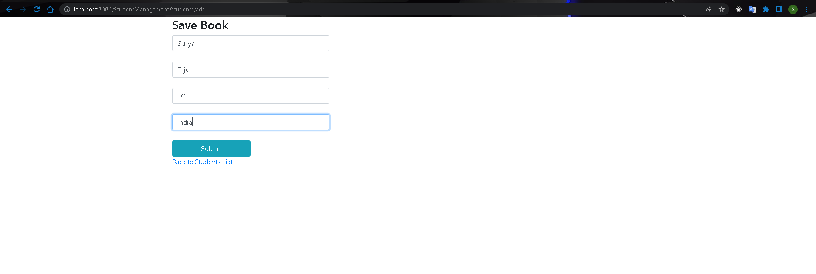

1. Click on Submit. User is redirected to listing screen and new student is visible

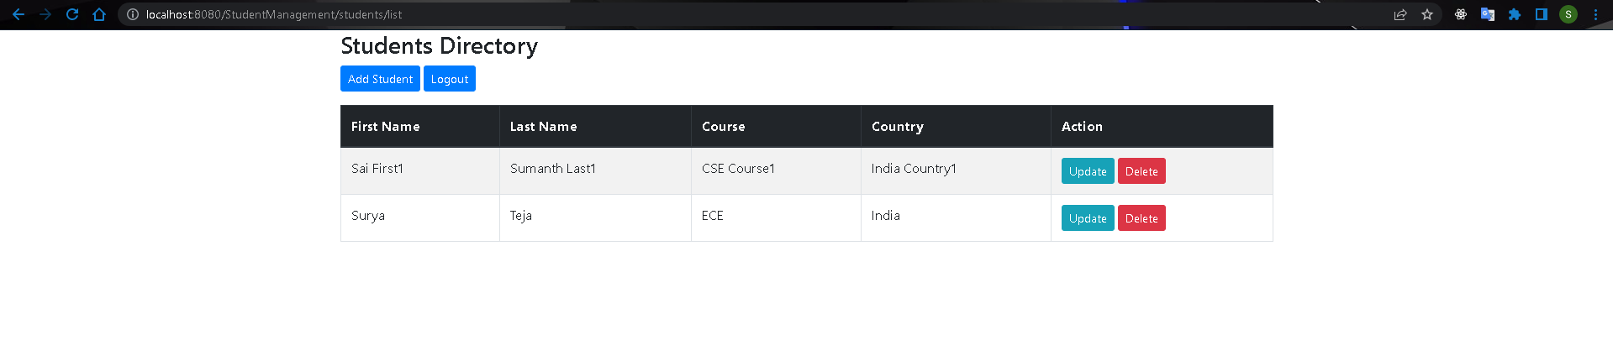

1. Click on update on any record.

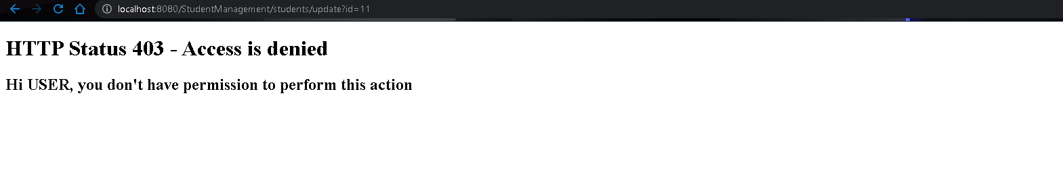

1. Above screen is shown as USER does not permission to update.
2. Comeback to listing screen

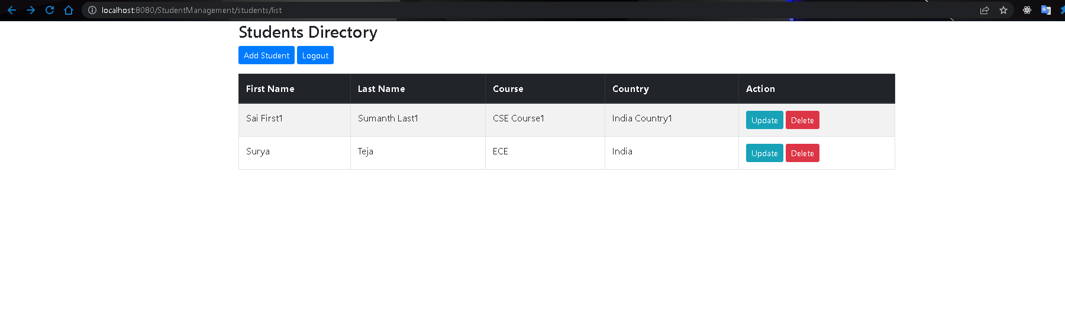11. Click on Delete on any record

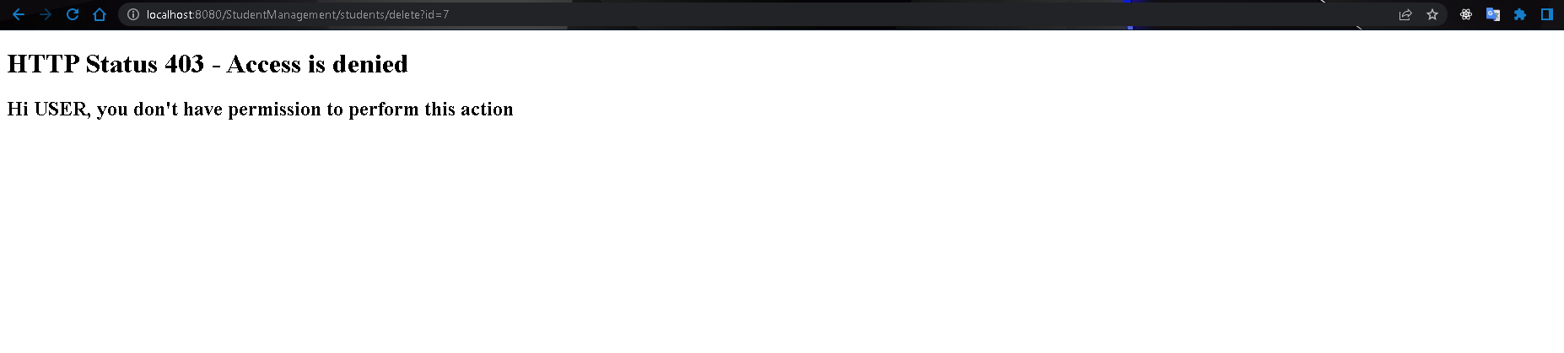

1. Above screen is shown as USER does not permission to delete.
2. Click on logout. User is redirected to login page.

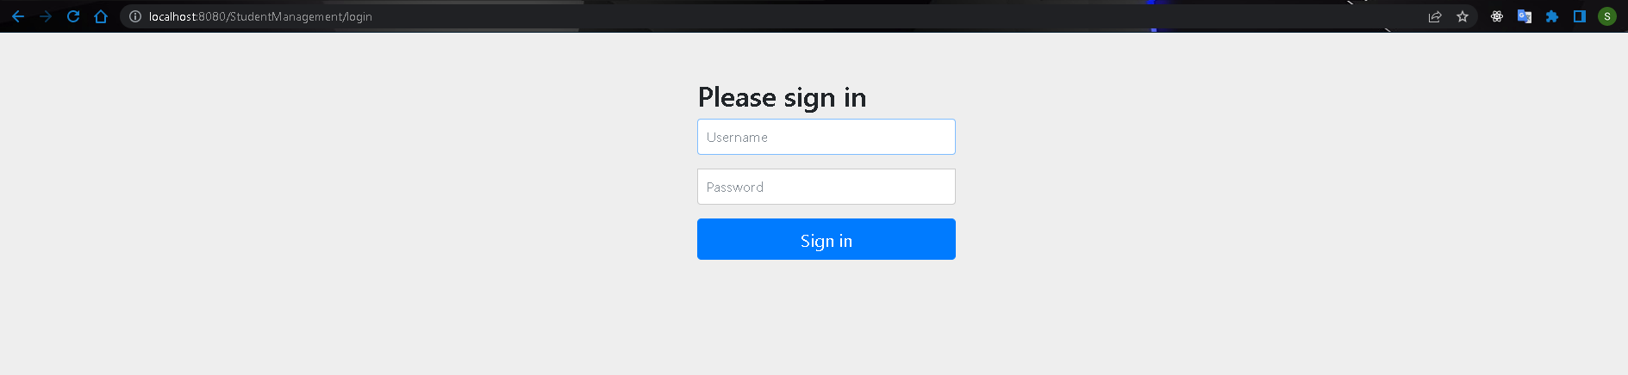

**Logging in as ADMIN(ADMIN has all permissions):**

1. Navigate to <http://localhost:8080/StudentManagement/students/list> in browser



1. User is redirected to login page



1. Login as ADMIN/admin
2. Students List is shown.

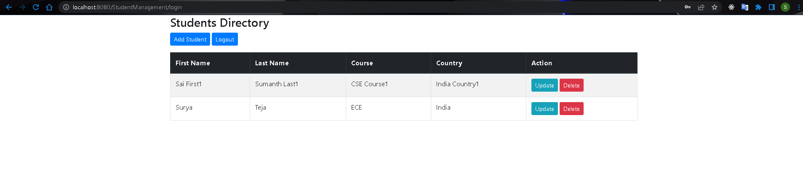

1. Click on Add Student
2. Fill all details.

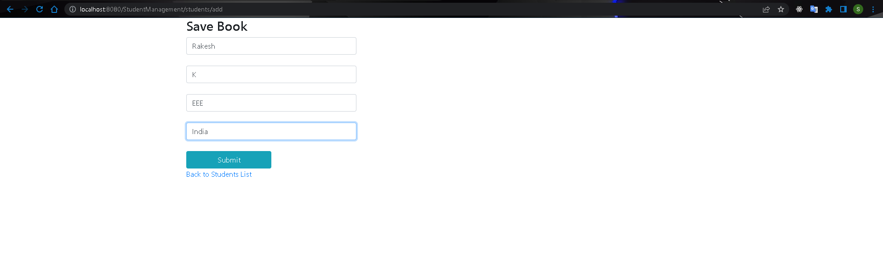

1. Click on Submit. User is redirected to listing screen and new Student is visible.

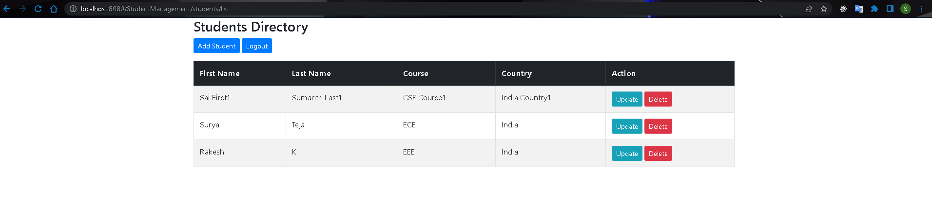

1. CLick Update on second record. User is redirected to update page with current user Details.

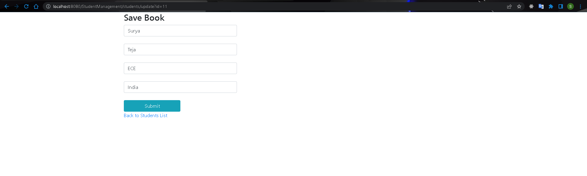

1. Update all fields

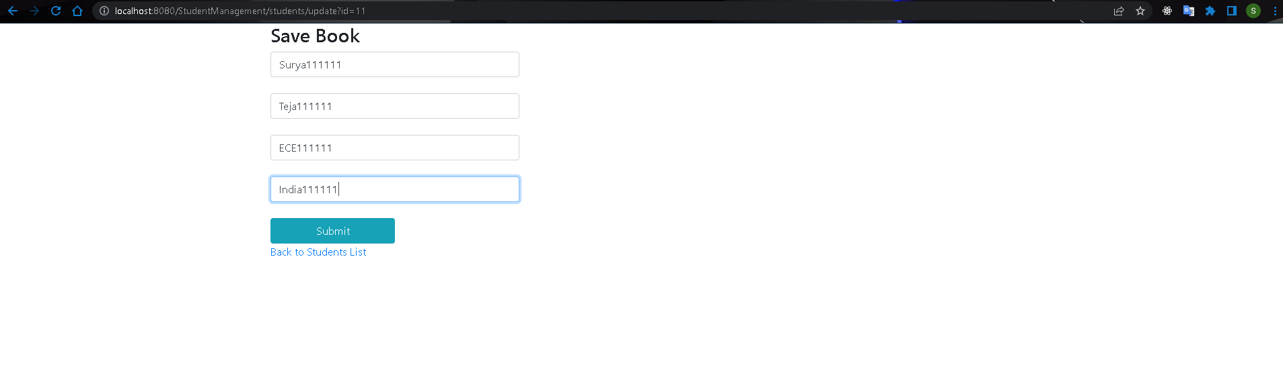

1. Click on Submit. User is redirected to listing screen and modified data is seen for 2nd record.

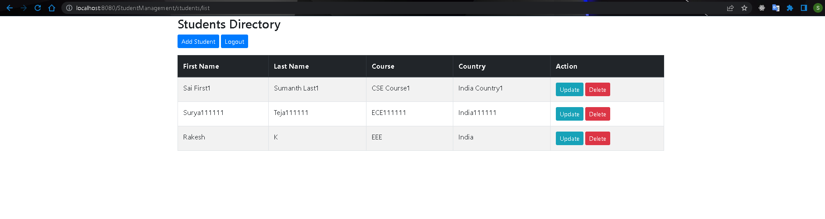

1. Click on delete on 2nd record.A confirmation alert is shown.

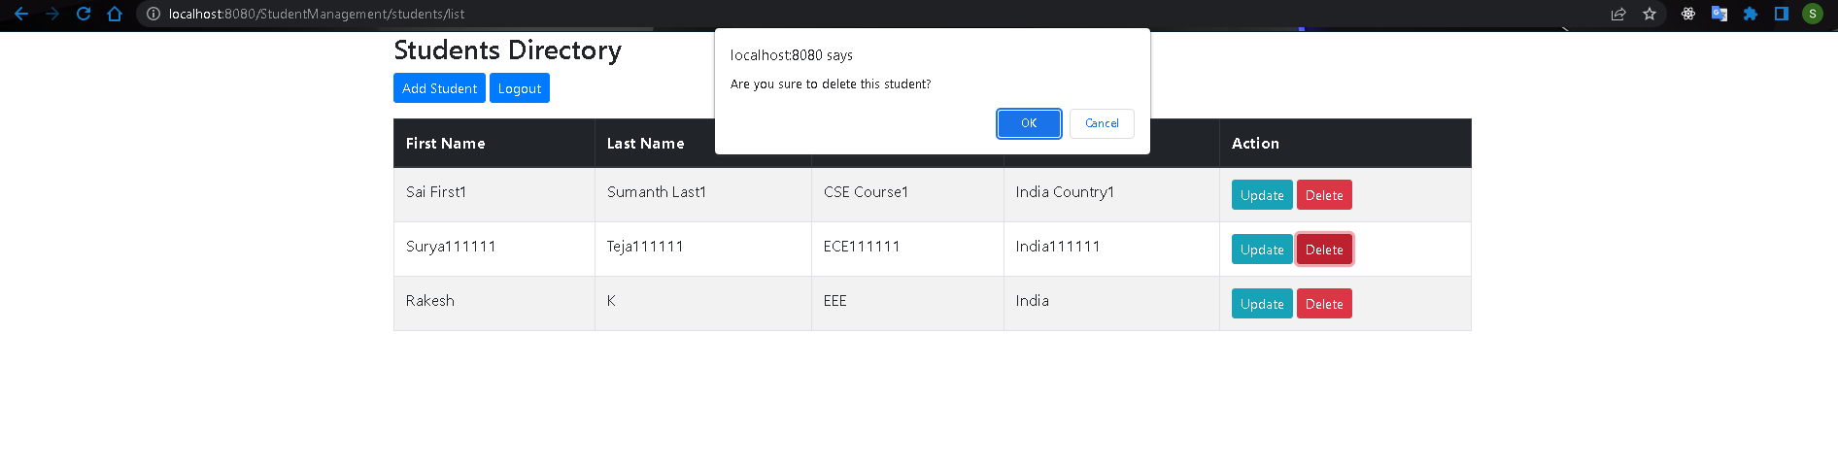

1. Click on ok and Student is deleted successfully.

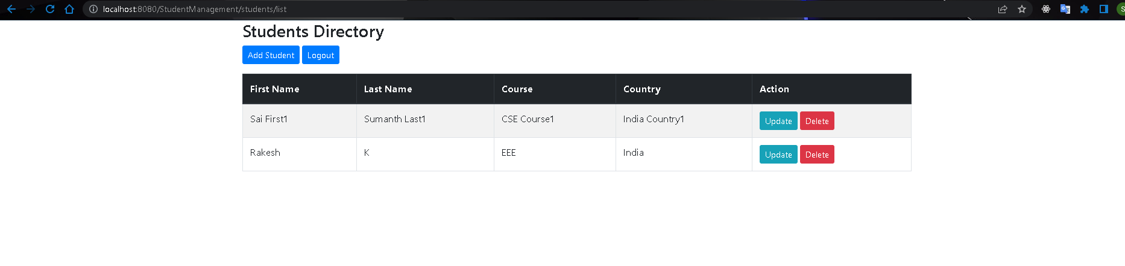

1. Click on logout. User is redirected to login page.

