1. Adding Role Admin

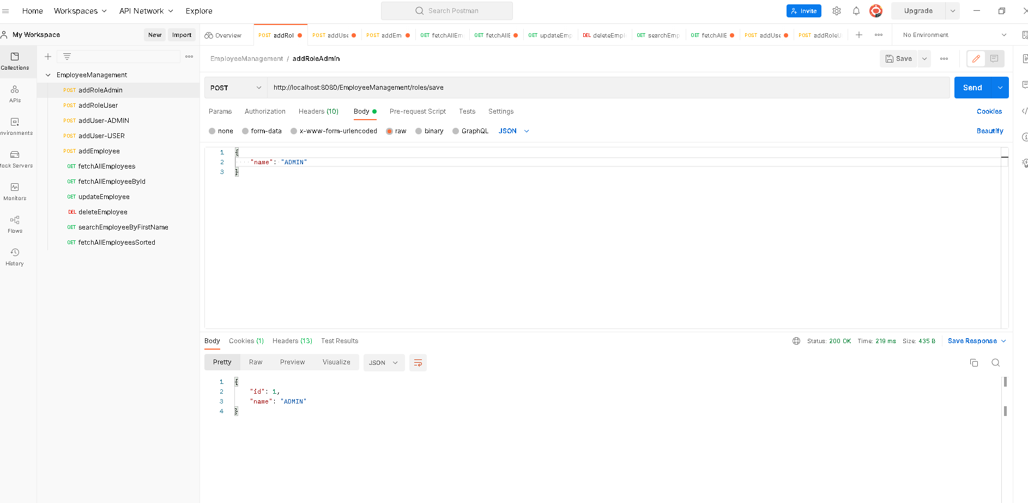

1. Adding Role User

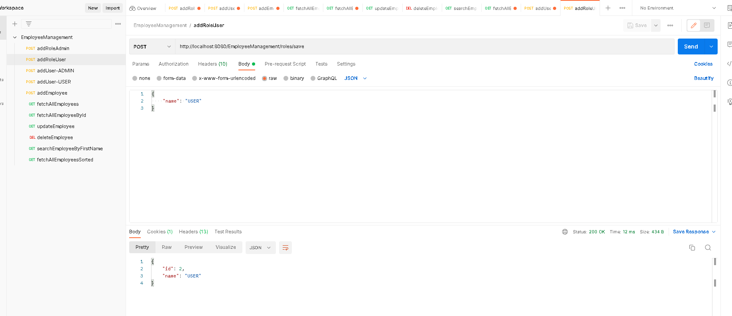

1. Adding a User with role Admin

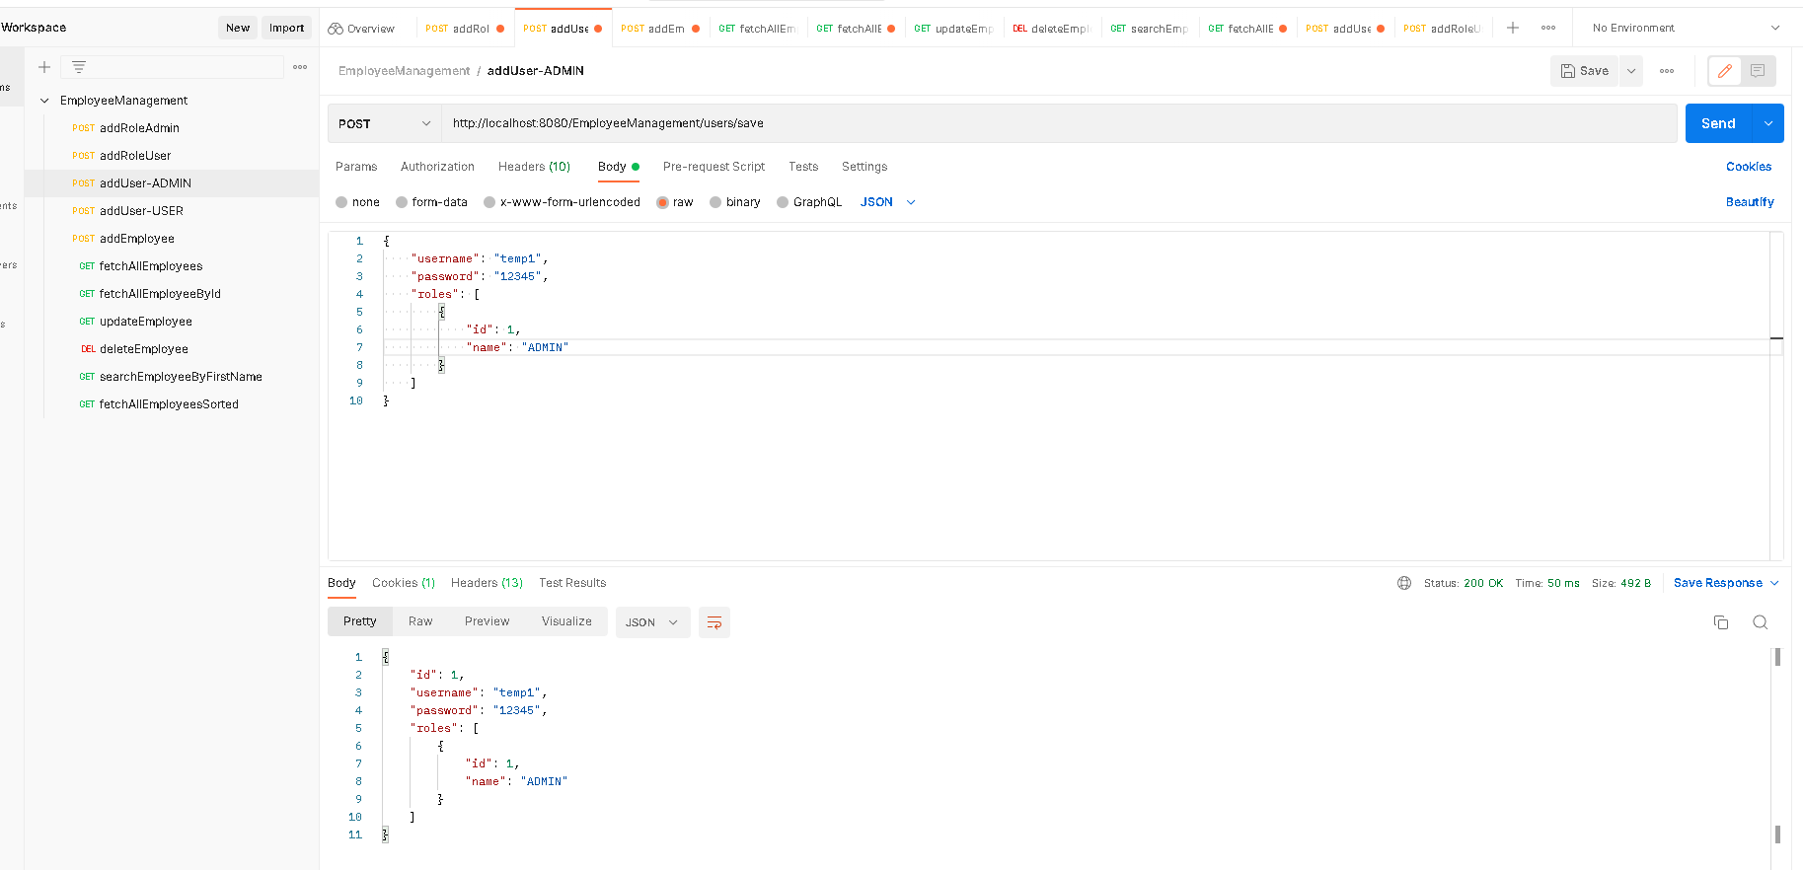

1. Adding a User with role User

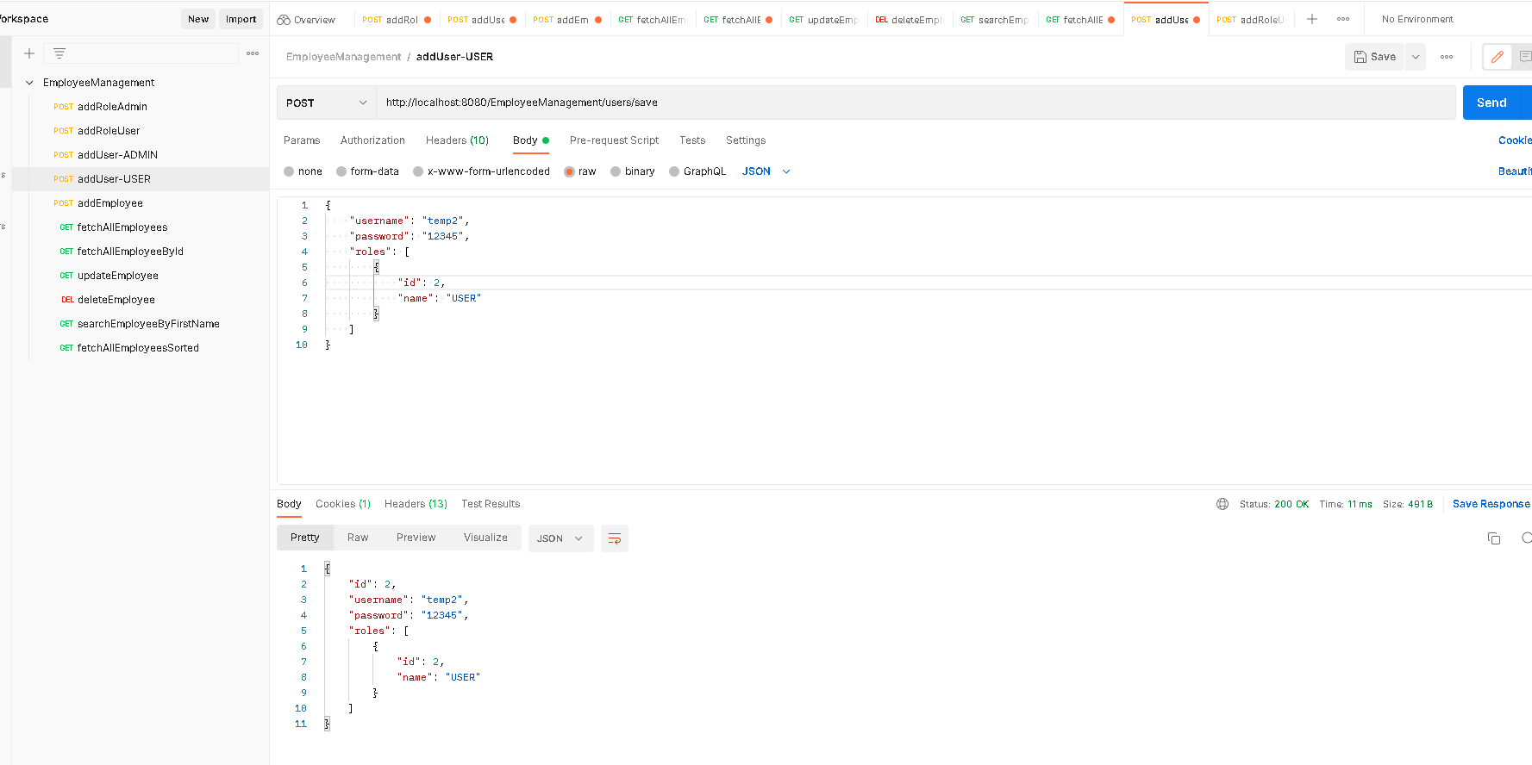

1. Adding an employee as temp2 user (temp2 user has USER role) and user is not allowed to add an employee as below.

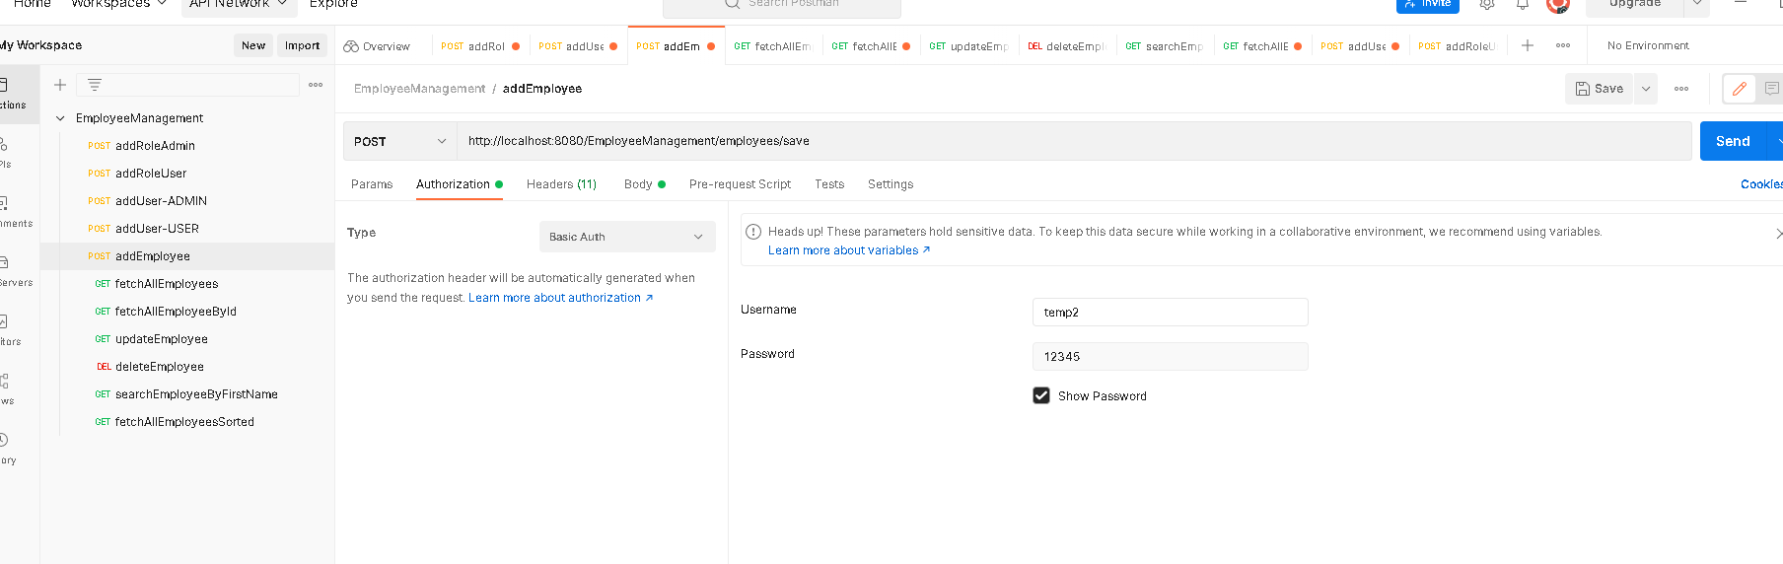

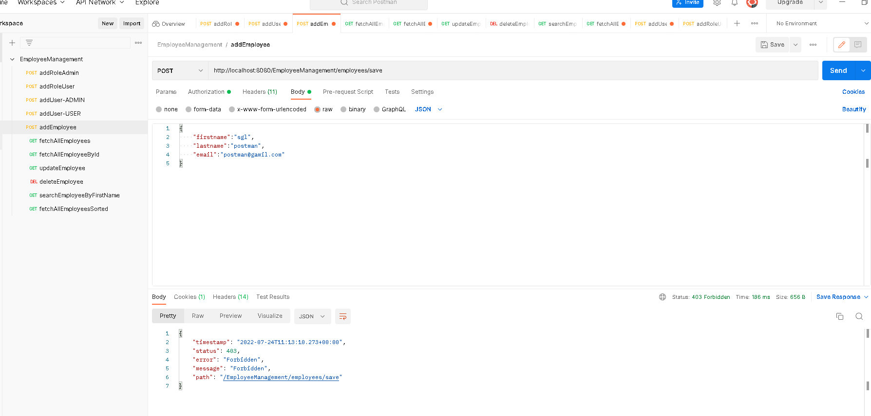

1. Adding an employee as temp1 user (temp1 user has ADMIN role)

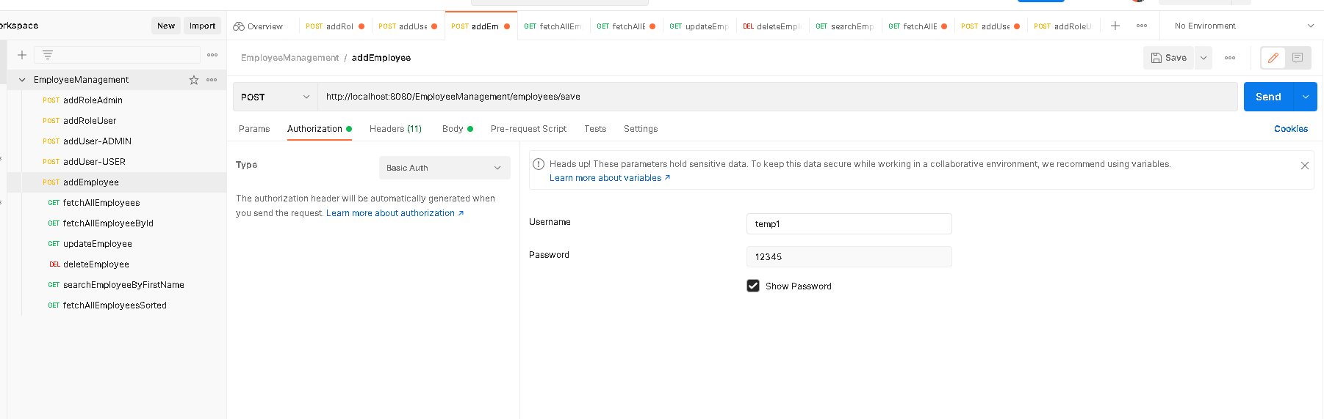

Employee “sgl” is added sucessfully.

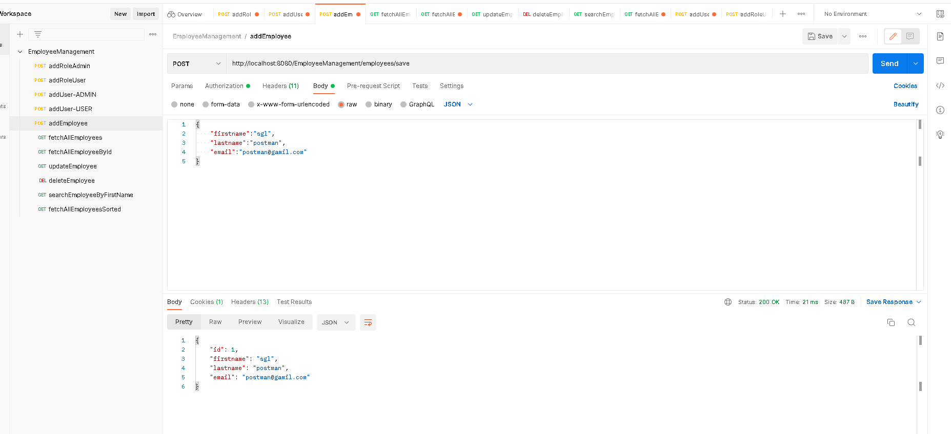

Adding 2 more employees with firstname “sgUser2” and “theUser3”

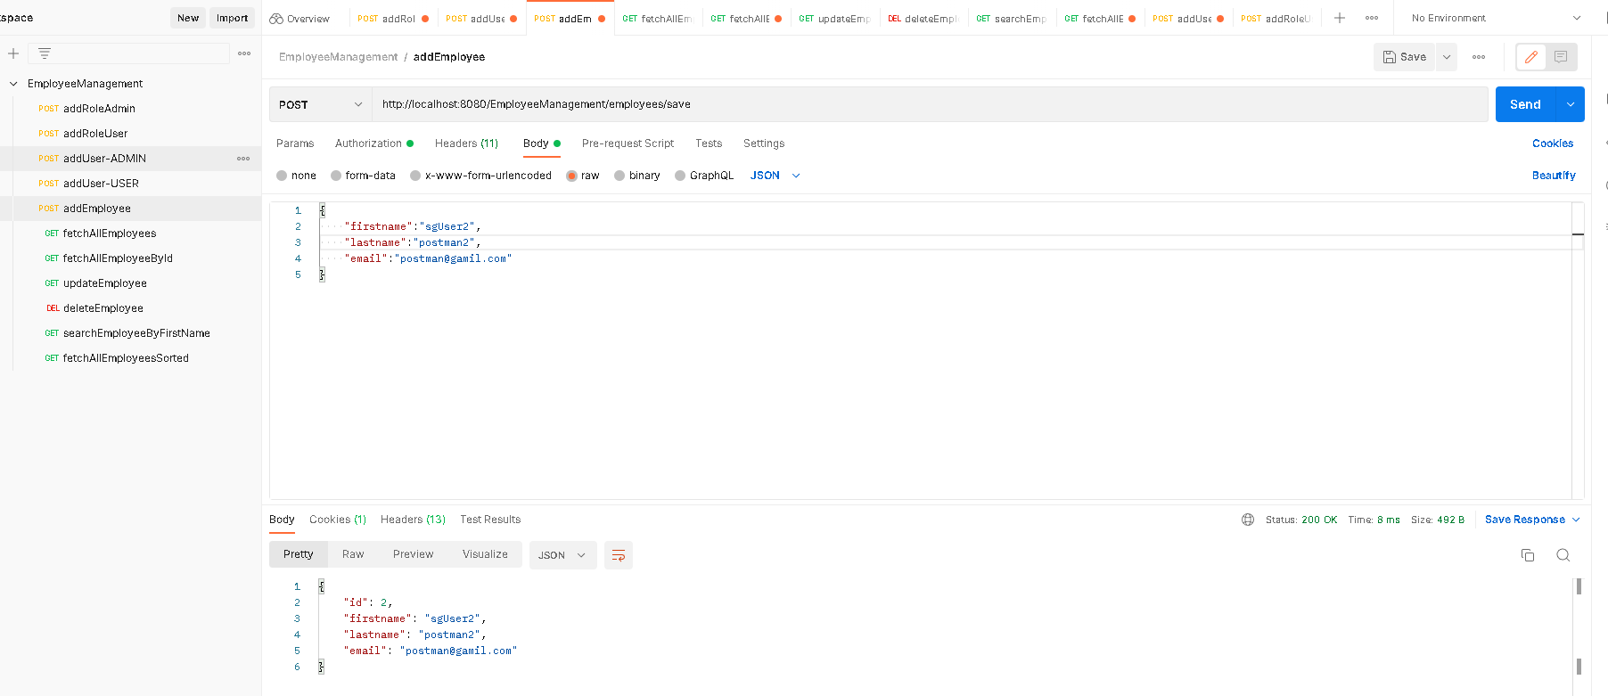

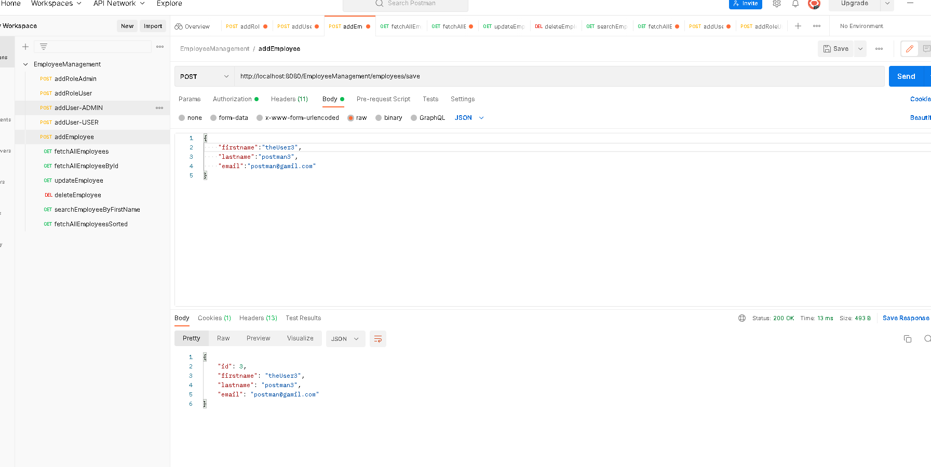

1. Listing all employees

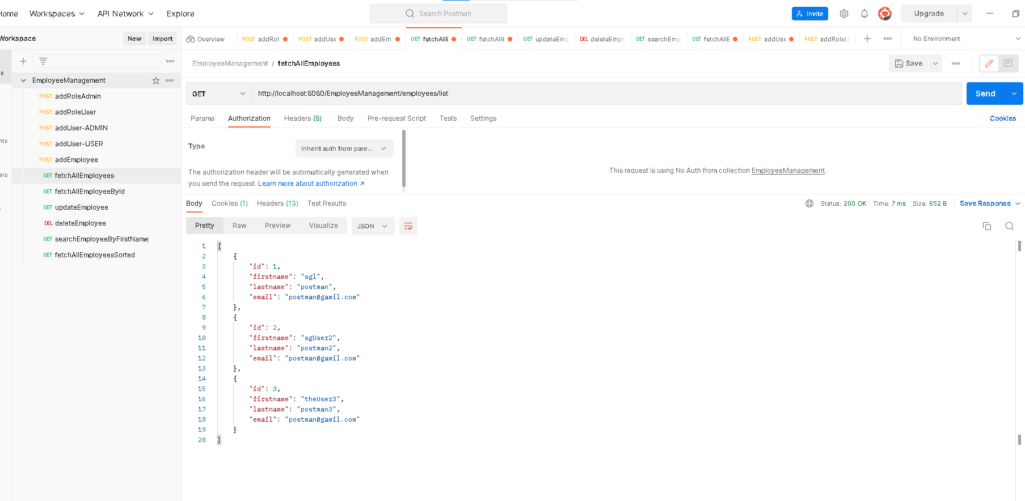

1. Fetching employee by id

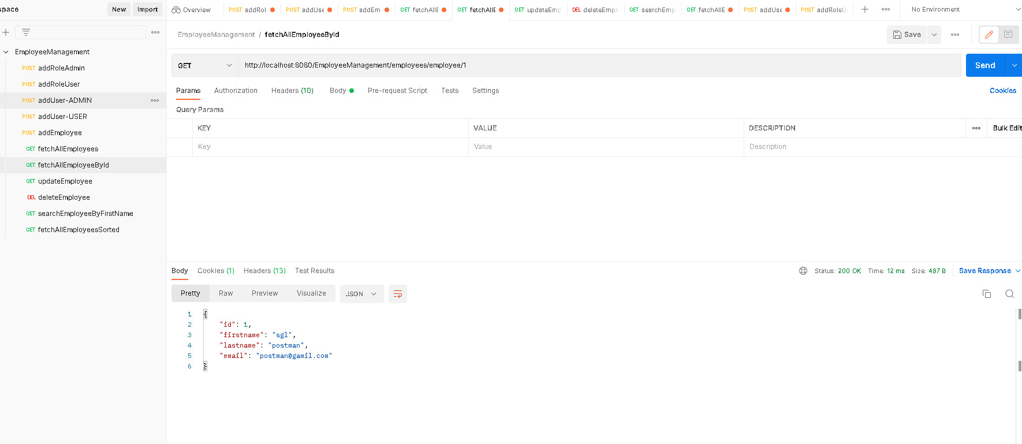

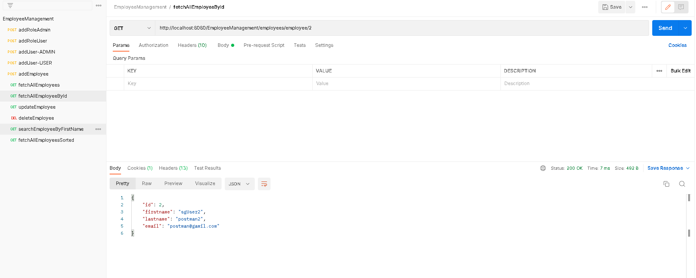

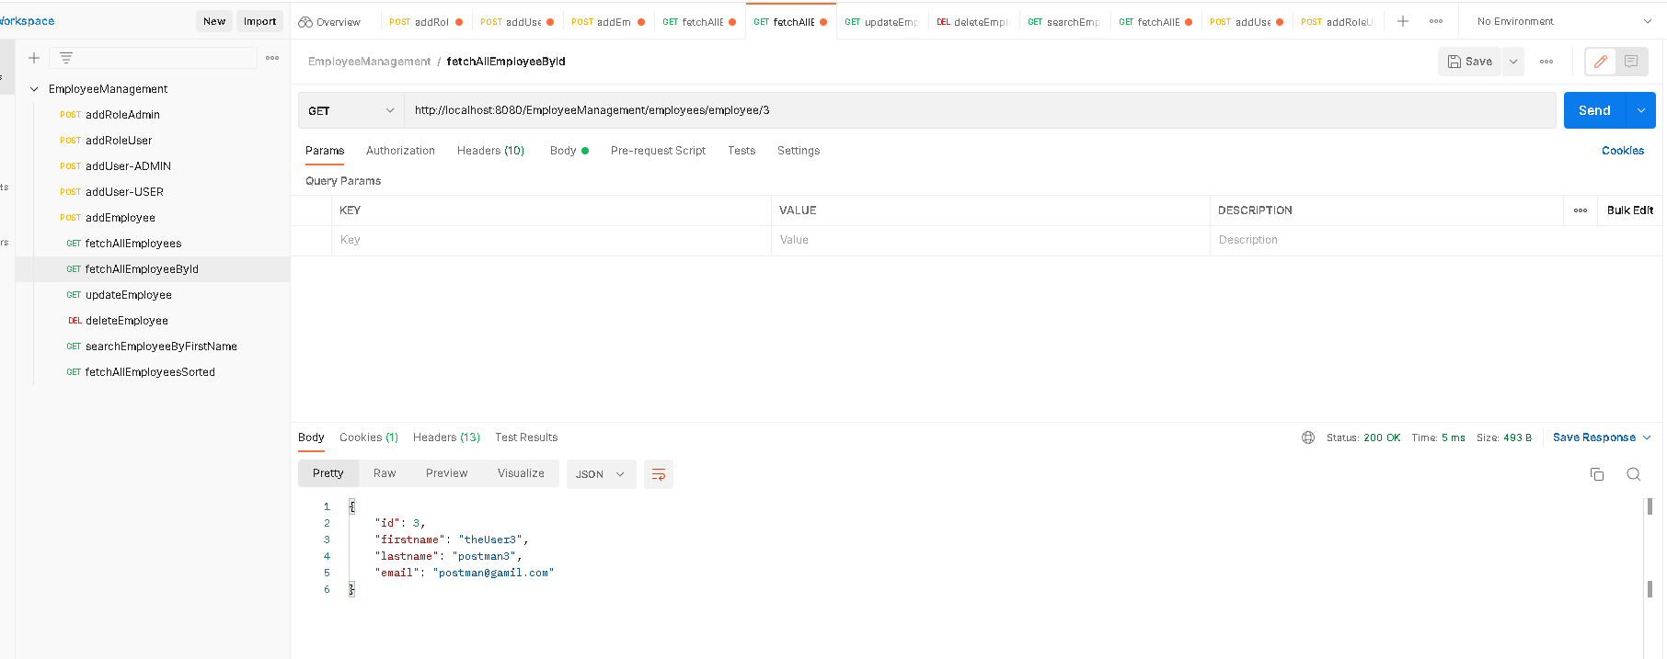

1. Updating employee of id:1 with

Firstname as “zUser1”

Lastname as “firstpost”

Email as [“first@gmail.com”](mailto:\“first@gmail.com\”)

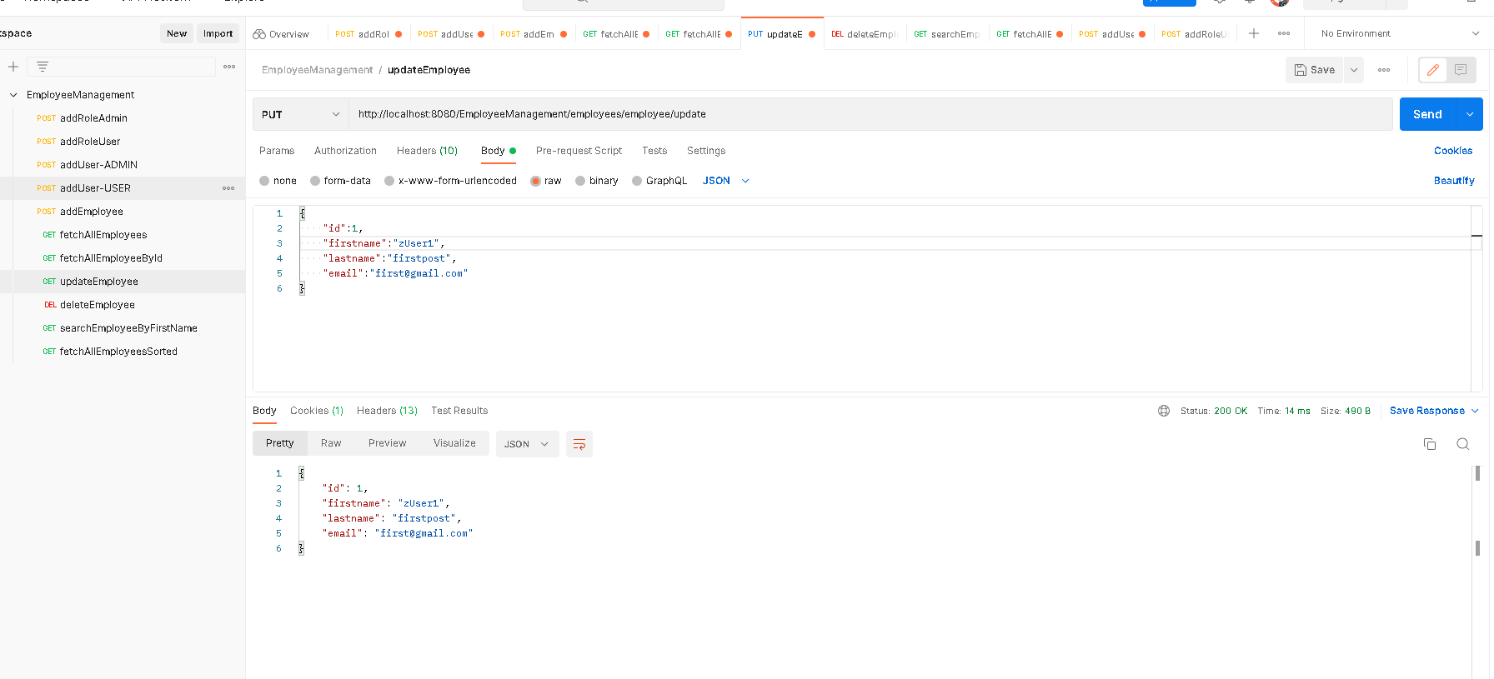

1. Delete employee with id:2

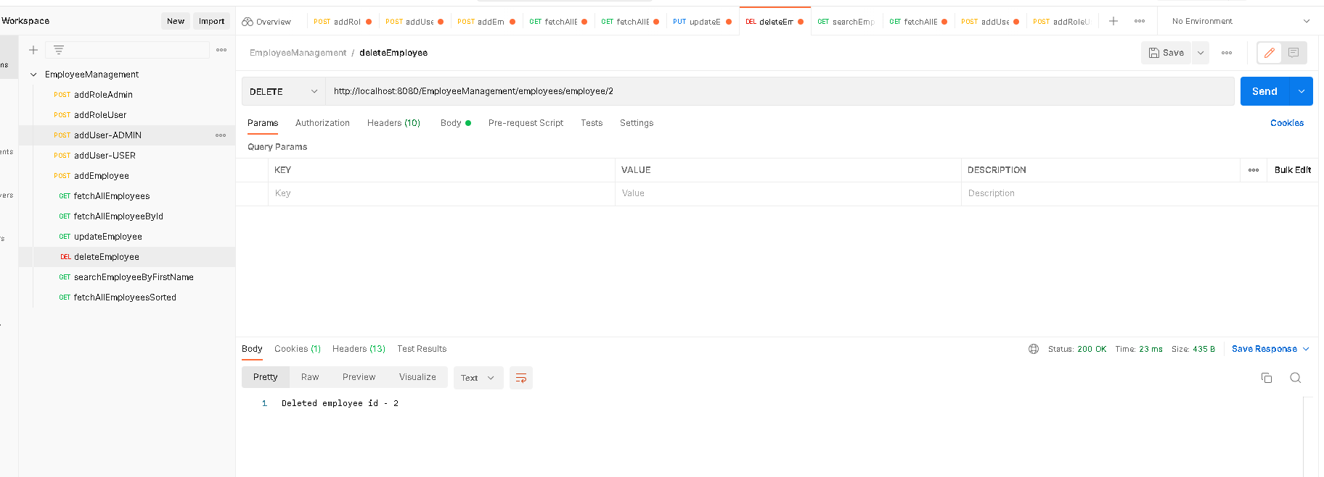

Listing all employees and employee id:2 is not present

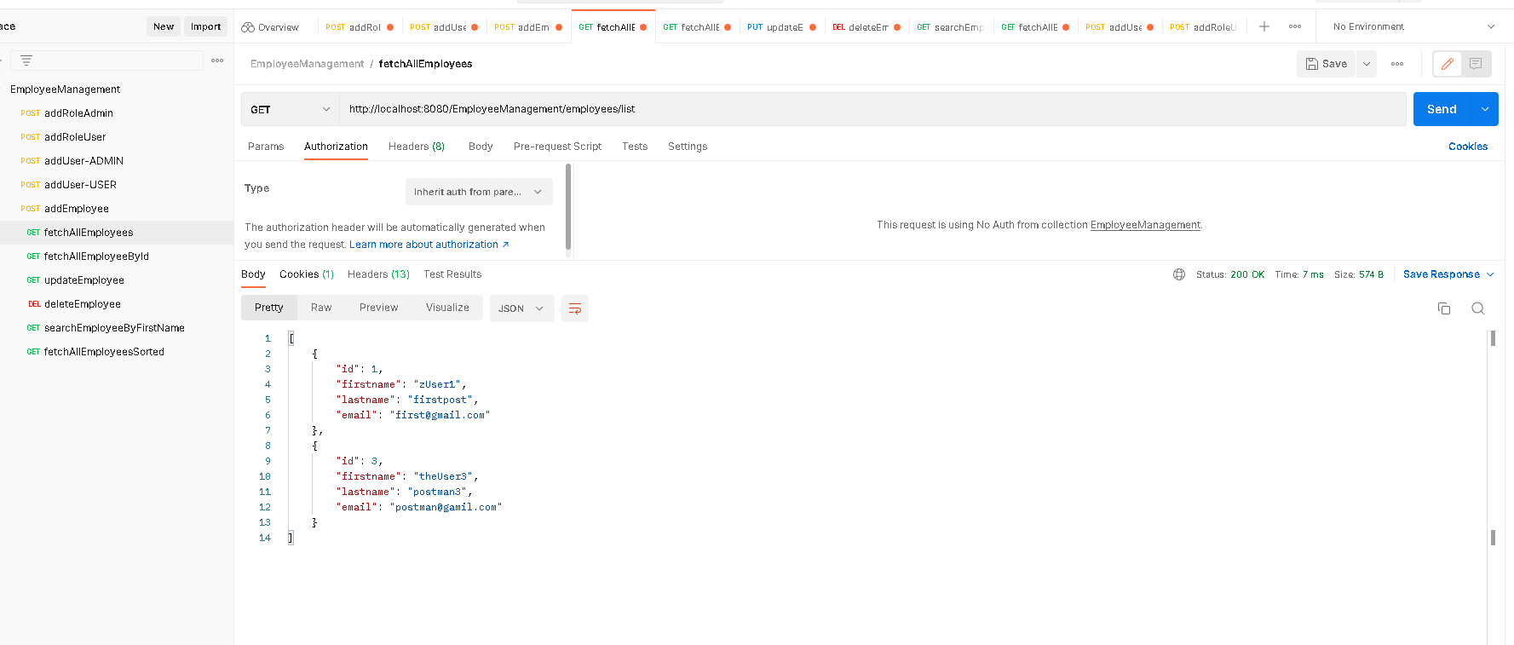

1. Searching employees whose firstname contains “z”

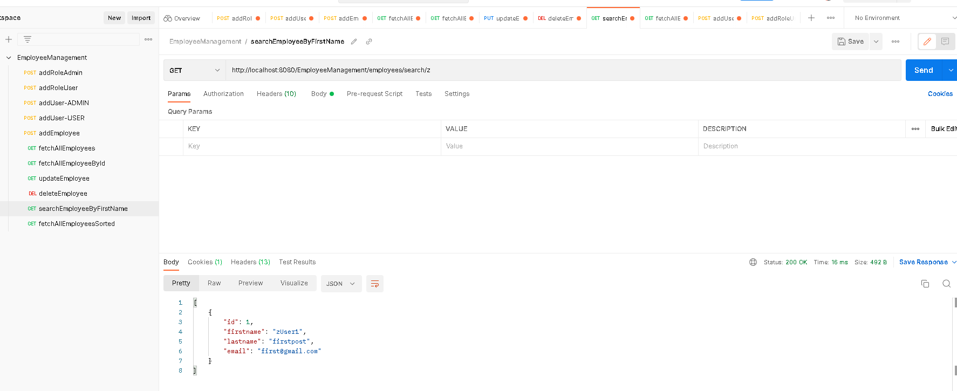

Searching employees whose firstName has “User”

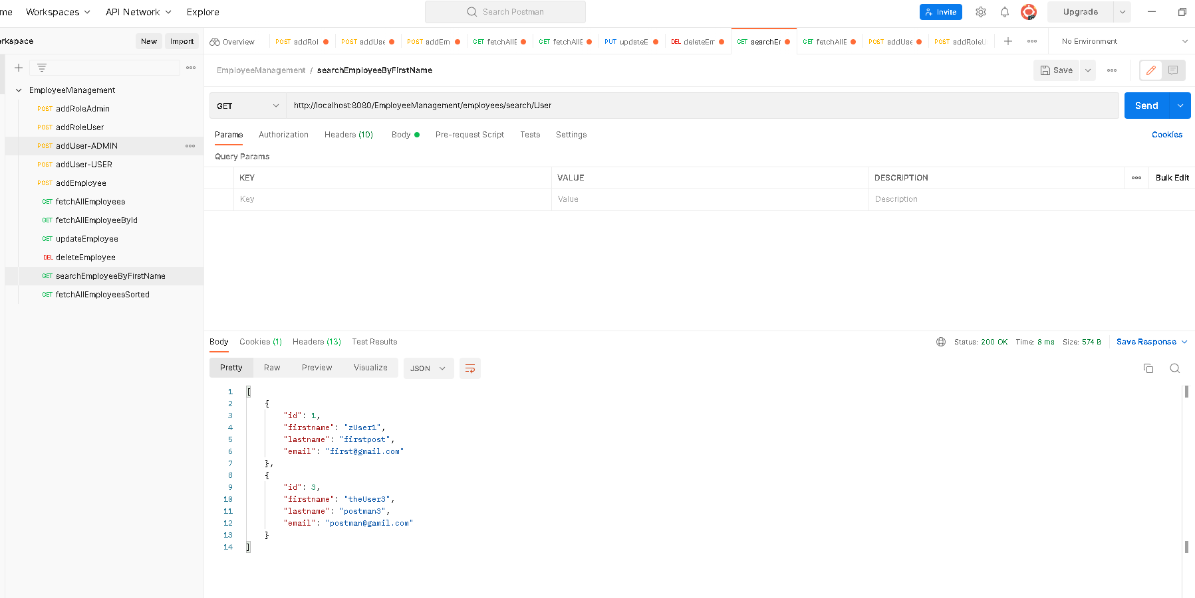

1. Fetching all employees with firstname ascending order

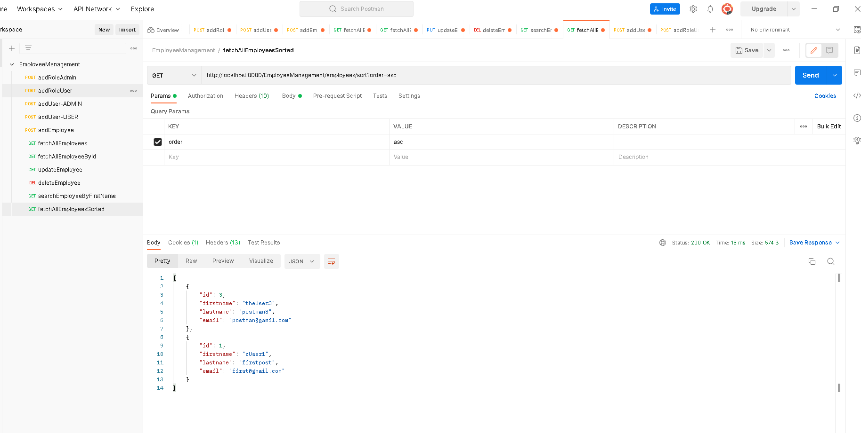

With firstname descending order

