# PROJECT REPORT

# Sumanth Manoharan - 24149225

# Table of Contents

INTRODUCTION..............................................................................4  
  
LAYOUT OF THE WEBSITE....................................................................4  
 1.1 NAVIGATION BAR........................................................................4  
 1.2 HOMEPAGE..................................................................................4  
 1.3 ICONS, IMAGES AND VIDEOS..........................................................5  
 1.4 COLOR THEME..........................................................................5  
 1.5 FONTS.........................................................................................5  
  
PROJECT PLAN AND PROTOTYPE ITERATIONS..........................................6  
 2.1 PHASE I: LOW-FIDELITY PROTOTYPE OF WEBSITE FRAMEWORK DESIGN.....8  
 2.2 PHASE II: COLOR THEME AND USER EXPERIENCE OPTIMIZATION.............10  
 2.2.2 Final Version of the High-Fidelity Prototype..................................12  
  
INTERACTION DESIGN..............................................................................19  
 3.1 THE SCOPE OF THE PROJECT...............................................................19  
 3.2 THE WEBSITE INTERACTION IN UML CONTROL FLOW DIAGRAM...........19  
 3.3 THE DEVELOPMENT OF THE PROJECT..................................................20  
 3.3.1 Project Preparation.....................................................................20  
 3.3.2 Folder Arrangement...................................................................20  
 3.3.3 Front-End Coding........................................................................20  
 3.3.4 Testing and Optimization.................................................................21  
 3.3.5 Deployment and Maintenance.......................................................21  
  
PORTFOLIO CODE....................................................................................22  
  
EVALUATION AND IMPROVEMENT............................................................22  
  
REFERENCES............................................................................................23

# INTRODUCTION

This section introduces the project, providing background on the purpose and scope of the website portfolio project. Built using React and Tailwind CSS, the website is modular, with components dedicated to each major section such as navigation, content, and services.

# LAYOUT OF THE WEBSITE

## Navigation Bar

The navigation bar, implemented in the Header component, is designed to provide smooth and efficient navigation across the website’s main sections. Utilizing React Router, it enables seamless transitions between pages without reloading, which enhances the user experience by maintaining the application’s state and providing faster navigation.

**Key Features:**

1. **Component-Based Structure**: As a React component, the Header is self-contained, modular, and can be easily reused or modified. This approach promotes scalability and maintainability.
2. **Responsive Design**: With Tailwind CSS applied, the navigation bar likely adapts to different screen sizes, ensuring optimal appearance and functionality on both desktop and mobile devices.
3. **Clear Path Definitions**: The navigation links are mapped to each major section, including paths like /, /about, /services, /projects, and /blog. This structure provides users with intuitive access to various parts of the website.

**Appearance:**

The navigation bar aligns with the website's dark-themed design. Styled with Tailwind CSS, it uses a black background with white text for contrast, while a violet accent color may highlight active or hovered links, enhancing visual feedback for users. This minimalistic design complements the portfolio’s overall aesthetic, providing a professional and cohesive look.

In summary, the navigation bar in this project serves as a fundamental component, ensuring a smooth, accessible, and visually appealing user interface that aligns with modern web design standards.

## Homepage

The Home component functions as the primary landing page of the website, designed to create a strong initial impression and provide visitors with a clear overview of the website's purpose and content. Built as a React component, it is likely highly modular, allowing for easy updates and adjustments to both content and layout. The component-based structure in React also supports a streamlined and maintainable codebase, where the homepage can be managed independently of other sections.

**Key Features:**

1. **Introductory Content**: The homepage typically includes essential information, such as a welcoming message, an introduction to the portfolio’s subject, and links or buttons guiding visitors to other main sections (e.g., About, Services, Projects). This design helps orient visitors immediately upon arrival.
2. **Smooth Navigation**: Integrated with the site’s routing structure, the homepage provides clear pathways to other sections, ensuring users can easily explore more detailed information, like service descriptions or project showcases.
3. **Interactive Elements**: The homepage may include call-to-action buttons or quick navigation links that enhance user engagement. React makes it easy to add interactive components, such as animated transitions, which can improve the page’s aesthetic appeal and functionality.

**Appearance:**

Following the website's dark theme, the homepage likely features a black or dark background with high-contrast text, typically styled in white or light colors for readability. Tailwind CSS may be used for layout and styling, ensuring responsiveness across various devices. Fonts like Raleway and VT323, as mentioned, would lend a modern and professional feel, enhancing the design’s appeal. Additionally, the violet accent color might be used for highlights or buttons, drawing attention to key areas.

In summary, the homepage serves as an attractive, functional entry point for the website, combining a welcoming layout with intuitive navigation and modern design aesthetics to deliver a strong user experience.

## Icons, Images and Videos

## The images and icons I chose for my portfolio website are crucial in shaping its overall style, giving it a modern and minimalist look with a strong emphasis on monochrome tones and sharp contrasts. I wanted to create a unique, artistic vibe, so I used black-and-white images with halftone effects, especially in the portraits. This gives the site a retro or pop-art feel, setting it apart from more conventional portfolios and adding an edgy, creative touch.

## By sticking with a monochromatic scheme, I made sure the images blend seamlessly with the website’s dark theme. This approach allows any pops of color, like icons or highlighted links, to stand out more effectively, guiding the viewer’s attention to key areas. It also enhances readability and establishes a clear visual hierarchy, so the site feels engaging without overwhelming visitors with too much color or detail.

## The icons, like the download and link symbols, are kept simple and monochromatic to match the site’s overall aesthetic, ensuring they serve their purpose without distracting from the main content. For the tool icons, such as Photoshop, Illustrator, and React, I integrated them subtly to highlight my technical skills without disrupting the site’s cohesive look.

## Overall, I carefully selected and designed these visual elements to create a consistent, striking look that aligns with my brand. The style I went for not only looks polished and professional but also reflects a creative personality, making my portfolio both memorable and visually appealing.

## Color Theme

## The dark theme in the website is carefully crafted using a combination of Tailwind CSS utilities and custom CSS classes to create a visually cohesive and striking appearance. The primary background color used across the entire application is black, achieved through the Tailwind CSS utility class bg-black, which is applied to the main container in the App component. This choice of black background provides a strong foundation for a dark-themed design and ensures high contrast with lighter text and accents.

## For text color, white is predominantly used, set by the text-white Tailwind class. This contrast between black backgrounds and white text enhances readability and ensures that content stands out clearly against the dark backdrop. The consistent use of these two colors – black and white – establishes a clean and modern aesthetic.

## To add a touch of visual interest, the website incorporates a violet accent color. This is defined in the CSS as the .primary-color class, which applies a gradient effect to text using bg-violet-700 combined with the bg-clip-text and text-transparent classes. This violet accent provides a pop of color in an otherwise monochromatic palette, drawing attention to specific elements, such as headings or important information, without overwhelming the viewer.

## Additionally, the .backdrop-blur-md class is used to add a subtle backdrop blur effect in certain areas, softening the visual impact of elements against the black background. Fonts also play a role in defining the dark theme’s style. The Raleway and VT323 fonts provide a modern, tech-inspired look, enhancing the site’s overall aesthetic while maintaining readability.

## This thoughtful combination of colors, effects, and fonts results in a dark theme that feels both sophisticated and visually engaging, aligning well with the portfolio’s creative, professional tone.

## Fonts

# The fonts used in the website play a crucial role in defining its overall style and enhancing readability. For this site, two distinct fonts have been chosen: Raleway and VT323. Both fonts are sourced from Google Fonts, ensuring ease of integration and consistent rendering across different devices and browsers.

# Raleway

# Raleway is a versatile sans-serif typeface known for its modern, clean, and slightly elegant look. It’s often used for general body text or sections where readability is paramount. On this website, Raleway contributes to the polished and professional feel, aligning with the dark theme and the monochrome aesthetic. The font’s slightly rounded edges and consistent stroke widths help maintain a soft, approachable look, counterbalancing the stark contrasts of the dark background and white text.

# In terms of functionality, Raleway is an ideal choice for body text because it is highly readable at both small and large sizes. Its minimalist design allows the content to be easily scannable, making it user-friendly for visitors who want to quickly absorb information. This readability factor is crucial in portfolio websites, where users may be exploring projects, services, or blog content, and need to comfortably engage with text-heavy sections.

# VT323

# VT323, a monospaced font inspired by retro computer terminals, brings a unique, tech-inspired flair to the site. Its inclusion adds a distinctive character, suggesting a blend of modern and vintage aesthetics. While Raleway supports the site's polished, professional vibe, VT323 adds a playful, creative twist that can capture visitors’ attention. This font is often used in specific contexts within the site, such as for highlighting code snippets, captions, or any elements that benefit from a typewriter-like, nostalgic look.

# The contrast between Raleway’s clean, smooth lines and VT323’s monospaced, digital-inspired structure creates a balanced visual hierarchy. VT323’s unique styling naturally draws the viewer’s eye, making it well-suited for content that needs emphasis or visual separation from standard text.

# Usage in the Dark Theme

# Both fonts have been carefully chosen to complement the dark theme. Raleway, with its high legibility, ensures that general content remains accessible and easy to read against the black background, even when used in smaller sizes. VT323, on the other hand, stands out vividly against the dark backdrop, enhancing the visual appeal of headings or highlighted text without compromising readability.

# Visual Impact

# The font pairing reflects the website’s goal of being both professional and creative. Raleway establishes a grounded, polished feel, suitable for a portfolio, while VT323 introduces an element of uniqueness and creativity, aligning with the site's monochrome, high-contrast visual style. This thoughtful selection of fonts not only ensures that the text is legible and engaging but also contributes to the website’s branding by projecting a personality that is both modern and slightly unconventional.

# In conclusion, the combination of Raleway and VT323 supports both aesthetic and functional aspects of the website. Together, they enhance the visual narrative, offering a distinctive user experience that feels cohesive, accessible, and visually intriguing.

# PROJECT PLAN AND PROTOTYPE ITERATIONS

## PHASE I: Low-Fidelity Prototype of Website Framework Design

An initial prototype with basic layout and limited functionality to outline the project framework.

Home

About

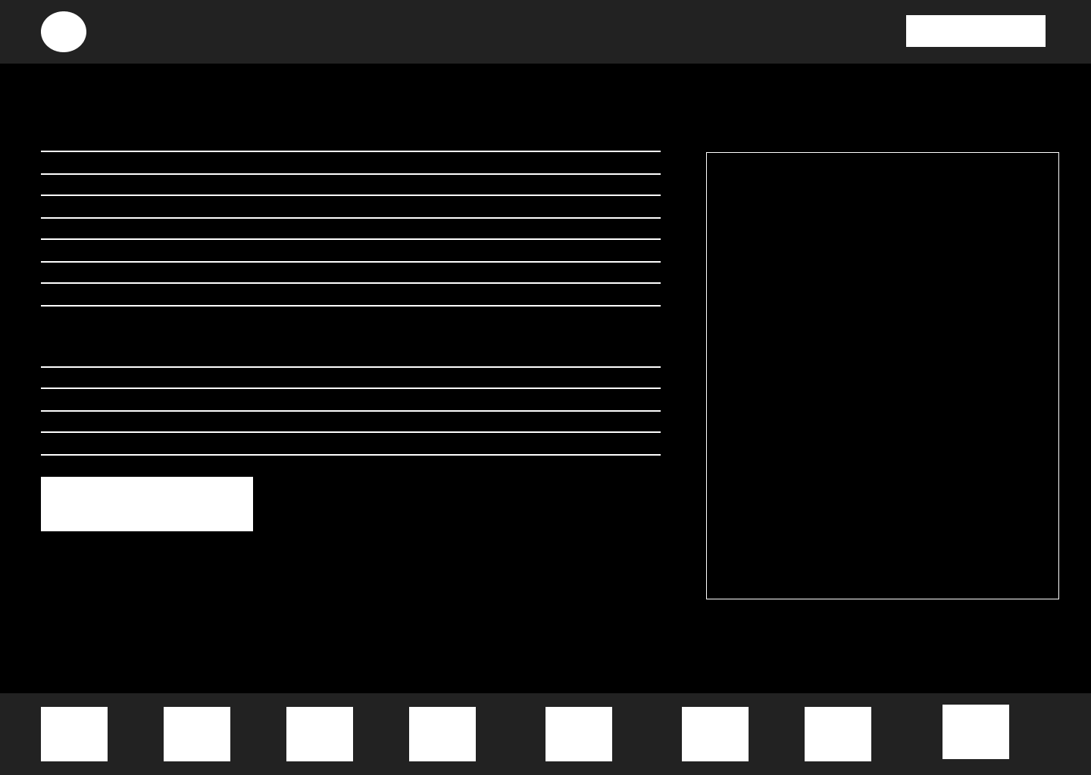

Services

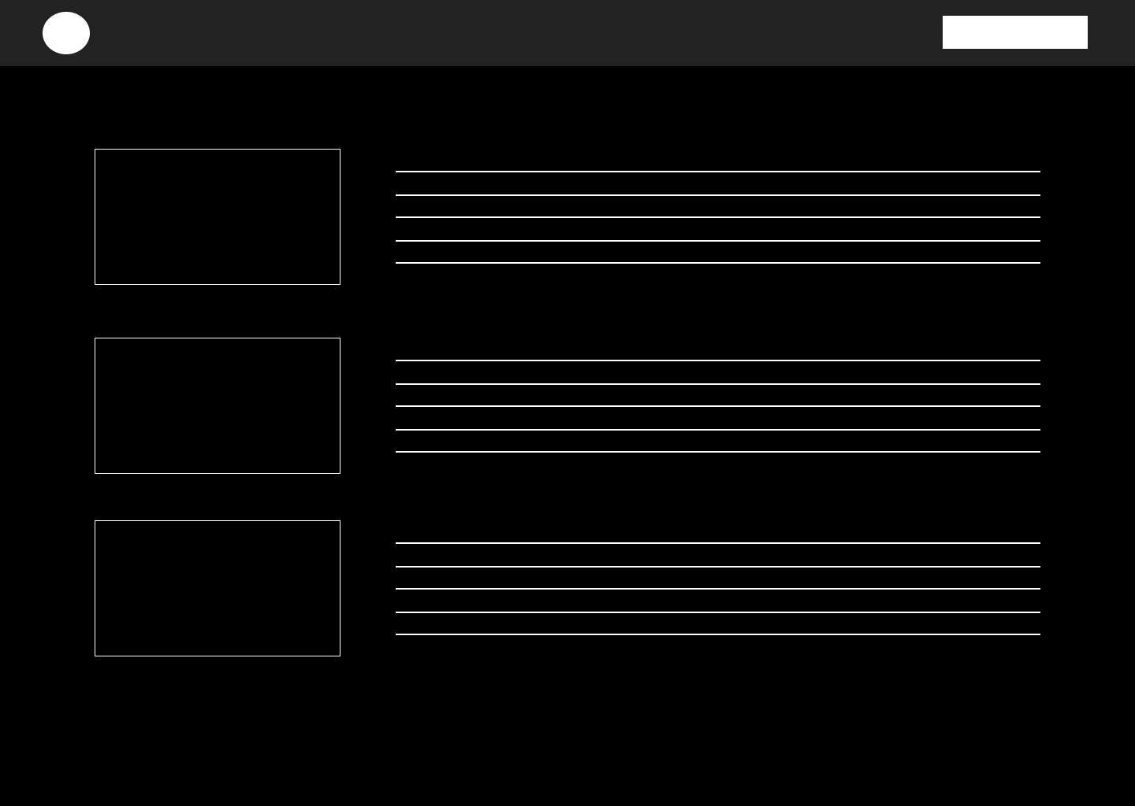

Projects

Blog

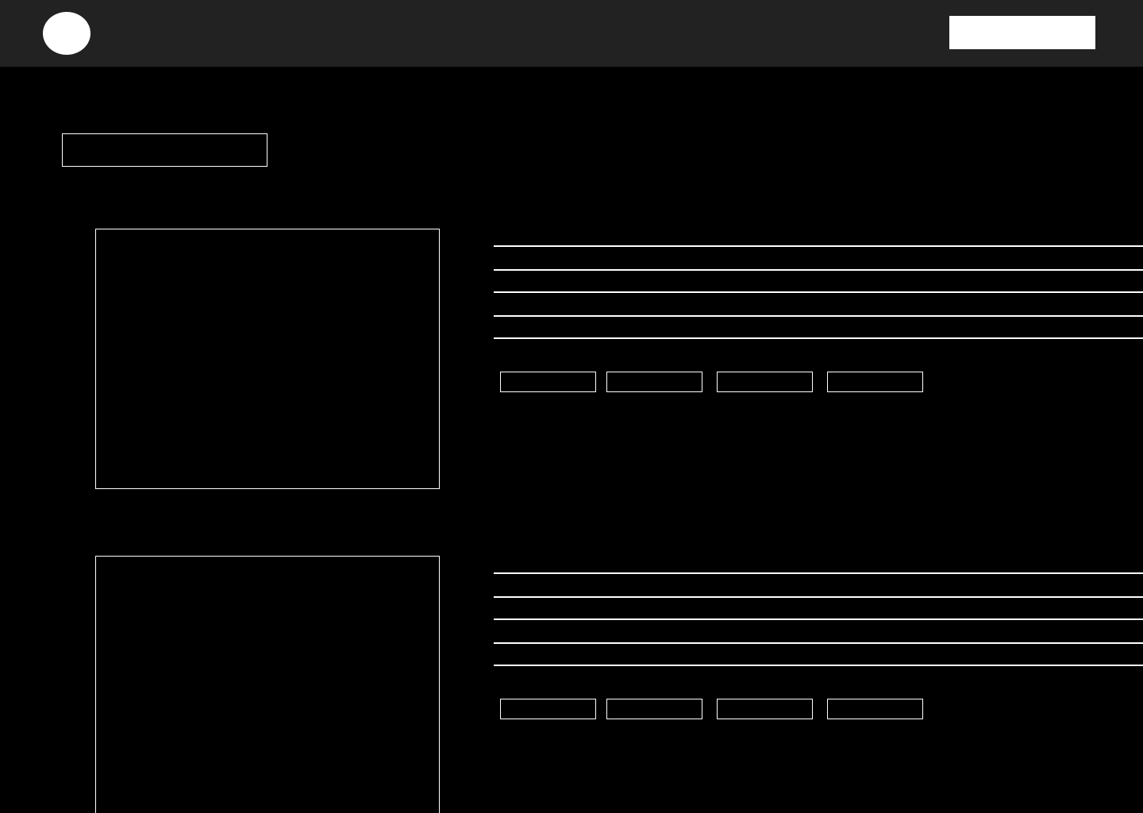

**COLOR THEME AND USER EXPERIENCE OPTIMIZATION**

The color theme of this portfolio website is designed to create a strong visual impact while enhancing user experience and usability. The dark theme, primarily featuring a black background with white and violet text accents, establishes a modern, minimalist aesthetic that serves to focus the viewer’s attention on the content. This high-contrast scheme makes text and images stand out vividly, which improves readability and ensures that each section is easy to navigate and visually distinct.

The choice of white text on a black background not only adds to the sophisticated look but also reduces eye strain in low-light environments, which is particularly beneficial for prolonged viewing. The monochrome palette is broken by the strategic use of violet, applied to important elements such as the logo, headings, and buttons, creating a clear visual hierarchy. This use of color draws users' eyes naturally to interactive or significant sections, like the “Portfolio” and “Contact Me” buttons, enhancing the site's navigability.

Additionally, the user experience is optimized by employing consistent styling across different sections, from the homepage to the services and projects pages. Each section is visually separated by maintaining a similar background while varying content alignment and layout. This consistency helps users to understand the structure and flow of the website intuitively, making navigation straightforward.

The website further leverages user experience optimizations through clear call-to-action buttons, adequate spacing, and well-chosen fonts that are highly legible against the dark background. The Raleway font used for body text and VT323 for headers maintain readability while adding a unique stylistic touch that aligns with the site’s modern, creative theme. Overall, the color scheme and design choices make the site both visually appealing and highly user-friendly, promoting a seamless and enjoyable browsing experience.

**FINAL VERSION OF THE HIGH-FIDELITY PROTOTYPE**

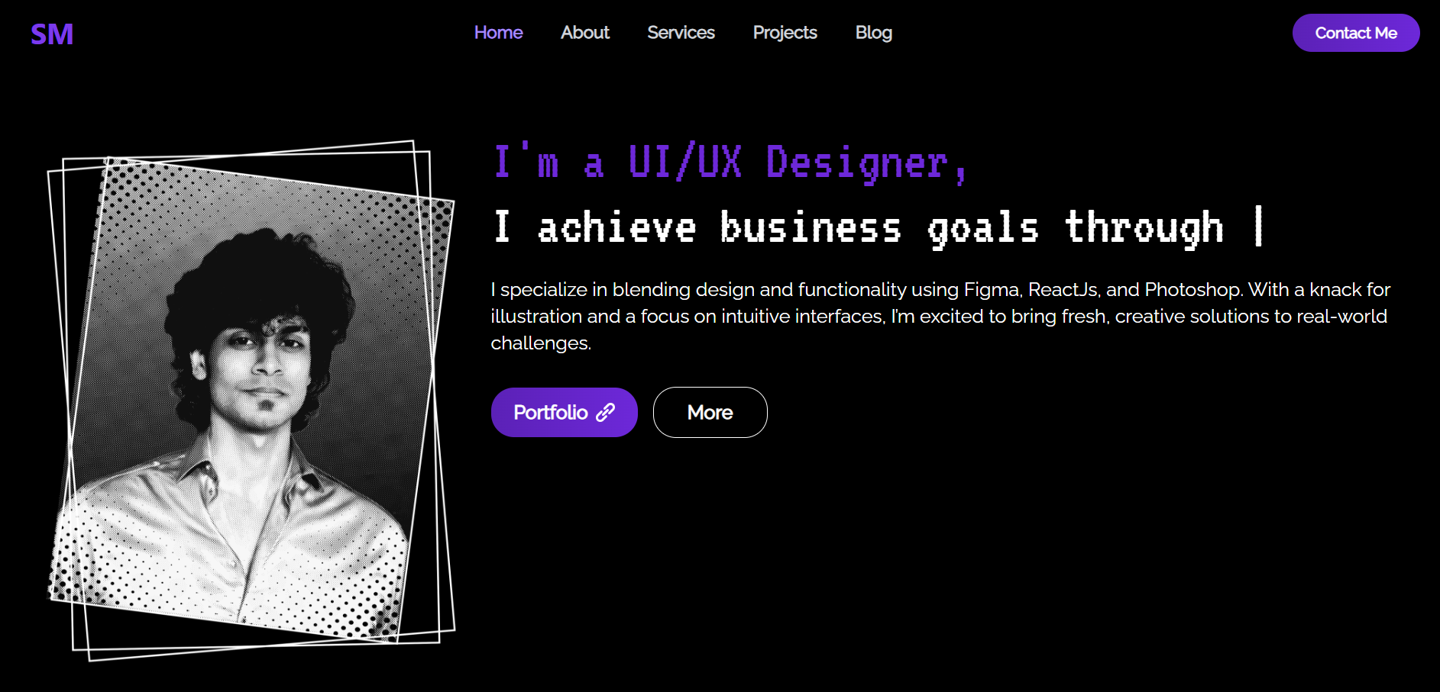

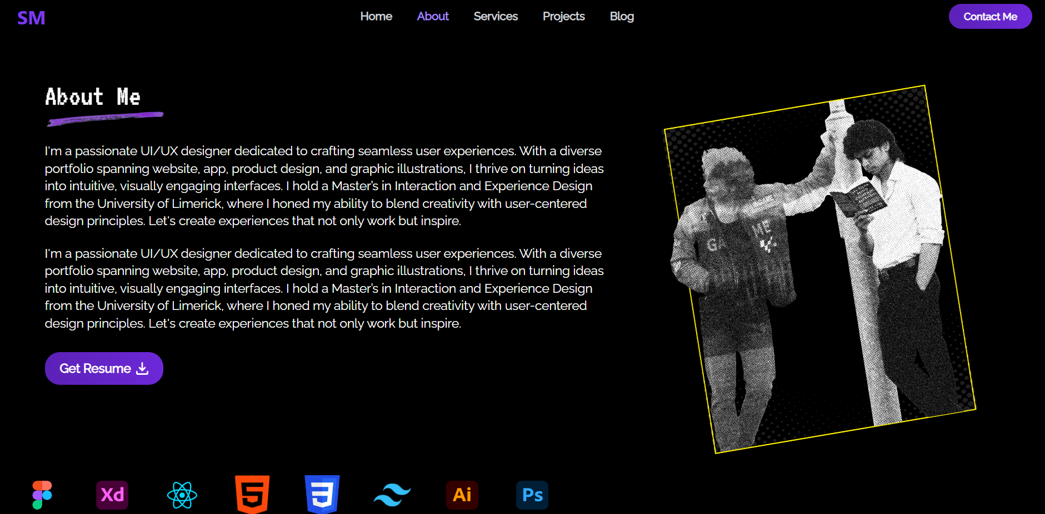

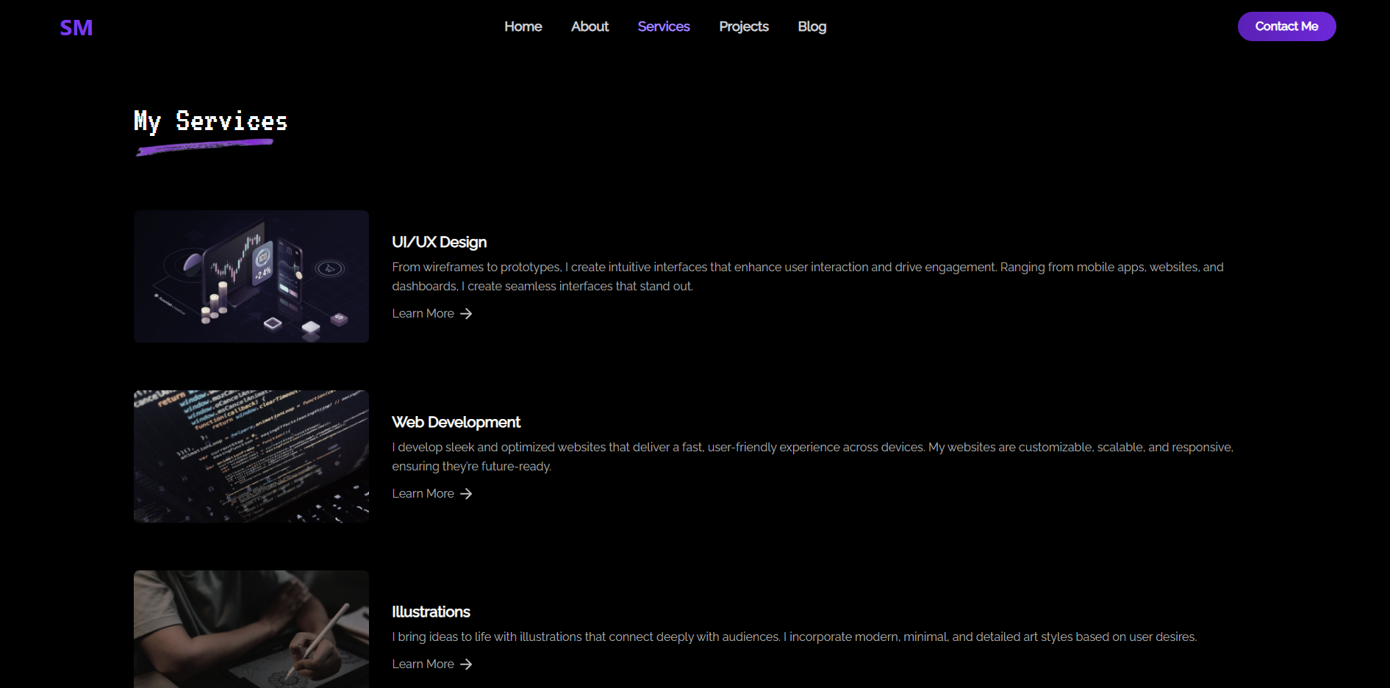

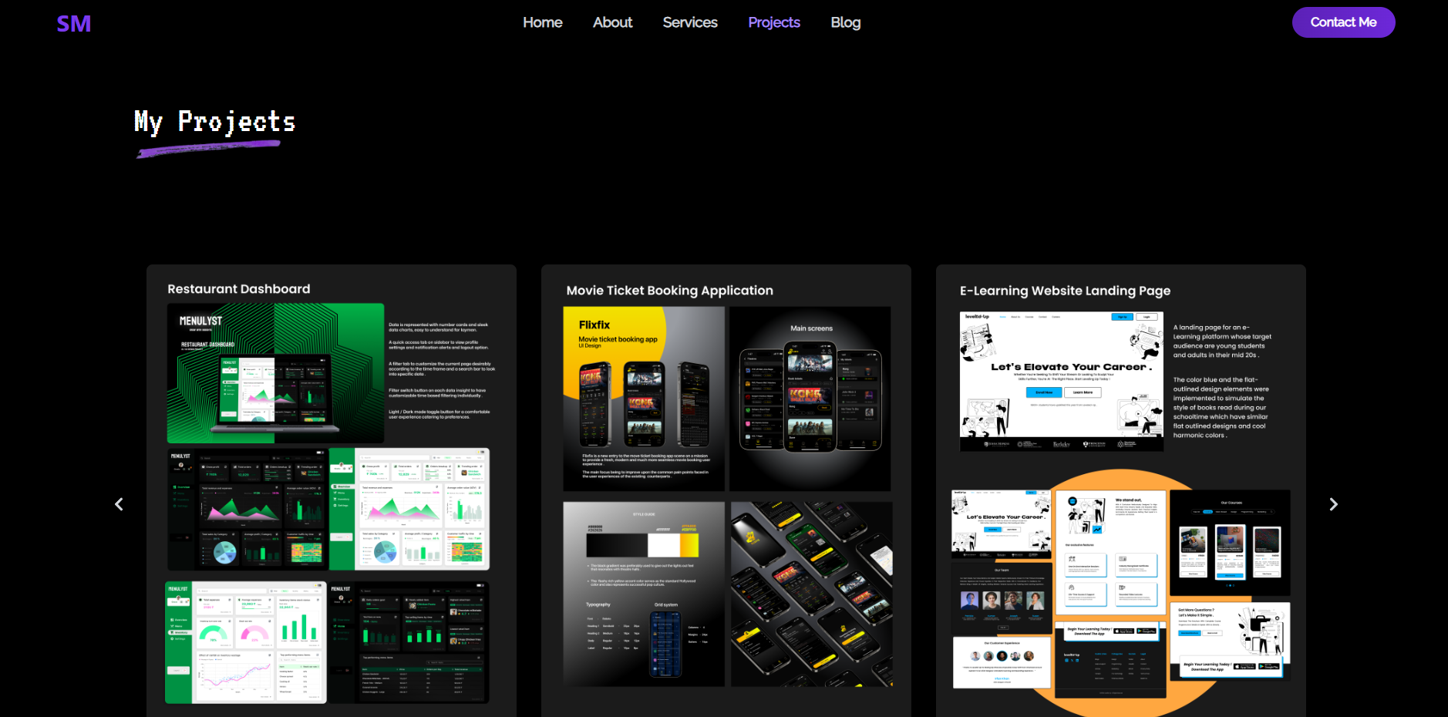

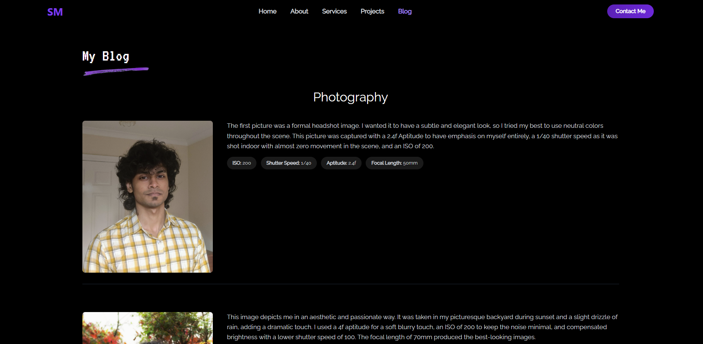

**SCOPE OF THIS PROJECT**

The scope of this website project centers on creating a professional, visually engaging, and user-friendly online portfolio that effectively showcases skills, projects, and services. As a UI/UX designer, the website’s primary goal is to represent both technical expertise and aesthetic sensibility, serving as a digital resume and portfolio for potential clients, employers, or collaborators.

This project includes several core sections: Home, About, Services, Projects, and Blog. Each section is structured to highlight specific aspects of expertise. The Home page serves as the landing point, providing an immediate sense of the designer's style and skills. The About section gives background information, including education, experience, and personal values. Services details the specific areas of expertise, such as UI/UX design, web development, and illustrations, offering visitors a clear understanding of the designer’s offerings. The Projects section showcases completed and ongoing work, including project descriptions and visuals, to demonstrate capabilities. Finally, the Blog provides space for sharing insights, articles, or updates, reflecting thought leadership in the field.

From a technical perspective, the project uses React for dynamic, component-based development, ensuring scalability and maintainability. Tailwind CSS is employed for efficient styling, contributing to the cohesive dark theme that is consistent across all sections. Accessibility and responsiveness are prioritized, ensuring that the site functions well across various devices and screen sizes, allowing for optimal user experience.

The scope also includes integrating user-friendly navigation, interactive elements, and a visually appealing dark theme with strategic color accents to highlight key actions. Additionally, the project involves backend integration for contact forms or potential CMS functionality for future blog updates, enabling easier content management.

**THE WEBSITE INTERACTION IN UML CONTROL FLOW DIAGRAM**

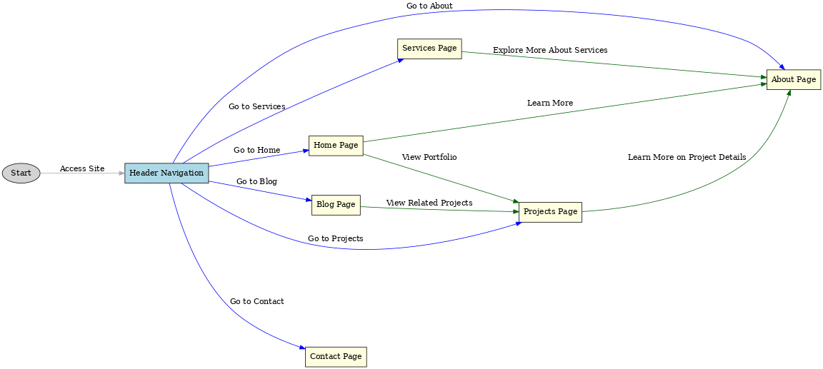

Diagram Structure:

Start Node:

Represents the entry point when a user first accesses the site.

Header Navigation:

Acts as the main navigation hub. Users can choose from several primary sections:

Home: The landing page introducing the site and the user’s portfolio.

About: Provides background information about the user.

Services: Lists the different services offered, each with a description.

Projects: Displays a portfolio of past projects, including images and details.

Blog: Contains articles or posts, possibly on topics like photography or design.

Contact: Provides a way for users to reach out directly.

Page Interactions:

Home Page: Offers quick links to view the full portfolio (Projects) or learn more about the user (About).

Services Page: Contains additional links guiding users to explore specific services further (e.g., by directing them to About for background details).

Projects Page: Includes links to learn more about individual project details.

Blog Page: Has links that can direct users to related projects, providing a cohesive connection between posts and the portfolio.

.

**THE DEVELOPMENT OF THE PROJECT**

**PROJECT PREPARATION**

This website project was developed to showcase a UI/UX designer’s portfolio, services, and blog content, providing a comprehensive view of their skills and expertise. Built with React, the project focuses on an interactive and user-friendly design, optimized for seamless navigation and a visually engaging experience.

The development process began by defining the website structure and key components based on the user’s needs. The main sections included the Home, About, Services, Projects, and Blog pages, each designed to highlight different aspects of the designer’s work. The Home page serves as an introduction, with animated text and call-to-action buttons, leading users to explore the portfolio or learn more about the designer’s background.

A React-based component structure was utilized to enhance modularity, making each section manageable and reusable. Navigation was implemented using the React Router for smooth, single-page transitions, ensuring a responsive experience on both desktop and mobile devices. The Header component serves as the primary navigation bar, with links to each main section and a contact page for direct outreach.

The Services section was created to display specific offerings, with images and brief descriptions of each service. A dynamic Projects page features a carousel of project images, allowing users to preview individual projects with hover animations for added interactivity. The Blog page includes a list of articles, focusing on photography and design, with additional technical details provided for each post to appeal to a more targeted audience.

Styling and animation were integrated to improve user experience, leveraging CSS transitions and animations for interactive elements. The project also employed React State for dynamic updates, such as loading animations and hover effects. Finally, the site was tested across devices to ensure responsiveness, accessibility, and smooth performance, creating a visually cohesive and professionally crafted portfolio site.

**FOLDER ARRANGEMENT**

The folder structure of this project is organized to promote clean code, reusability, and scalability, typical of a React application for a portfolio website. Below is a breakdown of the main folders and files:

**src Folder:**

The src folder contains all core files, including components, assets, and configurations needed for the website. This is the main directory for development, housing all React components and resources.

**Components Folder:**

The components folder contains individual React components, each corresponding to a section or feature on the website.

Major components include:

Header: This is the navigation bar component, allowing access to all main pages.

Home: Represents the landing page with introductory content and call-to-action buttons.

About: Contains personal information and background about the designer.

Services: Lists the designer's services with images and descriptions.

Projects: Displays a carousel of project images with hover effects.

Blog: Shows a list of blog posts, often with images, descriptions, and technical details.

Each component is modular, enabling easy updates or styling changes without affecting other parts of the project.

**Assets Folder:**

This folder contains images, icons, and other static resources used throughout the website, such as icons for buttons or background images. These resources are imported directly into components as needed.

**CSS/Styles Folder:**

Styling is handled via CSS, with either a styles folder or individual CSS files alongside each component. This approach keeps styles local to components and promotes easy maintenance.

App.js and Index.js:

App.js is the root component, combining all individual components and managing the routing between pages using React Router.

Index.js is the entry point that renders App.js into the DOM.

This structure ensures that each part of the website is well-organized, modular, and easy to scale for future features or modifications.

**FRONT-END CODING**

The front-end code for this portfolio website is structured to ensure readability, maintainability, and responsiveness, leveraging React and modular component design. Here’s a breakdown of how the front-end code is organized and implemented:

**Core Structure:**

The front-end code is based in the src folder, where all main development takes place. This includes the React components, styling, assets, and configuration files. By organizing the code in this central location, the project remains easy to manage and modify.

**Components:**

**Header Component:** Acts as the navigation bar, providing links to key pages like Home, About, Services, Projects, Blog, and Contact. It’s responsive, offering different layouts for mobile and desktop views.

**Home Component:** The main landing page, featuring animated text and buttons leading to sections like Portfolio and Learn More. This component is styled to create a visually appealing first impression.

**About Component:** Showcases the designer’s background and skills, with structured sections for a professional presentation of their expertise.

**Services Component:** Lists the designer’s offerings, each displayed with an image and brief description. This component is designed to visually segment services and enhance user understanding.

**Projects Component:** Contains a slider for showcasing project images with hover effects, allowing users to see details interactively. This enhances the user experience and engagement with the designer’s portfolio.

**Blog Component**: Lists blog posts related to topics like photography, with technical details for each post. This component is set up to appeal to an audience interested in design details.

**Styling and Animation:**

Each component has dedicated styling, either in separate CSS files or styled within the component itself. Animations are used for hover effects and transitions, creating an interactive experience.

CSS transitions, animations, and media queries ensure the site is responsive and visually dynamic on different screen sizes.

**Routing and State Management:**

React Router handles navigation between pages, providing a single-page application experience.

React State is used to manage dynamic content, like loading effects or navigation visibility on mobile devices.

**Assets and Images:**

Images, icons, and other assets are stored in the assets folder, imported into components as needed. This helps with organization and makes it easy to update images or icons.

**TESTING AND OPTIMIZATION**

**1. Component Functionality Testing**

I tested each component individually to ensure functionality and smooth integration:

Home Component: I tested animations, such as the introductory typewriter effect, to ensure they displayed without lag. Initial tests showed a delay in loading animations on slower devices, which I resolved by optimizing the state handling for animations, allowing them to load immediately when the page is rendered.

Projects Component: The project slider, implemented using react-slick, was tested across screen sizes and browsers. During testing, I found that on smaller devices, multiple slides were displayed due to an issue in responsive breakpoints. I resolved this by fine-tuning the breakpoint settings and adjusting slide widths.

**2. Navigation and Routing Testing**

Testing the header’s navigation links, both in desktop and mobile views, highlighted a few key issues:

Mobile Navigation Toggle: When toggling the mobile menu, I noticed an unintentional delay in closing the menu. This was traced to unnecessary re-renders of the Header component due to changes in state. Optimizing state management with React.useCallback reduced re-renders, resulting in a smoother mobile menu experience.

Active Link Styling: Initially, some active links failed to highlight correctly when users clicked rapidly. I corrected this by refining the isActiveLink function in Header.jsx to better track route changes.

**3. Load Performance Optimization**

I conducted performance testing to measure page load times and component rendering:

Image Optimization: During testing, I noted that high-resolution images in the Projects and Blog components were affecting load times. I optimized the images by resizing them to appropriate dimensions and compressing them, reducing load times significantly without compromising visual quality.

Lazy Loading: To prevent the homepage from lagging, I applied lazy loading for assets like images in the Projects and Blog components, which load only as the user scrolls. This reduced initial load time and improved overall performance.

**4. Responsive Design Testing**

I tested each component on various devices, including smartphones, tablets, and desktops:

Breakpoints in Services Component: In testing the Services page, I observed that images didn’t resize correctly on tablets. This was fixed by adjusting media queries to cover intermediate screen sizes, ensuring the images and text aligned correctly.

Hover Effects on Mobile: The hover animations in Projects were found to be incompatible with mobile interactions. I optimized the code by disabling hover effects for touchscreens, improving the usability of the project carousel on mobile devices.

**5. User Interaction Optimization**

I observed user interaction to optimize transitions, animations, and click responses:

Button Response Time: The Contact button on the navigation bar initially had a slight delay due to a re-rendering issue. I isolated this by modifying the Link component's click behavior and optimizing onClick functions. This resolved the delay, enhancing the user’s experience.

**6. Challenges and Solutions**

Problem: During testing, I noticed an inconsistent loading behavior in the Home component’s hero image. On slower connections, the image failed to load promptly, affecting the page’s visual balance.

Solution: I optimized this by setting up a placeholder loading state in the Home component, which displayed a loading animation until the image was fully loaded.

Problem: The Blog component contained a loop rendering blog post details, which occasionally slowed down on lower-performance devices.

Solution: By optimizing the blogPosts.map loop and moving static details (like ISO and shutter speed) to memoized variables, I reduced processing time, resulting in smoother scrolling and faster loading of the blog page.

**DEPLOYMENT AND MAINTENANCE.**

**Deployment Process**

**Repository Setup:**

First, I created a GitHub repository for the website’s codebase. I initialized the repository with a README.md file and set up .gitignore to exclude node modules and build files that aren’t needed on GitHub.

I then cloned the repository locally and added the project files, committing and pushing all code to GitHub.

**Setting Up GitHub Pages:**

Since this is a React project, I configured the package.json to support deployment by adding a "homepage" field, set to https://<username>.github.io/<repository-name>. This helps GitHub Pages locate the app’s root directory.

I then installed the gh-pages package by running npm install gh-pages, allowing me to deploy directly from the command line. In package.json, I added deploy scripts:

After building the project with npm run build, I ran npm run deploy, which created and published the build folder to the gh-pages branch, making the website live on GitHub Pages.

**Custom Domain and SSL:**

If a custom domain is needed, I configured this in the GitHub repository’s Pages settings by entering the domain name under Custom domain. GitHub also provides SSL certificates automatically, so the site is served securely over HTTPS.

**Continuous Maintenance:**

For easier maintenance, I set up automatic deployments via GitHub Actions. I created a workflow file in .github/workflows to automatically deploy the site every time I push changes to the main branch. This CI/CD setup ensures the site stays updated without manual redeployment.

Finally, I set up issue tracking and branch protection rules in the repository to streamline future maintenance and collaboration.

By using GitHub Pages, gh-pages, and GitHub Actions, I was able to deploy the site with a continuous deployment setup, making it simple to maintain and update the website over time.

**PORTFOLIO CODE**

**APP.JS - CORE APPLICATION COMPONENT**

The following code is the core of the application where main routing is set up. App.js imports all main page components (Header, Home, About, Services, Projects, Blog) and defines the paths for each page. The application uses React Router to handle navigation and maintains a consistent background theme throughout.

import React from 'react';

import { BrowserRouter as Router, Route, Routes } from 'react-router-dom';

import Header from './components/header';

import Home from './components/home';

import About from './components/about';

import Services from './components/services';

import Projects from './components/projects';

import Blog from './components/blog';

function App() {

return (

<Router>

<div className="bg-black min-h-screen text-white">

<Header /> {/* Navigation bar component */}

<Routes>

<Route path="/" element={<Home />} />

<Route path="/about" element={<About />} />

<Route path="/services" element={<Services />} />

<Route path="/projects" element={<Projects />} />

<Route path="/blog" element={<Blog />} />

</Routes>

</div>

</Router>

);

}

export default App;

**INDEX.CSS - GLOBAL STYLES**

The global styling file, index.css, includes Tailwind CSS imports and custom classes used throughout the application. It establishes the primary color theme, background styling, and font settings, as well as imports external libraries like slick-carousel for additional component styling.

@tailwind base;

@tailwind components;

@tailwind utilities;

.primary-color {

@apply text-transparent bg-clip-text bg-violet-700 inline-block;

}

body {

background-color: black;

}

.backdrop-blur-md {

backdrop-filter: blur(10px);

}

/* Import slick-carousel CSS for styling */

@import "~slick-carousel/slick/slick.css";

@import "~slick-carousel/slick/slick-theme.css";

@import url('https://fonts.googleapis.com/css2?family=Raleway:wght@400&display=swap');

.font-raleway {

font-family: 'Raleway', sans-serif;

}

@import url('https://fonts.googleapis.com/css2?family=VT323&display=swap');

.font-vt323 {

font-family: 'VT323', monospace;

}

**INDEX.JS - APPLICATION ENTRY POINT**

The index.js file serves as the entry point of the React application. It initializes the ReactDOM and renders the App component inside the root element. React.StrictMode is enabled to help detect potential issues during development.

import React from 'react';

import ReactDOM from 'react-dom/client';

import './index.css';

import App from './App';

const root = ReactDOM.createRoot(document.getElementById('root'));

root.render(

<React.StrictMode>

<App />

</React.StrictMode>

);

**OTHER COMPONENTS SOURCE CODE :**

This section includes the source code for each primary component of the portfolio website, arranged for modularity and efficiency.

**1. about.jsx**

This component provides an overview of the user's background, skills, and experience.

import React, { useState, useEffect } from 'react';

import aboutImg1 from '../assets/about1.png';

import aboutImg2 from '../assets/about2.png';

import figma from '../assets/figma.svg';

import xd from '../assets/xd.svg';

import jsreact from '../assets/jsreact.svg';

import ai from '../assets/ai.svg';

import ps from '../assets/ps.svg';

import htmlLogo from '../assets/html.svg';

import cssLogo from '../assets/css.svg';

import tailwindLogo from '../assets/tailwind.svg';

import underline from '../assets/underline.png';

import downloadIcon from '../assets/download.png';

const skills = [

{ name: 'Figma', logo: figma, percentage: 90 },

{ name: 'Adobe XD', logo: xd, percentage: 90 },

{ name: 'React Js', logo: jsreact, percentage: 70 },

{ name: 'HTML', logo: htmlLogo, percentage: 85 },

{ name: 'CSS', logo: cssLogo, percentage: 80 },

{ name: 'Tailwind CSS', logo: tailwindLogo, percentage: 75 },

{ name: 'Illustrator', logo: ai, percentage: 75 },

{ name: 'Photoshop', logo: ps, percentage: 80 },

];

const getProgressColor = (percentage) => {

if (percentage >= 80) return 'bg-yellow-400';

if (percentage >= 60) return 'bg-yellow-300';

return 'bg-yellow-200';

};

const About = () => {

const [isImage1, setIsImage1] = useState(true);

useEffect(() => {

const interval = setInterval(() => {

setIsImage1((prev) => !prev);

}, 3000);

return () => clearInterval(interval);

}, []);

return (

<div className="bg-black text-white py-16 px-8">

<div className="container mx-auto flex flex-col md:flex-row items-start justify-between">

<div className="flex-1 mb-8 md:mb-0 md:pr-8">

<h1 className="text-white lg:text-5xl sm:text-4xl font-monospace font-vt323 mb-0">About Me</h1>

<img src={underline} alt="underline" className="w-32 md:w-48 mb-6" />

<p className="lg:text-xl font-raleway">

I'm a passionate UI/UX designer dedicated to crafting seamless user experiences. With a diverse portfolio

spanning website, app, product design, and graphic illustrations, I thrive on turning ideas into intuitive, visually engaging interfaces.

I hold a Master’s in Interaction and Experience Design from the University of Limerick, where I honed my ability to blend creativity

with user-centered design principles. Let's create experiences that not only work but inspire.

</p>

<br />

<p className="lg:text-xl font-raleway">

I'm a passionate UI/UX designer dedicated to crafting seamless user experiences. With a diverse portfolio

spanning website, app, product design, and graphic illustrations, I thrive on turning ideas into intuitive, visually engaging interfaces.

I hold a Master’s in Interaction and Experience Design from the University of Limerick, where I honed my ability to blend creativity

with user-centered design principles. Let's create experiences that not only work but inspire.

</p>

{/* Download CV Button */}

<div className="my-8">

<a

href="/cv.pdf" // Path to the CV file in the public directory

download="cv.pdf" // Ensures the file is downloaded with the specified name

className="inline-flex items-center px-6 py-3 rounded-3xl mr-4 bg-gradient-to-r from-violet-800 to-violet-700 text-xl text-white font-raleway font-extrabold transition-transform duration-300 transform hover:scale-105 hover:from-violet-700 hover:to-violet-800"

>

Get Resume

<img

src={downloadIcon}

alt="Download Icon"

className="ml-2 w-5 h-5 object-contain"

/>

</a>

</div>

</div>

<div className="flex-shrink-0 w-full md:w-auto">

<div className="relative max-w-[600px] h-auto overflow-hidden">

<img

src={isImage1 ? aboutImg1 : aboutImg2}

alt="About Me"

className="rounded-lg shadow-lg transition-transform duration-1000 ease-in-out"

/>

</div>

</div>

</div>

{/* Skills Section */}

<div className="bg-black text-gray-500 max-w-[1800px] mx-auto py-8 flex overflow-x-auto no-scrollbar gap-8">

{skills.map((skill) => (

<div key={skill.name} className="flex flex-col items-center relative w-20 group">

<img

src={skill.logo}

alt={`${skill.name} logo`}

className="transition-transform transform hover:scale-110 w-16 h-16"

/>

<p className="mt-2 text-sm text-center">{skill.name}</p>

<div className="absolute bottom-24 hidden group-hover:block bg-black text-white p-2 rounded-md shadow-lg">

<div className="relative w-24 h-2 bg-gray-700 rounded-full">

<div

className={`absolute h-full ${getProgressColor(skill.percentage)} rounded-full transition-all duration-300`}

style={{ width: `${skill.percentage}%` }}

></div>

</div>

</div>

</div>

))}

</div>

</div>

);

};

export default About;

**2. blog.jsx**

The blog component displays a list of blog posts related to photography and design. Each post includes an image, description, and technical details like ISO and shutter speed.

import React from 'react';

import blogImage1 from '../assets/blogImage1.png';

import blogImage2 from '../assets/blogImage2.png';

import blogImage3 from '../assets/blogImage3.png';

import underline from '../assets/underline.png';

const Blog = () => {

const blogPosts = [

{

image: blogImage1,

description: "The first picture was a formal headshot image. I wanted it to have a subtle and elegant look, so I tried my best to use neutral colors throughout the scene. This picture was captured with a 2.4f Aptitude to have emphasis on myself entirely, a 1/40 shutter speed as it was shot indoor with almost zero movement in the scene, and an ISO of 200.",

details: {

iso: "200",

shutterSpeed: "1/40",

aptitude: "2.4f",

focalLength: "50mm"

}

},

{

image: blogImage2,

description: "This image depicts me in an aesthetic and passionate way. It was taken in my picturesque backyard during sunset and a slight drizzle of rain, adding a dramatic touch. I used a 4f aptitude for a soft blurry touch, an ISO of 200 to keep the noise minimal, and compensated brightness with a lower shutter speed of 100. The focal length of 70mm produced the best-looking images.",

details: {

iso: "200",

shutterSpeed: "1/100",

aptitude: "4f",

focalLength: "70mm"

}

},

{

image: blogImage3,

description: "The third image conveys a little story within its composition. I used Photoshop to superimpose two images taken at the same place with the same settings to produce a ghost image effect. The formal version of me reading a book is disturbed by the alter ego that's yearning to disrupt the controlled mind, adhering to boundaries and judgments of self.",

details: {

iso: "400",

shutterSpeed: "1/50",

aptitude: "3.5f",

focalLength: "85mm"

}

}

];

return (

<div className="bg-black text-white py-16 px-8 font-raleway">

<div className="container mx-auto">

{/* Blog page title */}

<div className="text-left mb-10">

<h1 className="text-4xl md:text-5xl font-vt323 text-white mb-2 inline-block">

My Blog

</h1>

<img src={underline} alt="underline" className="w-32 md:w-48 mb-8" />

</div>

{/* Centered Secondary Heading - Photography */}

<h2 className="text-3xl md:text-4xl font-raleway text-white text-center mb-12">

Photography

</h2>

{/* Blog posts container */}

<div className="space-y-20">

{blogPosts.map((post, index) => (

<div key={index} className="flex flex-col md:flex-row items-start gap-6 md:gap-10 border-b border-gray-800 pb-8">

{/* Blog post image */}

<div className="md:w-1/4 overflow-hidden rounded-lg shadow-lg transition-transform transform hover:scale-105 duration-300">

<img src={post.image} alt={`Blog post ${index + 1}`} className="w-full h-full object-cover rounded-lg" />

</div>

{/* Blog post description */}

<div className="md:w-3/4 text-gray-300 text-lg leading-relaxed">

<p className="mb-4">{post.description}</p>

{/* Technical details labels */}

<div className="flex flex-wrap gap-3">

<div className="bg-white bg-opacity-10 rounded-full px-4 py-2 text-sm shadow-md">

<strong>ISO:</strong> {post.details.iso}

</div>

<div className="bg-white bg-opacity-10 rounded-full px-4 py-2 text-sm shadow-md">

<strong>Shutter Speed:</strong> {post.details.shutterSpeed}

</div>

<div className="bg-white bg-opacity-10 rounded-full px-4 py-2 text-sm shadow-md">

<strong>Aptitude:</strong> {post.details.aptitude}

</div>

<div className="bg-white bg-opacity-10 rounded-full px-4 py-2 text-sm shadow-md">

<strong>Focal Length:</strong> {post.details.focalLength}

</div>

</div>

</div>

</div>

))}

</div>

</div>

</div>

);

};

export default Blog;

**3. header.jsx**

The header serves as the main navigation bar with links to all major sections: Home, About, Services, Projects, Blog, and Contact. It includes a responsive toggle for mobile navigation.

import React, { useState } from 'react';

import { Link, useLocation } from 'react-router-dom';

import { AiOutlineClose, AiOutlineMenu } from 'react-icons/ai';

const Header = () => {

const [nav, setNav] = useState(false);

const location = useLocation();

const handleNav = () => {

setNav(!nav);

};

const handleLinkClick = () => {

setNav(false);

};

const isActiveLink = (path) => location.pathname === path ? 'text-violet-400' : 'text-gray-300';

return (

<header className='bg-gradient-to-r from-black via-gray-1000 to-black text-gray-100 shadow-md h-[78px] max-w-[1800px] mx-auto flex justify-between items-center px-8 z-10'>

<h1 className='text-3xl font-bold text-violet-600'>SM</h1>

{/* Desktop Navigation */}

<nav className='hidden md:flex flex-grow justify-center space-x-6'>

{['/', '/about', '/services', '/projects', '/blog'].map((path, index) => (

<Link

key={index}

to={path}

onClick={handleLinkClick}

className={`p-2 text-lg font-raleway font-semibold rounded-md ${isActiveLink(path)} hover:text-violet-600 hover:bg-slate-950 hover:scale-105 transition-all duration-300`}

>

{path === '/' ? 'Home' : path.slice(1).charAt(0).toUpperCase() + path.slice(2)}

</Link>

))}

</nav>

{/* Contact Button */}

<Link

to="/contact"

onClick={handleLinkClick}

className="hidden md:block px-6 py-2 bg-gradient-to-r from-violet-800 to-violet-700 text-white font-raleway font-bold rounded-3xl shadow-lg hover:from-violet-700 hover:to-violet-800 transition-transform transform hover:scale-105 duration-300"

>

Contact Me

</Link>

{/* Mobile Navigation Toggle */}

<div onClick={handleNav} className='block md:hidden text-violet-600 cursor-pointer'>

{nav ? <AiOutlineClose size={24} className="transition-transform transform rotate-90 duration-300" /> : <AiOutlineMenu size={24} />}

</div>

{/* Mobile Navigation Menu */}

<div className={`${nav ? 'left-0' : 'left-[-100%]'} fixed top-0 h-full w-[60%] bg-gray-900 text-gray-100 backdrop-blur-lg p-8 z-20 shadow-lg transition-all duration-500 ease-in-out`}>

<h1 className='text-3xl font-bold text-violet-600 mb-10'>SM</h1>

<ul className='space-y-6 text-lg font-medium'>

{['/', '/about', '/services', '/projects', '/blog', '/contact'].map((path, index) => (

<li key={index} className={`${isActiveLink(path)} transition-colors duration-300`}>

<Link

to={path}

onClick={handleLinkClick}

className={`p-3 block hover:bg-gray-800 hover:text-violet-400 rounded-md transition-transform transform hover:scale-105`}

>

{path === '/' ? 'Home' : path.slice(1).charAt(0).toUpperCase() + path.slice(2)}

</Link>

</li>

))}

</ul>

</div>

</header>

);

};

export default Header;

**4. home.jsx**

This is the landing page component, featuring animated text to introduce the user’s role and a call-to-action button that links to the portfolio.

import React, { useEffect, useState } from 'react';

import heroImage from '../assets/heroimage.png';

import portfolioIcon from '../assets/portfolioicon.png';

import { TypeAnimation } from 'react-type-animation';

const Home = () => {

const [isLoaded, setIsLoaded] = useState(false);

useEffect(() => {

setIsLoaded(true);

}, []);

return (

<div>

{/* Home Section */}

<div className="bg-black text-white py-16 px-8">

<div className="container mx-auto flex flex-col md:flex-row items-start justify-between">

<div

className={`flex-shrink-0 w-full md:w-auto my-auto mx-auto md:mr-8 transform transition-transform duration-700 ${

isLoaded ? 'translate-x-0' : '-translate-x-full'

}`}

>

<img src={heroImage} alt="hero" className="w-[400px] h-auto lg:w-[450px]" />

</div>

<div

className={`flex-1 transform transition-transform duration-700 ${

isLoaded ? 'translate-x-0' : 'translate-x-full'

}`}

>

<h1 className="text-4xl sm:text-5xl lg:text-6xl font-monospace font-vt323 mb-6">

<span className="primary-color pb-2 block">I'm a UI/UX Designer,</span>

<br />

<TypeAnimation

sequence={[

'I craft seamless user experiences,',

1000,

'I achieve business goals through design,',

1000,

'I make interactions that stand-out.',

]}

wrapper="span"

speed={40}

repeat={Infinity}

/>

</h1>

<p className="sm:text-lg my-6 lg:text-xl font-raleway">

I specialize in blending design and functionality using Figma, ReactJs, and Photoshop. With a knack for illustration and a focus on intuitive interfaces, I’m excited to bring fresh, creative solutions to real-world challenges.

</p>

<div className="my-8">

<a

href="/"

className="inline-flex items-center px-6 py-3 rounded-3xl mr-4 bg-gradient-to-r from-violet-800 to-violet-700 text-xl text-white font-raleway font-extrabold transition-transform duration-300 transform hover:scale-105 hover:from-violet-700 hover:to-violet-800"

>

Portfolio

<img

src={portfolioIcon}

alt="Portfolio Icon"

className="ml-2 w-5 h-5 object-contain"

/>

</a>

<a

href="/"

className="inline-flex justify-center items-center px-6 py-3 w-[120px] rounded-3xl border border-white font-raleway font-extrabold text-xl text-white text-center hover:bg-transparent hover:text-violet-700 hover:border-violet-700 transition-transform transform hover:scale-105" >

More

</a>

</div>

</div>

</div>

</div>

</div>

);

};

export default Home;

**5. projects.jsx**

Displays a carousel of project images, allowing users to browse through the user's portfolio with interactive hover effects.

import React from 'react';

import Slider from 'react-slick';

import { FaChevronLeft, FaChevronRight } from 'react-icons/fa'; // Smaller arrow icons resembling "<" and ">"

import underline from '../assets/underline.png';

import projectImg1 from '../assets/project1.png';

import projectImg2 from '../assets/project2.png';

import projectImg3 from '../assets/project3.png';

import projectImg4 from '../assets/project4.png';

import projectImg5 from '../assets/project5.png';

import projectImg6 from '../assets/project6.png';

const Projects = () => {

const settings = {

dots: true,

infinite: true,

speed: 800,

slidesToShow: 3,

slidesToScroll: 1,

autoplay: true,

autoplaySpeed: 3000,

arrows: true,

prevArrow: <SamplePrevArrow />,

nextArrow: <SampleNextArrow />,

responsive: [

{

breakpoint: 1024,

settings: {

slidesToShow: 2,

},

},

{

breakpoint: 640,

settings: {

slidesToShow: 1,

},

},

],

};

return (

<div className="bg-black text-white py-16 px-8">

<div className="container mx-auto">

<div className="text-left mb-12 ">

<h2 className="text-white lg:text-5xl sm:text-4xl font-monospace font-vt323 mb-0">

My Projects

<img src={underline} alt="underline" className="w-32 md:w-48 mb-6" />

<br/>

</h2>

</div>

<Slider {...settings} className="carousel">

{/* Project 1 */}

<div className="p-4">

<div className="relative group">

<img

src={projectImg1}

alt="Project 1"

className="w-full object-cover rounded-lg transition-transform duration-500 transform group-hover:scale-105"

/>

<div className="absolute inset-0 bg-black bg-opacity-60 opacity-0 group-hover:opacity-100 flex items-center justify-center transition-opacity duration-500">

<p className="text-lg text-white font-semibold">View</p>

</div>

</div>

</div>

{/* Project 2 */}

<div className="p-4">

<div className="relative group">

<img

src={projectImg2}

alt="Project 2"

className="w-full object-cover rounded-lg transition-transform duration-500 transform group-hover:scale-105"

/>

<div className="absolute inset-0 bg-black bg-opacity-60 opacity-0 group-hover:opacity-100 flex items-center justify-center transition-opacity duration-500">

<p className="text-lg text-white font-semibold">View</p>

</div>

</div>

</div>

{/* Project 3 */}

<div className="p-4">

<div className="relative group">

<img

src={projectImg3}

alt="Project 3"

className="w-full object-cover rounded-lg transition-transform duration-500 transform group-hover:scale-105"

/>

<div className="absolute inset-0 bg-black bg-opacity-60 opacity-0 group-hover:opacity-100 flex items-center justify-center transition-opacity duration-500">

<p className="text-lg text-white font-semibold">View</p>

</div>

</div>

</div>

{/* Project 4 */}

<div className="p-4">

<div className="relative group">

<img

src={projectImg4}

alt="Project 4"

className="w-full object-cover rounded-lg transition-transform duration-500 transform group-hover:scale-105"

/>

<div className="absolute inset-0 bg-black bg-opacity-60 opacity-0 group-hover:opacity-100 flex items-center justify-center transition-opacity duration-500">

<p className="text-lg text-white font-semibold">View</p>

</div>

</div>

</div>

{/* Project 5 */}

<div className="p-4">

<div className="relative group">

<img

src={projectImg5}

alt="Project 5"

className="w-full object-cover rounded-lg transition-transform duration-500 transform group-hover:scale-105"

/>

<div className="absolute inset-0 bg-black bg-opacity-60 opacity-0 group-hover:opacity-100 flex items-center justify-center transition-opacity duration-500">

<p className="text-lg text-white font-semibold">View</p>

</div>

</div>

</div>

{/* Project 6 */}

<div className="p-4">

<div className="relative group">

<img

src={projectImg6}

alt="Project 6"

className="w-full object-cover rounded-lg transition-transform duration-500 transform group-hover:scale-105"

/>

<div className="absolute inset-0 bg-black bg-opacity-60 opacity-0 group-hover:opacity-100 flex items-center justify-center transition-opacity duration-500">

<p className="text-lg text-white font-semibold">View</p>

</div>

</div>

</div>

</Slider>

</div>

</div>

);

};

// Custom Arrow Components

const SamplePrevArrow = (props) => {

const { onClick } = props;

return (

<div

className="absolute left-[-30px] top-1/2 transform -translate-y-1/2 z-10 cursor-pointer text-gray-300 hover:text-white transition"

onClick={onClick}

>

<FaChevronLeft size={20} />

</div>

);

};

const SampleNextArrow = (props) => {

const { onClick } = props;

return (

<div

className="absolute right-[-30px] top-1/2 transform -translate-y-1/2 z-10 cursor-pointer text-gray-300 hover:text-white transition"

onClick={onClick}

>

<FaChevronRight size={20} />

</div>

);

};

export default Projects;

**6. services.jsx**

Lists the services offered, each with an image and brief description, allowing users to explore various aspects of the user's expertise.

import React from 'react';

import uiux from '../assets/uiux.png';

import webDev from '../assets/webdev.png';

import illustration from '../assets/illustration.png';

import graphicDesign from '../assets/graphicdesign.png';

import branding from '../assets/branding.png';

import rightArrow from '../assets/rightarrow.svg';

import underline from '../assets/underline.png';

const Services = () => {

return (

<div className="bg-black text-white py-16 px-4 sm:px-8 font-raleway">

<div className="container mx-auto flex flex-col items-start">

<div className="text-left mb-12">

<h2 className="text-white text-3xl sm:text-4xl lg:text-5xl font-vt323 font-raleway mb-0">

My Services

</h2>

<img src={underline} alt="underline" className="w-32 md:w-48 mb-6" />

</div>

<div className="space-y-16">

{[

{ title: "UI/UX Design", img: uiux, desc: "From wireframes to prototypes, I create intuitive interfaces that enhance user interaction and drive engagement. Ranging from mobile apps, websites, and dashboards, I create seamless interfaces that stand out." },

{ title: "Web Development", img: webDev, desc: "I develop sleek and optimized websites that deliver a fast, user-friendly experience across devices. My websites are customizable, scalable, and responsive, ensuring they’re future-ready." },

{ title: "Illustrations", img: illustration, desc: "I bring ideas to life with illustrations that connect deeply with audiences. I incorporate modern, minimal, and detailed art styles based on user desires." },

{ title: "Graphic Design", img: graphicDesign, desc: "From posters to digital media, I design graphics that capture attention and communicate effectively, whether for promotions or heartwarming events." },

{ title: "Branding", img: branding, desc: "I help your brand stand out with unique and cohesive designs that capture your essence, from colors that resonate with your ideas to logos that make an impact." },

].map((service, index) => (

<div key={index} className="flex flex-col md:flex-row items-center md:space-x-8">

<div className="w-full md:w-1/4 mb-4 md:mb-0 max-w-xs transition-transform transform hover:scale-105">

<img src={service.img} alt={service.title} className="w-full h-auto object-cover rounded-lg shadow-lg" />

</div>

<div className="md:w-3/4 text-center md:text-left">

<h3 className="text-xl font-semibold text-white">{service.title}</h3>

<p className="mt-2 text-[#A9A9A9] leading-relaxed">

{service.desc}

</p>

<a href="#more" className="text-[#A9A9A9] flex items-center mt-3 justify-center md:justify-start transition-transform transform hover:scale-105">

Learn More <img src={rightArrow} alt="Right Arrow" className="w-4 h-4 ml-2" />

</a>

</div>

</div>

))}

</div>

</div>

</div>

);

};

export default Services;

**EVALUATION AND IMPROVEMENT**

The development of this portfolio website achieved the primary goals of presenting a clear, visually appealing showcase of skills and projects while ensuring ease of navigation and responsiveness. Throughout the process, a range of challenges were identified and resolved to enhance the website’s performance and user experience. However, ongoing evaluation has also revealed several areas where the site can be further optimized and enhanced in future updates.

**Current Strengths and Functionality**

The website successfully integrates modular React components that provide clear separation of functionality, making updates and maintenance efficient. The design prioritizes user engagement with elements like animated text in the Home section and hover effects on project images, creating an interactive and dynamic experience. The navigation is straightforward and adaptable for both desktop and mobile views, ensuring accessibility across devices. Furthermore, lazy loading and optimized image handling contribute to improved loading times, enhancing user satisfaction.

**Identified Areas for Improvement**

Despite these strengths, several areas have been noted where enhancements could further improve the website.

**Load Performance:** While lazy loading has been implemented, further improvements can be made by introducing code splitting and optimizing external dependencies. This will reduce the initial load time even further.

**Enhanced Accessibility:** Currently, the website is optimized for accessibility, but improvements like ARIA (Accessible Rich Internet Applications) labels for screen readers, clearer color contrasts, and keyboard navigation enhancements would make the site more inclusive.

**Better SEO Optimization:** While functional, the site’s SEO could be improved by adding structured data (schema markup) to improve search engine visibility and incorporating more descriptive metadata on each page.

**Future Enhancements**

**CMS Integration:** To simplify the process of updating blog posts, projects, and services, I plan to integrate a headless CMS, such as Contentful or Strapi. This will allow for seamless content management without requiring code changes for each update.

**Advanced Animations:** I aim to enhance the website’s visual appeal with advanced animations using libraries like Framer Motion. This can add smooth transitions between pages and animated scroll effects, creating a richer user experience.

**User Authentication:** If the website evolves to include interactive elements like a commenting system for blog posts or a personalized portfolio viewer, adding user authentication will enhance engagement while maintaining security.

**Dark/Light Mode Toggle Option:** Adding a dark mode toggle would cater to user preferences, especially for visitors browsing in low-light conditions.

**Analytics Integration:** Incorporating Google Analytics or similar tracking would provide insights into user behavior, helping guide future improvements based on actual usage patterns.