**Development of an application on the Android and iOS platform along with image processing to inform users of the availability of parking spots**

Electrical, Computer, Software, and Systems Engineering

Embry-Riddle Aeronautical University

600 S. Clyde Morris Blvd., Daytona Beach, FL 32114

Advisors: Dr. Ilteris Demirkiran and Dr. Jianhua Liu

**Abstract:** The primary purpose of this project is to reduce the time spent by an individual who is looking to park their vehicle at the Embry Riddle Aeronautical University, on the Daytona Beach campus. Additionally this project will reducing fuel consumption, make campus roads safer, and provide the ability to monitor all parking lots on campus increasing overall campus safety.

Many schools in the United States deal with complications with parking on campus. For a university to accommodate all of the vehicles for faculty and students, takes countless hours of planning and management. ERAU has solved some of these problems by assigning specific parking lots to specific groups of individuals such as on-campus students, commuter students, and faculty. This research proposes a secondary solution to a growing problem. The solution will utilize cameras and advanced image processing algorithms to inform users of an available parking slot in the most efficient way while maintaining pedestrian and driver safety.

There are approximately 5,000 students presently enrolled at ERAU Daytona Beach campus, of which roughly 1500 own vehicles. The campus also has approximately 1000 staff members currently employed. To accommodate parking, the school currently has 37 parking lots of varying capacity and unique restrictions. Thus finding a vacant spot to park a vehicle that is close to an individual’s desired destination is quite cumbersome, especially during peak travel hours. On average a student or faculty member spends approximately 15 minutes looking for a parking spot during the peak hours between 8:30 to 11:00 am.

1. **Objectives :**

* To reduce the wait time for an individual looking to park at the Embry Riddle Aeronautical University, Daytona Beach campus.
* To decrease fuel consumption by reducing the amount of driving done before finding an empty parking spot.
* To help make the campus safer by reducing the vehicular throughput and actively track all vehicles in the campus.
* To set up a framework to establish a traffic management system in the Embry Riddle Aeronautical University Daytona beach campus

1. **Methodology**

The first phase of the project is to be implemented for the Citation East Extension parking lot. The presence of closed-circuit cameras makes that location an optimal place to test and implement this project.

* 1. *Install and setup an internet camera at the Citation East Extension parking lot*
     1. The number of parking spots and their position will be considered before the installation of the camera such that the camera is in full view of all parking spaces in the lot.
     2. The lighting conditions will be recorded over a specified time period and measurements will be conducted to implement the best possible algorithm that dynamically adapts to the incident light captured by the camera.
     3. Effect of weather such as rain, fog, and wind will be evaluated to maintain adequate visibility of the parking lot at all times.
  2. *Image Processing Algorithm Development*
     1. Images captured from the camera will be transferred to a computer using a 2.4 GHz wireless link device with a range of 200 feet.
     2. A digital video recorder (DVR) will store images taken throughout the day to be used as references and for monitoring the vehicles.
     3. The algorithm will be developed to filter the background noise in the images using a median filter.
     4. Reference images will be converted to gray scale based on threshold algorithms.
     5. A Gaussian filter will be applied on various pixels in the image to determine the availability of open parking slots.
  3. *Application Development*
     1. All current Android and iOS applications relevant to this project will be evaluated to further understand current trends, practices and features.
     2. Memory requirements will be evaluated. Background and foreground processes required for the proper functioning of the application will be developed.
     3. A graphical user interface will be designed and developed using the iOS Development Tool and Android Studio. The interface will be designed in accordance to specific user perspective. Features such as a superimposed grid, display of available parking spots and display of occupied parking spots will be implemented.
     4. Software and hardware integration will be performed in order to utilize the currently installed camera system. Integration of wireless data link between the camera and the real-time software algorithm to update the graphical user interface will be developed.
     5. The security of the application will be evaluated in accordance with Web Application Security Consortium evaluation criteria version 1.0.
     6. Maximum utility will be incorporated into the application with added streams including GPS way point navigation, live news feed pulled directly from Embry Riddle Aeronautical University website and user selected community pages.
     7. The Android and iOS application development will be evaluated internally after which they would be sent for certification by Google and Apple respectively.
  4. *Testing*
     1. The initial testing will be performed internally in order to verify that the application and image processing algorithm are performing to defined parameters.
     2. The beta version of the application will be deployed to a select group of testers in order to have a controlled pool of data to be analyzed.

1. **Flow Diagram**

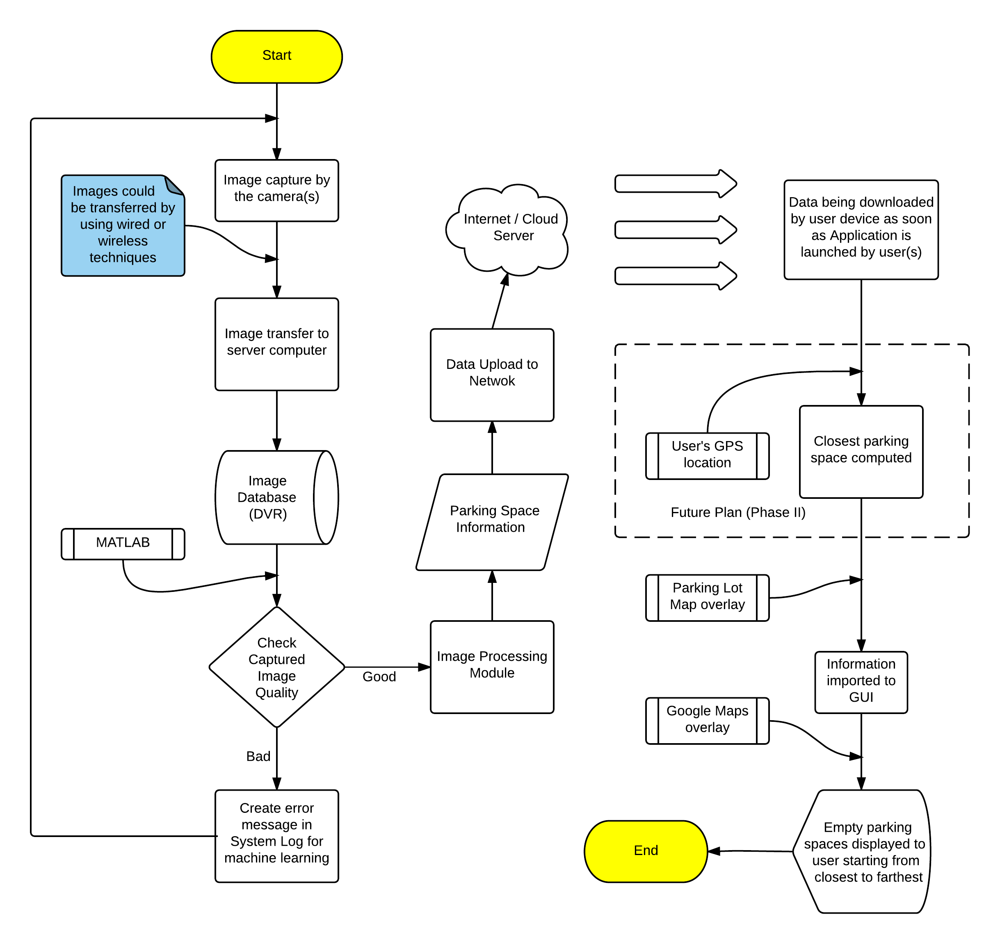

1. **Future Plan**

We plan to integrate the application with a traffic management system which would be designed keeping in mind major issues faced by commuters in the campus. This traffic management system will be able to efficiently manage the traffic on the campus by tracking all vehicles entering the campus and efficiently assigning them a parking spot based on their final destination on the campus. This would help in increasing campus safety as all vehicles on the campus at a given point of time are identified and tracked. Additionally more features will be added to the application based on user surveys to incorporate other campus events and information.

On a larger scale we are looking to introduce this project to other universities, hospitals, shopping malls, large parking lots where keeping track of vehicles and optimality can be implemented to add convenience to a user’s experience while looking for a parking spot at the above mentioned locations. These projects can be easily undertaken and completed in a short span of time if a map of the required area is obtained. The software can be customized based on the requirements of the parking space.

* + 1. The application will be enhanced and evaluated based on the feedback received.

1. **Timeline**

|  |  |  |
| --- | --- | --- |
| **Task Number** | **Task Description** | **Time Period** |
| 1 | Evaluation of parking lot for optimal positioning and installation of camera | July 01,2016 to July 20,2016 |
| 2 | Development of image processing algorithm | July 21,2016 to October 01,2016 |
| 3 | Design and development of end user application on Android and iOS platforms | 02 October, 2016 to 01 April, 2017 |
| 4 | Testing Phase 1 (Internal) | 02 April, 2017 to 01 May, 2017 |
| 5 | Testing Phase 2 ( Fixed user group) | 02 May, 2017 to 01 June,2017 |
| 6 | Deployment of application to general public and support | 02 June, 2017 to 01 July, 2017 |

1. **Budget**

|  |  |  |  |  |
| --- | --- | --- | --- | --- |
| **Sl No** | **Expense Description** | **Quantity** | **Individual cost** | **Total Cost** |
| 1 | High Resolution CCTV camera (Arecont Vision AV12186DN) | 5 | $1299.99 | $6499.95 |
| 2 | iOS and Android software development kit | 1 | $99 | $99 |
| 3 | Digital Video Recorder (Magnavo HD DVR) | 1 | $399.99 | $399.99 |
| 4 | Miscellaneous costs (Wires, Cabling, Overheads) | - | $1500 | $1500 |
| Total | | | | $8498.94 |

1. References
2. “Embry Riddle News Room” – [Online] - <http://news.erau.edu/>
3. “Embry Riddle Parking Map” - [Online] – https://daytonabeach.erau.edu
4. Q. Li, U. Niaz and B. Merialdo. An Improved Algorithm on Viola Jones Object Detector. In Proceeding of CBMI’2012.
5. Ying Wang; Xiangyang Wang; Wang Gen Wan "Object Tracking with Sparse Representation and Annealed Particle Filter", In IEEE proceeding of ICIG 2013.
6. Lun Wuˈ Yongtian Wangˈ Vue Liu. Multiple targets tracking with Robust PCA-based background subtraction and Mean-shift driven Particle filter. International Conference on Computer ˈ Mechatronics, Control and Electronic Engineering (CMCE)ˈ2010:244-247.
7. X. Mei and H. Ling. Robust visual tracking using L1 minimization. In Proceedings of the IEEE International Conference on Computer Vision, pages 1436–1443, 2009.
8. “ Android Application Development” – [Online]<http://developer.android.com/>
9. “ Apple Application Development” - https://developer.apple.com/
10. “Application Security evaluation Criterion” – [Online][http://www.webappsec.org](http://www.webappsec.org/)