Computer networks

**Lab activity – 4**

**Name :** N.V.M.Sumanth

**Reg no :** 192111449

**Faculty :** Dr. S. Ramesh

**Course code :** CSA0786 computer networks for wanet applications

**Lab activity : 4**

**Question : Data Link Layer Traffic Simulation using Packet Tracer Analysis of ARP.**

**Step 1 : Take a ISR4331 router**

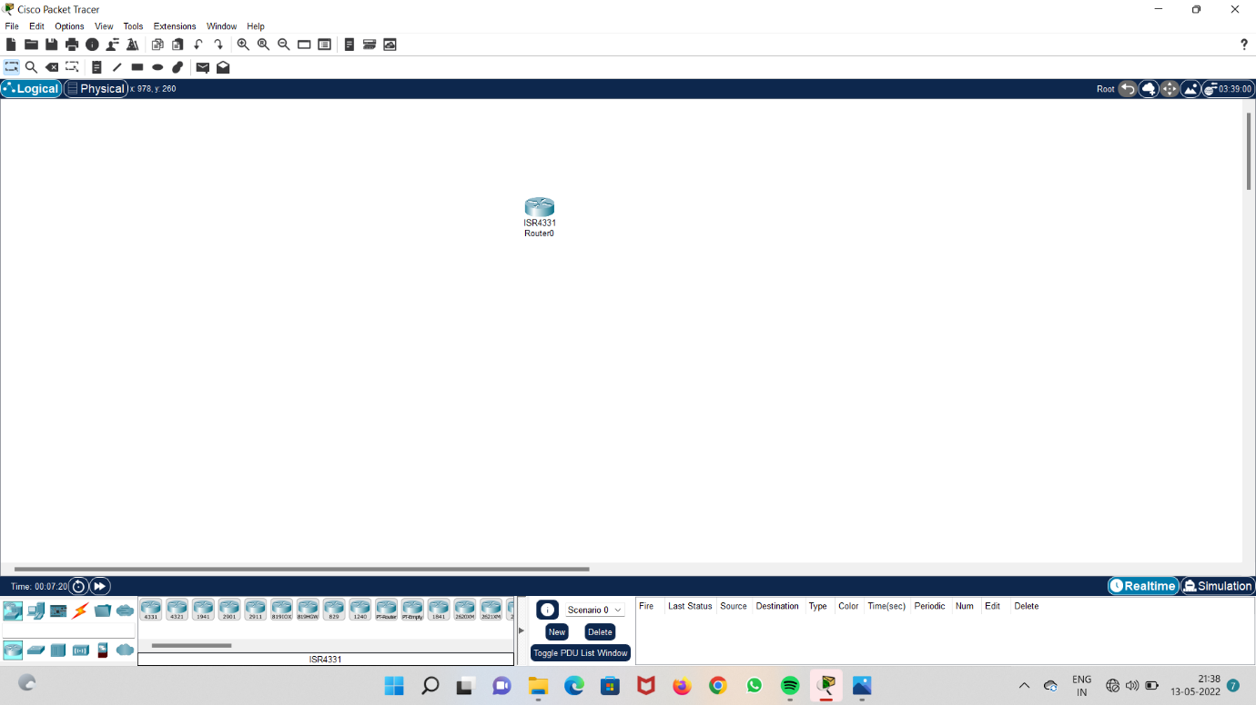

**Step 2 : Take two PT switches.**

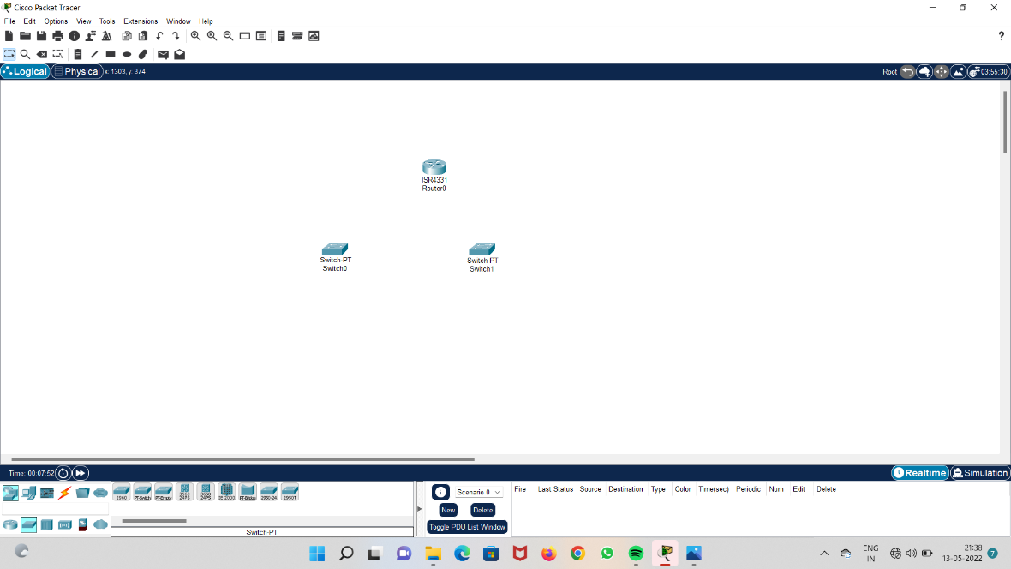

**Step 3 : Take three computers and connect computers to PT switches and switches to router.**

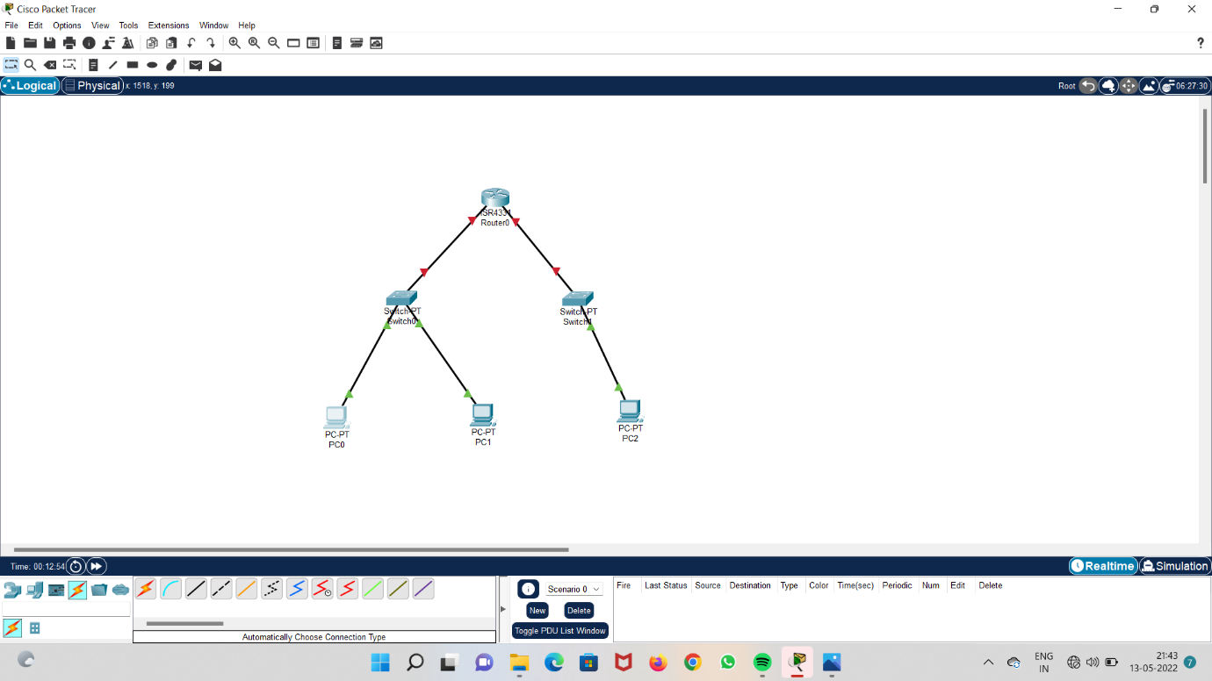

**Step 4 : take a cable and connect pc 2 to the router.**

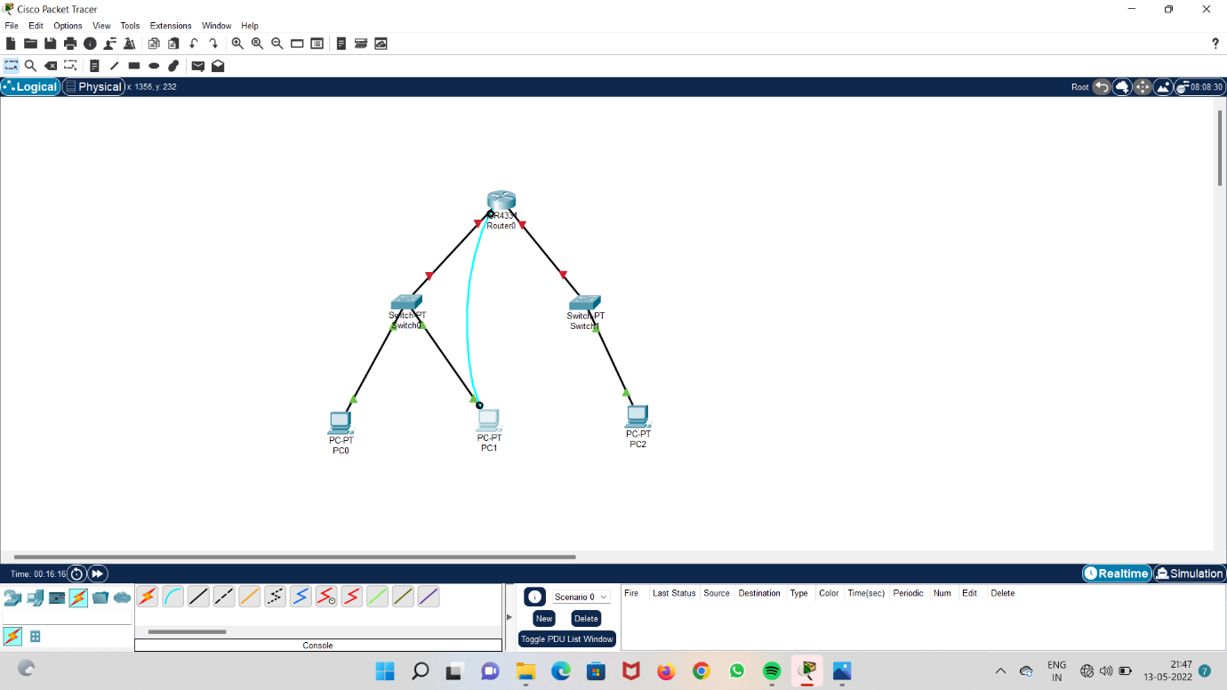

**Step 5 : add IP addresses to the systems.**

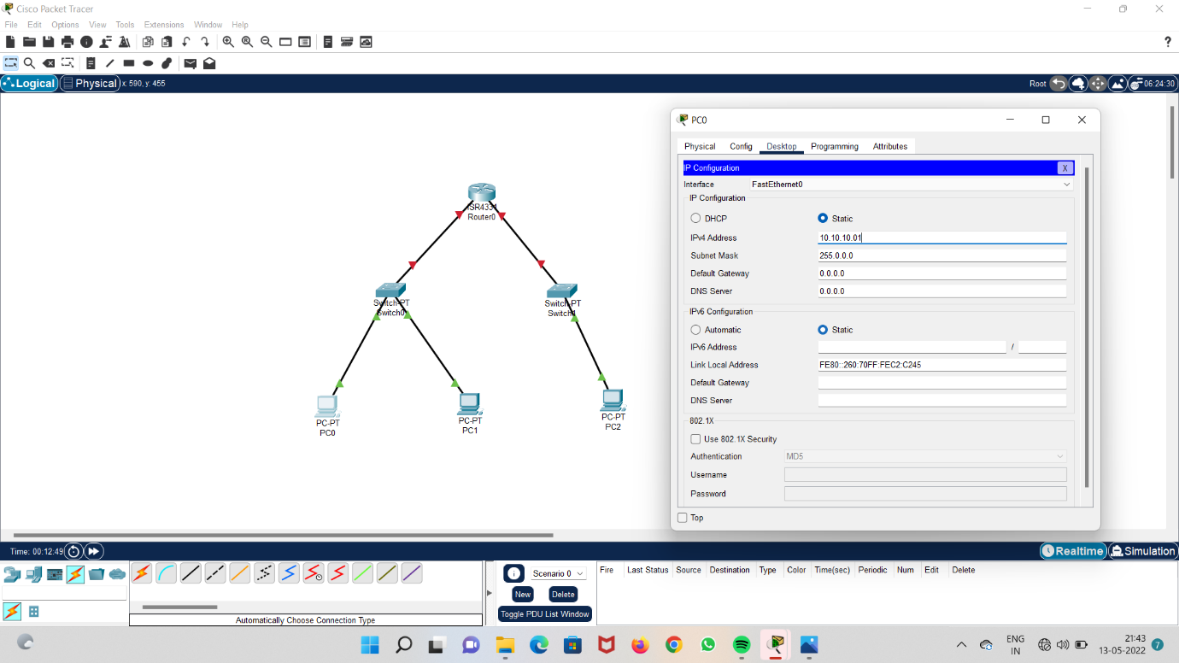

**Step 6 : check the terminal configuration.**

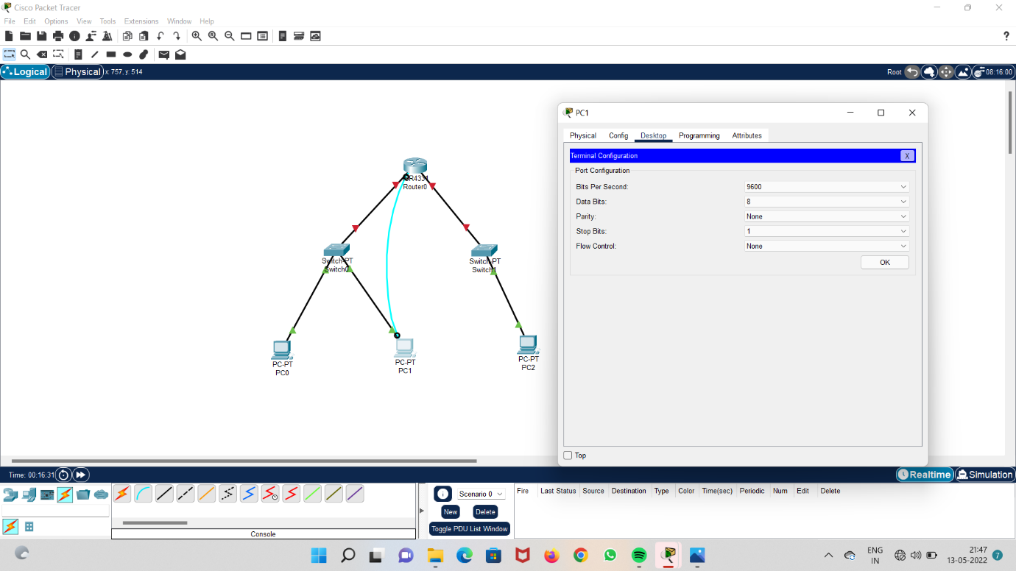

**Step 7 : Go to options on the menu bar and select system interface display option.**

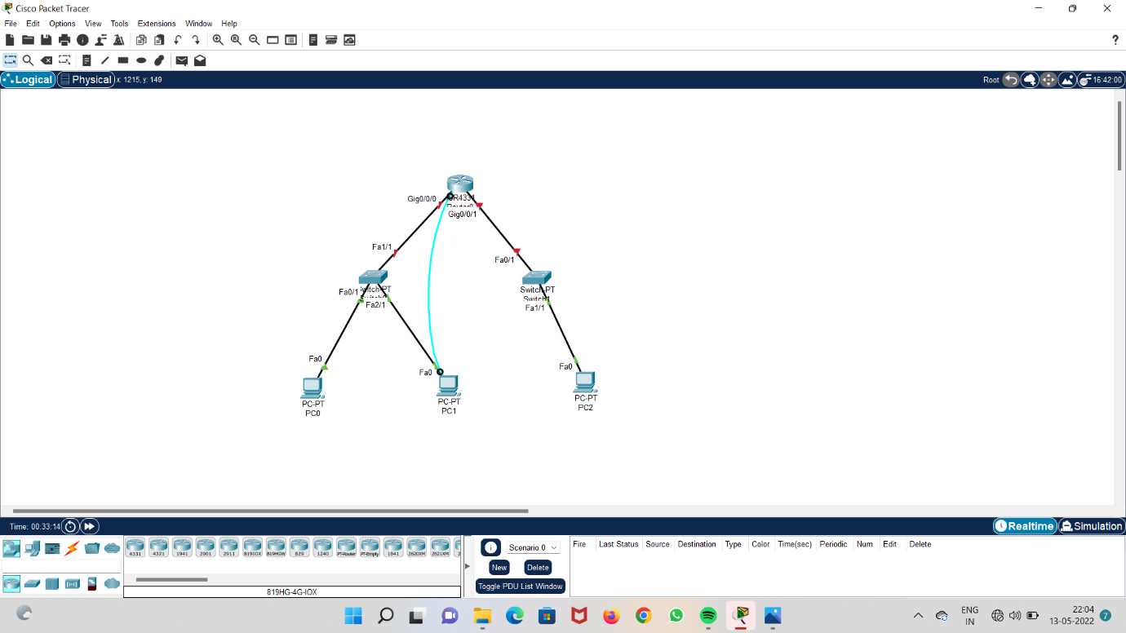

**Step 8 : open terminal in the desktop option and type no option.**

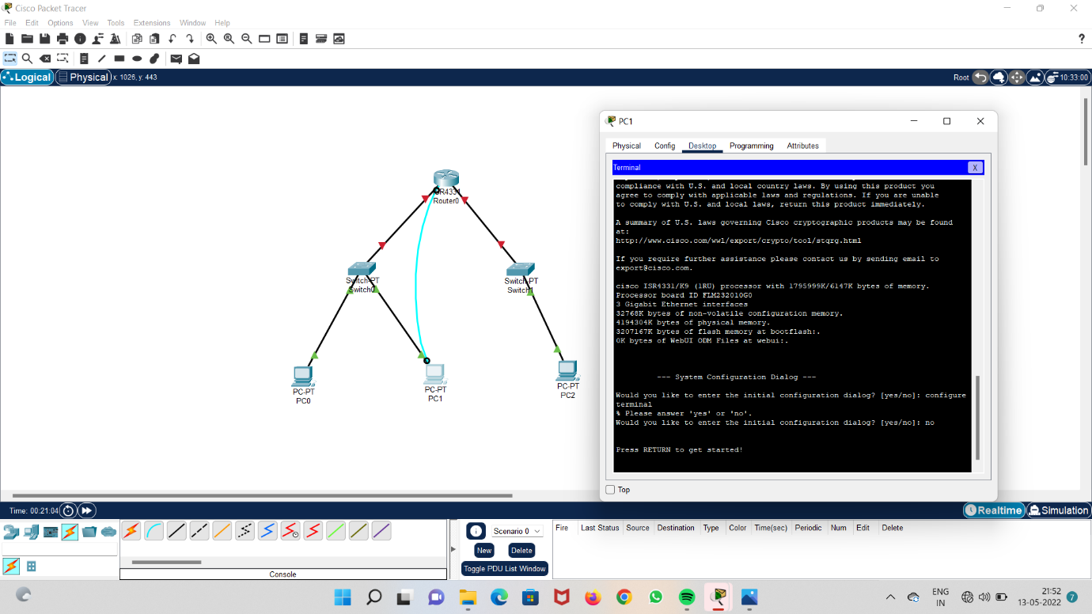

**Step 9 : Give default gateway address to the systems.**

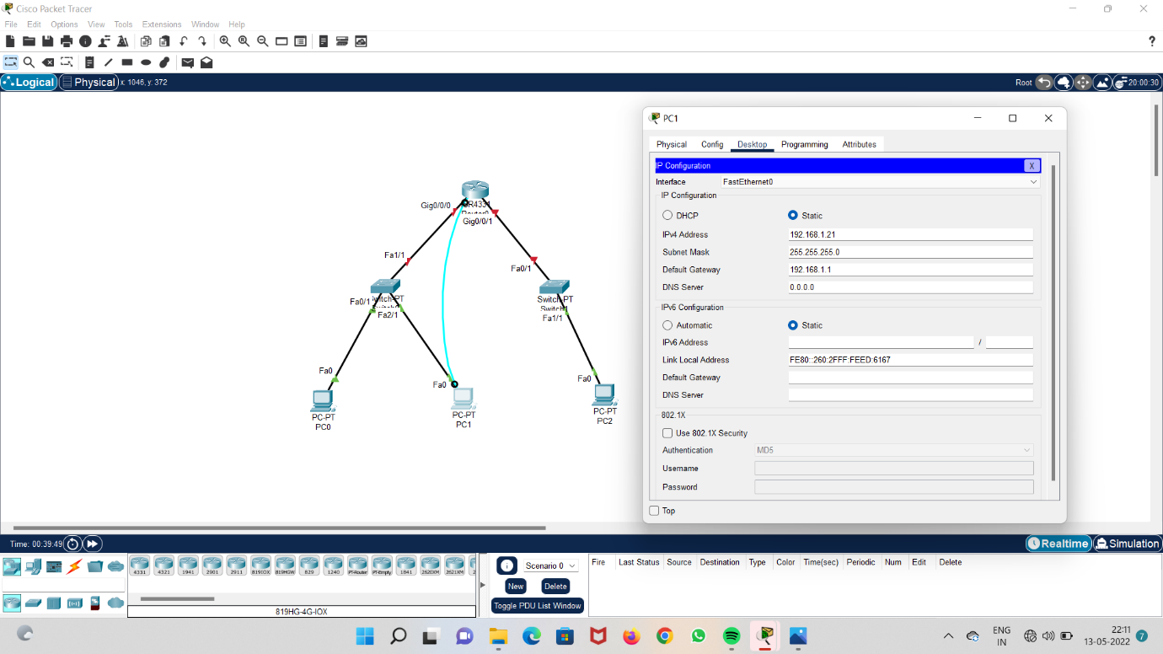

**Step 10 : Give first interface address and run the terminal and exit.**

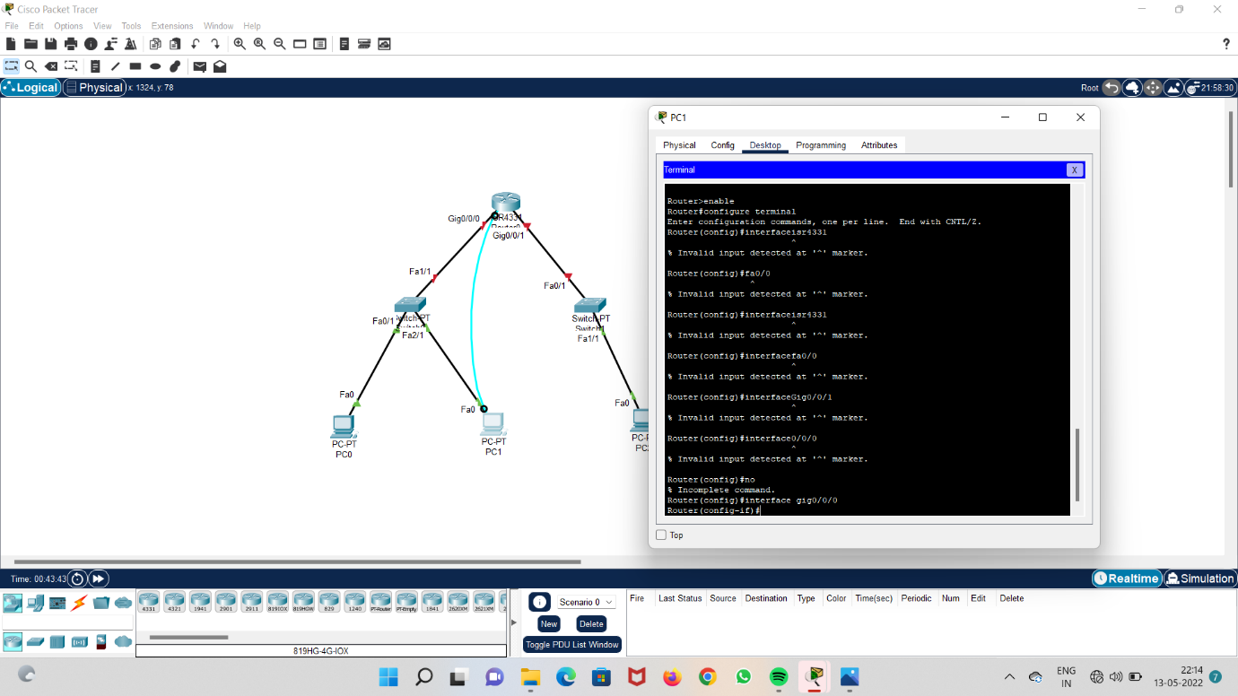

**Step 11 : Give second interface address and run the terminal and exit.**

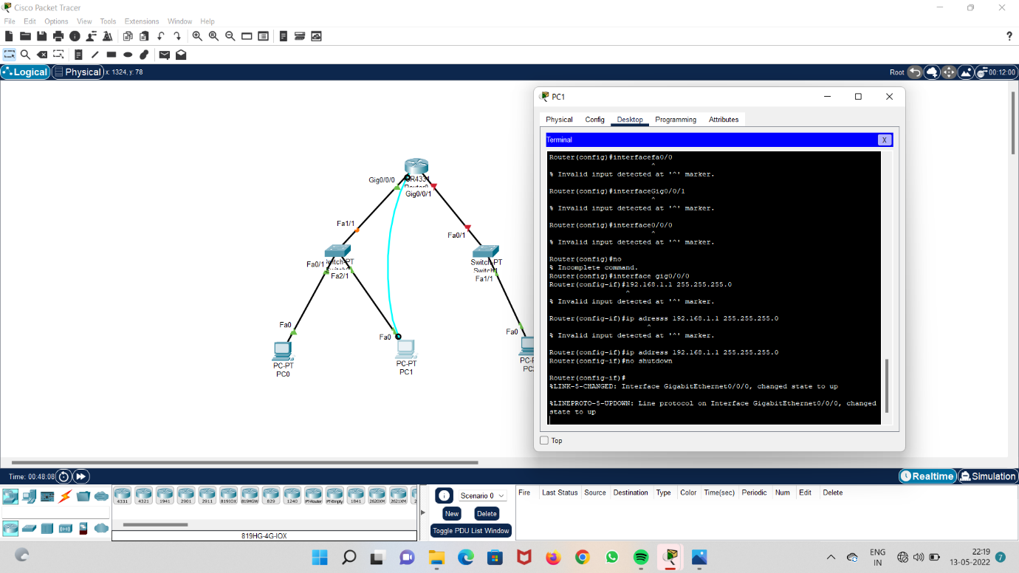

**Step 12 : open command prompt and run it.**

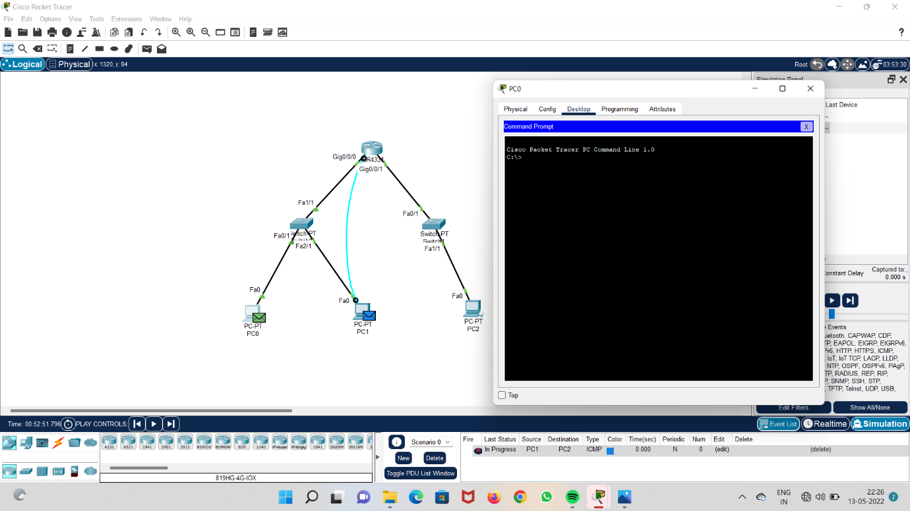

**Step 13 : run the network and check acknowledgement.**

