Computer networks

**Lab activity – 5**

**Name :** N.V.M.Sumanth

**Reg no :** 192111449

**Faculty :** Dr. S. Ramesh

**Course code :** CSA0786 computer networks for wanet applications

**Lab activity : 5**

**Question : Data Link Layer Traffic Simulation using Packet Tracer Analysis of LLDP.**

**Step 1 : Take 2 PT switches**

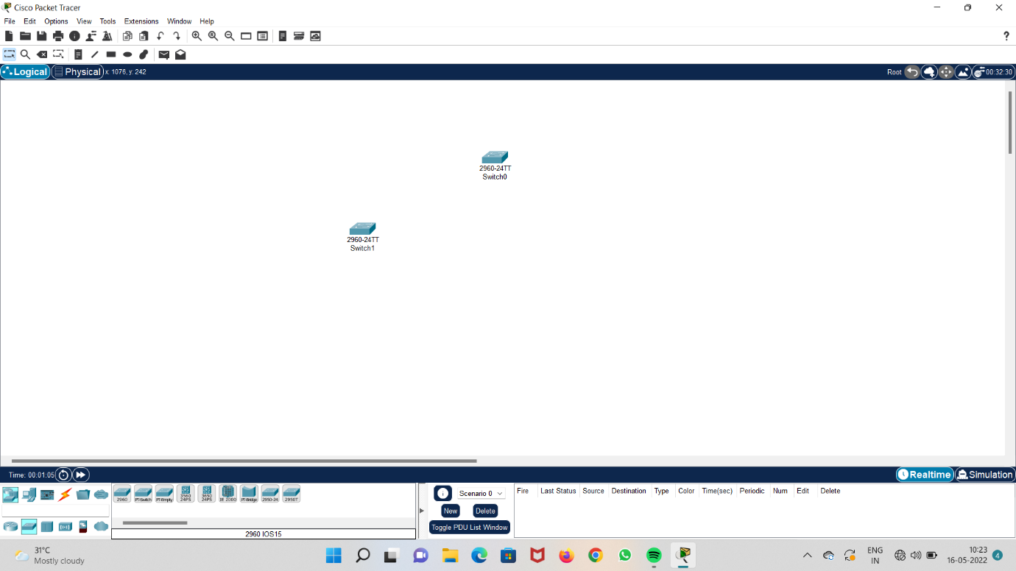

**Step 2 : Take a 1941 router.**

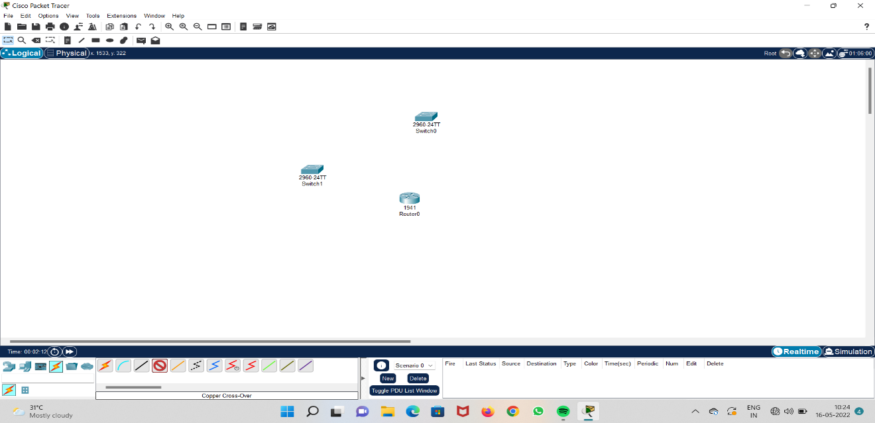

**Step 3 : connect both the switches to the router.**

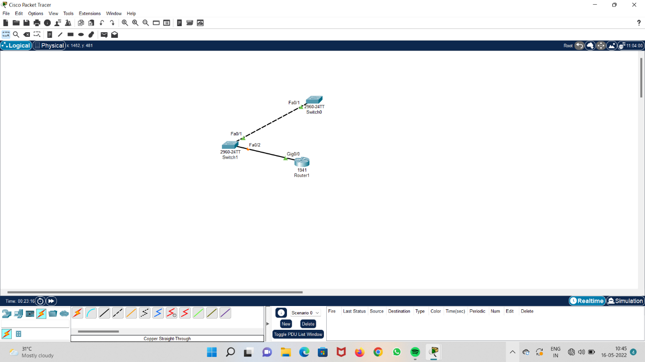

**Step 4 : open CLI in router and run the configuration**

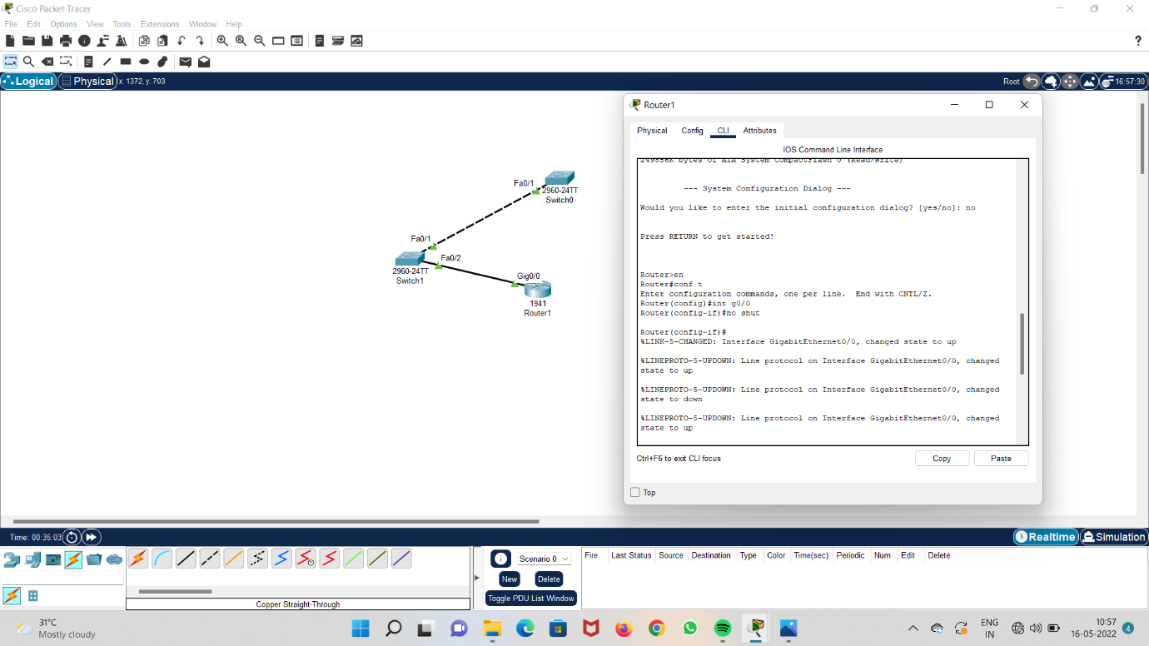

**Step 5 : open CLI in switch and run the configuration**

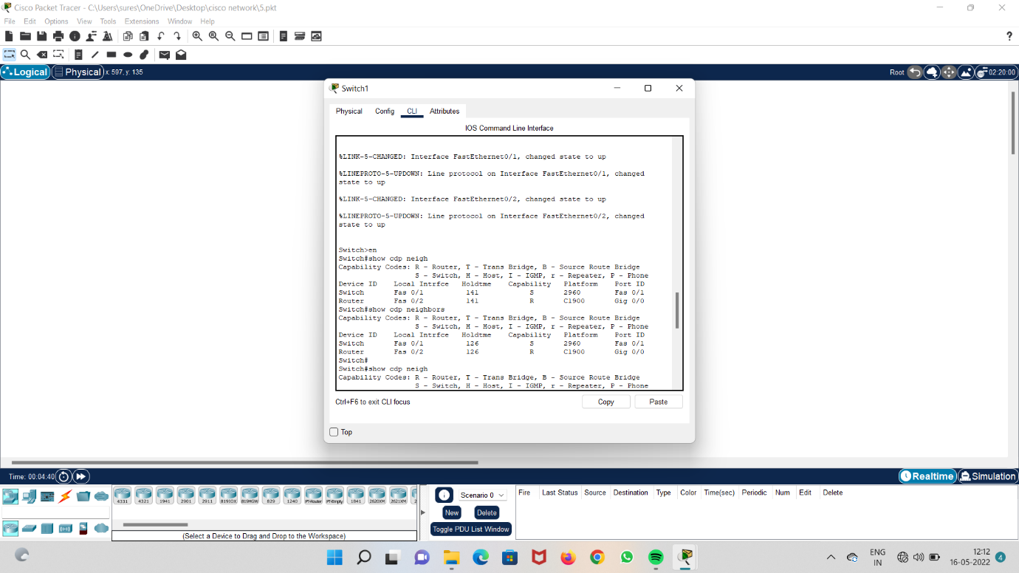

**Step 6 : run cdp interface in switch one**

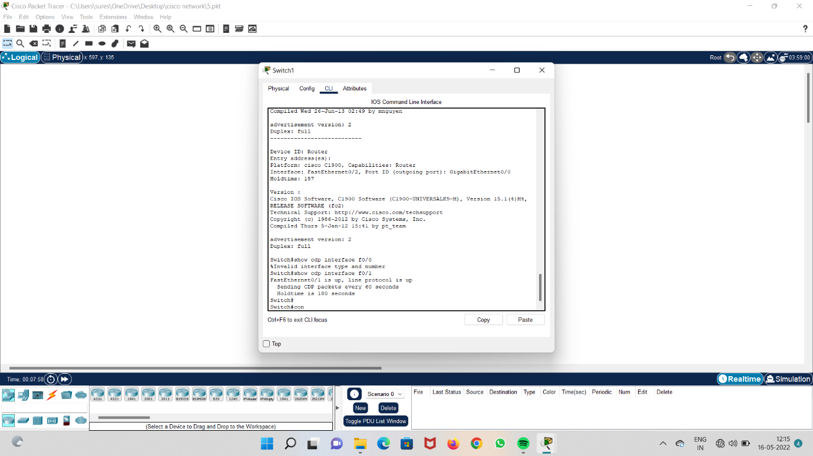

**Step 7 : Enable cdp interface in router one**

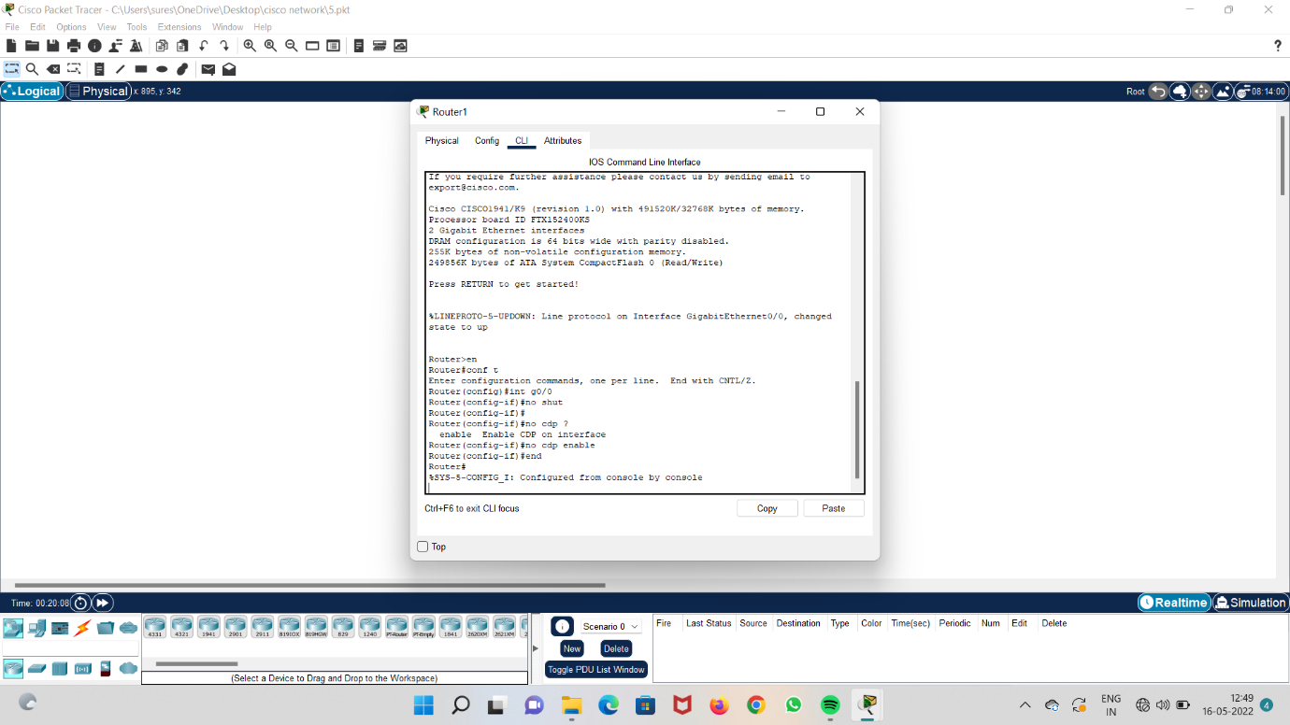

**Step 8 : run cdp interface f0/1 in switch one**

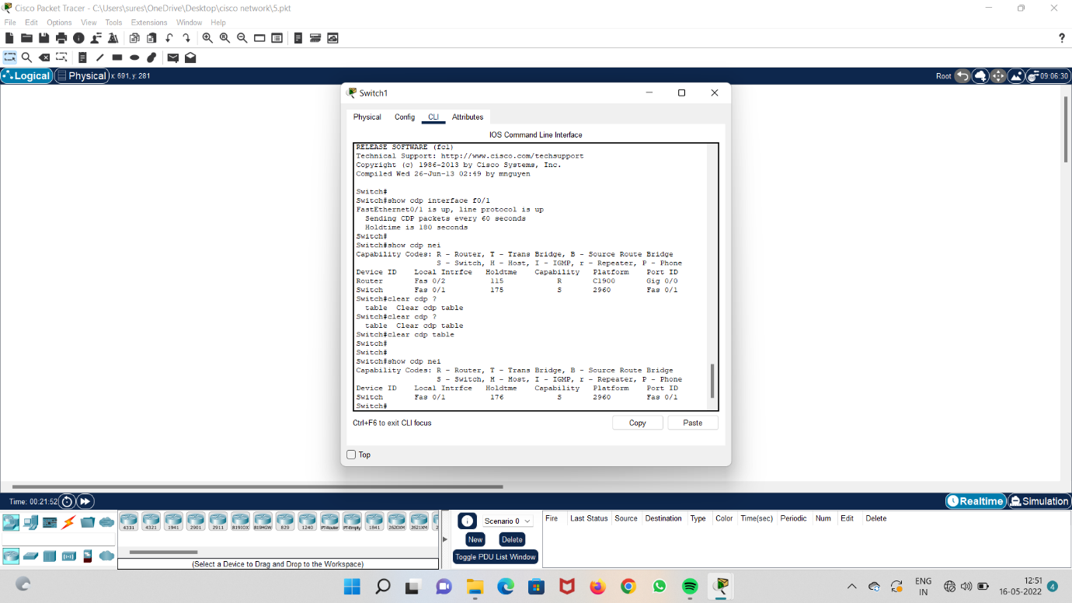

**Step 9 : clear cdp in switch one**

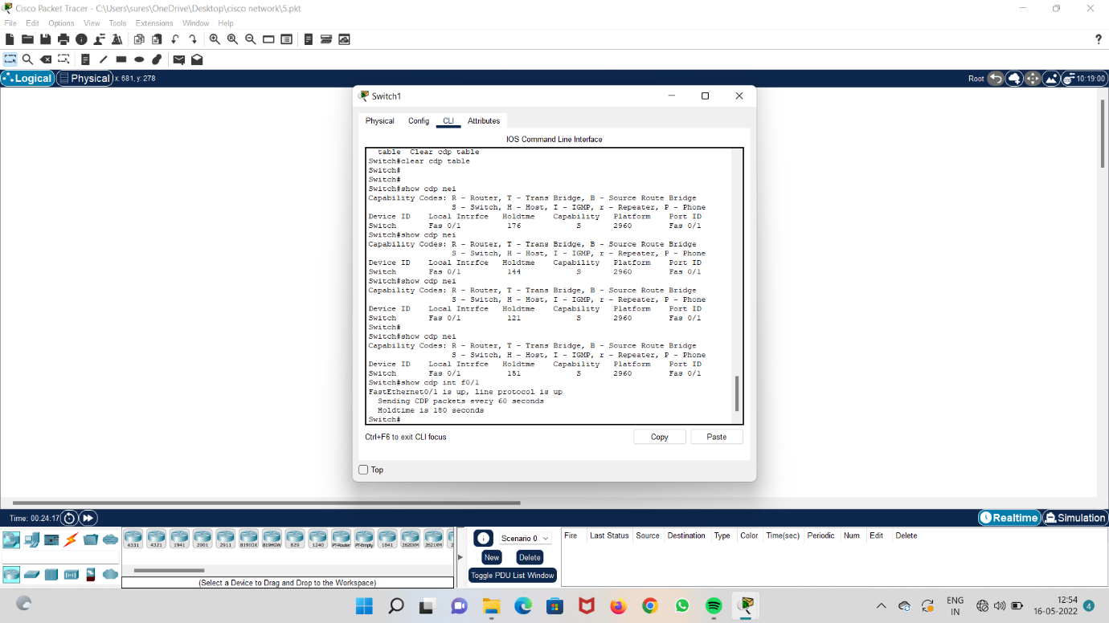

**Step 10 : check cdp nei and lldp**

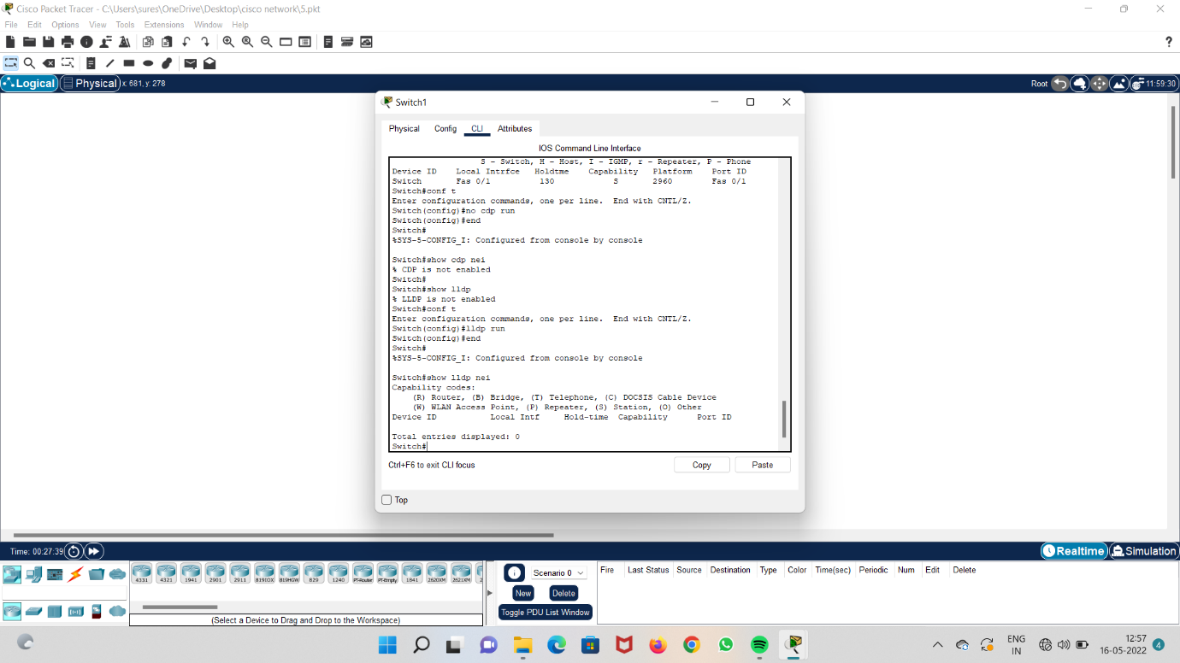

**Step 11 : Run lldp switch 0**

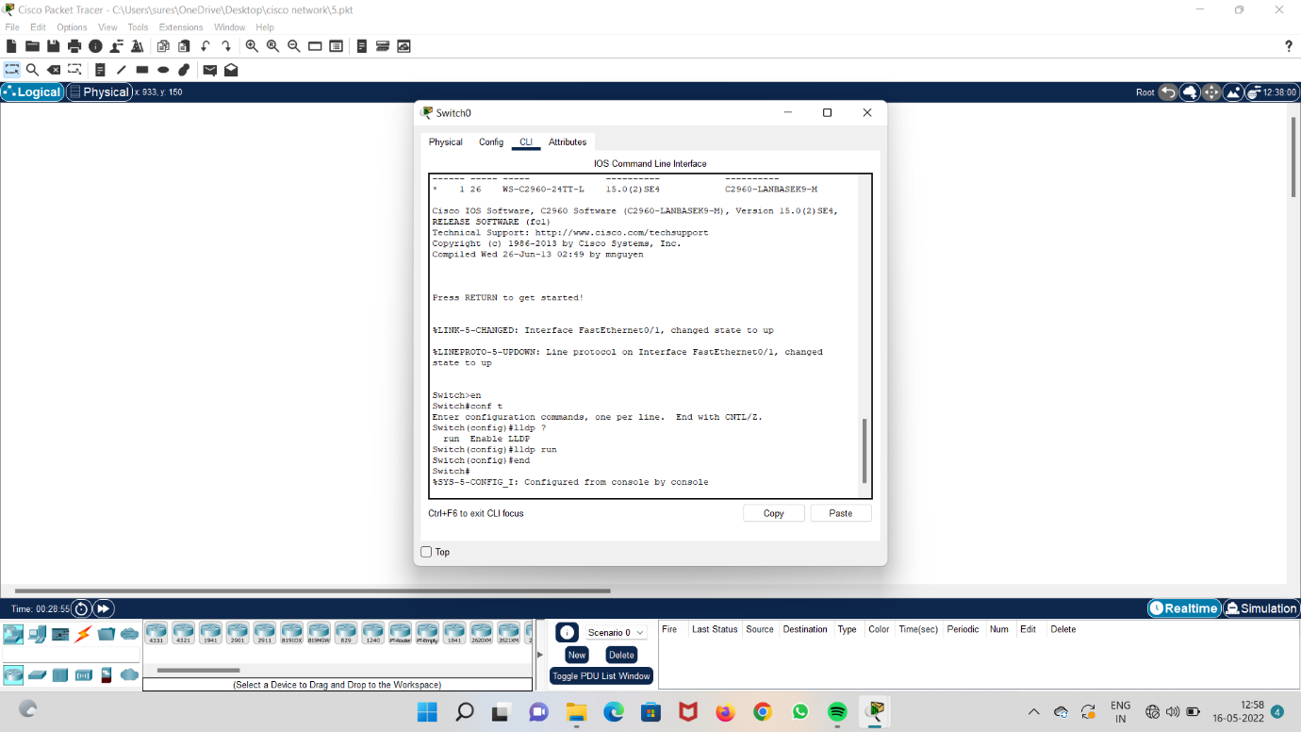

**Step 12 : run lldp in switch one**

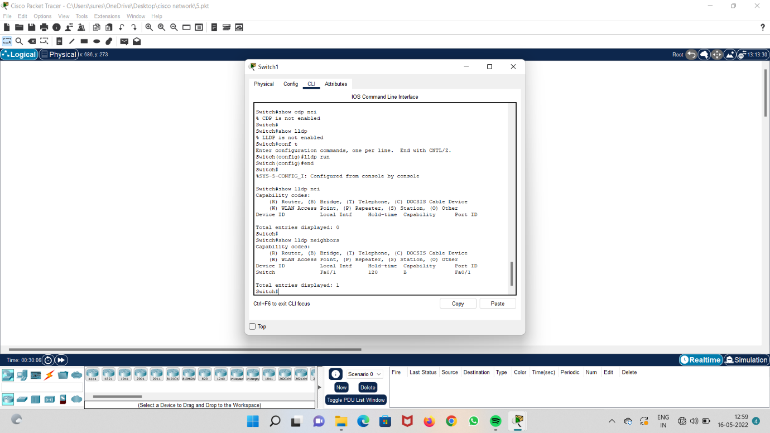

**Step 13 : end lldp in router**

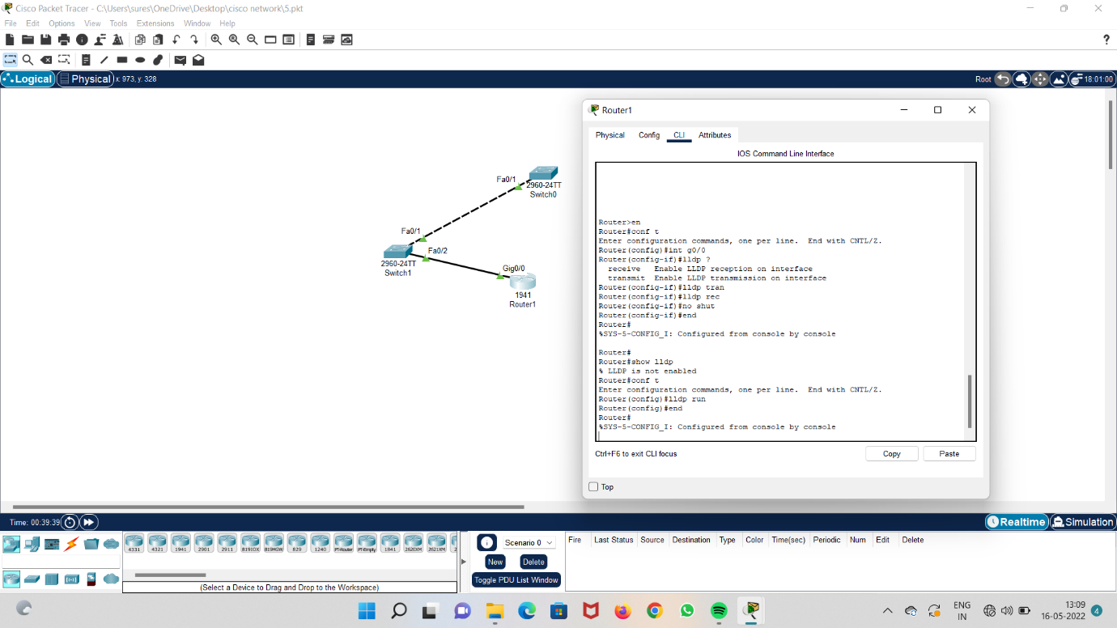

**Step 14 : check lldp status in switch one**

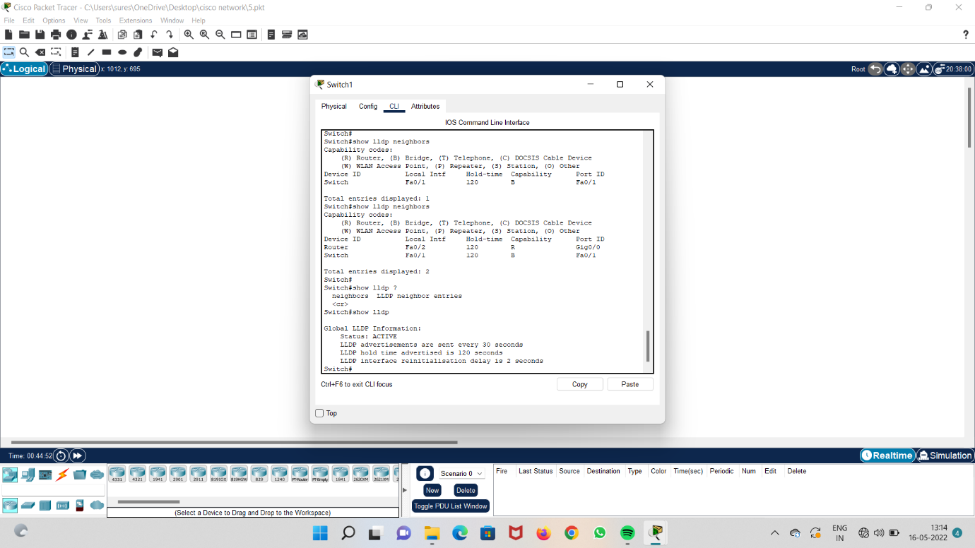

**Step 15 : connect two systems to the switches.**

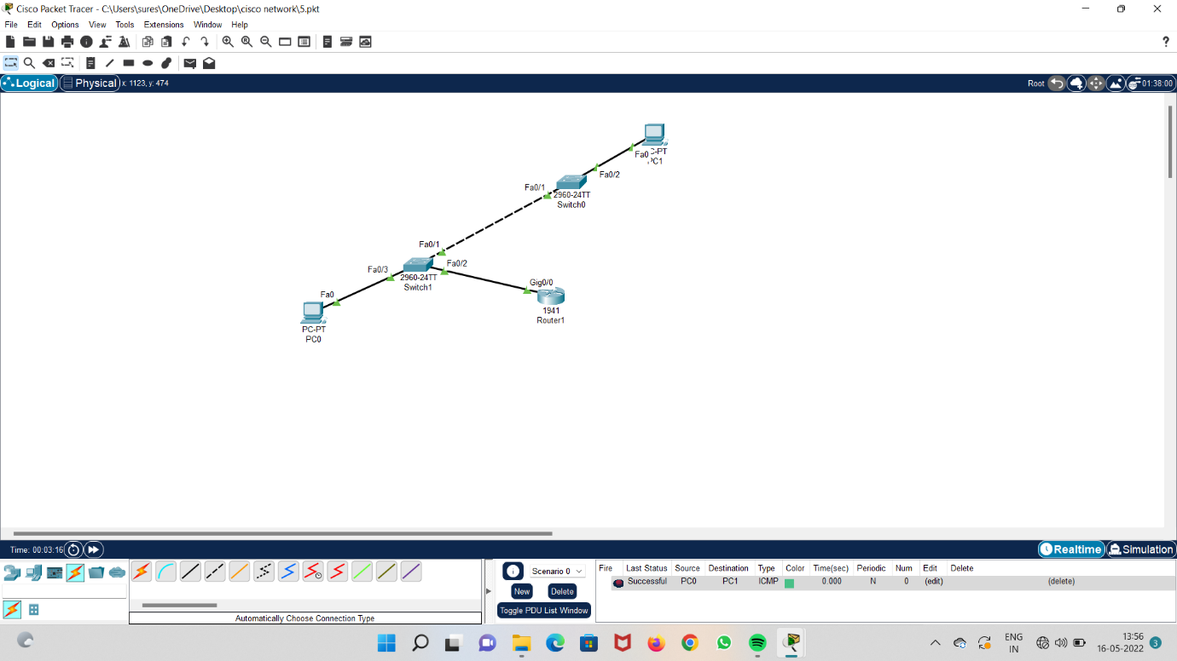

**Step 16 : give IP address to the system.**

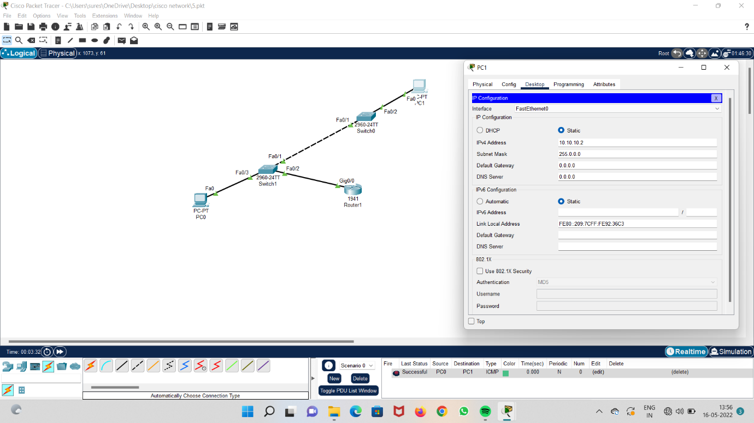

**Step 17 : run the system and check acknowledgement**

