EXPERIMENT-14

**NUMERICAL PREDICTION ANALYSIS USING LINEAR REGRESSION THROUGH WEKA**

**OUTPUT:**

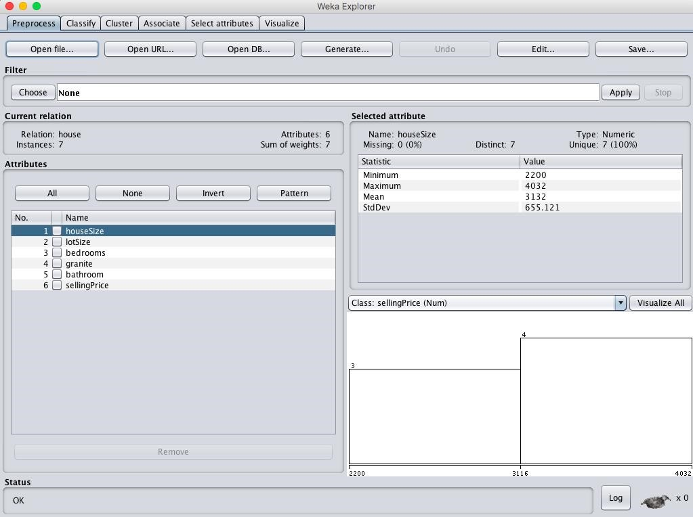

**When cross validation folds = 05 :**

