EXPERIMENT-6

**DATA SEGMENTATION BY K- MEANS CLUSTER**

**USING WEKA AND R-TOOL**

**OUTPUT:**

1)**Choose a set of attributes for clustering and give a motivation.**

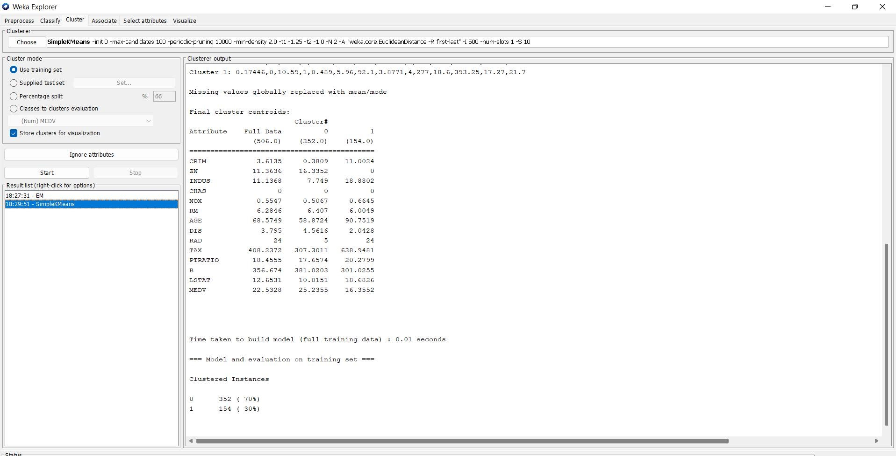

**2)Experiment with atleast 2 different number of clusters but with same seed values:**

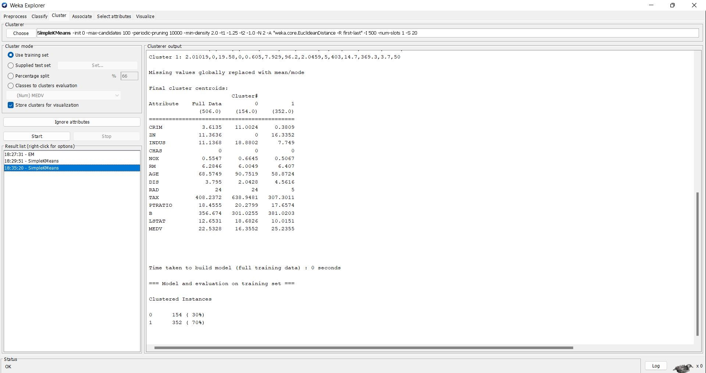

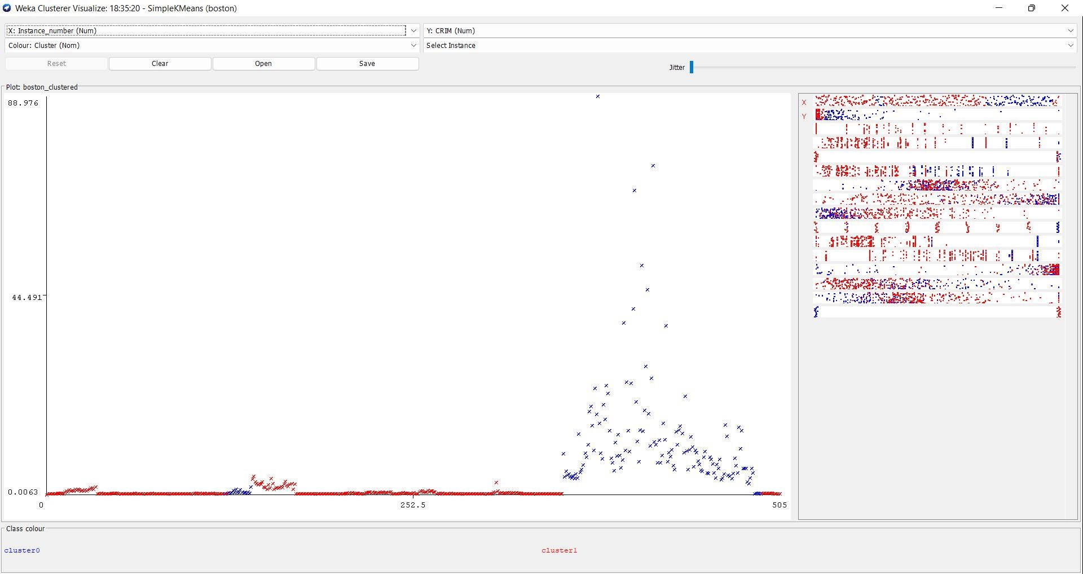

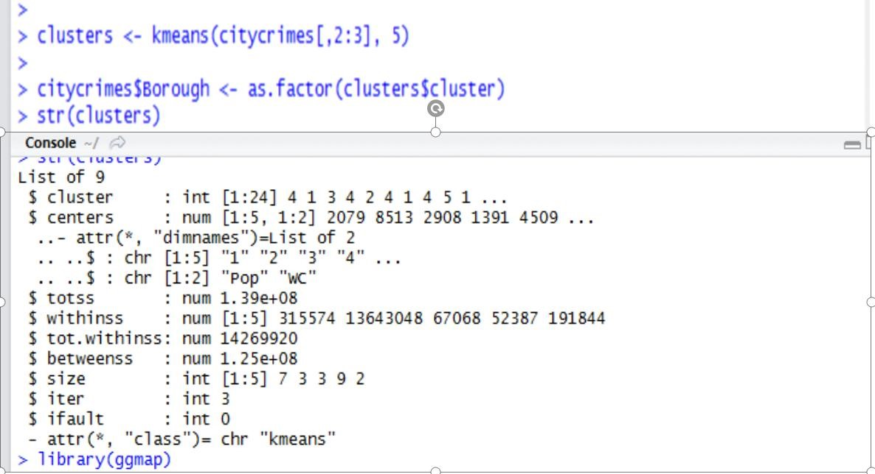**USING R-TOOL**

