EXPERIMENT-7

**DATASEGMENTATION BY EXPECTATION**

**MAXIMISATION ALGORITHM**

**THROUGH WEKA**

**OUTPUT:**

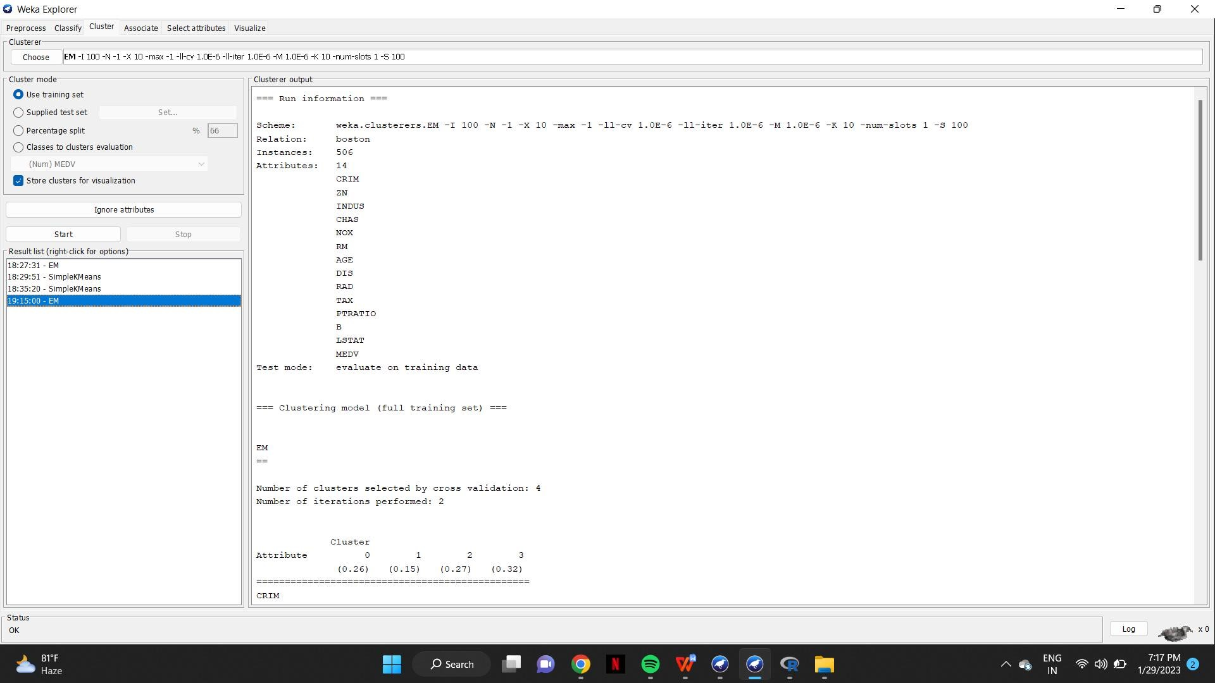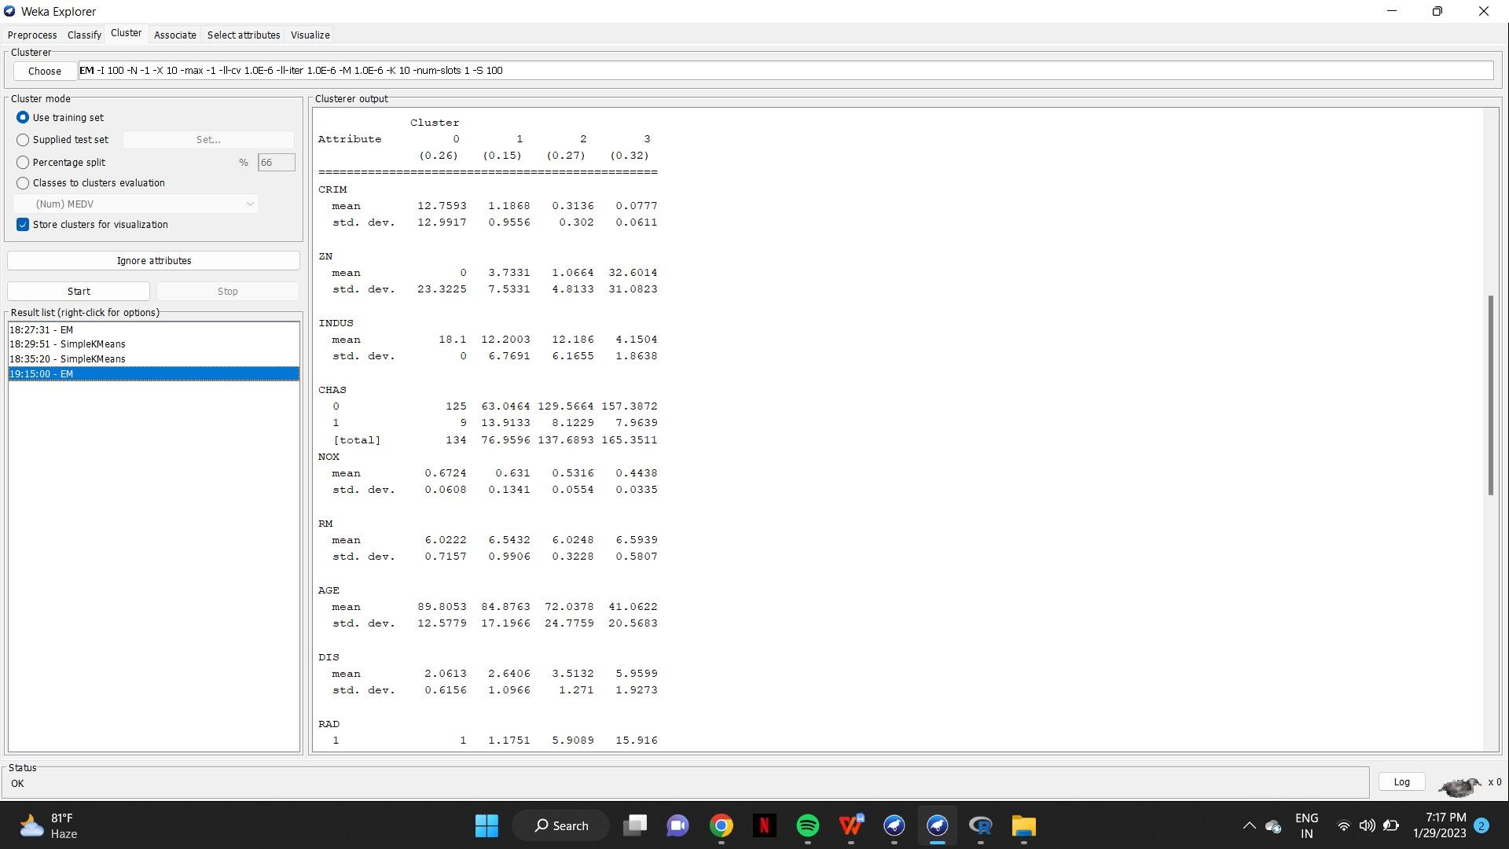

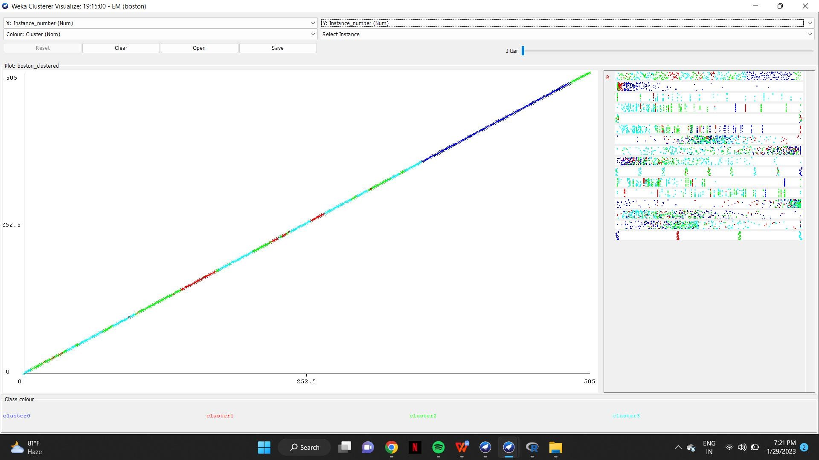

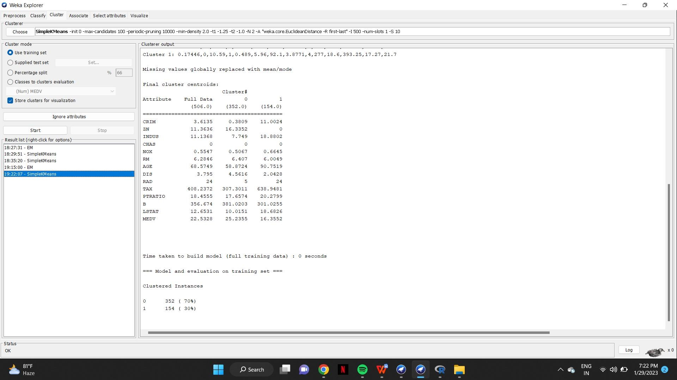K-MEANS: