EXPERIMENT-9

**FREQUENT PATTERN MINING USING ASSOCIATION RULE**

**THROUGH**

**WEKA AND R TOOLS**

**OUTPUT:**

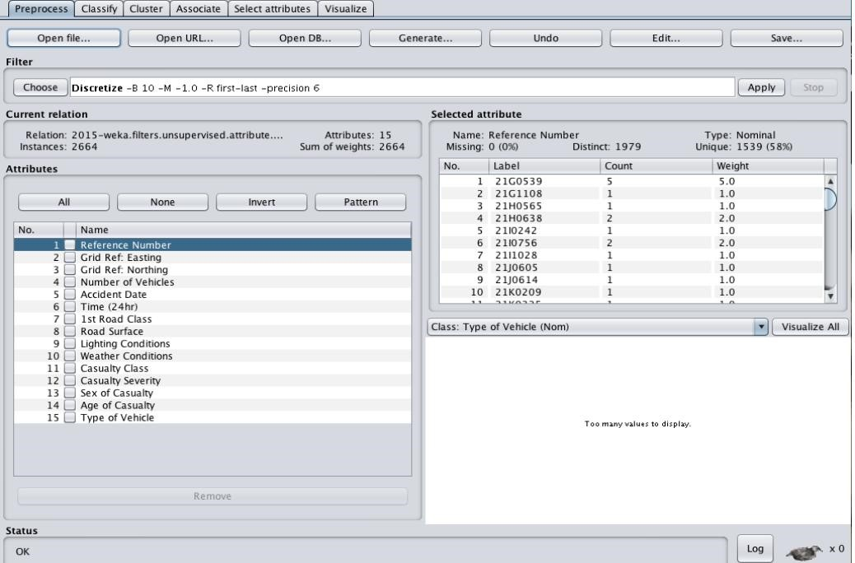

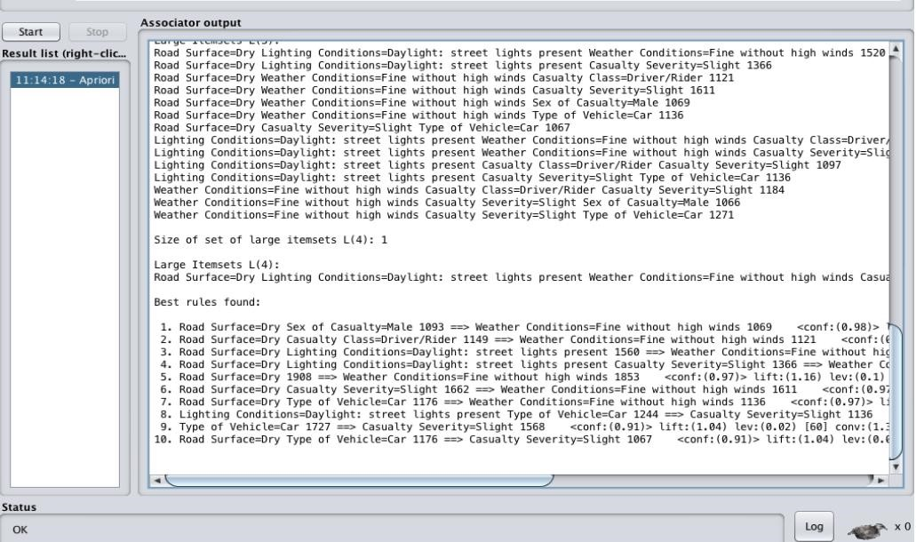

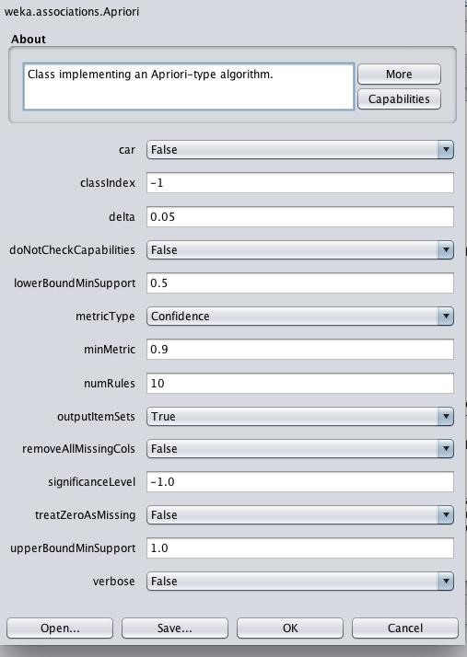

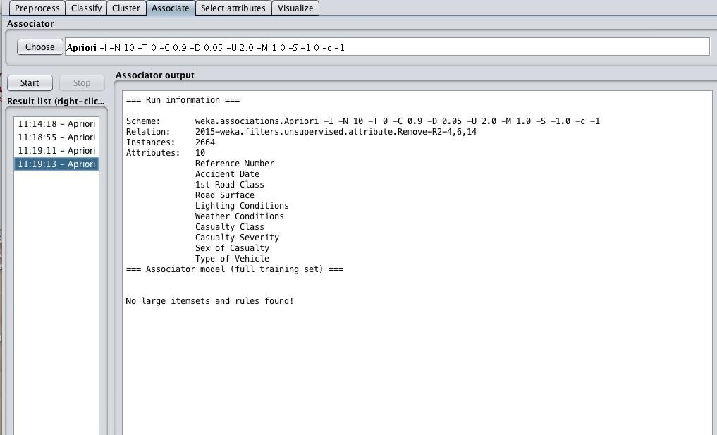

**USING R-TOOL:**

