EXPERIMENT-12

**PREDICTION OF CATEGORICAL DATA USING SMO ALGORTIHM THROUGH WEKA**

**OUTPUT:**

**DECISION TREE:**

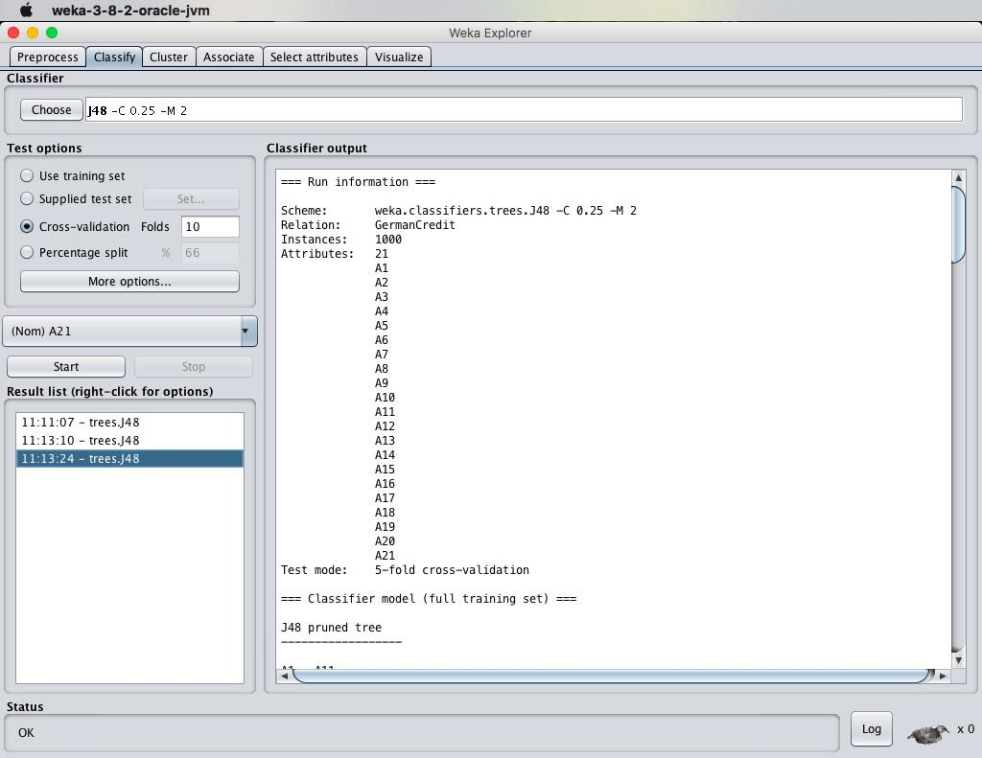

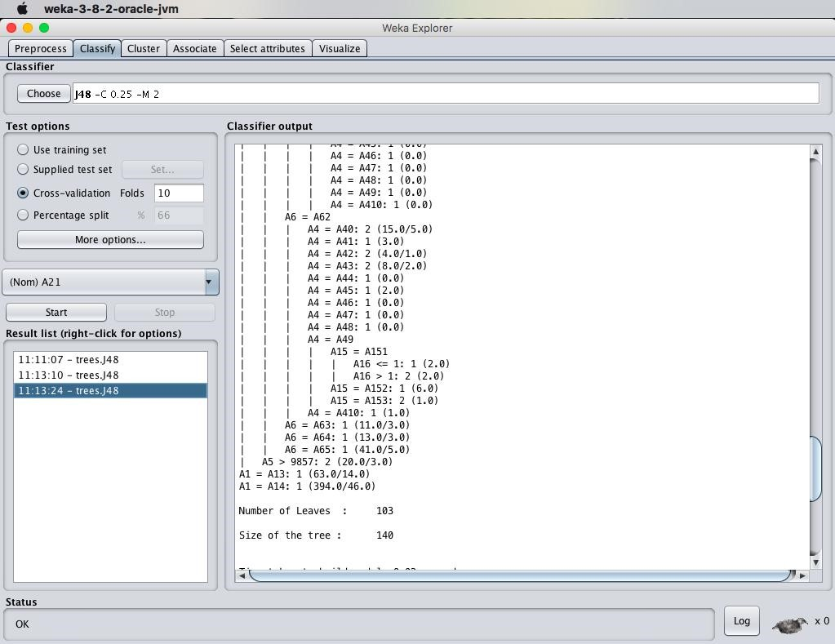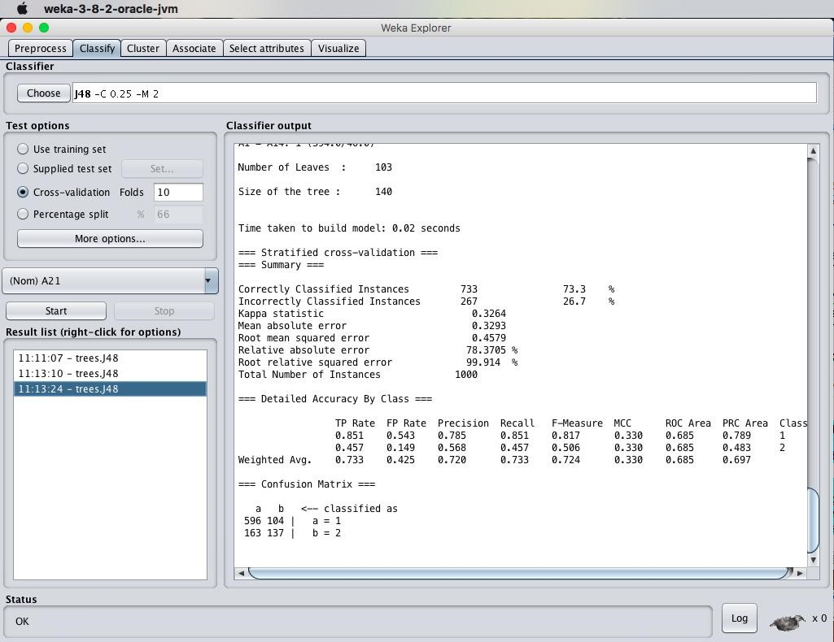

SMO ALGORITHM:

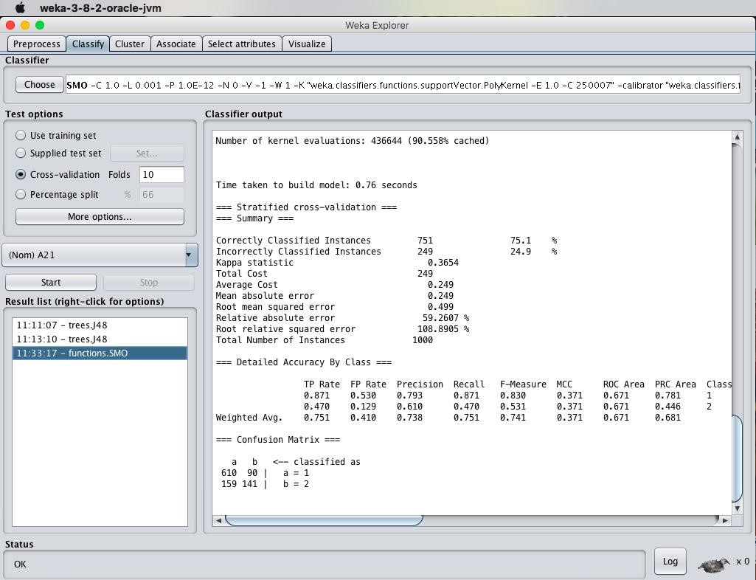

ANALYSIS:



