**Online Quiz System Using PHP with**

**Source Code**

**\*Introduction:*3**

In the age of digital education and remote learning, the demand for efficient and accessible assessment tools has grown significantly. Online quiz systems offer a flexible and scalable solution to assess knowledge and skills in various domains. These systems provide educators and learners with the ability to conduct assessments conveniently, regardless of geographical location or time constraints.

**\*Objective:\***

The primary objective of implementing an online quiz system is to enhance the assessment process by leveraging technology to streamline evaluation and feedback mechanisms. By transitioning from traditional paper-based assessments to digital quizzes, we aim to achieve the following goals:

1. *Accessibility*: Ensure quizzes are accessible anytime, anywhere, fostering flexibility for both educators and learners.

2. *Efficiency*: Automate grading and result compilation to save time and reduce administrative workload.

3. *Engagement*: Enhance student engagement through interactive and multimedia-rich quiz formats.

4. *Feedback*: Provide timely and constructive feedback to facilitate continuous learning and improvement.

5. *Data-Driven Insights*: Generate analytical reports to gain insights into learner performance and identify areas for curriculum enhancement.

By aligning these objectives with the needs of our educational community, we aim to create an online quiz system that supports effective teaching and learning practices in the digital age.This introduction sets the stage by highlighting the relevance of online quiz systems in modern education and outlines clear objectives to guide the development and implementation process.

**Language**

* [PHP](https://www.sourcecodester.com/language/php)

[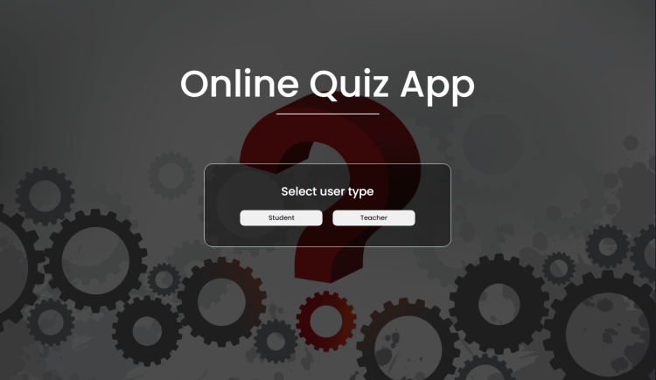](https://www.sourcecodester.com/sites/default/files/images/rems/oqs.png)

In today's fast-paced digital age, the education landscape is continually evolving, with technology playing a pivotal role in enhancing the learning experience. Online educational platforms have emerged as a versatile and effective means of imparting knowledge. As part of this educational transformation, the **"Online Quiz System Using PHP"** project offers a dynamic and interactive way to assess and engage students in the learning process.

You may also check some PHP projects that uses CRUD:

* [Password Manager App](https://www.sourcecodester.com/php/16908/password-manager-app-using-php-source-code.html)
* [File Manager App](https://www.sourcecodester.com/php/16919/file-manager-app-using-php-source-code.html)
* [School Task Manager](https://www.sourcecodester.com/php/16877/school-task-manager-using-php-source-code.html)
* [Expense Tracker App](https://www.sourcecodester.com/php/16794/simple-expense-tracker-app-using-php-source-code.html)
* [Book Catalog App](https://www.sourcecodester.com/php/16792/php-simple-book-catalog-app-free-source-code.html)
* [Contact Manager App](https://www.sourcecodester.com/php/16782/php-crud-contact-manager-app-image-free-source-code.html)

**Why an Online Quiz System?**

Traditional paper-and-pencil tests are giving way to online quizzes and assessments, which offer numerous advantages. An online quiz system allows teachers, students, and administrators to streamline the assessment process, providing benefits such as:

1. **Convenience:** Students can access quizzes from anywhere with an internet connection, reducing geographical limitations.
2. **Immediate Feedback:** Real-time feedback helps students understand their performance and areas of improvement.
3. **Time Efficiency:** Teachers can save time in grading, focusing on personalized instruction.
4. **Data Analysis:** The system collects data for in-depth analysis, aiding educators in curriculum development.

**Key Features:**

The "Online Quiz System Using PHP" project encompasses a variety of features, making it a comprehensive tool for educational institutions:

1. **User Roles:** The system supports multiple user roles, including students and teachers.
2. **Quiz Creation:** Teachers can create quizzes with customizable questions, multiple-choice options, and correct answers.
3. **Quiz Taking:** Students can take quizzes online and receive instant results.
4. **Result Tracking:** Both students and teachers can track quiz results and view historical performance.
5. **User-Friendly Interface:** A user-friendly interface enhances the overall user experience.
6. **Data Management:** Teachers can manage questions, quizzes, and results efficiently.
7. **Responsive Design:** The system adapts to various devices, including computers, tablets, and smartphones.

**Sample Screenshots of the Project:**

**Online Quiz System Landing Page**

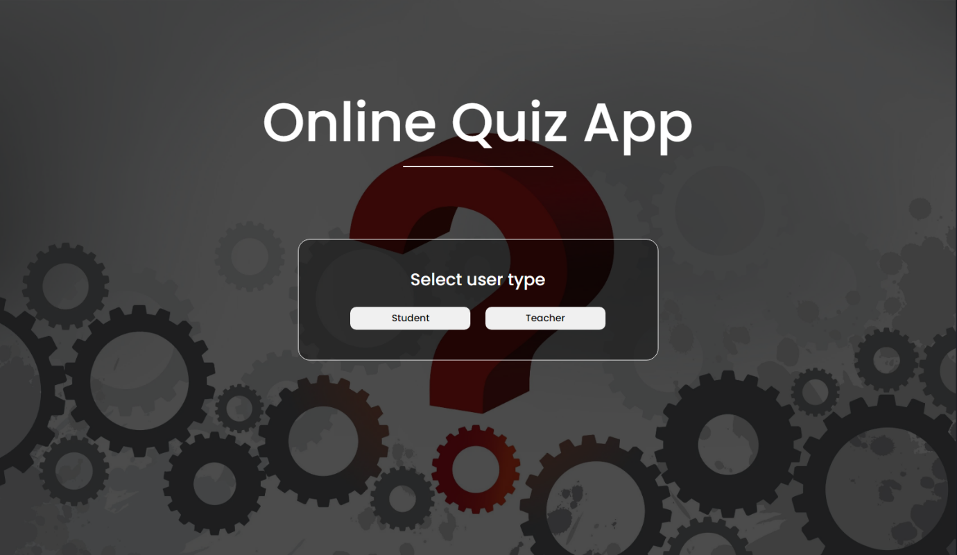

**Teacher Landing Page**

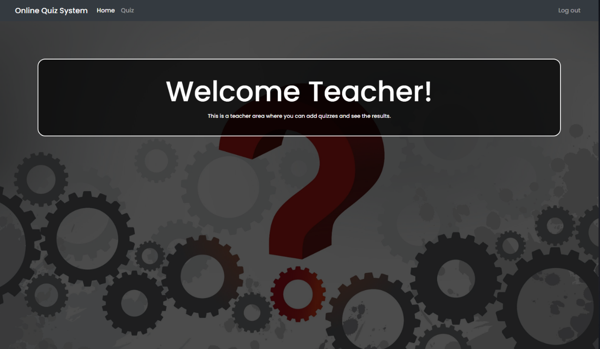

**Teacher Area (Questions)**

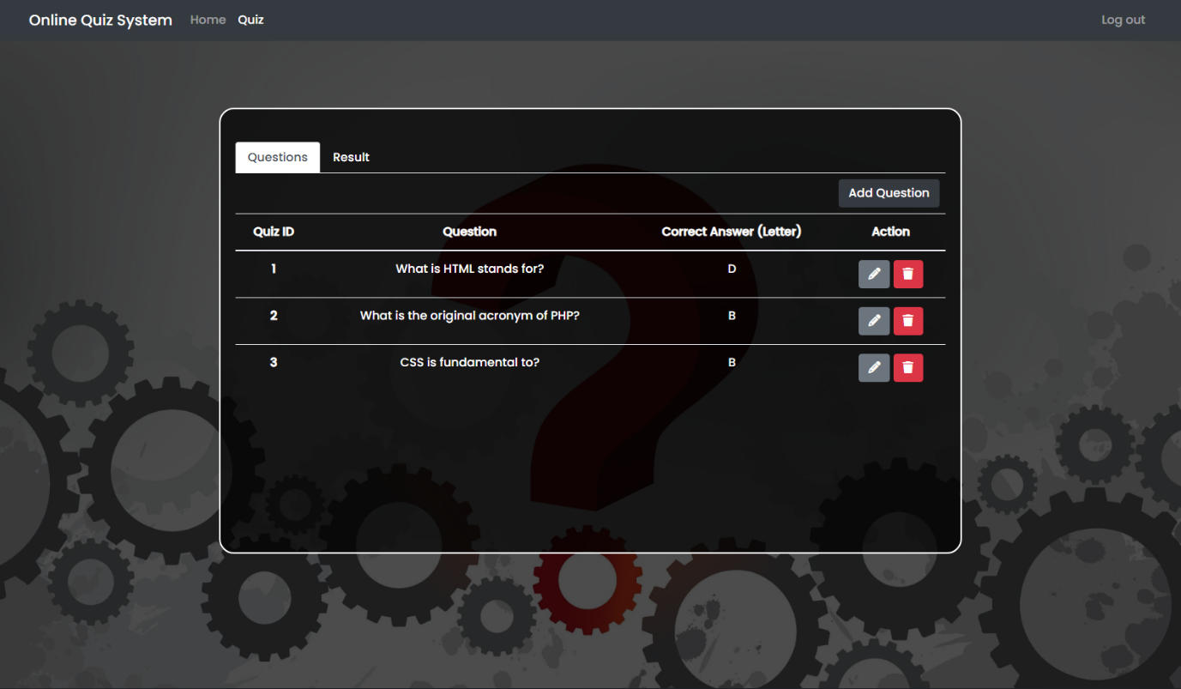

**Adding Question**

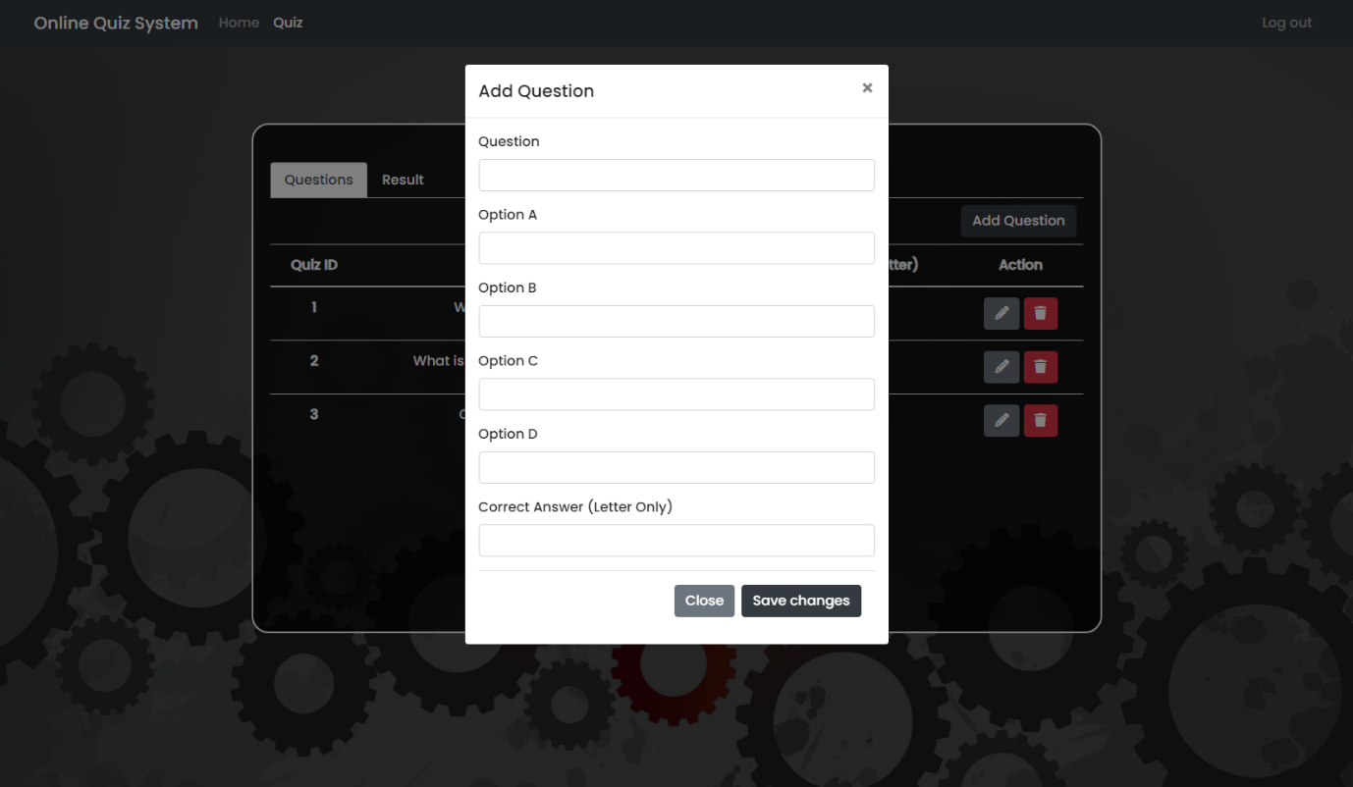

**Edit Question**

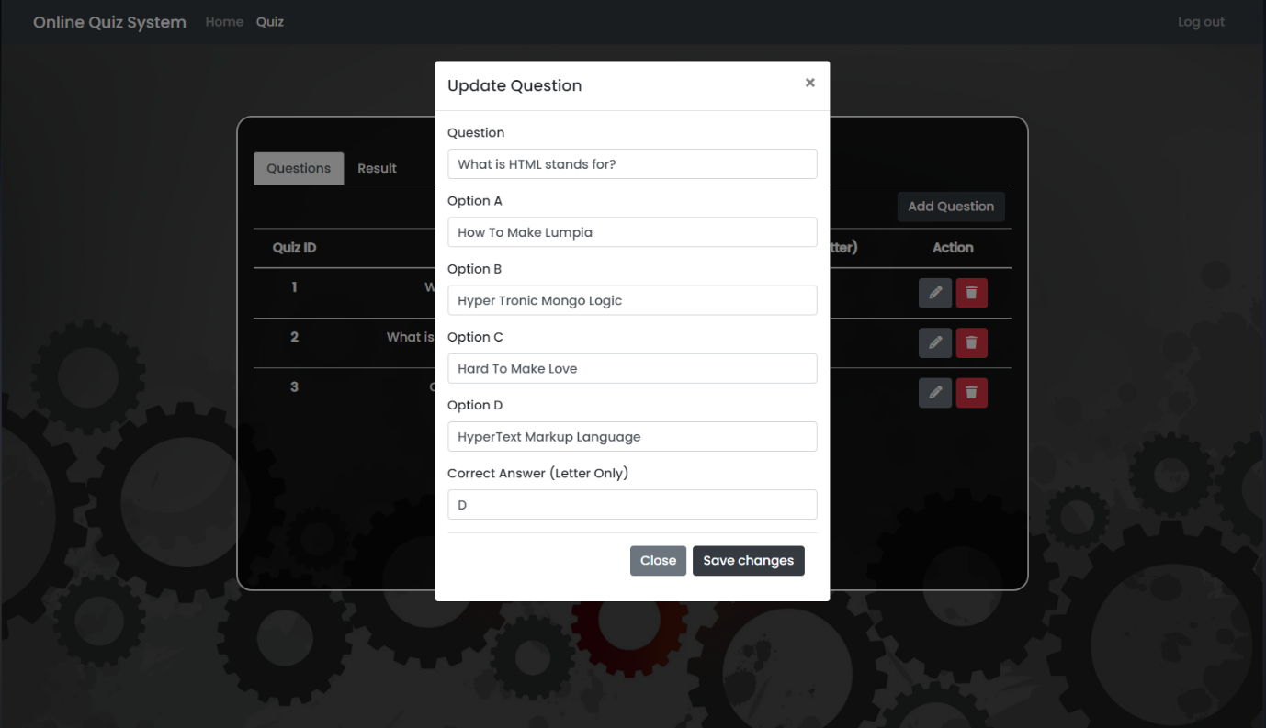

**Delete Question**

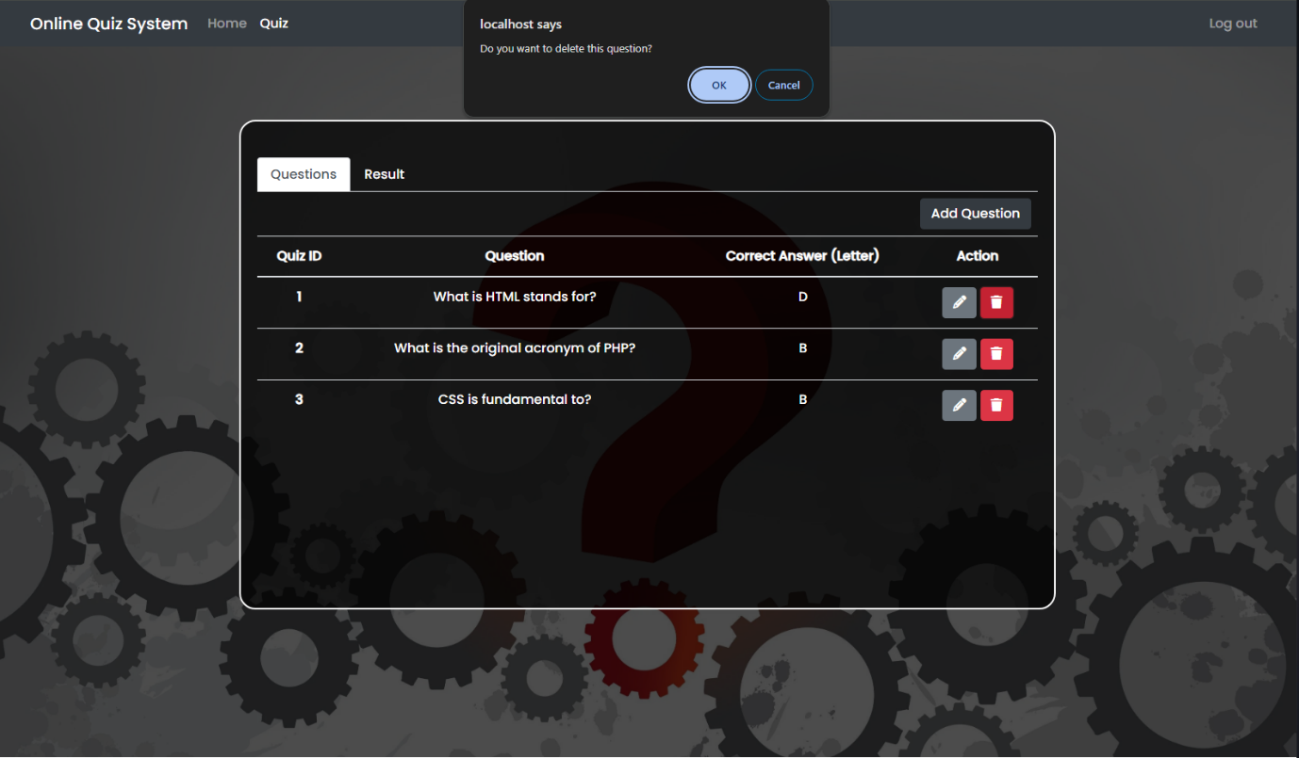

**Teacher Area (Results)**

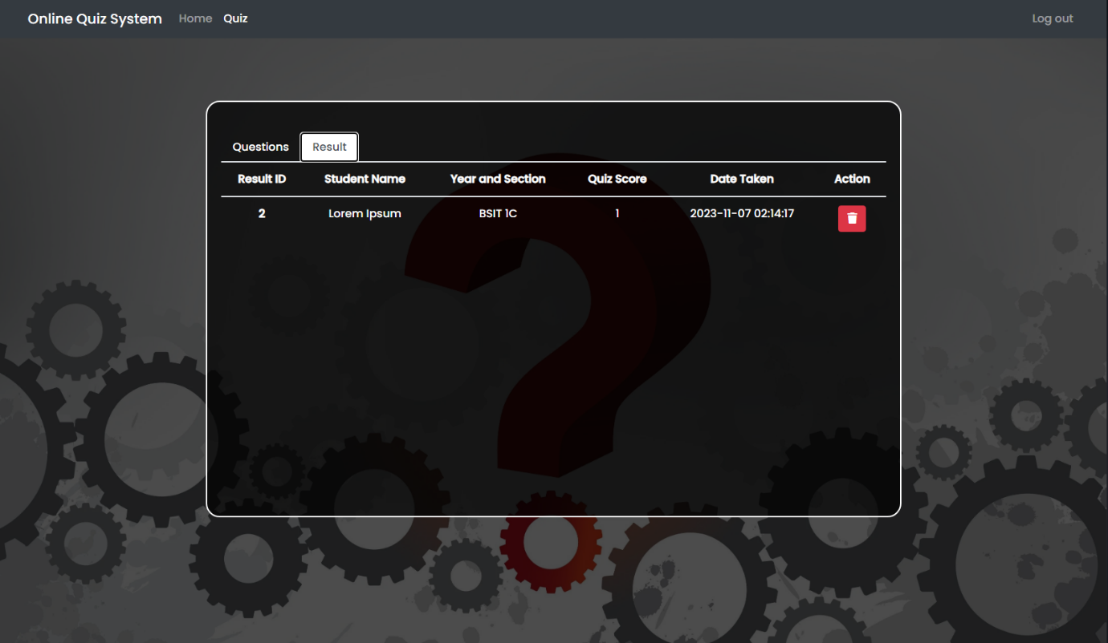

**Delete Result**

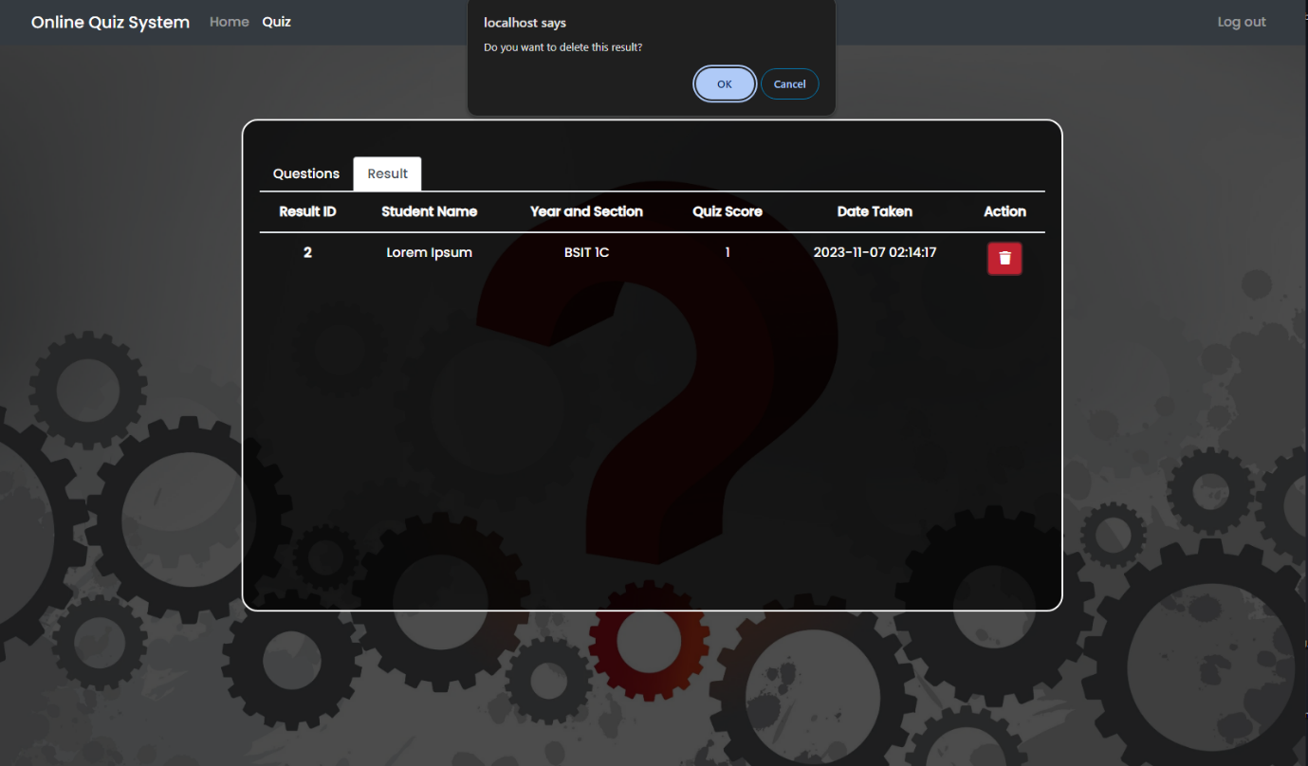

**Student Landing Page**



**Taking Quiz Area**

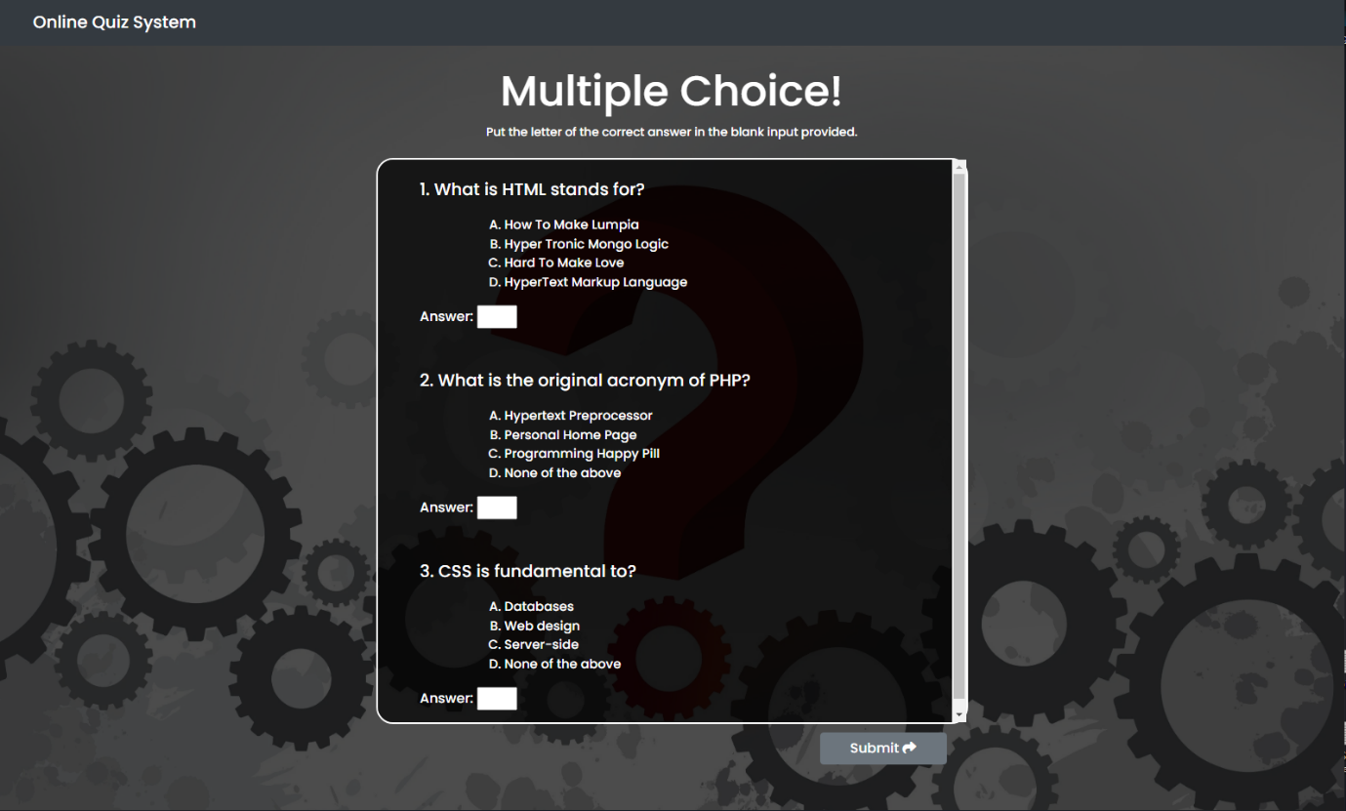

**Submit Result**

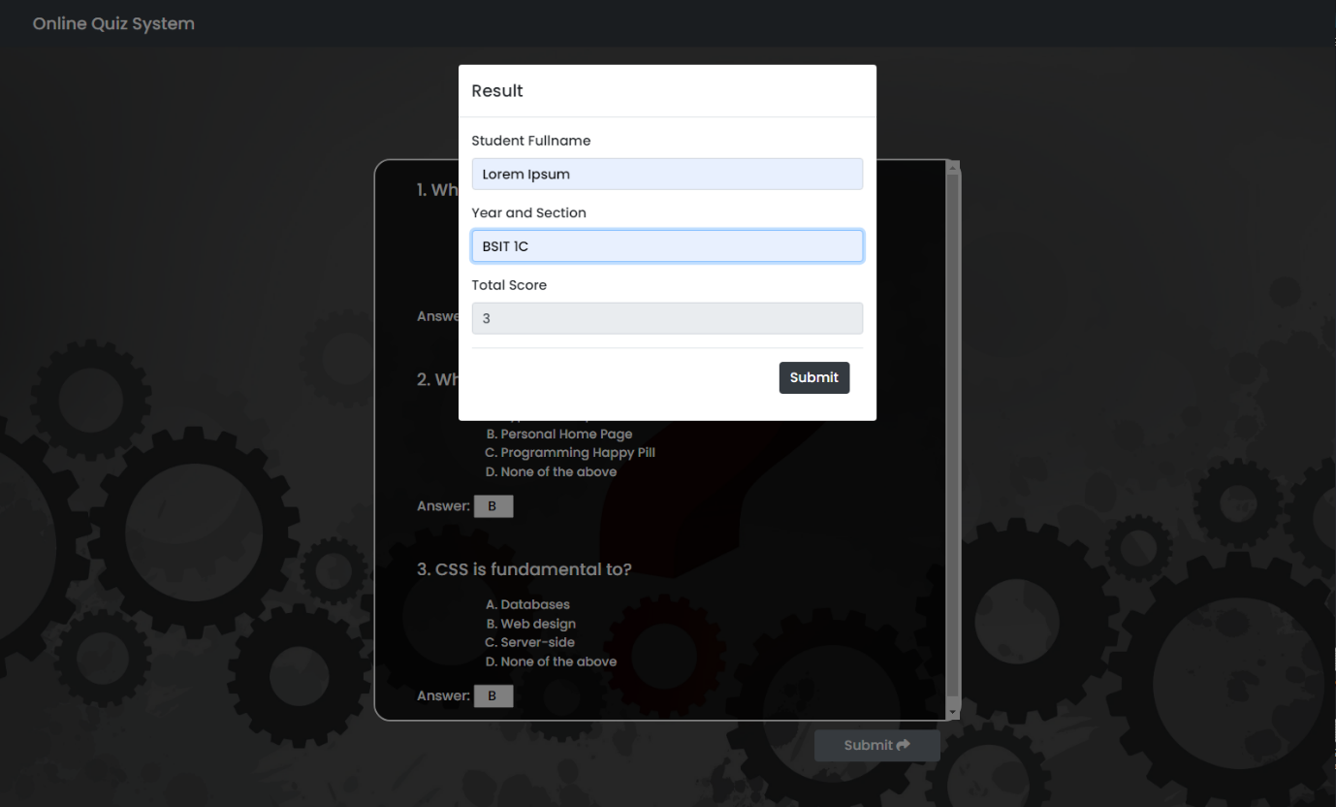

**How To Run?**

* **Download** and **Install** **XAMPP**.
* **Download** the provided source code **zip** file.

*Note: The database is included on the provided zip file.*

**Installation/Setup**

* **Transfer** the provided source code to the **htdocs** folder.
* **Create** a database named *"online_quiz_db"* in **phpMyAdmin MySQL**.
* **Import** the provided **SQL**file into the created database.

CREATE DATABASE IF NOT EXISTS quiz_system;

USE quiz_system;

CREATE TABLE IF NOT EXISTS questions (

id INT AUTO_INCREMENT PRIMARY KEY,

question_text TEXT NOT NULL

);

CREATE TABLE IF NOT EXISTS answers (

id INT AUTO_INCREMENT PRIMARY KEY,

question_id INT NOT NULL,

answer_text TEXT NOT NULL,

is_correct TINYINT(1) DEFAULT 0,

FOREIGN KEY (question_id) REFERENCES questions(id) ON DELETE CASCADE

);

PHP:

<?php

// Database connection

$servername = "localhost";

$username = "username";

$password = "password";

$dbname = "quiz_system";

$conn = new mysqli($servername, $username, $password, $dbname);

if ($conn->connect_error) {

die("Connection failed: " . $conn->connect_error);

}

// Function to fetch questions from the database

function getQuestions() {

global $conn;

$sql = "SELECT id, question_text FROM questions";

$result = $conn->query($sql);

$questions = array();

if ($result->num_rows > 0) {

while ($row = $result->fetch_assoc()) {

$questions[] = $row;

}

}

return $questions;

}

// Function to fetch answers for a given question

function getAnswers($question_id) {

global $conn;

$sql = "SELECT id, answer_text FROM answers WHERE question_id = $question_id";

$result = $conn->query($sql);

$answers = array();

if ($result->num_rows > 0) {

while ($row = $result->fetch_assoc()) {

$answers[] = $row;

}

}

return $answers;

}

// Display quiz questions

$questions = getQuestions();

echo "<form action='submit_quiz.php' method='post'>";

foreach ($questions as $question) {

echo "<p>{$question['question_text']}</p>";

$answers = getAnswers($question['id']);

foreach ($answers as $answer) {

echo "<input type='radio' name='question_{$question['id']}' value='{$answer['id']}'> {$answer['answer_text']}<br>";

}

echo "<br>";

}

echo "<input type='submit' value='Submit'>";

echo "</form>";

$conn->close();

?>

<?php

// Database connection

$servername = "localhost";

$username = "username";

$password = "password";

$dbname = "quiz_system";

$conn = new mysqli($servername, $username, $password, $dbname);

if ($conn->connect_error) {

die("Connection failed: " . $conn->connect_error);

}

// Initialize variables

$score = 0;

// Iterate through submitted answers

foreach ($_POST as $question_id => $answer_id) {

// Validate inputs to avoid SQL injection

$question_id = intval($question_id);

$answer_id = intval($answer_id);

// Retrieve correct answer for the question

$sql = "SELECT is_correct FROM answers WHERE id = $answer_id AND question_id = $question_id";

$result = $conn->query($sql);

if ($result->num_rows > 0) {

$row = $result->fetch_assoc();

if ($row['is_correct'] == 1) {

$score++;

}

}

}

echo "<h2>Your score is: $score</h2>";

$conn->close();

?>

**Conclusion:**

The **"Online Quiz System Using PHP"** project represents a modern approach to education and assessment, harnessing the power of technology to create engaging and efficient learning experiences. Whether you are a teacher seeking to simplify the assessment process or a student looking for a convenient and informative way to test your knowledge, this online quiz system promises a valuable educational tool.

That's it! I hope this "**Online Quiz System Using PHP**" will assist you on your programming journey, providing value to your current and upcoming PHP projects.

For additional tutorials and free source code, explore our websites.